EXPERIMENT :3
AIM: Demonstrate the working of the decision tree based ID3 algorithm. Use an appropriate data set
for building the decision tree and apply this knowledge to classify a new sample.
ALGORITHM:
- Load the training dataset.
- Convert categorical values into numerical values.
- Separate the features and target class.
- Train the Decision Tree classifier using the Entropy (ID3) criterion.
- Display the generated decision tree.
- Predict the class label for a new sample.
- Display the predicted result.
PROGRAM:
import pandas as pd
from sklearn.preprocessing import LabelEncoder
from sklearn.tree import DecisionTreeClassifier, export_text

# Load dataset
data = pd.read_csv("play_tennis.csv")

print("Dataset:\n")
print(data)

# Label Encoding
le = LabelEncoder()

for column in data.columns:
data[column] = le.fit_transform(data[column])

# Features and Target
X = data.iloc[:, :-1]
y = data.iloc[:, -1]

# Train ID3 Decision Tree
model = DecisionTreeClassifier(criterion="entropy")
model.fit(X, y)

# Display Decision Tree
print("\nDecision Tree:\n")
print(export_text(model, feature_names=list(X.columns)))

# New Sample
# Outlook=Sunny, Temperature=Cool, Humidity=High, Wind=Strong
new_sample = [[2, 0, 0, 0]]

prediction = model.predict(new_sample)

if prediction[0] == 1:
print("\nPrediction: Play = Yes")
else:
print("\nPrediction: Play = No")
SAMPLE INPUT:
New Sample

Outlook = Sunny
Temperature = Cool
Humidity = High
Wind = Strong
SAMPLE OUTPUT:
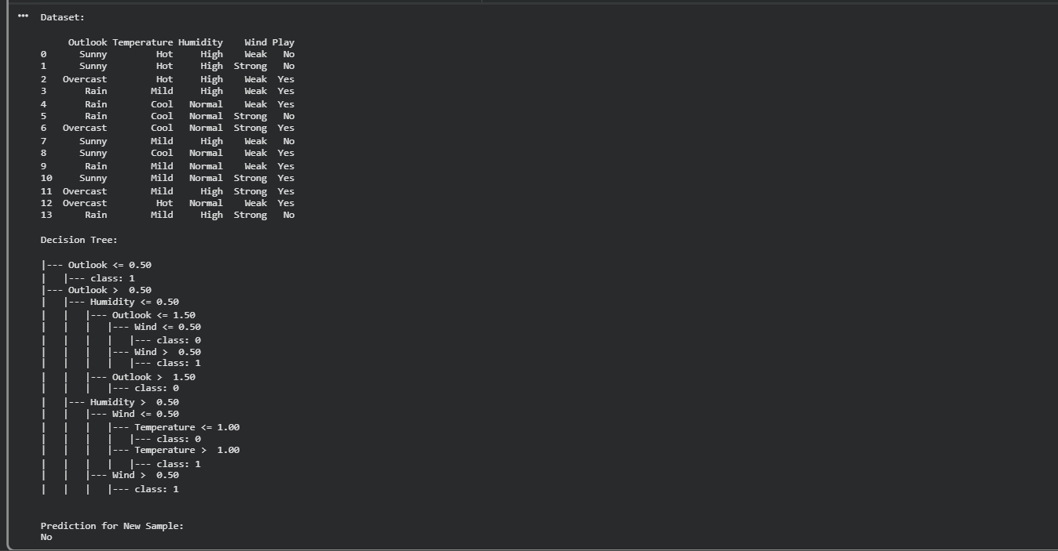
RESULT:
The ID3 Decision Tree algorithm was successfully implemented using Python. The model was trained on the given dataset, the decision tree was generated, and the new sample was successfully classified as Play = No.

