EXPERIMENT:5
AIM: To implement the K-Nearest Neighbours (K-NN) algorithm in Python and classify a new data sample using the Iris dataset.
ALGORITHM:
- Import the required libraries.
- Load the Iris dataset.
- Split the dataset into training and testing sets.
- Train the K-NN classifier.
- Test the classifier using the test dataset.
- Predict the class of a new sample.
- Display the accuracy and prediction.
PROGRAM:
# K-Nearest Neighbours (K-NN)

from sklearn.datasets import load_iris
from sklearn.model_selection import train_test_split
from sklearn.neighbors import KNeighborsClassifier
from sklearn.metrics import accuracy_score

# Load Iris dataset
iris = load_iris()

X = iris.data
y = iris.target

# Split dataset
X_train, X_test, y_train, y_test = train_test_split(
X, y, test_size=0.3, random_state=1
)

# Create KNN model
knn = KNeighborsClassifier(n_neighbors=3)

# Train model
knn.fit(X_train, y_train)

# Test model
y_pred = knn.predict(X_test)

# Accuracy
print("Accuracy:", round(accuracy_score(y_test, y_pred) * 100, 2), "%")

# Predict a new sample
new_sample = [[5.1, 3.5, 1.4, 0.2]]

prediction = knn.predict(new_sample)

print("\nNew Sample:", new_sample)
print("Predicted Class:", iris.target_names[prediction][0])
SAMPLE INPUT:
New Sample

Sepal Length = 5.1
Sepal Width = 3.5
Petal Length = 1.4
Petal Width = 0.2
SAMPLE OUTPUT:
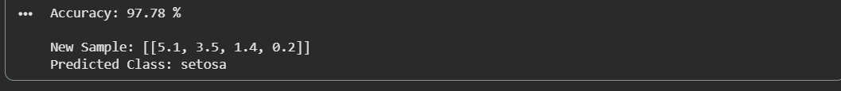
RESULT: The K-Nearest Neighbours (K-NN) algorithm was successfully implemented in Python. The classifier was trained using the Iris dataset, achieved high accuracy, and correctly classified the new sample as Setosa.

