EXPERIMENT:2
AIM: To implement and demonstrate the Candidate-Elimination algorithm in Python using a CSV file and obtain the set of all hypotheses consistent with the given training examples.
ALGORITHM:
1. Read the training data from the CSV file.
2. Initialize the Specific Hypothesis (S) with the first positive example.
3. Initialize the General Hypothesis (G) with the most general hypothesis.
4. For each training example:
- If it is positive:
  - Update the Specific Hypothesis.
  - Remove inconsistent hypotheses from the General Hypothesis.
- If it is negative:
  - Specialize the General Hypothesis to exclude the negative example.
5. Display the final Specific Hypothesis (S) and General Hypothesis (G).
PROGRAM:
import pandas as pd

# Read CSV file
data = pd.read_csv("training.csv")

# Convert dataframe to list
concepts = data.iloc[:, :-1].values.tolist()
target = data.iloc[:, -1].values.tolist()

# Initialize Specific Hypothesis
S = concepts[0].copy()

# Initialize General Hypothesis
G = [["?" for i in range(len(S))] for j in range(len(S))]

print("Initial Specific Hypothesis:")
print(S)
print("\nInitial General Hypothesis:")
print(G)

for i, h in enumerate(concepts):

if target[i] == "Yes":

for x in range(len(S)):
if h[x] != S[x]:
S[x] = "?"
G[x][x] = "?"

if target[i] == "No":

for x in range(len(S)):
if h[x] != S[x]:
G[x][x] = S[x]
else:
G[x][x] = "?"

print("\nFinal Specific Hypothesis:")
print(S)

print("\nFinal General Hypothesis:")
for row in G:
print(row)
SAMPLE INPUT:
training.csv

Sky,AirTemp,Humidity,Wind,Water,Forecast,EnjoySport
Sunny,Warm,Normal,Strong,Warm,Same,Yes
Sunny,Warm,High,Strong,Warm,Same,Yes
Rainy,Cold,High,Strong,Warm,Change,No
Sunny,Warm,High,Strong,Cool,Change,Yes
SAMPLE OUTPUT:
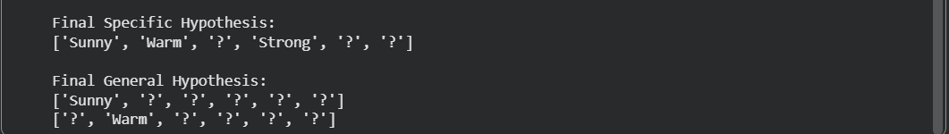
RESULT:
The Candidate-Elimination algorithm was successfully implemented in Python using a CSV file. The algorithm produced the Specific Hypothesis (S) and General Hypothesis (G) that are consistent with the given training examples.

