DSA0601-Data Handling and Visualizaton

Name: C.Nithisha

Reg.No:192424375

Question 1 – Amounts (Bar Chart) Scenario
A supermarket chain wants to compare the monthly sales revenue generated by different product categories during June 2026. The management wants to identify the best and worst performing categories using an appropriate visualization.

Dataset

Product Category | Sales (₹ Lakhs)
Groceries | 120
Dairy | 95
Fruits | 80
Vegetables | 75
Bakery | 68
Beverages | 90
Snacks | 110
Personal Care | 55
Household Items | 70
Frozen Foods | 60

Question
Create a Bar Chart to visualize the sales of each product category. Identify the highest and lowest selling categories and provide two observations based on the chart.

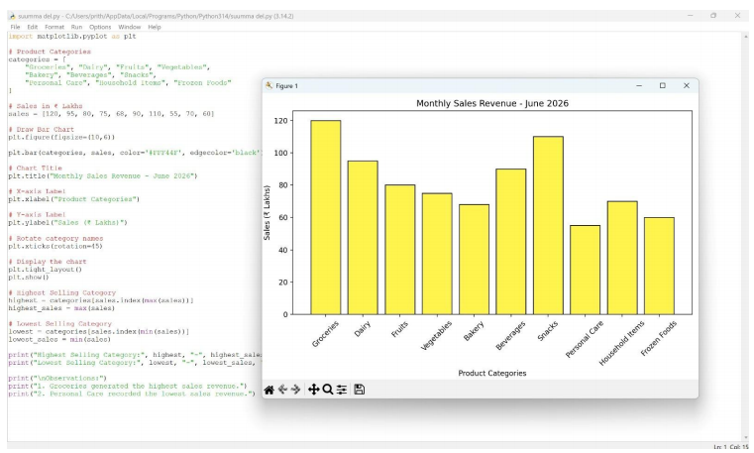

Question 2 – Distribution (Histogram) Scenario
A university placement cell collected the annual salary packages (in LPA) offered to students during the campus recruitment drive. The placement officer wants to study the distribution of salary packages.

Dataset

Student | Salary Package (LPA)
S1 | 3.2
S3 | 5.0
S4 | 6.8
S5 | 7.2
S6 | 8.5
S7 | 4.8
S8 | 5.5
S9 | 6.0
S10 | 7.8
S11 | 9.2
S12 | 10.5

Question
Construct a Histogram using the above data. Analyze the distribution of salary packages and comment on the spread, frequency, and possible outliers.
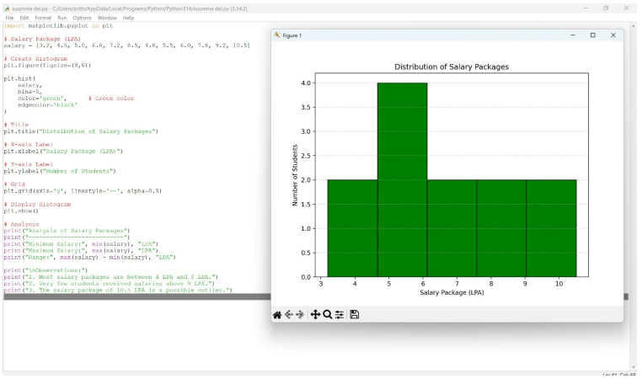

Question 3 – Proportions (Pie Chart) Scenario
A software company allocated its annual digital marketing budget across different advertising channels. The marketing manager wants to visualize how the budget is distributed.

Dataset

Marketing Channel | Budget (%)
Social Media | 28
Television | 22
Print Media | 10

Marketing Channel | Budget (%)
Radio | 8
Email Marketing | 12
Influencer Marketing | 9
SEO | 6
Events | 5

Question
Create a Pie Chart representing the marketing budget allocation. Identify the channel with the highest investment and explain the overall distribution.

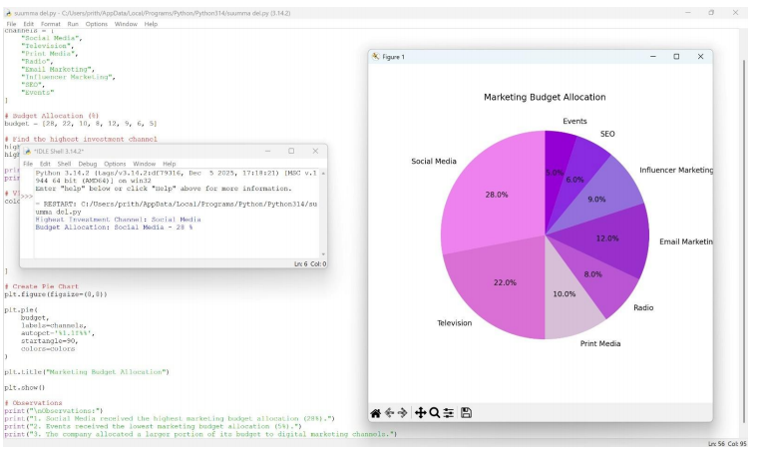

Question 4 – X–Y Relationship (Scatter Plot) Scenario
An e-commerce company wants to determine whether advertising expenditure influences monthly sales revenue.

Dataset

Month | Advertising Cost (₹ Lakhs) | Sales Revenue (₹ Lakhs)
Jan | 5 | 42
Feb | 8 | 55
Mar | 10 | 63
Apr | 12 | 70
May | 15 | 82
Jun | 18 | 91
Jul | 20 | 98
Aug | 22 | 110
Sep | 25 | 120
Oct | 28 | 132

Question

Using the above dataset, create a Scatter Plot to examine the relationship between advertising expenditure and sales revenue. Determine whether the relationship is positive, negative, or weak, and justify your answer.
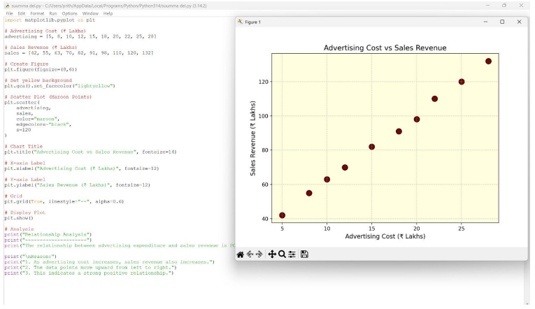

Question 5 – Amounts Over Time (Line Chart) Scenario
A renewable energy company recorded the monthly electricity generated by its solar power plant throughout the year 2025. The company wants to study the trend in electricity generation.

Dataset

Month | Energy Generated (MWh)
January | 420
February | 450
March | 490
April | 530
May | 560
June | 600
July | 580
August | 590
September | 610
October | 630
November | 590
December | 540

Question
Construct a Line Chart using the above data. Analyze the monthly trend in electricity generation and identify the months with the highest and lowest energy production. Also comment on any seasonal variations observed in the data.
