SIMATS ENGINEERING
ASSESSMENT TOOL I — Uncertainty Visualization Lab
Course: Data Handling and Visualization | Code: DSA0601 | CO: CO5
Duration: 180 min | Total Marks: 100 | Reg No : 192424403  Name: Prithika BH

COURSE OUTCOME COVERED
CO3: Analyze time-series data, trends, associations, and uncertainty through appropriate visualization methods. (BL4)
Activity Tool : Uncertainty Visualization Lab
Weightage: 20%
Code of Conduct:
I Prithika BH (192424403) (Name / Reg No) certify that this submission is my original work and that I have adhered to the guidelines specified for this assessment. I understand that any violation of academic integrity rules will result in disciplinary action.
Signature of the student:
Criteria | Understanding of Uncertainty  25% | Visualization of Uncertainty  25% | Application of Visualization Principles  20% | Organization 20% | Accuracy 10% | Clarity 5% | Total
Q1
Q2
Q3
Q4
Q5

Uncertainty Visualization Lab – Assessment Tool
R Programming Practical Questions with Datasets
Instructions: Answer all five questions. Use R programming to construct the required visualization, interpret uncertainty, and identify potential visualization pitfalls. Use the given data exactly unless a transformation is explicitly requested.
Q1. Bootstrapping and Confidence Intervals – Point Estimate
Question
A quality-control team records the following delivery times (in minutes) for 12 randomly selected orders. Using R, calculate the sample mean and obtain a 95% bootstrap confidence interval for the mean using at least 5,000 bootstrap resamples. Visualize the bootstrap distribution and mark the observed mean.
Data:
31, 35, 28, 42, 37, 33, 45, 29, 39, 34, 41, 36
Expected R tasks: Resampling, point estimate, confidence interval, histogram/density plot, interpretation.
Aim
To estimate the mean delivery time and quantify its uncertainty using bootstrap resampling, a 95% bootstrap confidence interval, and a visualization of the bootstrap distribution.
R Code
library(ggplot2)
delivery <- c(31,35,28,42,37,33,45,29,39,34,41,36)
set.seed(123)
observed_mean <- mean(delivery)
bootstrap_means <- replicate(5000,mean(sample(delivery,replace=TRUE)))
ci <- quantile(bootstrap_means,c(0.025,0.975))
print(observed_mean)
print(ci)
bootstrap_data <- data.frame(mean=bootstrap_means)
ggplot(bootstrap_data,aes(x=mean))+
geom_histogram(aes(y=after_stat(density)),bins=30,fill="skyblue",color="black")+
geom_density(linewidth=1)+
geom_vline(xintercept=observed_mean,color="red",linewidth=1.2)+
labs(title="Bootstrap Distribution of Mean Delivery Time",
x="Bootstrap Sample Mean",
y="Density")+
theme_minimal()
Interpretation
The sample mean represents the observed average delivery time of the 12 randomly selected orders.
The bootstrap procedure repeatedly samples the original observations with replacement and calculates the mean for each resample. The resulting distribution shows how the sample mean can vary from sample to sample.
The 95% bootstrap confidence interval provides a range of plausible values for the population mean delivery time. Approximately 95% of the bootstrap estimates are expected to fall within this interval.
Uncertainty Explanation
The spread of the bootstrap distribution represents sampling uncertainty in the estimated mean. A narrow distribution indicates that the mean is estimated relatively precisely, while a wider distribution indicates greater uncertainty.
Visualization Explanation
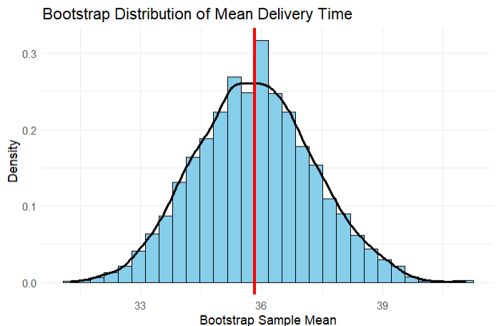
The histogram displays the distribution of bootstrap means, the density curve shows its overall shape, and the red vertical line identifies the observed sample mean.

Q2. Uncertainty in Trend Estimation
Question
The following data represent monthly advertising expenditure and sales. Fit a linear regression model in R to estimate the sales trend. Plot the observations with the fitted regression line and a 95% confidence band. Explain how the uncertainty changes across the range of advertising expenditure.
Data:
Advertising:
10, 12, 15, 18, 20, 23, 25, 28, 30, 33, 36, 40
Sales:
48, 51, 53, 57, 60, 61, 66, 69, 72, 75, 79, 84
Expected R tasks: lm(), prediction/confidence interval, ggplot2 visualization, trend interpretation.
Aim
To estimate the relationship between advertising expenditure and sales using linear regression and visualize the uncertainty around the estimated sales trend using a 95% confidence band.
R Code
library(ggplot2)
data <- data.frame(
Advertising=c(10,12,15,18,20,23,25,28,30,33,36,40),
Sales=c(48,51,53,57,60,61,66,69,72,75,79,84)
)
model <- lm(Sales~Advertising,data=data)
print(summary(model))
pred <- predict(model,interval="confidence")
data$Fit <- pred[,1]
data$Lower <- pred[,2]
data$Upper <- pred[,3]
ggplot(data,aes(x=Advertising,y=Sales))+
geom_point(size=3)+
geom_line(aes(y=Fit),linewidth=1)+
geom_ribbon(aes(ymin=Lower,ymax=Upper),alpha=0.25)+
labs(title="Advertising Expenditure and Sales",
x="Advertising Expenditure",
y="Sales")+
theme_minimal()
Interpretation
The scatterplot and fitted regression line show a positive relationship between advertising expenditure and sales.
As advertising expenditure increases, sales generally increase. Therefore, the fitted regression line represents an upward sales trend.
The shaded region represents the 95% confidence band around the estimated mean sales.
How Uncertainty Changes
The confidence band is generally narrower near the center of the observed advertising range and becomes wider toward the extreme values.
This occurs because there is more information available near the center of the predictor range, while estimates near the boundaries have greater uncertainty.
Visualization Explanation
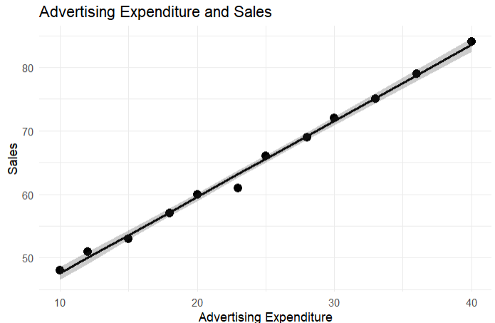
The points represent the actual observations, the line represents the estimated regression trend, and the shaded region represents uncertainty in the estimated mean response.

Q3. Overplotting, Jittering and Transparency
Question
A survey records the number of hours studied and examination scores for 30 students. Several students have identical values. Create a scatterplot in R first without modification, then redesign it using partial transparency and jittering. Compare the two plots and explain how overplotting affects interpretation.
Data:
Hours:
2,3,3,4,4,4,5,5,5,5,6,6,6,6,6,7,7,7,7,7,8,8,8,8,8,9,9,9,10,10
Scores:
45,52,52,58,60,60,64,66,66,66,70,72,72,72,72,76,78,78,80,80,84,84,85,85,85,88,90,90,94,94
Expected R tasks: geom_point(), alpha, position_jitter(), comparison of overplotting.
Aim
To identify the effect of overplotting in a scatterplot and improve data visibility using transparency and jittering.
R Code
library(ggplot2)
data <- data.frame(
Hours=c(2,3,3,4,4,4,5,5,5,5,6,6,6,6,6,7,7,7,7,7,8,8,8,8,8,9,9,9,10,10),
Scores=c(45,52,52,58,60,60,64,66,66,66,70,72,72,72,72,76,78,78,80,80,84,84,85,85,85,88,90,90,94,94))
ggplot(data,aes(x=Hours,y=Scores))+
geom_point(size=3)+
labs(title="Scatterplot Without Modification",
x="Hours Studied",
y="Examination Score")+
theme_minimal()
ggplot(data,aes(x=Hours,y=Scores))+
geom_point(alpha=0.5,size=3)+
labs(title="Scatterplot Using Transparency",
x="Hours Studied",
y="Examination Score")+
theme_minimal()
ggplot(data,aes(x=Hours,y=Scores))+
geom_jitter(width=0.15,height=0.5,alpha=0.6,size=3)+
labs(title="Scatterplot Using Jittering",
x="Hours Studied",
y="Examination Score")+
theme_minimal()
Interpretation
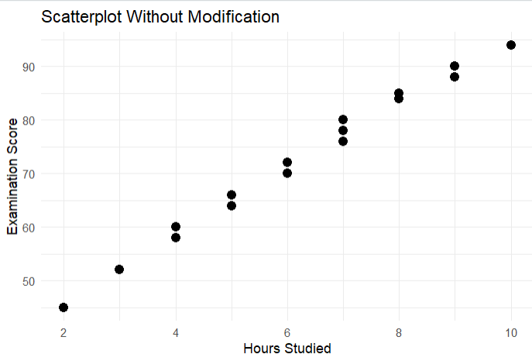
In the first scatterplot, several observations overlap because multiple students have the same number of study hours and similar examination scores. This is called overplotting.
Overplotting can make it difficult to determine:
- How many observations exist at a particular location.
- Where observations are concentrated.
- The actual distribution of the data.
Transparency
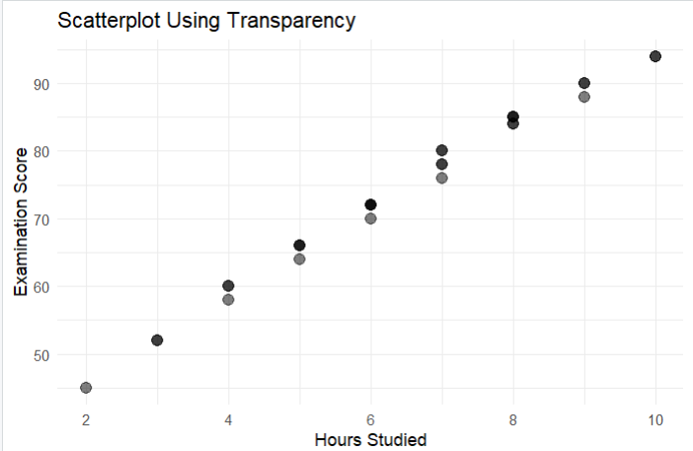
Using alpha=0.5 makes overlapping points partially transparent. Areas with many overlapping observations appear darker, making concentration easier to identify.
Jittering
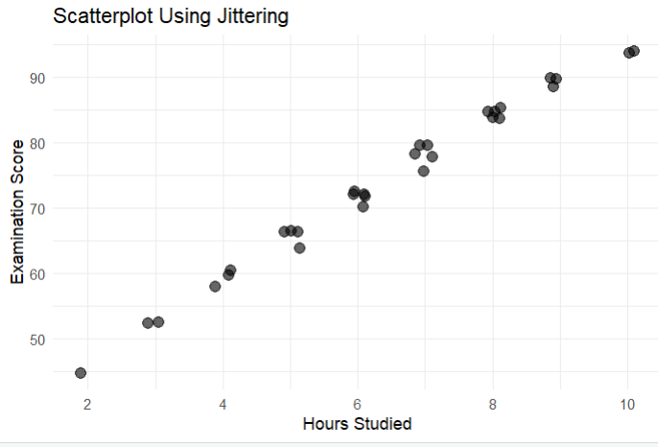
position_jitter() introduces a small random displacement to the points. This separates observations that would otherwise be drawn directly on top of one another.
Comparison
Plot | Advantage | Limitation
Original scatterplot | Shows actual values | Overlapping points are difficult to distinguish
Transparency | Shows concentration through darker regions | Heavy overlap may still be difficult
Jittering | Separates overlapping observations | Points are slightly displaced from exact positions
Conclusion
The redesigned plots provide a clearer representation of the observations. Transparency and jittering reduce the visual problems caused by overplotting without changing the underlying data values conceptually.

Q4. 2D Histogram and Density Estimation
Question
A researcher measures height and weight for 20 participants. Construct a 2D histogram and a 2D density visualization in R. Use the plots to identify regions with high observation density. State which visualization communicates concentration more clearly and justify your choice.
Data:
Height:
150,152,155,158,160,161,163,165,166,168,170,171,173,175,176,178,180,182,184,186
Weight:
48,50,53,55,57,59,60,62,64,65,68,69,71,73,74,77,80,82,85,88
Expected R tasks: 2D binning, density estimation, contour/density layers, interpretation of concentration.
Aim
To visualize the joint distribution of height and weight using a 2D histogram and 2D density estimation and identify regions where observations are concentrated.
R Code
library(ggplot2)
data <- data.frame(
Height=c(150,152,155,158,160,161,163,165,166,168,170,171,173,175,176,178,180,182,184,186),
Weight=c(48,50,53,55,57,59,60,62,64,65,68,69,71,73,74,77,80,82,85,88)
)
ggplot(data,aes(x=Height,y=Weight))+
geom_bin2d(bins=6)+
labs(title="2D Histogram of Height and Weight",
x="Height",
y="Weight")+
theme_minimal()
ggplot(data,aes(x=Height,y=Weight))+
stat_density_2d(aes(fill=after_stat(level)),geom="polygon",alpha=0.5)+
geom_point()+
labs(title="2D Density Estimation of Height and Weight",
x="Height",
y="Weight",
fill="Density")+
theme_minimal()
Interpretation
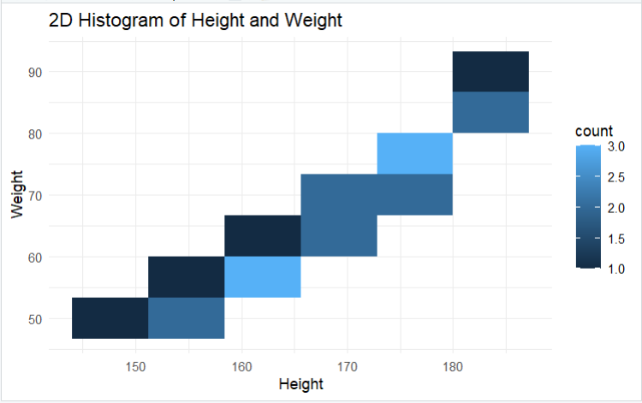
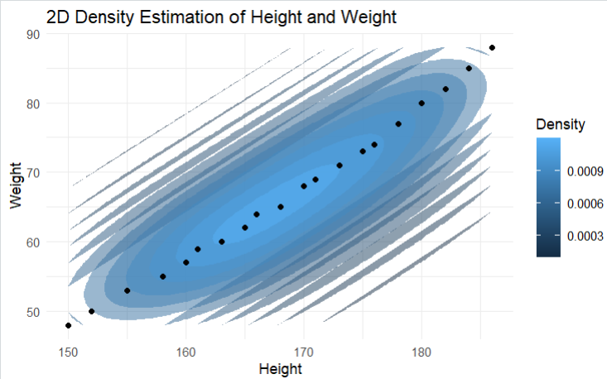
The 2D histogram divides the height-weight space into rectangular bins. Each bin represents the number of observations within that region.
Regions containing more observations represent areas of higher concentration.
The 2D density plot estimates a smooth probability density over the height-weight space. Higher-density regions indicate combinations of height and weight where observations are more concentrated.
Which Visualization Is Better?
The 2D density visualization communicates concentration more clearly because it provides a smoother representation of the distribution and makes the high-density regions easier to identify.
The 2D histogram is useful for directly showing counts in discrete rectangular regions, whereas the density plot gives a continuous representation of concentration.
Conclusion
Both visualizations are appropriate, but the density plot is preferable when the primary objective is to understand the overall concentration and shape of the joint distribution.

Q5. Color Scales, Accessibility and Misleading Visualization
Question
The following category-wise satisfaction scores must be visualized in R. Create two plots:
- A plot using a nonmonotonic/diverging color scheme that could mislead interpretation.
- A redesigned plot using an ordered, color-vision-deficiency-friendly sequential scale.
Explain why the second design is more effective and identify the visualization pitfall in the first design.
Data:
Category: A, B, C, D, E, F, G
Satisfaction: 42, 48, 55, 61, 67, 74, 82
Expected R tasks: Color mapping, scale selection, accessibility-aware redesign, critique of misleading color use.
Aim
To demonstrate how inappropriate color scales can mislead interpretation and redesign the visualization using an ordered, color-vision-deficiency-friendly sequential color scale.
R Code
library(ggplot2)
library(viridis)
data <- data.frame(
Category=c("A","B","C","D","E","F","G"),
Satisfaction=c(42,48,55,61,67,74,82)
)
ggplot(data,aes(x=Category,y=Satisfaction,fill=Satisfaction))+
geom_col()+
scale_fill_gradient2(
low="blue",
mid="white",
high="red",
midpoint=61
)+
labs(
title="Potentially Misleading Diverging Color Scale",
x="Category",
y="Satisfaction",
fill="Satisfaction"
)+
theme_minimal()
ggplot(data,aes(x=Category,y=Satisfaction,fill=Satisfaction))+
geom_col()+
scale_fill_viridis_c(option="viridis")+
labs(
title="Accessibility-Friendly Sequential Color Scale",
x="Category",
y="Satisfaction",
fill="Satisfaction"
)+
theme_minimal()
Interpretation
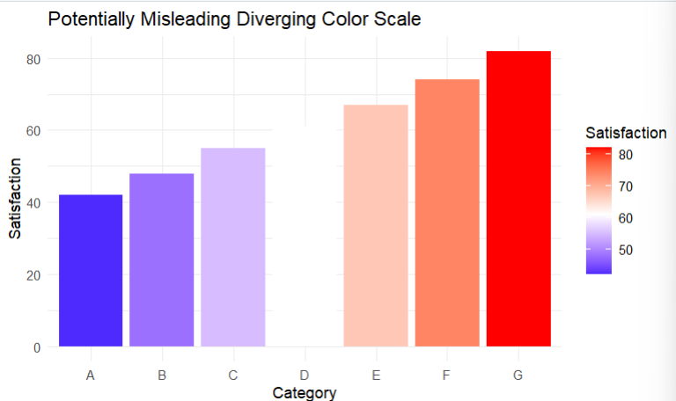
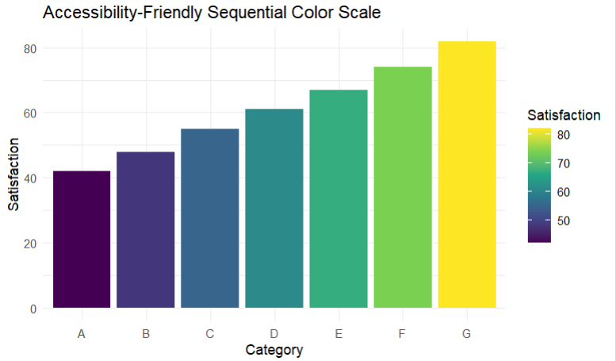
In the first plot, a diverging color scale is used. It introduces different visual meanings such as blue, white, and red around an artificial midpoint.
This can be misleading because the data represent a single ordered quantitative variable. There is no natural meaningful central threshold in the data that requires two contrasting color directions.
The color changes may cause viewers to perceive categories around the midpoint as fundamentally different even though satisfaction is simply increasing.
Why the Second Plot Is Better
The second plot uses the Viridis sequential color scale.
A sequential scale is appropriate because satisfaction has a natural low-to-high ordering.
The Viridis scale also has strong accessibility characteristics and is designed to remain distinguishable for many viewers with color-vision deficiencies.
Visualization Pitfall in the First Plot
The main pitfall is inappropriate color encoding.
A diverging scale should generally be used when values have a meaningful midpoint or reference value, such as:
- Below/above target
- Negative/positive
- Decrease/increase
Here, the satisfaction scores simply progress from low to high. Therefore, a sequential scale communicates the ordering more accurately.
Conclusion
The second visualization is more effective because the color progression corresponds directly to the numerical ordering of satisfaction. It is also more accessible and avoids introducing an artificial visual distinction between values below and above the midpoint.

