SIMATS ENGINEERING
ASSESSMENT TOOL II — Visualization Analysis Report
Course: Data Handling and Visualization | Code: DSA0601 | CO: CO5
Duration: 180 min | Total Marks: 100 | Reg No : 192424403  Name: Prithika BH

COURSE OUTCOME COVERED
CO5: Analyze and evaluate visualization choices to communicate patterns, comparisons, relationships, and potential misleading effects through appropriate visualization methods. (BL4)
Activity Tool : Visualization Analysis Report
Weightage: 20%
Code of Conduct:
I Prithika BH(192424403) (Name / Reg No) certify that this submission is my original work and that I have adhered to the guidelines specified for this assessment. I understand that any violation of academic integrity rules will result in disciplinary action.
Signature of the student:
Assessment Criteria
Criteria | Visualization  Selection and  Understanding 25% | Visualization  Analysis and  Interpretation 25% | Application of Visualization Principles  20% | Organization and Presentation 20% | Accuracy  10% | Clarity  5% | Total
Q1
Q2
Q3
Q4
Q5

AT2 – Visualization Analysis Report | Data Handling and Visualization | DSA06
Visualization Analysis Report – Assessment Tool
R Programming Practical Questions with Datasets
Instructions: Answer all five questions. Use R programming to construct the required visualizations, analyze the patterns, compare visualization choices where requested, and identify potential visualization pitfalls. Use the given data exactly unless a transformation is explicitly requested.

Q1. Comparing Distributions – Histogram, Density and ECDF
Question
A quality-control team records the following processing times (in minutes) for 20 randomly selected tasks. Using R, create a histogram and a density plot. Also construct an empirical cumulative distribution function (ECDF). Compare the three visualizations and explain which aspects of the distribution—center, spread, skewness, and cumulative behavior—are communicated most clearly by each.
Data:
Time = 18, 21, 22, 24, 25, 25, 27, 28, 29, 30, 31, 32, 33, 35, 36, 38, 41, 43, 46, 50
The required tasks include histogram, density estimation, ECDF, labels/scales, comparison and interpretation.
Answer
A histogram groups the processing times into intervals and shows their frequency. A density plot provides a smooth representation of the distribution, while an ECDF shows the cumulative proportion of observations below or equal to each value.
R Code
Time<-c(18,21,22,24,25,25,27,28,29,30,31,32,33,35,36,38,41,43,46,50)
par(mfrow=c(1,3))
hist(Time,main="Histogram of Processing Time",xlab="Time (minutes)",ylab="Frequency",col="lightblue")
plot(density(Time),main="Density Plot",xlab="Time (minutes)",ylab="Density")
plot(ecdf(Time),main="ECDF of Processing Time",xlab="Time (minutes)",ylab="Cumulative Proportion")
Analysis
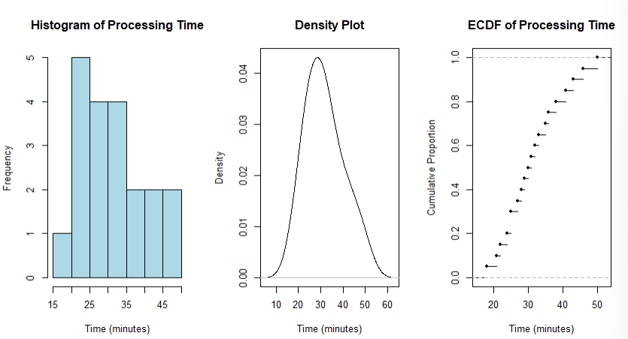
- Most processing times are concentrated between approximately 24 and 38 minutes.
- The center of the data is around 30–32 minutes.
- The values extend from 18 to 50 minutes, showing moderate spread.
- A few larger values such as 43, 46, and 50 create a slight right-skew.
- The histogram clearly shows frequency and overall shape.
- The density plot provides a smoother view of the distribution.
- The ECDF clearly shows the percentage of tasks completed within a particular time.
Comparison
Visualization | Best communicates
Histogram | Frequency, center, spread and overall shape
Density plot | Smooth distribution and skewness
ECDF | Cumulative behavior and percentiles
Conclusion
The histogram is easiest for understanding frequencies, the density plot is useful for identifying the smooth shape and skewness, and the ECDF is best for determining what proportion of tasks fall below a particular processing time.

Q2. Q-Q Plot and Normality Analysis
Question
A researcher measures the following response times in seconds. Use R to create a normal Q-Q plot and a histogram/density visualization. Assess whether the observations are reasonably consistent with a normal distribution. Identify any departures from the reference line and explain what they indicate about the distribution.
Data:
Response = 42, 45, 47, 49, 50, 51, 52, 53, 54, 55, 56, 57, 58, 60, 61, 63, 66, 70, 76, 85
The expected tasks include qqnorm()/qqline() or a ggplot2 Q-Q plot, histogram/density plot, and interpretation of deviations and outliers.
Answer
A normal Q-Q plot compares the observed quantiles with theoretical quantiles from a normal distribution. If the observations are normally distributed, the points should approximately follow the reference line.
R Code
Response<-c(42,45,47,49,50,51,52,53,54,55,56,57,58,60,61,63,66,70,76,85)
par(mfrow=c(1,2))
hist(Response,main="Histogram of Response Time",xlab="Response Time (seconds)",ylab="Frequency",col="lightgreen")
qqnorm(Response,main="Normal Q-Q Plot")
qqline(Response,col="red")
Analysis
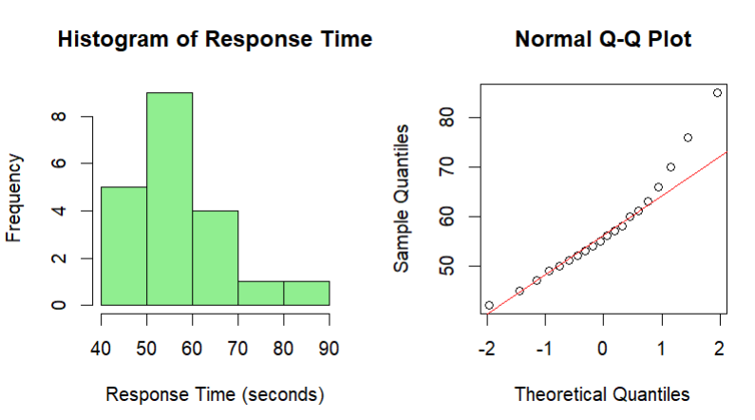
The observations are mostly concentrated between 47 and 66 seconds. However, the higher values 70, 76, and especially 85 seconds extend the upper tail.
In the Q-Q plot:
- Points near the center should approximately follow the reference line.
- Deviations at the upper end indicate a heavier/right tail.
- The value 85 seconds may behave like a potential high-end outlier.
- Therefore, the data are not perfectly normal, although much of the central portion is reasonably close to normal behavior.
Interpretation
A straight Q-Q pattern indicates approximate normality. Systematic deviations from the line indicate departures from normality. Here, the upper-tail observations deviate more noticeably, suggesting positive skewness.
Conclusion
The response times are approximately normal in the central region but show some right-tail deviation. The histogram and Q-Q plot together provide stronger evidence than either visualization alone.

Q3. Visualizing Many Distributions at Once
Question
Three groups of students have examination scores recorded below. Create a suitable visualization that compares the distributions of all three groups at once. Use boxplots and/or violin plots, and optionally overlay individual observations. Analyze differences in center, spread, and possible outliers. Explain why the selected visualization is more informative than displaying three separate plots.
Group A:
52,55,57,58,60,61,62,64,65,66,68,70,72,74,78
Group B:
45,49,51,53,55,56,58,59,60,62,63,65,67,69,71
Group C:
58,60,61,63,64,65,67,68,70,71,72,74,76,80,84
The question specifically asks for grouped boxplots/violin plots, optional jitter, and comparison of center, spread and outliers.
Answer
A grouped boxplot is suitable because it allows the three distributions to be compared using the same scale. A violin plot can additionally show the shape and density of each distribution.
R Code
Group<-factor(rep(c("Group A","Group B","Group C"),each=15))
Score<-c(52,55,57,58,60,61,62,64,65,66,68,70,72,74,78,
45,49,51,53,55,56,58,59,60,62,63,65,67,69,71,
58,60,61,63,64,65,67,68,70,71,72,74,76,80,84)
boxplot(Score~Group,main="Comparison of Examination Scores",xlab="Student Group",ylab="Score",col="lightblue")
Optional Violin Plot
library(ggplot2)
data<-data.frame(Group,Score)
ggplot(data,aes(x=Group,y=Score,fill=Group))+
geom_violin()+
geom_boxplot(width=0.15,fill="white")+
labs(title="Distribution of Examination Scores",x="Group",y="Score")
Analysis
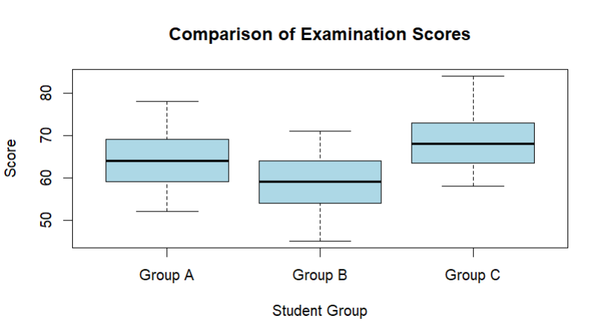
Group A
- Scores are centered around the low-to-mid 60s.
- The range is approximately 52–78.
- It has moderate spread.
Group B
- Has the lowest overall center.
- Scores range from 45 to 71.
- It shows a comparatively lower performance distribution.
Group C
- Has the highest center.
- Scores range from 58 to 84.
- The upper scores are higher than the other groups.
Comparison
Group | Center | Spread | Observation
A | Moderate-high | Moderate | Balanced distribution
B | Lowest | Moderate | Lower performance
C | Highest | Moderate | Higher performance
Why one combined visualization is better
A combined boxplot allows all three groups to be compared using:
- The same y-axis.
- The same visual scale.
- Median positions.
- Interquartile ranges.
- Overall spread.
- Potential outliers.
Three separate plots make direct comparison more difficult because the viewer must mentally switch between plots.
Conclusion
Group C performs best overall, while Group B has the lowest center. A grouped boxplot provides a compact and effective comparison of all three distributions.

Q4. Relationships and Multivariate Visualization
Question
A study records advertising expenditure, website visits, and sales for 15 observations. Create a scatterplot of advertising expenditure versus sales and use an appropriate visual encoding to incorporate website visits. Add a fitted trend line. Analyze the strength and direction of the relationship and explain whether the additional variable improves the interpretation or risks cluttering the visualization.
Data:
Advertising = 10,12,14,16,18,20,22,24,26,28,30,32,34,36,38
Visits = 120,135,150,165,180,195,210,225,245,260,275,290,305,320,340
Sales = 48,50,53,55,58,61,63,66,69,71,74,77,80,83,86
The expected tasks are scatterplot, trend line, third-variable encoding, legend/scale, relationship analysis and critique.
Answer
A scatterplot is appropriate for studying the relationship between advertising expenditure and sales. Website visits can be represented using point size.
R Code
Advertising<-c(10,12,14,16,18,20,22,24,26,28,30,32,34,36,38)
Visits<-c(120,135,150,165,180,195,210,225,245,260,275,290,305,320,340)
Sales<-c(48,50,53,55,58,61,63,66,69,71,74,77,80,83,86)
data<-data.frame(Advertising,Visits,Sales)
plot(data$Advertising,data$Sales,
main="Advertising Expenditure vs Sales",
xlab="Advertising Expenditure",
ylab="Sales",
pch=19,
cex=data$Visits/100)
abline(lm(Sales~Advertising,data=data),lwd=2)
Analysis
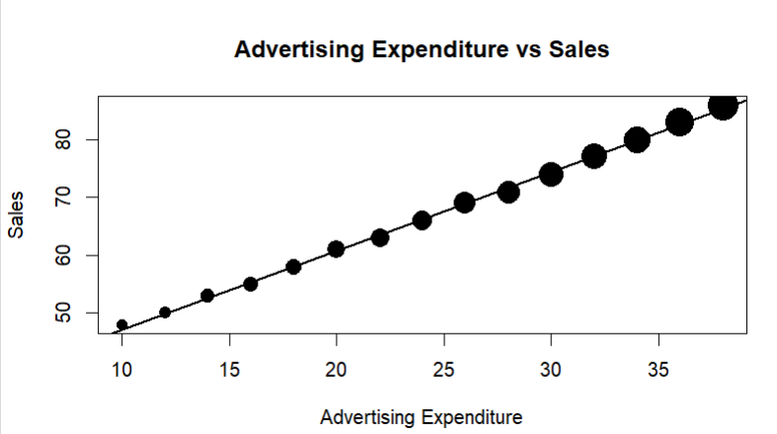
The scatterplot shows a strong positive relationship between advertising expenditure and sales.
As advertising expenditure increases:
- Sales consistently increase.
- Website visits also increase.
- The points follow an approximately linear pattern.
- There are no obvious extreme outliers.
The fitted trend line slopes upward, confirming the positive relationship.
Role of Website Visits
Website visits are incorporated using point size.
Larger points represent higher website visits.
This adds another dimension to the visualization without creating another graph.
Advantage
The additional variable helps identify whether observations with greater website traffic also tend to have greater advertising expenditure and sales.
Possible Problem
Using too many visual encodings can make a graph cluttered. If point size differences are too large or several additional variables are added, interpretation becomes difficult.
Conclusion
There is a strong positive relationship between advertising expenditure and sales. Website visits add useful information, but the number of visual encodings should be limited to maintain clarity.

Q5. Misleading Visualization and Redesign
Question
A college reports the following pass percentages for seven departments. Create two visualizations:
- A misleading version using a truncated y-axis and inappropriate visual emphasis.
- A redesigned version using an appropriate baseline, ordered categories, and clear labels.
Compare the two plots and explain how the first visualization can exaggerate differences and why the redesigned visualization communicates the data more honestly.
Data:
Department | Pass Percentage
CSE | 91
ECE | 93
EEE | 92
MECH | 89
CIVIL | 90
AIDS | 95
IT | 94
The question specifically requires a misleading bar chart, redesigned bar chart, ordering, labels, and critique of the misleading axis.
Part 1 – Misleading Visualization
R Code
Department<-c("CSE","ECE","EEE","MECH","CIVIL","AIDS","IT")
Pass_Percentage<-c(91,93,92,89,90,95,94)
barplot(Pass_Percentage,
names.arg=Department,
main="Misleading Pass Percentage",
ylab="Pass Percentage",
ylim=c(85,96),
col="skyblue")
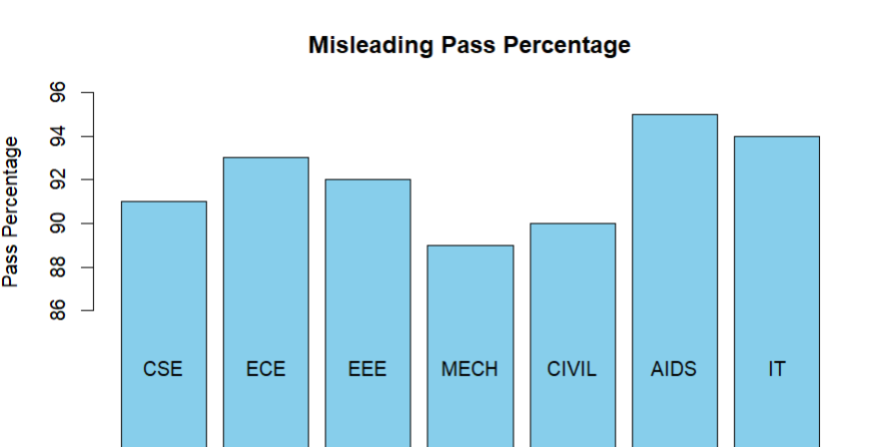
Why is it misleading?
The y-axis begins at 85% rather than 0%.
Although the actual difference between departments is small, the truncated scale visually makes the bars appear to have much larger differences.
For example:
- MECH = 89%
- AIDS = 95%
The actual difference is only 6 percentage points, but the truncated axis can make the difference appear much larger.

Part 2 – Redesigned Visualization
R Code
Department<-c("CSE","ECE","EEE","MECH","CIVIL","AIDS","IT")
Pass_Percentage<-c(91,93,92,89,90,95,94)
o<-order(Pass_Percentage,decreasing=TRUE)
barplot(Pass_Percentage[o],
names.arg=Department[o],
main="Pass Percentage by Department",
xlab="Department",
ylab="Pass Percentage",
ylim=c(0,100),
las=2)
Analysis
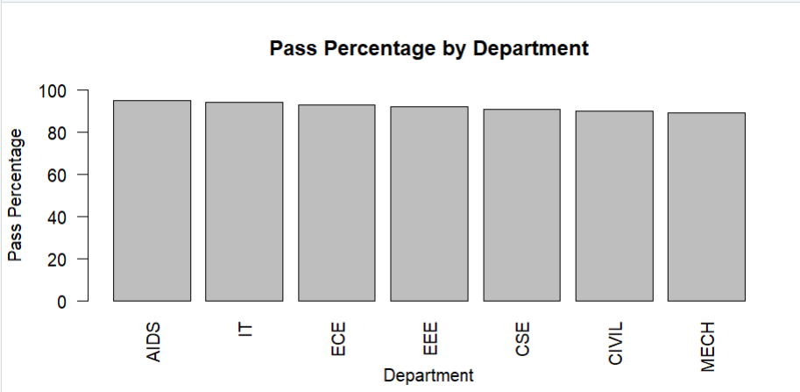
The redesigned graph:
- Starts the y-axis at 0%.
- Orders departments from highest to lowest.
- Uses clear department labels.
- Shows the actual magnitude of differences.
- Makes comparison easier and more honest.
Comparison
Feature | Misleading Graph | Redesigned Graph
Y-axis | Starts at 85% | Starts at 0%
Difference | Exaggerated visually | Accurately represented
Ordering | Original order | Ordered by percentage
Labels | Basic | Clear
Interpretation | Potentially misleading | More honest
Accessibility | Less clear | Easier to compare
Conclusion
The first visualization exaggerates the differences because of its truncated y-axis. The redesigned visualization uses a zero baseline, ordered categories and clear labels, making the differences easier to interpret accurately.

