SIMATS ENGINEERING
ASSESSMENT TOOL III— Interactive Dashboard Project
Course: Data Handling and  Visualization | Code: DSA06 | CO: CO5
Duration: 180 min | Total Marks: 100 | Reg No : 192424403  Name: Prithika BH
COURSE OUTCOME COVERED
CO5: Analyze and evaluate visualization choices to communicate patterns, comparisons, relationships, and potential misleading effects through appropriate visualization methods, applied through the design of interactive dashboards. (BL4)
Activity Tool : Interactive Dashboard Project
Weightage: 20%
Code of Conduct:
I Prithika BH (192424403)(Name / Reg No) certify that this submission is my original work and that I have adhered to the guidelines specified for this assessment. I understand that any violation of academic integrity rules will result in disciplinary action.
Signature of the student: ________________________
Assessment Criteria
Criteria | Dashboard  Design and  Understanding 25% | Visual  Analysis and  Interpretation 25% | Application of  Dashboard Design  Principles  20% | Organization and  Presentation 20% | Accuracy  10% | Clarity  5% | Total
Q1
Q2
Q3
Q4
Q5

Q1. Building a Sales Performance Dashboard
Objective
To create an interactive Tableau dashboard for analyzing regional and category-wise sales performance and to identify the regions and product categories contributing the highest sales.
Data Preparation
The Excel dataset was connected to Tableau using Microsoft Excel. The dataset contains 12 records with the following fields:
- S.No
- Region
- Category
- Sales
The data was used without changing the given sales values.
Dashboard Components
1. Sales by Region – Bar Chart
A bar chart was created by placing Region on Columns and Sales on Rows. The regions were sorted in descending order of sales.
Region | Total Sales
East | 130,000
North | 104,000
South | 95,500
West | 82,500
The East region has the highest total sales, while the West region has the lowest.
2. Sales by Category
The category-wise sales totals are:
Category | Total Sales
Technology | 200,000
Furniture | 127,000
Office Supplies | 85,000
Technology is the highest-performing category.
3. Region Filter
A Region filter was added to the dashboard. The filter can be used to select East, West, North, or South and analyze the selected region across the dashboard views.
The filter was configured using:
Apply to Worksheets → All Using This Data Source
This makes the dashboard interactive and allows users to focus on a particular region.
Sales Pattern Analysis
The East region is the strongest-performing region with total sales of 130,000. North follows with 104,000, while South and West have 95,500 and 82,500, respectively.
Among the categories, Technology generates the highest sales with 200,000, followed by Furniture with 127,000 and Office Supplies with 85,000.
The highest individual Region–Category combination is:
East – Technology = 62,000
Other strong combinations include North–Technology with 51,000 and South–Technology with 47,500.
Therefore, Technology sales, particularly in the East region, are the major drivers of overall sales performance.
Dashboard Layout and Quick Comparison
The dashboard uses separate visual areas for regional and category analysis. The bar chart allows users to quickly compare total sales between regions. The category view helps identify which products contribute most to sales. The Region filter provides interactive exploration by allowing users to focus on a particular region.
This layout makes it easy for management to identify high-performing and low-performing regions without examining individual records.
Visualization Limitations / Pitfalls
The supplied dataset has two important limitations:
- No Month/Date field is provided. Therefore, a genuine Sales Trend by Month line chart cannot be created without additional date information. Creating artificial months would make the visualization misleading.
- Region contains only North, South, East, and West. These are regional labels rather than specific geographic locations or coordinates. Therefore, Tableau cannot produce a geographically accurate map without additional geographic information.
Conclusion
The Tableau analysis shows that East is the best-performing region, while West has the lowest sales. Technology is the strongest category, and East–Technology is the highest-performing region-category combination with sales of 62,000. The interactive Region filter improves analysis by allowing users to examine individual regions quickly. However, the absence of Month/Date and geographic information limits the ability to create a genuine monthly trend and geographically accurate map.

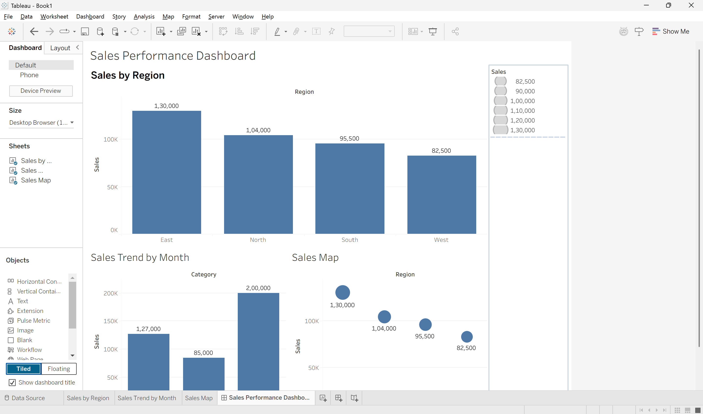
Q2. KPI Dashboard with Parameters
Objective
To create an interactive HR performance dashboard in Tableau using KPI cards and a parameter that allows users to switch the department bar chart between Average Rating and Average Attendance.
Data Preparation
The Excel dataset was connected to Tableau. It contains 10 employee records with the following fields:
- S.No
- Department
- Rating
- Attendance
The given data was used without modification.
Dashboard Components
1. Average Rating KPI
The Rating field was aggregated using Average.
Average Rating = 8.0
This KPI represents the overall average employee performance rating.
2. Total Employees KPI
The employee records were counted using the S.No field.
Total Employees = 10
This KPI displays the total number of employees in the dataset.
3. Average Attendance KPI
The Attendance field was aggregated using Average.
Average Attendance = 91.7%
This KPI represents the overall employee attendance level.

4. Average Rating by Department
A bar chart was created with Department on Columns and Average Rating on Rows.
Department | Average Rating
Engineering | 8.75
HR | 8.15
Sales | 7.95
Marketing | 7.70
Support | 7.30
Engineering has the highest average rating, while Support has the lowest.

5. Parameter Implementation
A Tableau parameter named Select Measure was created with two options:
- Average Rating
- Average Attendance
A calculated field named Selected Measure was created:
IF [Select Measure] = "Average Rating" THEN
AVG([Rating])
ELSE
AVG([Attendance])
END
The calculated field was used in the department bar chart. Therefore, changing the parameter automatically changes the measure displayed in the chart.
When Average Rating is selected:
Department | Average Rating
Engineering | 8.75
HR | 8.15
Sales | 7.95
Marketing | 7.70
Support | 7.30
When Average Attendance is selected:
Department | Average Attendance
Engineering | 96.5%
HR | 93.5%
Sales | 93.5%
Marketing | 89.0%
Support | 86.0%

Dashboard Layout
The dashboard contains three KPI cards at the top:
Average Rating | Total Employees | Average Attendance
The department bar chart is placed below the KPI cards, with the Select Measure parameter control displayed alongside or above the chart.
This layout provides a quick overview of the organization's HR performance while allowing detailed departmental comparison.
Analysis
The overall average employee rating is 8.0, while the average attendance is 91.7%. Engineering performs best in both measures, with an average rating of 8.75 and average attendance of 96.5%. Support has the lowest average rating of 7.30 and the lowest average attendance of 86%.
The results indicate that departments with stronger attendance generally show better performance ratings in this small dataset.
Benefits of Parameters
Using a parameter makes the dashboard more flexible than using separate static charts. Instead of displaying two different bar charts for Rating and Attendance, a single chart can dynamically switch between the two measures.
Advantages include:
- Saves dashboard space
- Reduces visual clutter
- Allows interactive analysis
- Enables users to switch measures quickly
- Keeps the same department comparison structure
- Makes the dashboard easier to maintain
Visualization Pitfall
Rating and Attendance use different scales: Rating ranges around 7–9, whereas Attendance ranges around 85–97%. Switching between them in the same chart can make visual comparison between the two measures confusing if the axis title and labels are not updated clearly.
Therefore, the selected measure should always be displayed clearly through the parameter control and chart title/axis.
Conclusion
The Tableau KPI dashboard provides a compact and interactive view of employee performance. Engineering is the highest-performing department in both rating and attendance, while Support records the lowest values. The parameter-based design improves flexibility by allowing users to switch between Average Rating and Average Attendance without requiring separate charts.
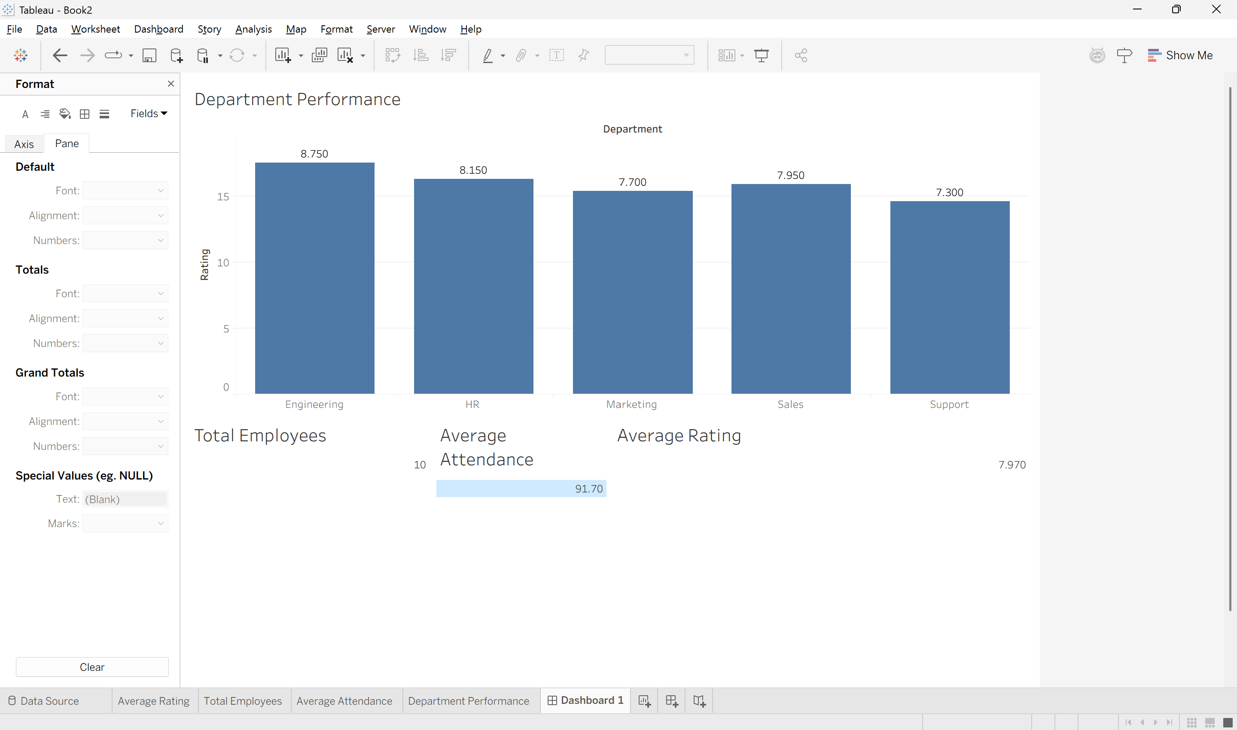
Q3. Drill-Down Dashboard with Dashboard Actions
Objective
To create an interactive Tableau dashboard for analyzing student enrollment at two levels: Program and Specialization. A dashboard filter action is used so that selecting a program automatically displays only its relevant specializations.
Data Preparation
The Excel dataset was connected to Tableau. It contains the following fields:
- S.No
- Program
- Specialization
- Enrollment
The given data was used without modification.

1. Program-Level Summary Chart
A bar chart was created to show total enrollment by Program.
- Drag Program → Columns
- Drag Enrollment → Rows
- Use SUM(Enrollment)
The program-wise enrollment is:
Program | Total Enrollment
CSE | 195
ECE | 85
MECH | 103
Analysis
CSE has the highest enrollment with 195 students, followed by MECH with 103 and ECE with 85.

2. Specialization-Level Detail Chart
A second bar chart was created to display enrollment by Specialization.
Program | Specialization | Enrollment
CSE | Core CSE | 90
CSE | AI/ML | 65
CSE | Cyber Security | 40
ECE | Communications | 50
ECE | VLSI | 35
MECH | Thermal | 45
MECH | Robotics | 30
MECH | Design | 28
This chart provides detailed information about the enrollment within each program.

3. Dashboard Filter Action
Both charts were placed on the same Tableau dashboard.
A Filter Action was then created:
Dashboard → Actions → Add Action → Filter
The Program-Level Chart was selected as the source sheet, and the Specialization-Level Chart was selected as the target sheet.
The action was configured so that:
Selecting a Program bar filters the Specialization chart.
For example, if the user clicks CSE, the specialization chart displays only:
- AI/ML → 65
- Cyber Security → 40
- Core CSE → 90
If the user clicks ECE, it displays:
- VLSI → 35
- Communications → 50
If the user clicks MECH, it displays:
- Robotics → 30
- Thermal → 45
- Design → 28

4. Drill-Down Interaction
The dashboard provides a simple drill-down experience:
Program Level
↓
Select Program
↓
Specialization Level
For example:
CSE
↓
AI/ML 65
Cyber Security 40
Core CSE 90
This allows users to start with an overall program comparison and then explore the specializations within a selected program.

5. Advantages of Drill-Down
The drill-down interaction improves exploration because:
- It reduces the amount of information displayed initially.
- Users can focus on one program at a time.
- It avoids displaying all specializations simultaneously.
- It makes the dashboard easier to understand.
- Users can quickly identify which specializations contribute most to a program's enrollment.
- It provides an interactive way to move from summary information to detailed information.
For example, instead of viewing all eight specializations at once, selecting CSE immediately narrows the analysis to its three specializations.

6. Limitations
The drill-down approach also has some limitations:
- Users may not realize that they need to click a program bar to see the details.
- Only one selected program may be analyzed at a time.
- Comparing specializations across different programs requires repeated selections.
- The dashboard depends on the filter action being configured correctly.
- If the dataset becomes very large, the detail view may still contain many records.
A clear instruction such as "Click a program to view specializations" can improve usability.
Conclusion
The Tableau drill-down dashboard provides an effective way to move from Program-level enrollment to Specialization-level details. The dashboard action makes the analysis interactive by filtering the specialization chart whenever a program is selected. This reduces visual clutter and allows users to focus on relevant information. However, users must know how to interact with the dashboard, and comparing multiple programs may require repeated selections.
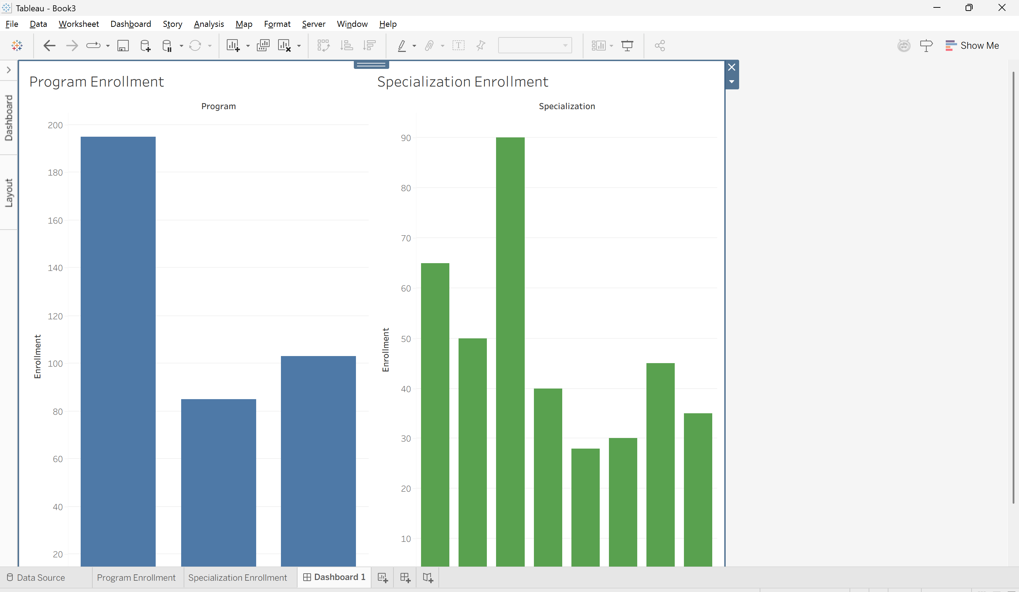

Q4. Multivariate Analysis Dashboard
Objective
The objective of this task is to create a Tableau dashboard to analyze the relationship between Advertising expenditure and Sales, while using Website Visits as an additional variable. A scatterplot with a trend line and a sales distribution chart are used for the analysis.
Data Preparation
The given Excel dataset was connected to Tableau. It contains 15 observations with the fields S.No, Advertising, Visits, and Sales. The data was used exactly as provided without any transformation.
Scatterplot of Advertising vs Sales
A scatterplot was created by placing Advertising on the Columns shelf and Sales on the Rows shelf. Each point represents one observation from the dataset.
The scatterplot shows a clear upward pattern. As advertising expenditure increases, sales also increase. Advertising increases from 10 to 38, while Sales increase from 48 to 86.
Website Visits Encoding
The Visits field was added to the Color property of the Marks card. This represents Website Visits using different colors in the scatterplot.
Website Visits increase from 120 to 340 as advertising expenditure increases. Therefore, the color encoding provides additional information about website traffic along with advertising and sales.
Trend Line
A linear trend line was added to the scatterplot using Analytics → Trend Line → Linear.
The trend line has a positive slope, indicating a strong positive relationship between Advertising and Sales. The correlation between Advertising and Sales is approximately 0.999, which indicates an almost perfect positive linear relationship in the given dataset.
Sales Distribution
A second visualization was created using a histogram/box plot to display the distribution of Sales.
The Sales values range from 48 to 86. The values are fairly evenly distributed and there are no obvious extreme outliers.
The distribution chart complements the scatterplot by providing an overall view of the spread of Sales values.
Dashboard Design
The two visualizations were combined into a single dashboard. The scatterplot was placed on one side and the Sales distribution chart was placed on the other side. The Website Visits legend was displayed clearly so that users could understand the third-variable encoding.
The dashboard provides both relationship analysis and distribution analysis in one view.
Relationship Analysis
The scatterplot indicates a very strong positive relationship between Advertising and Sales. Higher advertising expenditure is consistently associated with higher sales values. The points are very close to the trend line, confirming the strength of the relationship.
However, correlation does not necessarily mean that advertising alone causes an increase in sales. Other factors may also influence sales.
Effect of Website Visits Encoding
Website Visits adds useful information because it provides a third variable for understanding the relationship between Advertising and Sales. It shows that website visits also increase as advertising and sales increase.
However, excessive use of colors or different-sized marks can make the scatterplot cluttered. Therefore, using a simple color encoding is preferable to using multiple visual encodings.
Visualization Pitfalls
- A strong correlation does not prove that advertising directly causes higher sales.
- Using too many colors can make the scatterplot difficult to interpret.
- Using both color and size for Website Visits may create unnecessary visual clutter.
- A trend line summarizes the relationship but may hide individual variations.
- The dataset contains only 15 observations, so the results should be interpreted carefully.
Conclusion
The Tableau dashboard shows an extremely strong positive relationship between Advertising and Sales. As advertising expenditure increases, sales also increase consistently. Website Visits provides additional insight by showing the relationship between website traffic, advertising, and sales. The trend line confirms the strong upward relationship, while the Sales distribution chart provides information about the spread of sales values. Overall, the dashboard provides an effective multivariate analysis while demonstrating the importance of avoiding unnecessary visual clutter.
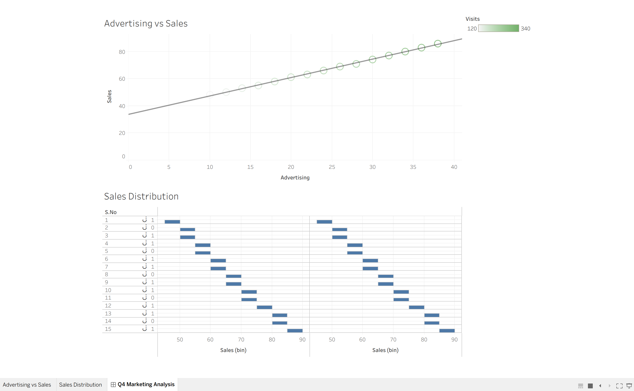

Q5. Misleading Dashboard and Redesign
Objective
The objective of this task is to create two Tableau dashboards using the given department-wise pass percentage data. The first dashboard is intentionally designed to be misleading using a truncated Y-axis, inappropriate colors, and exaggerated visual emphasis. The second dashboard is redesigned using an appropriate baseline, ordered categories, consistent colors, and clear labels. The two dashboards are then compared to understand how visualization choices can affect data interpretation.

Data Preparation
The given Excel dataset was connected to Tableau. It contains the fields S.No, Department, and Pass_Percentage. The data was used exactly as provided without modification.
Department | Pass Percentage
CSE | 91%
ECE | 93%
EEE | 92%
MECH | 89%
CIVIL | 90%
AIDS | 95%
IT | 94%

1. Misleading Dashboard
A bar chart was created using Department on the Columns shelf and Pass_Percentage on the Rows shelf.
The Y-axis was intentionally truncated so that it started around 85% instead of 0%. This makes small differences between departments appear much larger than they actually are.
An inappropriate or highly contrasting color scheme was also used. One department was given a very different and stronger color to create exaggerated visual emphasis.
Effect of the Misleading Design
The truncated Y-axis makes the difference between departments appear dramatic. For example, AIDS has a pass percentage of 95%, while MECH has 89%, which is a difference of only 6 percentage points. However, a truncated axis can visually make this difference appear much larger.
The exaggerated color emphasis may also make viewers think that the highlighted department is significantly more important or successful than the others.

2. Redesigned Dashboard
The second dashboard was created using a more appropriate and honest visualization design.
The Y-axis was set to start at 0%, allowing the bar lengths to represent the values proportionally.
The departments were ordered from highest to lowest pass percentage:
- AIDS – 95%
- IT – 94%
- ECE – 93%
- EEE – 92%
- CSE – 91%
- CIVIL – 90%
- MECH – 89%
A consistent color scheme was used for all departments, and clear data labels were added to display the exact percentages.

3. Comparison of the Two Dashboards
Feature | Misleading Dashboard | Redesigned Dashboard
Y-axis | Truncated | Starts at 0%
Colors | Inappropriate/contrasting | Consistent
Department order | Unordered | Highest to lowest
Labels | Less clear | Clear percentage labels
Visual emphasis | One department exaggerated | Equal visual treatment
Interpretation | Can exaggerate differences | Shows differences honestly

4. Analysis
The actual difference between the highest and lowest pass percentages is only 6 percentage points. AIDS has the highest pass percentage at 95%, while MECH has the lowest at 89%.
The misleading dashboard can make this relatively small difference appear much larger because the Y-axis does not start from zero. The use of an unusual color for one department can also draw unnecessary attention to that department.
The redesigned dashboard communicates the data more accurately. Starting the Y-axis at zero provides a proper visual baseline, while ordering the departments makes comparison easier. Consistent colors prevent any department from receiving artificial visual importance, and data labels allow viewers to see the exact values.

5. Visualization Pitfalls
The following visualization problems should be avoided:
- Truncating the Y-axis of a bar chart can exaggerate differences.
- Using too many colors can distract viewers.
- Highlighting one category without a meaningful reason can create bias.
- Poor category ordering can make comparisons difficult.
- Missing data labels can force users to estimate values from the chart.
- Decorative visual effects should not overpower the actual data.

Conclusion
The misleading dashboard demonstrates how visualization choices can influence the viewer's perception of data. The truncated Y-axis, inappropriate color scheme, and exaggerated emphasis can make small differences in pass percentages appear significant. The redesigned dashboard provides a more truthful representation by using a zero baseline, ordered categories, consistent colors, and clear labels. Therefore, appropriate visualization design is important for accurate and unbiased interpretation of data.
