

DSA0601 Data Handling and Visualization CO2 – AT1 Chart Construction Test
Name: Prithika B.H
Reg No: 192424403

Question 1 – Healthcare Analytics

Dataset

Patient | Age | BMI | Blood Pressure | Disease  Severity
P1 | 24 | 19.8 | 110 | Low
P2 | 32 | 24.5 | 118 | Medium
P3 | 41 | 28.1 | 132 | High
P4 | 48 | 30.3 | 145 | High
P5 | 56 | 33.2 | 152 | Critical
P6 | 65 | 36.5 | 168 | Critical
P7 | 38 | 26.2 | 124 | Medium
P8 | 29 | 22.1 | 116 | Low

R Program
library(ggplot2) health <- data.frame(
Patient=c("P1","P2","P3","P4","P5","P6","P7","P8"), Age=c(24,32,41,48,56,65,38,29), BMI=c(19.8,24.5,28.1,30.3,33.2,36.5,26.2,22.1),

BloodPressure=c(110,118,132,145,152,168,124,116),
Severity=factor(c("Low","Medium","High","High", "Critical","Critical","Medium","Low"),
levels=c("Low","Medium","High","Critical"))
)
ggplot(health, aes(x=Age,y=BloodPressure,color=Severity,size=BMI))+ geom_point(alpha=0.8)+ scale_color_manual(values=c("green","yellow","orange","red"))+ labs(title="Healthcare Risk Analysis",
x="Age",
y="Blood Pressure", color="Disease Severity", size="BMI")+ theme_minimal() OUTPUT:
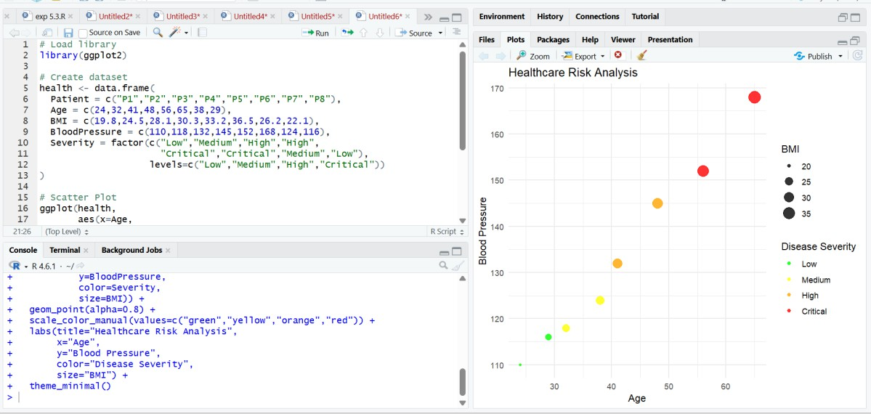

Justifiation:

- Age is placed on the X-axis because it is an independent variable.
- Blood Pressure is on the Y-axis to compare with age.
- Disease Severity uses a traffic-light color scale (green to red), making health risk easy to understand.
- BMI is represented by point size, where larger points indicate higher BMI.

Question 2 – Climate Science Dataset

Month | Solar | Temperature | Rainfall
Jan | 180 | 20 | 25
Feb | 200 | 23 | 18
Mar | 240 | 29 | 12
Apr | 280 | 35 | 8
May | 320 | 39 | 5
Jun | 300 | 36 | 65
Jul | 260 | 32 | 150
Aug | 250 | 31 | 170
Sep | 240 | 30 | 120
Oct | 220 | 28 | 85
Nov | 190 | 24 | 45
Dec | 170 | 21 | 30
R Program
library(ggplot2) climate <- data.frame(
Month=c("Jan","Feb","Mar","Apr","May","Jun",
"Jul","Aug","Sep","Oct","Nov","Dec"), Temperature=c(20,23,29,35,39,36,32,31,30,28,24,21), Rainfall=c(25,18,12,8,5,65,150,170,120,85,45,30)
)

ggplot(climate, aes(x=Month,y=Temperature,group=1))+ geom_line(color="blue",linewidth=1.2)+ geom_point(color="red",size=3)+ theme_minimal()
ggplot(climate, aes(x=Month,y=Rainfall,fill=Rainfall))+ geom_col()+
coord_polar()+ scale_fill_gradient(low="lightblue",high="darkblue")+ theme_minimal()

OUTPUT:
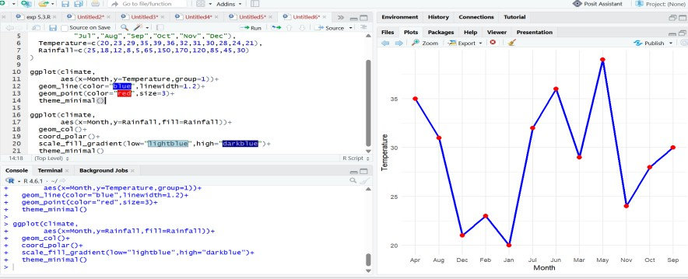
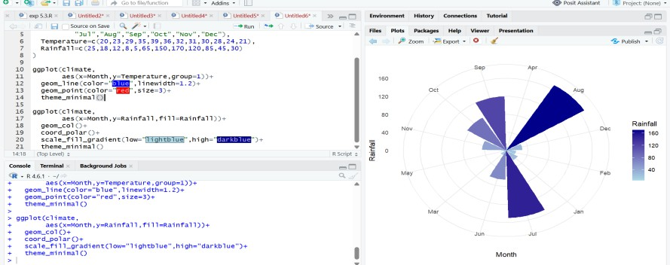

Justification

Cartesian Chart

- Clearly shows increasing and decreasing temperature.

- Easy to compare values.

Polar Chart

- Represents seasonal rainfall in a circular yearly pattern.
- Helps identify rainy and dry seasons.

Question 3 – Business Analytics and Marketing
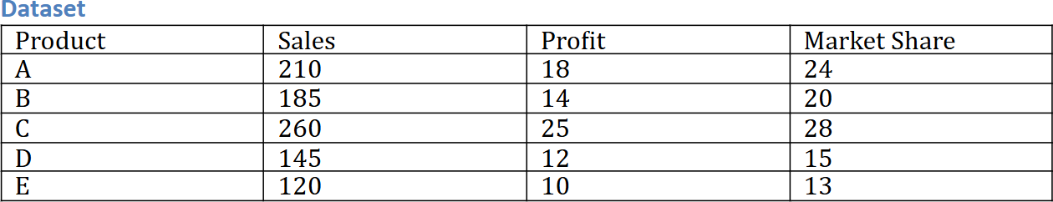

R Program library(ggplot2) business <- data.frame(
Product=c("A","B","C","D","E"), Sales=c(210,185,260,145,120), Profit=c(18,14,25,12,10),
MarketShare=c(24,20,28,15,13)
)
business$Highlight <- ifelse( business$MarketShare==max(business$MarketShare), "Highest","Normal")
ggplot(business, aes(Product,Sales,fill=Profit))+
geom_col()+ geom_col(data=subset(business,

Highlight=="Highest"), fill="red")+
scale_fill_gradient(low="lightgreen", high="darkgreen")+
theme_minimal()

OUTPUT:
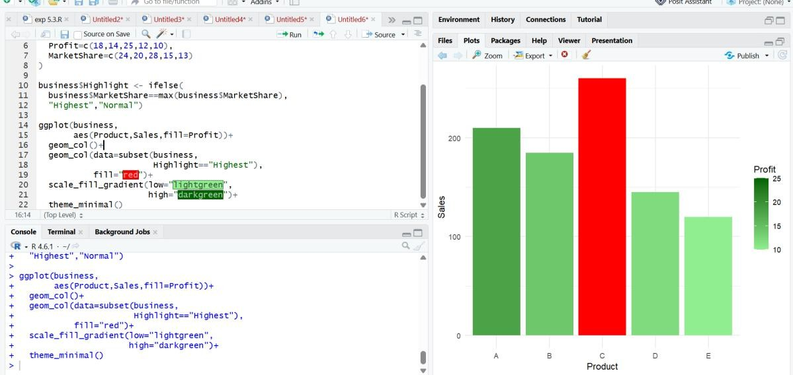

Justification

- Bar height allows easy comparison of sales.

- Sequential green colors represent increasing profit.

- Red immediately highlights the highest market share product.

Question 4 – Transportation Engineering Dataset

Direction | Vehicles/hour
North | 980
North-East | 760
East | 1240

South-East | 890
South | 1420
South-West | 1130
West | 860
North-West | 720

R Program
library(ggplot2) traffic <- data.frame(
Direction=c("North","North-East","East", "South-East","South","South-West",
"West","North-West"), Vehicles=c(980,760,1240,890,
1420,1130,860,720)
)
ggplot(traffic, aes(Direction,Vehicles,
fill=Vehicles))+ geom_col()+ coord_polar()+
scale_fill_gradient(low="yellow", high="red")+
theme_minimal()

OUTPUT:

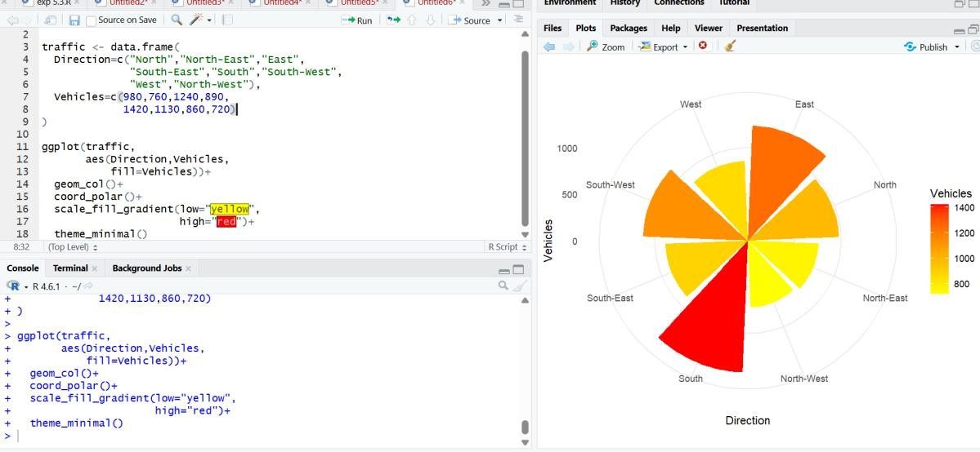

Justification

- Polar chart naturally represents compass directions.
- Makes directional traffic comparison easier.
- Color gradient clearly indicates traffic density.

Question 5 – Environmental Sustainability Dataset

City | AQI | Green Cover | CO2 | Population
A | 48 | 45 | 1.8 | 9
B | 82 | 32 | 3.5 | 15
C | 135 | 21 | 5.6 | 22
D | 165 | 18 | 7.4 | 28
E | 72 | 38 | 2.9 | 12
F | 95 | 30 | 4.2 | 18

R Program
library(ggplot2) library(gridExtra) city <- data.frame(
City=c("A","B","C","D","E","F"),

AQI=c(48,82,135,165,72,95), GreenCover=c(45,32,21,18,38,30), CO2=c(1.8,3.5,5.6,7.4,2.9,4.2),
Population=c(9,15,22,28,12,18)
)
city$AQI_Category <- cut( city$AQI, breaks=c(0,50,100,150,200),
labels=c("Good","Moderate","Poor","Very Poor")
)
p1 <- ggplot(city, aes(City,AQI, fill=AQI_Category))+ geom_col()
p2 <- ggplot(city, aes(GreenCover, CO2,
size=Population, color=AQI))+ geom_point() grid.arrange(p1,p2,ncol=2)

OUTPUT:
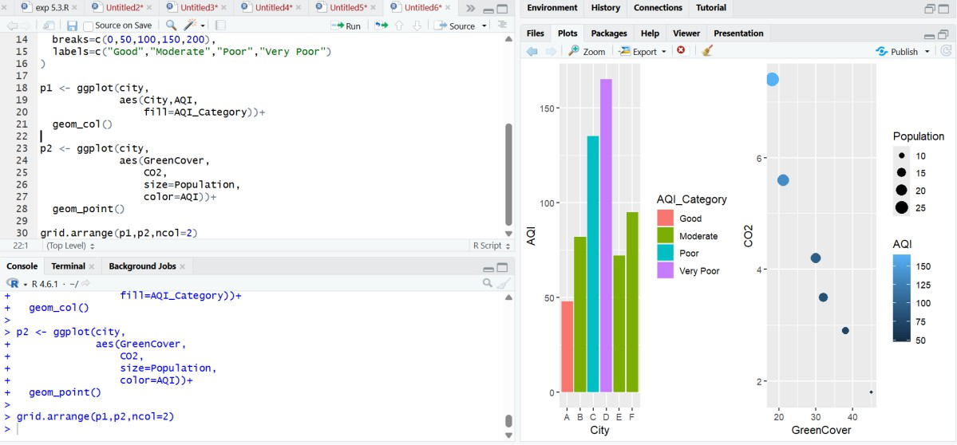

Justification
- Bar chart compares AQI among cities.
- Scatter plot shows the relationship between Green Cover and CO₂ emissions.
- Point size represents population.
- Green, Yellow, Orange, and Red colors effectively indicate AQI categories from good to poor air quality.

