CO-2 AT-2
Visualization Development Exercise
Prithika BH (192424403)

QUESTION 1 – CHART SELECTION
1. Comparing the population of 8 countries in the current year
Best Chart Type: Bar Chart (Amounts)
Justification:
A bar chart is the best choice because it clearly compares the population values of different countries. It makes it easy to identify the country with the highest and lowest population.

2. Showing how delivery times vary across 5 courier companies
Best Chart Type: Box Plot (Distribution)
Justification:
A box plot shows the distribution of delivery times, including the median, spread, and any outliers. It helps compare the variability and consistency of delivery times across courier companies.

3. Showing the proportion of a household budget spent on rent, food, transport, and savings
Best Chart Type: Pie Chart (Proportion)
Justification:
A pie chart is suitable because it shows how each expense contributes to the total household budget. It makes it easy to compare the percentage share of each category.

4. Showing the relationship between hours studied and exam marks for 50 students
Best Chart Type: Scatter Plot (X–Y Relationship)
Justification:
A scatter plot displays the relationship between two numerical variables. It helps identify whether there is a positive, negative, or no correlation between study hours and exam marks.

5. Showing average temperature for each month across 3 different cities at once
Best Chart Type: Line Chart (Temporal)
Justification:
A line chart is ideal for displaying changes over time. Multiple lines allow easy comparison of monthly temperature trends across the three cities.

6. Showing which airports are directly connected by flight routes
Best Chart Type: Network Diagram (Network)
Justification:
A network diagram effectively represents connections between airports. It clearly shows direct flight routes and the relationships between different locations.
QUESTION 2 – HORIZONTAL BAR PLOT (R PROGRAMMING)
R Code
# install.packages("ggplot2")
# install.packages("viridis")
library(ggplot2)
library(viridis)
#-----------------------------------------
# Create Data Frame
#-----------------------------------------
app_data <- data.frame(
App_Category = c("Social Media",
"Gaming",
"Productivity",
"Finance",
"Health & Fitness",
"Education"),
Downloads_Millions = c(58,46,27,19,33,24)
)
#-----------------------------------------
# Sort Data in Ascending Order
#-----------------------------------------
app_data <- app_data[order(app_data$Downloads_Millions), ]
#-----------------------------------------
# Create Attractive Horizontal Bar Plot
#-----------------------------------------
ggplot(app_data,
aes(x = reorder(App_Category, Downloads_Millions),
y = Downloads_Millions,
fill = Downloads_Millions)) +
geom_col(width = 0.7,
color = "black",
linewidth = 0.4) +
coord_flip() +
geom_text(aes(label = Downloads_Millions),
hjust = -0.2,
size = 5,
fontface = "bold",
color = "black") +
scale_fill_viridis(option = "C",
direction = 1,
name = "Downloads\n(Millions)") +
labs(
title = "📱 Mobile App Downloads by Category",
subtitle = "Categories arranged in Ascending Order",
x = "App Category",
y = "Downloads (Millions)"
) +
theme_minimal(base_size = 15) +
theme(
plot.title = element_text(size = 20,
face = "bold",
colour = "darkblue",
hjust = 0.5),
plot.subtitle = element_text(size = 13,
colour = "gray30",
hjust = 0.5),
axis.title = element_text(face = "bold",
size = 14),
axis.text = element_text(size = 12),
legend.position = "right",
panel.grid.major.y = element_blank(),
panel.grid.minor = element_blank(),
plot.background = element_rect(fill = "#F7F9FC",
colour = NA)
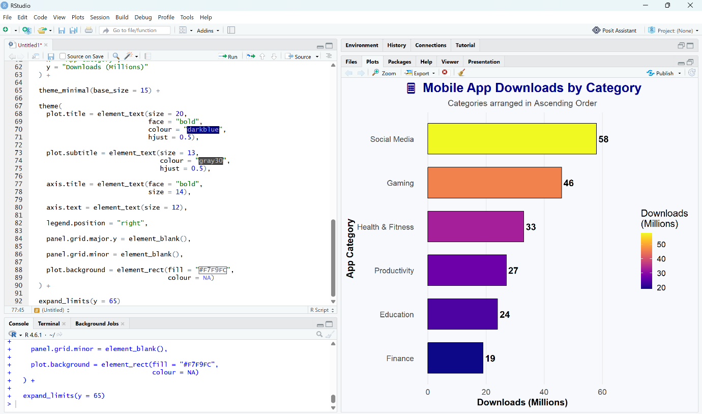
) +expand_limits(y = 65)
QUESTION 3 – GROUPED BAR CHART, STACKED BAR CHART, DOT PLOT & HEATMAP (R PROGRAMMING)
Dataset
#=========================================
# Load Required Packages
#========================================
# install.packages("ggplot2")
# install.packages("dplyr")
# install.packages("tidyr")
# install.packages("viridis")
library(ggplot2)
library(dplyr)
library(tidyr)
library(viridis)
#=========================================
# Create Dataset
#=========================================
traffic <- data.frame(
Device = c("Desktop","Desktop","Desktop","Desktop",
"Mobile","Mobile","Mobile","Mobile",
"Tablet","Tablet","Tablet","Tablet"),
Month = c("Jan","Feb","Mar","Apr",
"Jan","Feb","Mar","Apr",
"Jan","Feb","Mar","Apr"),
Visits_000s = c(45,48,42,50,
80,88,95,102,
20,18,17,15)
)
traffic$Month <- factor(traffic$Month,
levels=c("Jan","Feb","Mar","Apr"))
7. Grouped Bar Chart
ggplot(traffic,
aes(x=Month,
y=Visits_000s,
fill=Device))+
geom_col(position="dodge",
width=0.7,
color="black")+
geom_text(aes(label=Visits_000s),
position=position_dodge(0.7),
vjust=-0.4,
size=4)+

scale_fill_viridis_d(option="D")+
labs(
title="Monthly Website Traffic by Device",
subtitle="Grouped Bar Chart",
x="Month",
y="Visits (000s)"
)+
theme_minimal(base_size=15)+
theme(
plot.title=element_text(face="bold",
size=18,
hjust=0.5),
plot.subtitle=element_text(hjust=0.5),
legend.position="top"
)
Interpretation
- Mobile has the highest traffic every month.
- Tablet has the lowest traffic.
- April records the highest website traffic.
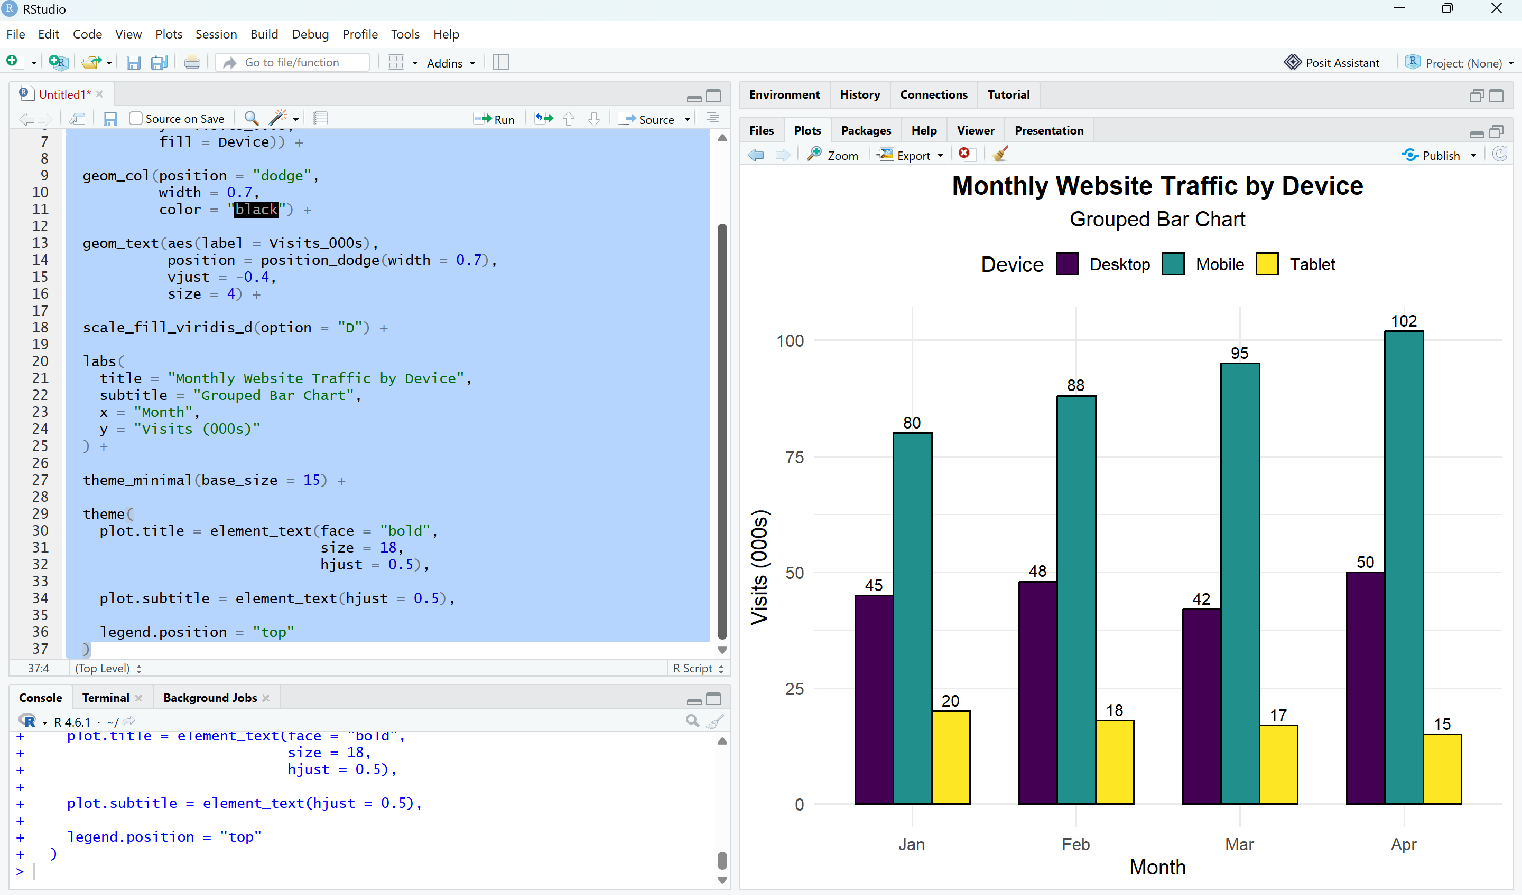
8. Stacked Bar Chart
ggplot(traffic,
aes(x=Month,
y=Visits_000s,
fill=Device))+
geom_col(color="black")+
geom_text(aes(label=Visits_000s),
position=position_stack(vjust=0.5),
color="white",
fontface="bold")+
scale_fill_viridis_d(option="C")+
labs(
title="Total Monthly Website Traffic",
subtitle="Stacked by Device",
x="Month",
y="Visits (000s)"
)+
theme_light(base_size=15)+
theme(
plot.title=element_text(face="bold",
size=18,
hjust=0.5),
plot.subtitle=element_text(hjust=0.5),
legend.position="right"
)
Interpretation
- Each bar represents the total website traffic for one month.
- Mobile contributes the largest share of traffic.
- Overall traffic increases from January to April.
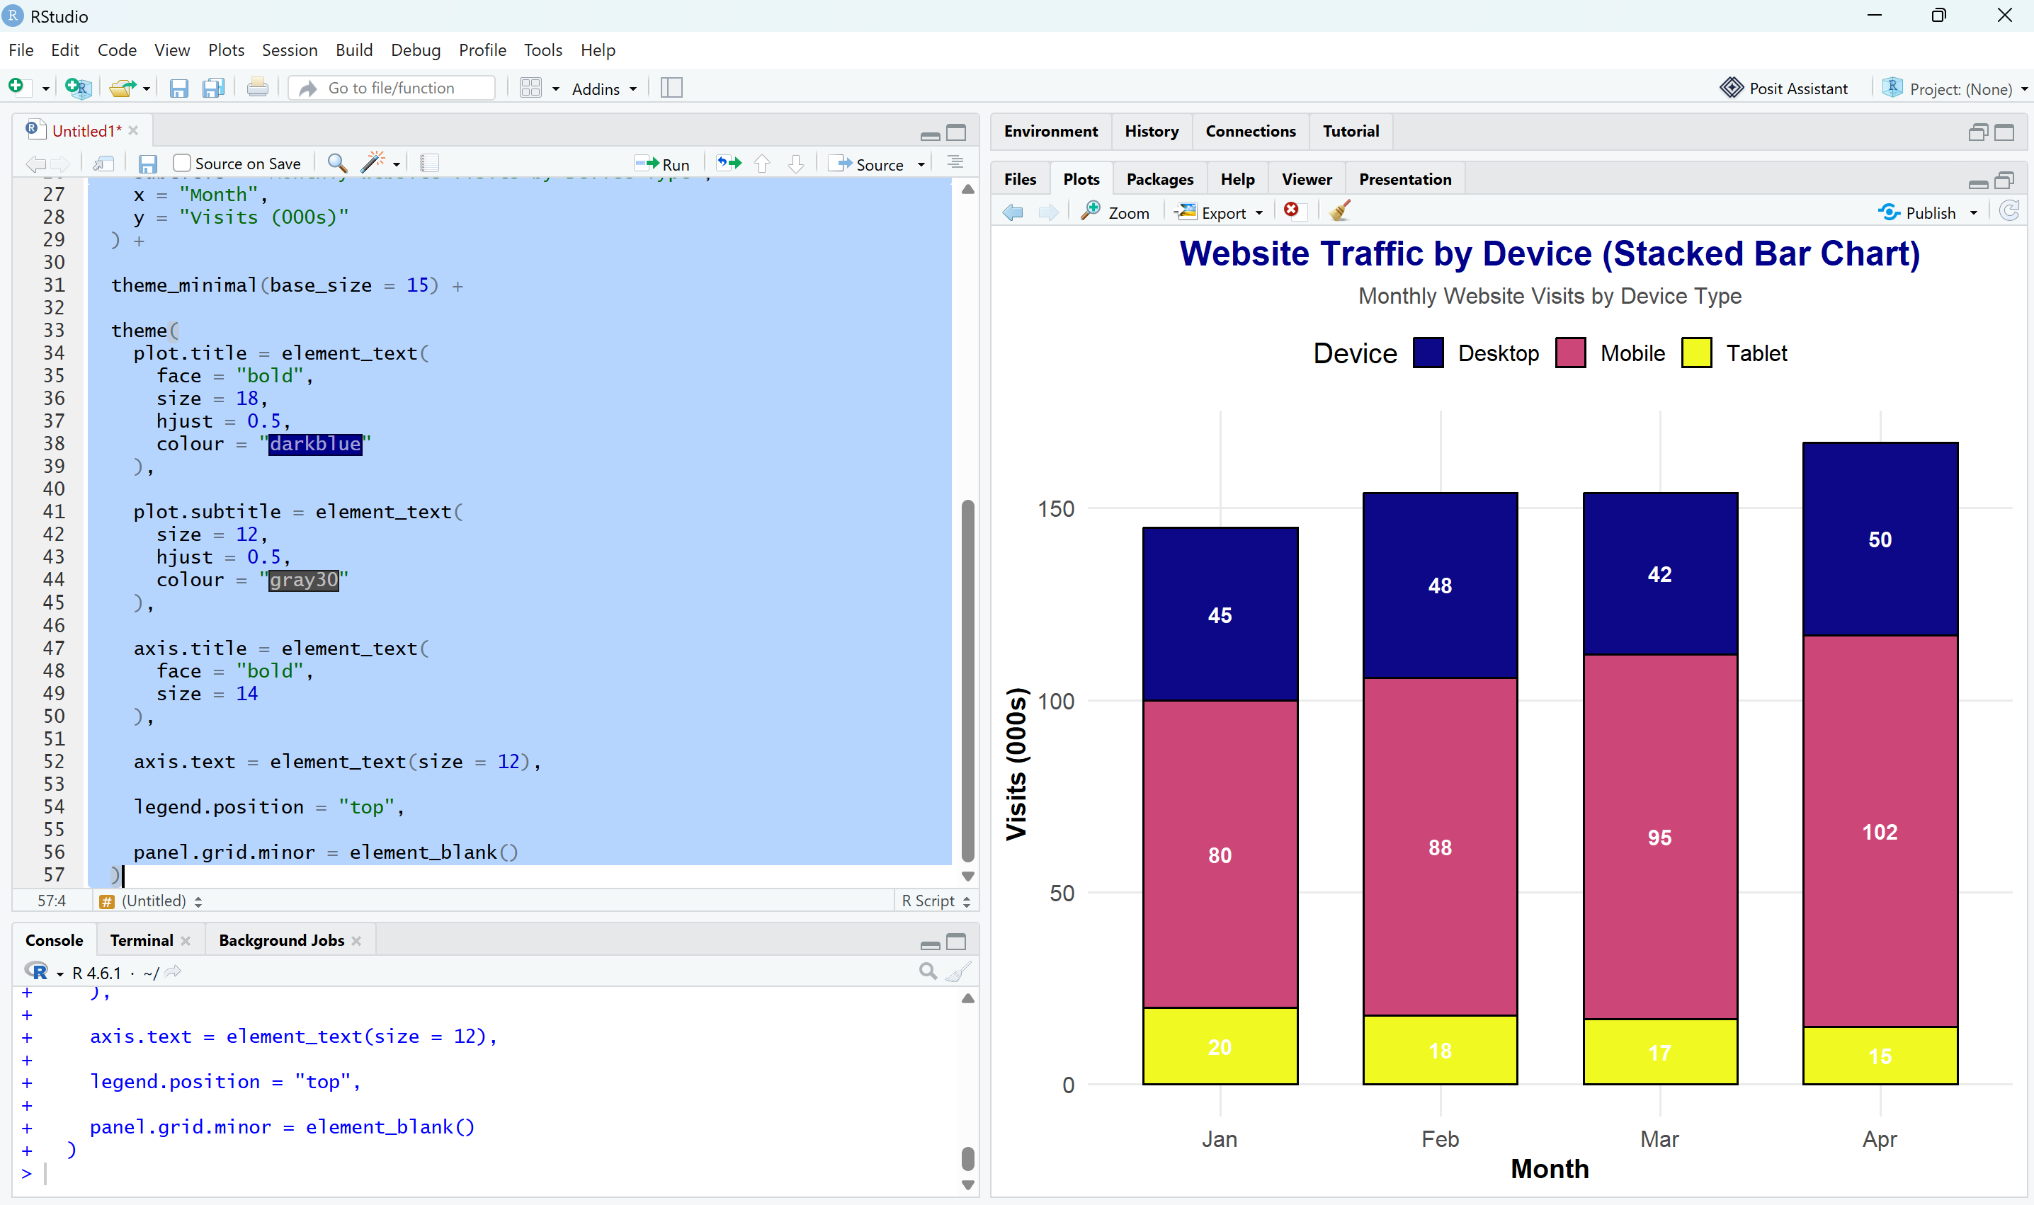
9. Dot Plot
device_total <- traffic %>%
group_by(Device) %>%
summarise(Total_Visits=sum(Visits_000s))
device_total <- device_total %>%
arrange(desc(Total_Visits))
ggplot(device_total,
aes(x=reorder(Device,Total_Visits),
y=Total_Visits,
color=Total_Visits))+
geom_point(size=8)+
geom_segment(aes(x=Device,
xend=Device,
y=0,
yend=Total_Visits),
linewidth=1)+
geom_text(aes(label=Total_Visits),
vjust=-1,
size=5)+
scale_color_viridis_c(option="A")+
coord_flip()+
labs(
title="Total 4-Month Website Traffic",
subtitle="Dot Plot",
x="Device",
y="Total Visits (000s)"
)+
theme_classic(base_size=15)+
theme(
plot.title=element_text(face="bold",
size=18,
hjust=0.5),
plot.subtitle=element_text(hjust=0.5),
legend.position="none"
)
Interpretation
- Mobile has the highest total traffic.
- Desktop ranks second.
- Tablet has the lowest total traffic.
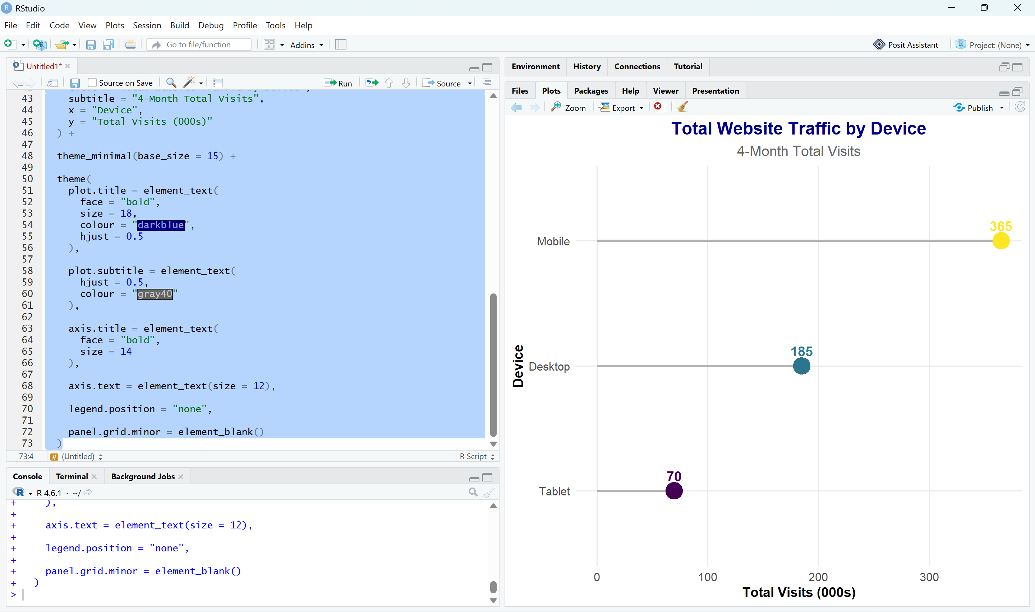
10. Heatmap
ggplot(traffic,
aes(x=Month,
y=Device,
fill=Visits_000s))+
geom_tile(color="white",
linewidth=1)+
geom_text(aes(label=Visits_000s),
color="white",
fontface="bold",
size=5)+
scale_fill_viridis(option="plasma")+
labs(
title="Website Traffic Heatmap",
subtitle="Device vs Month",
x="Month",
y="Device"
)+
theme_minimal(base_size=15)+
theme
plot.title=element_text(face="bold",
size=18,hjust=0.5),
plot.subtitle=element_text(hjust=0.5),
panel.grid=element_blank()
)
Interpretation
- Darker colors indicate higher website traffic.
- Mobile traffic consistently increases from January to April.
- Desktop traffic remains fairly stable.
- Tablet traffic gradually decreases over the four months.
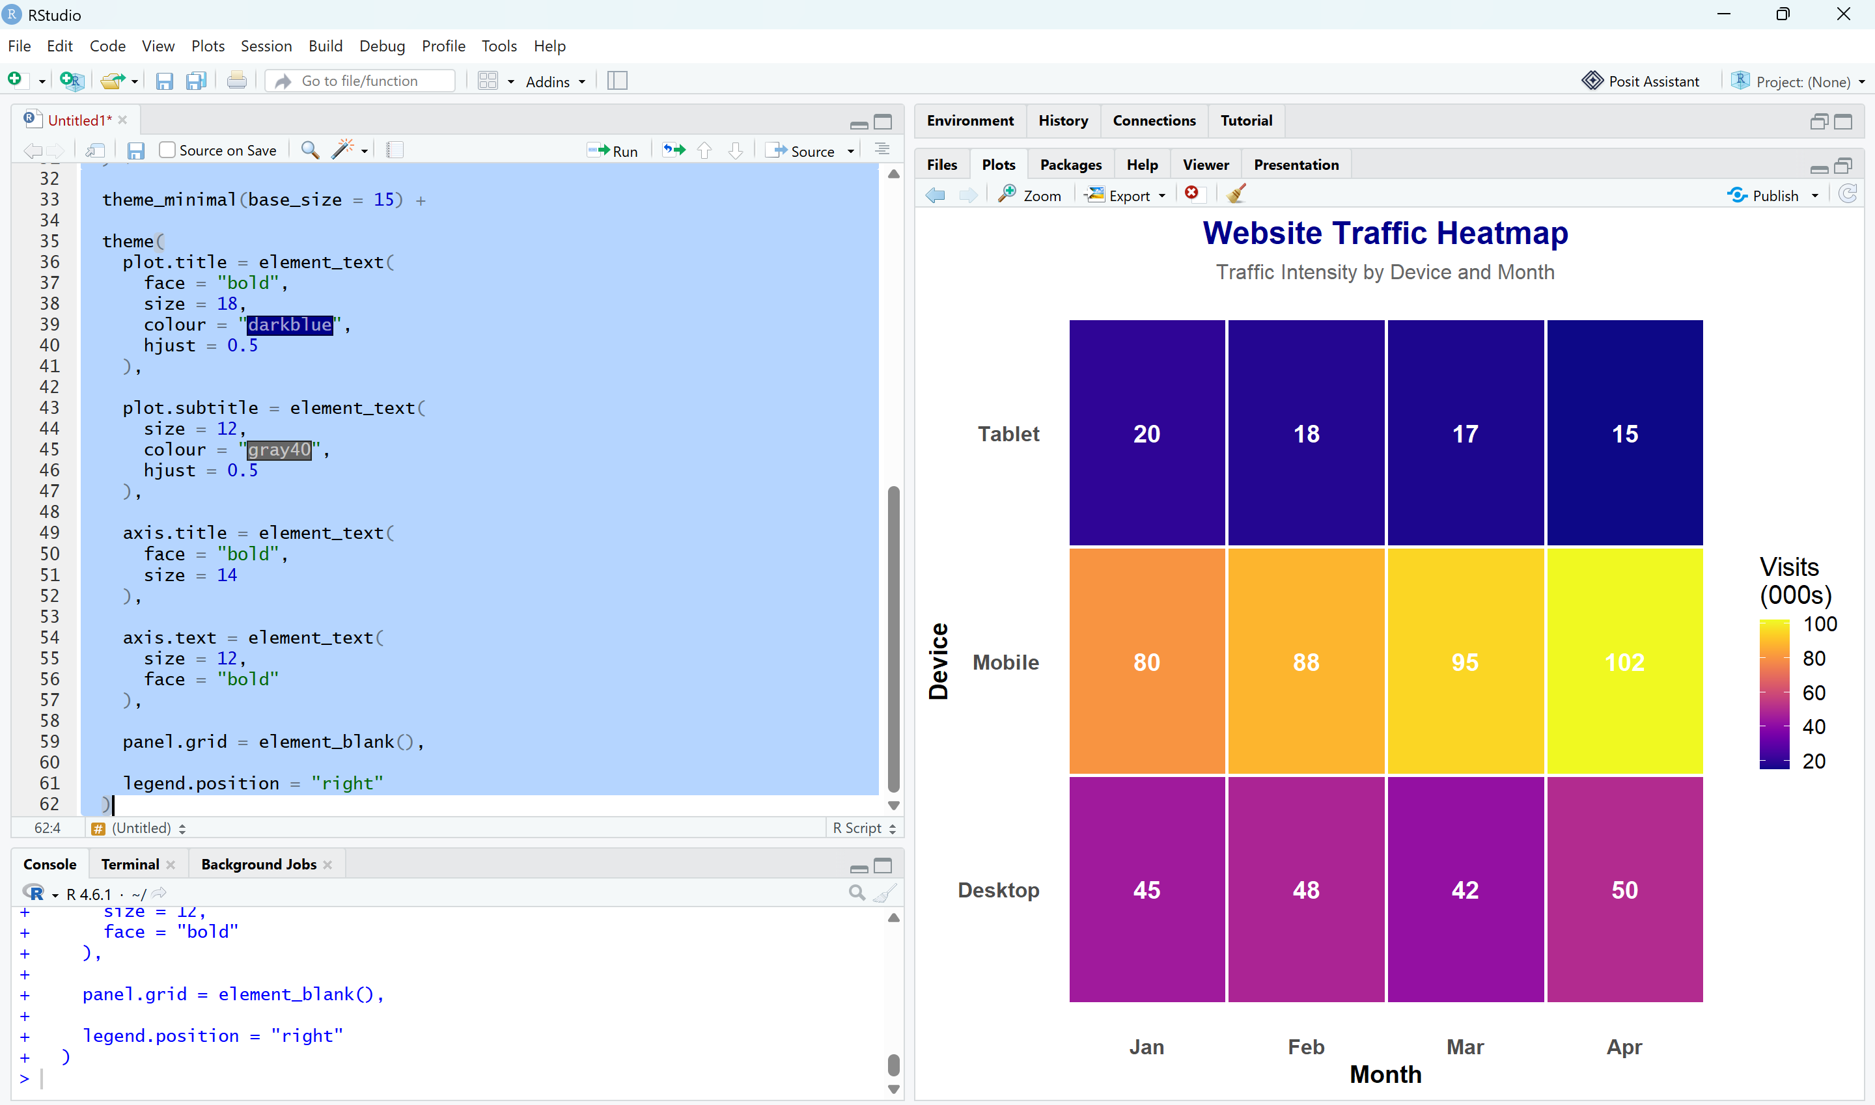
QUESTION 4 – VIOLIN PLOT & RIDGELINE PLOT (R PROGRAMMING)
Step 1: Load Required Packages
# Install packages (Run only once)
# install.packages("ggplot2")
# install.packages("ggridges")
# install.packages("dplyr")
library(ggplot2)
library(ggridges)
library(dplyr)
Step 2: Generate Synthetic Dataset
#=========================================
# Generate Delivery Time Data
#=========================================
set.seed(7)
routeA <- rnorm(50, mean = 32, sd = 6)
routeB <- rnorm(50, mean = 28, sd = 4)
routeC <- rnorm(50, mean = 40, sd = 9)
routeD <- rnorm(50, mean = 35, sd = 5)
delivery <- data.frame(
Route = factor(rep(c("Route A","Route B","Route C","Route D"), each = 50)),
Time = c(routeA, routeB, routeC, routeD)
)
11. Violin Plot
ggplot(delivery,
aes(x = Route,
y = Time,
fill = Route)) +
geom_violin(trim = FALSE,
alpha = 0.8,
color = "black") +
geom_boxplot(width = 0.12,
fill = "white",
color = "black",
outlier.color = "red") +
stat_summary(fun = median,
geom = "point",
shape = 23,
size = 4,
fill = "yellow",
color = "black") +
scale_fill_viridis_d(option = "C") +
labs(
title = "Delivery Time Distribution by Route",
subtitle = "Violin Plot with Embedded Boxplot",
x = "Delivery Route",
y = "Delivery Time (Minutes)"
) +
theme_minimal(base_size = 15) +
theme(
plot.title = element_text(
face = "bold",
size = 18,
colour = "darkblue",
hjust = 0.5
),
plot.subtitle = element_text(
hjust = 0.5,
colour = "gray40"
),
axis.title = element_text(
face = "bold"
),
legend.position = "none"
)
Interpretation
- Route B has the lowest median delivery time, making it the fastest.
- Route C shows the widest spread, indicating higher variability.
- Route A and D have moderate delivery times with less variation.
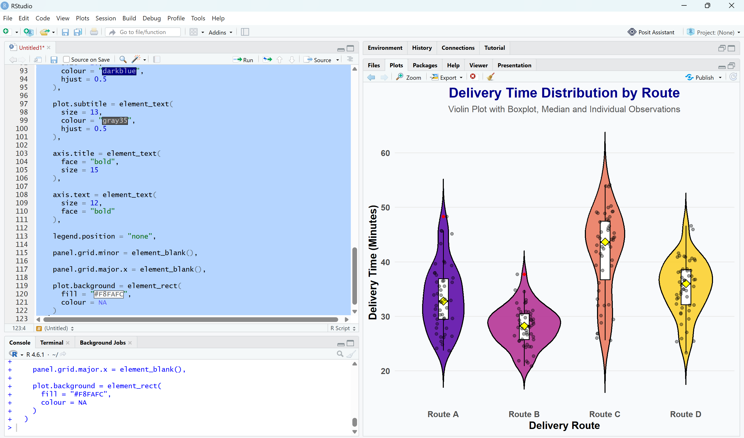
12. Ridgeline Plot
# Calculate mean delivery time
route_order <- delivery %>%
group_by(Route) %>%
summarise(Mean_Time = mean(Time)) %>%
arrange(Mean_Time)
# Reorder factor
delivery$Route <- factor(
delivery$Route,
levels = route_order$Route
)
ggplot(delivery,
aes(x = Time,
y = Route,
fill = after_stat(x))) +
geom_density_ridges_gradient(
scale = 3,
rel_min_height = 0.01,
color = "white",
alpha = 0.9
) +
scale_fill_viridis_c(option = "plasma") +
labs(
title = "Ridgeline Plot of Delivery Times",
subtitle = "Routes Ordered from Fastest to Slowest",
x = "Delivery Time (Minutes)",
y = "Route"
) +
theme_ridges(font_size = 14) +
theme(
plot.title = element_text(
face = "bold",
size = 18,
colour = "darkblue",
hjust = 0.5
),
plot.subtitle = element_text(
hjust = 0.5,
colour = "gray40"
),
legend.position = "none"
)
Interpretation
- Routes are ordered from the fastest (lowest mean delivery time) at the bottom to the slowest at the top.
- Route B has the fastest average delivery time.
- Route C has the slowest and most variable delivery times.
- The ridgeline plot clearly compares the shape, spread, and overlap of delivery time distributions across all four routes.
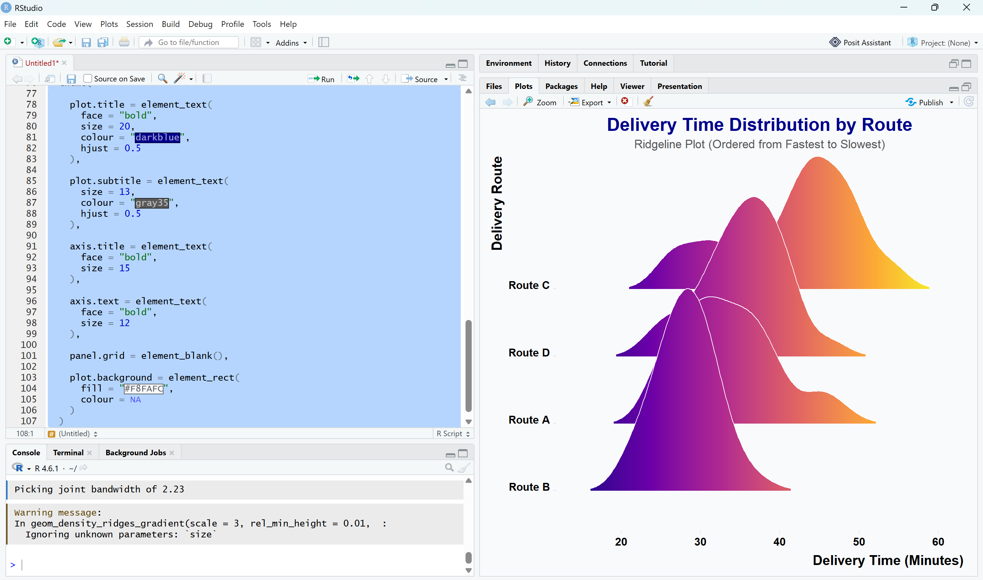
QUESTION 5 – HISTOGRAMS & DENSITY PLOTS (R PROGRAMMING)
Load Required Package
# Install once
# install.packages("ggplot2")
library(ggplot2)
13 & 14. Histogram with Density Curve
#=========================================
# Histogram + Density Curve
#=========================================
library(ggplot2)
ggplot(iris,
aes(x = Petal.Length)) +
geom_histogram(
aes(y = after_stat(density)),
bins = 20,
fill = "skyblue",
color = "black",
alpha = 0.8
) +
geom_density(
color = "red",
linewidth = 1.5
) +
labs(
title = "Histogram with Density Curve",
subtitle = "Distribution of Iris Petal Length",
x = "Petal Length (cm)",
y = "Density"
) +
theme_minimal(base_size = 15) +
theme(
plot.title = element_text(
face = "bold",
size = 20,
colour = "darkblue",
hjust = 0.5
),
plot.subtitle = element_text(
hjust = 0.5,
colour = "gray40"
),
axis.title = element_text(
face = "bold"
),
panel.grid.minor = element_blank()
)
Interpretation
- The histogram shows the frequency distribution of petal lengths.
- The red density curve provides a smooth representation of the data distribution.
- Most flowers have petal lengths between 1 cm and 6 cm.
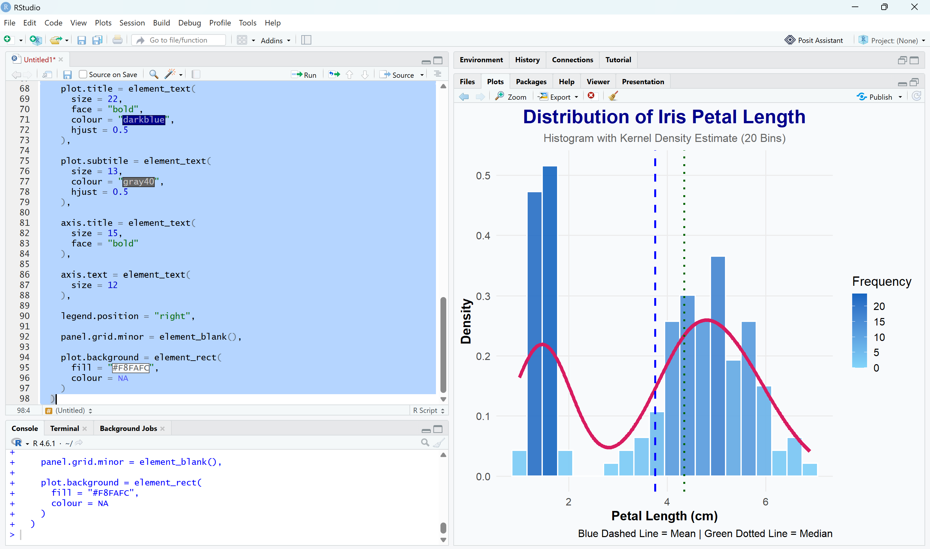
15. Histogram + Density by Species
#=========================================
# Histogram + Density by Species
#=========================================
ggplot(iris,
aes(x = Petal.Length,
fill = Species)) +
geom_histogram(
aes(y = after_stat(density)),
bins = 20,
alpha = 0.5,
color = "black",
position = "identity"
) +
geom_density(
aes(color = Species),
linewidth = 1.3
) +
labs(
title = "Petal Length Distribution by Species",
subtitle = "Histogram with Density Curves",
x = "Petal Length (cm)",
y = "Density"
) +
scale_fill_brewer(palette = "Pastel1") +
scale_color_brewer(palette = "Dark2") +
theme_minimal(base_size = 15) +
theme(
plot.title = element_text(
face = "bold",
size = 20,
colour = "darkblue",
hjust = 0.5
),
plot.subtitle = element_text(
hjust = 0.5,
colour = "gray40"
),
axis.title = element_text(
face = "bold"
),
legend.position = "top",
panel.grid.minor = element_blank()
)
Interpretation
- Setosa has the smallest petal lengths and forms a distinct distribution.
- Versicolor has medium-sized petal lengths.
- Virginica has the largest petal lengths.
- The density curves make it easy to compare the shape and spread of each species' distribution.
- There is some overlap between Versicolor and Virginica, while Setosa is clearly separated.
