DSA0601 Data Handling and Visualization
Slot A
CO2 – Assessment Test 1 (AT1)
Chart Construction Test
Instructions:
For each question, write the program in the specified language (R or Python), generate the required visualization, and answer the interpretation sub-questions clearly with justification.DSA06 – Data Handling and Visualization | Assessment Tool: Experiment
DSA06 – DATA HANDLING AND VISUALIZATION
CO3_AT1_Assessment Tool: EXPERIMENT
Topics Covered: ECDF and Q-Q Plots; Multiple Distributions; Vertical-Axis Distributions; Bean Plots; Proportions; Pie/Side-by Side/Stacked Bars; Stacked Densities; Treemaps; Sunburst Charts; Parallel Sets; Sankey Diagrams; Nested Proportions; Avoiding Misleading Proportions.
General Instruction: For each experiment, use an appropriate visualization, justify the design, interpret the result, and identify potential visualization bias. R/ggplot2 or an equivalent visualization tool may be used.
Question 1 – Distribution Diagnosis using ECDF and Q-Q Plot
Scenario: An engineering department records response time (ms) of an automated fault-detection system under 20 test runs. The team claims the distribution is approximately normal and wants to use mean and standard deviation for monitoring.
Dataset (n=20): 118, 121, 125, 127, 129, 131, 134, 136, 138, 141, 144, 147, 151, 156, 162, 171, 184, 205, 249, 318 Tasks:
1. Construct an ECDF and a normal Q-Q plot.
ECDF and Normal Q-Q Plot
Dataset:
118, 121, 125, 127, 129, 131, 134, 136, 138, 141, 144, 147, 151, 156, 162, 171, 184, 205, 249, 318 For the ECDF, the x-axis represents response time and the y-axis represents the cumulative proportion of observations. For the normal Q-Q plot, the observed response times are compared with theoretical normal-distribution quantiles.
2. Use both plots to evaluate the normality claim.
Evaluation of the Normality Claim
The data do not appear to follow a normal distribution.
● The ECDF shows that most observations are concentrated between approximately 118 and 184 ms, followed by a
long upper tail.
● The Q-Q plot would show noticeable departures from the straight reference line, particularly at the upper end. ● Therefore, the assumption of approximate normality is questionable.
3. Identify evidence of skewness and/or extreme observations.
Skewness and Extreme Observations
The distribution shows strong positive (right) skewness.
Important observations in the upper tail are:
● 205 ms
● 249 ms
● 318 ms
The sample statistics are approximately:
Statistic | Value
Mean | 159.35 ms
Median | 142.5 ms
Standard deviation | 49.00 ms
Skewness | 2.25

Since the mean > median and skewness is strongly positive, there is clear evidence of right skewness. Using the IQR rule:
● Q1 = 130.5 ms
● Q3 = 164.25 ms
● IQR = 33.75 ms
● Upper fence = 214.875 ms
Thus, 249 ms and 318 ms can be considered extreme observations by the IQR criterion.
4. Recommend percentile-based limits or mean ± standard-deviation limits, with justification.
Key competency: ECDF, Q-Q plot, skewness, outliers, distribution interpretation
Recommended Monitoring Limits
Percentile-based limits are recommended rather than mean ± standard deviation.
The reason is that the response-time distribution is strongly right-skewed and contains extreme high values. Mean ± SD limits are sensitive to these observations and rely on a roughly symmetric/normal distribution.
For example, empirical percentile limits could be used:
● 90th percentile ≈ 209.4 ms
● 95th percentile ≈ 252.45 ms
So, a practical monitoring approach could use a 95th-percentile upper limit of about 252 ms, depending on the department's desired false-alarm rate.
Conclusion
The normality claim should be rejected or treated with caution. The ECDF indicates a long right tail, while the Q-Q plot would show substantial deviation from normality at the upper end. The data have positive skewness (≈2.25) and extreme observations at 249 and 318 ms. Therefore, percentile-based monitoring limits are preferable to mean ± standard deviation limits for this dataset.
Question 2 – Comparing Many Distributions and Bean Plots
Scenario: A semiconductor manufacturer measures chip fabrication cycle time (minutes) for four production lines. Management wants to identify differences in variability and distribution shape.
Production Line | Cycle Times (minutes)
L1 | 42, 44, 45, 46, 47, 48, 49, 50, 51, 53
L2 | 38, 41, 44, 47, 50, 53, 56, 59, 62, 65
L3 | 45, 46, 46, 47, 47, 48, 48, 49, 49, 50
L4 | 40, 41, 42, 43, 44, 45, 48, 55, 61, 72

Tasks:
1. Create a visualization comparing all four distributions.
Visualization comparing all four distributions
A box plot/violin plot (bean-plot equivalent) is suitable because it allows the center, spread, and shape of all four production-line distributions to be compared on the same graph.
# Data
L1 <- c(42, 44, 45, 46, 47, 48, 49, 50, 51, 53)
L2 <- c(38, 41, 44, 47, 50, 53, 56, 59, 62, 65)
L3 <- c(45, 46, 46, 47, 47, 48, 48, 49, 49, 50)
L4 <- c(40, 41, 42, 43, 44, 45, 48, 55, 61, 72)
# Combine data
cycle_time <- c(L1, L2, L3, L4)
line <- factor(c(
rep("L1", 10),
rep("L2", 10),
rep("L3", 10),
rep("L4", 10)
))
data <- data.frame(line, cycle_time)
# Violin plot
boxplot(cycle_time ~ line,
data = data,
main = "Cycle Time Distribution Across Production Lines", xlab = "Production Line",
ylab = "Cycle Time (minutes)",
col = "lightblue")
# Add individual observations
stripchart(cycle_time ~ line,
data = data,
vertical = TRUE,
method = "jitter",
pch = 19,
add = TRUE)
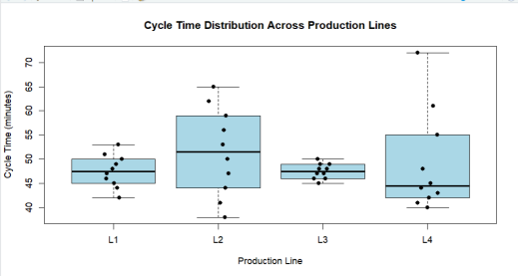Expected interpretation
● Greatest variability: L4
○ Range = 72 − 40 = 32 minutes
○ SD ≈ 10.44 minutes
● Most concentrated: L3
○ Range = 50 − 45 = 5 minutes
○ SD ≈ 1.58 minutes
● L1 and L3 have the same mean (47.5 min), but L3 is much more concentrated. This shows why mean alone is insufficient for comparing distributions.
Conclusion: L4 has the highest variability, while L3 has the most concentrated cycle-time distribution.
2. Construct bean plots or an equivalent distribution visualization along the vertical axis
Distribution comparison
Line | Mean (min) | Std. Dev. (min) | Range
L1 | 47.5 | 3.37 | 11
L2 | 51.5 | 9.08 | 27
L3 | 47.5 | 1.58 | 5
L4 | 49.1 | 10.44 | 32

3. Determine which line has greatest variability and which has the most concentrated distribution.
Greatest variability and most concentrated distribution
● Greatest variability: L4
○ Standard deviation = 10.44 min
○ Range = 32 min
○ The high values 55, 61, and 72 create a long upper tail.
● Most concentrated: L3
○ Standard deviation = 1.58 min
○ Range = 5 min
○ Most observations lie tightly between 45 and 50 minutes.
● L2 also has substantial variability and is spread fairly evenly from 38 to 65 minutes.
● L1 has relatively low variability and is fairly compact around 47–50 minutes.
4. Explain why comparing only means is insufficient.
Key competency: Multiple distributions, vertical-axis distributions, bean plots, variability
Why comparing only means is insufficient
Comparing only means can hide important differences in the distributions.
For example:
● L1 mean = 47.5 min
● L3 mean = 47.5 min
They have exactly the same mean, but their variability is very different:
● L1 SD = 3.37 min
● L3 SD = 1.58 min
Similarly, L4 has a mean of only 49.1 min, but its distribution is much more variable because of the high values up to 72 min. Conclusion
L4 has the greatest variability, while L3 has the most concentrated distribution. A bean plot or equivalent distribution visualization is better than comparing means alone because it reveals spread, concentration, skewness, and extreme observations.
Question 3 – Proportion Visualization and Choice of Chart
Scenario: A university analyzes preferred learning mode of 240 students across three departments. The dean wants comparison without exaggerating small differences.
DSA06 – Data Handling and Visualization | Assessment Tool: Experiment
Department | Online (%) | Blended (%) | Face-to-Face (%)
CSE | 52 | 28 | 20

ECE | 45 | 35 | 20
IT | 30 | 40 | 30

Tasks:
1. Create a side-by-side bar chart and a 100% stacked bar chart.
# Data
dept <- c("CSE", "ECE", "IT")
online <- c(52, 45, 30)
blended <- c(28, 35, 40)
face_to_face <- c(20, 20, 30)
# Create matrix
data <- rbind(online, blended, face_to_face)
# Side-by-side bar chart
barplot(data,
beside = TRUE,
names.arg = dept,
col = c("skyblue", "orange", "lightgreen"),
ylim = c(0, 60),
xlab = "Department",
ylab = "Percentage (%)",
main = "Preferred Learning Mode by Department")
legend("topright",
legend = c("Online", "Blended", "Face-to-Face"),
fill = c("skyblue", "orange", "lightgreen"))
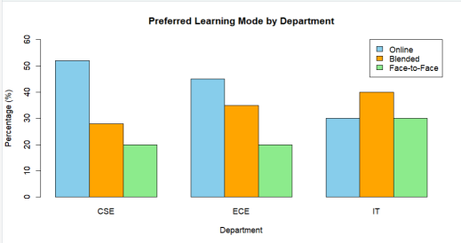
2. Explain which chart better supports comparison of individual proportions and why.
# 100% stacked bar chart
barplot(data,
beside = FALSE,
names.arg = dept,
col = c("skyblue", "orange", "lightgreen"),
ylim = c(0, 100),
xlab = "Department",
ylab = "Percentage (%)",
main = "Learning Mode Distribution by Department")
legend("topright",
legend = c("Online", "Blended", "Face-to-Face"),
fill = c("skyblue", "orange", "lightgreen"))
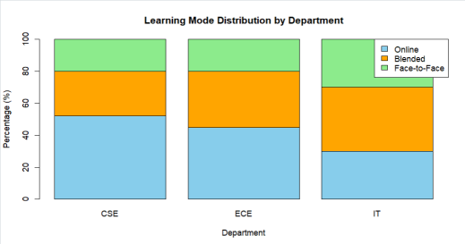Which chart is better for comparing individual proportions?
The side-by-side bar chart is better for comparing individual proportions because all bars start from the same baseline of zero. This makes differences such as CSE Online = 52% and ECE Online = 45% easier to see accurately.
The 100% stacked bar chart is better for understanding the overall composition of each department, but comparing segments that are not aligned to the same baseline is more difficult.
3. Explain why separate pie charts may be less effective for comparing departments.
Why separate pie charts are less effective
Separate pie charts make it difficult to compare similar-sized slices across departments because the slices have different angles and positions. Side-by-side bars provide a common baseline and make comparisons easier.
4. Identify one design choice that could make small proportional differences appear larger.
Design choice that can exaggerate small differences
Using a truncated y-axis can make small differences appear much larger than they really are.
For example, displaying the y-axis from 40% to 55% instead of 0% to 100% could make 45% and 52% look dramatically different.
Conclusion: Use the side-by-side bar chart when accurate comparison of individual percentages is the main goal, and the 100% stacked bar chart when comparing the composition of each department.
Key competency: Proportions, side-by-side bars, stacked bars, pie charts, misleading proportions
Question 4 – Nested Proportions using Treemap and Sunburst
Scenario: An e-commerce company analyzes annual revenue of ₹1.2 crore across product categories and subcategories. The dashboard must show both category contribution and internal composition.
Category | Subcategory | Revenue (₹ lakh)
Electronics | Mobiles | 24
Electronics | Laptops | 18
Electronics | Accessories | 8
Home | Furniture | 14
Home | Appliances | 10
Home | Decor | 6
Fashion | Men | 7
Fashion | Women | 8
Fashion | Kids | 5

Tasks:
1. Construct a treemap showing category and subcategory revenue.
# Create data
data <- data.frame(
Category = c(
"Electronics", "Electronics", "Electronics",
"Home", "Home", "Home",
"Fashion", "Fashion", "Fashion"
),
Subcategory = c(
"Mobiles", "Laptops", "Accessories",
"Furniture", "Appliances", "Decor",
"Men", "Women", "Kids"
),
Revenue = c(24, 18, 8, 14, 10, 6, 7, 8, 5)
)
# Treemap
treemap(
data,
index = c("Category", "Subcategory"),
vSize = "Revenue",
type = "index",
title = "Annual Revenue by Category and Subcategory",
palette = "Set3"
)
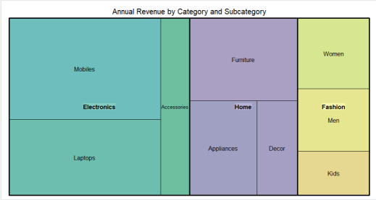2. Construct a sunburst chart representing the same hierarchy.
# Sunburst chart
fig <- plot_ly(
data = data,
ids = ~Subcategory,
labels = ~Subcategory,
parents = ~Category,
values = ~Revenue,
type = "sunburst"
)
fig <- fig %>%
layout(
title = "Revenue Distribution by Category and Subcategory"
)
fig
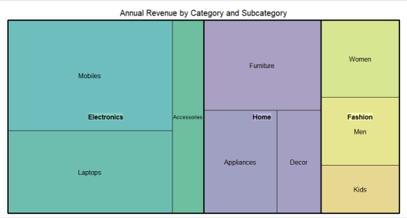3. Determine the largest category and calculate its percentage of total revenue.
category_total <- aggregate(
Revenue ~ Category,
data = data,
sum
)
print(category_total)
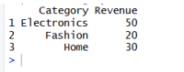
The totals are:
Category | Revenue (₹ lakh) | Percentage
Electronics | 50 | 41.67%

Home | 30 | 25.00%
Fashion | 20 | 16.67%

Note: The supplied subcategory data totals ₹100 lakh (₹1 crore), not ₹120 lakh (₹1.2 crore). So, based on the actual table, Electronics contributes:
10050×100=50%
Therefore, Electronics is the largest category and represents 50% of the provided revenue data.
4. Compare treemap and sunburst for identifying nested proportions.
Treemap vs Sunburst
● Treemap: Uses rectangular area to represent revenue. It is useful for quickly identifying the largest categories and subcategories.
● Sunburst: Uses concentric rings to show the hierarchy. The inner ring represents categories and the outer ring represents subcategories.
● Treemap is better for comparing sizes.
● Sunburst is better for understanding the parent-child relationship.
5. State one situation in which area encoding could mislead interpretation.
Key competency: Treemaps, sunburst charts, nested proportions, area encoding
When area encoding can mislead
Area encoding can be misleading when two regions have similar areas but different shapes. Humans generally compare length more accurately than area, so small differences in rectangular areas may be difficult to judge precisely.
Conclusion: Use a treemap for quick size comparison and a sunburst for hierarchical understanding.
Question 5 – Flow Proportions using Sankey Diagram / Parallel Sets Scenario: A smart-city mobility study follows 200 commuters from residential zone through primary transport mode to destination zone. The planning team wants dominant flows and possible bottlenecks.
Origin | Mode | Destination | Commuters
Residential | Bus | Central | 35
Residential | Bus | Industrial | 15
Residential | Train | Central | 25
Residential | Train | Industrial | 10
Suburban | Bus | Central | 20
Suburban | Bus | Industrial | 10

Suburban | Train | Central | 30
Suburban | Train | Industrial | 15
Rural | Bus | Central | 12

DSA06 – Data Handling and Visualization | Assessment Tool: Experiment
Rural | Bus | Industrial | 8
Rural | Train | Central | 10
Rural | Train | Industrial | 10

Tasks:
1. Construct a Sankey diagram showing Origin → Mode → Destination.
Sankey Diagram: Origin → Mode → Destination
# Install once
install.packages("networkD3")
# Load package
library(networkD3)
# Create nodes
nodes <- data.frame(
name = c(
"Residential", "Suburban", "Rural",
"Bus", "Train",
"Central", "Industrial"
)
)
# Create links
links <- data.frame(
source = c(
0, 0, 1, 1, 2, 2, 2,
3, 3, 4, 4, 3, 3, 4, 4
),
target = c(
3, 3, 3, 3, 3, 3, 4,
5, 6, 5, 6, 5, 6, 5, 6
),
value = c(
50, 15, 30, 10, 20, 12, 10, 35, 15, 25, 10, 20, 10, 30, 15 )
)
# Create Sankey diagram sankeyNetwork(
Links = links,
Nodes = nodes,
Source = "source",
Target = "target",
Value = "value",
NodeID = "name",
fontSize = 12,
nodeWidth = 30
)
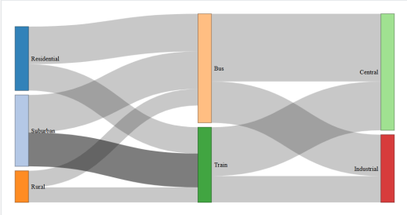2. Construct a parallel-sets representation of the same categorical flows.
data <- data.frame(
Origin = c(
"Residential", "Residential", "Residential", "Residential",
"Suburban", "Suburban", "Suburban", "Suburban",
"Rural", "Rural", "Rural", "Rural"
),
Mode = c(
"Bus", "Bus", "Train", "Train",
"Bus", "Bus", "Train", "Train",
"Bus", "Bus", "Train", "Train"
),
Destination = c(
"Central", "Industrial", "Central", "Industrial",
"Central", "Industrial", "Central", "Industrial",
"Central", "Industrial", "Central", "Industrial"
),
Commuters = c(35, 15, 25, 10, 20, 10, 30, 15, 12, 8, 10, 10)
)
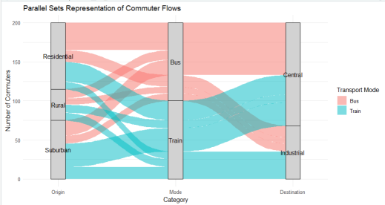3. Identify the three largest flows and calculate their percentages of all commuters.
Three Largest Flows
The largest individual flows are:
Rank | Origin → Mode →  Destination | Commuters | Percentage
1 | Residential → Bus → Central | 35 | 17.5%
2 | Suburban → Train → Central | 30 | 15%
3 | Residential → Train →  Central | 25 | 12.5%

Percentage is calculated as:
Percentage=200Commuters×100
Together, these three flows account for:
20035+30+25×100=45%
4. Compare Sankey and parallel sets for flow magnitude and category relationships.
Sankey vs Parallel Sets
Sankey diagram:
● Best for showing flow magnitude.
● Link width represents the number of commuters.
● Makes dominant routes and bottlenecks easy to identify.
Parallel sets:
● Best for showing relationships between categorical variables.
● Makes it easier to see how Origin, Mode and Destination categories interact.
● Useful when there are many categorical dimensions.
5. Explain one way poor link widths or category ordering could mislead the viewer.
Key competency: Sankey diagrams, parallel sets, flow proportions, categorical relationships
How visualization can mislead
If the link widths are not proportional to the actual commuter counts, a flow may appear more or less important than it really is.
Similarly, poor category ordering can create unnecessary crossings, making some relationships appear stronger or more complicated than they actually are.
Conclusion
The Residential → Bus → Central flow is the largest individual flow with 35 commuters (17.5%). A Sankey diagram is preferable for understanding flow magnitude, while parallel sets are useful for examining categorical relationships.
Suggested Evaluation Rubric – Experiment
Criterion | Excellent (4) Good (3) | Satisfactory (2) | Needs  Improvement (1)
Data preparation | Correct and complete Minor issue | Several issues | Incorrect/incomplete
Visualization choice | Highly appropriate  Appropriate  and justified | Partially appropriate | Poor choice
Technical execution | Accurate and clear Mostly accurate | Some errors | Major errors
Interpretation | Insightful and  Correct  evidence-based | Basic | Incorrect/unsupported

Misleading-design analysis
Bias clearly identified and explained
Bias identified Limited explanation Not identified
Suggested marks: 20 marks per question; 100 marks total. Level: Competitive / advanced undergraduate. DSA06 – Data Handling and Visualization | Assessment Tool: Experiment

