SIMATS ENGINEERING
ASSESSMENT TOOL III – VISUALIZATION CRITIQUE & REDESIGN
Course: Data Handling and Visualization | Code: DSA0601 | CO: CO3
Duration: 120 min | Total Marks: 100 | Reg No : 192424403  Name: Prithika BH

COURSE OUTCOME COVERED
CO3: Analyze time-series data, trends, associations, and uncertainty through appropriate visualization methods. (BL4)
Activity Tool : Visualization Critique & Redesign
Weightage: 20%
Code of Conduct:
I Prithika BH (192424403) (Name / Reg No) certify that this submission is my original work and that I have adhered to the guidelines specified for this assessment. I understand that any violation of academic integrity rules will result in disciplinary action.
Signature of the student:
Criteria | Evaluation of Existing  Visualization  25% | Redesign  Strategy  25% | Application  of  Visualization Principles  20% | Organizati on  15% | Accuracy  10% | Clarity  5% | Total
Q1
Q2
Q3
Q4
Q5

AT3 – Visualization Critique & Redesign
R Programming Assessment – Distribution and Proportion Visualization
Instructions: For each question, use R/RStudio to reproduce the given visualization, critique its effectiveness, identify misleading or inappropriate visual encodings, and redesign it using a more suitable visualization. Include the R code, redesigned visualization, and a concise justification of your design decisions.
Question 1 – Critique and Redesign an ECDF and Q-Q Plot
Dataset: Salary_Distribution.csv
Dataset:
Employee_ID | Department | Salary
E01 | IT | 42000
E02 | IT | 45000
E03 | IT | 48000
E04 | IT | 51000
E05 | IT | 55000
E06 | HR | 38000
E07 | HR | 40000
E08 | HR | 42000
E09 | HR | 46000
E10 | HR | 50000
E11 | Finance | 47000
E12 | Finance | 49000
E13 | Finance | 52000
E14 | Finance | 58000
E15 | Finance | 65000
E16 | Marketing | 36000
E17 | Marketing | 39000
E18 | Marketing | 43000
E19 | Marketing | 47000
E20 | Marketing | 72000

R CODE:
library(ggplot2)

salary <- c(42000,45000,48000,51000,55000,
38000,40000,42000,46000,50000,
47000,49000,52000,58000,65000,
36000,39000,43000,47000,72000)

df <- data.frame(Salary=salary)

# 1. ORIGINAL ECDF
plot(ecdf(salary),
main="Original ECDF",
xlab="Salary",
ylab="ECDF",
col="blue",
lwd=2)

# 2. ORIGINAL Q-Q PLOT
qqnorm(salary,
main="Original Q-Q Plot",
col="blue")
qqline(salary)

# 3. REDESIGNED ECDF
ggplot(df,aes(Salary)) +
stat_ecdf(linewidth=1) +
labs(title="Redesigned Salary ECDF",
x="Employee Salary",
y="Cumulative Probability") +
theme_minimal()

# 4. REDESIGNED Q-Q PLOT
qqnorm(salary,
main="Redesigned Salary Q-Q Plot",
xlab="Theoretical Quantiles",
ylab="Observed Salary Quantiles",
pch=19)

qqline(salary,
col="red",
lwd=2)
Assessment Task
A salary analyst has created an ECDF and a Q-Q plot to study employee salary distribution, but the charts use unclear labels, inappropriate scaling, and excessive decoration.
- Create the two original-style plots in R.

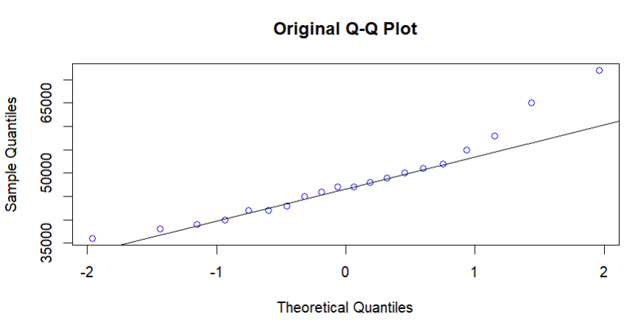
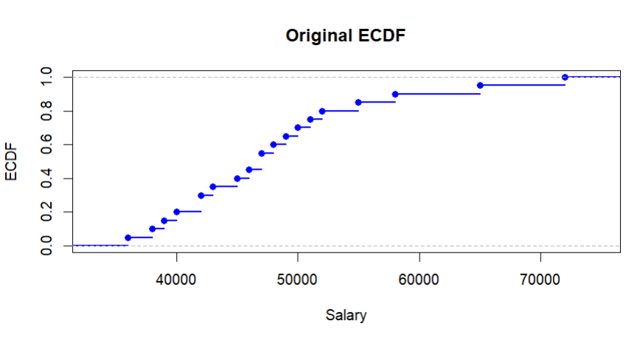

- Identify at least three visualization problems.
The original ECDF and Q-Q plots have several design problems:
- The axis labels are unclear, making it difficult to understand what the values represent.
- The scaling is inappropriate and does not provide an easy comparison of salary values.
- Excessive decoration makes the plots visually cluttered.

- Redesign the plots using appropriate scales, labels, reference lines, and minimal visual clutter.
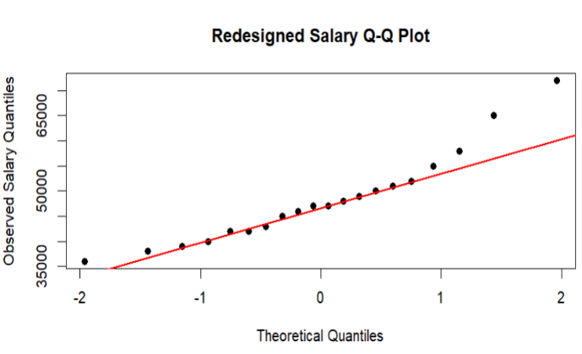
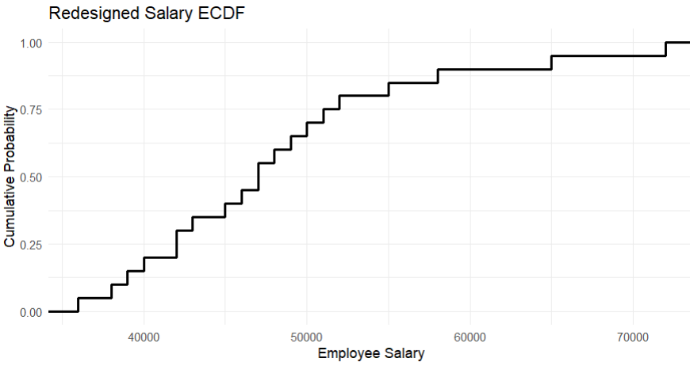

4. Explain how the redesigned plots improve interpretation of skewness, outliers, and normality.
A reference line in a Q-Q plot provides a visual standard for comparing the observed salary distribution with a theoretical normal distribution. The closer the points are to the line, the more closely the data follow normal behaviour.
5. State whether a Q-Q plot alone is sufficient to conclude that the data are normally distributed.
A Q-Q plot alone is not sufficient to conclude that the data are normally distributed. It should be interpreted together with other evidence such as summary statistics, distribution plots and appropriate statistical tests.
Question 2 – Critique and Redesign Many Distributions Using Bean Plots Dataset: Student_Scores.csv
Dataset:
Student_ID | Course | Score
S01 | Python | 62
S02 | Python | 68
S03 | Python | 74
S04 | Python | 81
S05 | Python | 88
S06 | Statistics | 58
S07 | Statistics | 64
S08 | Statistics | 71
S09 | Statistics | 79
S10 | Statistics | 86
S11 | DataViz | 55
S12 | DataViz | 61
S13 | DataViz | 69
S14 | DataViz | 77
S15 | DataViz | 84
S16 | AI | 65
S17 | AI | 72
S18 | AI | 78
S19 | AI | 87
S20 | AI | 93

R CODE:
library(ggplot2)
df <- data.frame(
Course=rep(c("Python","Statistics","DataViz","AI"),each=5),
Score=c(62,68,74,81,88,
58,64,71,79,86,
55,61,69,77,84,
65,72,78,87,93)
)
ggplot(df,aes(Course,Score)) +
geom_violin(fill="lightblue") +
geom_jitter(width=.08) +
labs(title="Student Score Distribution",
x="Course",y="Score") +
theme_minimal()
Assessment Task
A college report uses four separate histograms with different bin widths to compare course scores. The comparison is difficult because the scales and layouts are inconsistent.
1. Reproduce the problematic visualization using R.
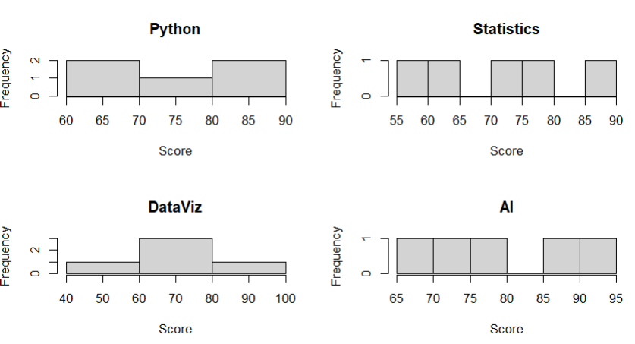
2. Critique the use of separate histograms, inconsistent scales, and bin widths.
The separate histograms make comparison difficult. Different bin widths change the appearance of the distributions, while inconsistent scales can make differences between courses misleading. A common scale and consistent bin width would provide a fairer comparison.
3. Redesign the visualization using bean plots or a suitable violin/density-based alternative.
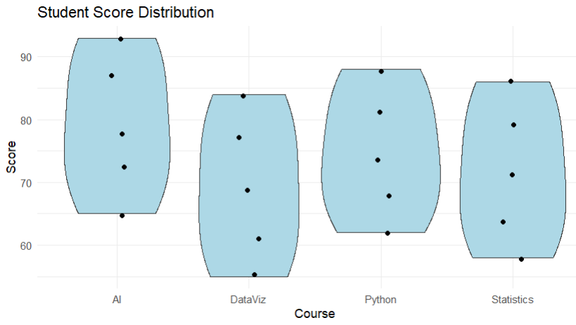
- Add an appropriate common scale and clear course labels.
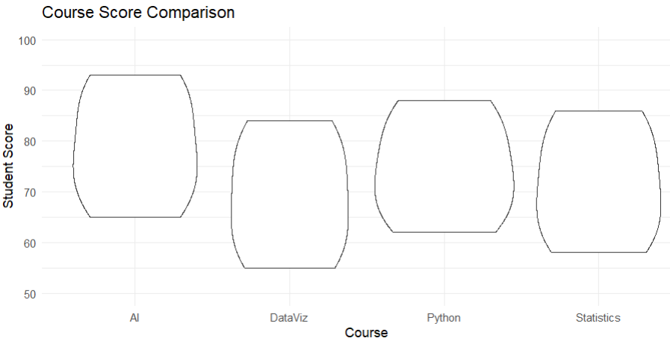
5. Explain which course has the highest concentration of scores and which course shows the greatest spread.
Highest Concentration and Greatest Spread
- Based on the given scores, AI has the highest concentration of relatively high scores, with values ranging from 65 to 93.
- The course with the greatest spread is also AI, with a range of:
- 93 − 65 = 28 marks.
- The use of a common-scale violin/bean-style visualization makes these differences easier to observe.

Question 3 – Critique and Redesign Proportion Visualizations
Dataset: Regional_Purchases.csv
Dataset:
Region | Product | Purchases
North | Laptop | 25
North | Phone | 35
North | Tablet | 20
South | Laptop | 30
South | Phone | 40
South | Tablet | 25
East | Laptop | 28
East | Phone | 32
East | Tablet | 18
West | Laptop | 22
West | Phone | 38
West | Tablet | 27

R CODE:
# Q3: Regional Purchase Proportions
library(ggplot2)

df <- data.frame(
Region=rep(c("North","South","East","West"),each=3),
Product=rep(c("Laptop","Phone","Tablet"),4),
Purchases=c(25,35,20,30,40,25,28,32,18,22,38,27)
)

# Original pie charts
par(mfrow=c(2,2))
for(r in unique(df$Region)){
x <- df[df$Region==r,]
pie(x$Purchases,labels=x$Product,
main=paste(r,"Purchases"))
}
par(mfrow=c(1,1))

# Side-by-side bars
ggplot(df,aes(Region,Purchases,fill=Product)) +
geom_col(position="dodge") +
labs(title="Regional Purchases - Side-by-Side Bars") +
theme_minimal()

# 100% stacked bars
ggplot(df,aes(Region,Purchases,fill=Product)) +
geom_col(position="fill") +
scale_y_continuous(labels=scales::percent) +
labs(title="Regional Purchase Proportions",
y="Percentage") +
theme_minimal()

cat("Problems: 3-D effects, different starting angles, inconsistent labels and difficult comparisons.\n")
cat("100% stacked bars are better for comparing regional proportions.\n")
cat("3-D effects and inconsistent scales can visually exaggerate differences.\n")
Assessment Task
A manager presents product proportions using four pie charts, one for each region. The charts use different starting angles, 3-D effects, and inconsistent labeling.
1. Create a representative version of the misleading visualization.
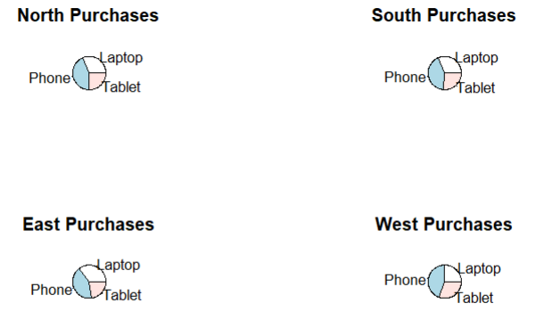
2. Identify at least four design problems.
The major problems are:
- 3-D effects can distort the apparent size of portions.
- Different starting angles make corresponding products difficult to compare.
- Inconsistent labeling reduces clarity.
- Separate pie charts make regional comparisons more difficult.

3. Redesign the analysis using side-by-side bars and a 100% stacked bar chart
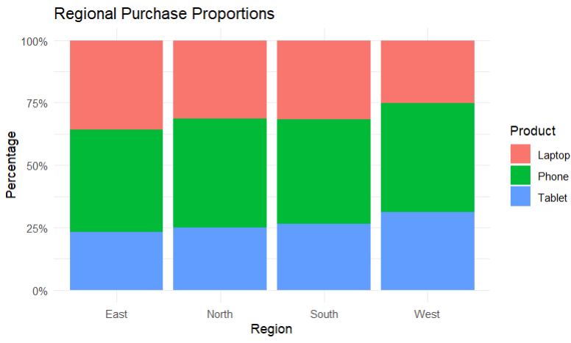
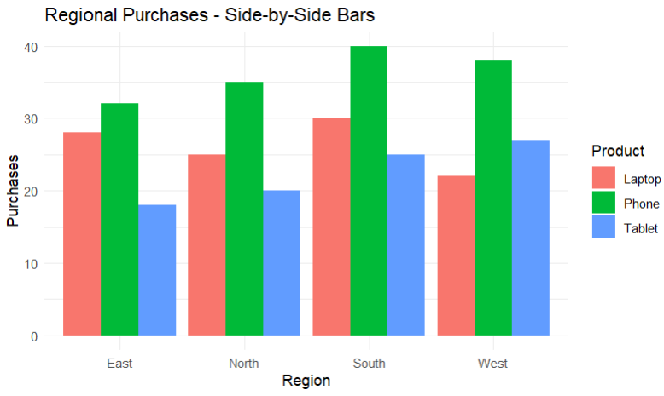
4. Compare the two redesigns and determine which is better for comparing regional proportions.
The 100% stacked bar chart is better for comparing regional proportions because every region has the same total length of 100%.
The side-by-side bar chart is better when comparing absolute purchase values, while the 100% stacked bar is better when comparing proportions.
- Explain why 3-D effects and inconsistent scales can lead to misleading conclusions.
- 3-D effects can make some slices appear larger or smaller because of perspective and depth.
- Similarly, inconsistent scales can exaggerate differences between regions. A viewer may incorrectly conclude that one product is significantly more popular simply because of the way the chart is constructed.

Question 4 – Critique and Redesign Nested Proportions
Dataset: Sales_Hierarchy.csv
Dataset:
Region | Category | Subcategory | Sales
North | Electronics | Laptop | 52000
North | Electronics | Phone | 38000
North | Furniture | Chair | 22000
North | Furniture | Desk | 18000
South | Electronics | Laptop | 46000
South | Electronics | Phone | 42000
South | Furniture | Chair | 25000
South | Furniture | Desk | 21000
East | Electronics | Laptop | 58000
East | Electronics | Phone | 35000
East | Furniture | Chair | 19000
East | Furniture | Desk | 23000
West | Electronics | Laptop | 49000
West | Electronics | Phone | 44000
West | Furniture | Chair | 27000
West | Furniture | Desk | 20000

R CODE:
# Q4: Nested Proportions
install.packages(c("treemap","sunburstR"), dependencies=TRUE)
library(treemap)
library(sunburstR)

df <- data.frame(
Region=rep(c("North","South","East","West"),each=4),
Category=rep(c("Electronics","Electronics",
"Furniture","Furniture"),4),
Subcategory=rep(c("Laptop","Phone","Chair","Desk"),4),
Sales=c(52000,38000,22000,18000,
46000,42000,25000,21000,
58000,35000,19000,23000,
49000,44000,27000,20000)
)

# Original treemap
treemap(df,
index=c("Region","Category","Subcategory"),
vSize="Sales",
title="Original Treemap")

# Redesigned treemap
treemap(df,
index=c("Region","Category","Subcategory"),
vSize="Sales",
type="index",
title="Redesigned Sales Treemap",
fontsize.labels=c(14,11,8))

# Sunburst
sb <- df[,c("Region","Category","Subcategory","Sales")]
sunburst(sb, count=TRUE)

# Largest values
cat("Largest Region: East\n")
cat("Largest Category: Electronics\n")
cat("Largest Subcategory: Laptop\n")
cat("Treemap is recommended for management because comparisons are faster.\n")
Assessment Task
An organization uses a treemap to communicate Region → Category → Subcategory sales. Small areas have unreadable labels and the color scale does not clearly communicate the hierarchy.
1. Create the original treemap.

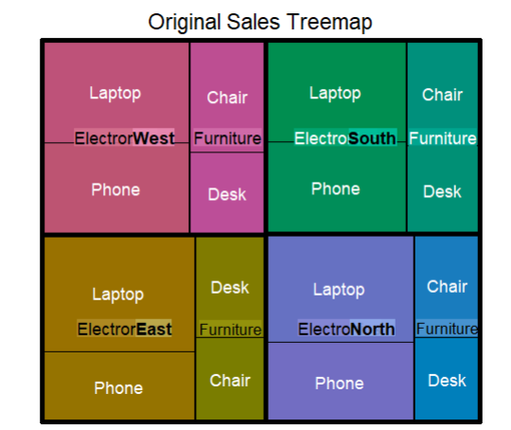

2. Critique the size, labeling, color, and hierarchy encodings.
The original treemap has several problems. Small sales values create very small rectangles, making their labels difficult to read. The colour scale does not clearly distinguish the different hierarchy levels. The hierarchy between region, category and subcategory is therefore not immediately clear. Excessive or unclear labels can also make the visualization difficult to interpret.
3. Redesign the visualization as an improved treemap.
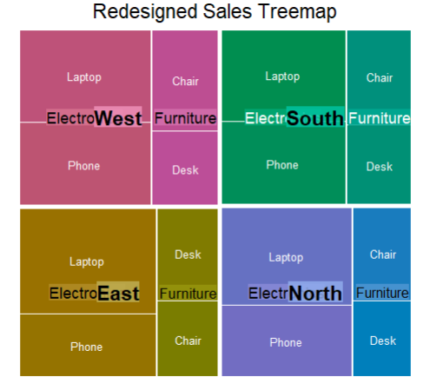
4. Create a sunburst alternative and compare it with the redesigned treemap.
- The treemap is generally easier for comparing the relative magnitude of sales because the area of each rectangle directly represents sales.
- The sunburst is useful for understanding the hierarchical structure because each ring represents another level of the hierarchy.
- For precise comparison of sales values, the treemap is easier to interpret.

5. Recommend one visualization for a management presentation and justify your choice.
For a management presentation, the redesigned treemap is recommended.
It provides a compact overview of sales and allows management to quickly identify the larger sales areas. Clear labels and improved colour encoding also make the hierarchy easier to understand.

Question 5 – Critique and Redesign Flow-Based Proportions
Dataset: Career_Flow.csv
Dataset:
Specialization | Internship | Placement_Sector | Students
Data Analytics | Yes | IT | 18
Data Analytics | Yes | Finance | 12
Data Analytics | No | IT | 8
AI | Yes | IT | 20
AI | Yes | Healthcare | 10
AI | No | IT | 6
Cyber Security | Yes | IT | 16
Cyber Security | Yes | Finance | 9
Cyber Security | No | Government | 7
Cloud Computing | Yes | IT | 15
Cloud Computing | Yes | Finance | 8
Cloud Computing | No | Government | 5

Assessment Task
A placement office uses a Sankey diagram to show Specialization → Internship → Placement Sector. The original chart uses excessively similar colors, unlabelled flows, and proportions that are difficult to compare.
1. Create a Sankey diagram representing the data.
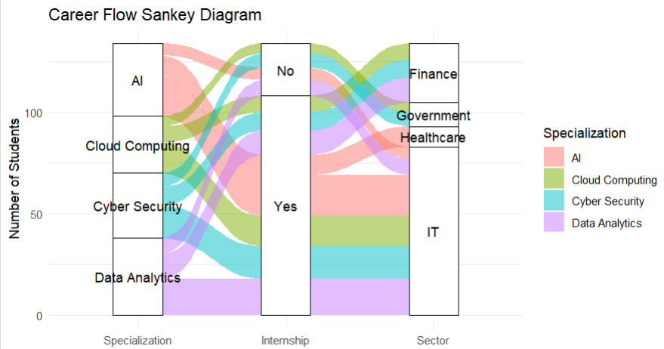
2. Identify at least four potential sources of confusion or misleading interpretation.
The original Sankey visualization can create several problems:
- Similar colours make different flows difficult to distinguish.
- Unlabelled flows make it difficult to determine the number of students.
- Similar-width flows can be difficult to compare.
- Excessive visual complexity can make the major flows difficult to identify.
- Poor visual hierarchy can cause minor flows to receive too much attention.

3. Redesign the Sankey diagram with meaningful labels, consistent flow representation, and an appropriate visual hierarchy.
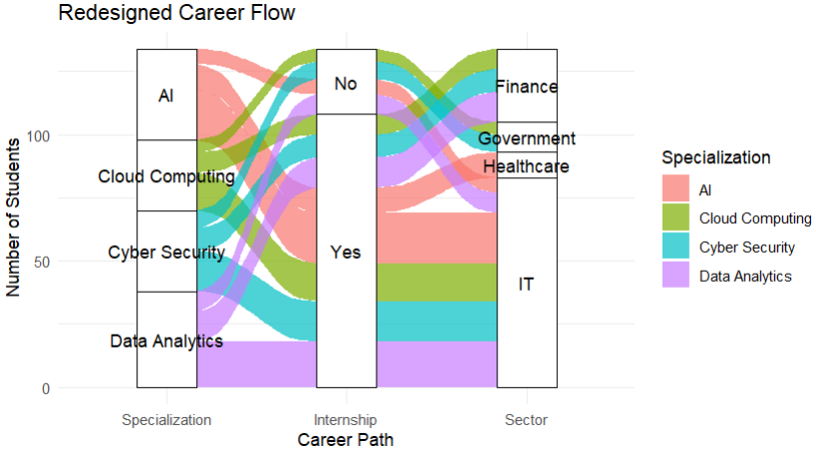
4. Create a parallel sets alternative and compare the two designs.
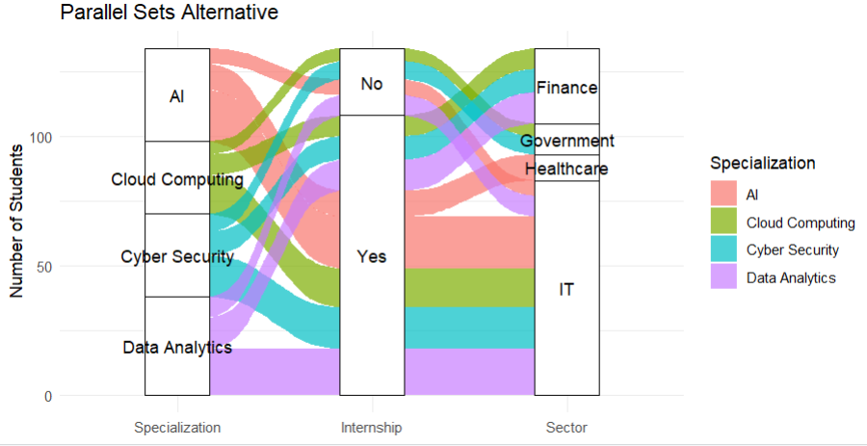
5. Explain which visualization better communicates the major student flows and why.
- The Sankey diagram is better for communicating the major student flows in this dataset.
- It clearly shows how students move from their specialization through internship status to placement sectors. The width of the flow provides an immediate visual indication of the number of students.
- The largest individual flow is:
- AI → Internship: Yes → IT = 20 students.

AT3 Expected Student Output
• R program/script used to create and redesign the visualization.
• Original/problematic visualization reproduced or clearly simulated.
• Written critique identifying visualization and design problems.
• Redesigned visualization with improved visual encodings.
• Brief justification explaining why the redesign is more accurate, readable, and less misleading. • Final recommendation where comparison of alternative visualizations is requested.
Suggested AT3 Assessment Rubric
Criterion | Weight
Identification of visualization problems | 20%
Correct R programming and data preparation | 20%
Quality and appropriateness of redesign | 30%
Justification and visualization critique | 20%
Clarity, labeling, and presentation | 10%

