EXP NO 5: CREATE A SIMPLE CLOUD SOFTWARE APPLICATION FOR
LIBRARY BOOK RESERVATION SYSTEM FOR SIMATS LIBRARY USING
ANY CLOUD SERVICE PROVIDER TO DEMONSTRATE SAAS
AIM:
To Create a simple cloud software application for Library book reservation system for
SIMATS library using any Cloud Service Provider to demonstrate SaaS
PROCEDURE:
step1: Go to zoho.com.
step 2: Log into the zoho.com.
step 3: Select one application step.
step4: Enter application name as library book reservation system.
step 5: Created new application as library book reservation system.
step 6: Select one form
step 7: The software has been created.
IMPLEMENTATION:
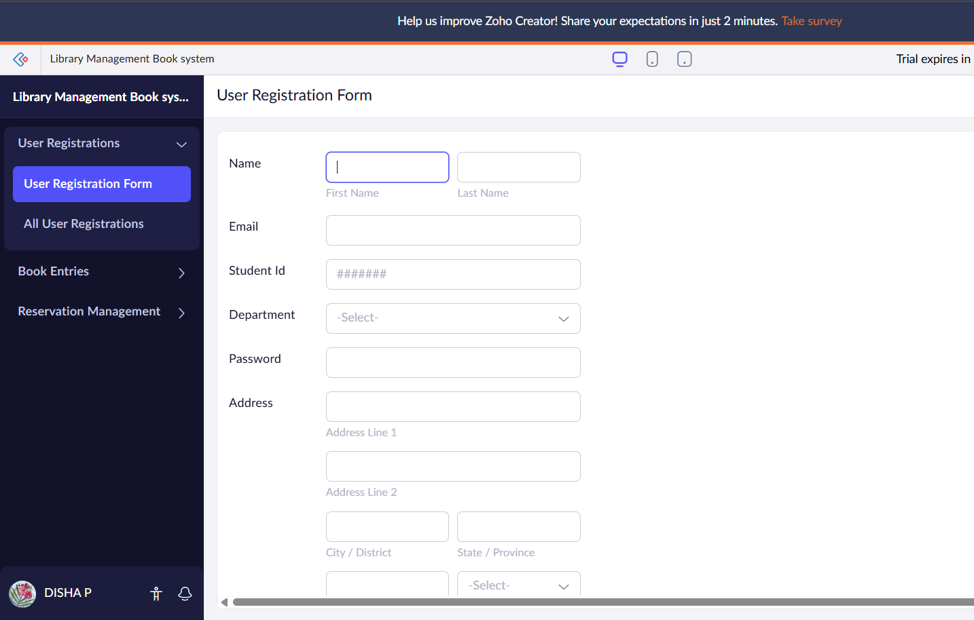
Here the form has been created to fill the details of User registration.

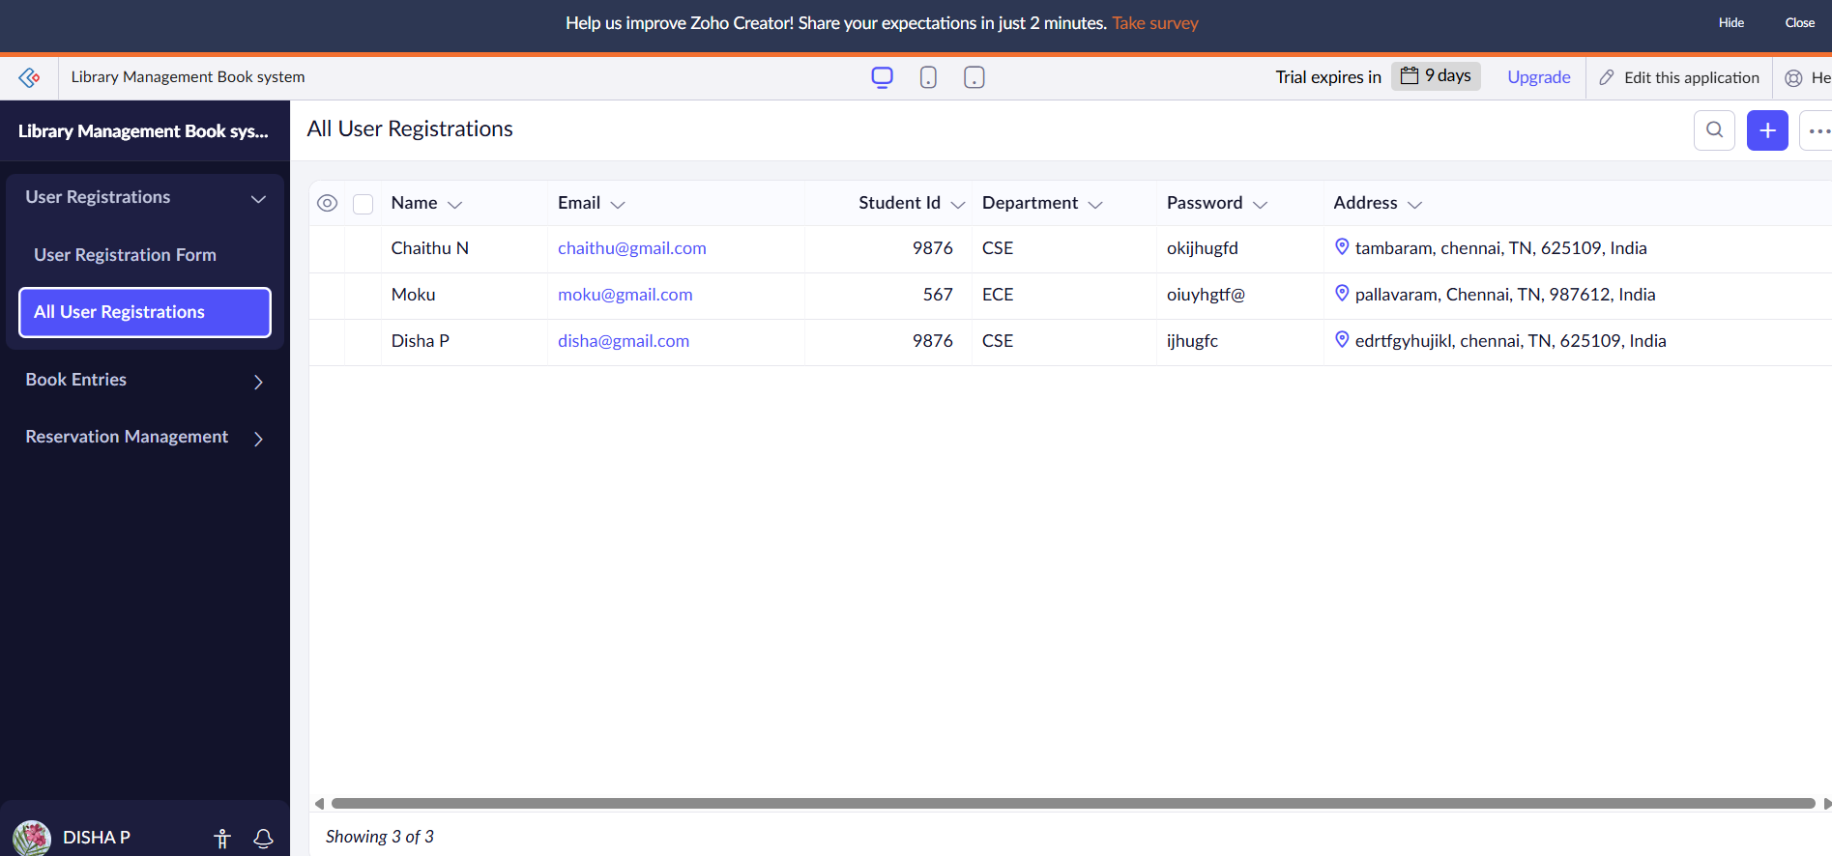
The details of user registration has been filled.

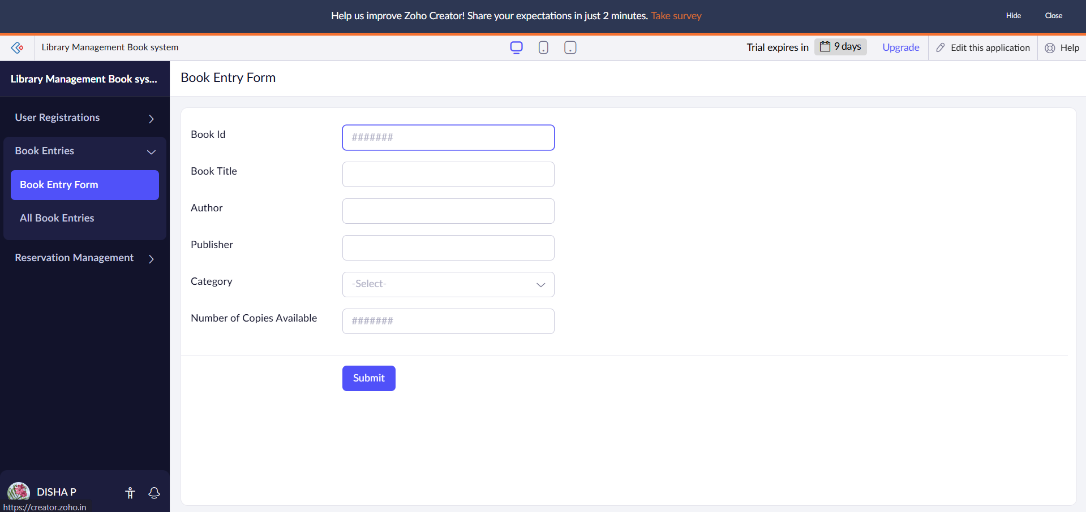
The details Book Entry has been created to fill.

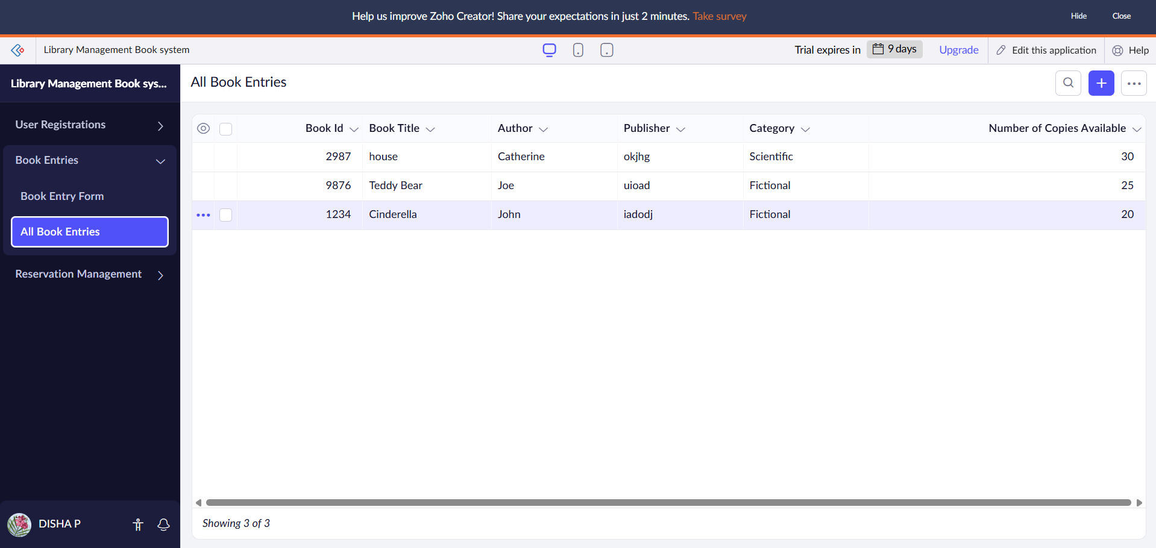
The details of the Books has been entered.

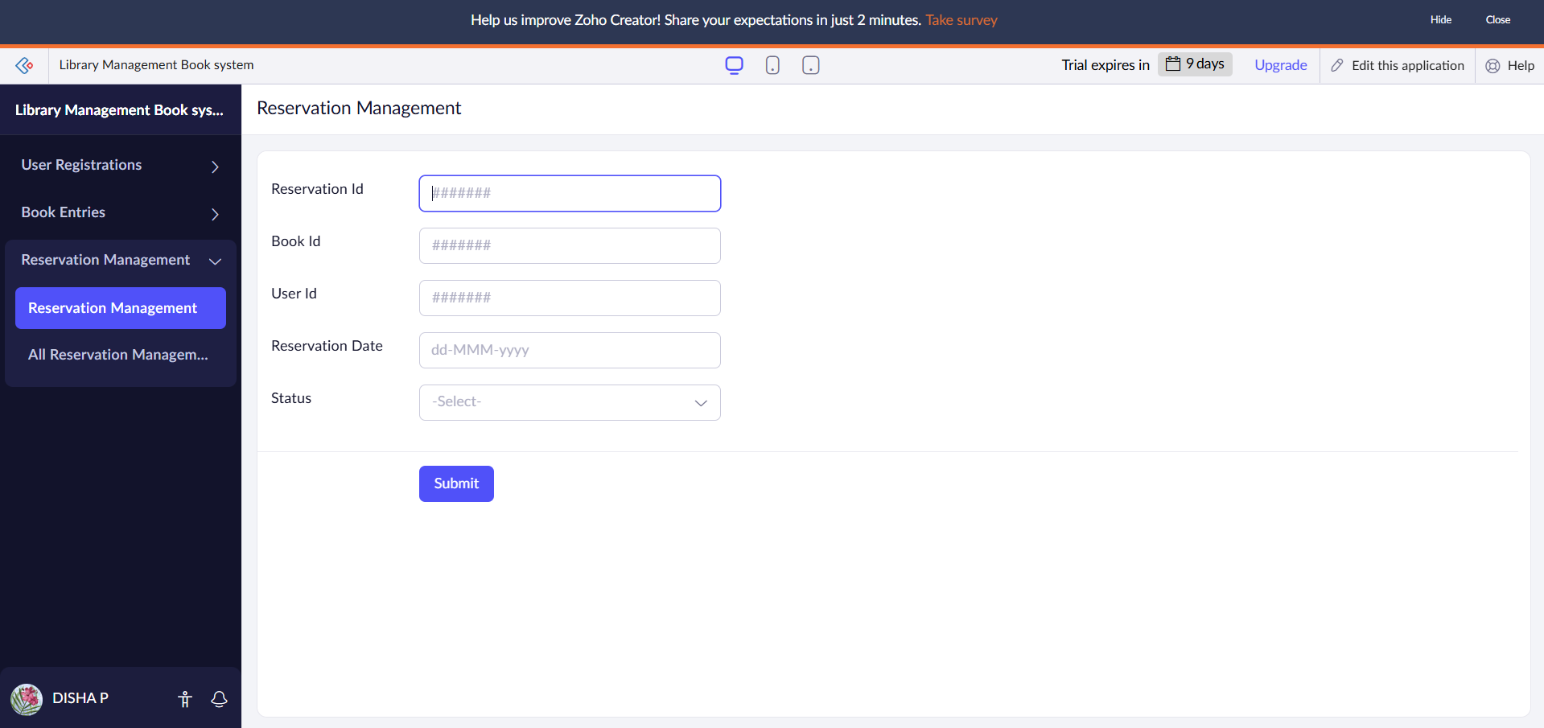

Here the details of Reservation form has been created.

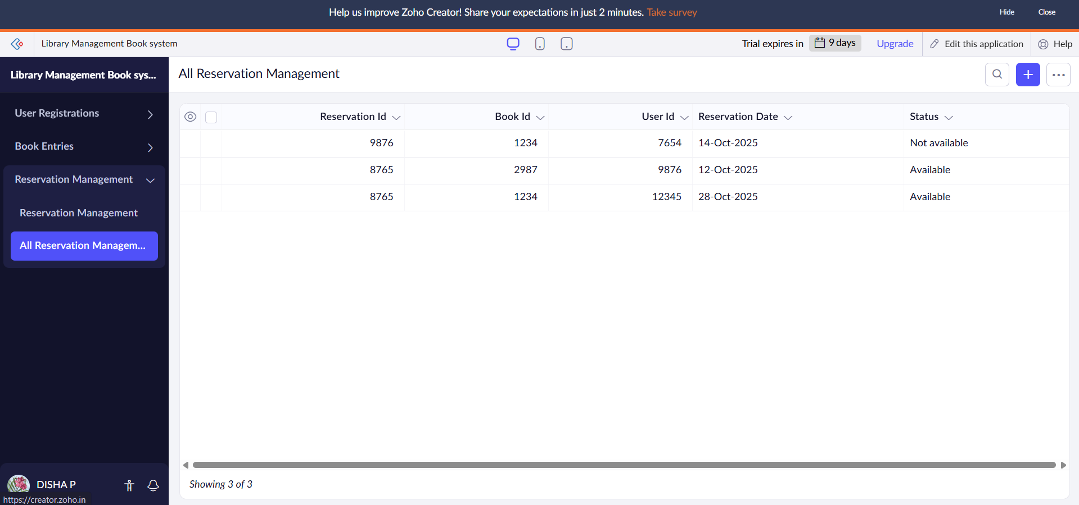
The details are filled here for the Reservation Management.

RESULT:
The Library Book Resevation System application was successfully created using Zoho Creator (Cloud SaaS platform) with the following forms:
- User_Registration
- Book_Entries
- Reservation_Management
This demonstrates SaaS, as customers can register, view available cars, make bookings, and check their booking status entirely online without installing any software.

