
AI-POWERED PERSONAL FINANCE MANAGEMENT AND BUDGET RECOMMENDATION SYSTEM USING DEEP LEARNING

A CAPSTONE PROJECT REPORT
A Capstone Project Report submitted in partial fulfilment of the requirements for the Course of
MLA0408 - DEEP LEARNING
to the award of the degree of
BACHELOR OF TECHNOLOGY IN
ARTIFICIAL INTELLIGENCE AND MACHINE LEARNING

Submitted by
Nalipi Reddy Rohith (192425115)
G.J.D.Sai Sharan (192425152)
K Giridhar (192425160)
S Syed Abuzar (192425384)

Under the Supervision of
Dr Sudhagar D

SIMATS ENGINEERING
Saveetha Institute of Medical and Technical Sciences
Chennai-602105

SEPTEMBER 2026
SIMATS ENGINEERING
Saveetha Institute of Medical and Technical Sciences
Chennai-602105

BONAFIDE CERTIFICATE

This is to certify that the Capstone Project entitled "AI-Powered Personal Finance Management and Budget Recommendation System Using Deep Learning" has been carried out by Nalipi Reddy Rohith (192425115), G.J.D.Sai Sharan (192425152), K Giridhar (192425160), S Syed Abuzar (192425384) under the supervision of Dr Sudhagar D and is submitted in partial fulfilment of the requirements for the current semester of the Computer Science and Engineering (B.Tech) program at Saveetha Institute of Medical and Technical Sciences, Chennai.

COURSE COORDINATOR  Dr G Bindu,  Professor,  Edge Computing,  SIMATS Engineering,  SIMATS, Chennai – 602105. | COURSE FACULTY  Dr. D. Sudhagar,  Professor,  Quantum Intelligence,  SIMATS Engineering,  SIMATS, Chennai – 602105.
SIMATS ENGINEERING
Saveetha Institute of Medical and Technical Sciences
Chennai-602105

DECLARATION

We, Nalipi Reddy Rohith (192425115), G.J.D.Sai Sharan (192425152), K Giridhar (192425160), S Syed Abuzar (192425384) of the B.Tech-AI&ML, SIMATS Engineering, Saveetha Institute of Medical and Technical Sciences, Chennai, hereby declare that the Capstone Project Work entitled "AI-Powered Personal Finance Management and Budget Recommendation System Using Deep Learning" is the result of our own bonafide efforts. To the best of our knowledge, the work presented herein is original, accurate, and has been carried out in accordance with the principles of engineering ethics and academic integrity. All sources, references, data, and other materials used in the project have been appropriately acknowledged. We further declare that the data, results, analysis, and findings presented in this report have not been fabricated, falsified, or manipulated. Any external tools, software, datasets, computational resources, or AI-assisted tools used during the project have been appropriately disclosed. We confirm that all applicable ethical, academic, institutional, and professional requirements have been duly followed throughout the planning, execution, analysis, and documentation of the project.

Place: Chennai
Date: 07/09/2026
Signature of the Students with Names
Nalipi Reddy Rohith (192425115)
G.J.D.Sai Sharan (192425152)
K Giridhar (192425160)
S Syed Abuzar (192425384)
SIMATS ENGINEERING
Saveetha Institute of Medical and Technical Sciences
Chennai-602105

Individual Contribution Statement

Student | Specific Responsibilities | Design & Development | Testing & Analysis | Report Contribution | Contribution (%)
Nalipi Reddy Rohith (192425115) | User and financial data management | Financial data collection and preprocessing | Data validation and testing | Chapters 1–2 | 25%
G.J.D.Sai Sharan (192425152) | Smart expense classification and analytics | Expense classification and spending analysis | Classification accuracy analysis | Chapter 3 | 25%
K Giridhar (192425160) | Budget prediction and recommendation | Deep learning-based budget prediction | Prediction and recommendation evaluation | Chapter 4 | 25%
S Syed Abuzar (192425384) | Financial health monitoring and reporting | Financial dashboard and report generation | Performance evaluation and result analysis | Chapter 5 | 25%
Total |  |  |  |  | 100%
ABSTRACT
Personal finance management is an important challenge for individuals who need to effectively control their income, expenses, savings, and financial goals. Traditional methods of financial management mainly depend on manual tracking and fixed budgeting rules, which may not adequately consider individual spending behavior. The proposed AI-Powered Personal Finance Management and Budget Recommendation System Using Deep Learning addresses this problem by providing an intelligent system for financial data management, expense analysis, budget prediction, personalized recommendations, and financial health monitoring.
The proposed system consists of four major modules. The first module manages user and financial data, including income, expenses, savings, investments, loans, and financial goals. The second module performs smart expense classification and analytics by categorizing transactions and identifying spending patterns. The third module uses deep learning techniques to analyze historical financial data, predict future expenses, and generate personalized budget recommendations. The fourth module monitors financial health by analyzing income, expenditure, savings, and budget adherence and generates financial reports and insights.
The system aims to help users understand their financial behavior, identify unnecessary spending, maintain appropriate budgets, improve savings, and make informed financial decisions. By combining financial data processing with deep learning-based prediction and recommendation, the proposed system provides a personalized approach to personal finance management.
Keywords: Personal Finance, Deep Learning, Budget Prediction, Expense Classification, Financial Analytics, Recommendation System
TABLE OF CONTENTS
Sl. No | Title | Page No
i | CERTIFICATE FROM THE SUPERVISOR | ii
ii | DECLARATION BY THE CANDIDATE | iii
iii | INDIVIDUAL CONTRIBUTION STATEMENT | iv
iv | ABSTRACT | v
v | LIST OF FIGURES | vi
vi | LIST OF TABLES | vii
vii | LIST OF ABBREVIATIONS | viii
1 | CHAPTER 1: Introduction
2 | CHAPTER 2: Literature Review
3 | CHAPTER 3: Engineering Design & Trade-offs, Sustainability, Ethics, Safety, Risk & Security
4 | CHAPTER 4: Implementation, Testing & Results, Project Management
5 | CHAPTER 5: Conclusion & Reflection
 | References
 | Appendices
LIST OF FIGURES
Figure No. | Figure Name | Page No.
Figure 1.1 | Overall System Architecture
Figure 1.2 | Proposed System Workflow
Figure 2.1 | Existing System Architecture
Figure 2.2 | Comparative Analysis of Existing and Proposed System
Figure 3.1 | Proposed System Design Architecture
Figure 3.2 | Data Flow Diagram
Figure 3.3 | Deep Learning-Based Budget Prediction Workflow
Figure 3.4 | System Risk and Security Workflow
Figure 4.1 | User & Financial Data Management Interface
Figure 4.2 | Smart Expense Classification & Analytics Dashboard
Figure 4.3 | Budget Prediction & Recommendation Output
Figure 4.4 | Financial Health Monitoring Dashboard
Figure 4.5 | Expense and Budget Visualization
Figure 4.6 | Testing and Performance Results
Figure 5.1 | Future Enhancement Workflow
LIST OF TABLES
Table No. | Table Name
Table 1.1 | Project Objectives
Table 2.1 | Comparative Analysis of Existing Solutions
Table 3.1 | Functional and Non-Functional Requirements
Table 3.2 | Design Specifications
Table 3.3 | Alternative Solutions Evaluation
Table 3.4 | Trade-Off Analysis
Table 3.5 | Sustainability, Ethics, Safety, Risk & Security Analysis
Table 3.6 | Risk Register
Table 4.1 | Software Tools and Technologies Used
Table 4.2 | Test Plan and Verification
Table 4.3 | Test Results
Table 4.4 | Comparison with Existing Solutions & Achievement of Objectives
Table 4.5 | Project Roles and Responsibilities
Table 4.6 | Project Budget
Table 5.1 | Future Work and Enhancements
LIST OF ABBREVIATIONS / SYMBOLS
Symbol | Description | Unit
AI | Artificial Intelligence | —
DL | Deep Learning | —
ML | Machine Learning | —
PM | Personal Finance Management | —
ECR | Expense-to-Income Ratio | %
SR | Savings Rate | %
CNN | Convolutional Neural Network | —
RNN | Recurrent Neural Network | —
LSTM | Long Short-Term Memory | —
RMSE | Root Mean Square Error | —
MAE | Mean Absolute Error | —
MSE | Mean Squared Error | —
₹ | Indian Rupee | INR
% | Percentage | %
INR | Indian Rupee | —
API | Application Programming Interface | —
UI | User Interface | —
DB | Database | —
CHAPTER 1
INTRODUCTION AND ENGINEERING PROBLEM

1.1Background
Personal finance management involves planning and controlling an individual's income, expenses, savings, investments, loans, and financial goals. With the increasing use of digital payments and online transactions, individuals generate a large amount of financial data. However, managing and analyzing this information manually can be difficult and time-consuming.
Many users are unable to accurately understand their spending patterns or determine how much they should allocate to different expense categories. Conventional budgeting approaches generally use fixed limits and do not sufficiently adapt to changes in individual financial behavior.
Artificial Intelligence and Deep Learning provide opportunities to analyze large amounts of financial data and identify complex patterns. By learning from historical income and expense information, an intelligent system can predict future spending and generate personalized budget recommendations.
The proposed project combines financial data management, expense classification, analytics, deep learning-based prediction, budget recommendation, and financial health monitoring into one integrated system.
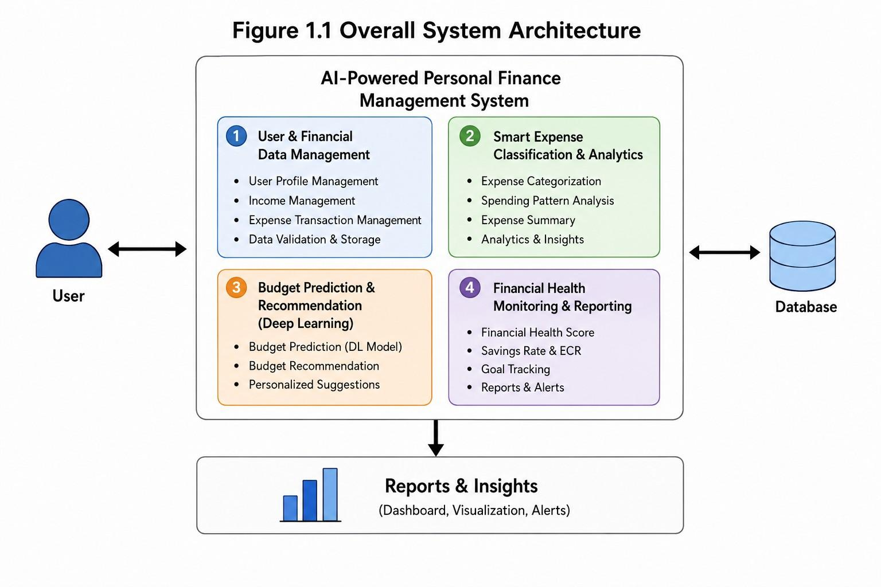

1.2 Need for the Project
The project is needed because:
- Manual financial tracking can be time-consuming.
- Users may have difficulty categorizing expenses.
- Unnecessary spending may not be easily identified.
- Fixed budgets may not match individual spending behavior.
- Future expenses are difficult to estimate manually.
- Users require personalized budget recommendations.
- Financial health needs continuous monitoring.
- Historical financial data can be utilized for intelligent predictions.
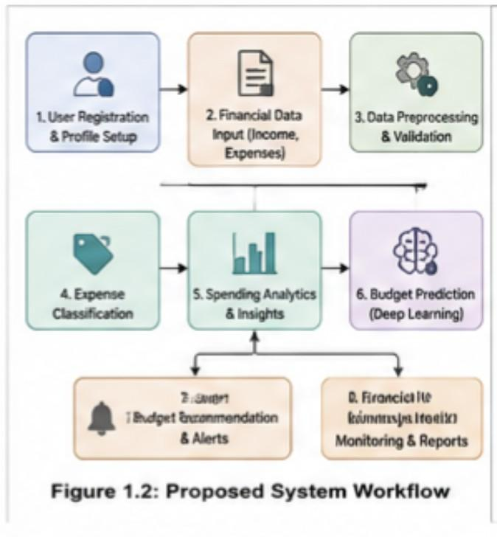

1.3 Problem Statement
To design and develop an AI-powered personal finance management system that collects and analyzes financial data, automatically classifies expenses, predicts future spending using deep learning, recommends personalized budgets, and monitors the user's financial health through analytical reports.

1.4 Project Aim
To develop an intelligent personal finance management and budget recommendation system using deep learning for analyzing financial behavior, predicting expenses, recommending suitable budgets, and improving users' financial planning.

1.5 Project Objectives
- To design a system for collecting and managing user financial information.
- To develop a mechanism for recording and categorizing income and expenses.
- To analyze user spending patterns and identify major expenditure categories.
- To implement smart expense classification and financial analytics.
- To develop a deep learning model for predicting future expenses.
- To generate personalized budget recommendations based on financial behavior.
- To monitor financial health using income, expenditure, and savings indicators.
- To generate financial reports and visualizations.
- To test and evaluate the performance of the proposed system.

1.6 Scope
The project includes:
- User financial data management
- Income and expense tracking
- Expense classification
- Spending analytics
- Historical financial data preprocessing
- Deep learning-based expense prediction
- Budget recommendation
- Savings-related recommendations
- Financial health monitoring
- Financial reports and visualizations
The system does not include direct execution of banking transactions or guaranteed investment returns.

1.7 Expected Engineering Outcome
The expected outcome is a software-based intelligent personal finance management prototype capable of collecting financial information, analyzing spending behavior, predicting future expenses, recommending budgets, and generating financial health reports.
CHAPTER 2
LITERATURE REVIEW AND EXISTING SOLUTIONS

2.1 Review Method
The review focuses on existing personal finance management applications, expense classification approaches, financial prediction techniques, machine learning and deep learning methods, and recommendation systems.
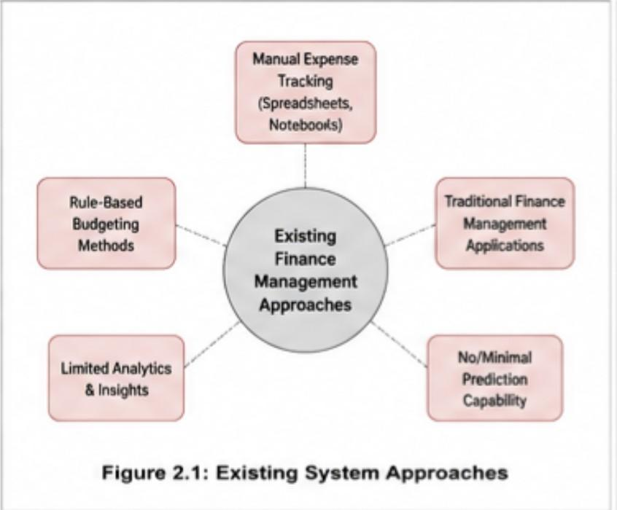

2.2 Review of Existing Work
Manual Financial Management
Traditional financial management uses notebooks, spreadsheets, or manually maintained records. These methods are simple but require continuous user effort and provide limited automated analysis.
Rule-Based Budgeting
Rule-based systems assign budgets using predefined financial rules. Although easy to implement, these systems may not sufficiently adapt to individual spending patterns.
Personal Finance Applications
Existing applications provide features such as expense recording, transaction categorization, budget tracking, and financial reports. However, the level of personalized prediction and recommendation varies between systems.
Machine Learning-Based Financial Analysis
Machine learning can analyze historical financial data and identify spending patterns. It can improve automated classification and prediction compared with purely rule-based systems.
Deep Learning-Based Prediction
Deep learning can learn complex patterns from historical financial information and can be applied to expense forecasting and personalized budget recommendation.
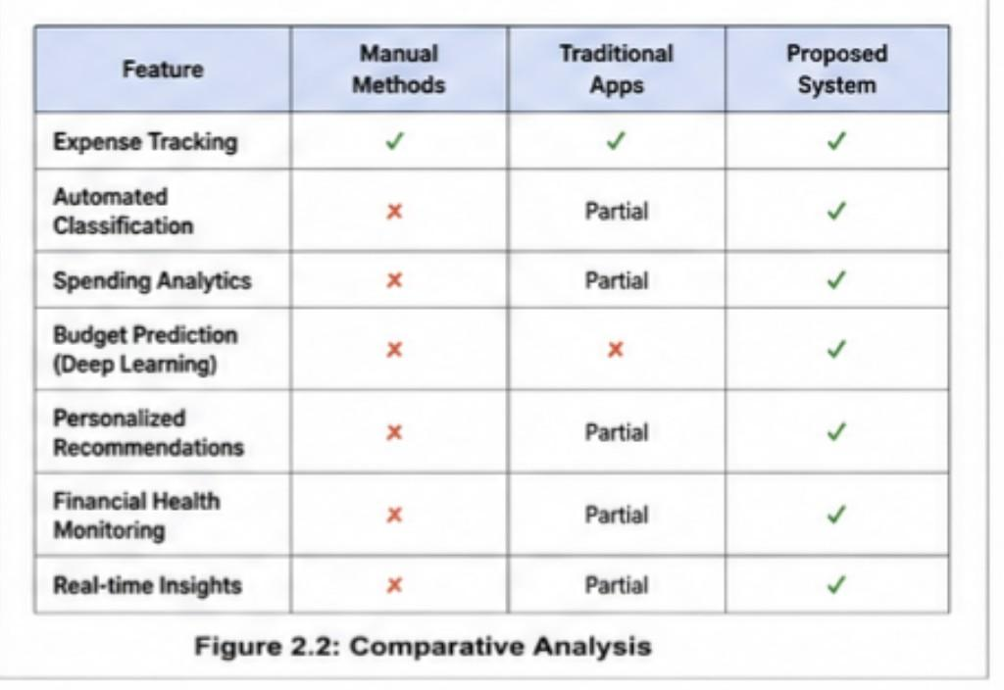

2.3 Comparative Analysis
Existing Approach | Advantages | Limitations | Relevance
Manual Tracking | Simple | Time-consuming | Basic financial recording
Traditional Finance Apps | Expense tracking and reports | Limited intelligent prediction | Financial management
Machine Learning | Pattern recognition | Requires quality data | Financial analysis
Proposed System | Integrated AI-based prediction and recommendation | Requires sufficient historical data | Complete solution

2.4 Research / Engineering Gap
Existing approaches often focus primarily on expense recording and historical reporting. A more integrated approach is required to combine financial data management, automatic expense classification, spending analytics, deep learning-based prediction, personalized budget recommendation, and financial health monitoring.

2.5 Proposed Contribution
The proposed system integrates four major modules into a single personal finance management framework:
Financial Data → Expense Classification → Deep Learning Prediction → Budget Recommendation → Financial Health Monitoring
CHAPTER 3
ENGINEERING DESIGN & TRADE-OFFS, SUSTAINABILITY, ETHICS, SAFETY, RISK & SECURITY

3.1 Requirements
Functional Requirements
Requirement | Description
User Management | Manage user financial profile
Income Management | Record and track income
Expense Management | Record and track expenses
Expense Classification | Categorize transactions
Financial Analytics | Analyze spending patterns
Expense Prediction | Predict future expenses
Budget Recommendation | Recommend category-wise budgets
Financial Health Monitoring | Monitor financial indicators
Reporting | Generate financial reports
Non-Functional Requirements
Requirement | Target
Usability | Simple and understandable interface
Reliability | Consistent financial calculations
Security | Protect financial information
Performance | Provide timely analysis
Scalability | Support increasing transaction records

3.2 Constraints & Applicable Standards
Standard / Requirement | Application
Data privacy principles | Protection of personal financial information
Secure software practices | Authentication and controlled access
Academic integrity requirements | Proper acknowledgement of datasets, software, and resources

3.3 Design Specifications
Parameter | Target
Financial data management | Structured
Expense classification | Automated
Financial prediction | Deep learning based
Budget recommendation | Personalized
Reporting | Category-wise and monthly
Security | Authorized access
Data processing | Clean and model-ready

3.4 Alternative Solutions & Evaluation
Alternative 1 — Manual System
Uses spreadsheets or manual records.
Alternative 2 — Rule-Based System
Uses predefined budgeting and classification rules.
Alternative 3 — AI-Based System
Uses financial data analytics and deep learning to predict spending and recommend budgets.
Criterion | Weight | Manual | Rule-Based | AI-Based
Performance | 25% | Medium | Medium | High
Personalization | 25% | Low | Medium | High
Automation | 20% | Low | Medium | High
Scalability | 15% | Low | Medium | High
Prediction | 15% | Low | Low | High
Selected: AI-Based System.

3.5 Selected Design & Detailed Design
Proposed Architecture
User → User & Financial Data Management → Data Preprocessing → Smart Expense Classification & Analytics → Deep Learning-Based Budget Prediction → Personalized Budget Recommendation → Financial Health Monitoring → Reports & Dashboard
The selected design integrates all four modules so that the output of one component becomes the input for the next stage.

3.6 Trade-Off Analysis
Design Decision | Alternative | Benefit | Disadvantage | Final Decision
Automated classification | Manual classification | Saves time | Requires trained model/rules | Automated
Deep learning prediction | Fixed rules | More adaptive | Requires data | Deep learning
Personalized budget | Fixed budget | User-specific | Requires user history | Personalized
Digital reporting | Manual reports | Faster analysis | Requires visualization system | Digital

3.7 Sustainability, Ethics, Safety, Risk & Security
Domain | Consideration | Impact
Sustainability | Digital financial records | Reduces paper-based records
Ethics | Responsible handling of financial information | Protect user privacy
Safety | Software-based system | No physical safety hazard
Security | Financial information protection | Authentication and controlled access
Risk Register
Risk | Likelihood | Severity | Mitigation
Incorrect user data | Medium | Medium | Input validation
Missing transaction data | Medium | Medium | Data preprocessing
Insufficient training data | Medium | High | Increase dataset size
Incorrect prediction | Medium | High | Model evaluation
Unauthorized access | Low | High | Authentication and access control
CHAPTER 4
IMPLEMENTATION, TESTING & RESULTS, PROJECT MANAGEMENT

4.1 Development Approach & Resources
The proposed system is developed using a modular architecture. Financial information is first collected and preprocessed before being analyzed by the expense classification module. The resulting financial patterns are provided to the deep learning prediction component, which estimates future expenditure and supports personalized budget recommendations. The final module monitors financial health and presents analytical reports to the user.
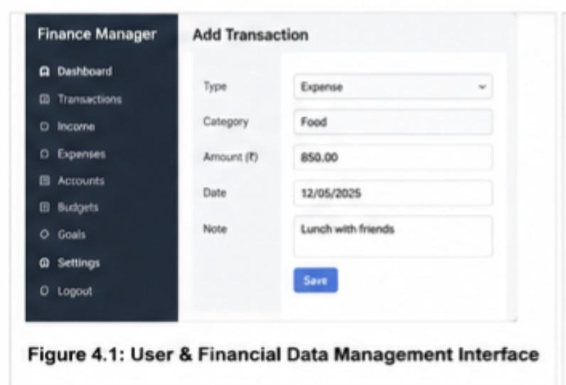

4.2 Software Implementation & Modern Tools Used
Tool / Software | Purpose
Python | System development
Pandas | Data preprocessing
NumPy | Numerical operations
Database | Financial data storage
Deep Learning Framework | Prediction model
Matplotlib / Visualization Tools | Financial charts
Web/Application Framework | User interface

4.3 Test Plan & Verification
Requirement | Test Method | Acceptance Criterion
User management | Enter user details | Data stored correctly
Expense recording | Add transactions | Transactions recorded
Classification | Test transactions | Correct category assigned
Analytics | Analyze transaction data | Spending summary generated
Prediction | Test historical data | Future expense predicted
Recommendation | Provide financial profile | Budget generated
Reporting | Generate report | Financial report displayed

4.4 Results
The proposed system is expected to provide:
- Structured user financial records.
- Automated expense categorization.
- Category-wise spending analysis.
- Identification of major spending areas.
- Future expense predictions.
- Personalized budget recommendations.
- Savings-related insights.
- Financial health indicators.
- Monthly and category-wise financial reports.
Important: For the final report, actual accuracy, prediction error, graphs, screenshots, and test values should be inserted here based on the implemented system. The sample specifically asks for measurements, graphs, and key data in the Results section.
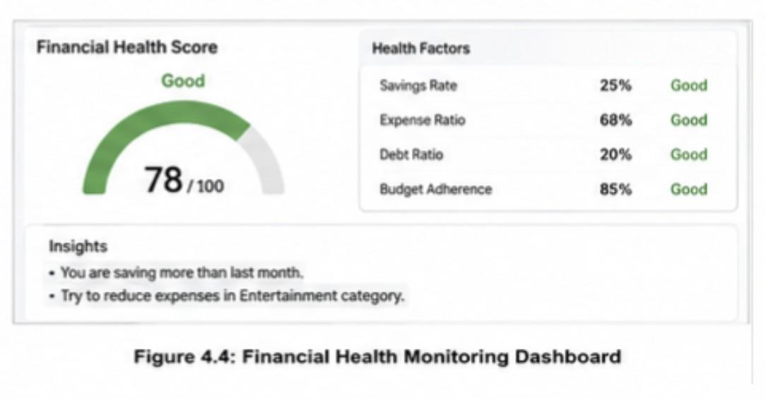

4.5 Data Analysis & Engineering Judgment
The performance of the system depends strongly on the quality and quantity of financial data. Proper preprocessing and expense classification are necessary before applying the deep learning model. Prediction performance should be evaluated using appropriate error or accuracy metrics. The recommendations should be evaluated based on whether the generated budget is consistent with the user's income, historical expenditure, and financial goals.

Comparison with Existing Solutions & Achievement of Objectives
Objective | Evidence | Achievement
Manage financial data | Financial data module | Fully/Partially
Classify expenses | Expense classification | Fully/Partially
Analyze spending | Analytics module | Fully/Partially
Predict expenses | Deep learning model | Fully/Partially
Recommend budgets | Recommendation module | Fully/Partially
Monitor financial health | Monitoring module | Fully/Partially
Generate reports | Reporting dashboard | Fully/Partially

4.6 Strengths & Limitations
Strengths
- AI-based financial analysis.
- Personalized budget recommendations.
- Automated expense classification.
- Future expense prediction.
- Financial health monitoring.
- Integrated financial reporting.
- Supports better financial decision-making.
Limitations
- Prediction performance depends on historical data quality.
- Insufficient transaction history may reduce prediction reliability.
- Incorrect user input can affect recommendations.
- The system provides decision-support recommendations and does not guarantee financial outcomes.

4.7 Project Planning, Roles & Budget
Project Modules
Module | Responsibility
Module 1 | User & Financial Data Management
Module 2 | Smart Expense Classification & Analytics
Module 3 | Deep Learning-Based Budget Prediction & Recommendation
Module 4 | Financial Health Monitoring & Reporting
Project Development Stages
Requirement Analysis → Data Collection → Data Preprocessing → Module Development → Deep Learning Model → Integration → Testing → Evaluation → Documentation
CHAPTER 5
CONCLUSION, FUTURE WORK AND REFLECTION

5.1 Conclusion
The AI-Powered Personal Finance Management and Budget Recommendation System Using Deep Learning provides an integrated approach to personal financial management. The system combines user and financial data management, smart expense classification, financial analytics, deep learning-based budget prediction, personalized recommendations, and financial health monitoring.
The system aims to overcome the limitations of traditional manual and fixed-rule budgeting methods by using historical financial behavior to generate more personalized insights. By analyzing income and expenditure patterns, the system can support users in controlling unnecessary spending, maintaining appropriate budgets, and improving their financial planning.
Overall, the proposed system demonstrates how Artificial Intelligence and Deep Learning can be applied to personal finance management to provide automated, data-driven, and personalized financial assistance.
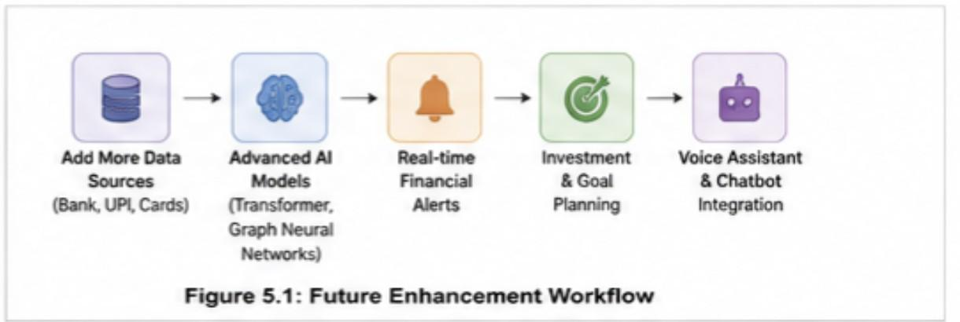

5.2 Future Work
Future enhancements can include:
- Real-time banking transaction integration.
- Automatic transaction collection.
- Advanced deep learning architectures.
- Improved expense classification.
- Real-time financial alerts.
- Investment planning features.
- Fraud and abnormal spending detection.
- Mobile application development.
- Multilingual support.
- Improved personalized financial goals.

5.3 Professional Learning & Individual Reflection
New Knowledge Acquired
- Personal financial data management
- Expense analytics
- Deep learning
- Financial prediction
- Recommendation systems
- Data visualization
- Software system integration
Engineering & Professional Skills Developed
- Problem analysis
- Data preprocessing
- Machine learning/deep learning implementation
- Software development
- Testing and validation
- Technical documentation
- Team collaboration
Individual Reflection
During the development of this project, I gained practical knowledge of applying Artificial Intelligence and Deep Learning to a real-world financial management problem. I learned how financial data can be collected, processed, analyzed, and transformed into useful predictions and recommendations. Working on the project also improved my understanding of software design, model evaluation, testing, and technical documentation. The project helped me understand the importance of data quality, system security, and user-specific requirements when developing an intelligent application.

REFERENCES
[1] Z. Yang, B. Biibosunov, S. Biibosunova, G. Kalmanbetova, and X. Wang, "A deep learning framework for automated transaction classification and budget prediction in personal financial management," Discover Artificial Intelligence, vol. 6, Art. no. 885, 2026.
[2] J. Kumar, A. Vishwakarma, N. Sainy, A. Kumar, and R. Aggarwal, "Personal Finance Manager with Predictive Analytics Using LSTM for Enhanced Financial Decision Making," International Journal of Research - GRANTHAALAYAH, vol. 12, no. 5, 2024.
[3] M. D'Souza, P. Bhalekar, P. Bhegade, and Y. Bhavsar, "A Multimodal Machine Learning Framework for Personal Financial Behavior Modeling and Analysis," SSRN, 2026.
[4] Saraswathy, "Personal Finance Dataset," Kaggle, 2026. [Online]. Available: Kaggle personal finance dataset.
[5] Shriyash Jagtap, "Indian Personal Finance and Spending Habits," Kaggle, 2025. [Online]. Available: Kaggle dataset.
[6] Mohammed Arfath R., "BudgetWise Personal Finance Dataset," Kaggle, 2026. [Online]. Available: Kaggle dataset.
[7] The pandas development team, "pandas Documentation," pandas, 2026. [Online]. Available: https://pandas.pydata.org/docs/
[8] TensorFlow, "TensorFlow Core Documentation," Google, 2026. [Online]. Available: https://www.tensorflow.org/guide
[9] TensorFlow, "TensorFlow Tutorials," Google, 2026. [Online]. Available: https://www.tensorflow.org/tutorials
APPENDICES

Appendix A – Detailed Calculations
This appendix contains the important calculations used in the proposed AI-Powered Personal Finance Management and Budget Recommendation System Using Deep Learning.
The calculations include:
- Total monthly income calculation.
- Total monthly expense calculation.
- Category-wise expense calculation.
- Monthly savings calculation.
- Savings rate calculation.
- Expense-to-income ratio.
- Budget allocation calculations.
- Prediction performance calculations such as MAE, MSE, RMSE, or other applicable evaluation metrics.

Appendix B – Engineering Drawings / Schematics
This appendix contains the system architecture and workflow diagrams of the proposed system. The major components represented in the system architecture are:
User Input → User & Financial Data Management → Data Preprocessing → Smart Expense Classification & Analytics → Deep Learning-Based Budget Prediction & Recommendation → Financial Health Monitoring & Reporting
The diagrams illustrate the interaction and data flow between the different modules of the proposed system.

Appendix C – Source Code / Code Repository Information
This appendix contains essential source-code excerpts used for implementing the proposed system. The important code components include:
- User and financial data management.
- Data preprocessing.
- Expense classification.
- Financial analytics.
- Deep learning model implementation.
- Budget prediction.
- Budget recommendation.
- Financial health calculation.
- Report and dashboard generation.
The complete source code may be maintained separately in the approved project repository. Only essential code excerpts and implementation details are included in the report.

Appendix D – Datasheets
This appendix contains the technical information related to the software tools, frameworks, libraries, datasets, and other resources used in the project.
The resources include:
- Python development environment.
- Pandas and NumPy libraries.
- Deep learning framework.
- Data visualization libraries.
- Database technologies.
- Financial dataset used for training and testing.
- Other open-source resources used during development.

Appendix E – Experimental / Raw Data
This appendix contains the raw and processed financial data used for developing and evaluating the system.
The data may include:
- User financial profiles.
- Monthly income records.
- Expense transactions.
- Expense categories.
- Savings information.
- Financial goals.
- Historical spending records.
- Training and testing datasets.
- Model prediction results.
- Budget recommendation outputs.

Appendix F – Ethics / Institutional Approval
The project involves handling financial information, which requires responsible data management and protection of user privacy.
The system is designed to:
- Avoid unnecessary collection of personal information.
- Protect financial information from unauthorized access.
- Use financial data only for the intended analysis.
- Maintain responsible handling of datasets.
- Clearly acknowledge external datasets, software, and AI-assisted resources used in the project.
Institutional approval documentation will be included if applicable.

Appendix G – Project Meeting / Progress Records
This appendix contains records of project discussions, development progress, review meetings, and milestones.
The records may include:
- Project topic selection.
- Requirement analysis.
- Module planning.
- Dataset selection.
- System design discussions.
- Development progress.
- Testing and evaluation discussions.
- Final project review.

Appendix H – User / Industry Feedback
This appendix contains feedback obtained from users or relevant stakeholders regarding the proposed personal finance management system.
The feedback may cover:
- Ease of entering financial information.
- Ease of understanding expense categories.
- Usefulness of spending analytics.
- Relevance of budget recommendations.
- Understanding of financial health reports.
- Suggestions for improving the system. This section will be included where applicable.

Appendix I – Publications / Patents / Competitions / Product Outcomes
This appendix contains details of any publications, patents, competitions, demonstrations, or product outcomes resulting from the project.
Where applicable, the following information may be included:
- Research paper publication.
- Conference presentation.
- Project competition participation.
- Prototype demonstration.
- Product or application outcome.
- Awards or recognitions.
If none are applicable, this appendix may be marked as Not Applicable.

Appendix J – Individual Contribution Evidence
This appendix provides evidence of the individual contribution of G J D Sai Sharan (192425152) and other team members, where applicable.
The evidence may include:
- Module development records.
- Source-code contributions.
- System design contributions.
- Testing and analysis records.
- Screenshots of implementation work.
- Report-writing contributions.
- Project meeting records.
- Module-wise responsibilities.

