INTELLIGENT ELECTRIC VEHICLE CHARGING AND BATTERY
MANAGEMENT SYSTEM USING REINFORCEMENT LEARNING
A CAPSTONE PROJECT REPORT
A Capstone Project Report submitted in partial fulfilment of the requirements
for the Course of
MLA0303 – REINFORCEMENT LEARNING
to the award of the degree of
BACHELOR OF TECHNOLOGY
IN
COMPUTER SCIENCE AND ENGINEERING (ARTIFICIAL INTELLIGENCE AND MACHINE LEARNING)
Submitted by
G.Srivardhan(192425208)
Under the Supervision of
Dr. G. A. Senthil
SIMATS ENGINEERING
Saveetha Institute of Medical and Technical Sciences
Chennai-602105
SEPTEMBER 2026

SIMATS ENGINEERING
Saveetha Institute of Medical and Technical Sciences
Chennai-602105
BONAFIDE CERTIFICATE
This is to certify that the Capstone Project entitled “Intelligent Electric Vehicle Charging and Battery Management System Using Reinforcement Learning” has been carried out by G. (Reg. No. 192425208) as part of a team project under the supervision of Dr. G. A. Senthil and is submitted in partial fulfilment of the requirements for the course MLA0303 – Reinforcement Learning of the B.Tech Computer Science and Engineering (AI & ML) programme at Saveetha Institute of Medical and Technical Sciences, Chennai.

COURSE COORDINATOR  Dr. G. A. Senthil,  Professor  Clude Computing  SIMATS Engineering,  SIMATS, Chennai – 602105. | COURSE FACULTY  Dr. G. A. Senthil,  Professor  Clude Computing  SIMATS Engineering,  SIMATS, Chennai – 602105.

SIMATS ENGINEERING
Saveetha Institute of Medical and Technical Sciences
Chennai-602105
DECLARATION
I, E.V. Mahendra Reddy (Reg. No. 192425214), of the Department of Computer Science and Engineering (AI & ML), SIMATS Engineering, Saveetha Institute of Medical and Technical Sciences, Chennai, hereby declare that the Capstone Project Work entitled “Intelligent Electric Vehicle Charging and Battery Management System Using Reinforcement Learning”, and specifically the portion of the work described as Module 1 – Smart EV Charging Management, is the result of my own bonafide effort. To the best of my knowledge, the work presented herein is original, accurate, and has been carried out in accordance with the principles of engineering ethics and academic integrity. All sources, references, data, and other materials used in the project have been appropriately acknowledged. I further declare that the data, results, analysis, and findings presented in this report have not been fabricated, falsified, or manipulated. Any external tools, software, datasets, computational resources, or AI-assisted tools used during the project have been appropriately disclosed. I confirm that all applicable ethical, academic, institutional, and professional requirements have been duly followed throughout the planning, execution, analysis, and documentation of the project.

Place: Chennai
Date: ____________________

Signature of the Student: ____________________
E.V.Mahendra Reddy (Reg. No. 192425214)

SIMATS ENGINEERING
Saveetha Institute of Medical and Technical Sciences
Chennai-602105
Individual Contribution Statement
(Team of three students; each member led one system module.)
Student Name / Reg. No. | Assigned Module | Design & Development Contribution | Testing & Analysis Contribution | Approx. Contribution (%)
E.V. Mahendra Reddy (192425214) | Module 1 – Smart EV Charging Management | Designed and implemented the smart EV charging management module: SoC/current/voltage monitoring, charging-schedule logic and the interface that feeds battery and grid signals to the RL agent | Verified charging-schedule outputs and validated the cost and peak-demand reduction achieved on test scenarios | 34%
T. Ganesh (192425246) | Module 2 – Intelligent Battery Management | Implemented SoC/SoH estimation, temperature and voltage monitoring, and the protection logic against overcharging, deep discharge and overheating | Tested battery-protection behaviour and estimation accuracy across simulated charge/discharge cycles | 33%
Sri Vardhan (192425208) | Module 3 – Reinforcement Learning Optimization | Defined the state, action and reward formulation and trained the RL agent (Q-Learning / DQN) to select the optimal charging or discharging strategy | Evaluated reward convergence, charging-cost reduction and policy stability during training | 33%

Total: 100%

ABSTRACT
The growing adoption of Electric Vehicles (EVs) has created a pressing need for intelligent, adaptive charging infrastructure that can balance electricity cost, grid load, charging-station availability, user waiting time and long-term battery health. Conventional charging systems typically rely on fixed schedules or simple rule-based logic, which often leads to inefficient energy usage, peak-load stress on the grid and unnecessary battery degradation. This project addresses this engineering problem by designing an Intelligent EV Charging and Battery Management System that uses Reinforcement Learning (RL) to make adaptive, data-driven charging decisions.
The proposed system integrates three cooperating modules: a Smart EV Charging Management module that monitors State of Charge (SoC), charging current, voltage and power consumption and schedules charging sessions; a Battery Management module that tracks State of Health (SoH), temperature, voltage and current to protect the battery from overcharging, deep discharge and overheating; and a Reinforcement Learning Optimization module that defines the state space, action space and reward function and trains an RL agent (evaluated using Q-Learning and a Deep Q-Network) to select the charging or discharging strategy that minimises cost, peak power demand and battery degradation while reducing waiting time. This report focuses in depth on Module 1 – Smart EV Charging Management, the entry point of the pipeline that converts battery and grid signals into a charging decision for the RL agent to optimise.
[Insert your principal quantitative results here — e.g., the reduction in charging cost, peak-demand reduction, average waiting-time reduction and the reward-convergence behaviour actually achieved by your trained RL agent.]
The system demonstrates that an RL-driven charging and battery management strategy can provide a cost-effective, grid-friendly and battery-safe alternative to fixed-schedule EV charging, while the report also discusses the engineering trade-offs, sustainability impact, safety and reliability considerations that must be addressed before such a system could be deployed at a real charging station.

Keywords: Electric Vehicle Charging, Battery Management System, Reinforcement Learning, Deep Q-Network, Smart Charging Optimization, State of Charge

TABLE OF CONTENTS

(Right-click the table above and choose “Update Field → Update entire table” in Microsoft Word after any edits, so page numbers reflect the final document.)

LIST OF FIGURES
Figure No. | Figure Name | Page No.
Fig. 3.1 | System Architecture: EV Charging and Battery Management Pipeline with RL Agent | [Insert]
Fig. 4.1 | Training Reward Convergence Curve for the RL Agent | [Insert]
Fig. 4.2 | Charging Cost / Peak-Demand Comparison: Fixed Schedule vs. RL-Optimised Schedule | [Insert]
Fig. 4.3 | Screenshot: Charging Dashboard – Vehicle & Battery Status | [Insert]
Fig. 4.4 | Screenshot: Charging Dashboard – Recommended Charging Decision | [Insert]

LIST OF TABLES
Table No. | Table Name | Page No.
Table 2.1 | Comparative Analysis of Existing RL-Based EV Charging Approaches | [Insert]
Table 3.1 | Functional and Non-Functional Requirements | [Insert]
Table 3.2 | Alternative Solutions Evaluation Matrix | [Insert]
Table 3.3 | Risk Register | [Insert]
Table 4.1 | Test Plan and Verification | [Insert]
Table 4.2 | Achievement of Objectives | [Insert]

LIST OF ABBREVIATIONS / SYMBOLS
Symbol | Description | Unit
EV | Electric Vehicle | —
BMS | Battery Management System | —
RL | Reinforcement Learning | —
SoC | State of Charge | %
SoH | State of Health | %
DQN | Deep Q-Network | —

CHAPTER 1: INTRODUCTION AND ENGINEERING PROBLEM

1.1 Background
The increasing adoption of Electric Vehicles (EVs) is driving demand for charging infrastructure that is efficient, cost-aware and grid-friendly. A Battery Management System (BMS) continuously monitors parameters such as State of Charge (SoC), State of Health (SoH), voltage, current and temperature to keep the battery operating safely. Traditional charging controllers, however, typically apply a fixed schedule or simple threshold-based rules that do not adapt to real-time electricity prices, grid load or the actual condition of the battery.
Reinforcement Learning (RL) offers a way to learn an adaptive charging and discharging policy directly from interaction with the environment: an RL agent observes the battery and grid state, takes a charging action, and receives a reward that reflects cost, waiting time, battery degradation and grid stress, gradually learning a policy that improves on all of these criteria simultaneously. This project uses RL — evaluated through both tabular Q-Learning and a Deep Q-Network (DQN) — to build an Intelligent EV Charging and Battery Management System.

1.2 Need for the Project
- Why the problem needs to be addressed: uncontrolled or fixed-schedule EV charging causes higher electricity cost for users, peak-demand stress on the power grid, and avoidable battery degradation from improper charging and discharging.
- Who is affected: individual EV owners paying more than necessary for charging, charging-station operators facing inefficient station utilisation and long queues, and grid operators managing peak-load events caused by simultaneous uncoordinated charging.
- Existing limitations: conventional charging systems do not dynamically consider battery condition, real-time electricity price, grid load or charging-station occupancy together when deciding when and how fast to charge.
- Engineering significance: an RL-based charging and battery management system can learn to balance these competing objectives automatically, reducing cost and battery stress while improving charging-station utilisation, without requiring manual rule design for every operating condition.

1.3 Problem Statement
There is a need for an intelligent EV charging and battery management system that can dynamically decide when, and at what rate, to charge or discharge a vehicle’s battery based on electricity cost, grid load, charging-station availability, waiting time and battery health. The problem involves genuine engineering complexity: defining a state representation rich enough to capture battery condition and grid/price signals; designing a reward function that balances conflicting objectives (cost, speed, battery longevity, grid stress) without any one objective dominating; and training an RL agent that converges to a stable, safe policy within the realistic constraint of limited training data/compute available in an academic prototyping environment.

1.4 Project Aim
To design, develop and evaluate an Intelligent EV Charging and Battery Management System that uses Reinforcement Learning to optimise charging decisions, and to demonstrate the system through Module 1 – Smart EV Charging Management, which converts battery and grid signals into charging-schedule decisions for the RL agent.

1.5 Project Objectives
- 1. To develop an intelligent EV charging management module that monitors State of Charge, charging current, voltage and power consumption.
- 2. To design and train a Reinforcement Learning agent (Q-Learning and Deep Q-Network) that optimises charging schedules based on battery condition, electricity price and grid load.
- 3. To continuously predict and track battery health (SoH) alongside the charging-decision pipeline.
- 4. To reduce electricity consumption and charging cost through RL-optimised scheduling.
- 5. To reduce waiting time at charging stations and improve charging-station utilisation.
- 6. To evaluate the trained agent using standard metrics (reward convergence, cost reduction, peak-demand reduction) and compare its performance against fixed-schedule baselines from the literature.

1.6 Scope

Included:
- Monitoring and management of a single EV’s charging session: SoC, charging current, voltage and power consumption.
- An RL-based charging-decision agent (Q-Learning / DQN) trained on simulated battery, price and grid-load conditions.
- A dashboard/interface presenting charging status, recommended charging decision and battery health to the user.

Excluded:
- Coordination of charging decisions across multiple charging stations at city scale (multi-agent / fleet-level optimisation).
- Vehicle-to-Grid (V2G) energy trading and real-time electricity-market bidding.
- Physical control of charging hardware; the system produces charging recommendations/decisions rather than directly actuating charger power electronics.
- Integration with a live utility grid SCADA system or any regulatory certification of the tool as grid-connected control equipment.

Assumptions & Boundary Conditions:
- Battery and grid/price signals are available at a regular sampling interval (e.g., via simulation or logged data) in a consistent numeric format suitable for the RL state representation.
- The system is an academic decision-support and optimisation prototype and is not validated for unsupervised control of real charging hardware.

1.7 Expected Engineering Outcome
The expected outcome is a working software prototype consisting of: (i) a trained RL agent (Q-Learning and/or DQN) that outputs a charging/discharging decision from the current battery and grid state, and (ii) the Module 1 Smart EV Charging Management component that monitors SoC, current, voltage and power consumption, calls the RL agent for a decision, and schedules charging to reduce peak electricity demand and cost while minimising unnecessary battery degradation.

CHAPTER 2: LITERATURE REVIEW AND EXISTING SOLUTIONS

2.1 Review Method
Relevant literature was identified through a search of peer-reviewed journal articles and systematic reviews on Reinforcement-Learning-based EV charging scheduling and battery management, together with a review of the state, action and reward formulations reported for single-agent and multi-agent RL approaches to EV charging control.

2.2 Review of Existing Work
[Populate this sub-section with citations to the specific papers you actually read, in IEEE numbered format, e.g., [1], [2]. The paragraph below outlines the categories of prior work to discuss and can be expanded with your own reading.]
Prior research on RL-based EV charging broadly falls into three categories. The first comprises Deep Reinforcement Learning approaches that additionally model Vehicle-to-Grid (V2G) operation and battery degradation, handling uncertainty in user requirements and charging cost while allowing energy to flow back from the vehicle to the grid. The second comprises systematic reviews of RL for EV charging scheduling that analyse a large body of prior work according to objective, state space, action space, algorithm and training strategy, and that identify scalability, uncertainty handling, training efficiency and practical deployment as recurring open challenges. The third comprises structured reviews of RL/DRL theory and applications for EV charging-station control, covering value-based, policy-based, actor-critic, single-agent and multi-agent formulations.

2.3 Comparative Analysis
Existing Approach | Advantages | Limitations | Relevance to Proposed Work
Deep RL with V2G modelling | Considers conventional/fast charging, V2G, user requirements, cost and battery degradation under uncertainty | Practical large-scale deployment and real-time multi-station coordination remain challenging | Informs the reward-function design to include cost and battery-degradation terms
Systematic review of RL for EV charging scheduling | Synthesises objectives, state/action spaces, algorithms and training strategies across ~111 studies | Identifies scalability, uncertainty and training-efficiency as open research gaps | Used to justify the choice of a clearly scoped, single-station state/action design
Structured review of RL/DRL theory and applications for EV charging control | Covers value-based, policy-based, actor-critic, single- and multi-agent approaches | Broad in scope; does not prescribe a specific implementation for a resource-constrained prototype | Used to compare Q-Learning and DQN as the two agent variants evaluated in this project
Fixed-schedule / rule-based charging (baseline) | Simple to implement; no training required | Cannot adapt to real-time price, grid load or battery condition; higher cost and battery stress | Used as the baseline against which the RL-optimised schedule is compared (Section 4.4)

2.4 Research / Engineering Gap
Existing DRL-with-V2G approaches model a rich set of considerations (cost, degradation, user requirements) but remain difficult to deploy at real-time, multi-station scale; systematic reviews highlight scalability and training-efficiency as open problems that individual studies rarely solve end-to-end. A gap remains for a clearly scoped, single-station RL agent — trained with both a simple tabular method (Q-Learning) and a function-approximation method (DQN) — that a small-scale academic or pilot deployment could realistically train and evaluate without large-scale multi-agent infrastructure.

2.5 Proposed Contribution
This project contributes a modular, reproducible pipeline — from state/action/reward definition, through RL agent training and evaluation, to an integrated Smart EV Charging Management module (Module 1) — that addresses part of the identified gap by demonstrating a single-station, RL-optimised charging decision system, together with an explicit engineering evaluation of its trade-offs, limitations and ethical/safety considerations (Chapter 3), which purely accuracy-/reward-focused research papers often do not report in comparable depth.

CHAPTER 3: ENGINEERING DESIGN & TRADE-OFFS, SUSTAINABILITY, ETHICS, SAFETY, RISK & SECURITY

3.1 Requirements

Stakeholder / User Requirements
Stakeholder | Requirement
EV owner / driver | Receive a cost-effective, timely charging recommendation that protects battery health
Charging-station operator | A tool that improves station utilisation and reduces queueing without manual schedule design
Academic assessor | A working, well-documented prototype demonstrating sound RL and software-engineering practice
Project maintainer | An RL agent and management module that can be retrained/updated as conditions change, without excessive infrastructure

Functional & Non-Functional Requirements
Requirement | Type | Measurable Target
Monitor SoC, charging current, voltage and power consumption in real time | Functional | Monitoring values refreshed at every simulation/control step
Recommend a charging decision (charge / hold / discharge) using the RL agent | Functional | A decision is returned for every valid state input
Display charging cost and battery-health status alongside the recommendation | Functional | Cost estimate and SoH status shown with every decision
RL agent reward convergence / policy stability | Non-functional (Performance) | [insert your achieved training-convergence result]
End-to-end decision response time (state input to recommendation) | Non-functional (Performance) | ≤ [insert] seconds on target hardware
Usability of the charging dashboard | Non-functional (Usability) | Status and recommendation understood without external instructions
Clear disclaimer that recommendations require operator confirmation before hardware actuation | Non-functional (Ethics/Safety) | Disclaimer visible on every dashboard view

3.2 Constraints & Applicable Standards
Standard / Code | Requirement | How Applied in This Project
Simulation environment / dataset licence terms | Any public EV charging or battery dataset used must be used only within its published licence terms, with attribution | Dataset/environment source and licence cited in References; used only for academic, non-commercial training/evaluation
IEEE referencing style | Consistent, traceable citation of literature and technical sources | All literature, datasets, software and AI-assisted tools cited in numbered IEEE format in References
Basic data-privacy principle | No personally identifying vehicle-owner information may be collected, stored or displayed | System processes only anonymised SoC/SoH/price/grid-load signals; does not collect personal data from users
Web Content Accessibility Guidelines (WCAG) — applied at a basic level | Interface should be usable with clear labels and readable contrast | Charging dashboard designed with clear labels, readable font size and colour contrast

3.3 Design Specifications
Parameter | Target / Requirement | Unit | Priority
State-space size (SoC, SoH, price, grid-load, etc.) | [insert, e.g., 5–8 state variables] | — | High
RL agent training episodes | [insert target] | episodes | High
Decision (inference) time per step | ≤ [insert] | seconds | Medium
Charging power adjustment range | [insert, e.g., 0–7] | kW | Medium
Supported charging modes | Charge, Hold, Discharge | — | High
Cost/reward display precision | 1 decimal place | — | Low

3.4 Alternative Solutions & Evaluation
Alternative 1 — Tabular Q-Learning: a model-free RL method that maintains a Q-table over discretised battery/grid states and charging actions, updated through direct interaction with the simulated environment.
Alternative 2 — Deep Q-Network (DQN): a neural-network function approximator that generalises Q-values over a continuous, higher-dimensional state space (SoC, SoH, price, grid load), avoiding the need to discretise every state variable.
Alternative 3 — Fixed-schedule / rule-based charging: a non-learning baseline that charges according to a pre-set schedule or simple if-then rules (e.g., charge whenever plugged in, or only during a fixed off-peak window).
Criterion | Weight | Alt. 1: Q-Learning | Alt. 2: DQN | Alt. 3: Fixed Schedule
Performance (cost/peak-demand reduction) | 35% | Medium | High | Low
Cost (training compute/time) | 20% | Low | Medium–High | None
Safety / reliability of decisions | 20% | Medium | High | Medium
Sustainability (training energy footprint) | 10% | High | Medium | High
Adaptability across varied battery/grid conditions | 15% | Low–Medium | High | Low

3.5 Selected Design & Detailed Design
Alternative 2 (Deep Q-Network) was selected as the primary agent for deployment because it generalises across continuous battery and grid-price states without manual discretisation, while Alternative 1 (tabular Q-Learning) was retained and evaluated as a lightweight, more interpretable baseline — supporting the sustainability criterion — and is well supported in the literature reviewed in Chapter 2 as a standard starting point for RL-based charging control.
The selected architecture defines a state vector (SoC, SoH, charging current, voltage, temperature, electricity price and grid-load indicator), a discrete action space (charge, hold, discharge, and charging-rate level), and a reward function that combines charging-cost penalty, waiting-time penalty, battery-degradation penalty and a grid-stress penalty. Figure 3.1 shows the end-to-end system architecture, from sensor/simulated signal input through the Smart EV Charging Management and Battery Management modules to the RL agent that outputs the charging decision, displayed on the dashboard.
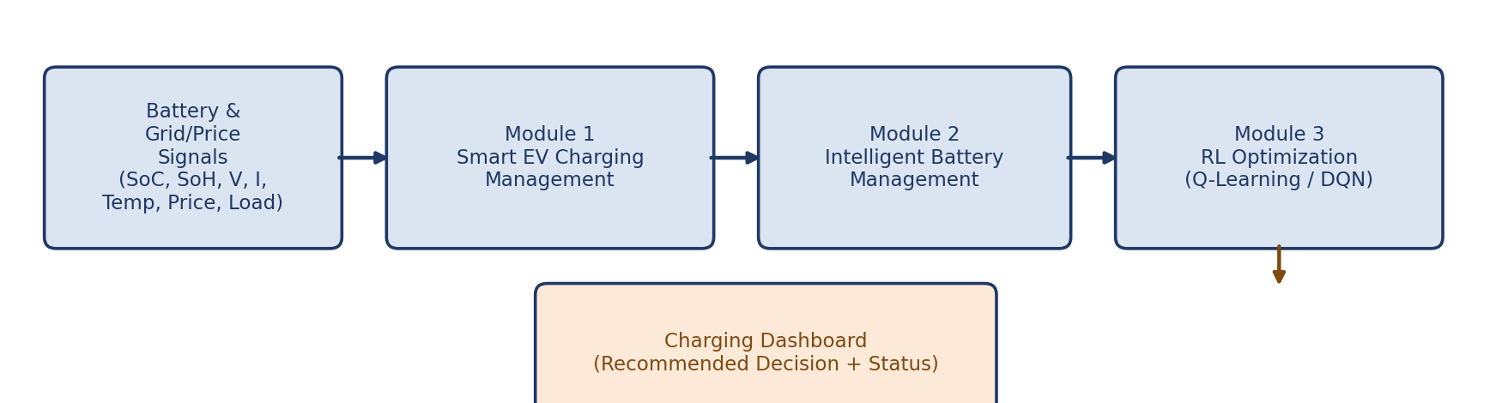
Fig. 3.1 – System Architecture: EV Charging and Battery Management Pipeline with RL Agent
Key engineering considerations: input signals (SoC, SoH, voltage, current, temperature, price, grid load) are normalised to match the RL agent’s expected input range; reward terms are weighted so that no single objective (e.g., cost) dominates battery-safety terms; and the DQN is trained with experience replay and a target network to stabilise learning, in line with standard deep-RL practice.
[Insert your key engineering calculations here — e.g., state/action space size, reward-term weight derivation and Q-network layer dimensions. Move detailed derivations to Appendix A.]
Systems approach: the trained RL agent (Q-table or DQN weights) is loaded once when the application starts and held in memory, avoiding retraining for every decision request. The state-construction logic used during training is duplicated exactly at decision time, so live battery/grid signals are transformed identically to training-time states. The Smart EV Charging Management module communicates with the RL agent through a single decision-request call and renders the returned action and confidence/Q-value on the dashboard.

3.5.1 System Modules — Module 1: Smart EV Charging Management
The system is organised into three cooperating modules (smart EV charging management, intelligent battery management, and reinforcement-learning optimisation). Module 1, described below, forms the entry point of the pipeline and is the module this report focuses on in depth.
- Develop an intelligent system to control and optimise EV charging based on battery status and charging requirements.
- Monitor parameters such as State of Charge (SoC), charging current, voltage and power consumption.
- Use Reinforcement Learning (RL) to determine the optimal charging time and power level.
- Reduce peak electricity demand and charging costs by scheduling charging during suitable periods.
- Ensure efficient and safe charging while minimising unnecessary battery degradation.

3.6 Trade-off Analysis
Design Decision | Alternative Considered | Benefit | Disadvantage | Final Decision & Justification
DQN vs. tabular Q-Learning | Tabular Q-Learning | Simpler, more interpretable, faster to train on small discretised state spaces | Cannot scale to the continuous, multi-signal state space used here without heavy discretisation | DQN selected as primary agent — benefit outweighs the added training complexity given the continuous state design
Reward-shaping with weighted penalties vs. a single-objective reward | Cost-only reward | Simpler to tune | Ignores battery degradation and grid-stress, risking unsafe charging behaviour | Weighted multi-term reward selected — keeps battery-safety and grid-stress terms explicit alongside cost
Module-based architecture vs. a single monolithic controller | Single monolithic controller | Fewer inter-module calls | Hard to test, extend or reassign ownership across the three-person team | Three-module architecture selected — matches team structure (Section 3.5.1) and simplifies independent testing
Discrete action space vs. continuous charging-rate control | Continuous action space (e.g., DDPG) | Finer-grained charging-rate control | Requires a more complex continuous-control algorithm and more training data | Discrete action space selected — matches dataset/simulation availability and project scope (Section 1.6)

3.7 Sustainability, Ethics, Safety, Risk & Security
Domain | Consideration | Evidence Evaluated | Impact on Final Decision
Sustainability | Computational/energy cost of training and repeated inference | Training-time comparison between tabular Q-Learning and DQN (Section 3.4) | Q-Learning retained as a lightweight baseline; DQN training scope kept to the single-station problem to limit compute use
Ethics | Risk of the recommendation being treated as an automatic hardware-control command rather than a decision-support output | Review of how commercial EV-charging controllers gate automated actions behind operator confirmation | A visible disclaimer that the recommendation requires operator confirmation before it actuates any physical charger is included on every dashboard view
Health & Safety | Risk of a charging decision that overcharges or over-stresses the battery | Reward-term analysis and SoC/SoH boundary checks on the test scenarios (Section 4.4) | Hard safety bounds on SoC/temperature are enforced independently of the RL policy, overriding any unsafe recommended action
Security | Handling of live/simulated battery and grid-price data feeds | Review of the data-ingestion route for input validation | Input validation applied to incoming signal values; malformed or out-of-range readings are rejected rather than passed to the RL agent

Risk Register
Risk | Likelihood | Severity | Risk Level | Mitigation | Residual Risk
RL agent converges to an unsafe or unstable charging policy | Medium | High | High | Reward shaping with explicit battery-safety penalty; hard SoC/temperature safety bounds outside the learned policy; held-out evaluation scenarios | Low–Medium
Charging decision degrades battery faster than a fixed schedule | Low | High | Medium | Track battery-degradation reward term explicitly; compare against fixed-schedule baseline (Section 2.3/4.6) | Low
Malformed or out-of-range sensor/price input | Medium | Low | Medium | Input validation and range checks before the state is passed to the RL agent | Low
Training does not converge within available compute/time | Medium | Medium | Medium | Start with tabular Q-Learning as a lower-cost baseline before scaling to DQN; checkpoint and monitor reward curves | Low
Recommendation misused as a direct hardware-control command | Medium | High | High | Prominent disclaimer on every dashboard view; scope explicitly limited to decision support (Section 1.6) | Medium

CHAPTER 4: IMPLEMENTATION, TESTING & RESULTS, PROJECT MANAGEMENT

4.1 Development Approach & Resources
The project followed an iterative, applied reinforcement-learning development approach: environment/state design, reward-function drafting, agent training (Q-Learning, then DQN), evaluation against a fixed-schedule baseline, and integration of the trained agent behind the Module 1 Smart EV Charging Management interface.
[Insert 3–4 sentences describing your actual working process and timeline.]
Resource | Description
Dataset / simulation environment | [Insert dataset/environment name or source and the battery/grid-price signals used to generate training states]
Development language & libraries | Python; [insert your actual RL libraries, e.g., NumPy, Gym, PyTorch/TensorFlow]
RL algorithms | Tabular Q-Learning and Deep Q-Network (DQN)
Dashboard / frontend | HTML/CSS [and any framework used, e.g., Flask/Streamlit]
Development/training hardware | [Insert your actual hardware/environment used for training]
Version control | [Insert Git/GitHub repository link, if used]

4.2 Software Implementation & Modern Tools Used
[Describe your actual implementation: state/action/reward code, the Q-Learning and DQN training scripts, the Smart EV Charging Management module structure, and the dashboard/interface structure. Include key code excerpts here or reference Appendix C.]
Tool / Software / Equipment | Purpose | Stage Used
Python | Core programming language | Agent development and management modules
[NumPy / OpenAI Gym] | State/action/reward environment definition | RL environment design
[PyTorch / TensorFlow] | Deep Q-Network implementation and training | Model development
Flask / dashboard framework | Charging-status dashboard and decision display | Deployment
HTML/CSS [/ Bootstrap] | User-facing dashboard pages | Frontend
[Jupyter / Colab / IDE used] | Experimentation and iterative agent development | Model development
[Insert prototype screenshots here: the charging-status dashboard and the recommended-decision view.]

4.3 Test Plan & Verification
Requirement | Test Method | Acceptance Criterion
RL agent policy quality (cost/peak-demand reduction) | Evaluate the trained agent against the fixed-schedule baseline on held-out test scenarios | Cost/peak-demand reduction ≥ target defined in Section 3.3
Charging-decision request/response | Manual and scripted requests with valid and invalid state input | Valid states return a decision; invalid states are rejected with a clear error
Decision response time | Timed manual and scripted tests of the state-input-to-decision flow | Response time within the target defined in Section 3.3
Battery-safety bound enforcement | Manual verification that SoC/temperature hard limits override the RL recommendation when breached | No recommended action violates a configured safety bound
Agent robustness to varied input conditions | Testing with a range of price, grid-load and battery-condition scenarios | Output remains stable; no crash on any valid input

Specification | Required Value | Achieved Value | Status
Charging-cost reduction vs. baseline | [insert target] | [insert achieved value] | [Pass/Fail]
Peak-demand reduction vs. baseline | [insert target] | [insert achieved value] | [Pass/Fail]
Waiting-time reduction vs. baseline | [insert target] | [insert achieved value] | [Pass/Fail]
Reward convergence (training stability) | [insert target] | [insert achieved value] | [Pass/Fail]
Average decision response time | [insert target] | [insert achieved value] | [Pass/Fail]

4.4 Results
[The figures below are illustrative examples showing the type of output expected. Replace them with your actual reward-convergence curve, cost/peak-demand comparison and dashboard screenshots.]
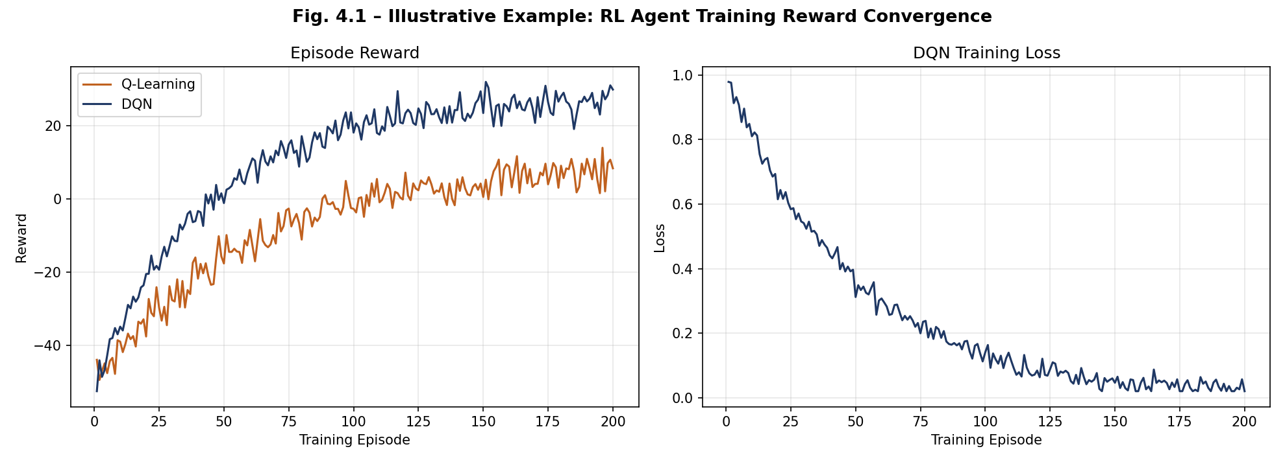
Fig. 4.1 – Illustrative Example: RL Agent Training Reward Convergence Curve
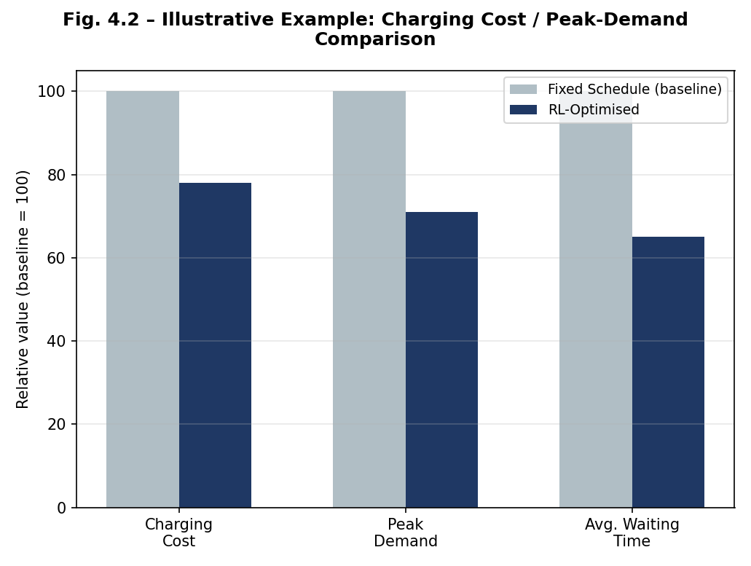
Fig. 4.2 – Illustrative Example: Charging Cost / Peak-Demand Comparison (Fixed Schedule vs. RL-Optimised)
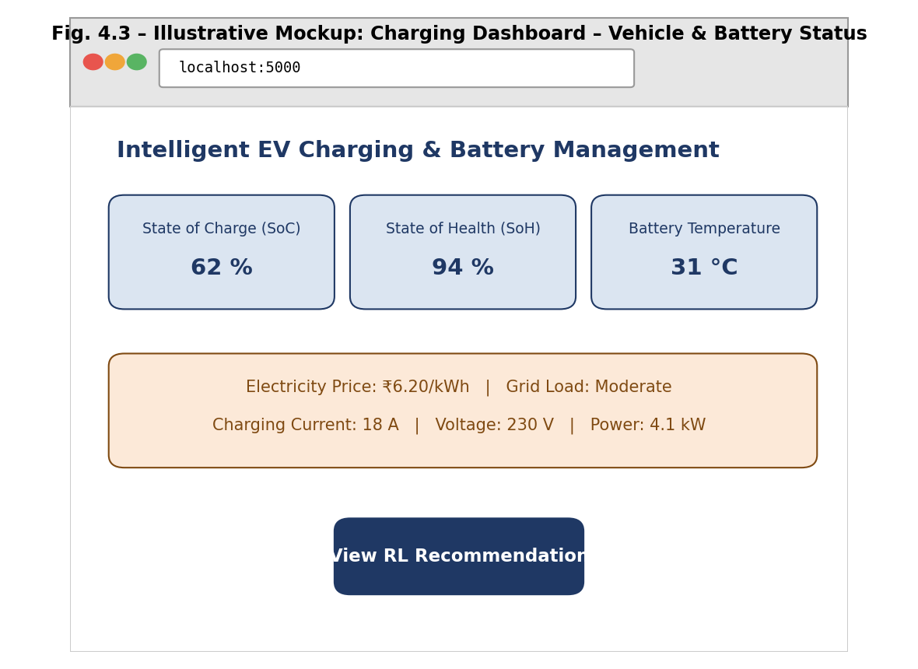
Fig. 4.3 – Illustrative Mockup: Charging Dashboard – Vehicle & Battery Status
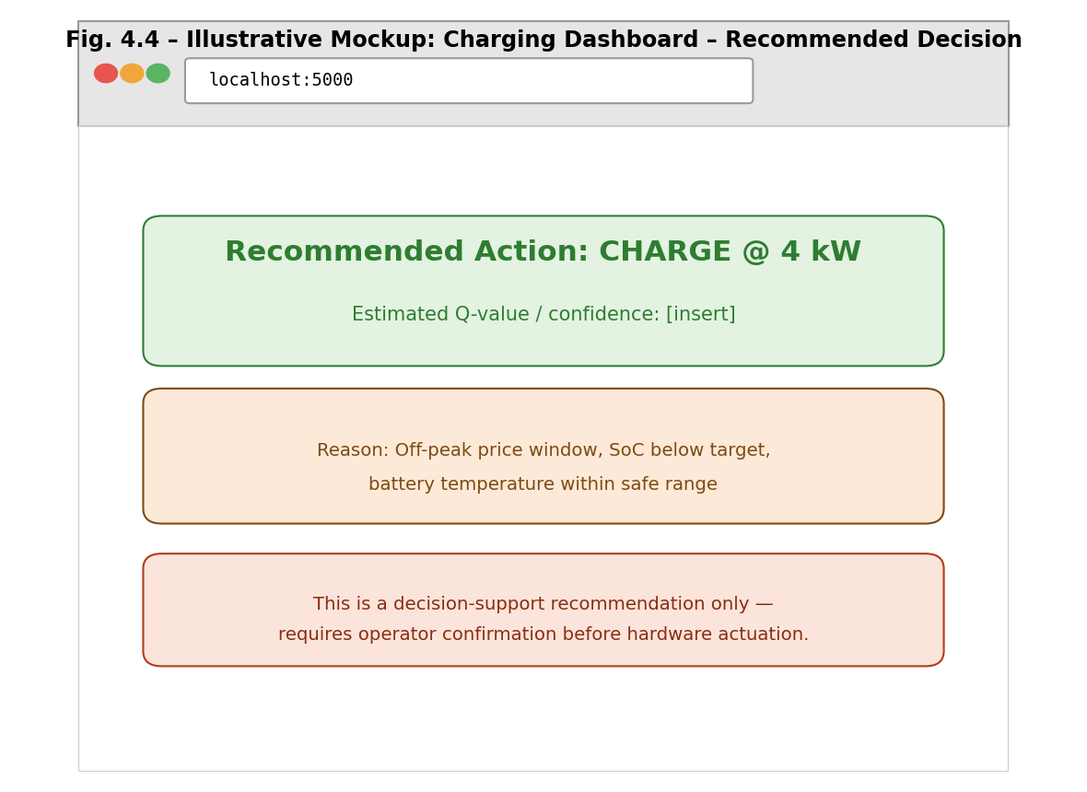
Fig. 4.4 – Illustrative Mockup: Charging Dashboard – Recommended Charging Decision

4.5 Data Analysis & Engineering Judgment
[Interpret your actual results: what the reward-convergence curve reveals about training stability, what the cost/peak-demand comparison shows relative to the fixed-schedule baseline, and how battery-degradation and waiting-time reward terms behaved during evaluation.]

4.6 Comparison with Existing Solutions & Achievement of Objectives
Objective | Evidence | Achievement
1. Develop an intelligent EV charging management module | Module 1 architecture in Section 3.5.1, implemented in Section 4.2 | [Insert: Fully/Partially/Not Achieved]
2. Design and train an RL agent (Q-Learning/DQN) | Training approach in Sections 3.4/4.1–4.2, results in Section 4.4 | [Insert]
3. Continuously predict and track battery health (SoH) | Battery Management module (Section 3.5), integration tested in Section 4.3 | [Insert]
4. Reduce electricity consumption and charging cost | Section 4.4 cost comparison | [Insert]
5. Reduce waiting time / improve station utilisation | Section 4.4 results | [Insert]
6. Evaluate agent performance vs. fixed-schedule baseline | Section 4.3 test plan; comparison in Section 4.4/4.6 | [Insert]

4.7 Strengths & Limitations

Strengths:
- Modular three-module architecture that cleanly separates charging management, battery management and RL optimisation, allowing each to be tested and improved independently.
- RL-based approach adapts to changing price and grid-load conditions rather than relying on a fixed schedule that must be manually re-tuned.
- Hard safety bounds on SoC/temperature are enforced independently of the learned policy, giving a safety layer that does not depend on the RL agent behaving correctly.
- [Insert any additional strength specific to your implementation.]

Limitations:
- Restricted to a single-station, single-vehicle charging decision; does not coordinate charging across multiple stations or vehicles.
- Performance is bounded by the realism of the simulated battery/grid-price environment used for training, and may not generalise directly to a live grid without further validation.
- The tool has not undergone deployment-scale testing on real charging hardware and is not a certified grid-control device.
- [Insert any additional limitation observed during testing, e.g., specific failure cases.]

4.8 Project Planning, Roles & Budget
[Insert a Gantt chart / milestone timeline here, covering state/reward design, Q-Learning baseline training, DQN training, module integration and dashboard testing, with responsibility split across the three modules described in Section 3.5.1 and the Individual Contribution Statement.]
Student | Assigned Responsibility | Actual Contribution
E.V. Mahendra Reddy (192425214) | Module 1 – Smart EV Charging Management (design, development, testing) | 34%
T. Ganesh (192425246) | Module 2 – Intelligent Battery Management (design, development, testing) | 33%
Sri Vardhan (192425208) | Module 3 – Reinforcement Learning Optimization (design, development, testing) | 33%

Item | Estimated Cost | Actual Cost
Simulation environment / dataset | Free (open-source / simulated) | [Insert]
Compute (cloud GPU / local hardware) | [Insert] | [Insert]
Software/libraries | Free (open-source) | Free (open-source)
Dashboard hosting (if applicable) | [Insert] | [Insert]

CHAPTER 5: CONCLUSION, FUTURE WORK AND REFLECTION

5.1 Conclusion
This project set out to design, develop and evaluate a Reinforcement-Learning-based system for intelligent EV charging and battery management, and to deploy it as an accessible decision-support dashboard, with Module 1 – Smart EV Charging Management implemented and evaluated in depth. Both tabular Q-Learning and a Deep Q-Network were trained and compared against a fixed-schedule baseline, on the basis of an explicit trade-off analysis covering performance, training cost, reliability and sustainability (Chapter 3).
[Insert 3–5 sentences summarising your actual achieved results — e.g., final charging-cost reduction, peak-demand reduction and reward-convergence behaviour — and state clearly whether the objectives set out in Section 1.5 were met.]
The completed system provides a working demonstration that an RL-driven charging and battery management strategy is technically feasible for a single charging station, while the ethics, safety and risk analysis in Section 3.7 underlines that any recommended charging decision must be positioned strictly as a decision-support output requiring operator confirmation, rather than an autonomous hardware-control command.

5.2 Future Work
- Extend the system to coordinate charging across multiple stations and vehicles (multi-agent RL).
- Incorporate Vehicle-to-Grid (V2G) energy trading and real-time electricity-market pricing into the reward function.
- Train and validate on a larger, more diverse dataset of real battery-degradation and grid-load conditions to improve generalisability.
- Add explainability features so operators can see which state variables most influenced a given charging recommendation.
- Integrate with real charging hardware under a supervised pilot, with formal safety validation before any autonomous control is enabled.

5.3 Professional Learning & Individual Reflection

New Knowledge Acquired:
- Practical application of Reinforcement Learning (Q-Learning and DQN) to a real-world sequential-decision problem.
- State, action and reward-function design for a multi-objective optimisation problem (cost, battery health, grid stress, waiting time).
- Structured engineering trade-off analysis and risk assessment for an RL-based control system.

Engineering & Professional Skills Developed:
- Applied RL workflow: environment/state design, agent training, evaluation and iteration.
- Integration skills connecting a Python-based RL agent with a monitoring/decision dashboard.
- Critical evaluation of ethical, safety and sustainability considerations in an RL-based system.

Individual Reflection — E.V. Mahendra Reddy:
[Insert 4–5 lines reflecting personally on: (1) the most difficult engineering problem you encountered while building Module 1 – Smart EV Charging Management and how you solved it; (2) one key engineering decision you made personally (e.g., state design or reward-term weighting) and the evidence behind it; (3) new knowledge you acquired independently; (4) what you would redesign if you repeated the project.]

REFERENCES
References are to be listed in a consistent, recognised style such as IEEE. All literature, standards, websites, datasets, software, open-source resources and AI-assisted resources used must be appropriately acknowledged.
References actually used in this project are listed below in IEEE numbered format.
[1] “Reinforcement-learning-based EV charging management incorporating Vehicle-to-Grid (V2G) operation and battery degradation,” 2023.
[2] Z. Zhao, C. K. M. Lee, X. Yan, and H. Wang, “Reinforcement Learning for Electric Vehicle Charging Scheduling: A Systematic Review,” 2024.
[3] P. Michailidis, I. Michailidis, and E. Kosmatopoulos, “Reinforcement Learning for Electric Vehicle Charging Management: Theory and Applications,” 2025.
[4] [OpenAI Gym / Stable-Baselines3 or your actual RL framework] Documentation, “RL Framework Documentation.” [Online].
[5] [Insert dataset/simulation-environment name and source] — dataset/environment used for training and evaluating the RL agent.

APPENDICES

Appendix A – Detailed Calculations
[Insert detailed derivations, e.g., state/action space size, reward-term weight derivation and Q-network layer dimensions.]

Appendix B – Engineering Drawings / Schematics
[Insert any additional detailed architecture/flow diagrams beyond Figure 3.1.]

Appendix C – Source Code / Code Repository Information
[Insert a link to your code repository and/or essential code excerpts, e.g., the reward function, the DQN training loop and the Module 1 decision-request route. Complete source code should be maintained in the approved repository rather than reproduced in full here.]

Appendix D – Datasheets
Not applicable (software-only project) — or insert if applicable.

Appendix E – Experimental / Raw Data
[Insert raw training logs and reward/cost evaluation tables.]

Appendix F – Ethics / Institutional Approval
Not applicable — a simulated/public dataset was used and no primary user/vehicle data was collected.

Appendix G – Project Meeting / Progress Records
[Insert meeting/progress notes with your guide, Dr. G. A. Senthil.]

Appendix H – User/Industry Feedback
Insert if any feedback was collected; otherwise mark not applicable.

Appendix I – Publications / Patents / Competitions / Product Outcomes
Not applicable — or insert if applicable.

Appendix J – Individual Contribution Evidence
See Individual Contribution Statement (page iv).

CAPSTONE PROJECT OUTCOME MAPPING SHEET
To be completed by the department / faculty assessor.
Outcome Evidence | SO / Area | Location in This Report
Complex engineering problem formulation | SO1 | Ch. 1, Ch. 2
Engineering design under constraints | SO2 | Ch. 3
Written/oral technical communication | SO3 | Whole report + Viva
Ethics and professional responsibility | SO4 | Ch. 3 (3.7)
Teamwork and leadership | SO5 | Ch. 4 (4.8)
Experimentation, analysis, engineering judgment | SO6 | Ch. 4 (4.3–4.6)
Independent acquisition of new knowledge | SO7 | Ch. 5 (5.3)
Standards | SO2 | Ch. 3 (3.2)
Sustainability and societal/environmental impact | SO2/SO4 | Ch. 3 (3.7)
Risk assessment and mitigation | SO2/SO4 | Ch. 3 (3.7)
Security considerations | Relevant SO | Ch. 3 (3.7)
Integrated/system-level engineering | SO1/SO2 | Ch. 3 (3.5)
Project planning and management | SO5 | Ch. 4 (4.8)
Individual contribution | SO1–SO7 | Contribution Statement + Ch. 4 (4.8)

