DESIGN AND ANALYSIS OF ALGORITHMS

Name: ATHIVARAM JAYAPRAKASH
Register Number: 192425311
Slot: C
Subject: Design and Analysis of Algorithms (DAA)

1. Detailed Bug Analysis (Why the Provided Code Fails)

Bug 1: Initializing min_dist = 0
- Location: min_dist = 0
- Why it fails: Euclidean distance between any two distinct points is strictly positive ($d > 0$). When searching for a minimum value, initializing your benchmark to 0 sets the threshold lower than any possible actual result. Any legitimate distance calculated will be greater than 0, making it impossible to update the minimum distance correctly.

Bug 2: Incorrect Comparison Operator (dist > min_dist)
- Location: if dist > min_dist:
- Why it fails: The > operator checks for values greater than the current benchmark. Coupled with min_dist = 0, this code actually searches for the maximum distance (farthest pair) rather than the minimum distance (closest pair). To find the closest pair, the algorithm must check if the newly computed distance is smaller (dist < min_dist).

Bug 3: Loss of Point Identification Data
- Location: return min_dist
- Why it fails: The function returns a single numerical distance value. In real-world applications, knowing the distance alone is insufficient—the algorithm must return the specific pair of coordinates $(P_i, P_j)$ that produced that minimum distance.

2. Optimization Strategy (Eliminating Computational Bottlenecks)

The Redundancy Problem:
In the original code, math.sqrt() is called inside the nested loops. For $N$ points, math.sqrt() is executed $\frac{N(N-1)}{2}$ times. Square root operations require costly floating-point calculations at CPU level.

Mathematical Optimization:
Since Euclidean distance $d = \sqrt{\Delta x^2 + \Delta y^2}$ is monotonically increasing for non-negative values:
$$\text{If } d_1 < d_2 \iff d_1^2 < d_2^2$$
- Solution: Compare squared distances ($d^2 = \Delta x^2 + \Delta y^2$) inside the loop, using simple multiplication and addition.
- Final Step: Perform a single math.sqrt() operation at the very end on the final minimum squared distance value.

3. Step-by-Step Debugging Transformation
Step | Original Line | Debugged & Optimized Line | Reason for Revision
1. Initialization | min_dist = 0 | min_dist_sq = float('inf') | Sets benchmark to infinity so the first valid distance replaces it.
2. Loop Computation | dist = math.sqrt(...) | dist_sq = dx*dx + dy*dy | Avoids calculating square root $\mathcal{O}(N^2)$ times.
3. Condition Check | if dist > min_dist: | if dist_sq < min_dist_sq: | Changes logic from finding maximum distance to minimum distance.
4. Tracking Result | min_dist = dist | closest_pairs = [(P_i, P_j)] | Stores actual coordinate pairs alongside the minimum distance.
5. Return Value | return min_dist | return math.sqrt(min_dist_sq), pairs | Computes square root once and returns both scalar distance and point coordinates.

4. Time & Space Complexity Analysis
- Time Complexity:
  - Nested Loops: $\frac{N(N-1)}{2}$ comparisons $\implies \mathbf{\mathcal{O}(N^2)}$.
  - Per-Iteration Cost: Reduced from $\mathcal{O}(\text{sqrt operation})$ to $\mathcal{O}(\text{basic arithmetic})$.
- Space Complexity:
  - Uses scalar variables to track minimum distance and index arrays $\implies \mathbf{\mathcal{O}(1)}$ auxiliary space.

5. Corrected, Fully Commented Code with Dynamic User Input
import math
def closest_pair_debugged(points):
"""
Finds the minimum Euclidean distance and the closest pair(s) of points.
Parameters:
points (list of tuples): List containing (x, y) coordinates.
Returns:
min_dist (float): Minimum Euclidean distance found.
closest_pairs (list): List of coordinate pairs producing min_dist.
"""
n = len(points)
# Handle edge case where insufficient points are provided
if n < 2:
return None, []

# FIX 1: Initialize minimum squared distance to positive infinity
min_dist_sq = float('inf')
closest_pairs = []
# Iterate through all unique pairs (i, j) where j > i
for i in range(n):
for j in range(i + 1, n):
# Compute coordinate differences
dx = points[i][0] - points[j][0]
dy = points[i][1] - points[j][1]
# OPTIMIZATION: Compare squared distance to avoid sqrt in loop
dist_sq = dx * dx + dy * dy
# FIX 2: Use '<' operator to look for smaller distances
if dist_sq < min_dist_sq:
min_dist_sq = dist_sq
# FIX 3: Store actual point coordinates
closest_pairs = [(points[i], points[j])]
elif math.isclose(dist_sq, min_dist_sq):
# Handle ties if multiple pairs share the same minimum distance
closest_pairs.append((points[i], points[j])
# OPTIMIZATION: Compute square root only ONCE at the end
min_dist = math.sqrt(min_dist_sq)
return min_dist, closest_pairs
# =====================================================================
# INTERACTIVE DRIVER PROGRAM
# =====================================================================
if __name__ == "__main__":
print("=========================================================")
print(" Register No: 192425311")
print(" Student: ATHIVARAM JAYAPRAKASH")
print(" Debugged & Optimized Closest Pair Algorithm")
print("=========================================================\n")
# Take dynamic input from the user
try:
num_points = int(input("Enter the total number of points (N >= 2): "))
if num_points < 2:
print("Error: At least 2 points are required to find a pair.")
else:
user_points = []
print(f"\nEnter x and y coordinates separated by space for {num_points} points:")
for idx in range(1, num_points + 1):
coord_str = input(f" Point P{idx} (x y): ")
x_val, y_val = map(float, coord_str.strip().split())
user_points.append((x_val, y_val))
# Run debugged algorithm
calculated_min_dist, pairs_found = closest_pair_debugged(user_points)
print("\n---------------------------------------------------------")
print("EXECUTION RESULTS:")
print("---------------------------------------------------------")
print(f"Input Coordinate Set : {user_points}")
print(f"Minimum Distance : {calculated_min_dist:.4f}")
print("Closest Pair(s) :")
for pair in pairs_found:
print(f" -> {pair[0]} and {pair[1]}")
print("---------------------------------------------------------"
except ValueError:
print("\nInvalid input format. Please enter numeric values for coordinates."

6. Sample Execution Run

Input Prompt:
Plaintext
Enter the total number of points (N >= 2): 5
Enter x and y coordinates separated by space for 5 points:
Point P1 (x y): 1 2
Point P2 (x y): 4 6
Point P3 (x y): 5 5
Point P4 (x y): 9 1
Point P5 (x y): 2 3

Output Terminal:
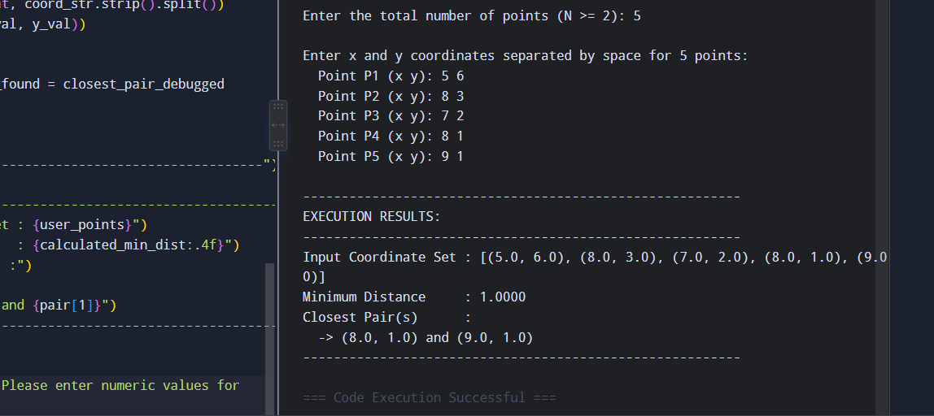
Input Coordinate Set : [(1.0, 2.0), (4.0, 6.0), (5.0, 5.0), (9.0, 1.0), (2.0, 3.0)]
Minimum Distance : 1.4142
Closest Pair(s) :
-> (1.0, 2.0) and (2.0, 3.0)
-> (4.0, 6.0) and (5.0, 5.0)

