DESIGN AND ANALYSIS OF ALGORITHMS

Name: ATHIVARAM JAYAPRAKASH
Register Number: 192425311
Slot: C
Subject: Design and Analysis of Algorithms (DAA)

Documentation: Traveling Salesman Problem (TSP) Solver
This document provides a technical overview and user guide for the Held-Karp Dynamic Programming implementation of the Traveling Salesman Problem (TSP).

1. Executive Overview
- Problem Statement: Find the shortest possible route that visits a set of $n$ cities exactly once and returns to the origin city, given a matrix of pairwise travel costs.
- Algorithm Used: Held-Karp Algorithm (Dynamic Programming with Bitmasking).
- Time Complexity: $\mathcal{O}(n^2 \cdot 2^n)$
- Space Complexity: $\mathcal{O}(n \cdot 2^n)$
Compared to a brute-force approach ($\mathcal{O}(n!)$), the Held-Karp algorithm drastically reduces runtime, making exact solutions feasible for values up to $n \approx 20$.

2. Theoretical Background

Recurrence Relation
Let $g(i, S)$ be the minimum path cost starting at city $i$, visiting every city in the subset $S \subseteq \{1, 2, \dots, n-1\} \setminus \{i\}$ exactly once, and returning to the origin city $0$.
$$g(i, S) = \min_{j \in S} \left\{ C_{i, j} + g(j, S \setminus \{j\}) \right\}$$
Base Case:
When all cities have been visited ($S = \emptyset$), the cost is simply the distance back to the starting city $0$:
$$g(i, \emptyset) = C_{i, 0}$$

3. Key Optimization Techniques Used

Bitmasking for State Representation
Rather than using heavy data structures (like Python's set or frozenset) to keep track of visited cities, state sets are encoded into integer bitmasks.
- Bit representation: The $k$-th bit of an integer is set to 1 if city $k$ has been visited, and 0 otherwise.
- Example ($n = 4$):
  - mask = 1 (0001 in binary) $\rightarrow$ Only city 0 is visited.
  - mask = 15 (1111 in binary) $\rightarrow$ All 4 cities are visited.
- Bitwise Operations:
  - Check if city $v$ is visited: not (mask & (1 << v))
  - Mark city $v$ as visited: mask | (1 << v)

Memoization via @lru_cache
Python's built-in functools.lru_cache dynamically stores calculated sub-problem results in memory. When a state (mask, u) is encountered again through a different permutation, the cached minimum cost is returned instantly in $\mathcal{O}(1)$ time.

4. Code Structure & Mechanics
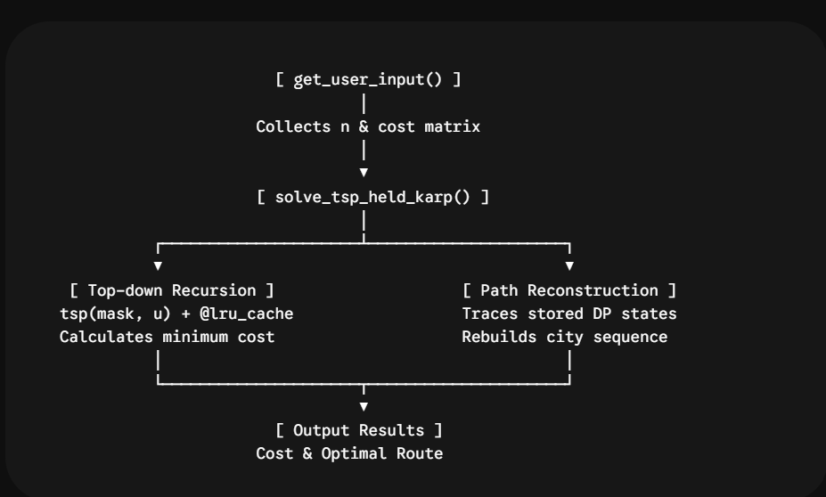

Function Breakdown

solve_tsp_held_karp(cost_matrix)
- Input: A 2D list cost_matrix of size $n \times n$.
- Process:
  - Computes the maximum bitmask (ALL_VISITED_MASK = (1 << n) - 1).
  - Runs recursive memoized searches via the inner tsp(mask, u) helper function.
  - Reconstructs the exact path by identifying the minimal transition choices at each state step.
- Output: Returns a tuple (min_cost, optimal_path).

get_user_input()
- Handles interactive standard I/O in execution environments such as Google Colab or local terminals.
- Validates row input lengths against $n$ to prevent indexing errors.

5. Usage Example

Input
import math
from functools import lru_cache

def solve_tsp_held_karp(cost_matrix):
"""
Solves TSP using Dynamic Programming (Held-Karp algorithm)
with Bitmasking and LRU Caching.
"""
n = len(cost_matrix)

if n == 0:
return 0, []
if n == 1:
return 0, [0, 0]

# Full mask representing all 'n' cities visited
ALL_VISITED_MASK = (1 << n) - 1

@lru_cache(maxsize=None)
def tsp(mask, u):
# Base Case: return cost to return to start node (city 0)
if mask == ALL_VISITED_MASK:
return cost_matrix[u][0], 0

min_cost = math.inf
best_next_city = -1

# Try visiting all unvisited cities
for v in range(n):
if not (mask & (1 << v)): # Check if city 'v' is NOT visited
cost, _ = tsp(mask | (1 << v), v)
total_cost = cost_matrix[u][v] + cost

if total_cost < min_cost:
min_cost = total_cost
best_next_city = v

return min_cost, best_next_city

# Start DP from city 0
min_cost, _ = tsp(1, 0)

# Reconstruct optimal path
path = [0]
curr_mask = 1
curr_city = 0

while curr_mask != ALL_VISITED_MASK:
_, next_city = tsp(curr_mask, curr_city)
path.append(next_city)
curr_mask |= (1 << next_city)
curr_city = next_city

path.append(0) # Return to start

return min_cost, path

def get_user_input():
"""
Interactive helper function to collect user input.
"""
print("==========================================")
print(" TSP Solver (Held-Karp Method) ")
print("==========================================")

n = int(input("\nEnter total number of cities (n): ").strip())

print(f"\nEnter the {n}x{n} cost matrix row by row.")
print("Example format for a row: 0 10 15 20")

cost_matrix = []
for i in range(n):
while True:
row_str = input(f"Row {i} (space-separated values): ").strip()
row_values = list(map(int, row_str.split()))

if len(row_values) == n:
cost_matrix.append(row_values)
break
else:
print(f" [Error] Expected {n} values, but got {len(row_values)}. Please re-enter Row {i}.")

return n, cost_matrix

# ==========================================
# Google Colab Execution
# ==========================================
if __name__ == "__main__":
# Get inputs from user
n, cost = get_user_input()

# Solve TSP
min_cost, optimal_path = solve_tsp_held_karp(cost)

# Display results
print("\n------------------------------------------")
print("RESULTS:")
print(f"Minimum Cost = {min_cost}")
print(f"Optimal Path = {' -> '.join(map(str, optimal_path))}")
print("------------------------------------------")

Output
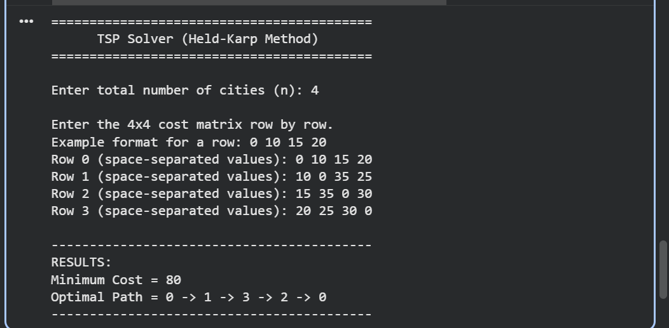

6. Performance Characteristics
Number of Cities (n) | Number of States (n⋅2n) | Held-Karp Operations | Brute Force (n!)
4 | 64 | $\approx 2.5 \times 10^2$ | 24
10 | 10,240 | $\approx 1 \times 10^5$ | $3.6 \times 10^6$
15 | 491,520 | $\approx 7.3 \times 10^6$ | $1.3 \times 10^{12}$
20 | 20,971,520 | $\approx 4.1 \times 10^8$ | $2.4 \times 10^{18}$

