DESIGN AND ANALYSIS OF ALGORITHMS
COURSE CODE: CSA0609

Q3. PASSWORD GENERATION
(COMBINATORIAL BACKTRACKING PROBLEM)

Register Number: 192425311
Student Name: ATHIVARAM JAYAPRAKASH

1. Aim
To design and analyze a backtracking algorithm for generating secure passwords of length N subject to constraints such as at least one uppercase letter, at least one digit, and no repeated characters. The algorithm should generate only valid passwords by applying constraint checking and pruning during the search.

2. Problem Statement
A system needs to generate passwords of a specified length N. Each password must satisfy security constraints. The required solution uses combinatorial backtracking so that characters are selected one position at a time, invalid partial passwords are rejected as early as possible, and all valid passwords can be generated without producing duplicate-character combinations.

3. Constraints
- Password length must be N.
- The password must contain at least one uppercase English letter (A–Z).
- The password must contain at least one digit (0–9).
- No character may be repeated.
- A selected character can be a lowercase letter, uppercase letter, or digit, according to the allowed character set.
- The value of N should not exceed the number of available distinct characters if repetition is prohibited.
- If N is smaller than 2, the requirements of at least one uppercase letter and at least one digit cannot both be satisfied.

4. Input Requirements
Input consists of the required password length N and an optional maximum number of passwords to display. The character set used by the algorithm is divided into uppercase letters, lowercase letters, and digits.
Example input: N = 6
Allowed character set: A–Z, a–z, 0–9

5. Output Requirements
The algorithm outputs every password of length N that satisfies all specified constraints. Each output password has at least one uppercase letter, at least one digit, and no repeated character.

6. Effect of Constraints on Search Space
Without constraints, if 62 characters are available (26 uppercase + 26 lowercase + 10 digits) and repetition is allowed, there are 62^N possible strings. When repetition is prohibited, the number of possible strings becomes a permutation: 62 × 61 × 60 × ... × (62 − N + 1), or P(62,N), for N ≤ 62.
The uppercase and digit requirements further reduce the number of acceptable passwords. For the exact requirements of at least one uppercase and at least one digit, the number of valid passwords can be calculated using inclusion–exclusion. For N positions, it is P(62,N) − P(36,N) − P(52,N) + P(26,N), where P(a,N) = a(a−1)...(a−N+1). Here 36 characters are lowercase letters plus digits, 52 are letters, and 26 are lowercase letters. This shows that the constraints significantly reduce the search space.

7. Backtracking Approach
Backtracking constructs the password from left to right. At each level of the recursion, one unused character is selected. Before continuing, the algorithm checks whether the selected character is valid for the current partial solution. If a partial solution cannot possibly become a valid password, that branch is pruned immediately.
Two Boolean conditions are maintained: hasUpper indicates whether an uppercase letter has already been selected, and hasDigit indicates whether a digit has already been selected. A used set prevents character repetition.

8. Pseudocode
BACKTRACK(password, used, hasUpper, hasDigit):
IF length(password) = N:
IF hasUpper = TRUE AND hasDigit = TRUE:
OUTPUT password
RETURN
remaining = N - length(password)
IF hasUpper = FALSE AND remaining < 2:
RETURN
IF hasDigit = FALSE AND remaining < 2:
RETURN
FOR each character c in characterSet:
IF c is already in used:
CONTINUE
newUpper = hasUpper OR isUppercase(c)
newDigit = hasDigit OR isDigit(c)
# Pruning
remainingAfterChoice = N - (length(password) + 1)
IF newUpper = FALSE AND remainingAfterChoice = 0:
CONTINUE
IF newDigit = FALSE AND remainingAfterChoice = 0:
CONTINUE
ADD c to password
ADD c to used
BACKTRACK(password, used, newUpper, newDigit)
REMOVE c from used
REMOVE last character from password
MAIN:
READ N
IF N < 2 OR N > 62:
PRINT "Invalid N"
STOP
BACKTRACK("", emptySet, FALSE, FALSE)

9. Python Implementation
import string
UPPER = string.ascii_uppercase
LOWER = string.ascii_lowercase
DIGITS = string.digits
CHARACTERS = UPPER + LOWER + DIGITS
def generate_passwords(n):
result = []
if n < 2 or n > len(CHARACTERS):
return result
password = []
used = set()
def backtrack(has_upper, has_digit):
if len(password) == n:
if has_upper and has_digit:
result.append("".join(password))
return
remaining = n - len(password)
# Pruning: both required categories must still fit.
missing = int(not has_upper) + int(not has_digit)
if remaining < missing:
return
for ch in CHARACTERS:
if ch in used:
continue
next_upper = has_upper or ch.isupper()
next_digit = has_digit or ch.isdigit()
password.append(ch)
used.add(ch)
backtrack(next_upper, next_digit)
used.remove(ch)
password.pop()
backtrack(False, False)
return result
# Example
N = 4
passwords = generate_passwords(N)
print("Number of valid passwords:", len(passwords))
for p in passwords[:20]:
print(p)

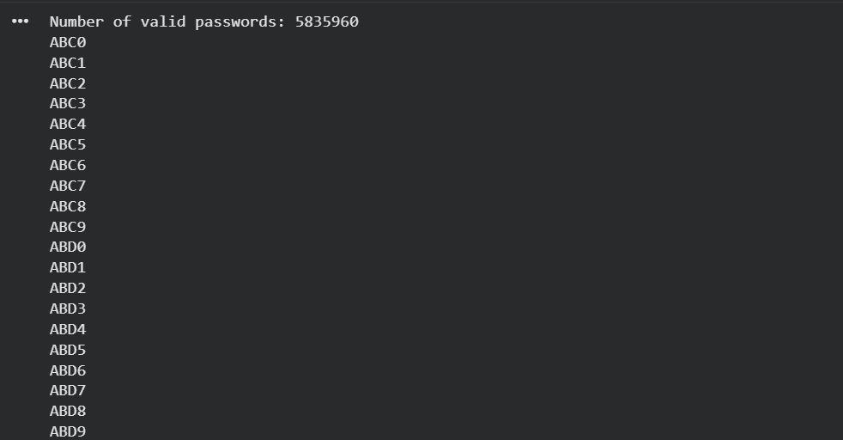

10. Working of the Algorithm
- Start with an empty password.
- Choose an unused character from the allowed character set.
- Update the two constraint flags: hasUpper and hasDigit.
- If the partial password cannot satisfy the remaining requirements, prune the branch.
- Continue recursively until the password reaches length N.
- At length N, output the password only if both required constraints are satisfied.
- Undo the last choice and try the next unused character. This is the backtracking step.

11. Example
For N = 4, a valid password may be "A7bc" because it contains uppercase A, digit 7, and all four characters are distinct. "abcd" is rejected because it has no uppercase letter or digit. "Aabc" is rejected because it has no digit. "A7aa" is rejected because the character 'a' is repeated.
During execution, if the current partial password is "Abc" for N = 4, only one position remains. Since neither a digit nor an additional required category has been selected, the branch is pruned if the digit requirement is still unsatisfied. This avoids exploring an invalid completion.

12. Constraint Checking and Pruning
Constraint checking is performed during recursion rather than only after a complete password is generated. The used set immediately prevents repeated characters. The hasUpper and hasDigit flags record whether the mandatory categories have already appeared. The remaining-position test checks whether enough positions are available to satisfy missing constraints. These checks reduce unnecessary recursive calls and improve practical performance.

13. Correctness and Completeness
The algorithm is complete because every character in the allowed character set is considered at each password position, except characters that have already been used. Therefore, every distinct length-N arrangement is reachable through some recursive path.
The algorithm avoids invalid combinations because a character is never selected twice, and a password is output only when both mandatory constraints are satisfied. Pruning removes only branches that are mathematically unable to satisfy the constraints. Therefore, no valid password is removed by pruning, and every valid password is generated exactly once.

14. Time and Space Complexity
Let C = 62 be the number of available characters. Without repetition, the maximum number of partial arrangements is O(P(C,N)), where P(C,N) = C!/(C−N)!. In the worst case, the backtracking search is therefore exponential/factorial in N relative to the character-set size. Constraint pruning reduces the number of explored branches in practice.
The recursion depth is N, and the used set requires O(C) auxiliary space. The output itself can require O(KN) space, where K is the number of valid passwords generated.

15. Advantages
- Generates only passwords satisfying the required constraints.
- Prevents repeated characters during construction.
- Uses early pruning instead of checking every invalid complete string.
- Generates all valid solutions systematically.
- Can be easily extended with additional constraints such as special characters, minimum lowercase count, or forbidden patterns.

16. Result
Thus, a backtracking-based password generation algorithm was designed successfully. The algorithm constructs passwords character by character, checks constraints during construction, prunes impossible branches, and outputs only passwords of length N containing at least one uppercase letter, at least one digit, and no repeated characters. The method is both complete and correct for the defined search space.

17. Conclusion
Backtracking is suitable for constrained password generation because it systematically explores combinations while rejecting invalid partial solutions early. The use of constraint flags and a used-character set makes the solution efficient compared with generating all strings first and validating them afterward. Since pruning is applied only when a valid completion is impossible, the algorithm maintains completeness while avoiding unnecessary search.

