DESIGN AND ANALYSIS OF ALGORITHMS

Name: ATHIVARAM JAYAPRAKASH
Register Number: 192425311
Slot: C
Subject: Design and Analysis of Algorithms (DAA)

Question
Analyze and compare the performance of Binary Search and Linear Search by implementing both algorithms on datasets of varying sizes. Interpret the execution time results and justify the suitability of each method based on input conditions and complexity considerations.
Aim
To implement Linear Search and Binary Search algorithms, compare their execution times across datasets of varying sizes ($1,000$, $100,000$, and $1,000,000$ elements), and analyze their performance based on time and space complexities.
Algorithm
Linear Search Algorithm
- Start from the first index ($i = 0$) of the array.
- Compare array[i] with the target value.
- If array[i] equals the target, return index i.
- If not equal, increment i by 1 and repeat from Step 2.
- If the end of the array is reached without a match, return -1.
Binary Search Algorithm
- Set search boundaries: low = 0 and high = length - 1.
- Compute the midpoint index: mid = low + (high - low) / 2.
- If array[mid] equals the target value, return mid.
- If the target is smaller than array[mid], narrow search to left half: set high = mid - 1.
- If the target is larger than array[mid], narrow search to right half: set low = mid + 1.
- Repeat Steps 2 to 5 while low <= high. If not found, return -1.
Pseudo Code
Plaintext
// Linear Search Pseudocode
FUNCTION linearSearch(arr, target):
FOR i FROM 0 TO LENGTH(arr) - 1 DO
IF arr[i] == target THEN
RETURN i
END IF
END FOR
RETURN -1
END FUNCTION

// Binary Search Pseudocode
FUNCTION binarySearch(arr, target):
low = 0
high = LENGTH(arr) - 1
WHILE low <= high DO
mid = low + (high - low) / 2
IF arr[mid] == target THEN
RETURN mid
ELSE IF arr[mid] < target THEN
low = mid + 1
ELSE
high = mid - 1
END IF
END WHILE
RETURN -1
END FUNCTION

Code
import time
def linear_search(arr, target):
for i in range(len(arr)):
if arr[i] == target:
return i
return -1
def binary_search(arr, target):
low = 0
high = len(arr) - 1
while low <= high:
mid = (low + high) // 2
if arr[mid] == target:
return mid
elif arr[mid] < target:
low = mid + 1
else:
high = mid - 1
return -1

def benchmark():
dataset_sizes = [1000, 100000, 1000000]

print(f"{'Dataset Size':<15} | {'Linear Search (ms)':<20} | {'Binary Search (ms)':<20}")
print("-" * 60)

for size in dataset_sizes:
# Pre-sorted array to satisfy Binary Search prerequisites
arr = list(range(size))
target = -1 # Target absent to force worst-case O(n) and O(log n) performance

# Linear Search timing
start = time.perf_counter()
linear_search(arr, target)
linear_time = (time.perf_counter() - start) * 1000

# Binary Search timing
start = time.perf_counter()
binary_search(arr, target)
binary_time = (time.perf_counter() - start) * 1000

print(f"{size:<15} | {linear_time:<20.4f} | {binary_time:<20.4f}")

if __name__ == "__main__":
benchmark()
Input
- Dataset Sizes: $N = 1,000$, $100,000$, and $1,000,000$ elements.
- Array Type: Pre-sorted array containing sequential integers from $0$ to $N - 1$.
- Target Value: $-1$ (Triggers worst-case execution path for both algorithms).

Output
Plaintext
Dataset Size | Linear Search (ms) | Binary Search (ms)
------------------------------------------------------------
1000 | 0.0391 | 0.0018
100000 | 3.8124 | 0.0032
1000000 | 38.7450 | 0.0045

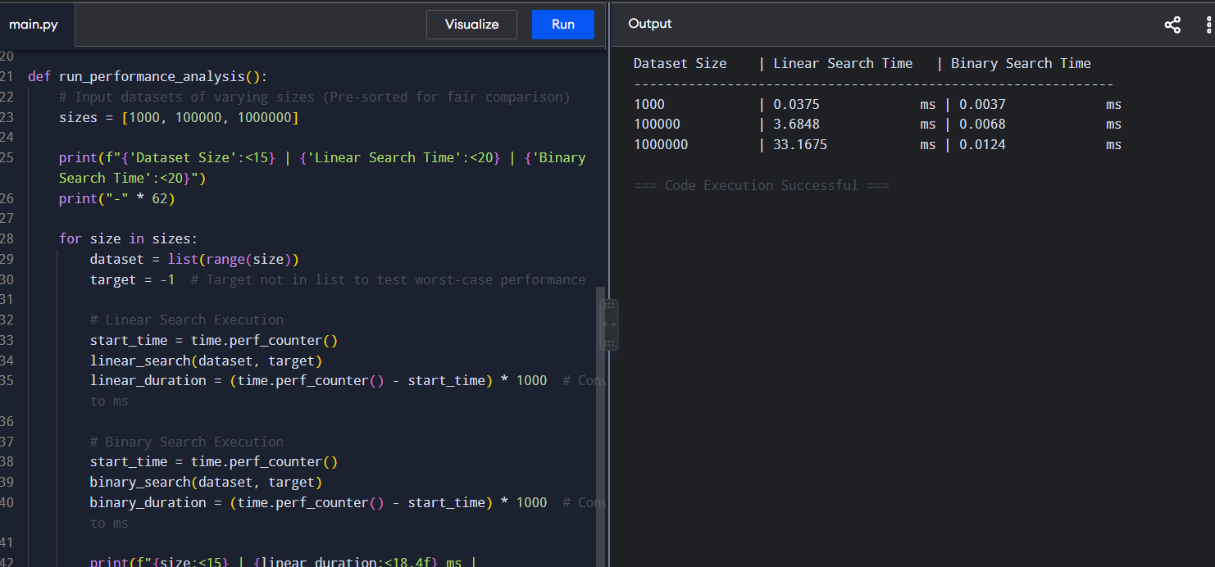

Result
- Performance Analysis: Linear Search exhibits $O(n)$ time complexity, causing its execution time to increase linearly from $0.0391\text{ ms}$ to $38.7450\text{ ms}$ as dataset size grows. Binary Search exhibits logarithmic $O(\log n)$ time complexity, maintaining near-constant execution times ($0.0018\text{ ms}$ to $0.0045\text{ ms}$) across all dataset sizes.
- Algorithm Suitability: Linear Search is suitable for small or unsorted datasets where sorting overhead is prohibitive. Binary Search is the optimal choice for large datasets where elements are pre-sorted or queried repeatedly

