ASSESSMENT TOOL 3 – CODING CHALLENGE

1.
import re
EMAIL_PATTERN = re.compile(
r"^[A-Za-z][A-Za-z0-9._]*@[A-Za-z]+\.(?:com|org|edu|net|in)$",
re.IGNORECASE,
)
PASSWORD_PATTERN = re.compile(
r"^(?=.*[A-Z])(?=.*[a-z])(?=.*\d)(?=.*[@#$%&!]).{8,}$")
MOBILE_PATTERN = re.compile(r"^[6-9]\d{9}$")
def validate_email(email: str) -> bool:
"""Return True if email follows the challenge's email rules.""" return bool(EMAIL_PATTERN.fullmatch(email))
def validate_password(password: str) -> bool:
"""Return True if password meets all strength rules.""" return bool(PASSWORD_PATTERN.fullmatch(password))
def validate_mobile(mobile: str) -> bool:
"""Return True for exactly 10 digits beginning with 6, 7, 8, or 9.""" return bool(MOBILE_PATTERN.fullmatch(mobile))
def main() -> None:
print("=== Ex1: Credential Validator ===")
email = input("Enter email: ").strip()
password = input("Enter password: ")
mobile = input("Enter mobile number: ").strip()
print("\n--- Results ---")
print("Valid Email" if validate_email(email) else "Invalid Email")
print("Strong Password" if validate_password(password) else "Weak Password")
print(
"Valid Mobile Number" if validate_mobile(mobile)
else "Invalid Mobile Number" )
if __name__ == "__main__":
main()
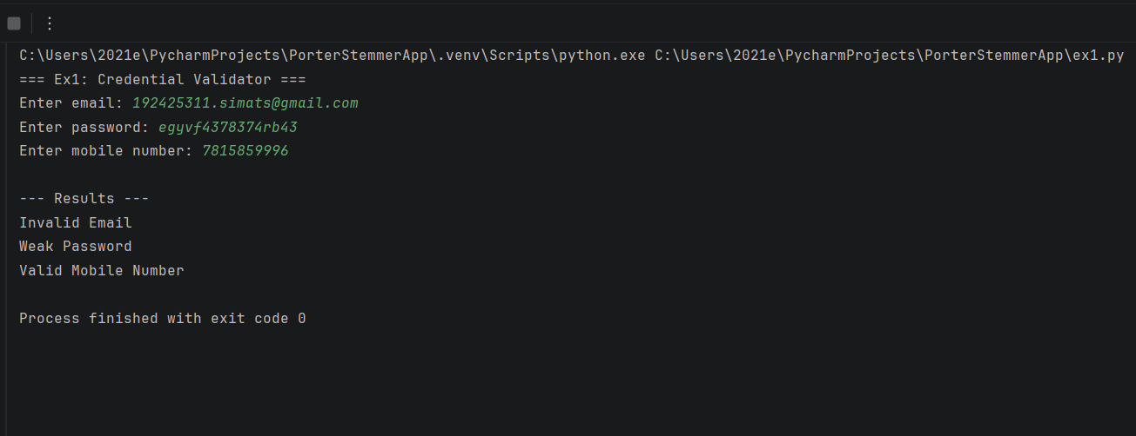

2.
def read_csv(prompt: str) -> list[str]:
"""Read comma-separated values, trimming spaces and ignoring empty items.""" while True:
values = [item.strip() for item in input(prompt).split(",") if item.strip()]
if values:
return values
print("Input cannot be empty. Try again.")
def build_dfa():
states = read_csv("Enter states (comma-separated, e.g. q0,q1,q2): ")
alphabet = read_csv("Enter input alphabet (comma-separated, e.g. a,b): ")
if len(set(states)) != len(states):
raise ValueError("States must be unique.")
if len(set(alphabet)) != len(alphabet):
raise ValueError("Alphabet symbols must be unique.")
if any(len(symbol) != 1 for symbol in alphabet):
raise ValueError("This simulator expects each alphabet symbol to be one character.")
state_set = set(states)
alphabet_set = set(alphabet)
transitions = {}
print("\nEnter one destination state for each state/symbol pair.")
print("Example: for state q0 and symbol a, enter q1.")
for state in states:
for symbol in alphabet:
destination = input(f"delta({state}, {symbol}) = ").strip()
if destination not in state_set:
raise ValueError(f"Unknown destination state: {destination!r}")
transitions[(state, symbol)] = destination
start_state = input("Enter initial state: ").strip()
if start_state not in state_set:
raise ValueError("Initial state must be one of the declared states.")
final_states = read_csv("Enter final state(s), comma-separated: ")
if not set(final_states).issubset(state_set):
raise ValueError("Every final state must be one of the declared states.")
return states, alphabet_set, transitions, start_state, set(final_states)
def simulate(text: str, alphabet: set[str], transitions: dict,
start_state: str, final_states: set[str]):
"""Return (accepted, visited_states); invalid symbols cause rejection.""" current_state = start_state
path = [current_state]
for symbol in text:
if symbol not in alphabet:
return False, path, f"Invalid input symbol: {symbol!r}" current_state = transitions[(current_state, symbol)]
path.append(current_state)
return current_state in final_states, path, Nonedef main() -> None:
print("=== Ex2: DFA Simulator ===")
try:
_, alphabet, transitions, start_state, final_states = build_dfa()
count_text = input("\nHow many input strings do you want to test? ").strip()
count = int(count_text)
if count < 1:
raise ValueError("Number of strings must be at least 1.")
for index in range(1, count + 1):
text = input(f"\nInput string {index} (press Enter for empty string): ")
accepted, path, error = simulate(
text, alphabet, transitions, start_state, final_states
)
print("Transition Path:", " -> ".join(path))
if error:
print(error)
print("Accepted" if accepted else "Rejected")
except (ValueError, EOFError) as error:
print("Input error:", error)
if __name__ == "__main__":
main()

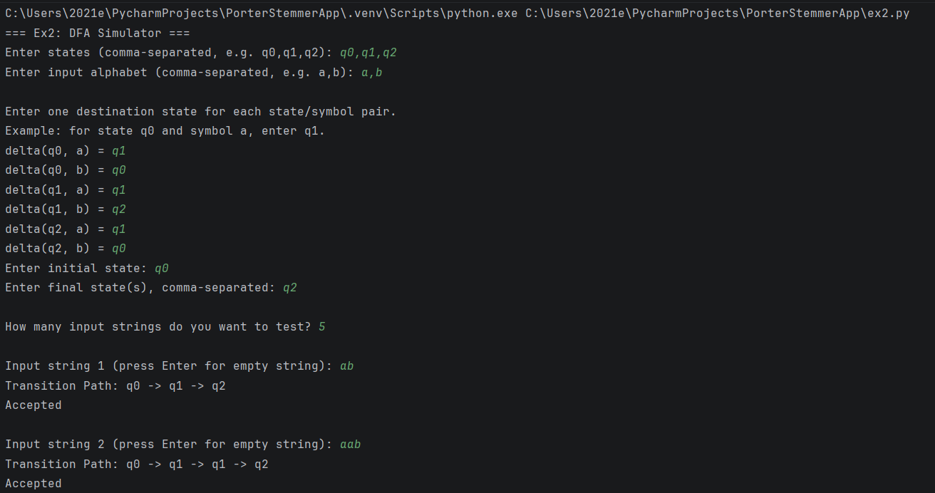
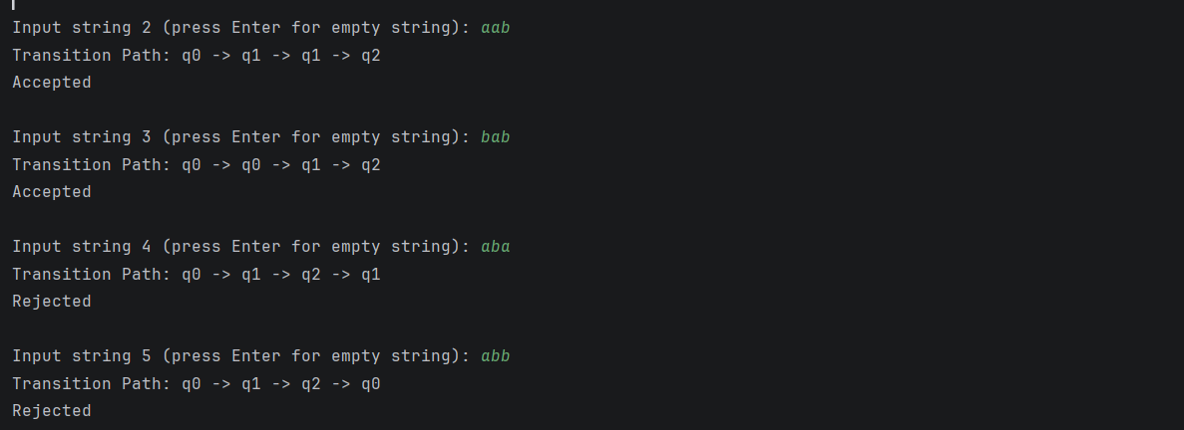

3.
import re
# Regular expression patternsPATTERNS = {
"1": (
"Date",
re.compile(
r"\b(?:0?[1-9]|[12]\d|3[01])/" r"(?:0?[1-9]|1[0-2])/\d{4}\b" )
),
"2": (
"Phone Number",
re.compile(r"(?<!\d)[6-9]\d{9}(?!\d)")
),
"3": (
"Hashtag",
re.compile(r"(?<!\w)#[A-Za-z0-9_]+")
),
"4": (
"Mention",
re.compile(r"(?<!\w)@[A-Za-z0-9_]+")
),
}
def search_pattern(text, pattern):
"""Find all matches of a regular expression.""" return pattern.findall(text)
def search_prefix(text, prefix):
"""Find words starting with a prefix.""" if not prefix:
return []
words = re.findall(r"\b\w+\b", text)
return [
word for word in words
if word.lower().startswith(prefix.lower())
]
def search_suffix(text, suffix):
"""Find words ending with a suffix.""" if not suffix:
return []
words = re.findall(r"\b\w+\b", text)
return [
word for word in words
if word.lower().endswith(suffix.lower())
]
def search_word(text, word):
"""Find whole-word matches, ignoring case.""" if not word:
return []
pattern = re.compile(
r"(?<!\w)" + re.escape(word) + r"(?!\w)",
re.IGNORECASE
)
return pattern.findall(text)
def display_results(label, results):
"""Display matching results.""" print(f"\n{label}:")
if results:
for result in results:
print(" ", result)
print("Total matches:", len(results))
else:
print("No matches found.")
def main():
print("=" * 45)
print(" SMART PATTERN MATCHING ENGINE")
print("=" * 45)
text = input("\nEnter your text: ")
while True:
print("\n========== MENU ==========")
print("1. Search Date")
print("2. Search Phone Number")
print("3. Search Hashtag")
print("4. Search Mention")
print("5. Search Prefix")
print("6. Search Suffix")
print("7. Search Word")
print("0. Exit")
print("==========================")
choice = input("Enter your choice: ").strip()
if choice == "0":
print("Program terminated.")
break elif choice in PATTERNS:
label, pattern = PATTERNS[choice]
results = search_pattern(text, pattern)
display_results(label, results)
elif choice == "5":
prefix = input("Enter prefix: ").strip()
results = search_prefix(text, prefix)
display_results("Prefix Search Results", results)
elif choice == "6":
suffix = input("Enter suffix: ").strip()
results = search_suffix(text, suffix)
display_results("Suffix Search Results", results)
elif choice == "7":
word = input("Enter word: ").strip()
results = search_word(text, word)
display_results("Word Search Results", results)
else:
print("Invalid choice! Enter a number from 0 to 7.")
if __name__ == "__main__":
main()



