

Name: M. Samanvi
Reg. No.: 192425318
Course Code: MLA0401
Course Name: Deep Learning

Experiment 15:
Aim: To demonstrate the segmentation of image using python
Program:
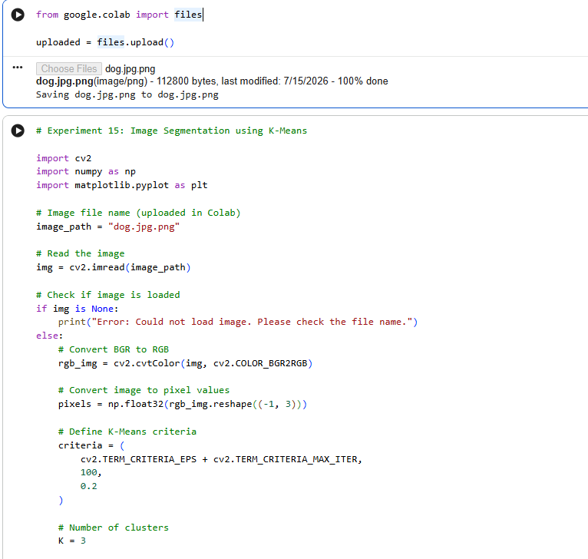

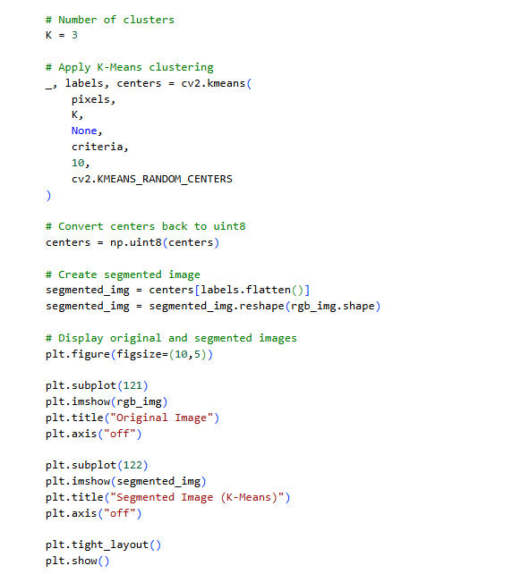
Output:
