

Name: M. Samanvi
Reg. No.: 192425318
Course Code: MLA0401
Course Name: Deep Learning
Experiment 16:
Aim: To demonstrate image segmentation using Python
Program:
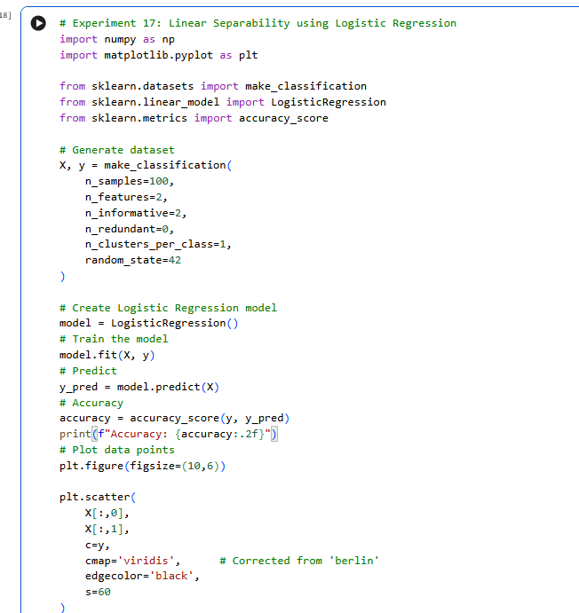
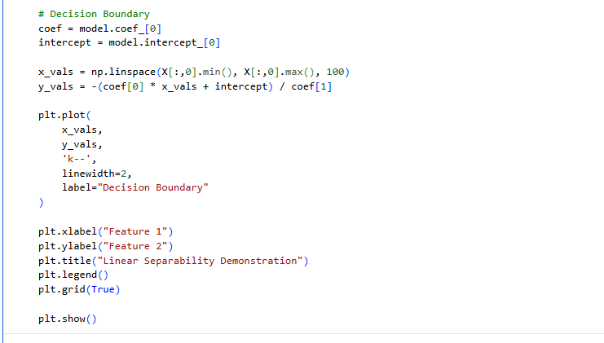

Output:
