Experiment 1: University Performance Analysis
Question
A university database contains:
- Student(SID, Name, Dept)
- Course(CID, CName, Credits)
- Enroll(SID, CID, Marks)
Task
- Find students who failed in at least one course.
- Identify top-performing students in each department.
- Write Relational Algebra and SQL queries.

Aim
To analyze student academic performance by identifying students who failed in at least one course and finding the top-performing students in each department using relational algebra and SQL queries.
Task 1: Find Students Who Failed in At Least One Course
Relational Algebra
SQL Query
SELECT DISTINCT S.SID, S.Name
FROM Student S
JOIN Enroll E
ON S.SID = E.SID
WHERE E.Marks < 40;
Task 2: Identify Top-Performing Students in Each Department
SQL Query
SELECT S.SID,
S.Name,
S.Dept,
AVG(E.Marks) AS AverageMarks
FROM Student S
JOIN Enroll E
ON S.SID = E.SID
GROUP BY S.SID, S.Name, S.Dept
HAVING AVG(E.Marks) =
(
SELECT MAX(AvgMarks)
FROM
(
SELECT AVG(E2.Marks) AS AvgMarks
FROM Student S2
JOIN Enroll E2
ON S2.SID = E2.SID
WHERE S2.Dept = S.Dept
GROUP BY S2.SID
) AS DeptAverage
);
Task 2: Relational Algebra (Conceptual)
Average and maximum are aggregate operations, so extended relational algebra is used:
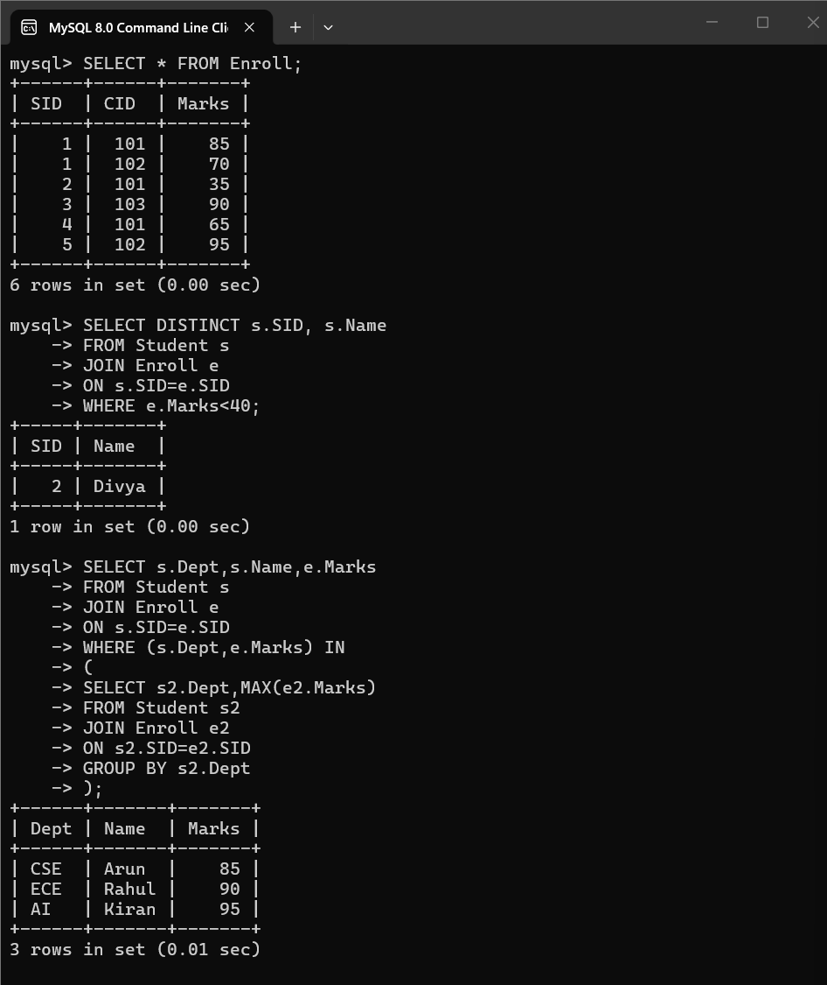
Output
- Students who scored less than 40 are displayed.
- The student with the highest average marks in each department is displayed.

Experiment 2: E-Commerce Order Insights
Question
Database
- Customer(CID, Name, City)
- Orders(OID, CID, Amount, Date)
Scenario
Management wants to analyze customer purchasing behavior.
Task
- Find customers who placed orders worth more than ₹50,000 in total.
- Compare the query using JOIN and Subquery.
- Evaluate which approach is better and justify.

Aim
To identify customers whose total order amount exceeds ₹50,000, compare the JOIN and Subquery approaches, and evaluate the better method.
Task 1: Find Customers Who Placed Orders Worth More Than ₹50,000
Aim
To retrieve customers whose total order amount is greater than ₹50,000.
Task 2: Comparison
JOIN Approach
- Combines Customer and Orders tables.
- Returns customer details and total purchase amount.
- Suitable for reports and summaries.
Subquery Approach
- Retrieves customer details using a nested query.
- Simpler when only filtering customer records.
- Does not directly show the total purchase amount.
Task 3: Evaluation
Which Approach is Better?
The JOIN approach is generally better because:
- It retrieves customer information and total order amount in a single query.
- It is more efficient for reporting and aggregation.
- It avoids executing an additional lookup after filtering.
- It is easier to extend with extra columns (such as City or Order Count).

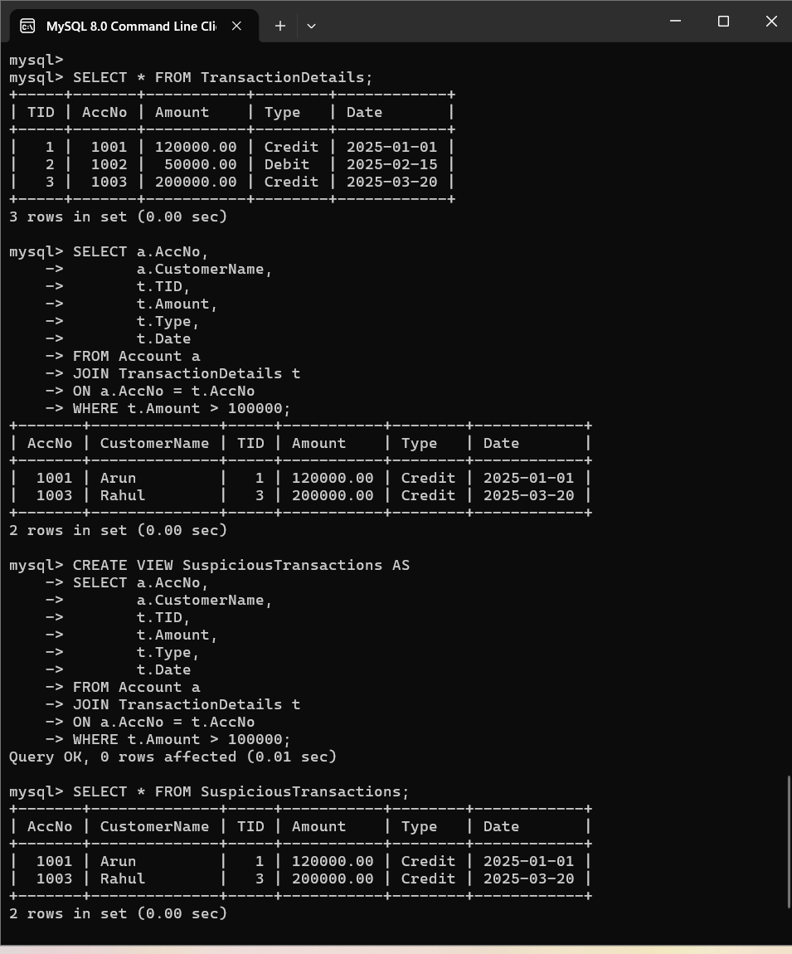
Output
- Displays customers whose total purchases exceed ₹50,000.
- Compares the results using JOIN and Subquery.
Experiment 3: Banking Fraud Detection Database
Question
Database
- ACCOUNT(AccNo, CustomerName, Balance)
- TRANSACTION(TID, AccNo, Amount, Type, Date)
Scenario
Detect suspicious transactions.
Task
- Identify accounts with transactions above ₹1,00,000.
- Create a View for suspicious transactions.
- Design SQL queries for fraud monitoring.

Aim
To identify suspicious transactions above ₹1,00,000, create a view for suspicious transactions, and design SQL queries for fraud monitoring using MySQL.

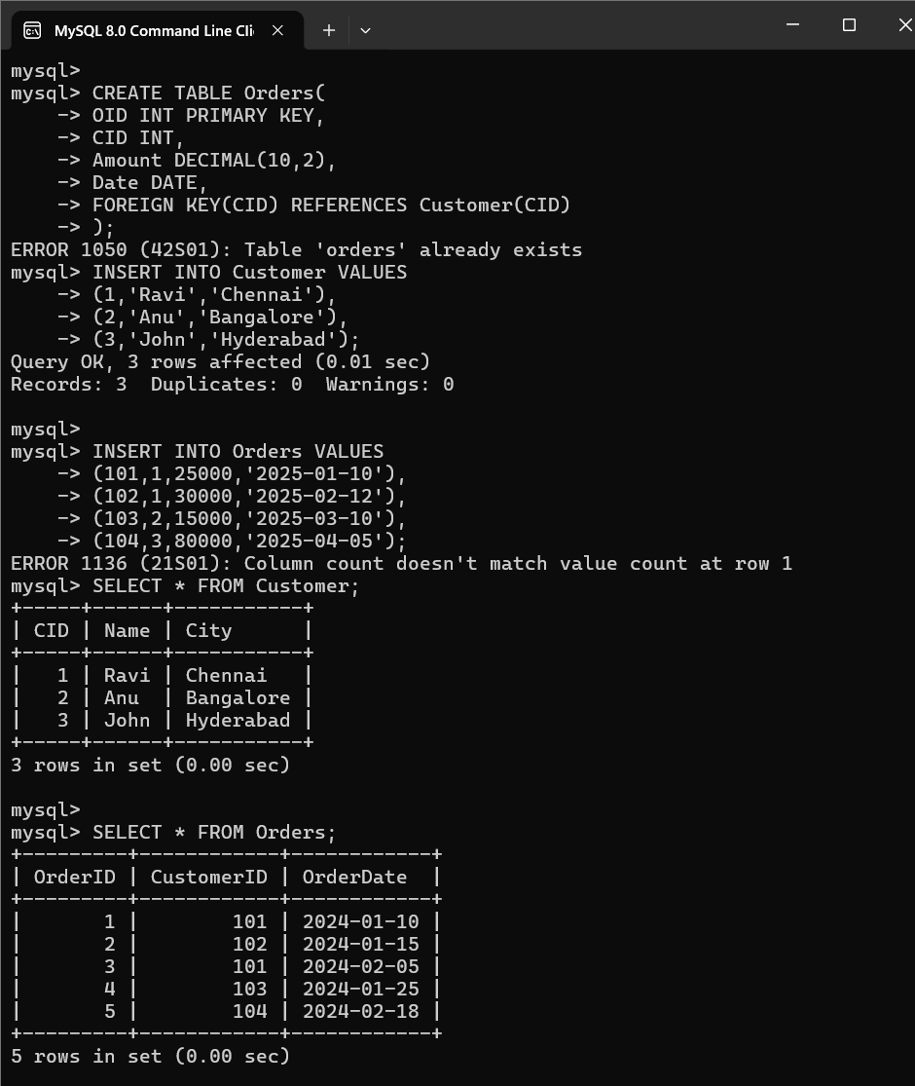

Experiment 4: Employee Performance System Database
Question
Database
- Employee(EID, Name, DeptID, Salary)
- Project(PID, PName)
- Works(EID, PID, Hours)
Scenario
A company wants to evaluate employee performance based on project involvement and working hours.
Task
- Find employees working on more than 2 projects.
- Calculate the total hours worked by each employee.
- Write Relational Algebra expressions.

Aim
To analyze employee performance by identifying employees working on more than two projects and calculating the total hours worked by each employee using SQL and Relational Algebra.
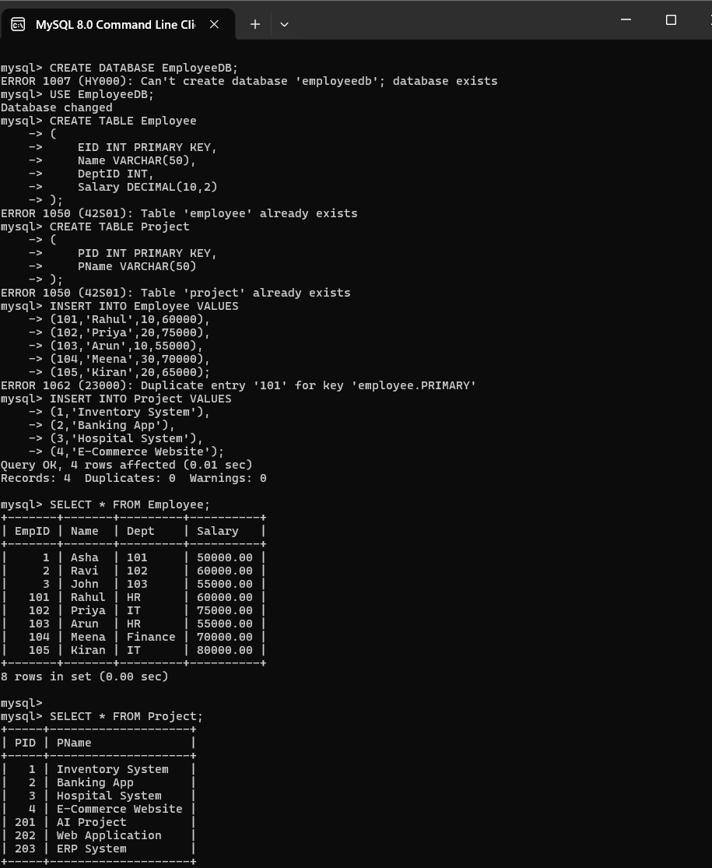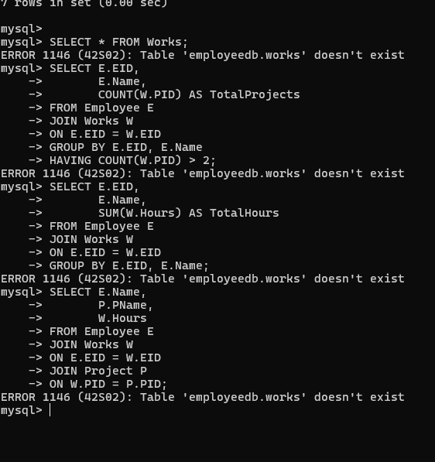
Output
- Displays employees working on more than two projects.
- Calculates the total hours worked by each employee.
- Shows employee, project, and hours worked.
Experiment 5: Hospital Patient Management Database
Question
Database
- Patient(PID, Name, Age)
- Doctor(DID, Name, Specialization)
- Visit(PID, DID, Date, Fees)
Scenario
Optimize patient care analysis.
Task
- Find doctors who treated more than 50 patients.
- Evaluate the need for indexing or views.
- Suggest optimized SQL queries.

Aim
To identify doctors who have treated more than 50 patients and improve query performance using indexing, views, and optimized SQL queries.
Task 1: Find Doctors Who Treated More Than 50 Patients
Aim
To identify doctors who have treated more than 50 patients.

SQL Query
SELECT D.DID,
D.Name,
COUNT(V.PID) AS TotalPatients
FROM Doctor D
JOIN Visit V
ON D.DID = V.DID
GROUP BY D.DID, D.Name
HAVING COUNT(V.PID) > 50;
Relational Algebra (Extended)
Task 2: Create a View for Doctor Visit Summary
Aim
To create a view that summarizes the number of patients treated by each doctor.
Query
CREATE VIEW Doctor_Visit_Summary AS
SELECT D.DID,
D.Name,
COUNT(V.PID) AS TotalPatients
FROM Doctor D
JOIN Visit V
ON D.DID = V.DID
GROUP BY D.DID, D.Name;
Display the View
SELECT * FROM Doctor_Visit_Summary;
Task 3: Create an Index
Aim
To improve the performance of search and join operations on the Visit table.
Query
CREATE INDEX idx_doctor
ON Visit(DID);
Task 4: Optimized SQL Query
SELECT *
FROM Doctor_Visit_Summary
WHERE TotalPatients > 50;
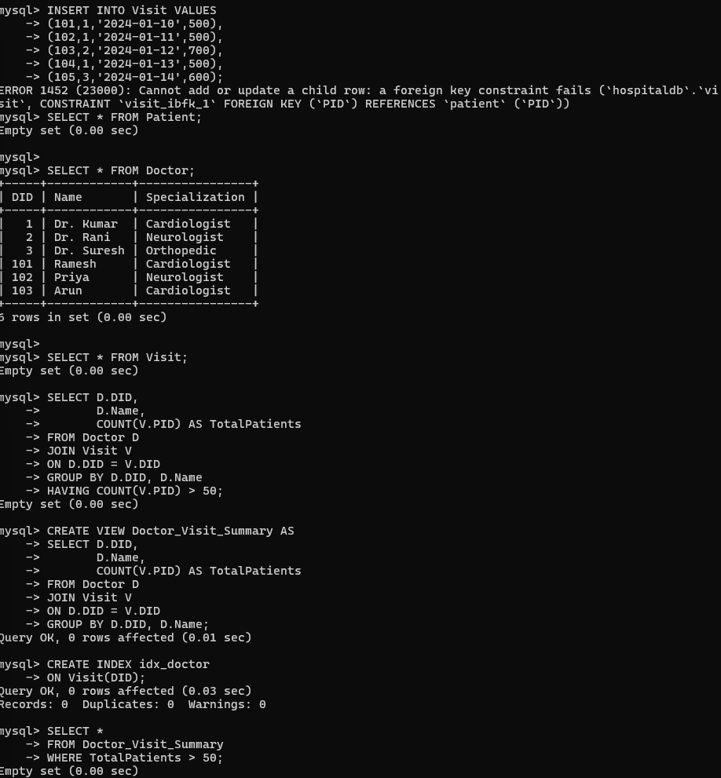
Result
The Hospital Patient Management System successfully identifies doctors based on the number of patients treated. By using indexes, views, and optimized SQL queries, the database performance is improved, making patient care analysis faster and more efficient.

