SIMATS ENGINEERING (SAVEETHA SCHOOL OF ENGINEERING)
Department of Computer Science and Engineering
CO2 ASSESSMENT TOOL 1 – Scenario-Based Requirement Analysis

Course Code: | CSA10 / CSA1005 | Course Title: | Software Engineering
CO Assessed: | CO2 | Assessment: | Assessment Tool 2 – Scenario-Based Requirement Analysis
Weightage: | 20% | Total Marks: | 25
CO2 Statement: | Perform detailed requirements analysis, design scalable architectures, and prioritize features with a focus on cross-disciplinary skills
Student Name: | Patteela Yashwanth kumar | Reg. No.: | 192471055
Date: | 27.10.26 | Duration: | 60 minutes

Code of Conduct
I Patteela Yashwamth Kumar/192471055 (Name / Reg No) certify that this submission is my original work and that I have adhered to the guidelines specified for this assessment. I understand that any violation of academic integrity rules will result in disciplinary action.
Signature of the Student: Patteela Yashwanth Kumar
Annexure A – Scenario-Based Requirement Analysis
Instructions to Students:
Each student will be assigned an individual software project problem statement. Analyze the given scenario and prepare a complete Software Requirement Analysis document by following the steps below.
Question
Based on the assigned problem statement, perform a Scenario-Based Requirement Analysis and prepare a Software Requirement Specification (SRS) document. Your analysis should include the following:
- Study and Analyze the Scenario
- Carefully understand the given problem statement.
- Identify the business domain, stakeholders, existing challenges, and system objectives.
- Identify Functional and Non-Functional Requirements
- List all functional requirements required by the proposed system.
- Identify suitable non-functional requirements such as performance, security, reliability, usability, scalability, maintainability, and availability.
- Identify Actors and Use Cases
- Identify all primary and secondary actors interacting with the system.
- List the major use cases associated with each actor.
- Draw a Use Case Diagram representing the interactions between actors and the system.
- Prepare the Software Requirement Specification (SRS)
Develop an SRS document containing:
- Introduction
- Problem Description
- Scope of the System
- Functional Requirements
- Non-Functional Requirements
- Use Case Descriptions
- Data Requirements
- External Interface Requirements
- System Features
- Identify Assumptions and Constraints
- List the assumptions considered while developing the system.
- Identify technical, operational, economic, legal, and time-related constraints affecting the
project.
- Validate Requirement Completeness and Consistency
- Verify whether all stakeholder requirements have been addressed.
- Check for ambiguity, redundancy, inconsistency, and missing requirements.
- Suggest improvements to enhance the quality and completeness of the requirement specification.
Rubrics for Calculation
Criteria | Excellent (4 Marks) | Good (3 Marks) | Satisfactory (2 Marks) | Needs Improvement (1 Mark)
Scenario Understanding and Problem Analysis (30%) | Demonstrates thorough understanding of the scenario, stakeholders, objectives, and business context with clear analysis. | Demonstrates good understanding with minor omissions. | Basic understanding with limited analysis. | Poor understanding; major aspects missing or incorrect.
Functional and Non-Functiona l Requirement Identification (25%) | Clearly identifies comprehensive, accurate, and well-classified functional and non-functional requirements. | Identifies most requirements with minor classification errors. | Identifies only basic requirements; several omissions. | Requirements are incomplete, inaccurate, or poorly classified.
Actor Identification and Use Case Modelling (20%) | Correctly identifies all relevant actors and use cases; use case diagram is complete, accurate, and follows UML standards. | Most actors and use cases identified; diagram has minor errors. | Limited actors/use cases identified; diagram partially correct. | Actors/use cases missing or incorrect; diagram absent or inaccurate.
Software Requirement Specification (SRS) | SRS is well-structured, complete, professionally | SRS is organized with minor missing sections or formatting issues. | SRS includes only essential sections with limited detail. | SRS is incomplete, poorly organized, or

Documentation organized, and lacks essential (15%) includes all required components.
sections.

Assumptions, Constraints, and Requirement Validation (10%)
Clearly identifies
realistic assumptions
and constraints; Identifies most validates requirements assumptions and for completeness, constraints; consistency, and validation is ambiguity with adequate. appropriate
justification.
Limited assumptions/con straints; validation is superficial.
Assumptions, constraints, and validation are missing or incorrect.

Criteria | Mark
Scenario Understanding and Problem Analysis (30%) | /5
Functional and Non-Functional Requirement Identification (25%) | /5
Actor Identification and Use Case Modelling (20%) | /5
Software Requirement Specification (SRS) Documentation (15%) | /5
Assumptions, Constraints, and Requirement Validation (10%) | /5
TOTAL | /25

Smart Donation and Charity Management Platform
1. Study and Analysis of the Scenario
Business domain: Non-profit and social welfare sector (philanthropy technology). The platform connects donors, charitable organizations (NGOs), beneficiaries and volunteers on a single transparent online system.
Existing challenges: Charities depend on manual receipts, spreadsheets and cash or cheque collection. Donors cannot see how their money is used, trust is low because of fraud and misuse, and duplicate or fake beneficiaries are hard to detect. Reporting, tax-receipt generation and volunteer coordination consume large amounts of staff time.
Stakeholders
- Donors: give money or goods, want secure payment, receipts and proof of impact.
- NGO / Charity administrators: run campaigns, verify cases, allocate funds and publish reports.
- Beneficiaries: apply for aid and track the status of their requests.
- Volunteers: register for drives, events and tasks.
- System administrator and external services: manage users, security and system configuration; payment gateway and SMS/email providers support the system externally.
System objectives
- Enable quick, secure online donations (money, goods or time) through multiple payment modes.
- Provide full transparency by tracking every donation from collection to utilization.
- Automate receipts, beneficiary verification, fund allocation, notifications and reports.
- Reduce fraud, administrative effort and delay while improving donor trust and retention.
2. Functional and Non-Functional Requirements
2.1 Functional Requirements (Table 1)
ID | Requirement | Priority
FR-01 | The system shall allow users to register, log in and manage profiles with role-based access. | High
FR-02 | The system shall display campaigns with goal, raised amount, progress and deadline, with search and filters. | High
FR-03 | The system shall allow donors to donate one-time or recurring, anonymously or with identity. | High
FR-04 | The system shall integrate with a payment gateway (UPI, cards, net banking, wallets) and confirm payment status. | High
FR-05 | The system shall generate and email a donation receipt, including a tax-exemption certificate. | High
FR-06 | The system shall let admins create, edit, approve, pause and close campaigns. | High
FR-07 | The system shall allow beneficiaries to submit aid applications with supporting documents. | High
FR-08 | The system shall support verification and approval or rejection of beneficiaries by admins. | High
FR-09 | The system shall record fund allocation and expenses against each campaign and beneficiary. | High
FR-10 | The system shall show donors a real-time impact tracker with utilization updates and photos. | Medium
FR-11 | The system shall support in-kind donations (items) with pickup or drop-off scheduling. | Medium
FR-12 | The system shall let volunteers register, join events and log hours. | Medium
FR-13 | The system shall send email, SMS and in-app notifications for key events. | Medium
FR-14 | The system shall generate financial, donor and campaign reports exportable as PDF and Excel. | Medium
FR-15 | The system shall maintain an audit log of financial and administrative actions. | High
FR-16 | The system shall provide a refund and complaint management facility. | Low

2.2 Non-Functional Requirements (Table 2)
Category | Requirement
Performance | Pages load within 3 seconds; payment confirmation within 5 seconds; supports 5,000 concurrent users.
Security | HTTPS/TLS, password hashing, two-factor authentication for admins, no card data stored (PCI-DSS via gateway), protection from SQL injection and XSS.
Reliability | No loss of confirmed transactions; automatic daily backups; recovery within 4 hours of failure.
Usability | Simple responsive interface for web and mobile; donation in at most 3 steps; multilingual and accessibility support (WCAG 2.1).
Scalability | Modular architecture that scales horizontally for festival or disaster-relief donation peaks.
Maintainability | Layered design with documented APIs and coding standards; fixes deployable without full downtime.
Availability | 99.5 percent uptime, excluding planned maintenance announced 24 hours earlier.
3. Actors and Use Cases
Actor | Type | Major Use Cases
Donor | Primary | Register/Login, Browse Campaigns, Make Donation, Download Receipt, Track Donation Impact, Submit Complaint
NGO / Charity Admin | Primary | Manage Campaigns, Verify Beneficiaries, Allocate Funds, Generate Reports, Publish Impact Updates
Beneficiary | Primary | Register/Login, Apply for Aid, Upload Documents, Track Application Status
Volunteer | Primary | Register as Volunteer, Join Events, Log Hours
System Admin | Primary | Manage Users and Roles, Configure System, View Audit Logs, Backup/Restore
Payment Gateway | Secondary | Process Payment, Confirm Transaction, Process Refund
Notification Service (Email/SMS) | Secondary | Send Notifications, Send Receipts

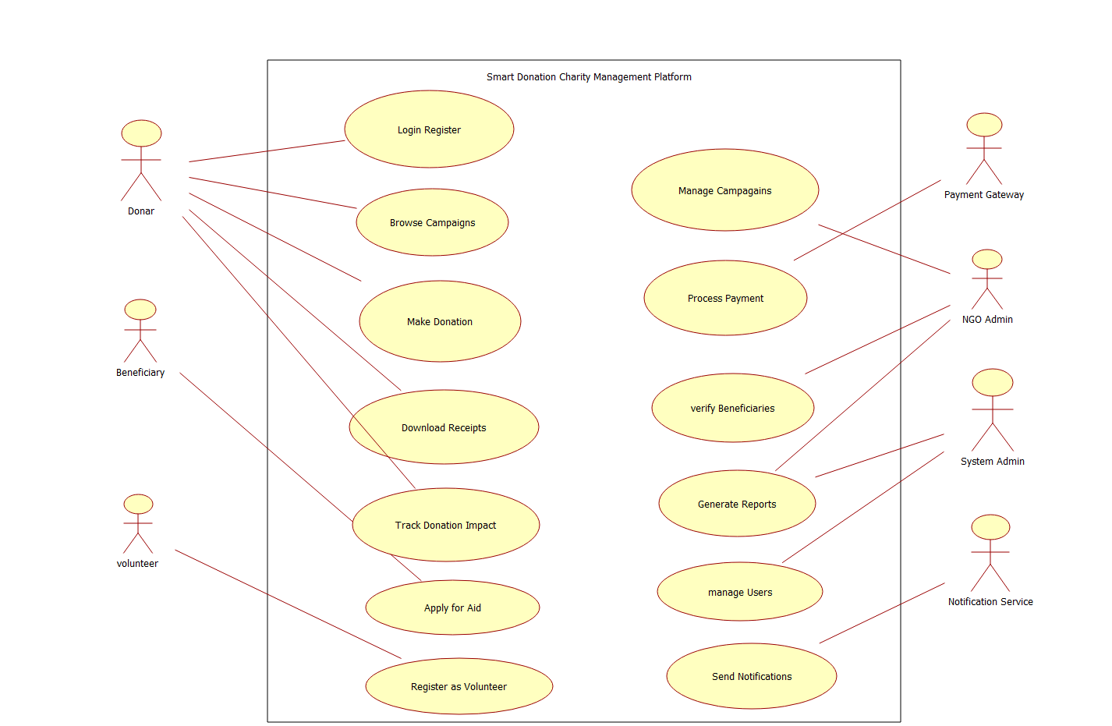

Figure 1: Use Case Diagram of the Smart Donation and Charity Management Platform
4. Software Requirement Specification (SRS)
4.1 Introduction
Purpose: this SRS defines the requirements of the Smart Donation and Charity Management Platform, a web and mobile application for online giving, campaign management and transparent fund utilization. Intended readers are developers, testers, project managers, charity management and the course evaluators. Definitions: NGO – Non-Governmental Organization; UPI – Unified Payments Interface; SRS – Software Requirement Specification; PCI-DSS – Payment Card Industry Data Security Standard.
4.2 Problem Description
Traditional donation handling is manual, opaque and slow. Donors have no visibility of fund usage, NGOs struggle with record keeping and fraud control, and beneficiaries face long approval cycles. The proposed system digitizes the complete cycle of donation, verification, allocation, reporting and feedback in one secure platform.
4.3 Scope of the System
In scope: user management, campaign management, online and in-kind donations, payment integration, receipts, beneficiary verification, fund allocation, impact tracking, volunteer management, notifications, reports and audit logs. Out of scope: direct bank-to-bank settlement for NGOs, cryptocurrency donations, physical goods logistics and government tax filing.
4.4 Functional Requirements and 4.5 Non-Functional Requirements
The complete lists FR-01 to FR-16 (Table 1) and the quality attributes in Table 2 form the functional and non-functional requirements of this SRS. Each requirement is uniquely numbered so that it can be traced to design, test cases and use cases.
4.6 Use Case Descriptions
UC-03: Make Donation
- Actors: Donor (primary); Payment Gateway (secondary).
- Precondition: Donor is logged in and the selected campaign is active.
- Main flow: Donor selects campaign and amount; system shows summary; donor chooses payment mode; gateway confirms payment; system records the donation and emails the receipt.
- Alternate flow: If payment fails or is cancelled, no donation is recorded and the donor may retry.
- Postcondition: Donation stored and campaign total updated.
UC-07: Apply for Aid
- Actors: Beneficiary (primary); NGO Admin (secondary).
- Precondition: Beneficiary is registered with a verified phone number.
- Main flow: Beneficiary fills the aid form and uploads documents; system validates and checks duplicates; application is submitted with a reference number; admin is notified.
- Alternate flow: Duplicate or incomplete application is rejected with a list of corrections.
- Postcondition: Application saved with status Pending Verification.
UC-09: Verify Beneficiary
- Actor: NGO Admin.
- Precondition: A pending application exists.
- Main flow: Admin reviews documents and history, approves or rejects with remarks; system updates status and notifies the beneficiary.
- Postcondition: Status updated and action stored in the audit log.
4.7 Data Requirements
Entity | Key Attributes
User | user_id, name, email, phone, password_hash, role, status
Campaign | campaign_id, title, description, goal_amount, raised_amount, start/end date, status, admin_id
Donation | donation_id, donor_id, campaign_id, amount, type, payment_ref, status, date
Receipt | receipt_id, donation_id, PAN/tax details, issue date
Beneficiary / Aid Request | request_id, user_id, need details, documents, verification status, approved amount
Fund Allocation | allocation_id, campaign_id, request_id, amount, expense proof, date
Volunteer Activity | activity_id, volunteer_id, event, hours, status
Notification / Audit Log | log_id, user_id, action, timestamp, message, channel
Data is stored in a relational database with referential integrity. Financial records are retained for at least 8 years, and personal data is protected as per data protection laws.

4.8 External Interface Requirements
- User interface: responsive web interface and mobile application with dashboards for each role, forms, progress bars and charts.
- Hardware interface: any device with a modern browser or Android/iOS smartphone; server hosted on cloud infrastructure.
- Software interface: payment gateway API (UPI, cards, net banking), email and SMS APIs, cloud storage for documents, and optional maps API for item pickup.
- Communication interface: HTTPS with REST/JSON APIs and secure webhooks for payment status.
4.9 System Features
- F1 Donation Management: secure multi-mode donation with instant receipt.
- F2 Campaign Management: end-to-end lifecycle of fundraising campaigns.
- F3 Beneficiary Management: application, verification and fraud screening of aid seekers.
- F4 Transparency and Impact Tracking: live utilization dashboard, photos and reports for donors.
- F5 Volunteer Management: events, roles and hour logging.
- F6 Notification and Reporting: alerts, analytics and exportable reports.
5. Assumptions and Constraints
Assumptions
- Users have internet access and a smartphone or computer; donors hold a valid payment instrument.
- NGOs registered on the platform are legally recognized and supply valid registration documents.
- The payment gateway and SMS/email providers are available and follow their service agreements.
- Beneficiaries can provide identity and need-proof documents in digital form.
Constraints
- Technical: must work on common browsers and Android/iOS; depends on third-party gateway APIs; limited by hosting capacity.
- Operational: NGO staff need training; verification needs human review; support is required during campaign peaks.
- Economic: limited budget for development, hosting and gateway fees; low-cost open-source tools preferred.
- Legal: compliance with the IT Act, data protection rules, RBI payment guidelines, Section 80G tax rules and FCRA for foreign donations.
- Time: the first release must be completed within one academic semester using phased delivery.
6. Validation of Requirement Completeness and Consistency
- Completeness: Every stakeholder need is mapped to a requirement: donors (FR-02 to FR-05, FR-10), admins (FR-06, FR-08, FR-09, FR-14), beneficiaries (FR-07), volunteers (FR-12), system admin (FR-01, FR-15). No stakeholder is left uncovered.
- Ambiguity: Vague words such as "fast" and "secure" were replaced by measurable values (3-second load, TLS, 99.5 percent uptime).
- Redundancy: Notification handling appears in FR-05 and FR-13; it was merged so receipts are treated as a type of notification, avoiding duplicate effort.
- Inconsistency: Anonymous donation (FR-03) conflicts with tax receipts (FR-05); resolved by storing donor identity privately while hiding it from public display.
- Missing requirements: Initial draft lacked refunds, audit logs, data retention and disaster recovery; these were added as FR-15, FR-16 and NFR entries.
- Suggested improvements: add prototype reviews with NGOs, define acceptance criteria for each requirement, add a requirement traceability matrix, and include fraud-detection and AI-based recommendation features in later releases.

