Experiment 10
Map Colouring Using CSP
Question: Write a Python program to implement the Map Colouring problem using a Constraint Satisfaction Problem (CSP).
Aim:
To write a Python program to solve the Map Colouring problem by assigning different colours to neighbouring regions using CSP.
Algorithm:
- Start the program.
- Create a graph representing regions and their neighbours.
- Define a set of available colours.
- Assign a colour to each region.
- Check that neighbouring regions do not have the same colour.
- If a conflict occurs, try another colour using backtracking.
- Repeat until all regions are coloured successfully.
- Display the colour assigned to each region.
- Stop the program.
Code:
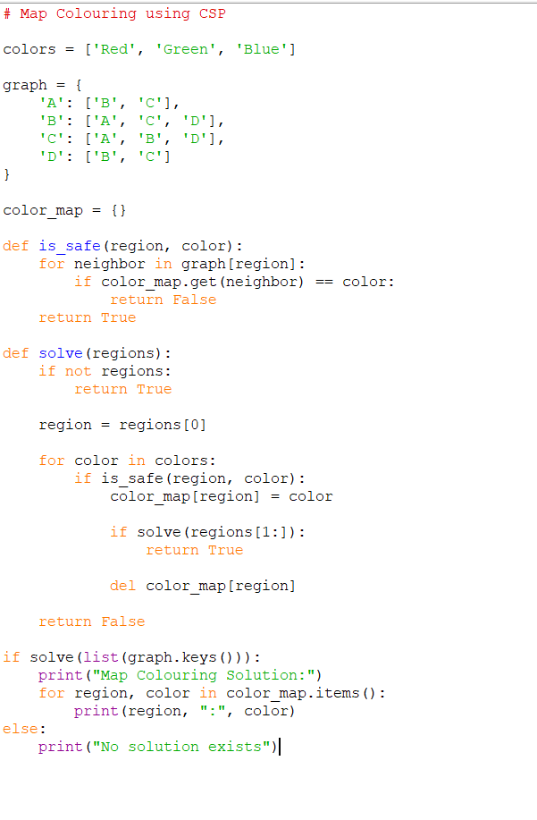
Output:
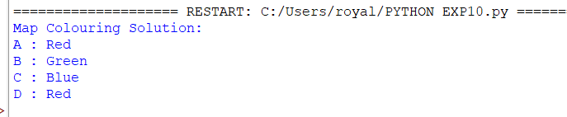

Result:
Thus, the Map Colouring problem was successfully implemented in Python using CSP and backtracking, ensuring that neighbouring regions have different colours.

