Experiment 6
Breadth-First Search (BFS)
Question: Write a Python program to implement the Breadth-First Search (BFS) algorithm.
Aim:
To write a Python program to implement the Breadth-First Search (BFS) algorithm for traversing a graph level by level.
Algorithm:
- Start the program.
- Create a graph using nodes and edges.
- Initialize an empty visited list and a queue with the starting node.
- Remove the first node from the queue.
- Print the node and mark it as visited if it has not been visited before.
- Add its unvisited neighbouring nodes to the queue.
- Repeat until the queue becomes empty.
- Stop the program.

Code:
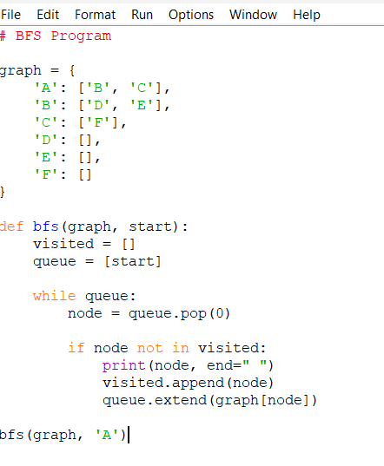

Output:
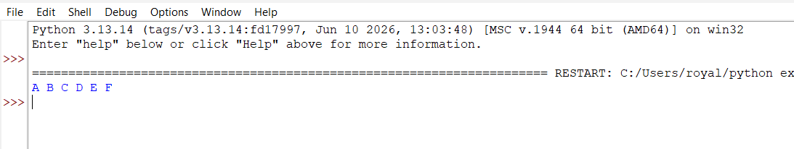

Result:
Thus, the Breadth-First Search (BFS) algorithm was successfully implemented in Python, and the graph was traversed level by level.

