Experiment 7
Depth-First Search (DFS)
Question: Write a Python program to implement the Depth-First Search (DFS) algorithm to traverse a graph.
Aim:
To write a Python program to implement the Depth-First Search (DFS) algorithm for traversing a graph.
Algorithm:
- Start the program.
- Create a graph using nodes and edges.
- Initialize an empty set to store visited nodes.
- Start from the given initial node.
- Mark the current node as visited and print it.
- Visit an unvisited neighbouring node recursively.
- Continue until all reachable nodes are visited.
- Stop the program.
Code:
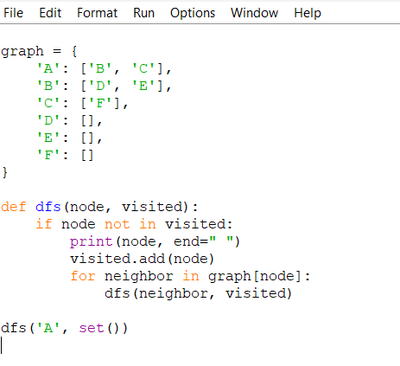
Output:

Result:
Thus, the Depth-First Search (DFS) algorithm was successfully implemented in Python to traverse a graph.

