Experiment 8
Travelling Salesman Problem (TSP)
Question: Write a Python program to implement the Travelling Salesman Problem (TSP) to find the shortest route that visits all cities and returns to the starting city.
Aim:
To write a Python program to solve the Travelling Salesman Problem (TSP) by finding the minimum-cost route.
Algorithm:
- Start the program.
- Create a distance matrix to represent the distances between cities.
- Generate all possible routes between the cities.
- Calculate the total distance of each route.
- Find the route with the minimum total distance.
- Display the shortest route and its minimum cost.
- Stop the program.
Code:
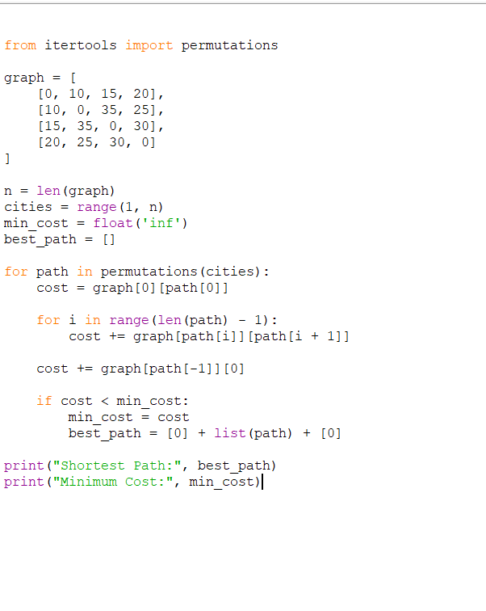
Output:
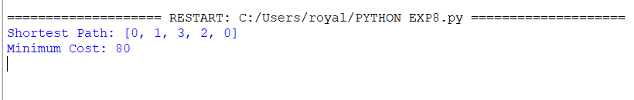

Result:
Thus, the Travelling Salesman Problem (TSP) was successfully implemented in Python to find the shortest route with minimum cost.

