Experiment 9
A* Algorithm
Question: Write a Python program to implement the A* algorithm to find the shortest path from a starting node to a goal node.
Aim:
To write a Python program to implement the A* search algorithm for finding the shortest path using cost and heuristic values.
Algorithm:
- Start the program.
- Create a graph with nodes and their distances.
- Assign heuristic values to each node.
- Select the starting node and goal node.
- Calculate the estimated total cost using f(n) = g(n) + h(n).
- Select the node with the lowest estimated total cost.
- Repeat until the goal node is reached.
- Display the shortest path.
- Stop the program.
Code:
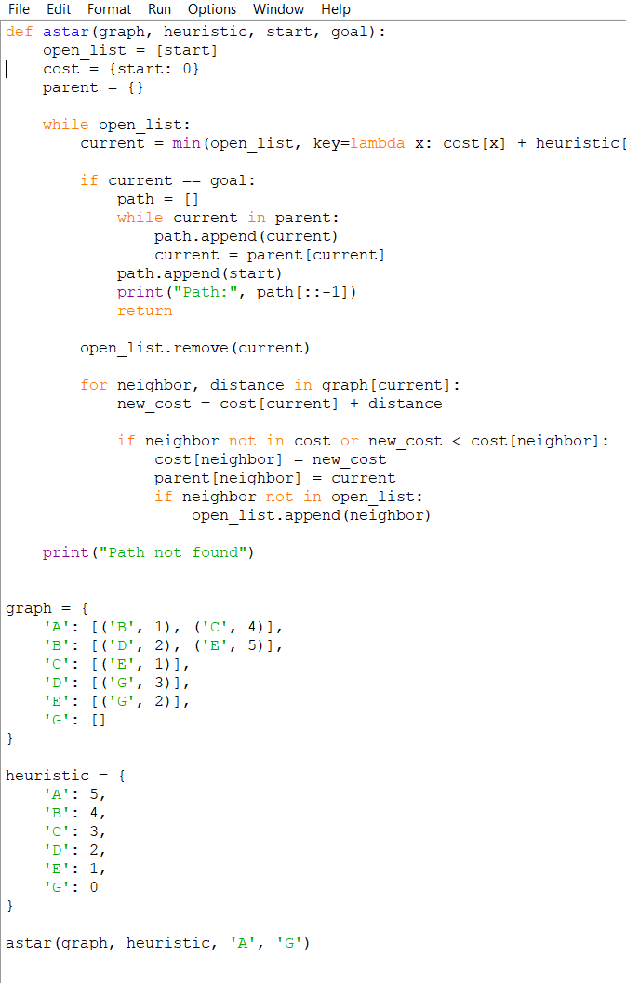
Output:
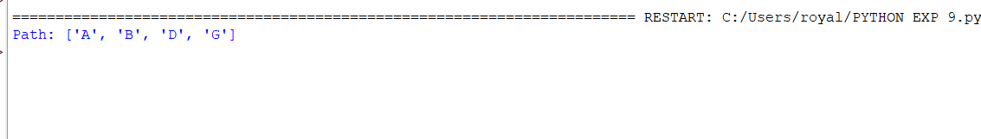

Result:
Thus, the A* search algorithm was successfully implemented in Python to find the shortest path from the starting node to the goal node.

