23. C program for AVL Tree
#include <stdio.h>
#include <stdlib.h>

// AVL Tree Node Structure
struct Node {
int key;
struct Node* left;
struct Node* right;
int height;
};

// Get height of node
int height(struct Node* n) {
if (n == NULL)
return 0;
return n->height;
}

// Get maximum of two integers
int max(int a, int b) {
return (a > b) ? a : b;
}

// Create a new node
struct Node* newNode(int key) {
struct Node* node = (struct Node*)malloc(sizeof(struct Node));
node->key = key;
node->left = NULL;
node->right = NULL;
node->height = 1; // New node is at height 1
return node;
}

// Get balance factor of node
int getBalance(struct Node* n) {
if (n == NULL)
return 0;
return height(n->left) - height(n->right);
}

// Right rotation
struct Node* rightRotate(struct Node* y) {
struct Node* x = y->left;
struct Node* T2 = x->right;

// Perform rotation
x->right = y;
y->left = T2;

// Update heights
y->height = max(height(y->left), height(y->right)) + 1;
x->height = max(height(x->left), height(x->right)) + 1;

return x;
}

// Left rotation
struct Node* leftRotate(struct Node* x) {
struct Node* y = x->right;
struct Node* T2 = y->left;

// Rotate
y->left = x;
x->right = T2;

// Update heights
x->height = max(height(x->left), height(x->right)) + 1;
y->height = max(height(y->left), height(y->right)) + 1;

return y;
}

// Insert a key in AVL tree
struct Node* insert(struct Node* node, int key) {
// Normal BST insertion
if (node == NULL)
return newNode(key);

if (key < node->key)
node->left = insert(node->left, key);
else if (key > node->key)
node->right = insert(node->right, key);
else
return node; // No duplicates allowed

// Update height
node->height = 1 + max(height(node->left), height(node->right));

// Get balance factor
int balance = getBalance(node);

// 4 Rotation Cases
// Left Left Case
if (balance > 1 && key < node->left->key)
return rightRotate(node);

// Right Right Case
if (balance < -1 && key > node->right->key)
return leftRotate(node);

// Left Right Case
if (balance > 1 && key > node->left->key) {
node->left = leftRotate(node->left);
return rightRotate(node);
}

// Right Left Case
if (balance < -1 && key < node->right->key) {
node->right = rightRotate(node->right);
return leftRotate(node);
}

return node; // No rotation needed
}

// Find minimum node (used in delete)
struct Node* minValueNode(struct Node* node) {
struct Node* current = node;
while (current->left != NULL)
current = current->left;
return current;
}

// Delete a key from AVL tree
struct Node* deleteNode(struct Node* root, int key) {
if (root == NULL)
return root;

if (key < root->key)
root->left = deleteNode(root->left, key);
else if (key > root->key)
root->right = deleteNode(root->right, key);
else {
// Node with one child or no child
if ((root->left == NULL) || (root->right == NULL)) {
struct Node* temp = root->left ? root->left : root->right;
if (temp == NULL) {
temp = root;
root = NULL;
} else {
*root = *temp;
}
free(temp);
}
// Two children
else {
struct Node* temp = minValueNode(root->right);
root->key = temp->key;
root->right = deleteNode(root->right, temp->key);
}
}

// If tree had only one node
if (root == NULL)
return root;

// Update height
root->height = 1 + max(height(root->left), height(root->right));

int balance = getBalance(root);

// Balance fixing cases
// Left Left
if (balance > 1 && getBalance(root->left) >= 0)
return rightRotate(root);

// Left Right
if (balance > 1 && getBalance(root->left) < 0) {
root->left = leftRotate(root->left);
return rightRotate(root);
}

// Right Right
if (balance < -1 && getBalance(root->right) <= 0)
return leftRotate(root);

// Right Left
if (balance < -1 && getBalance(root->right) > 0) {
root->right = rightRotate(root->right);
return leftRotate(root);
}

return root;
}

// Traversals
void preorder(struct Node* root) {
if (root != NULL) {
printf("%d ", root->key);
preorder(root->left);
preorder(root->right);
}
}

void inorder(struct Node* root) {
if (root != NULL) {
inorder(root->left);
printf("%d ", root->key);
inorder(root->right);
}
}

void postorder(struct Node* root) {
if (root != NULL) {
postorder(root->left);
postorder(root->right);
printf("%d ", root->key);
}
}

int main() {
struct Node* root = NULL;
int choice, val;

while (1) {
printf("\n===== AVL TREE MENU =====\n");
printf("1. Insert\n2. Delete\n3. Preorder\n4. Inorder\n5. Postorder\n6. Exit\n");
printf("Enter choice: ");
scanf("%d", &choice);

switch (choice) {
case 1:
printf("Enter value: ");
scanf("%d", &val);
root = insert(root, val);
break;

case 2:
printf("Enter value: ");
scanf("%d", &val);
root = deleteNode(root, val);
break;

case 3:
printf("Preorder: ");
preorder(root);
printf("\n");
break;

case 4:
printf("Inorder: ");
inorder(root);
printf("\n");
break;

case 5:
printf("Postorder: ");
postorder(root);
printf("\n");
break;

case 6:
exit(0);

default:
printf("Invalid choice!\n");
}
}

return 0;
}
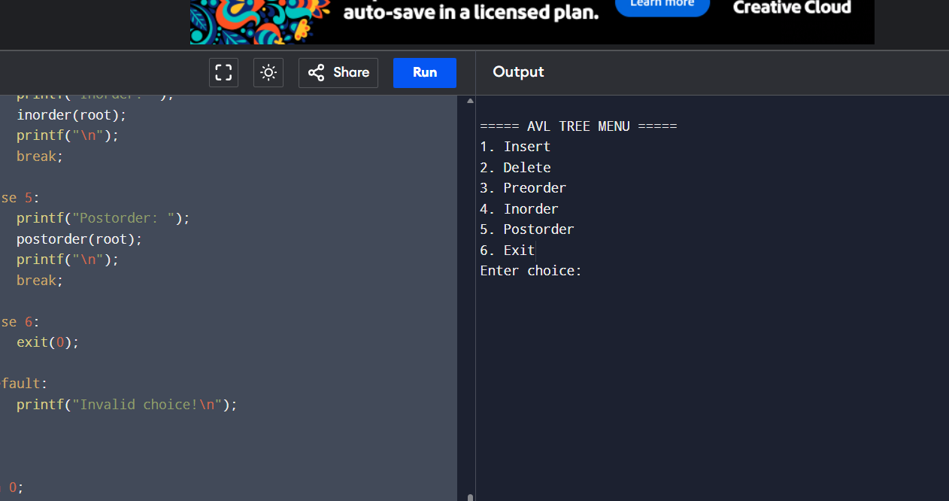
24. Whether it is the while stack
#include <stdio.h>
#include <stdlib.h>

#define MAX 100

int stack[MAX];
int top = -1;

// Push operation
void push(int x) {
if (top == MAX - 1) {
printf("Stack Overflow\n");
} else {
top++;
stack[top] = x;
printf("%d pushed into stack\n", x);
}
}

// Pop operation
void pop() {
if (top == -1) {
printf("Stack Underflow\n");
} else {
printf("%d popped from stack\n", stack[top]);
top--;
}
}

// Display stack
void display() {
if (top == -1) {
printf("Stack is empty\n");
} else {
printf("Stack elements: ");
for (int i = top; i >= 0; i--) {
printf("%d ", stack[i]);
}
printf("\n");
}
}

int main() {
int choice, value;

while (1) {
printf("\n====== STACK MENU ======\n");
printf("1. Push\n2. Pop\n3. Display\n4. Exit\n");
printf("Enter your choice: ");
scanf("%d", &choice);

switch (choice) {
case 1:
printf("Enter value to push: ");
scanf("%d", &value);
push(value);
break;

case 2:
pop();
break;

case 3:
display();
break;

case 4:
exit(0);

default:
printf("Invalid choice! Try again.\n");
}
}

return 0;
}
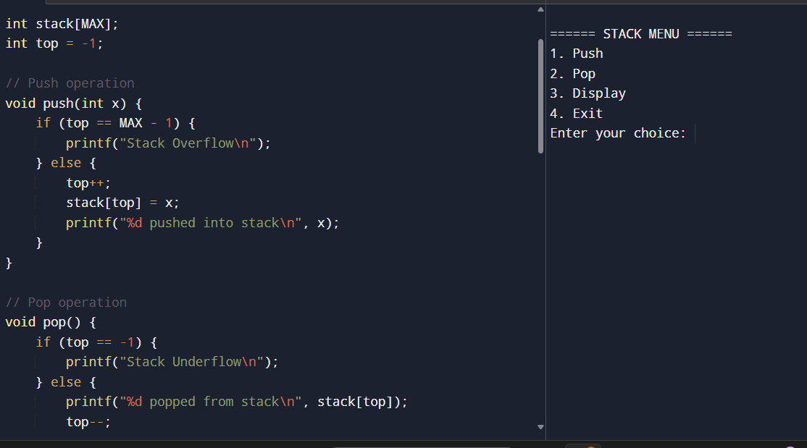
25.Binary search tree- search for element ,min,max element
#include <stdio.h>
#include <stdlib.h>

struct Node {
int data;
struct Node *left, *right;
};

// Create a new node
struct Node* createNode(int value) {
struct Node* temp = (struct Node*)malloc(sizeof(struct Node));
temp->data = value;
temp->left = temp->right = NULL;
return temp;
}

// Insert into BST
struct Node* insert(struct Node* root, int value) {
if (root == NULL)
return createNode(value);

if (value < root->data)
root->left = insert(root->left, value);
else if (value > root->data)
root->right = insert(root->right, value);

return root;
}

// Search for an element
struct Node* search(struct Node* root, int key) {
if (root == NULL || root->data == key)
return root;

if (key < root->data)
return search(root->left, key);
else
return search(root->right, key);
}

// Find minimum element
struct Node* findMin(struct Node* root) {
if (root == NULL)
return NULL;

while (root->left != NULL)
root = root->left;

return root;
}

// Find maximum element
struct Node* findMax(struct Node* root) {
if (root == NULL)
return NULL;

while (root->right != NULL)
root = root->right;

return root;
}

// Inorder traversal
void inorder(struct Node* root) {
if (root != NULL) {
inorder(root->left);
printf("%d ", root->data);
inorder(root->right);
}
}

int main() {
struct Node* root = NULL;
struct Node* temp;
int choice, value;

while (1) {
printf("\n===== BINARY SEARCH TREE MENU =====\n");
printf("1. Insert\n");
printf("2. Search Element\n");
printf("3. Find Minimum\n");
printf("4. Find Maximum\n");
printf("5. Inorder Traversal\n");
printf("6. Exit\n");
printf("Enter your choice: ");
scanf("%d", &choice);

switch (choice) {
case 1:
printf("Enter value to insert: ");
scanf("%d", &value);
root = insert(root, value);
break;

case 2:
printf("Enter element to search: ");
scanf("%d", &value);
temp = search(root, value);
if (temp)
printf("Element %d found in BST\n", value);
else
printf("Element %d NOT found in BST\n", value);
break;

case 3:
temp = findMin(root);
if (temp)
printf("Minimum element = %d\n", temp->data);
else
printf("Tree is empty!\n");
break;

case 4:
temp = findMax(root);
if (temp)
printf("Maximum element = %d\n", temp->data);
else
printf("Tree is empty!\n");
break;

case 5:
printf("Inorder Traversal: ");
inorder(root);
printf("\n");
break;

case 6:
exit(0);

default:
printf("Invalid choice! Try again.\n");
}
}
return 0;
}
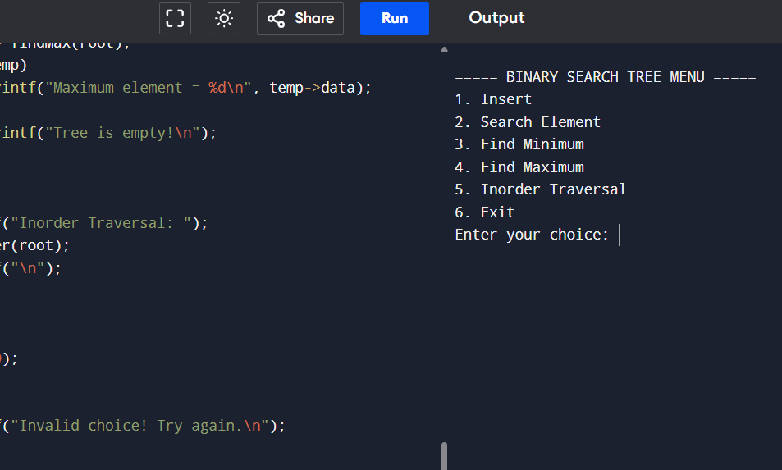
26.Bidecetional
#include <stdio.h>
#include <stdlib.h>

struct Node {
int data;
struct Node* prev;
struct Node* next;
};

struct Node* head = NULL;

// Create a new node
struct Node* createNode(int value) {
struct Node* temp = (struct Node*)malloc(sizeof(struct Node));
temp->data = value;
temp->prev = NULL;
temp->next = NULL;
return temp;
}

// Insert at beginning
void insertBegin(int value) {
struct Node* newNode = createNode(value);

if (head == NULL) {
head = newNode;
} else {
newNode->next = head;
head->prev = newNode;
head = newNode;
}
}

// Insert at end
void insertEnd(int value) {
struct Node* newNode = createNode(value);

if (head == NULL) {
head = newNode;
return;
}

struct Node* temp = head;
while (temp->next != NULL)
temp = temp->next;

temp->next = newNode;
newNode->prev = temp;
}

// Delete element
void deleteNode(int value) {
struct Node* temp = head;

while (temp != NULL && temp->data != value)
temp = temp->next;

if (temp == NULL) {
printf("Element not found!\n");
return;
}

if (temp->prev != NULL)
temp->prev->next = temp->next;
else
head = temp->next;

if (temp->next != NULL)
temp->next->prev = temp->prev;

free(temp);
printf("Deleted %d\n", value);
}

// Display forward
void displayForward() {
struct Node* temp = head;
printf("Forward: ");
while (temp != NULL) {
printf("%d ", temp->data);
temp = temp->next;
}
printf("\n");
}

// Display backward
void displayBackward() {
struct Node* temp = head;

if (temp == NULL) {
printf("List empty!\n");
return;
}

while (temp->next != NULL)
temp = temp->next;

printf("Backward: ");
while (temp != NULL) {
printf("%d ", temp->data);
temp = temp->prev;
}
printf("\n");
}

int main() {
int choice, value;

while (1) {
printf("\n===== BIDIRECTIONAL (DOUBLY) LINKED LIST MENU =====\n");
printf("1. Insert at Beginning\n");
printf("2. Insert at End\n");
printf("3. Delete\n");
printf("4. Display Forward\n");
printf("5. Display Backward\n");
printf("6. Exit\n");
printf("Enter your choice: ");
scanf("%d", &choice);

switch (choice) {
case 1:
printf("Enter value: ");
scanf("%d", &value);
insertBegin(value);
break;

case 2:
printf("Enter value: ");
scanf("%d", &value);
insertEnd(value);
break;

case 3:
printf("Enter value to delete: ");
scanf("%d", &value);
deleteNode(value);
break;

case 4:
displayForward();
break;

case 5:
displayBackward();
break;

case 6:
exit(0);

default:
printf("Invalid choice!\n");
}
}

return 0;
}
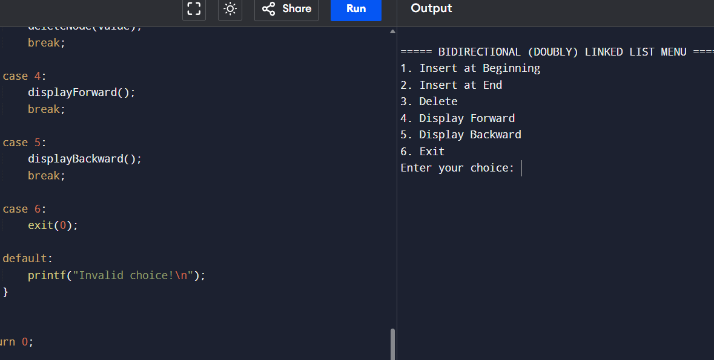
27.Merge two Arrays
#include <stdio.h>

int main() {
int a[50], b[50], c[100];
int n1, n2, i, j, k;

printf("Enter size of first array: ");
scanf("%d", &n1);

printf("Enter elements of first array (sorted): ");
for (i = 0; i < n1; i++)
scanf("%d", &a[i]);

printf("Enter size of second array: ");
scanf("%d", &n2);

printf("Enter elements of second array (sorted): ");
for (i = 0; i < n2; i++)
scanf("%d", &b[i]);

i = 0;
j = 0;
k = 0;

// Merge two sorted arrays
while (i < n1 && j < n2) {
if (a[i] < b[j])
c[k++] = a[i++];
else
c[k++] = b[j++];
}

// Copy remaining elements
while (i < n1)
c[k++] = a[i++];

while (j < n2)
c[k++] = b[j++];

// Print merged array
printf("Merged Array: ");
for (i = 0; i < k; i++)
printf("%d ", c[i]);

printf("\n");

return 0;
}
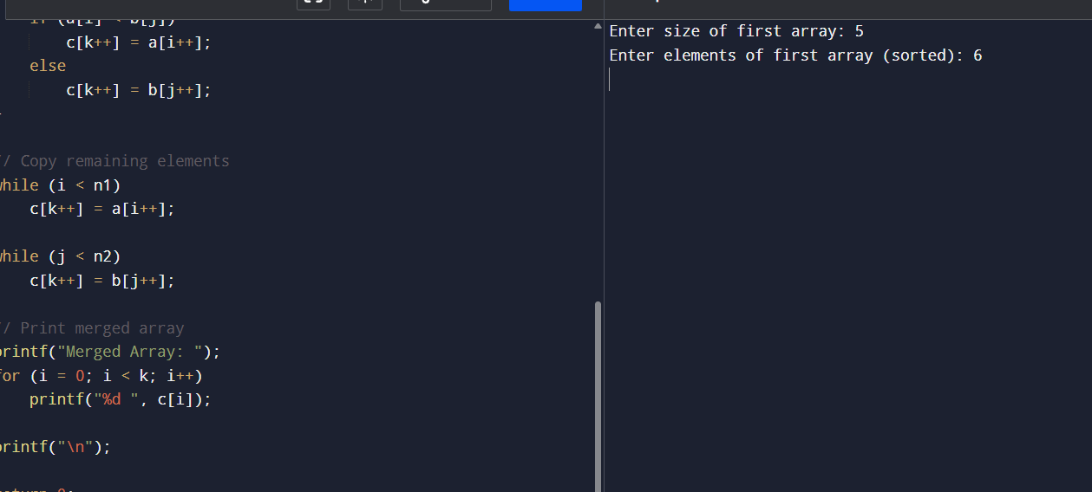
28. Finding duplication value
#include <stdio.h>

int main() {
int a[50], n, i, j;

printf("Enter size of array: ");
scanf("%d", &n);

printf("Enter elements: ");
for (i = 0; i < n; i++)
scanf("%d", &a[i]);

printf("Duplicate values: ");

int found = 0;
for (i = 0; i < n; i++) {
for (j = i + 1; j < n; j++) {
if (a[i] == a[j]) {
printf("%d ", a[i]);
found = 1;
break; // avoid printing same duplicate multiple times
}
}
}

if (!found)
printf("No duplicates found");

printf("\n");

return 0;
}
