SIMATS ENGINEERING
SAVEETHA SCHOOL OF ENGINEERING
Department of Computer Science and Engineering
ASSESSMENT TOOL – 3
Case Study
Course Code | DSA0127 | Course Title | Object Oriented Programming using C++ for Mobile App Development
CO Assessed | CO4 (BL3 & BL4) | Assessment | Tool – 3
Weightage | 20% | Total Marks | 100
Student Name | M. Yasodha Krishna | Reg No | 192472100
Section / Batch | CSE-AI 2nd year | Date | 12-05-2026
CO Statement | Analyse and implement C++ applications using inheritance, types of inheritance, virtual base classes, abstract classes, pointers, and polymorphism to design reusable and extensible programs. (BL3 & BL4)
Total Questions: 1 Total Marks: 100
RUBRICS FOR EVALUATION
Criteria | Weightage | Level 4 – Exemplary | Level 3 – Proficient | Level 2 – Developing | Level 1 – Beginning
Understanding of Case | 25 | Thorough understanding; clearly identifies all key issues | Good understanding with most issues identified | Basic understanding; some issues missed | Poor understanding; problem not identified correctly
Application of Concepts | 25 | Effectively applies relevant concepts to analyze the case deeply | Applies appropriate concepts with minor gaps | Limited application of concepts | Fails to apply relevant concepts
Analysis | 20 | In-depth analysis with strong reasoning and insights | Good analysis with logical reasoning | Basic analysis with limited depth | Weak or no analysis; lacks reasoning
Solution Design | 20 | Innovative, feasible solutions with strong justification | Logical solutions with adequate justification | Basic solutions with weak justification | Incorrect or no solution provided
Clarity | 10 | Clear, well-structured, and easy to understand | Organized and understandable presentation | Limited clarity and structure | Poor clarity; difficult to understand
Code of Conduct:
I ____________________ (Name / Reg No) certify that this submission is my original work and that I have adhered to the guidelines specified for this assessment. I understand that any violation of academic integrity rules will result in disciplinary action.
Signature of the student:

Hospital Management System using Advanced OOP Concepts in C++
Part A – System Analysis
1. Limitations of the Existing System
a) Redundant Data Storage
The current HMS stores patient information separately for different patient categories. This causes:
- Duplicate records
- Increased memory usage
- Difficulty in updating patient details
b) Lack of Flexibility in Billing
Different billing methods for Inpatients, Outpatients, and Emergency Patients are handled separately, making the system rigid and difficult to modify.
c) Poor Scalability
Adding new patient categories requires rewriting existing code, which increases development time and complexity.
d) Inefficient Memory Management
The system does not efficiently use memory allocation techniques, resulting in slower performance when handling large numbers of patients.
e) No Proper Code Reusability
Common patient information such as patient ID, name, and age are repeatedly written in multiple modules.
2. How OOP Principles Solve These Issues
a) Encapsulation
Encapsulation protects patient data by keeping variables private and allowing controlled access using public member functions.
b) Inheritance
Inheritance helps reuse common patient details from a base class (Patient) and reduces code duplication.
c) Polymorphism
Runtime polymorphism allows different patient types to implement their own billing methods using function overriding.
d) Abstraction
Abstract classes hide implementation details and provide only essential functionalities.
e) Dynamic Binding
The system can decide at runtime which billing function to execute, improving flexibility.
f) Composition
Using a Doctor member class inside Patient improves modularity and better organization.
3. Functional Requirements of the Improved System
The improved HMS should:
- Store patient details efficiently
- Support multiple patient categories
- Calculate bills dynamically
- Allow easy addition of new patient types
- Reduce redundant data storage
- Use dynamic memory allocation
- Maintain doctor details for every patient
- Provide a menu-driven interface
- Support runtime polymorphism
- Handle critical patients using multiple inheritance
Part B – System Design
1. Class Hierarchy Design
Abstract Base Class: Patient
Responsibilities
- Store common patient details
- Define abstract billing function
- Contain doctor information
Data Members
- Patient ID
- Patient Name
- Age
- Doctor object
Member Functions
- Input details
- Display details
- Pure virtual function calculateBill()
Member Class: Doctor
Responsibilities
Stores doctor-related information.
Data Members
- Doctor Name
- Specialization
Functions
- Input doctor details
- Display doctor details
Derived Classes
a) InPatient
Additional Members
- Room Charge
- Treatment Cost
Billing Logic
Total Bill = Room Charge + Treatment Cost
b) OutPatient
Additional Member
- Consultation Fee
Billing Logic
Total Bill = Consultation Fee
c) EmergencyPatient
Additional Member
- Emergency Charge
Billing Logic
Total Bill = Emergency Charge
2. Multiple Inheritance
CriticalPatient
CriticalPatient inherits from:
- InPatient
- EmergencyPatient
Purpose
Represents patients requiring hospitalization and emergency treatment.
Billing Logic
Total Bill = Room Charge + Treatment Cost + Emergency Charge
3. Use of Virtual Base Classes
Problem: Diamond Problem
Both InPatient and EmergencyPatient inherit from Patient.
Without virtual inheritance:
- CriticalPatient gets two copies of Patient
- Causes ambiguity
Solution
class InPatient : virtual public Patient
class EmergencyPatient : virtual public Patient
Benefits
- Only one copy of Patient is created
- Removes ambiguity
- Saves memory
UML Style Class Representation
Patient (Abstract)
|
-----------------------------------
| | |
InPatient OutPatient EmergencyPatient
\ /
\ /
---- CriticalPatient ----

Part C – Comparative Analysis
1. Inheritance vs Composition
Feature | Inheritance | Composition
Relationship | IS-A | HAS-A
Reusability | High | Moderate
Flexibility | Less flexible | More flexible
Example | InPatient is a Patient | Patient has a Doctor
Coupling | Tight | Loose

Conclusion
Inheritance is suitable for patient categories, while composition is suitable for doctor information.

2. Static Binding vs Dynamic Binding
Feature | Static Binding | Dynamic Binding
Decision Time | Compile Time | Runtime
Speed | Faster | Slightly slower
Flexibility | Low | High
Functions | Normal functions | Virtual functions

Conclusion
Dynamic binding improves flexibility in handling multiple patient types.
3. Role of Virtual Base Classes in Diamond Problem
Virtual base classes:
- Prevent duplicate inheritance
- Ensure only one base object exists
- Reduce ambiguity
- Improve memory efficiency
4. Benefits of Pointers in Dynamic Patient Handling
Pointers help:
- Allocate memory dynamically
- Store objects efficiently
- Implement runtime polymorphism
- Handle large patient records dynamically
Example:
Patient *p;
5. Justification of Design Approach
The design uses advanced OOP concepts to improve:
- Code reusability
- Scalability
- Maintainability
- Memory efficiency
The modular structure allows:
- Easy extension for future patient categories
- Independent billing implementations
- Better data organization
Part D – C++ Program Implementation
CODE :
#include <iostream>
#include <string>
using namespace std;

class Doctor
{
string doctorName;
string specialization;

public:
void getDoctor()
{
cin.ignore();

cout << "Enter Doctor Name: ";
getline(cin, doctorName);

cout << "Enter Specialization: ";
getline(cin, specialization);
}

void showDoctor()
{
cout << "Doctor Name: " << doctorName << endl;
cout << "Specialization: " << specialization << endl;
}
};

class Patient
{
protected:
int patientID;
string patientName;
int age;

public:
Doctor d;

Patient()
{
cout << "Patient Constructor Called" << endl;
}

virtual void getData()
{
cout << "Enter Patient ID: ";
cin >> patientID;

cin.ignore();

cout << "Enter Patient Name: ";
getline(cin, patientName);

cout << "Enter Age: ";
cin >> age;

d.getDoctor();
}

virtual void display()
{
cout << "\nPatient ID: " << patientID << endl;
cout << "Patient Name: " << patientName << endl;
cout << "Age: " << age << endl;

d.showDoctor();
}

virtual float calculateBill() = 0;

virtual ~Patient()
{
cout << "Patient Destructor Called" << endl;
}
};

class InPatient : virtual public Patient
{
protected:
float roomCharge;
float treatmentCost;

public:
void getData()
{
Patient::getData();

cout << "Enter Room Charge: ";
cin >> roomCharge;

cout << "Enter Treatment Cost: ";
cin >> treatmentCost;
}

float calculateBill()
{
return this->roomCharge + this->treatmentCost;
}
};

class OutPatient : virtual public Patient
{
protected:
float consultationFee;

public:
void getData()
{
Patient::getData();

cout << "Enter Consultation Fee: ";
cin >> consultationFee;
}

float calculateBill()
{
return consultationFee;
}
};

class EmergencyPatient : virtual public Patient
{
protected:
float emergencyCharge;

public:
void getData()
{
Patient::getData();

cout << "Enter Emergency Charge: ";
cin >> emergencyCharge;
}

float calculateBill()
{
return emergencyCharge;
}
};

class CriticalPatient : public InPatient, public EmergencyPatient
{
public:
void getData()
{
Patient::getData();

cout << "Enter Room Charge: ";
cin >> roomCharge;

cout << "Enter Treatment Cost: ";
cin >> treatmentCost;

cout << "Enter Emergency Charge: ";
cin >> emergencyCharge;
}

float calculateBill()
{
return roomCharge + treatmentCost + emergencyCharge;
}
};

int main()
{
Patient *p;
int choice;

cout << "1. InPatient" << endl;
cout << "2. OutPatient" << endl;
cout << "3. EmergencyPatient" << endl;
cout << "4. CriticalPatient" << endl;

cout << "Enter Choice: ";
cin >> choice;

switch(choice)
{
case 1:
p = new InPatient();
break;

case 2:
p = new OutPatient();
break;

case 3:
p = new EmergencyPatient();
break;

case 4:
p = new CriticalPatient();
break;

default:
cout << "Invalid Choice";
return 0;
}

p->getData();

p->display();

cout << "Total Bill = Rs." << p->calculateBill() << endl;

delete p;

return 0;
}

OUTPUT
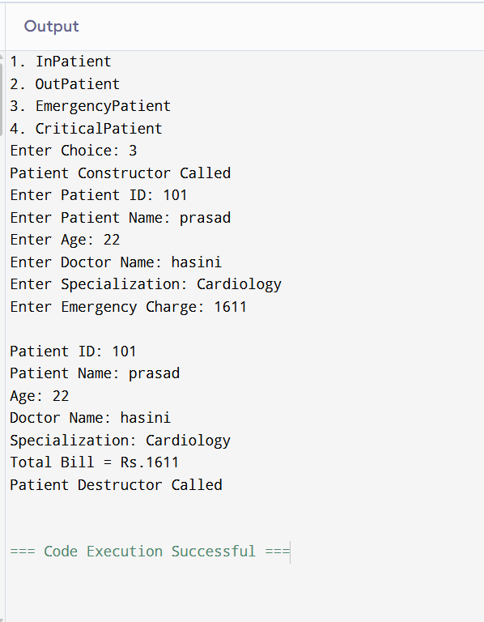
Conclusion
The redesigned Hospital Management System successfully applies advanced Object-Oriented Programming concepts such as:
- Inheritance
- Virtual base classes
- Runtime polymorphism
- Abstract classes
- Composition
- Dynamic memory allocation
This design improves:
- Flexibility
- Scalability
- Code reusability
- Maintainability
- Memory efficiency
The system can be easily extended in the future for additional patient categories and advanced hospital functionalities.

