SIMATS ENGINEERING (SAVEETHA SCHOOL OF ENGINEERING)
Department of Artificial Intelligence and Data Science
ASSESSMENT TOOL 1 – APPLICATION BASED QUESTIONS

Course Code: | DSA03 | Course Title: | Natural Language Processing
CO Assessed: | CO1 – Imitation (L1) | Assessment: | Assessment Tool 1 – Application Based Questions
Weightage: | 40% of CIA
CO1 Statement: | Analyse NLP models, regular expression patterns, finite state automata, morphological processing techniques and to interpret language processing. (BL-3)
Student Name: | M Yasodha Krishna | Reg. No.: | 192472100
Section / Batch: | DSA0304 | Date: | 13/7/2026

Code of Conduct
I __________________________ (Name / Reg No) certify that this submission is my original work and that I have adhered to the guidelines specified for this assessment. I understand that any violation of academic integrity rules will result in disciplinary action.
Signature of the Student: _________________________

Instructions
- Develop a modular and efficient Python program that satisfies all the functional requirements specified in the problem statement.
- Demonstrate the correctness of the implementation using suitable test cases and justify the output obtained.
- Follow good programming practices, including meaningful variable names, proper code indentation, comments, and error handling wherever applicable.
- Duration: 30 minutes.

Section / Topic | Focus | Q Nos
Information Extraction | Regex-Based Information Extraction | 1
Pattern Matching | Regex Pattern Matching | 2
Regular Expression Patterns | Regex-Based Input Validation | 3

Annexure A – Application Based Questions

Section 1: Regular Expressions – Resume Information Extraction
- A multinational recruitment company receives thousands of resumes every day in text format. The HR department requires an automated system to extract candidate information for shortlisting.

Design and implement a Python-based resume information extraction system using Regular Expressions that performs the following tasks:

Extract the candidate's name.
Identify email addresses.
Extract mobile numbers.
Detect technical skills (Python, Java, SQL, Machine Learning, NLP).
Extract years of experience.
Generate a structured summary of the candidate's profile.
Display candidates who satisfy the minimum eligibility criteria (minimum 2 years of experience and Python skill).

Section 2: Regular Expressions – Product Search System
- An e-commerce company plans to enhance its product search engine to improve customer experience through flexible keyword matching.

Design and implement a Python-based product search system using Regular Expressions that performs the following tasks:

Search products using an exact keyword.
Perform prefix-based searches.
Perform suffix-based searches.
Search using partial keywords.
Perform case-insensitive searches.
Display all matching product names.
Generate a report showing the total number of matching products for each search.
Section 3: Regular Expressions – University Registration System
A university is developing an automated online registration portal to verify student information before course enrollment.

Design and implement a Python-based validation system using Regular Expressions that performs the following tasks:

Validate the student register number.
Validate the institutional email address.
Validate the course code.
Validate the semester information.
Validate the student's mobile number.
Display appropriate validation messages for each field.
Generate a final registration status report indicating whether the registration is successful.

Rubrics for Calculation
Criteria | Weightage | Level 4 – Exemplary | Level 3 – Proficient | Level 2 – Developing | Level 1 – Beginning
Understanding of Problem Context | 20 | Clearly understands the problem and accurately identifies all requirements | Good understanding with minor gaps | Basic understanding; some requirements unclear | Poor understanding or misinterpretation of the problem
Application of Concepts | 30 | Accurately applies appropriate concepts to solve complex problems | Applies relevant concepts correctly with minor errors | Applies basic concepts with limited accuracy | Fails to apply appropriate concepts
Problem-Solving Approach | 20 | Logical, well-structured, and efficient approach | Mostly logical approach with minor gaps | Basic approach with some inconsistencies | Illogical or unclear approach
Accuracy of Solution | 20 | Completely correct solution with proper justification | Mostly correct with minor errors | Partially correct solution | Incorrect or incomplete solution
Clarity | 10 | Clear, well-organized, and properly explained solution | Understandable with minor clarity issues | Limited clarity and explanation | Poorly presented and difficult to understand

Q. No. / Criteria | Understanding of Problem Context | Application of Concepts | Problem-Solving Approach | Accuracy of Solution | Clarity | Sub. Total | Total %
1
2
3

Faculty In-charge | Course Coordinator | Program Director
Signature: _______________ | Signature: _______________ | Signature: _______________
Date: ___________________ | Date: ___________________ | Date: ___________________

QUESTION 1
Resume Information Extraction
Logic
- Imported the re module to use Regular Expressions in Python.
- Created a sample resume containing the candidate's details.
- Used regular expression patterns to extract the candidate's name, email address, mobile number, skills, and years of experience.
- Compared the extracted skills with the predefined skill list (Python, Java, SQL, Machine Learning, NLP).
- Displayed the extracted information in a structured format.
- Checked whether the candidate has Python skill and at least 2 years of experience.
- Displayed the eligibility status based on the given criteria.

CODE

import re

resume = """
Name: Ram
Email: ram@gmail.com
Mobile: 9876543210
Skills: Python, SQL, Machine Learning, NLP
Experience: 3 years
"""

name = re.search(r"Name:\s*(.*)", resume)
email = re.findall(r'[\w\.-]+@[\w\.-]+\.\w+', resume)
mobile = re.findall(r'\b\d{10}\b', resume)

skills_list = ["Python", "Java", "SQL", "Machine Learning", "NLP"]
skills_found = []

for skill in skills_list:
if re.search(skill, resume, re.IGNORECASE):
skills_found.append(skill)

experience = re.search(r'(\d+)\s+years', resume)

print("----- Candidate Profile -----")

if name:
print("Name:", name.group(1))

print("Email:", email[0])
print("Mobile:", mobile[0])
print("Skills:", ", ".join(skills_found))

exp_years = int(experience.group(1))
print("Experience:", exp_years, "years")

print("\nEligibility Status")

if exp_years >= 2 and "Python" in skills_found:
print("Eligible for Shortlisting")
else:
print("Not Eligible")

OUTPUT
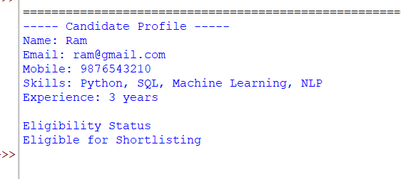

QUESTION 2
Logic
- Imported the re module for Regular Expression operations.
- Created a list of product names available in the system.
- Accepted a search keyword from the user.
- Used regular expressions to perform different types of searches:
- Exact keyword search
- Prefix search
- Suffix search
- Partial keyword search
- Case-insensitive search
- Stored all matching products in separate lists.
- Displayed the matching product names for each search type.
- Counted the number of matching products and generated a search report.

CODE

import re

# Product list
products = [
"Laptop",
"Laptop Bag",
"Smartphone",
"Phone Charger",
"Bluetooth Speaker",
"Wireless Mouse",
"Gaming Laptop",
"USB Cable"
]

keyword = input("Enter search keyword: ")

# Exact Match
exact_matches = [p for p in products if re.fullmatch(keyword, p, re.IGNORECASE)]

# Prefix Search
prefix_matches = [p for p in products if re.search("^" + re.escape(keyword), p, re.IGNORECASE)]

# Suffix Search
suffix_matches = [p for p in products if re.search(re.escape(keyword) + "$", p, re.IGNORECASE)]

# Partial Search
partial_matches = [p for p in products if re.search(re.escape(keyword), p, re.IGNORECASE)]

print("\n----- PRODUCT SEARCH REPORT -----")

print("\nExact Match:")
for item in exact_matches:
print(item)
print("Total Matches:", len(exact_matches))

print("\nPrefix Search:")
for item in prefix_matches:
print(item)
print("Total Matches:", len(prefix_matches))

print("\nSuffix Search:")
for item in suffix_matches:
print(item)
print("Total Matches:", len(suffix_matches))

print("\nPartial / Case-Insensitive Search:")
for item in partial_matches:
print(item)
print("Total Matches:", len(partial_matches))

OUTPUT
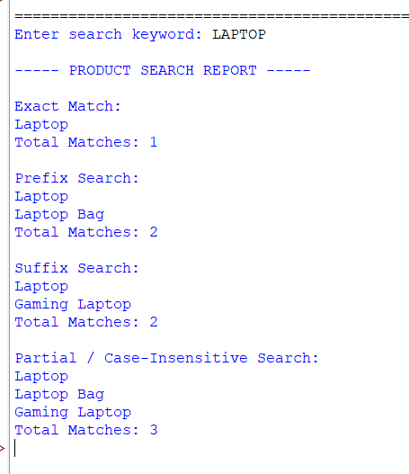

QUESTION 3
1. Imported the re module to perform input validation using Regular Expressions.
2. Accepted the student's register number, email address, course code, semester, and mobile number.
3. Used suitable regular expression patterns to validate each field.
4. Displayed a valid or invalid message for every input field.
5. Maintained a status variable to track whether all validations are successful.
6. If all fields are valid, the registration status is marked as successful.
7. If any field is invalid, the registration status is marked as failed.
8. Displayed the final registration status report.

CODE
import re

# Input from user
reg_no = input("Enter Register Number: ")
email = input("Enter Institutional Email: ")
course_code = input("Enter Course Code: ")
semester = input("Enter Semester (1-8): ")
mobile = input("Enter Mobile Number: ")

status = True

# Validate Register Number (Example: 192472100)
if re.fullmatch(r'\d{9}', reg_no):
print("Register Number: Valid")
else:
print("Register Number: Invalid")
status = False

# Validate Institutional Email
if re.fullmatch(r'[a-zA-Z0-9._%+-]+@saveetha\.com', email):
print("Email Address: Valid")
else:
print("Email Address: Invalid")
status = False

# Validate Course Code (Example: DSA03)
if re.fullmatch(r'[A-Z]{3}\d{2}', course_code):
print("Course Code: Valid")
else:
print("Course Code: Invalid")
status = False

# Validate Semester (1 to 8)
if re.fullmatch(r'[1-8]', semester):
print("Semester: Valid")
else:
print("Semester: Invalid")
status = False

# Validate Mobile Number (10 digits starting with 6,7,8,9)
if re.fullmatch(r'[6-9]\d{9}', mobile):
print("Mobile Number: Valid")
else:
print("Mobile Number: Invalid")
status = False

# Final Registration Status
print("\n----- REGISTRATION STATUS -----")

if status:
print("Registration Successful")
else:
print("Registration Failed")

OUTPUT
