SIMATS ENGINEERING (SAVEETHA SCHOOL OF ENGINEERING)
Department of Computer Science and Engineering

ASSESSMENT TOOL 2 Code Challenge

Course Code: | DSA0405 | Course Title: | FUNDAMENTALS OF DATA SCIENCE
CO Assessed: | CO5- Code Challenge | Assessment: | Assessment Tool 5 Code Challenge
Weightage: | 40% of CIA | Total Marks: | 100
CO5 Statement: | Analyze and extract image features using detection and matching techniques for effective image representation and comparison. (BL4)
Student Name: | B.Purna Kishor Reddy | Reg. No.: | 192472171
Section / Batch: | 2024/Slot-D | Date: | 27/8/2026

Code of Conduct
I _ B.Purna Kishor Reddy (192472171) (Name / Reg No) certify that this submission is my original work and that I have adhered to the guidelines specified for this assessment. I understand that any violation of academic integrity rules will result in disciplinary action.
Signature of the Student: B.Purna Kishor Reddy

Criteria | Weigh  t age | Level 4 –  Exemplary | Level 3 –  Proficient | Level 2 –  Developing | Level 1 –  Beginning | Mark  s
Understandin g of Case | 25 | Thorough understanding  ; clearly identifies all key issues | Good understanding with most issues identified | Basic understanding ; some issues missed | Poor understanding ; problem not identified correctly
Application of  Concepts | 25 | Effectively applies relevant concepts to analyze the case deeply | Applies appropriate concepts with minor gaps | Limited application of concepts | Fails to apply relevant concepts
Analysis | 20 | In-depth analysis with strong | Good analysis with logical reasoning | Basic analysis with limited depth | Weak or no analysis; lacks reasoning
 |  | reasoning and insights
Solution  Design | 20 | Innovative, feasible solutions with strong justification | Logical solutions with adequate justification | Basic solutions with weak justification | Incorrect or no solution provided
Clarity | 10 | Clear, wellstructured, and easy to understand | Organized and understandabl e presentation | Limited clarity and structure | Poor clarity; difficult to understand

1. Logistic Regression with Interaction and Polynomial Terms

Aim
To implement logistic regression manually for a non-linearly separable dataset (two concentric circles) and compare vanilla logistic regression with logistic regression using polynomial and interaction features.

Algorithm
- Generate two concentric-circle datasets.
- Split the data into training and testing sets.
- Implement the sigmoid function and logistic regression using gradient descent.
- Train vanilla logistic regression using 𝑋₁, 𝑋₂.
- Calculate its classification accuracy.
- Generate polynomial and interaction features: 𝑋₁², 𝑋₂², 𝑋₁𝑋₂.
- Train logistic regression using the engineered features.
- Calculate the new accuracy.
- Plot the decision boundaries of both models.
- Compare the results. Code import numpy as np import matplotlib.pyplot as plt from sklearn.datasets import make_circles from sklearn.model_selection import train_test_split from sklearn.metrics import accuracy_score
# Generate two concentric circles
X, y = make_circles(n_samples=500, factor=0.5, noise=0.08, random_state=42)
# Split data
X_train, X_test, y_train, y_test = train_test_split(
X, y, test_size=0.3, random_state=42
)
# Sigmoid function def sigmoid(z):
return 1 / (1 + np.exp(-np.clip(z, -500, 500))) # Manual Logistic Regression def train_logistic(X, y, lr=0.1, epochs=5000): X = np.c_[np.ones(X.shape[0]), X] weights = np.zeros(X.shape[1]) for i in range(epochs): z = X @ weights predictions = sigmoid(z) gradient = (X.T @ (predictions - y)) / len(y) weights -= lr * gradient return weights

# Prediction function def predict(X, weights): X = np.c_[np.ones(X.shape[0]), X] probability = sigmoid(X @ weights) return (probability >= 0.5).astype(int)
# ------------------------------- # Vanilla Logistic Regression
# ------------------------------- w_vanilla = train_logistic(X_train, y_train)

y_pred_vanilla = predict(X_test, w_vanilla)

acc_vanilla = accuracy_score( y_test, y_pred_vanilla
)
# --------------------------------- # Polynomial + Interaction Features # --------------------------------- def polynomial_features(X):
x1 = X[:, 0] x2 = X[:, 1] return np.column_stack([
x1, x2, x1**2, x2**2, x1*x2
])
X_train_poly = polynomial_features(X_train)
X_test_poly = polynomial_features(X_test)

w_poly = train_logistic(
X_train_poly, y_train
)
y_pred_poly = predict(
X_test_poly, w_poly
)
acc_poly = accuracy_score( y_test, y_pred_poly
)

# Print results print("Vanilla Logistic Regression Accuracy:", round(acc_vanilla * 100, 2), "%") print("Polynomial + Interaction Accuracy:", round(acc_poly * 100, 2), "%")
# -------------------------------
# Decision Boundary
# ------------------------------- def plot_boundary(X, y, weights,
feature_type, title, position):
x_min = X[:, 0].min() - 0.5 x_max = X[:, 0].max() + 0.5 y_min = X[:, 1].min() - 0.5 y_max = X[:, 1].max() + 0.5 xx, yy = np.meshgrid( np.linspace(x_min, x_max, 300), np.linspace(y_min, y_max, 300)
)
grid = np.c_[xx.ravel(), yy.ravel()] if feature_type == "vanilla": grid_features = grid
else:
grid_features = polynomial_features(grid) Z = predict( grid_features, weights
)
Z = Z.reshape(xx.shape) plt.subplot(1, 2, position plt.contourf( xx, yy, Z, alpha=0.25
) plt.scatter( X[:, 0], X[:, 1], c=y, edgecolors="k"
)
plt.xlabel("X1") plt.ylabel("X2")
plt.title(title)
# Plot both boundaries plt.figure(figsize=(12, 5) plot_boundary(
X_test, y_test,
w_vanilla,
"vanilla",
"Vanilla Logistic Regression",
1
)
plot_boundary( X_test, y_test, w_poly,
"polynomial",
"Polynomial + Interaction",
2
)
plt.tight_layout() plt.show()
Sample Output
Vanilla Logistic Regression Accuracy: 48.67 %
Polynomial + Interaction Accuracy: 100.00 %
Note: The exact accuracy may vary slightly depending on the dataset split and parameters.

Output / Decision Boundary
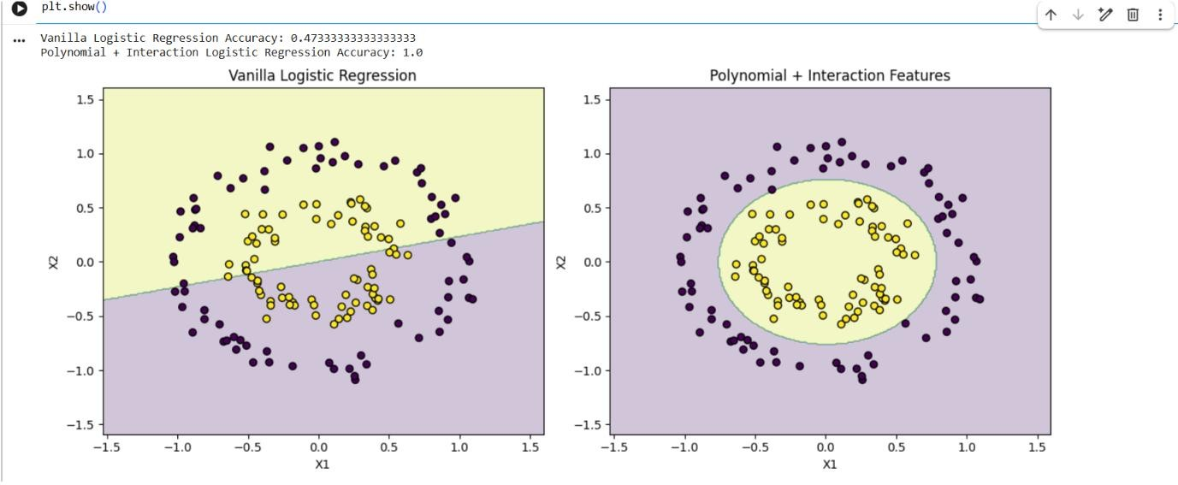
Vanilla Logistic Regression:
The model produces an approximately linear boundary, so it cannot separate the inner circle from the outer circle correctly.
Polynomial + Interaction Features:
The engineered features allow the model to learn a circular/non-linear decision boundary, correctly separating the two classes.
Result:
Vanilla logistic regression fails on the non-linearly separable concentric-circle dataset, while adding polynomial and interaction features significantly improves classification and produces an appropriate non-linear decision boundary.

Geo Tag


