UNIT 2 – PROMPT ENGINEERING
EXPERIMENT 1
Name: Akshaya Gajjala
Registration Number: 192472338

Aim
To demonstrate zero-shot, one-shot, and few-shot prompting techniques by generating a product description for a smart fitness watch.

Algorithm
- Start the program.
- Define a zero-shot prompt that asks for a smart fitness watch description without examples.
- Define a one-shot prompt that includes one example of the expected style.
- Define a few-shot prompt that includes multiple examples.
- Display each prompt type and its corresponding sample response.
- End the program.

Process
The program compares three prompting methods. Zero-shot prompting gives the model only an instruction. One-shot prompting provides one example, while few-shot prompting provides multiple examples to guide the response. The sample outputs below are illustrative and are printed directly by the program; they are not generated by a live language model.

Input
Product: Smart Fitness Watch
Required output: A short, attractive product description.

Python Code
def experiment_1():
print("ZERO-SHOT PROMPT")
zero_shot_prompt = (
"Write a short product description for a smart fitness watch."
)
print("Prompt:", zero_shot_prompt)
print("Output: Track your steps, monitor your heart rate, and stay "
"connected with this smart fitness watch. Its sleek design and "
"helpful health features support your everyday goals.\n")
print("ONE-SHOT PROMPT")
one_shot_prompt = (
"Example: Product: Wireless Earbuds. Description: Enjoy clear sound "
"and comfortable listening wherever you go.\n"
"Now write a description for a Smart Fitness Watch."
)
print("Prompt:", one_shot_prompt)
print("Output: Keep your fitness goals on track with a smart watch that "
"monitors activity, checks your heart rate, and keeps you connected.\n")
print("FEW-SHOT PROMPT")
few_shot_prompt = (
"Product: Water Bottle. Description: Stay hydrated throughout the day.\n"
"Product: Backpack. Description: Carry your essentials in comfort.\n"
"Product: Smart Fitness Watch. Description:"
)
print("Prompt:", few_shot_prompt)
print("Output: Monitor your daily activity and heart rate while enjoying "
"smart notifications in a stylish, easy-to-wear design.")
experiment_1()

Output
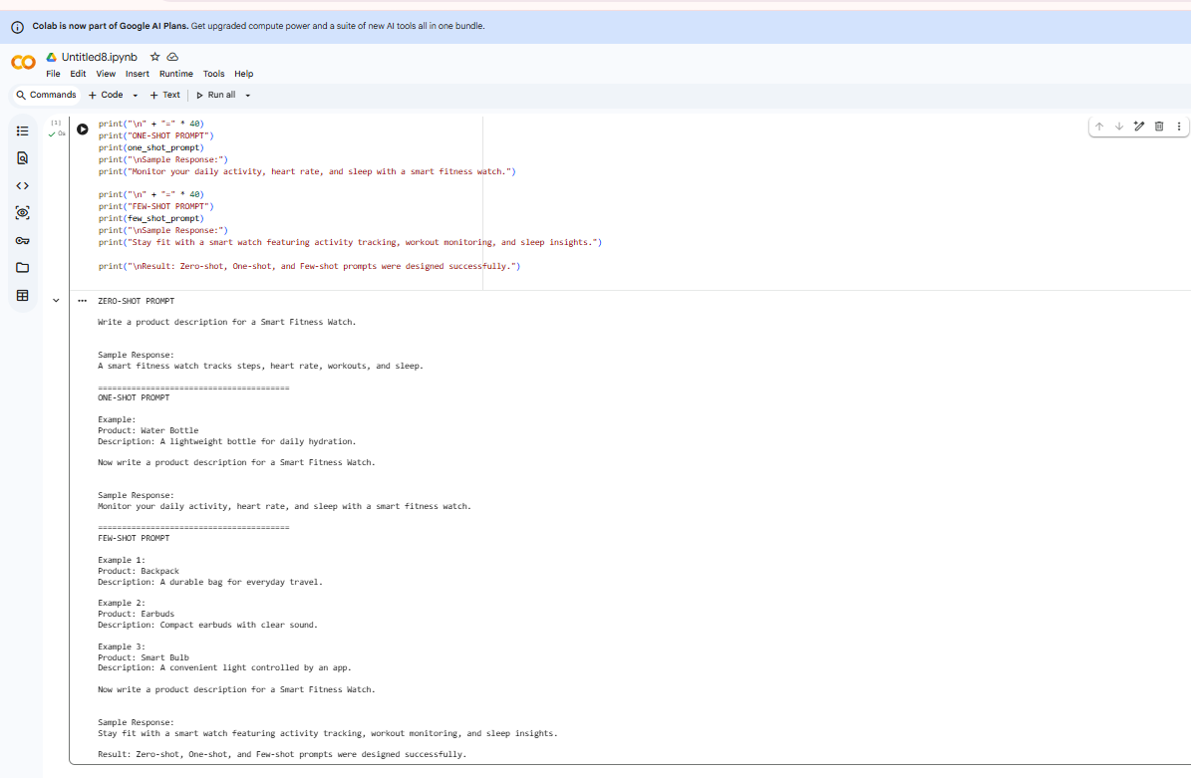

Result
The program demonstrates the difference between zero-shot, one-shot, and few-shot prompting. Examples can help guide the style and structure of the expected response.

