SOFTWARE ENGINEERING
Assignment 2
CSA10 – SOFTWARE ENGINEERING
CO2: Analyze software requirements to design scalable and efficient system architectures using collaborative tools like Jira and Confluence, along with structured modeling techniques such as UML diagrams and architectural design patterns.
Assignment Title: Design and Validate Requirements and Architecture for the Omnichannel Order Fulfilment Platform
Nature of Assignment: Individual
Duration: One week
Total Marks: 50
Submission Date: __________________
Scenario — Order Fulfilment Requirements and Scalable Architecture
A retailer needs an order fulfilment architecture that connects checkout, stock reservation, payment callbacks, warehouse picking, courier tracking and refunds without losing consistency or exposing restricted customer information. Repeated payment callbacks, two buyers competing for the last unit and failed courier synchronization create conflicting requirements for speed, availability, accountability and confidentiality. Analyze stakeholder needs and create a testable requirements specification with traceable UML models and justified architectural alternatives. Validate order and refund invariants, data ownership and failure handling. Redesign the selected architecture for additional regions, increased demand and disconnected warehouse scanners while explaining consistency, availability and operating-cost trade-offs.
The retailer proposes an omnichannel order fulfilment platform. Its intended modules are a storefront catalogue, cart and checkout, payment integration, inventory synchronization, order tracking, a warehouse picking dashboard, returns and refunds, a support console and sales analytics. The system should connect a customer order to stock reservation, payment confirmation, picking, dispatch, tracking, delivery and, where needed, an authorized return and refund.
Architecture conditions for the representative release are stated below.

Observation Scenario planning condition
Operational scope Checkout, stock reservation, payment confirmation, picking, dispatch, tracking, returns and refunds Users Administrator, picker, support agent, finance reviewer, store manager and customer Reference data Synthetic products, orders and stock movements; no real customer or card data.

Observation Scenario planning condition
Integration constraint Payment gateway or courier API may be unavailable or may send duplicate callbacks; preserve local order records and retry safely
Validation need Verify stock, order status, price, authorization, persistence and refund audit behaviour
Principal users are enterprise administrators, warehouse pickers, support agents, finance reviewers, store managers and customers. They need different permissions. Pickers require accurate pick lists; support agents require readable order and return status; finance reviewers require auditable refund approvals; engineers require traceable links between orders, payments and courier shipments. Automation must preserve human responsibility for refund approval and stock corrections.
Customers want fast checkout and clear tracking; pickers want reliable stock reservation; support agents want order visibility without seeing payment data; finance reviewers require approval before refunds above a limit. Management wants consolidated sales, stock and refund reporting. These interests may conflict when speed, privacy and refund controls compete.
Use a manageable representative release and synthetic orders and stock events. Jira, Confluence, GitHub, Jenkins and Docker are suitable reference tools; select and justify alternatives where appropriate. A React interface, FastAPI service and PostgreSQL database are one feasible reference architecture, not compulsory choices. External integrations may be demonstrated through controlled test interfaces when live access is unavailable, with their status disclosed.
Define workload, service-level policies and acceptance thresholds as explicit planning assumptions. Dashboard values, stock counts and screenshots are illustrative evidence of displayed behaviour, not proof of production accuracy, performance, live inventory control or secure payment handling. Verify claims through repeatable checks. Distinguish deterministic rules, such as fixed low-stock thresholds, from trained machine-learning forecasting, and label simulations and proposed extensions accurately.
Design Challenge:
Repeated payment callbacks may create duplicate payments or orders, while two customers may buy the last unit. Courier synchronization may fail after the order is stored. A refund must not bypass its required approval, and a support agent must not gain finance privileges merely by selecting another role in the interface.
The organization requires consistent order state, auditable refunds and dependable integration while its small technical team initially operates a modest deployment. Additional services must be justified against operational cost and complexity.
Design and validate a requirements specification and scalable system architecture using collaborative and modeling tools of your choice that address these conditions.
Develop alternative architectural solutions and create a justified design connecting stakeholder needs, allocation rules, quality requirements and architectural decisions. Maintain traceability
between requirements, UML models, architectural components and validation scenarios.
Examine at least two suitable tool arrangements for requirements tracking, collaborative documentation and UML modeling. Select a tool or combination of tools and justify its suitability, considering traceability, collaboration, version history, diagram support, accessibility and cost. Explain any limitations and how you will address them.
Validate the design against deliberately constructed scenarios. Use the findings to revise your requirements and architecture, and defend the final design’s consistency, scalability and limitations. Explain how the selected tools support collaboration and keep the specification, models and design decisions consistent.
Q1 – Investigate Stakeholder Needs and Resolve Conflicts 5 Marks
Investigate the needs of customers, pickers, support agents, administrators, store managers and finance reviewers.
• Formulate at least three questions that investigate an unresolved requirement or stakeholder conflict.
• Gather findings through a small stakeholder discussion, questionnaire or process review. Where access is unavailable, use clearly labelled simulated responses.
• Identify at least three conflicting expectations.
• Develop and justify a resolution for each conflict.
• Define the system boundary, principal actors and scope exclusions.
Do not assume that every stakeholder request should become a requirement.
Evidence Expected Investigation questions, findings or labelled simulated responses, a stakeholder analysis, conflict- resolution decisions and a justified system boundary.

Stakeholder Investigation:
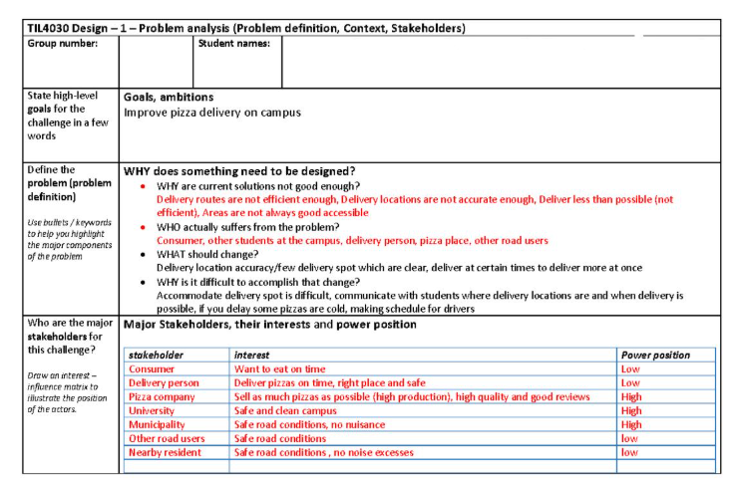
Conflict Resolution:
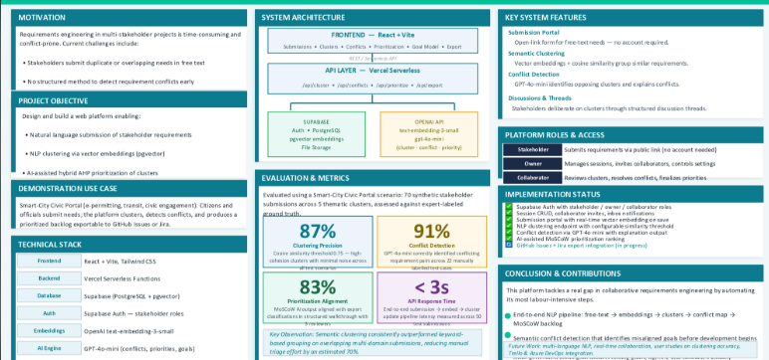

System Boundary Diagram
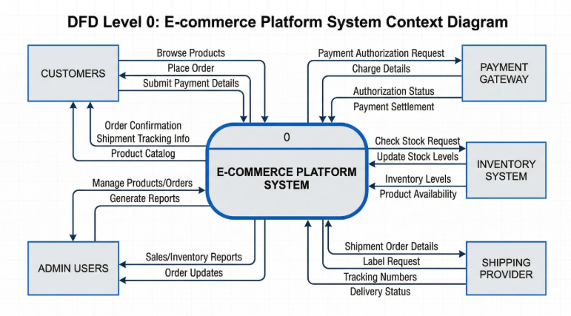
Output:
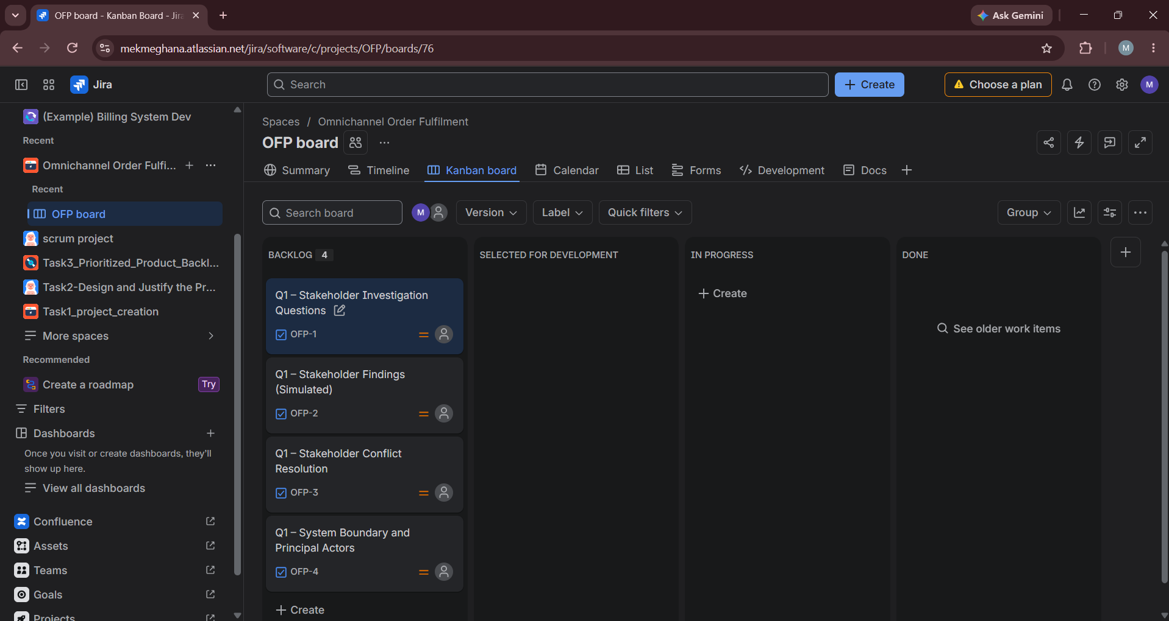
Q2 – Create a Prioritized and Testable Requirements Specification 8 Marks
Create a requirements specification in a selected collaborative documentation tool and represent prioritized requirements in a selected issue tracker. Jira and Confluence are reference options; justify the arrangement chosen.
• At least twelve functional requirements and six non-functional requirements.
• Unique identifiers, sources, priorities and acceptance criteria.
• Order rules covering price and tax calculation, stock reservation, ownership, permitted status changes, dispatch deadlines, duplicate payment callbacks and refund approvals.
• Measurable quality requirements for performance, availability, security and usability.
• Explicit assumptions and unresolved questions.
• A justified prioritization method.
• Replacement of vague statements such as “checkout should be fast” with requirements that specify the operating condition and an observable acceptance threshold.
Page 4
• An explanation of how at least two stakeholder conflicts influenced the final specification.
Evidence Expected Collaborative specification, requirement records, measurable acceptance criteria, prioritization rationale and documented assumptions.
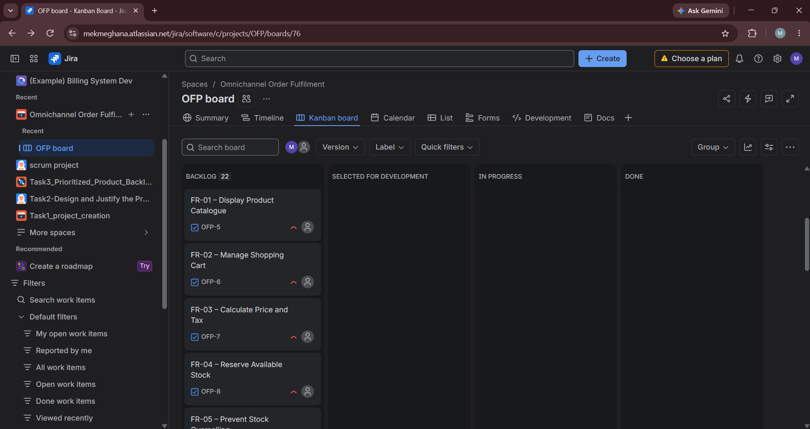
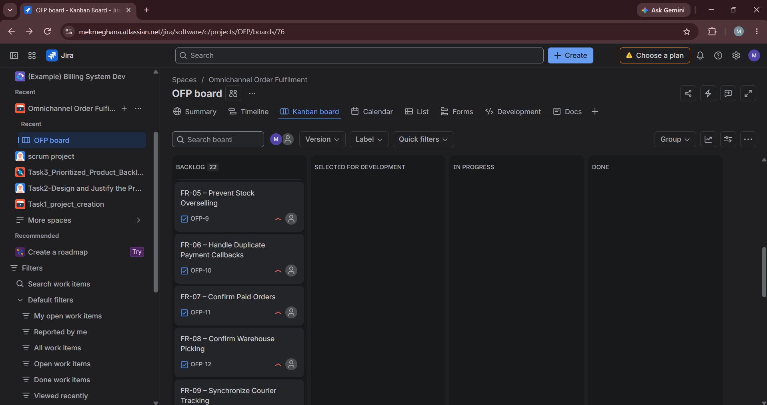
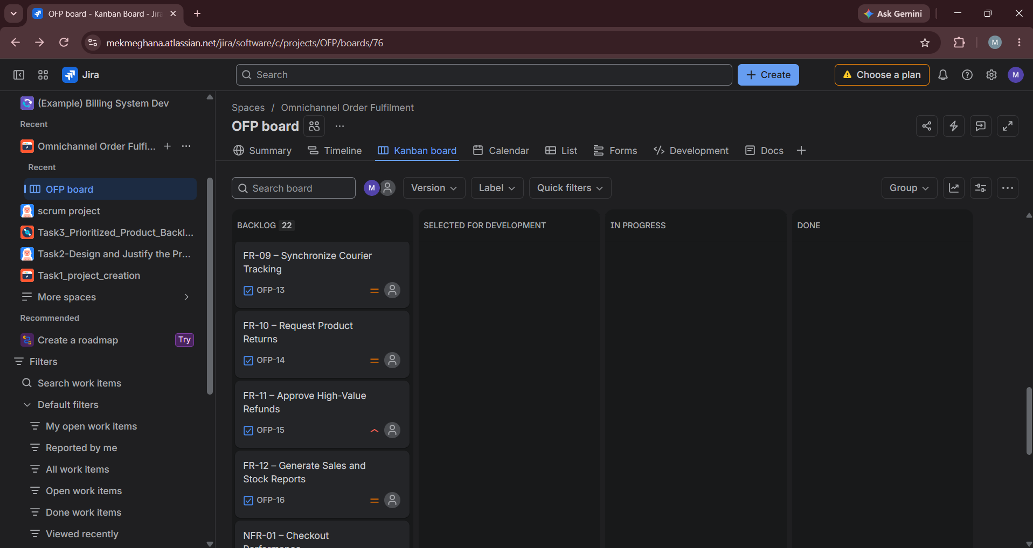
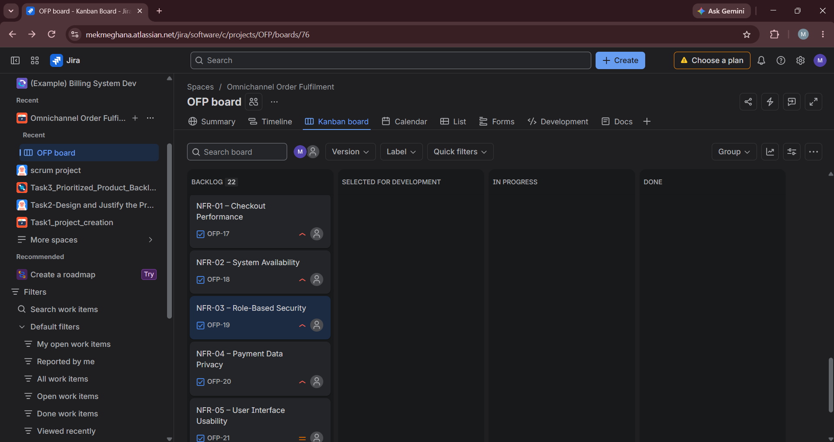
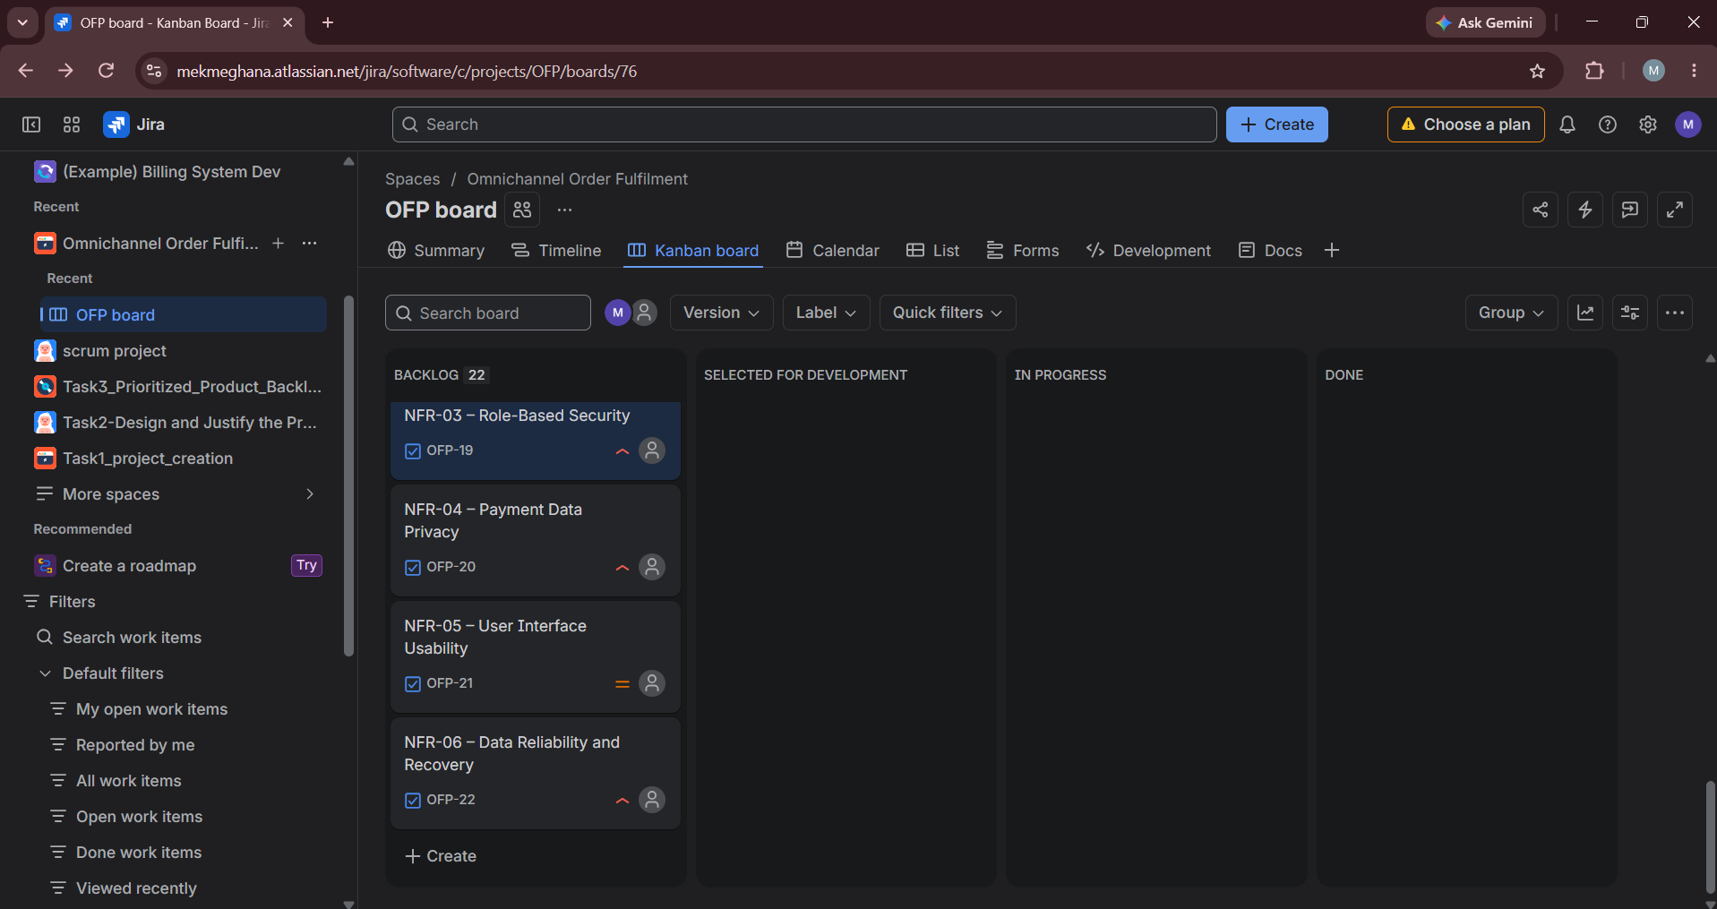
Q3 – Construct UML Models and Maintain Traceability 7 Marks
Create a consistent set of UML models covering:
• A use case diagram showing actors and principal interactions.
• A class diagram representing important domain concepts and relationships.
• A sequence diagram tracing a payment callback through order confirmation, shipment creation and courier synchronization, including a retry or failure.
• A state machine for Placed, Paid, Packed, Dispatched, Delivered and Closed orders, including authorized cancellation or return if supported.
• Approval, rejection, execution and rollback behaviour for refunds, modelled where relevant.
• A traceability matrix connecting Requirement → UML Element → Architectural Component → Validation Scenario.
• Identification and resolution of at least two inconsistencies discovered while connecting these representations.
Evidence Expected Four UML diagrams, a traceability matrix, identified inconsistencies and documented corrections.
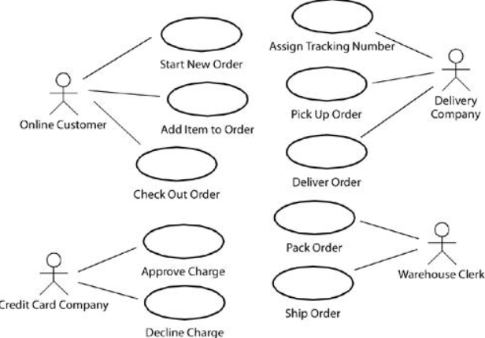
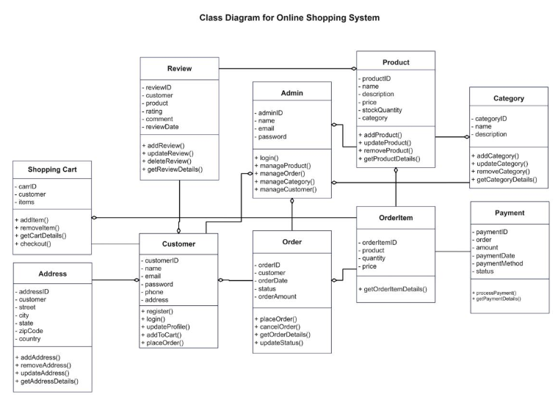
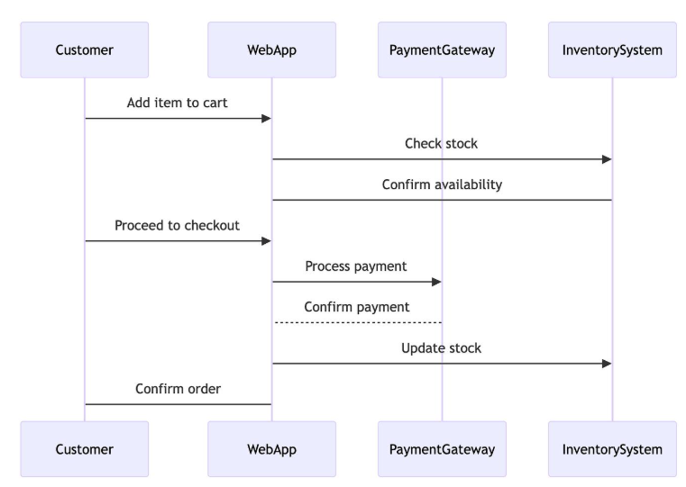
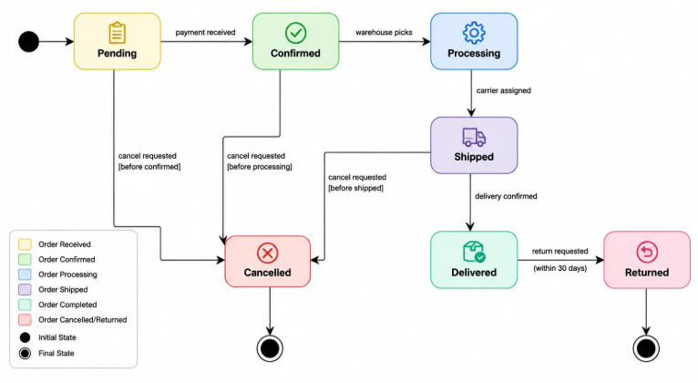

Q4 – Design and Justify Alternative Architectures 8 Marks
Develop two meaningfully different architectural alternatives for the system. Select appropriate patterns, such as a modular monolith, microservices or event-driven architecture. For each alternative:
• Define the principal components and responsibilities.
• Explain communication and data ownership.
• Describe how duplicate payment processing and overselling of the last unit would be prevented.
• Examine scalability, consistency, availability, security and operational complexity.
• Identify likely failure points and maintenance implications.
Then select an architecture and create component and deployment diagrams. Document at least three architectural decisions in your selected documentation tool. State each problem, alternatives, selection, justification and consequences.
Evidence Expected Two architectural alternatives, a reasoned comparison, selected component and deployment diagrams, and three architectural decision records.
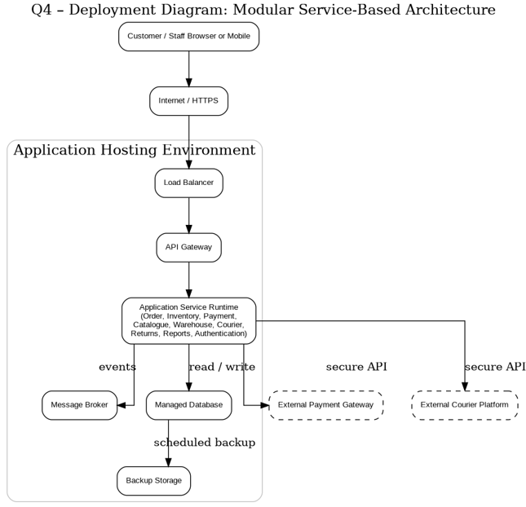
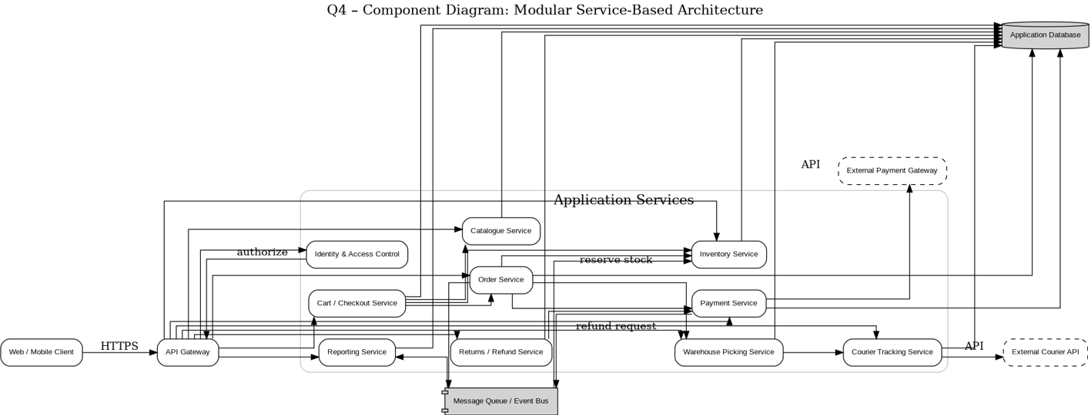
Q5 – Validate Critical Behaviour and Revise the Design 7 Marks
Define order and refund rules that must remain true throughout operation. Include invariants such as:
The same gateway event identity must not create multiple payments or order confirmations; an unapproved refund must not be marked as executed through an approval-gated operation.
Specify preconditions and postconditions for at least two critical operations. Construct at least six validation scenarios, including:
• Two customers attempting to buy the last unit of a product.
• A repeated payment callback arriving while the original callback is being processed.
• An approved refund failing at the gateway and requiring a controlled retry or rollback.
• A dispatch attempt without confirmed payment or pick confirmation.
• A courier synchronization request failing and then being retried.
• A customer or support agent attempting to approve a refund or access another customer’s order.
Before validation, predict the expected behaviour and identify which requirement or design decision should enforce it.
Validate using a small prototype, executable model, structured walkthrough or another justified method. Clearly distinguish demonstrated results from predictions.
Identify a weakness and revise the relevant requirements, UML models or architecture.
Evidence Expected Invariants, operation contracts, six validation scenarios, expected and observed behaviour, validation evidence and a documented design revision.
Q5 – System Validation and Testing
Add system invariants
- Stock quantity must never become negative.
- Duplicate payment callbacks must not create duplicate payments.
- Orders become Paid only after successful payment verification.
- Only authorized users can access restricted functions.
- Refunds above ₹5,000 require finance approval.
- Every refund must be recorded in the audit log.
Add preconditions and postconditions
Operation | Preconditions | Postconditions
Place Order | Valid customer and cart | Order created
Reserve Stock | Stock available | Stock reserved
Confirm Payment | Valid payment confirmation | Order marked Paid
Confirm Picking | Authorized picker | Picking completed
Approve Refund | Finance reviewer authorized | Approval recorded
Process Refund | Approval received if required | Refund processed
Create the test cases
Test ID | Test input / action | Expected output | Observed output (simulated) | Result
TC-01 | Place order with available stock | Order created | Order created | Pass
TC-02 | Two customers buy the last item | Only one succeeds | One succeeds | Pass
TC-03 | Send duplicate payment callback | One payment record | Duplicate ignored | Pass
TC-04 | Unauthorized user approves refund | Access denied | Access denied | Pass
TC-05 | Refund ₹6,000 without approval | Refund blocked | Pending approval | Pass
TC-06 | Restart after saving order | Order remains saved | Order remains saved | Pass
Explain one weakness and correction
Weakness Identified
The system may receive the same payment callback multiple times because of network failures.
Correction
A unique payment event ID is used. Before saving a payment, the system checks whether the event ID already exists. Duplicate callbacks are ignored.
Result
This prevents duplicate payment records and improves system reliability.
Add output and conclusion
Output
Six validation scenarios were prepared to check stock reservation, payment verification, access control, refund approval and data recovery. One design weakness was identified and corrected.
Conclusion
The proposed system design was validated using invariants, preconditions, postconditions and six simulated test cases. The validation helps improve system accuracy, security and reliability.

Q6 – Redesign for Expansion and Partial Failure 10 Marks
Changed Requirement
The organization expands from three to twelve regions. The planning workload increases from 50 to 500 simultaneous users and from 100 to 1,000 stock, payment and scan events per minute. These are design assumptions rather than demonstrated system capacity.
• Each region can define local tax, shipping and refund-approval rules.
• A disconnected warehouse scanner node must buffer uniquely identified scan and stock events for later synchronization.
• A locally queued refund approval must not be displayed as globally approved before server validation.
• Management requires consolidated sales, stock and refund reports.
• The operating budget permits only a limited increase in infrastructure expenditure.
Create a revised requirements and architecture design that addresses the expansion.

Component Required Work Marks
A. Diagnose the impact Identify affected requirements, assumptions, components and
quality attributes.
2
B. Create the revised architecture
Redesign component responsibilities, data ownership, communication and deployment. Explain pending buffered events, deduplication and server-validated approval.
4
4
C. Validate the redesign Construct at least three additional scenarios covering increased
load, synchronization and partial failure. Provide validation evidence appropriate to your method.
2
D. Defend the design Explain benefits, costs, consistency and availability trade-offs,
and remaining limitations.
2
Do not assume that increasing the number of services automatically improves scalability. Connect each architectural change to an identified requirement or limitation.
Evidence Expected Impact analysis, revised requirements and diagrams, synchronization rules, validation findings and an evidence-supported architectural defence.
1. Impact Analysis
The expansion creates the following challenges:
Requirement | Impact on the system
12 regions | Data must be managed across multiple regions.
500 simultaneous users | The system must handle more user requests.
1,000 events/minute | Payment, stock and courier events must be processed efficiently.
Offline warehouse scanner | Scanner data must be stored locally and synchronized later.
Consolidated reports | Reports must combine data from all 12 regions.
Limited budget | The architecture must use shared and cost-effective resources.
2. Revised Architecture
I recommend continuing with the Modular Service-Based Architecture selected in Q4, with the following improvements:
- Load Balancer: Distributes user requests across application instances.
- Independent Services: Catalogue, Order, Inventory, Payment, Warehouse and Refund services operate as separate modules.
- Message Queue: Processes payment callbacks, stock updates and courier events reliably.
- Database: Stores regional order, stock and payment records securely.
- Offline Scanner Buffer: Stores warehouse scanning events locally when the internet is unavailable.
- Central Reporting Service: Collects information from all regions and generates consolidated reports.
- Role-Based Access Control: Ensures that only authorized users can perform restricted operations.
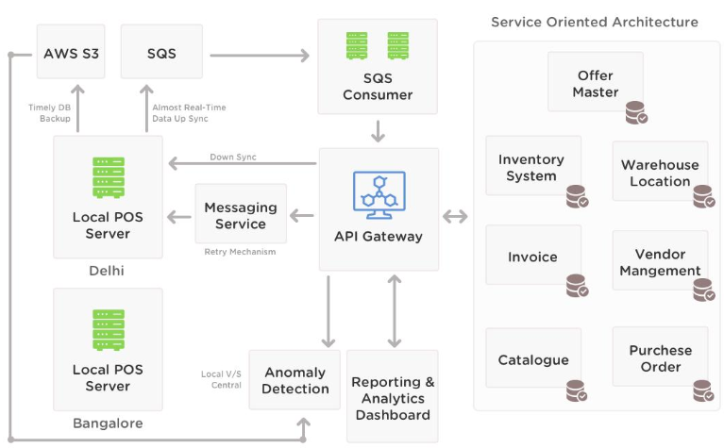
3. Offline Scanner Handling
- The warehouse scanner stores events locally when the internet is unavailable.
- After reconnection, it sends the stored events to the server.
- Each event has a unique event ID to prevent duplicate processing.
- The server validates the user's authorization before accepting sensitive operations.
- Successfully processed events are marked as synchronized.
4. Additional Test Scenarios
Test ID | Test scenario | Expected result
TC-07 | 500 users access the system simultaneously. | Requests are handled without system failure.
TC-08 | System receives 1,000 events per minute. | Events are processed without losing valid events.
TC-09 | Warehouse scanner works without internet. | Events are stored locally and synchronized later.
TC-10 | Same scanner event is uploaded twice. | Duplicate event is ignored.
TC-11 | Unauthorized user attempts an approval. | Access is denied.
TC-12 | Generate reports for all 12 regions. | Consolidated report is generated correctly.
These are proposed test scenarios and expected results, not actual executed test results.
5. Trade-offs and Challenges
Advantages | Challenges
Supports more users and regions. | Increased infrastructure cost.
Message queue improves reliability. | Event processing becomes more complex.
Offline scanner supports warehouse work. | Synchronization conflicts must be handled.
Central reports improve decision-making. | Combining regional data takes time.
6. Output
The revised architecture is designed to support 12 regions, 500 simultaneous users and 1,000 events per minute. It includes offline scanner synchronization, duplicate event prevention, secure approvals and consolidated reporting.
7. Conclusion
The proposed architecture improves scalability, reliability and security while considering the limited budget. Load testing and integration testing are required to confirm whether the system meets the proposed performance targets.

Q7 – Individual Technical Reflection 5 Marks
Explain:
• Which requirement had the greatest influence on your architecture.
• Which stakeholder conflict was most difficult to resolve.
• Which inconsistency was discovered through modeling or validation.
• Which architectural trade-off remains unresolved or significant.
• What additional evidence would be needed before implementing the system.
Evidence Expected A concise reflection demonstrating understanding of the created design and its limitations. Refer to your own specification, diagrams, decisions and validation findings.
1. Which requirement had the greatest influence on your architecture?
The requirement to support 12 regions, 500 simultaneous users and 1,000 events per minute had the greatest influence. It encouraged me to select a Modular Service-Based Architecture with a load balancer and message queue to improve scalability and reliability.
2. Which stakeholder conflict was most difficult to resolve?
The most difficult conflict was between customers who wanted fast checkout and warehouse staff who needed accurate stock information. I resolved this by reserving stock before confirming an order.
3. Which inconsistency was discovered through modeling or validation?
The sequence diagram revealed that the order was initially confirmed before stock reservation. I corrected the sequence to reserve stock before final order confirmation.
4. Which architectural trade-off remains unresolved or significant?
The main trade-off is between scalability and infrastructure cost. Separate services improve flexibility, but they increase deloyment and maintenance costs. A shared infrastructure can reduce costs but needs performance testing.
5. What additional evidence would be needed before implementing the system?
Before implementation, I would need:
- Load-testing results for 500 simultaneous users.
- Performance results for 1,000 events per minute.
- Security and role-authorization test results.
- Payment gateway and courier API integration tests.
- Offline scanner synchronization test results.
- Actual stakeholder feedback and budget approval.
Output
The reflection identifies the important requirements, stakeholder conflicts, design corrections, architectural limitations and additional evidence needed before implementation.
Conclusion
This assignment helped me understand how requirements, UML diagrams, architecture and validation are connected. I learned that a good system design must balance performance, security, reliability and cost. The proposed design still requires practical testing before real implementation.

MARK DISTRIBUTION
Question Assessed Area Marks
Q1 Stakeholder investigation and conflict resolution 5
Q2 Prioritized and testable requirements specification 8
Q3 UML modeling and requirements traceability 7
Q4 Alternative architectures and justified design 8
Q5 Critical-behaviour validation and design revision 7
Q6 Day-4 Design Challenge – architecture redesign for expansion and partial
failure
10
Q7 Individual technical reflection 5
TOTAL 50
Submission Requirements
• Assignment report covering stakeholder analysis, scope, architectural alternatives and tool selection.
• Collaborative requirements specification and issue-tracker records with unique identifiers and acceptance criteria.
• UML diagrams (use case, class, sequence, state machine, component and deployment) and the traceability matrix.
• Architectural decision records, invariants, operation contracts and validation scenarios with expected and observed behaviour.
• Day-4 revisions: impact analysis, revised requirements and diagrams, synchronization rules and validation findings.
• Individual reflection and acknowledgement of sources and tools used.
OBE Assessment Evidence
Successful completion should demonstrate the ability to analyze conflicting requirements, create a testable specification, model the system with UML, evaluate and select an architecture, validate critical behaviour, and revise the design when scale and failure conditions change.
Assessment Verification
Students may be asked to trace a requirement to its UML element, component and validation scenario, explain an order or refund invariant, justify an architectural decision, or revise the design when a requirement changes.
Overall Assessment Expectation
Investigate → Specify → Model → Architect → Validate → Redesign → Defend
Page 8
The final submission must demonstrate an original, evidence-supported specification and architecture aligned with CO2, BTL 5 – Evaluate and BTL 6 – Create.

