SIMATS ENGINEERING
CSA1023 – SOFTWARE ENGINEERING
ASSIGNMENT 1
CO1: Apply agile methodologies and project management techniques such as scale and lean to effectively manage software projects using industry-standard tools like Jira.
Student Name | M. Meghana | Register Number | 192472351
Department / Section | BE-CSE-AI | Academic Year / Semester | 2025-2026
Faculty Name | V. Karpagam | Nature of Assignment | Individual
Duration | 1 Week | Total Marks | 50
Date of Submission | 01/11/2026 | Date of Evaluation

MARK SHEET (Rubric-based Evaluation)
 | Task Task Title | Max | Marks  Awarded | Remarks
1 | Algorithm Design and Grading Comparison | 4
2 | Pipeline Design and Operation | 5
3 | Image Representation Analysis | 4
4 | Connectivity Analysis | 4
5 | Image Acquisition Analysis | 5
6 | Sampling Analysis | 5
7 | Quantization Analysis | 4
8 | Image Formation Analysis | 5
9 | Implementation and Performance Evaluation | 6
10 | Front-End Adaptation Challenge | 8
 | TOTAL | 50

OVERALL REMARKS:
Student Signature | Faculty Signature | Program Director

SOFTWARE ENGINEERING Assignment 1
Page 1

SIMATS ENGINEERING
CSA10 – SOFTWARE ENGINEERING
ASSIGNMENT 1
CO1: Apply agile methodologies and project management techniques such as scale and lean to effectively manage software projects using industry-standard tools like Jira.
Assignment Title: Design, Simulate and Validate an Agile Delivery Strategy for the ITSM Platform
Nature of Assignment: Individual
Duration: One week
Total Marks: 50
Submission Date: __________________
Scenario — Agile Delivery Planning for the ITSM Platform
An enterprise plans an integrated ITSM platform to reduce delayed incident response, repeated handovers and unclear ownership. Service desk analysts prioritize intake and SLA visibility, SREs prioritize telemetry correlation, and managers require auditable approvals and developer issue links. An eight-member team must select a feasible six-week release despite uncertain capacity, limited stakeholder time and delayed integration access. Create and validate an Agile delivery strategy connecting these priorities to a justified backlog, team responsibilities, Lean flow controls and sprint goals. Revise the strategy when business units, staffing and coordination needs change, while protecting a complete incident-resolution journey.
Planning conditions for the representative release are stated below.
Observation | Scenario planning condition
Operational scope | Incident intake, triage, telemetry, approvals, problem investigation and DevOps links
Users | Administrator, SRE, analyst, CAB reviewer, manager and employee
Reference data | Synthetic incident records and controlled telemetry events
Integration constraint | External issue tracker may be unavailable; preserve local incident records and retry safely
Validation need | Verify priority, status, SLA, authorization, persistence and audit behaviour

Page 2
The organization proposes an AI-assisted IT Service Management and Incident Resolution Platform. Its intended modules are an operations dashboard, assisted triage and diagnostics, incident lifecycle management, infrastructure telemetry, a service request catalog, change approval, problem investigation and a DevOps integration hub. The system should connect an alert or report to a tracked incident, authorized investigation, a justified change, deployment verification and closure.
An eight-member cross-functional team plans an initial release within six weeks using three two-week sprints. There is no established velocity. Test access to the external issue-tracking interface begins in week three. Service desk and change-review stakeholders can attend clarification and review meetings for two hours per week. These are assignment planning assumptions.
Principal users are enterprise administrators, SRE or incident commanders, service desk analysts, change advisory board reviewers, department managers and standard employees. They need different permissions. Analysts require useful diagnostic suggestions; managers require auditable approvals; engineers require traceable links to development issues and releases. Automation must preserve human responsibility for prioritization, approval and operational changes.
Define workload, service-level policies and acceptance thresholds as explicit planning assumptions. Dashboard values, diagnostic scores and screenshots are illustrative evidence of displayed behaviour, not proof of production accuracy, performance, live monitoring or secure authorization. Verify claims through repeatable checks. Distinguish deterministic keyword rules from trained machine learning and label simulations and proposed extensions accurately.
Design Challenge:
Management requests all eight modules in the initial release. Service desk analysts prioritize incident intake, assignment and SLA visibility; SREs prioritize telemetry-to-incident correlation; managers prioritize service and change approvals. Integration access and limited review time constrain delivery. A broad release may leave every workflow incomplete, while a narrow dashboard-only release may fail to improve incident resolution.
Design, simulate and validate an Agile project delivery strategy using a project-management tool of your choice that produces a coherent and achievable first release under these conditions.
Develop alternative delivery approaches and create a justified strategy connecting backlog priorities to the identified operational problems. Establish team responsibilities, capacity assumptions, dependency sequencing, stakeholder review arrangements and Lean practices for controlling waiting, rework and work in progress.
Investigate at least two suitable project-management tools, such as Jira, Trello, Azure DevOps or GitHub Projects. Select one and justify its suitability for your
Page 3
strategy, considering planning, workflow management, collaboration, reporting, accessibility and cost. Explain any limitations and how you will address them.
Before simulation, predict the principal delivery bottleneck and define measurable criteria for judging the strategy. Use the resulting evidence to revise your plan and defend the features retained, deferred or resequenced. Your final design must explain how the team will deliver, why the selected release should improve the service process, and how the chosen tool supports the strategy.
TASK 1 – Investigate the Problem and Define Delivery Outcomes 5 Marks Investigate the platform from the perspectives of employees, service desk analysts, SREs, approval authorities and the development team.
• Formulate at least three questions to investigate about priorities, workflow problems or delivery constraints.
• Obtain initial evidence through a small stakeholder discussion, questionnaire or documented review of the existing process. If access is unavailable, use clearly identified simulated stakeholder responses.
• Define the product goal, first-release scope and exclusions.
• Establish at least three measurable delivery-success criteria. • Examine technical, operational and financial feasibility at a level appropriate to project planning.
Evidence Expected
Investigation questions, stakeholder findings or labelled simulated responses, a problem statement, scope boundaries, feasibility observations and measurable success criteria.
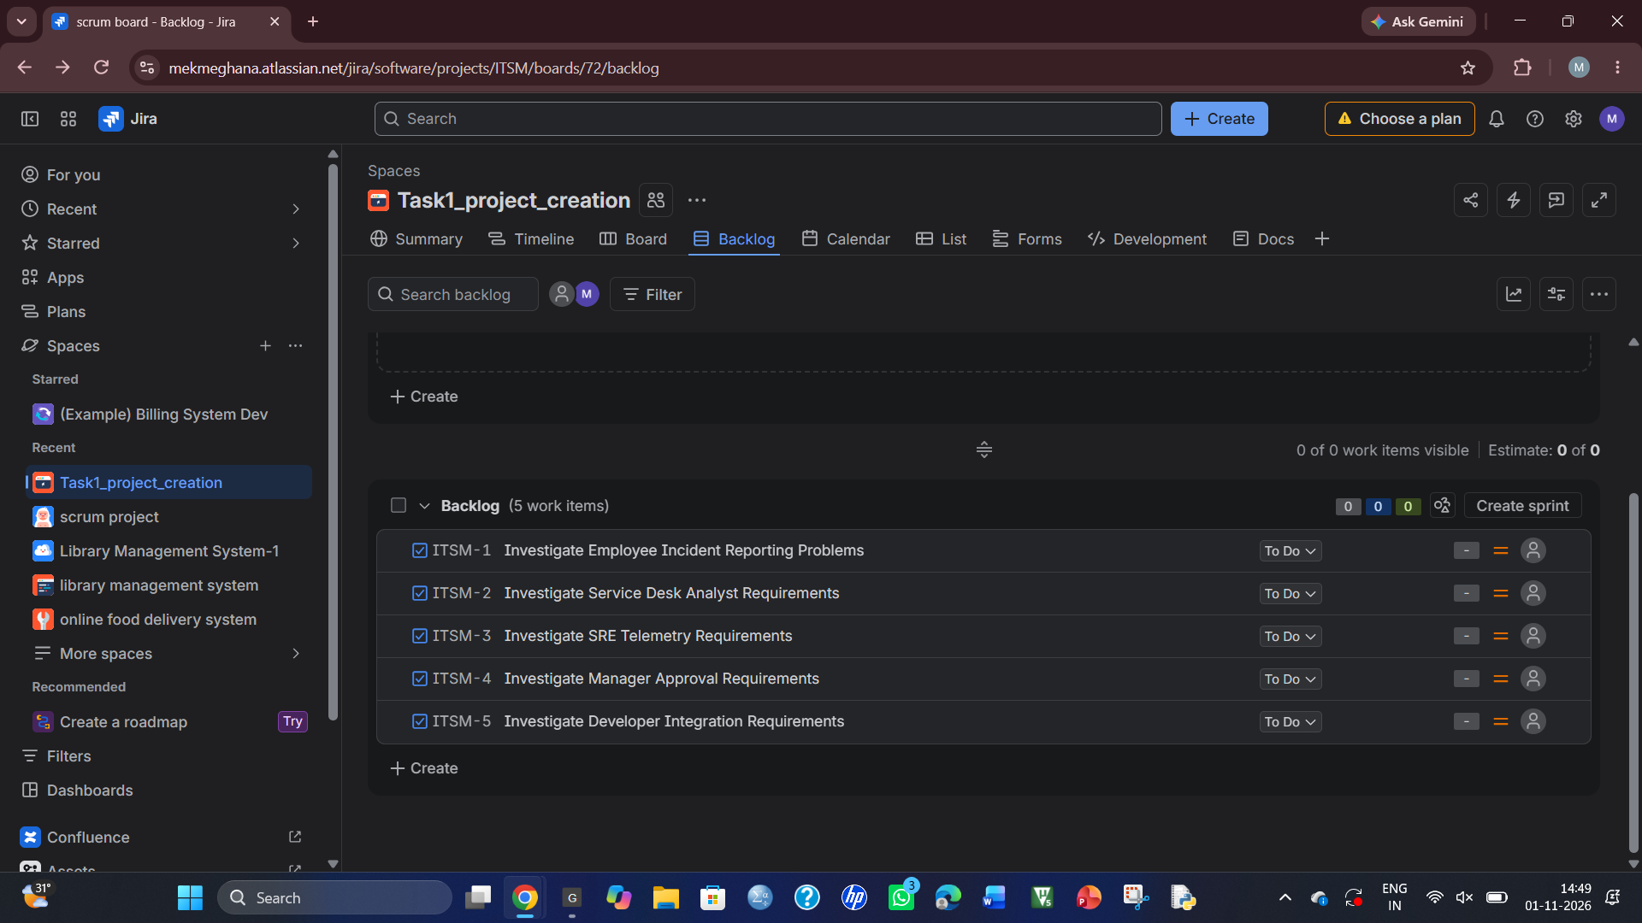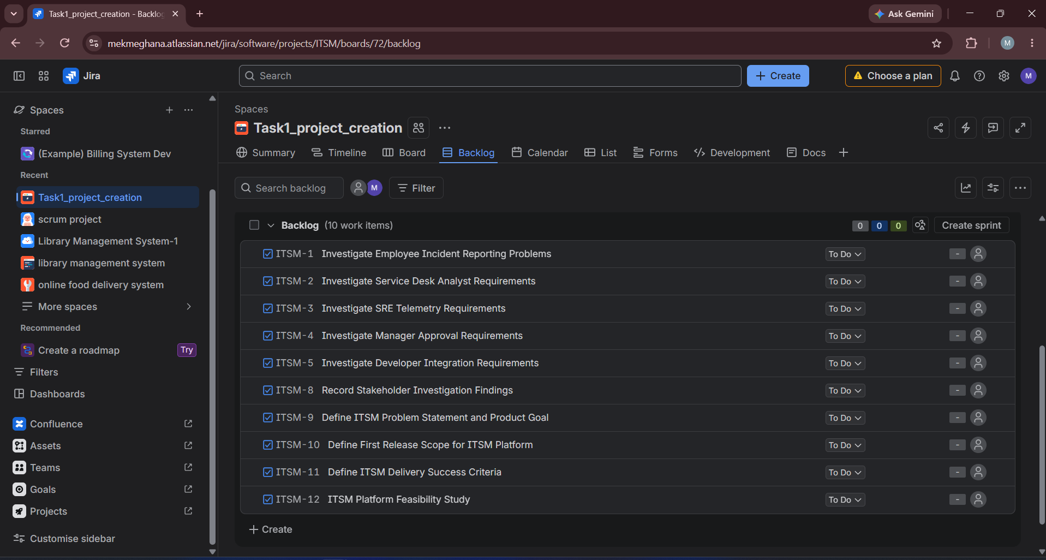
TASK 2 – Design and Justify the Project Management Approach 6 Marks Develop two meaningfully different delivery approaches for the scenario. Consider Scrum, Lean flow management, XP practices or a justified combination.
• For each approach, explain how work would be selected, coordinated and reviewed.
• Identify its suitability for changing requirements and cross-functional work. • Examine likely limitations, overheads and delivery risks.
• Select an approach and create a tailored operating model defining responsibilities, planning activities, review points, escalation procedures and stakeholder participation.
• Explain how Lean principles will help reduce waiting, unnecessary handovers, rework or excessive work in progress.
Page 4
Evidence Expected
Comparison of two approaches, a justified selection and an original operating model with explicit Lean practices.
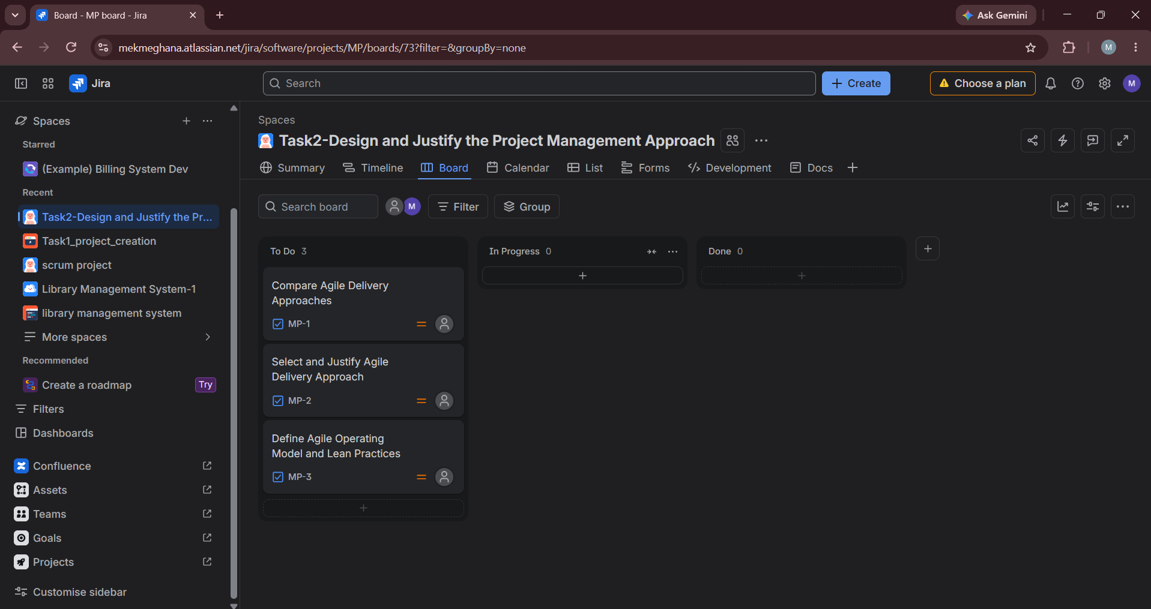
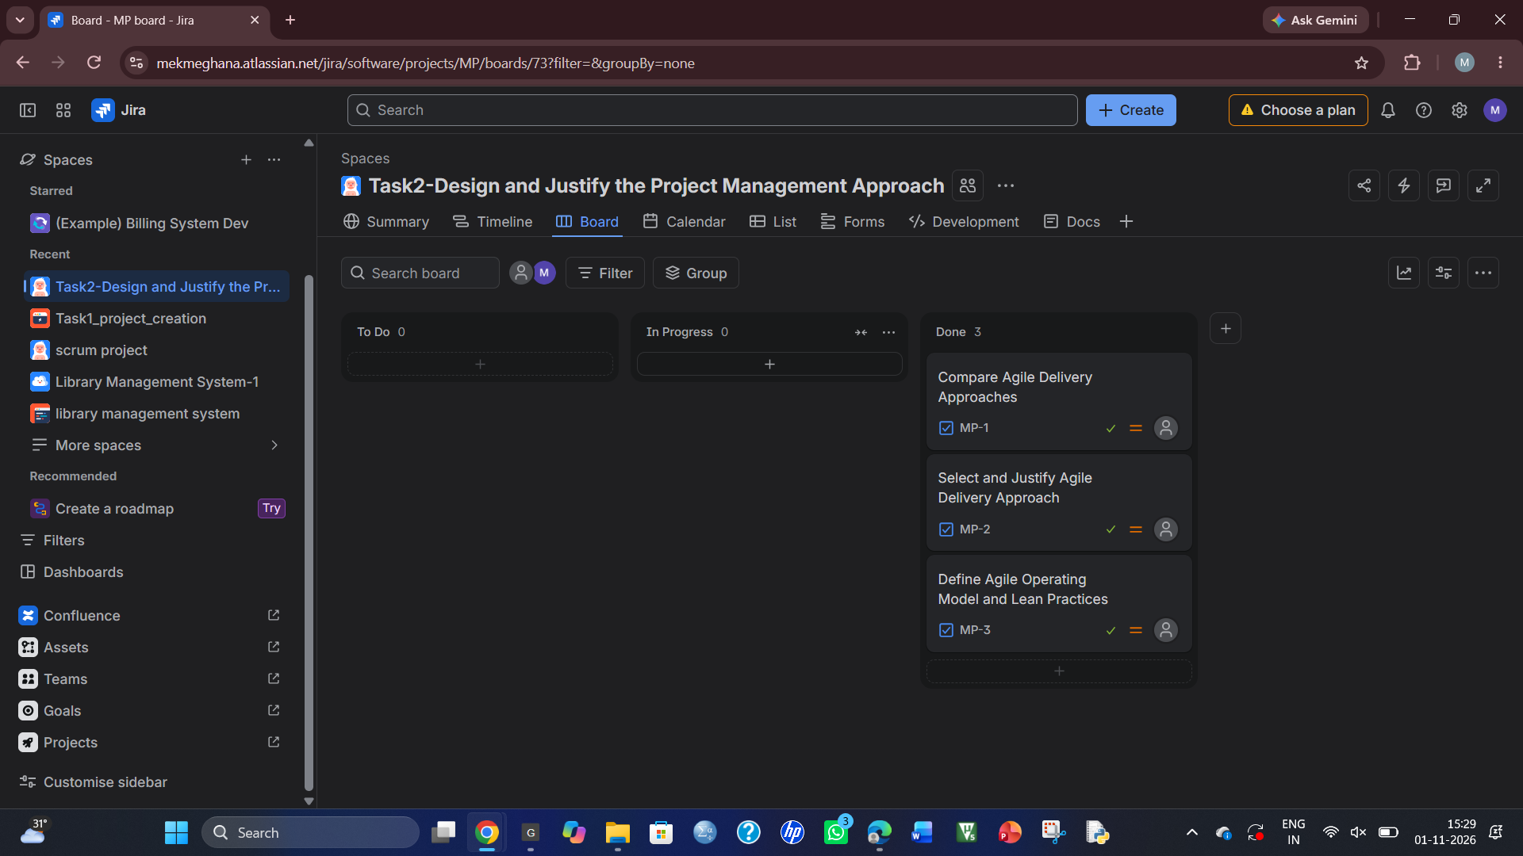
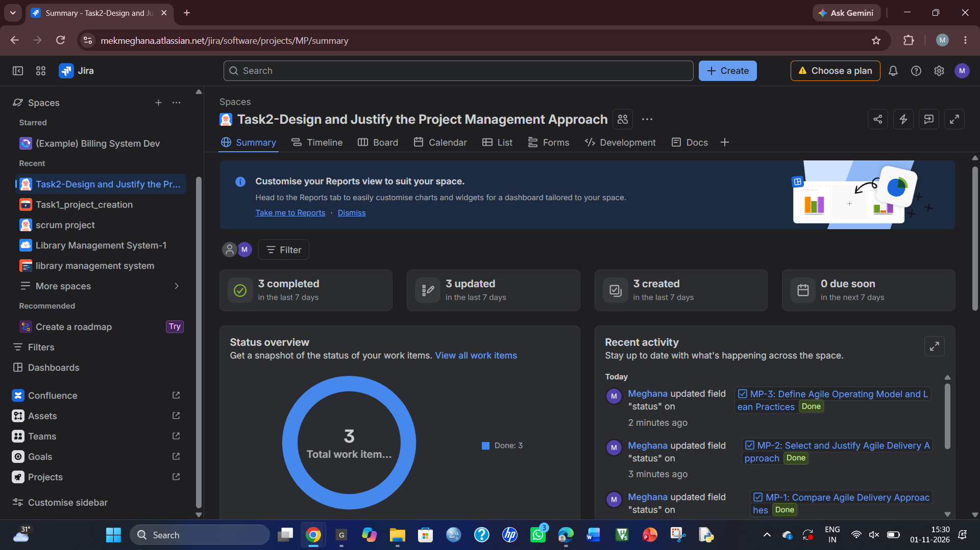
TASK 3 – Construct a Prioritized Product Backlog in the Selected Tool 8 Marks Create a project in your selected management tool and develop a backlog containing:
• At least four epics and twelve user stories covering incident management, triage and telemetry, approval governance, and DevOps integration. Justify which modules are retained or deferred.
• User stories with clear acceptance criteria.
• Priorities, estimates, dependencies and responsible roles.
• A justified prioritization method.
• A distinction between essential first-release features and deferred features. • A Definition of Ready and a Definition of Done appropriate to the project. Incorporate relevant privacy, accessibility and quality expectations into the backlog or completion criteria.
• An explanation of at least two decisions where competing stakeholder requests influenced your priorities.
Evidence Expected
Selected-tool backlog screenshots or export, story acceptance criteria, prioritization rationale, dependencies, and Definitions of Ready and Done.
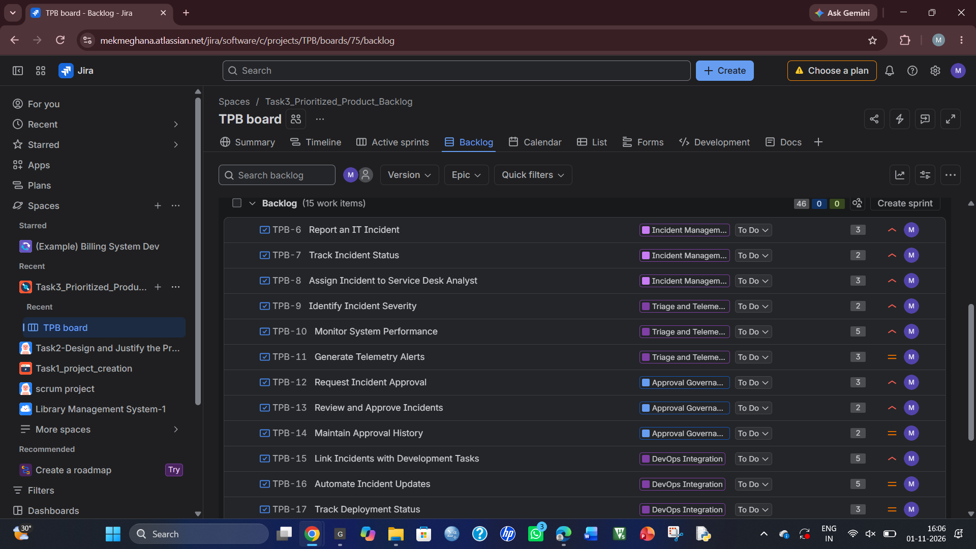
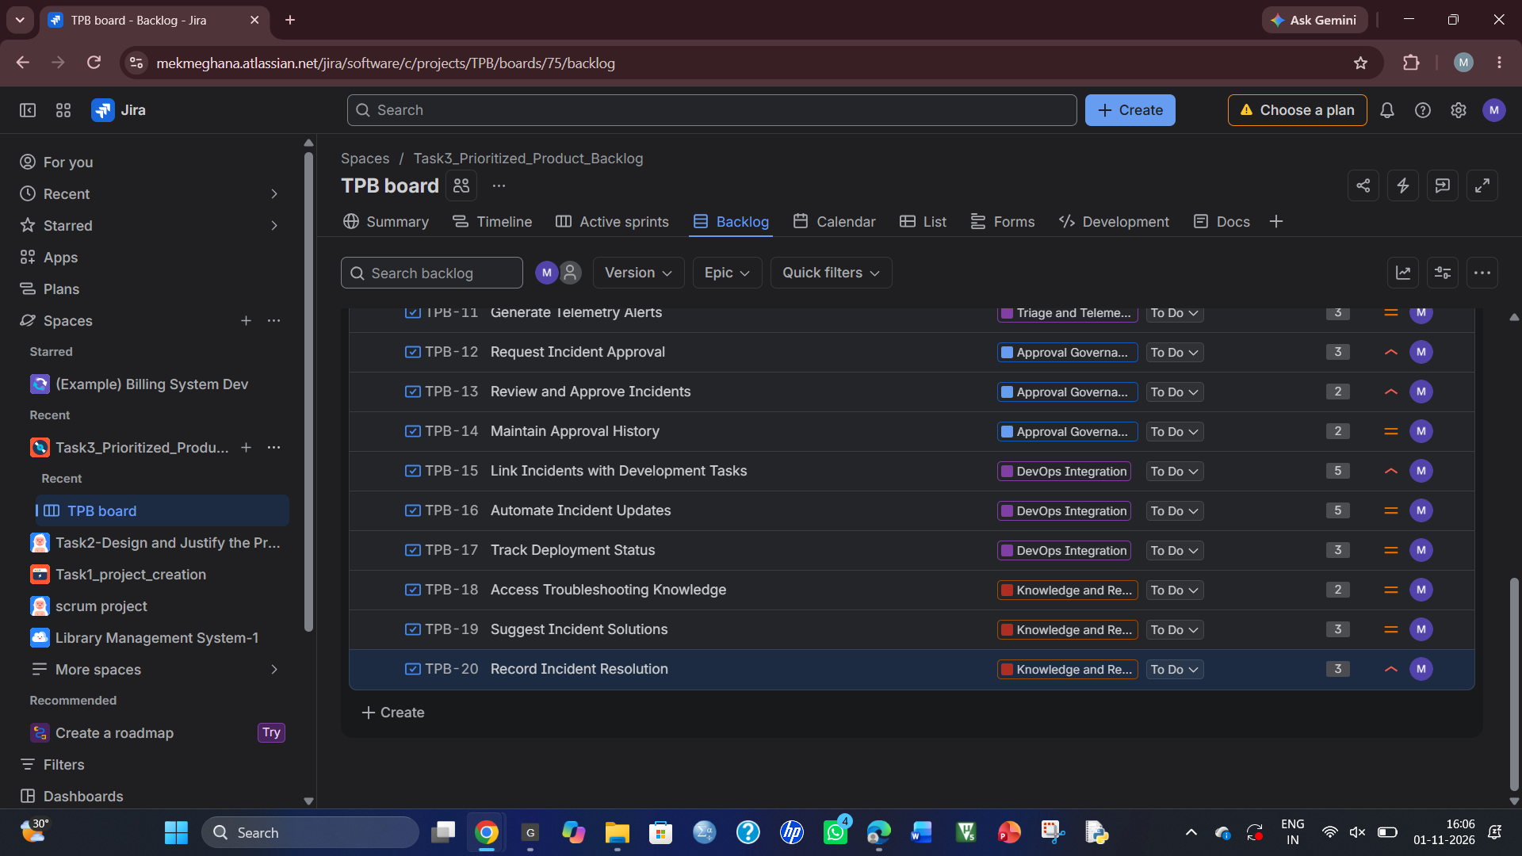
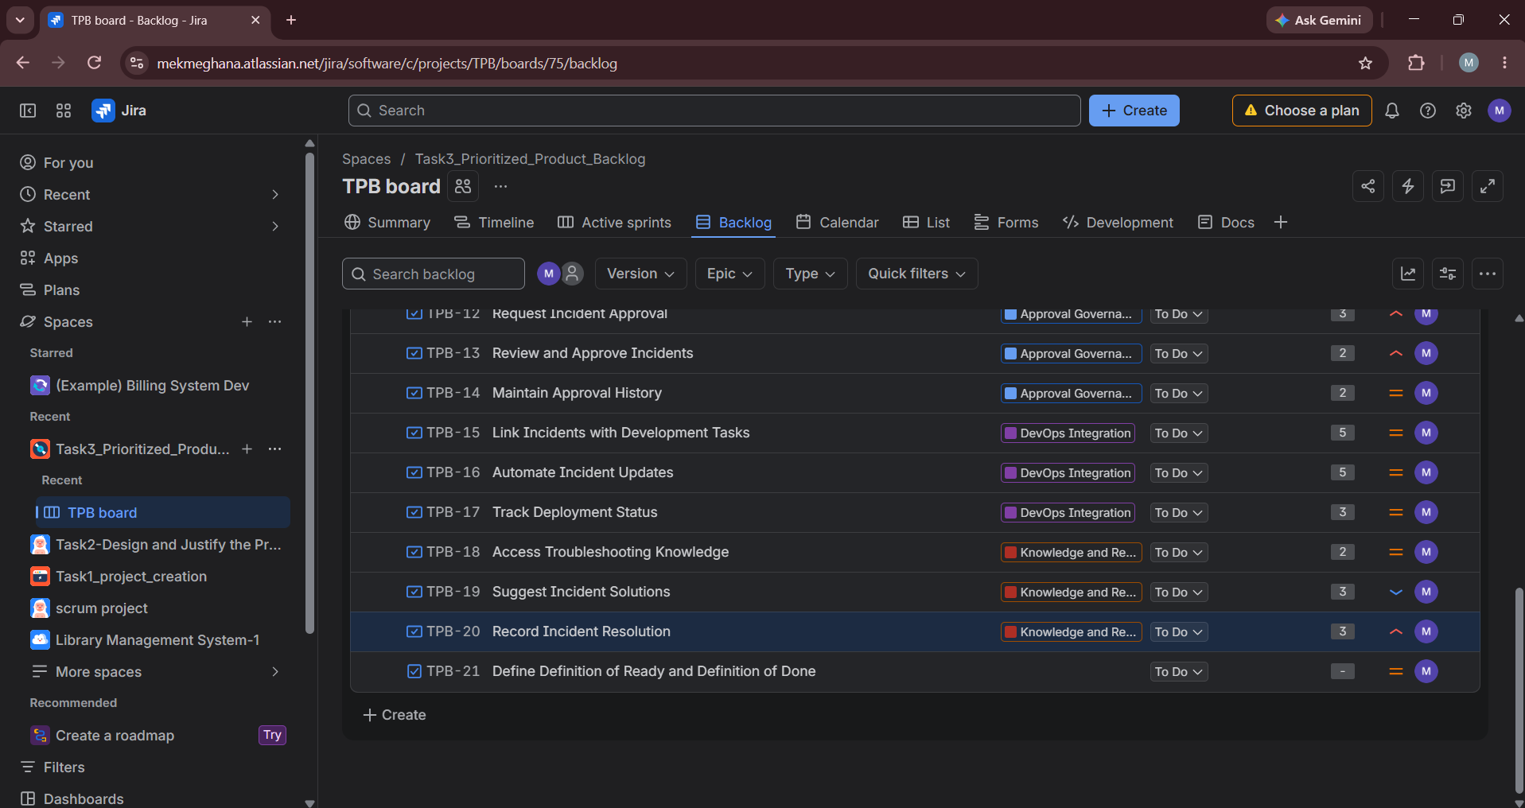
TASK 4 – Create a Capacity-Based Release Plan and Delivery Workflow7 Marks Design the three-sprint release plan using explicit assumptions about team availability and capacity.
• Define a goal for each sprint.
• Select work that fits the assumed capacity.
• Explain your estimation method and avoid treating story points as fixed hours. • Represent dependencies and cross-functional responsibilities. • Create a development workflow in the selected tool with statuses, transition
rules and completion checks. Distinguish this workflow from the operational incident lifecycle.
• Set and justify work-in-progress limits where applicable.
• Define how blocked work, urgent requests and unfinished stories will be handled.
• Show how the selected features collectively achieve the product goal. Page 5
Evidence Expected
Release plan, capacity assumptions, sprint goals, selected-tool board or workflow, work-in-progress policies and dependency-management decisions.
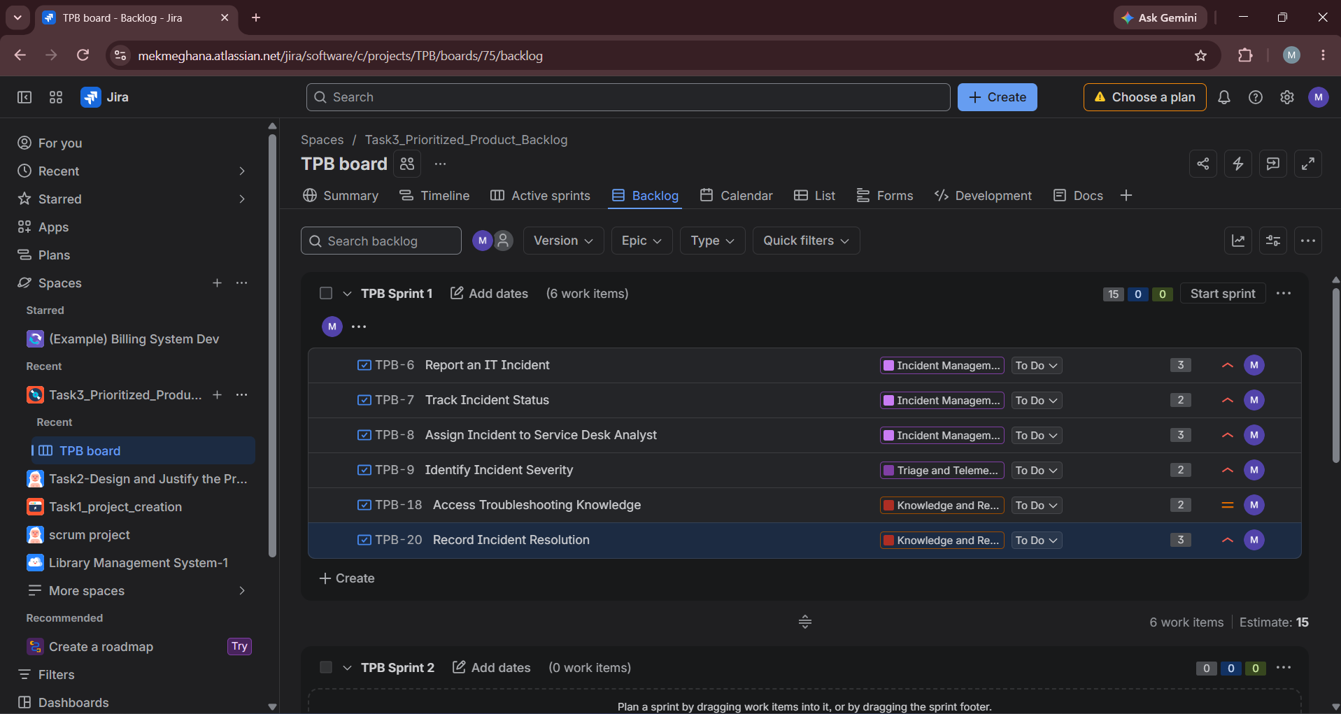
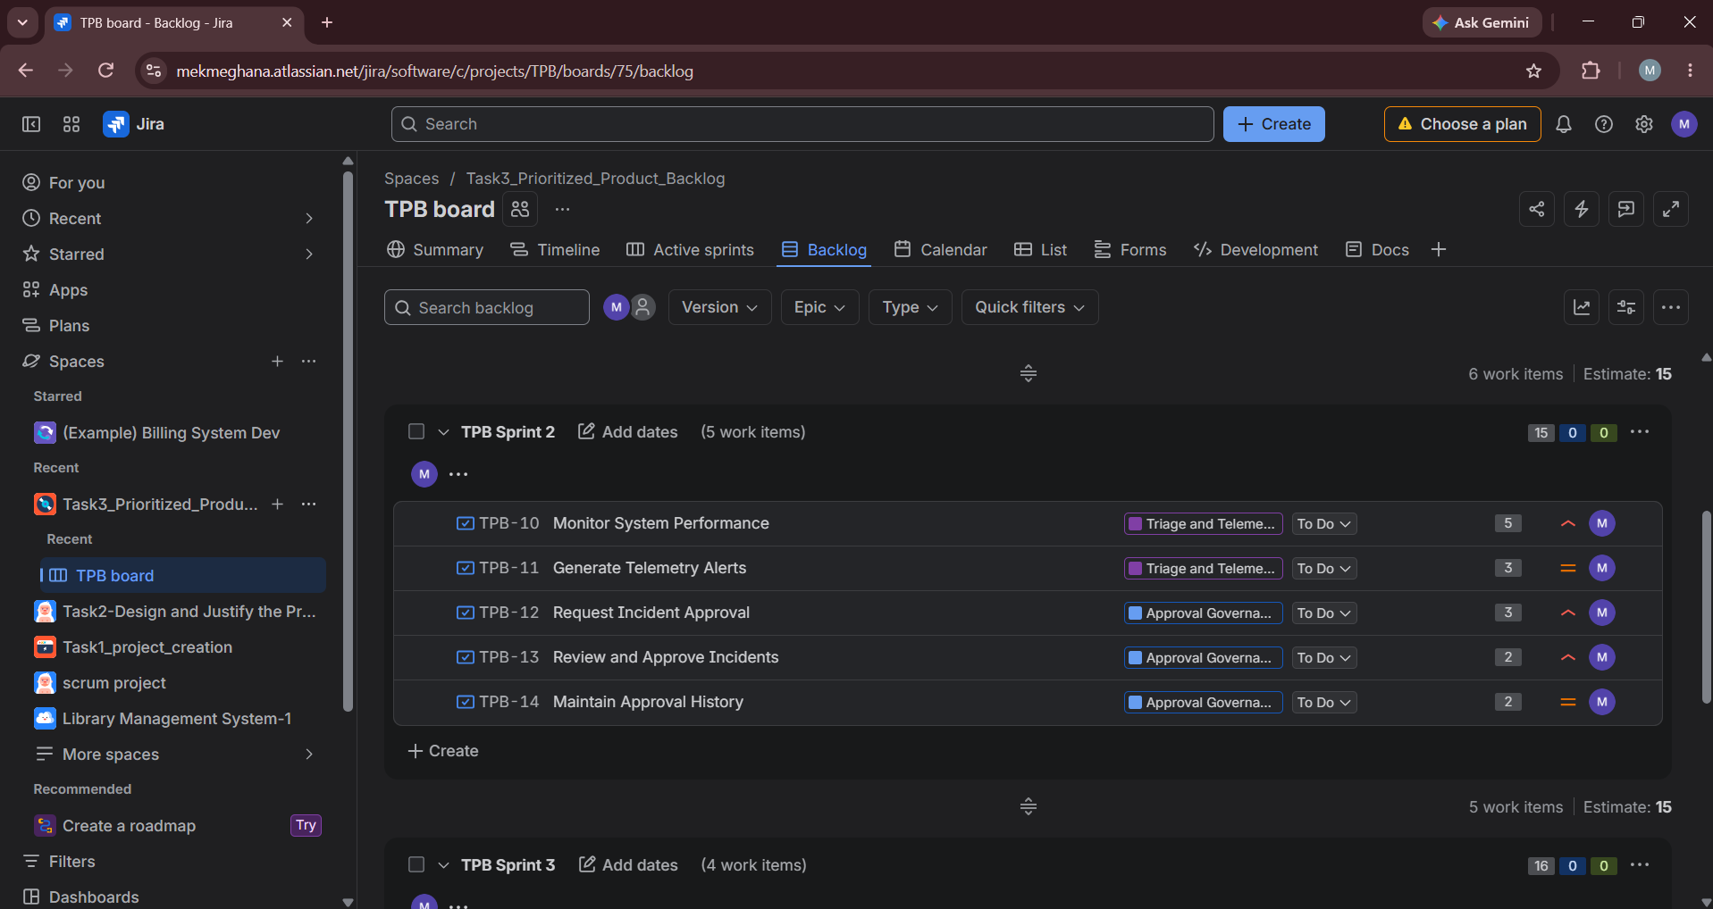
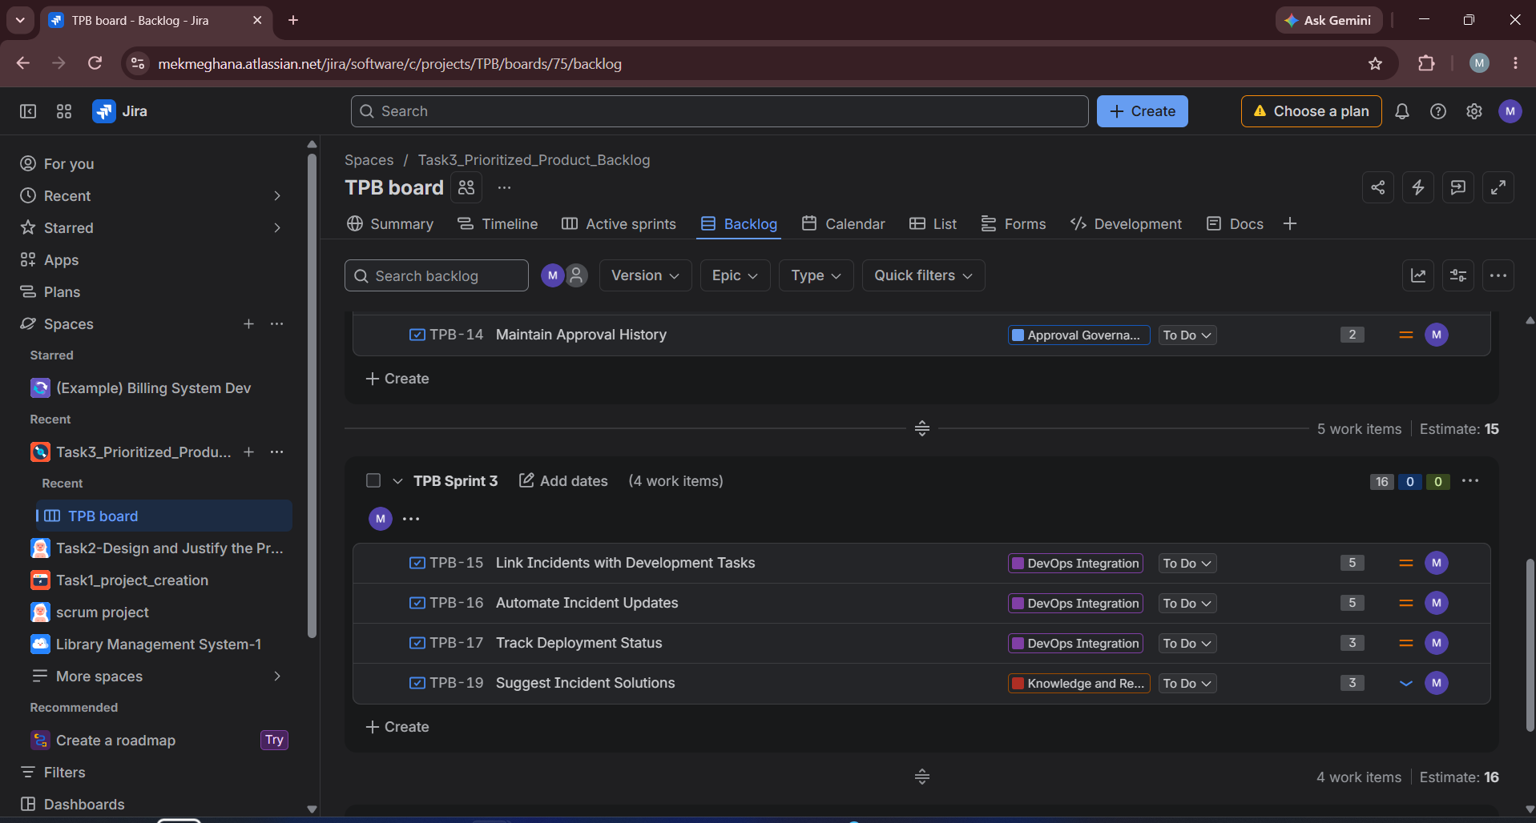
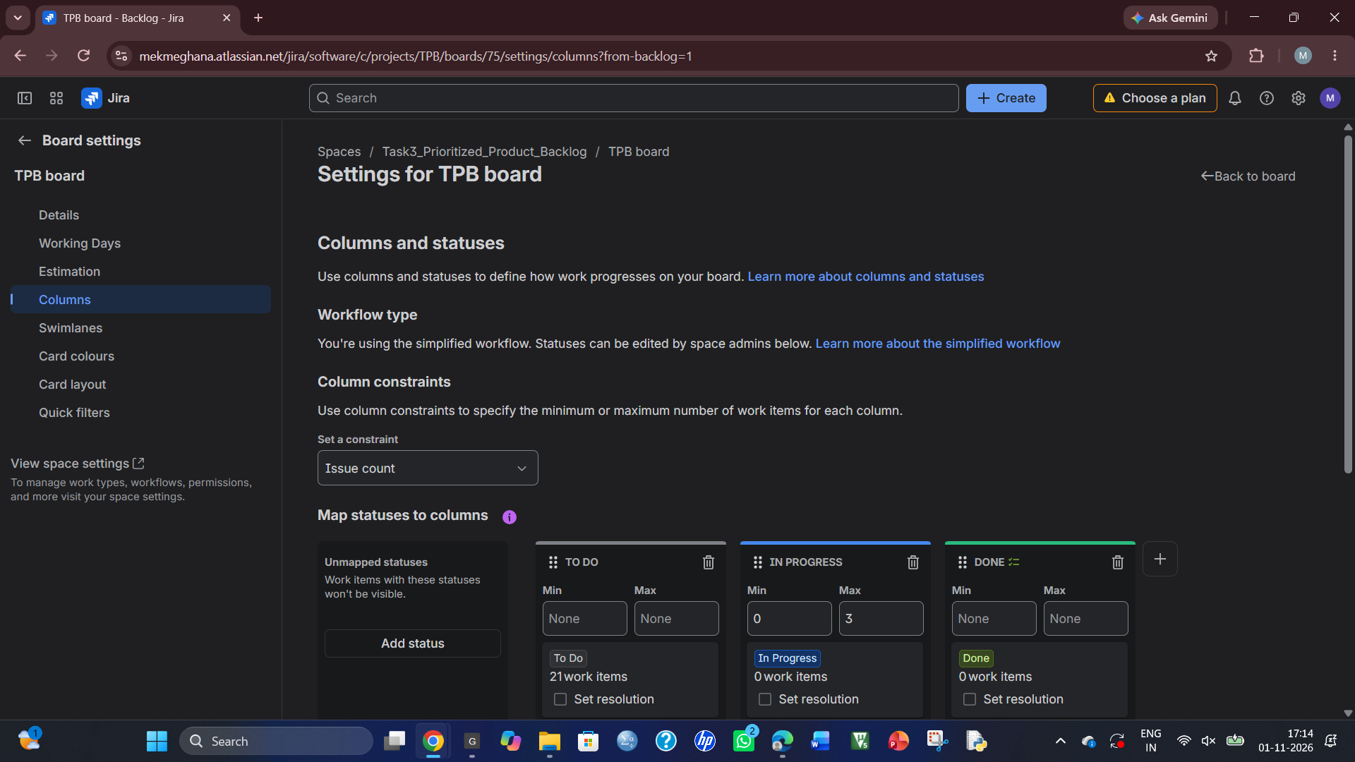
TASK 5 – Simulate Delivery and Validate Your Design 7 Marks Simulate the first sprint using a documented sequence of at least ten work events, such as starting a story, identifying a dependency, encountering a defect, receiving clarification or completing a review.
• Before simulation, predict where a bottleneck is most likely to occur. • Identify which planning or workflow rule should help control it and what evidence would indicate that the rule is effective.
• Update the selected management tool to reflect the simulated events. • Record suitable indicators such as completed versus planned work, blocked time, cycle time, work in progress or reopened stories.
• Use the results to identify a limitation in your original plan and create an improvement for the next sprint.
Evidence Expected
Prediction, event log, management-tool updates, at least three delivery indicators, interpretation of results and a revised planning or workflow decision.
All simulated results must be clearly labelled. Do not present simulated activity as actual team delivery.
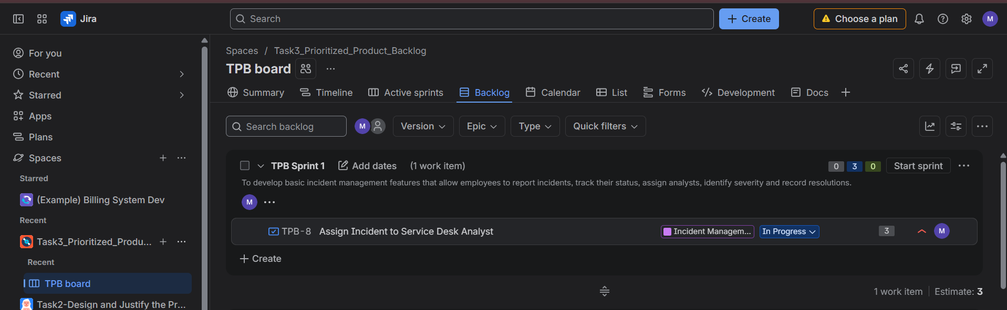
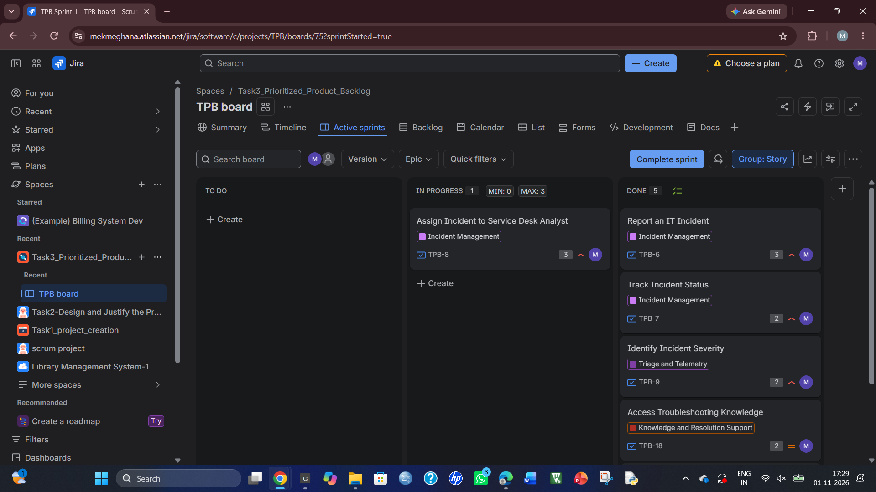
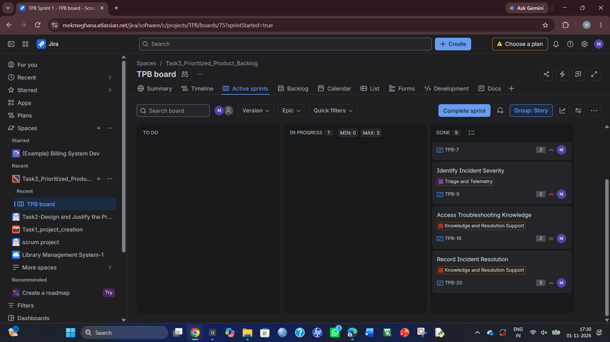
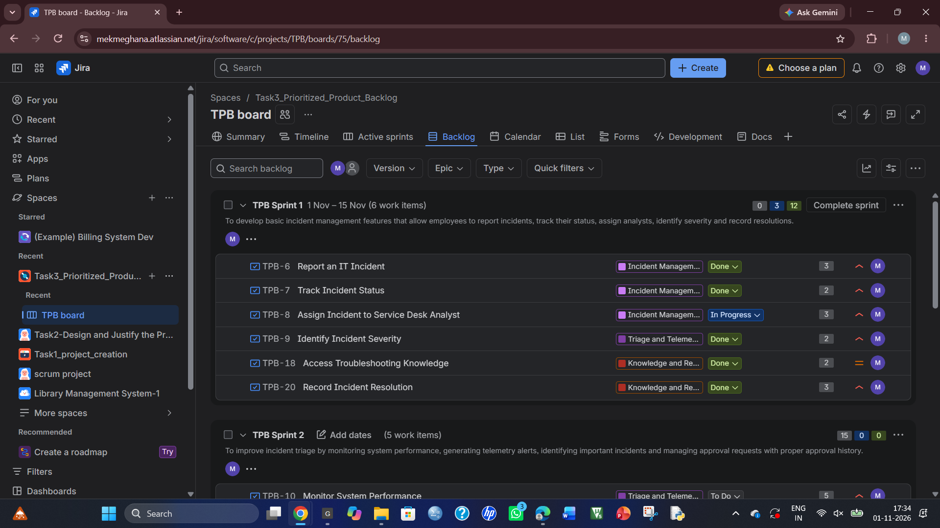
TASK 6 – Redesign Delivery Under Changed Conditions 12 Marks Changed Requirement
At the end of the first simulated sprint, the organization introduces the following changes:
• Three additional business units must use the platform.
• A second eight-member development team joins the project.
• A backend developer from the original team becomes unavailable for the remaining period.
• Business-unit-specific SLA policies and service request approvals are now required.
• The original release deadline remains unchanged.
Create a revised strategy that coordinates both teams, preserves a useful first release and manages the new constraints.
Page 6
Component | Required Work | Marks
A. Diagnose the impact | Identify affected assumptions, capacity, scope, dependencies and risks using evidence from your original plan. | 2
B. Define redesign objectives | Establish measurable objectives for the revised strategy, including achievable scope and coordination expectations. | 2
C. Create the revised strategy | Redesign backlog priorities, team responsibilities, release sequencing and dependency coordination. Incorporate justified scaled Agile and Lean practices. | 4
D. Validate the redesign | Simulate at least five additional events and compare the revised strategy with the original using equivalent indicators. | 2
E. Defend the decision | Explain benefits, limitations and trade-offs. Show why the revised strategy remains feasible under the unchanged deadline. | 2

You may use selected SAFe-inspired coordination practices or another justified scaled Agile approach. Explain what you adopt and why it fits this project.
Evidence Expected
Impact analysis, measurable redesign objectives, revised management-tool artefacts, cross-team coordination design, comparative simulation evidence and an evidence-based defence.
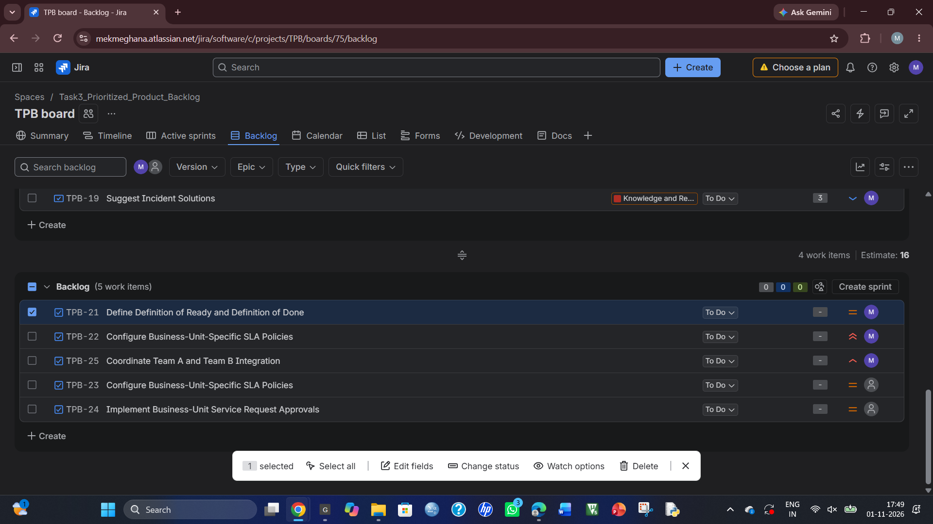
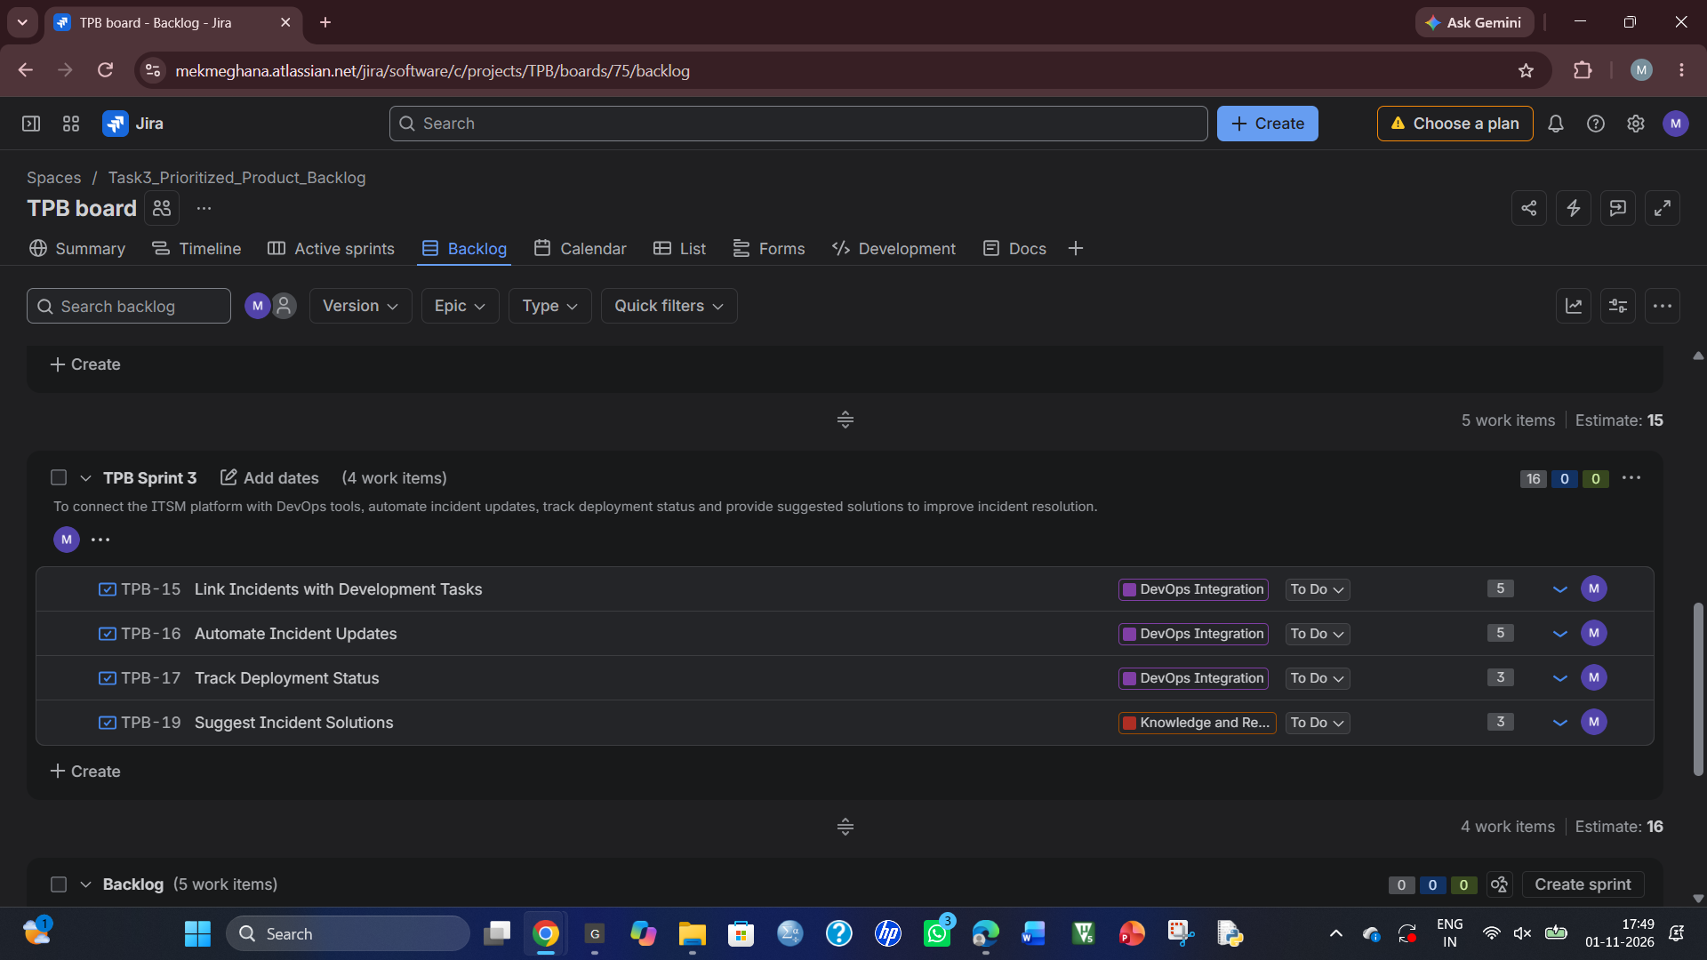

TASK 7 – Individual Technical Reflection 5 Marks Explain:
• Which project-management decision you consider most significant and why. • How your evidence influenced a change to the original strategy. • Where your final design remains vulnerable.
• How you addressed an ethical concern involving privacy, workload, accessibility or transparency.
• What you would investigate next before using the strategy with a real development team.
Evidence Expected
A concise individual reflection demonstrating understanding of the created strategy and its limitations. Refer to your own artefacts and findings.
Project: AI-Assisted IT Service Management (ITSM) and Incident Resolution Platform
1. Most Significant Project-Management Decision
The most significant decision was selecting Kanban with Lean practices. It helps the team visualize tasks, control work in progress and identify delays. It is suitable because project requirements may change frequently.
2. How Evidence Influenced the Strategy
In Task 5, the simulation showed that 5 out of 6 planned stories were completed, representing 12 out of 15 story points. TPB-8 remained unfinished because clarification was required. Therefore, I introduced daily blocker reviews, WIP limits and better requirement clarification in the revised strategy.
3. Vulnerabilities in the Final Design
The design may face backend resource shortages, communication delays between two teams and integration problems. The estimated team capacity may also differ from actual performance.
4. Ethical Concern
I considered privacy and accessibility. The platform should use role-based access to protect confidential incident information. It should also provide readable text, keyboard navigation and an accessible interface for all users.
5. Future Investigation
Before using this strategy with a real development team, I would investigate actual team capacity, business-unit SLA requirements, integration risks, security standards and stakeholder feedback.
Conclusion
This project helped me understand how Agile and Lean practices can be adapted when requirements, team size and available resources change. I learned that continuous monitoring, prioritization and coordination are important for successful project delivery.

MARK DISTRIBUTION
Task | Assessed Area | Marks
Task 1 | Problem investigation and measurable delivery outcomes | 5
Task 2 | Original Agile and Lean operating model | 6

Page 7
Task | Assessed Area | Marks
Task 3 | Prioritized Jira backlog and acceptance criteria | 8
Task 4 | Capacity-based release plan and workflow | 7
Task 5 | Delivery simulation and evidence-based improvement | 7
Task 6 | Day-4 Design Challenge – scaled delivery redesign and validation | 12
Task 7 | Individual technical reflection | 5
TOTAL |  | 50

Submission Requirements
• Assignment report covering investigation findings, scope, delivery approaches and project-management tool selection.
• Project export or screenshots showing epics, user stories, acceptance criteria, priorities, estimates and dependencies.
• Definition of Ready, Definition of Done, release plan, capacity assumptions and selected-tool workflow with work-in-progress limits.
• Sprint 1 simulation: prediction, event log, management-tool updates and delivery indicators, all clearly labelled as simulated.
• Day-4 redesign artefacts: impact analysis, redesign objectives, revised backlog, cross-team coordination design and comparative simulation evidence.
• Individual reflection and acknowledgement of sources and tools used.
Assessment Verification
Students may be asked to explain a prioritization decision, trace a story through the selected workflow, justify capacity or a work-in-progress limit, interpret an indicator, or revise the plan when a constraint changes.
Overall Assessment Expectation
Investigate → Design → Plan → Simulate → Validate → Redesign → Defend
The final submission must demonstrate an original, evidence-supported delivery strategy aligned with CO1, BTL 5 – Evaluate and BTL 6 – Create.
Page 8

