CSA10 - SOFTWARE ENGINEERING
ASSIGNMENT 3
CO3: Develop full-stack applications using version control systems like git/GitHub and containerization tools like Docker, Kubernetes.
Assignment Title: Design, Develop and Validate a Containerized Full Stack Smart Campus Facility Booking and Maintenance Platform
Nature of Assignment: Individual
Duration: One week
Total Marks: 50
Submission Date:10/11/2026
Name: M. Meghana - 192472351
Scenario - Integrated Campus Operations Development and Container Deployment
A university requires a working full-stack campus operations release that supports facility booking or sensor-alert intake, explainable maintenance triage, technician assignment, inspection, approval and verified completion. Separate frontend, backend and database changes create integration problems, while inconsistent developer environments make deployment difficult to reproduce. Develop an integrated application with persistent records, server-enforced permissions and valid booking and ticket transitions. Establish a traceable Git workflow and a reproducible container deployment. Adapt the implementation for duplicate requests, overlapping reservations, conflicting updates and two backend instances, validating that retries and restarts preserve booking state, ticket
state and audit history.
The university proposes an AI-assisted Smart Campus Facility and Maintenance Platform. Its intended modules are an operations dashboard, a facility and room catalogue, booking management, maintenance ticket lifecycle, utility and sensor monitoring, equipment loan requests, an approval workflow and a DevOps integration hub. The system should connect a booking problem or sensor alert to a tracked maintenance ticket, an authorized inspection, a justified approval, deployment verification and closure.
Implementation conditions for the representative release are stated below.
Scenario planning condition
External issue tracker or calendar service may be unavailable; preserve local records and retry safely Verify booking overlap, priority, status, SLA, authorization, persistence and audit behaviour Principal users are campus administrators, facility managers, maintenance technicians, department approvers, faculty members and students. They need different permissions. Facility managers require useful triage suggestions; approvers require auditable decisions; engineers require traceable links to development issues and releases. Automation must preserve human responsibility for prioritization, approval and operational changes.
The application must distinguish users, facilities or assets, sensor alerts, bookings, maintenance tickets, SLA policies, approvals, integration links and audit events. Duplicate sensor messages, repeated booking submissions or repeated integration requests must not silently create inconsistent records. Two users attempting to reserve the same facility slot, and concurrent technician updates, must be handled explicitly. The development team also faces integration problems. Changes to the user interface, backend API and database may be developed separately, and an application that works on one contributor's computer may fail on another. Define workload, service-level policies and acceptance thresholds as explicit planning assumptions. Dashboard values, utilisation figures, triage scores and screenshots are illustrative evidence of displayed behaviour, not proof of production accuracy, performance, live monitoring or secure authorization. Verify claims through repeatable checks. Distinguish deterministic keyword rules from trained machine learning and label simulations and proposed extensions accurately.
Design Challenge:
The university requires a working first release supporting facility booking or sensor-alert intake, assisted triage, assignment, SLA visibility, resolution and closure. Demonstrate one linked approval or DevOps operation. Integrate the interface, API and persistent database and reproduce execution in a clean environment.
Design, develop and validate a containerized full-stack application that addresses these conditions. Explore alternative technology choices and select a suitable frontend framework, backend framework, database, version-control platform and container deployment approach. Justify your selections against integration needs, maintainability, reproducibility, available resources and cost. Create a working application with traceable version history and reproducible deployment. Construct scenarios exposing duplicate requests, overlapping bookings, conflicting status changes, unauthorized actions and environment failures. Revise the implementation using observed evidence.
Q1 - Define the Application Scope and Select the Technology Stack 5 Marks
1. Application Scope
The proposed application is an AI-Assisted Smart Campus Facility and Maintenance Platform. It helps universities manage facility bookings, maintenance requests, technician assignments, approvals and sensor alerts through a single integrated system.
2. Principal Users
User | Responsibilities
Administrator | Manages users, facilities and system settings.
Facility Manager | Manages bookings and maintenance requests.
Maintenance Technician | Inspects and resolves maintenance issues.
Department Approver | Approves or rejects restricted requests.
Faculty Member | Books rooms and reports issues.
Student | Views facilities and submits booking requests.

3. Main Workflows
- Facility Booking – Users search and book available rooms.
- Sensor Alert – Sensors detect abnormal conditions and generate alerts.
- Maintenance Management – Tickets are created and assigned to technicians.
- Inspection – Technicians inspect problems and record notes.
- Approval – Authorized managers approve or reject requests.
- Completion – Technicians resolve issues and authorized users close tickets.

4. User Stories and Acceptance Criteria
No. | User Story | Acceptance Criteria
1 | As a student, I want to view available rooms. | Available facilities must be displayed correctly.
2 | As a faculty member, I want to book a room. | A booking must be saved successfully without overlapping reservations.
3 | As a facility manager, I want to view maintenance tickets. | All active tickets must appear in the maintenance queue.
4 | As a technician, I want to update ticket status. | Only assigned or authorized technicians can update tickets.
5 | As an approver, I want to approve booking requests. | Only authorized approvers can approve or reject requests.
6 | As an administrator, I want to manage users. | User roles and permissions must be maintained correctly.
7 | As a facility manager, I want to receive sensor alerts. | A controlled sensor event must create one maintenance ticket.
8 | As a technician, I want to record inspection and resolution details. | Inspection notes and closure details must be stored.

5. Scope Exclusions
The following features are excluded from the first release because of the one-week time limit:
- Real-time payment integration.
- Actual university-wide sensor installation.
- Mobile application development.
- Advanced machine learning model training.
- Integration with external calendar services.
- Full multi-campus production deployment.

6. Technology Stack Comparison
Component | Option 1 | Option 2
Frontend | React | Angular
Backend | Python FastAPI | Node.js Express
Database | PostgreSQL | MySQL
Version Control | GitHub | GitLab
Containerization | Docker Compose | Kubernetes

7. Selected Technology Stack
Technology | Purpose
React | Develops the user interface.
Python FastAPI | Handles backend APIs and business logic.
PostgreSQL | Stores users, bookings and tickets.
Git and GitHub | Manages source code and version history.
Docker | Creates application containers.
Docker Compose | Runs frontend, backend and database together.

Justification:
- React provides reusable user interface components.
- FastAPI supports quick API development and validation.
- PostgreSQL provides reliable transactions and data consistency.
- GitHub supports collaboration, branches and code reviews.
- Docker provides a consistent development and deployment environment.
- Docker Compose makes it easy to run multiple application services.
8. Success Criteria
- All six user roles must have appropriate permissions.
- At least six user stories must work correctly.
- Overlapping bookings must be rejected.
- Duplicate sensor events must not create duplicate tickets.
- Booking and ticket records must remain after restarting containers.
- Unauthorized users must not perform restricted operations.
- The application must start successfully using Docker Compose.

Q2 – Create the Integrated Application Design (7 Marks)

1. Component Diagram
The application contains three major layers: frontend, backend and database.
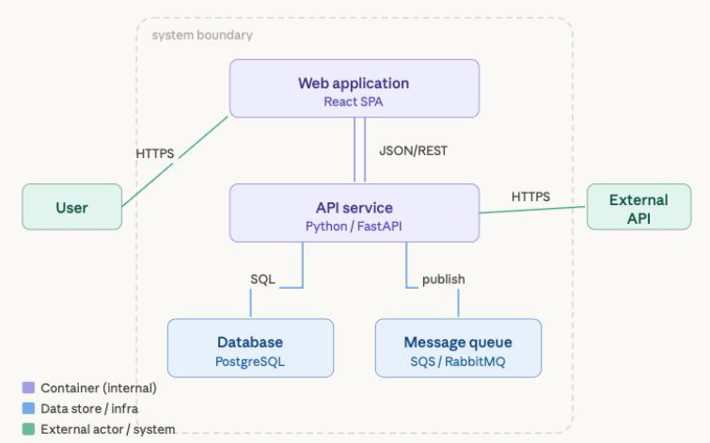
Explanation:
- Frontend: React provides dashboard, booking calendar and maintenance screens.
- Backend: FastAPI processes requests, validates data and enforces permissions.
- Database: PostgreSQL stores all application records.
- Docker: Runs the application components in separate containers.
- GitHub: Maintains source code and development history.

2. Data Model
The system maintains the following entities:
Entity | Important Attributes
Users | User ID, name, email, role
Facilities | Facility ID, name, location, capacity
Bookings | Booking ID, user ID, facility ID, date, time, status
Sensor Alerts | Alert ID, sensor ID, event ID, temperature, timestamp
Maintenance Tickets | Ticket ID, alert ID, category, priority, status
SLA Policies | SLA ID, priority, response time, resolution time
Approvals | Approval ID, request ID, approver ID, decision
Integration Links | Link ID, ticket ID, external issue ID, sync status
Audit Events | Event ID, user ID, action, timestamp, old and new values

Relationships:
- One user can create multiple bookings.
- One facility can have multiple bookings.
- One sensor alert can generate a maintenance ticket.
- One maintenance ticket can have multiple audit events.
- One approval is associated with a booking or restricted request.
- One ticket can have an integration link.

3. API Contracts
API Endpoint | Method | Purpose
/api/facilities | GET | View facilities
/api/bookings | POST | Create booking
/api/bookings | GET | View bookings
/api/alerts | POST | Submit sensor alert
/api/tickets | GET | View maintenance tickets
/api/tickets/{id}/assign | PUT | Assign technician
/api/tickets/{id}/inspect | POST | Record inspection
/api/tickets/{id}/resolve | PUT | Resolve ticket
/api/tickets/{id}/close | PUT | Close ticket
/api/approvals/{id} | PUT | Approve or reject request
All important operations require authentication and backend authorization.
4. Booking State Model
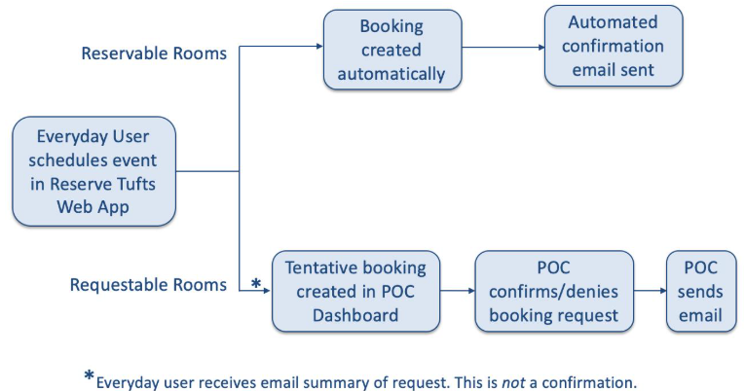
Booking states:
- Requested – User submits a booking.
- Approved – Authorized manager approves the request.
- Confirmed – Booking is successfully confirmed.
- In Use – Facility is being used.
- Completed – Booking period is finished.
- Cancelled – Booking is cancelled.
Only valid state transitions are permitted.
5.Maintenance Ticket State Model
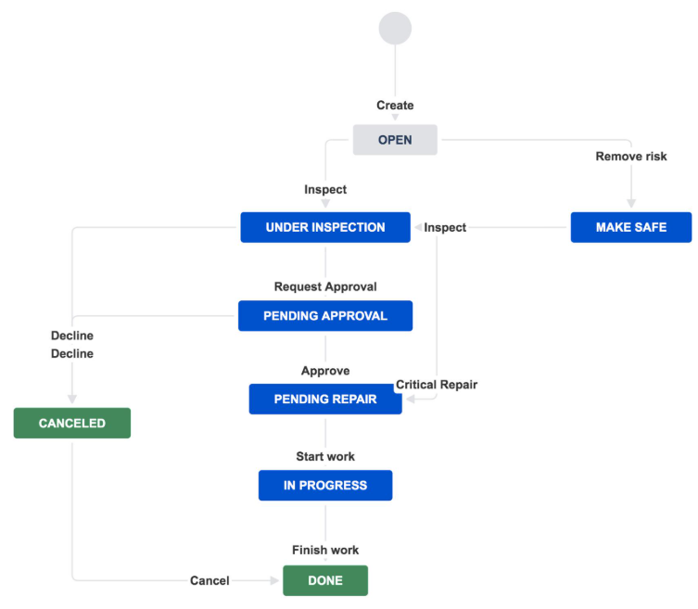
Ticket states:
- Intake – A maintenance request is received.
- Assignment – A technician is assigned.
- Inspection – Technician examines the problem.
- Pending Work – Repair work is required.
- Resolution – Technician records the completed repair.
- Closure – Authorized person verifies and closes the ticket.
6.Rules for Consistency
Duplicate Requests:
- Generate a unique idempotency key for each request.
- Repeated requests with the same key return the original result.
- Sensor events use a unique event ID.
Overlapping Reservations:
- Check existing confirmed bookings before accepting a new booking.
- PostgreSQL transactions and database constraints prevent two users from reserving the same facility for overlapping periods.
Competing Updates:
- Use version numbers for ticket records.
- If two technicians update the same ticket, the second conflicting update must be rejected and refreshed.
Approval Restrictions:
- Only authorized department approvers can approve restricted requests.
- Every approval or rejection is recorded in the audit history.
7.Validation Responsibilities
Layer Responsibility
Frontend Checks required fields and displays errors.
Backend Validates roles, booking rules, priorities and status transitions.
Database Enforces unique constraints, relationships and transaction consistency.
Q3 – Develop a Working Full-Stack Application (12 Marks)
1. Application Development
The Smart Campus Facility and Maintenance Platform is developed using React, FastAPI and PostgreSQL.
The application contains the following screens:
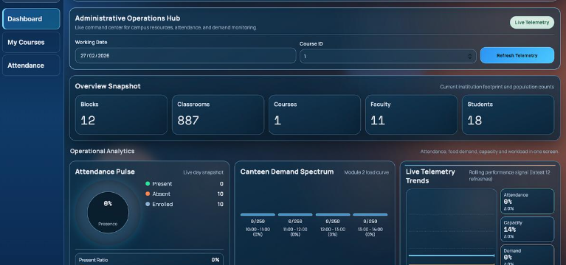
2. Main Modules
Module 1: Operations Dashboard
- Displays total facilities.
- Displays active bookings.
- Shows pending maintenance tickets.
- Displays high-priority alerts.
- Shows SLA indicators.
Module 2: Facility and Booking Management
- Displays available rooms.
- Allows users to submit booking requests.
- Checks booking availability.
- Prevents overlapping reservations.
Module 3: Maintenance Management
- Creates maintenance tickets.
- Assigns technicians.
- Records inspection notes.
- Updates ticket status.
- Supports resolution and closure.
Module 4: Sensor Monitoring
- Receives controlled sensor events.
- Detects abnormal readings using predefined thresholds.
- Creates maintenance tickets.
- Prevents duplicate alerts.
Module 5: Approval Management
- Allows authorized approvers to review requests.
- Supports approval and rejection.
- Stores decision details and timestamps.
Module 6: DevOps Integration
- Links maintenance tickets with developer issues.
- Displays issue and delivery status.
- Stores local records if the external service is unavailable.
- Retries failed requests safely.

3. Explainable AI-Assisted Triage
The system uses predefined keyword rules to suggest maintenance categories and priorities.
Example:
Problem Description | Category | Suggested Priority
AC not working | Electrical/Mechanical | High
Water leakage | Plumbing | High
Broken chair | Furniture | Low
Light not working | Electrical | Medium
The suggestions are generated using deterministic keyword rules, not a trained machine learning model.
The facility manager makes the final priority decision.
4. Role-Based Access Control
Role | Access
Administrator | Full system access
Facility Manager | Booking and maintenance management
Technician | Assigned ticket inspection and resolution
Department Approver | Approve or reject restricted requests
Faculty | Submit booking requests
Student | View facilities and submit permitted requests
5. Complete Application Workflow
- A user submits a facility booking or a sensor alert is generated.
- Backend validates the request.
- A maintenance ticket is created if required.
- The system suggests a category and priority.
- The facility manager assigns a technician.
- The technician performs an inspection.
- The approver authorizes restricted work where required.
- The technician records resolution details.
- An authorized user verifies and closes the ticket.
- All activities are saved in the database and audit history.

6. Testing and Validation
Test Case | Expected Result
Submit valid booking | Booking saved
Submit overlapping booking | Request rejected
Submit duplicate sensor event | Only one ticket created
Unauthorized ticket closure | Access denied
Valid technician assignment | Assignment successful
Invalid status transition | Operation rejected
Restart backend | Existing records preserved
External integration unavailable | Local record preserved
Conclusion: The application integrates the user interface, backend APIs and persistent database to support campus booking and maintenance operations.
Q4 – Establish and Demonstrate a Version-Control Workflow (6 Marks)
1. Repository Creation
Create a GitHub repository named:
Smart-Campus-Facility-Maintenance
2. Repository Structure
Smart-Campus/
│
├── frontend/
│ ├── src/
│ └── package.json
│
├── backend/
│ ├── main.py
│ ├── models.py
│ └── requirements.txt
│
├── database/
│ └── schema.sql
│
├── docker-compose.yml
├── Dockerfile
├── .env.example
├── .gitignore
└── README.md
3. Git Branches
Create at least two feature branches:
Branch | Purpose
feature/booking | Facility booking functionality
feature/maintenance | Maintenance ticket management
main | Stable application code

4. Meaningful Commits
Example commit messages:
git add .
git commit -m "Create campus facility dashboard"
git commit -m "Add facility booking validation"
git commit -m "Implement maintenance ticket lifecycle"
git commit -m "Add role-based access control"
5.Git Workflow
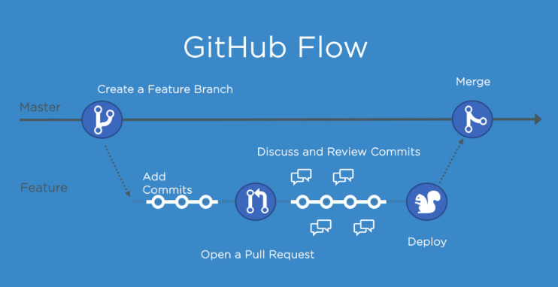
Steps:
- Create a GitHub repository.
- Create feature branches.
- Develop separate application modules.
- Commit changes with meaningful messages.
- Push branches to GitHub.
- Create a Pull Request.
- Review the proposed changes.
- Merge the approved changes.
- Resolve a deliberately introduced merge conflict.
- Create a stable release tag.
6. Merge Conflict Resolution
Example:
- Branch 1 changes the booking validation function.
- Branch 2 changes the same function differently.
- Git identifies a merge conflict.
- Review both changes and combine the correct logic.
- Commit the resolved version.

7. Release Identification
Create a release tag:
git tag -a v1.0.0 -m "Smart Campus First Release"
git push origin v1.0.0
8. Advantages
- Maintains complete source-code history.
- Supports parallel development.
- Identifies errors introduced by changes.
- Allows recovery using previous commits.
- Reduces integration problems.
- Supports controlled releases.
Conclusion: Git and GitHub provide traceability, collaboration and recovery throughout application development.
Q5 – Create and Validate a Reproducible Container Deployment (8 Marks)
1. Containerization
Docker is used to package the frontend, backend and database into separate services.
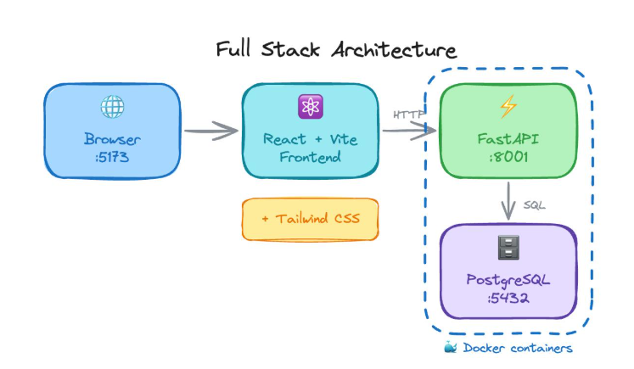
2. Container Components
Container | Purpose
Frontend | Runs React application
Backend | Runs FastAPI server
Database | Runs PostgreSQL

3. Dockerfile
Example backend Dockerfile:
FROM python:3.12-slim
WORKDIR /app
COPY requirements.txt .
RUN pip install --no-cache-dir -r requirements.txt
COPY . .
CMD ["uvicorn", "main:app", "--host", "0.0.0.0", "--port", "8000"]
4. Docker Compose Configuration
Example:
services:
backend:
build: ./backend
ports:
- "8000:8000"
environment:
DATABASE_URL: postgresql://campus:campus123@db:5432/campus
depends_on:
- db

frontend:
build: ./frontend
ports:
- "3000:80"
depends_on:
- backend

db:
image: postgres:16
environment:
POSTGRES_USER: campus
POSTGRES_PASSWORD: ${DB_PASSWORD}
POSTGRES_DB: campus
volumes:
- campus_data:/var/lib/postgresql/data

volumes:
campus_data:
5. Deployment Commands
Start the application:
docker compose up --build -d
docker compose ps
docker compose logs
docker compose down
docker compose restart backend
6. Persistent Storage
Docker volumes store database information outside the database container.
Therefore:
- Booking records remain after backend restart.
- Maintenance tickets remain available.
- Approval history is preserved.
- Audit records are retained.
Do not use docker compose down -v when testing persistence because it deletes the named database volume.
7. Deployment Validation
Test | Expected Result
Fresh deployment | All containers start
Open frontend | Dashboard appears
Create booking | Record saved in PostgreSQL
Create maintenance ticket | Ticket saved
Restart backend | Records remain
Restart database container | Records remain in volume
Stop and start application | Application works again

Conclusion: Docker and Docker Compose provide a reproducible deployment environment and reduce differences between developers' computers.
Q6 – Adapt the Application for Concurrent Access and Deployment Changes (8 Marks)
A. Diagnose the Impact (2 Marks)
The university expands to six campuses and increases the expected peak workload from 60 to 300 users.
The following problems may occur:
Problem | Impact
Overlapping bookings | Two users may reserve the same room.
Conflicting updates | Two technicians may overwrite each other's changes.
Duplicate requests | Repeated sensor events may create duplicate tickets.
Backend restart | Requests may fail temporarily.
Two backend instances | Shared data must remain consistent.
Increased users | Database load and response time may increase.
The original single-backend deployment is insufficient for the revised requirement.
B. Create the Adaptation (3 Marks)
1. Two Backend Instances
Modify the architecture to use two backend instances sharing one PostgreSQL database.
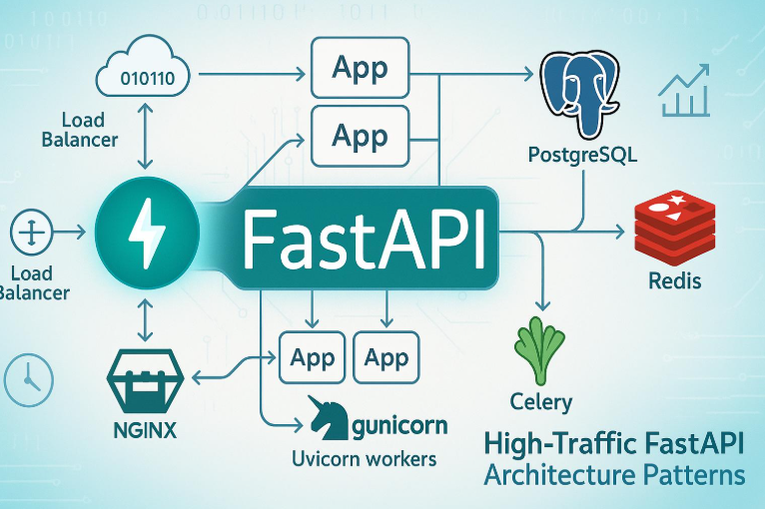
- Backend 1 handles some user requests.
- Backend 2 handles other user requests.
- Both connect to the same PostgreSQL database.
- A load balancer distributes requests.
- Database transactions maintain consistency.

2. Prevent Overlapping Bookings
Use database transactions and PostgreSQL exclusion constraints to prevent overlapping confirmed reservations.
Example:
CREATE EXTENSION IF NOT EXISTS btree_gist;
ALTER TABLE bookings
ADD CONSTRAINT no_booking_overlap
EXCLUDE USING gist (
facility_id WITH =,
tsrange(start_time, end_time, '[)') WITH &&
)
WHERE (status IN ('confirmed', 'in_use'));
This prevents two confirmed bookings for the same facility during overlapping time periods.
3. Prevent Conflicting Ticket Updates
Use optimistic locking with a version number.
Example:
UPDATE maintenance_tickets
SET status = 'resolved',
version = version + 1
WHERE ticket_id = 101
AND version = 1;
If another technician has already updated the ticket, the second update affects zero rows and is rejected.
4. Prevent Duplicate Requests
- Assign a unique idempotency key to each request.
- Store processed request IDs.
- Reject duplicate sensor event IDs.
- Return the previous result for repeated requests.
- Use the same method for external developer issue creation.
5. Handle Backend Restart
- Store all important application data in PostgreSQL.
- Keep backend instances stateless.
- Use persistent database volumes.
- Configure container health checks.
- Allow the remaining backend instance to continue serving requests.

C. Validate and Defend (3 Marks)
The following tests are used to validate the revised system.
Test | Test Procedure | Expected Result
Booking conflict | Two users book the same room at the same time. | Only one booking succeeds.
Ticket conflict | Two technicians update one ticket. | Conflicting update is rejected.
Duplicate sensor event | Send the same event twice. | Only one ticket is created.
Repeated integration | Retry developer issue creation. | No duplicate external issue.
Instance restart | Restart Backend 1. | Backend 2 continues serving requests.
Database restart | Restart database container. | Stored records remain.

6. Bounded Load Testing
Use a load-testing tool such as Locust.
Proposed experiment:
Parameter | Planning Assumption
Number of users | 30 simulated users
Duration | 5 minutes
Backend instances | 2
Database | Shared PostgreSQL
Main operations | View facilities, create bookings and view tickets

Measure:
- Total successful requests.
- Failed requests.
- Average response time.
- 95th percentile response time.
- Duplicate booking count.
- Database errors.
Important: The above is a proposed test configuration, not an observed result. Actual measurements must be collected and reported. Testing with 30 simulated users does not prove support for 300 simultaneous users.
7. Limitations and Trade-offs
- Two backend instances increase availability but require more resources.
- Database transactions improve consistency but may increase waiting time.
- Load testing provides useful evidence but cannot guarantee production performance.
- External services may still fail, so retry mechanisms are required.
Conclusion: The revised application uses two backend instances, database transactions, idempotency keys and optimistic locking to maintain consistent bookings, tickets and audit history.
Q7 – Individual Technical Reflection (4 Marks)
1. Which integration decision had the greatest effect on your application?
The most important integration decision was selecting React, FastAPI and PostgreSQL. These technologies connected the frontend, backend and database effectively. They helped maintain consistent application data and simplified development.
2. Which defect or failure led to a meaningful implementation change?
The overlapping booking problem was an important defect. Initially, two users could attempt to reserve the same facility. I improved the implementation by adding backend validation and database-level overlap constraints. This prevented conflicting reservations.
3. How did version control and containerization improve reproducibility?
Git and GitHub maintained source-code history and supported branch-based development. Docker packaged the application components into containers. Docker Compose allowed the same application environment to run on different computers.
4. Which limitation should be addressed before wider deployment?
The application requires further load testing, security testing and real sensor integration. It should also be tested with 300 users and multiple campuses before production deployment.
Final Conclusion
The proposed Smart Campus Facility and Maintenance Platform integrates facility booking, sensor monitoring, maintenance management, technician assignment, approval and DevOps operations. React, FastAPI and PostgreSQL provide the full-stack architecture, while GitHub supports version control and Docker enables reproducible deployment.
The revised architecture uses two backend instances, database transactions and duplicate-request protection to improve reliability and consistency. The system provides a foundation for a scalable and maintainable campus operations platform.

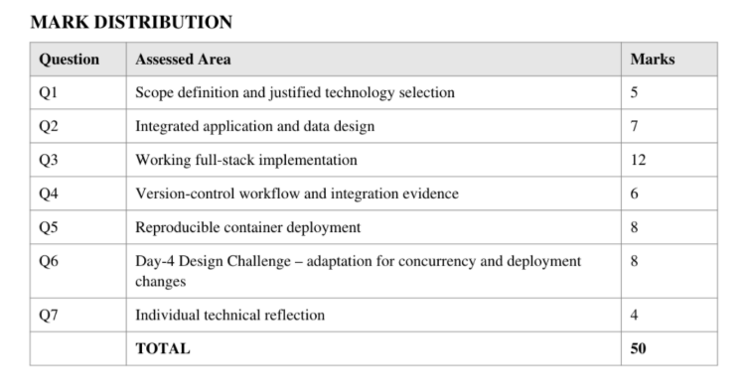
Assessment Verification
Students may be asked to trace a booking or ticket from interface to database, explain a consistency or authorization rule, demonstrate a merge, reproduce deployment or diagnose a deployment failure.
Overall Assessment Expectation
Investigate > Design > Develop > Integrate > Containerize > Validate > Adapt > Defend
The final submission must demonstrate an original working solution aligned with CO3, BTL 5- Evaluate and BTL 6- Create.

