Generative AI Lab Record

Experiment 1
Experiment Title:
Install Matplotlib and display a simple line graph.
Aim:
To install Matplotlib and display a simple line graph.
Code:
import matplotlib.pyplot as plt

x=[1,2,3,4,5]
y=[2,4,6,8,10]

plt.plot(x,y,marker="o")
plt.title("Line Graph")
plt.xlabel("X")
plt.ylabel("Y")
plt.show()
Screenshot:
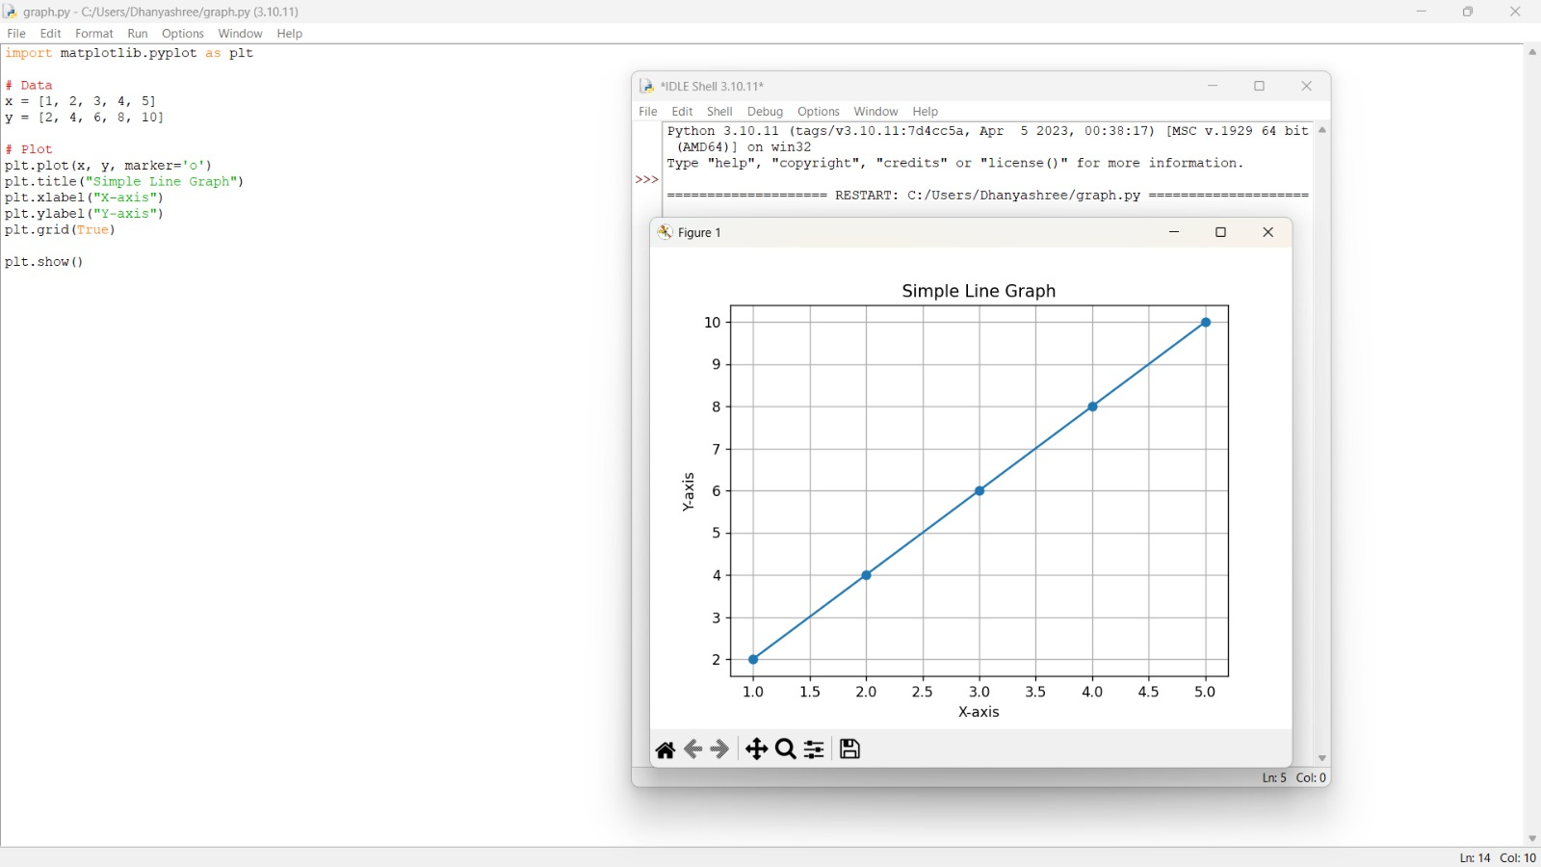
Result:
Thus, install Matplotlib and display a simple line graph. was completed successfully.

Experiment 2
Experiment Title:
Install Scikit-learn and print its version.
Aim:
To install Scikit-learn and print its version.
Code:
import sklearn
print(sklearn.__version__)
Screenshot:
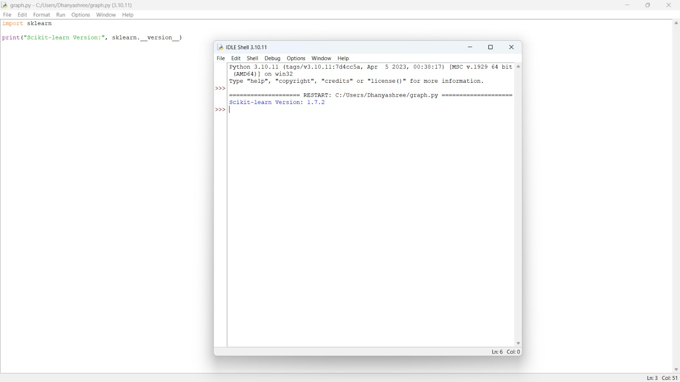
Result:
Thus, install Scikit-learn and print its version. was completed successfully.

Experiment 3
Experiment Title:
Create a NumPy array containing the first 20 natural numbers.
Aim:
To create a NumPy array containing the first 20 natural numbers.
Code:
import numpy as np

a=np.arange(1,21)
print(a)
Screenshot:
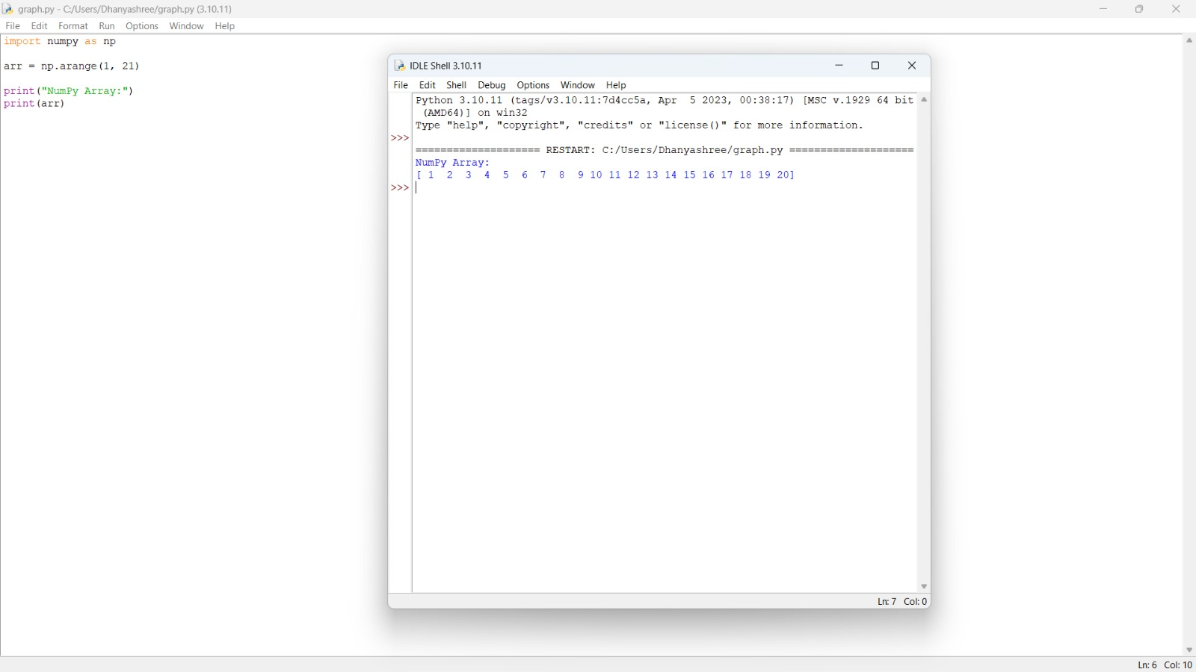
Result:
Thus, create a NumPy array containing the first 20 natural numbers. was completed successfully.

Experiment 4
Experiment Title:
Create a Pandas DataFrame with student names and grades.
Aim:
To create a Pandas DataFrame with student names and grades.
Code:
import pandas as pd

df=pd.DataFrame({
"Name":["Ram","Sita","John","Sara"],
"Grade":["A","B","A+","A"]
})

print(df)
Screenshot:
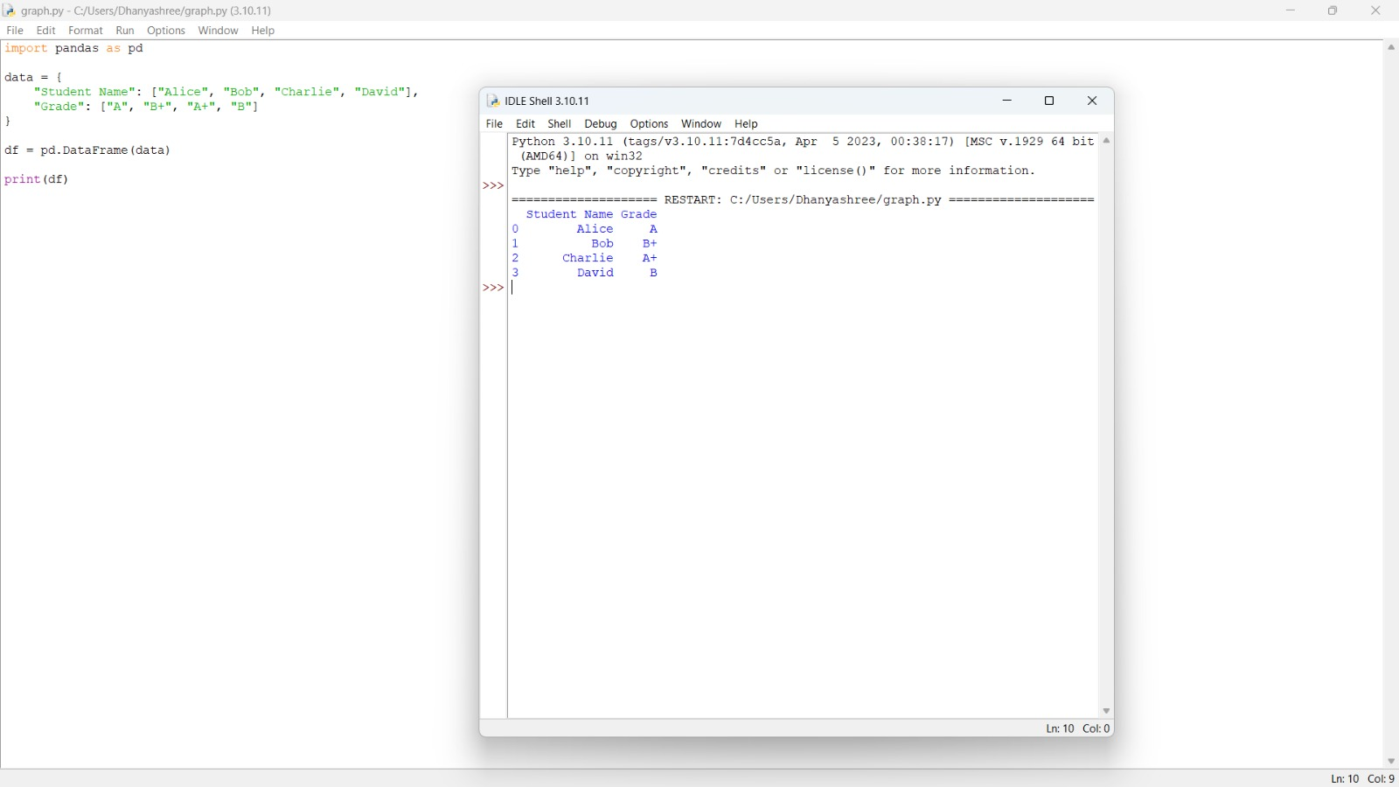
Result:
Thus, create a Pandas DataFrame with student names and grades. was completed successfully.

Experiment 5
Experiment Title:
Verify the installed versions of all AI libraries on your system.
Aim:
To verify the installed versions of all AI libraries on your system.
Code:
import numpy
import pandas
import matplotlib
import sklearn
import torch
import transformers

print("NumPy:",numpy.__version__)
print("Pandas:",pandas.__version__)
print("Matplotlib:",matplotlib.__version__)
print("Scikit-learn:",sklearn.__version__)
print("PyTorch:",torch.__version__)
print("Transformers:",transformers.__version__)
Screenshot:
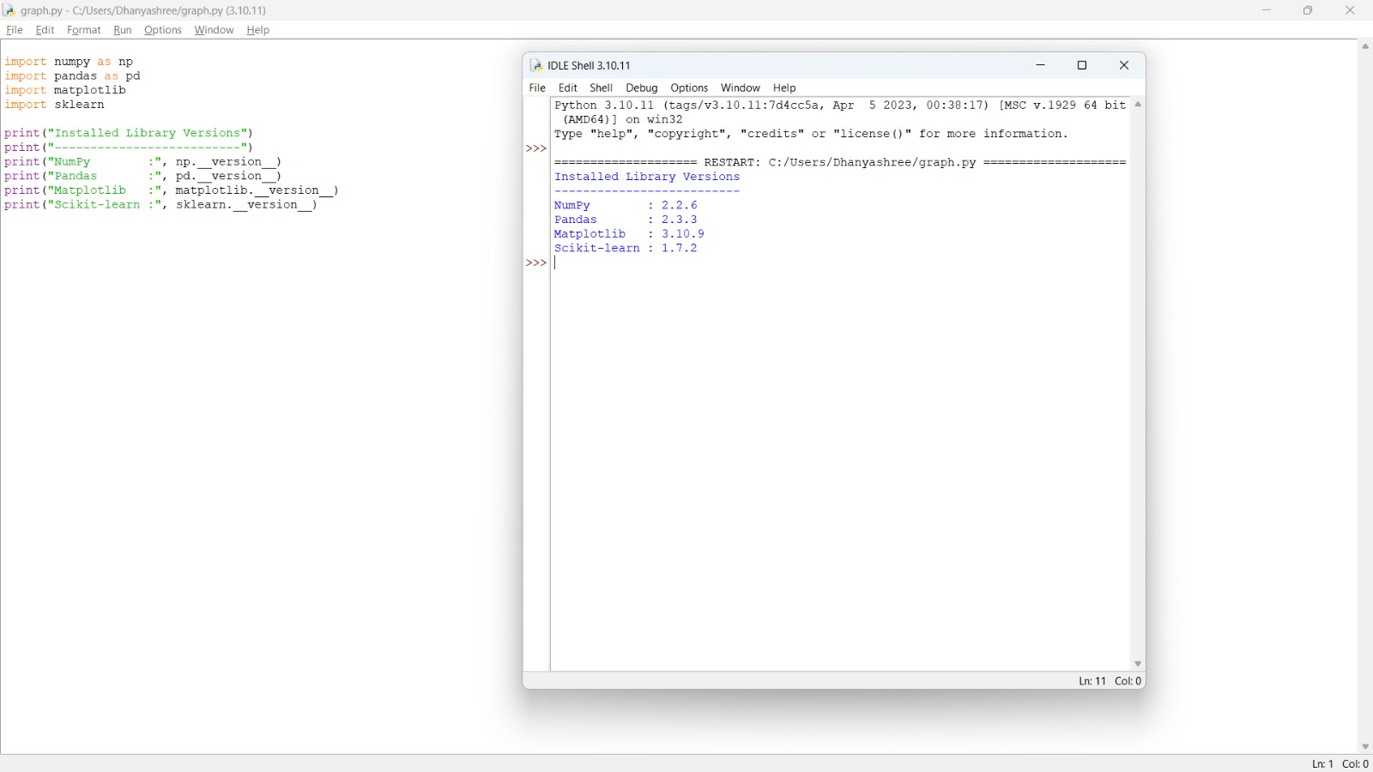
Result:
Thus, verify the installed versions of all AI libraries on your system. was completed successfully.

Experiment 6
Experiment Title:
Create tensors using PyTorch and perform basic mathematical operations.
Aim:
To create tensors using PyTorch and perform basic mathematical operations.
Code:
import torch

a=torch.tensor([1,2,3])
b=torch.tensor([4,5,6])

print("Tensor A:",a)
print("Tensor B:",b)
print("Addition:",a+b)
print("Multiplication:",a*b)
Screenshot:
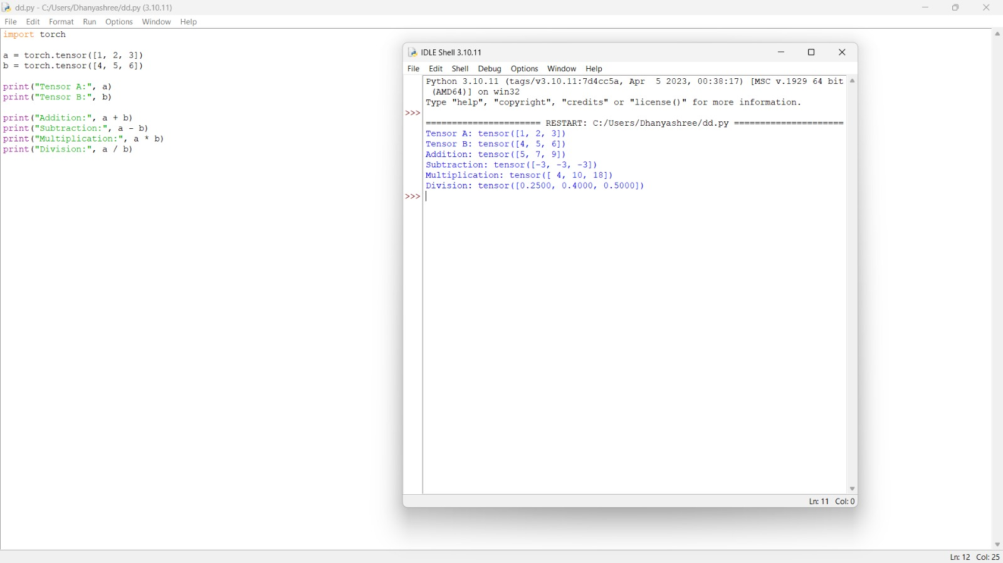
Result:
Thus, create tensors using PyTorch and perform basic mathematical operations. was completed successfully.

Experiment 7
Experiment Title:
Load a Pre-trained Transformer Model using Hugging Face and perform sentiment analysis.
Aim:
To load a Pre-trained Transformer Model using Hugging Face and perform sentiment analysis.
Code:
from transformers import pipeline

classifier=pipeline("sentiment-analysis")

result=classifier("I love Generative AI.")

print(result)
Screenshot:
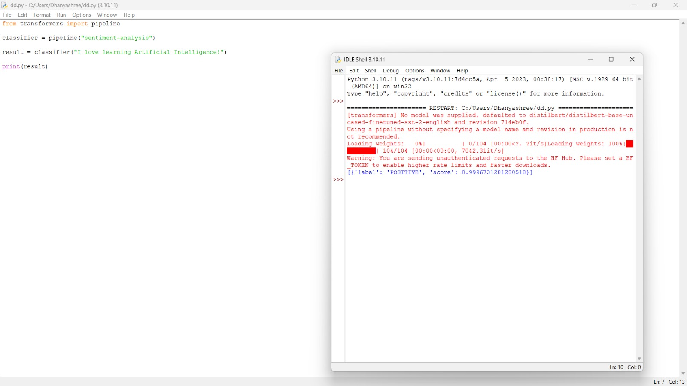
Result:
Thus, load a Pre-trained Transformer Model using Hugging Face and perform sentiment analysis. was completed successfully.

Experiment 8
Experiment Title:
Tokenization using BERT Tokenizer.
Aim:
To tokenization using BERT Tokenizer.
Code:
from transformers import BertTokenizer

tokenizer=BertTokenizer.from_pretrained("bert-base-uncased")

text="Artificial Intelligence is amazing."

tokens=tokenizer.tokenize(text)

print(tokens)
Screenshot:
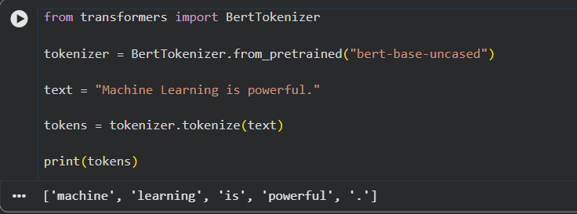
Result:
Thus, tokenization using BERT Tokenizer. was completed successfully.

Experiment 9
Experiment Title:
Generate text using a pre-trained GPT-2 model.
Aim:
To generate text using a pre-trained GPT-2 model.
Code:
from transformers import pipeline

generator=pipeline("text-generation",model="gpt2")

result=generator(
"Artificial Intelligence",
max_new_tokens=30,
do_sample=True
)

print(result[0]["generated_text"])
Screenshot:
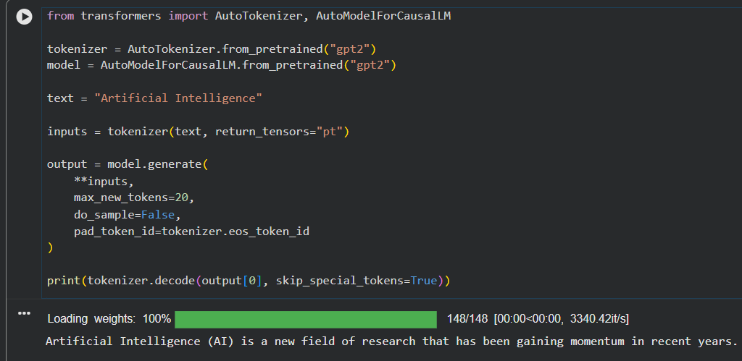
Result:
Thus, generate text using a pre-trained GPT-2 model. was completed successfully.

Experiment 10
Experiment Title:
Load a pre-trained transformer model using the Hugging Face pipeline() API and perform sentiment analysis.
Aim:
To load a pre-trained transformer model using the Hugging Face pipeline() API and perform sentiment analysis.
Code:
from transformers import pipeline

classifier=pipeline("sentiment-analysis")

print(classifier("This course is very interesting."))
Screenshot:
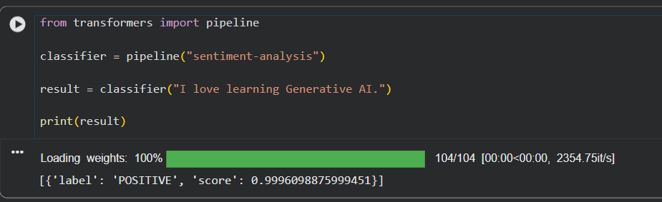
Result:
Thus, load a pre-trained transformer model using the Hugging Face pipeline() API and perform sentiment analysis. was completed successfully.

Experiment 11
Experiment Title:
Load the BERT tokenizer and tokenize a sentence.
Aim:
To load the BERT tokenizer and tokenize a sentence.
Code:
from transformers import BertTokenizer

tokenizer=BertTokenizer.from_pretrained("bert-base-uncased")

sentence="Machine Learning is powerful."

print(tokenizer.tokenize(sentence))
Screenshot:
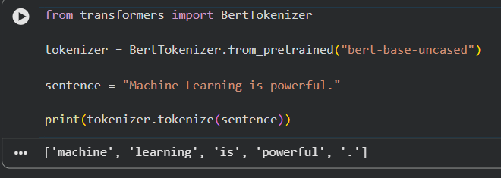
Result:
Thus, load the BERT tokenizer and tokenize a sentence. was completed successfully.

Experiment 12
Experiment Title:
Load a pre-trained BERT model and generate contextual embeddings.
Aim:
To load a pre-trained BERT model and generate contextual embeddings.
Code:
from transformers import BertTokenizer,BertModel

tokenizer=BertTokenizer.from_pretrained("bert-base-uncased")
model=BertModel.from_pretrained("bert-base-uncased")

inputs=tokenizer("Artificial Intelligence",return_tensors="pt")

outputs=model(**inputs)

print(outputs.last_hidden_state.shape)
Screenshot:
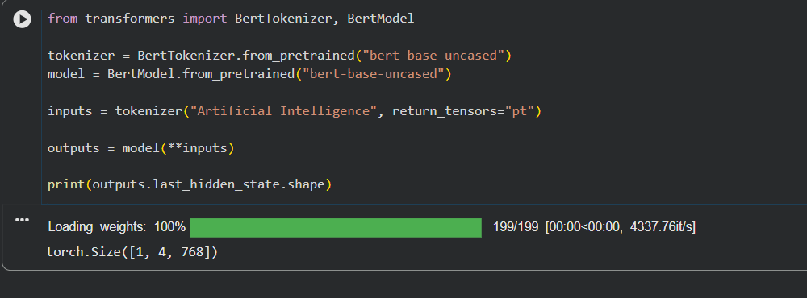
Result:Thus, load a pre-trained BERT model and generate contextual embeddings. was completed successfully.

Experiment 13
Experiment Title:
Generate text using a pre-trained GPT-2 model.
Aim:
To generate text using a pre-trained GPT-2 model.
Code:
from transformers import pipeline

generator=pipeline("text-generation",model="gpt2")

result=generator(
"Deep Learning",
max_new_tokens=40
)

print(result[0]["generated_text"])
Screenshot:
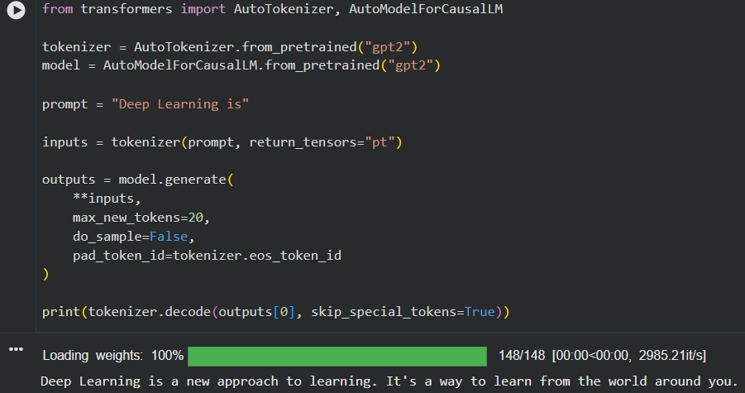
Result:
Thus, generate text using a pre-trained GPT-2 model. was completed successfully.

Experiment 14
Experiment Title:
Question Answering using a Pre-trained Transformer.
Aim:
To question Answering using a Pre-trained Transformer.
Code:
from transformers import AutoTokenizer, AutoModelForQuestionAnswering
import torch

model_name = "distilbert-base-cased-distilled-squad"

tokenizer = AutoTokenizer.from_pretrained(model_name)
model = AutoModelForQuestionAnswering.from_pretrained(model_name)

context = "Python was created by Guido van Rossum."
question = "Who created Python?"

inputs = tokenizer(question, context, return_tensors="pt")

with torch.no_grad():
outputs = model(**inputs)

start = torch.argmax(outputs.start_logits)
end = torch.argmax(outputs.end_logits) + 1

answer = tokenizer.convert_tokens_to_string(
tokenizer.convert_ids_to_tokens(inputs["input_ids"][0][start:end])
)

print("Question:", question)
print("Answer:", answer)
Screenshot:
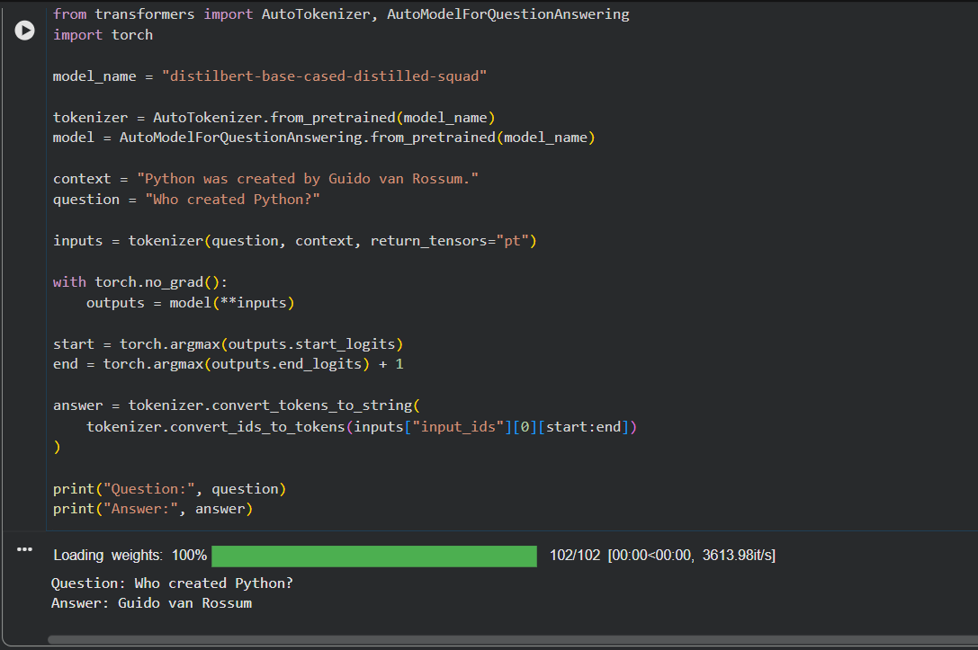
Result:
Thus, question Answering using a Pre-trained Transformer. was completed successfully.

Experiment 15
Experiment Title:
Tokenize a sentence using the BERT tokenizer and display the generated tokens and token IDs.
Aim:
To tokenize a sentence using the BERT tokenizer and display the generated tokens and token IDs.
Code:
from transformers import BertTokenizer

tokenizer=BertTokenizer.from_pretrained("bert-base-uncased")

text="Artificial Intelligence"

tokens=tokenizer.tokenize(text)

ids=tokenizer.convert_tokens_to_ids(tokens)

print("Tokens:",tokens)

print("Token IDs:",ids)
Screenshot:
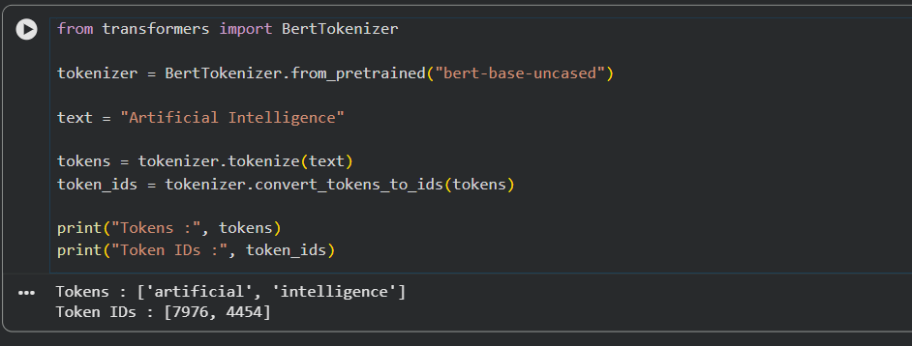
Result:
Thus, tokenize a sentence using the BERT tokenizer and display the generated tokens and token IDs. was completed successfully.

Experiment 16
Experiment Title:
Compare the tokenization outputs of BERT and GPT-2.
Aim:
To compare the tokenization outputs of BERT and GPT-2.
Code:
from transformers import BertTokenizer,GPT2Tokenizer

bert=BertTokenizer.from_pretrained("bert-base-uncased")
gpt2=GPT2Tokenizer.from_pretrained("gpt2")

text="Artificial Intelligence is amazing"

print("BERT:",bert.tokenize(text))

print("GPT2:",gpt2.tokenize(text))
Screenshot:
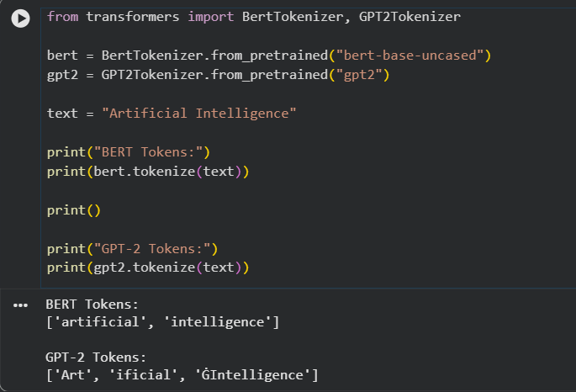
Result:
Thus, compare the tokenization outputs of BERT and GPT-2. was completed successfully.

Experiment 17
Experiment Title:
Generate contextual embeddings for a sentence using BERT.
Aim:
To generate contextual embeddings for a sentence using BERT.
Code:
from transformers import BertTokenizer,BertModel

tokenizer=BertTokenizer.from_pretrained("bert-base-uncased")
model=BertModel.from_pretrained("bert-base-uncased")

inputs=tokenizer("Natural Language Processing",return_tensors="pt")

outputs=model(**inputs)

print(outputs.last_hidden_state)
Screenshot:
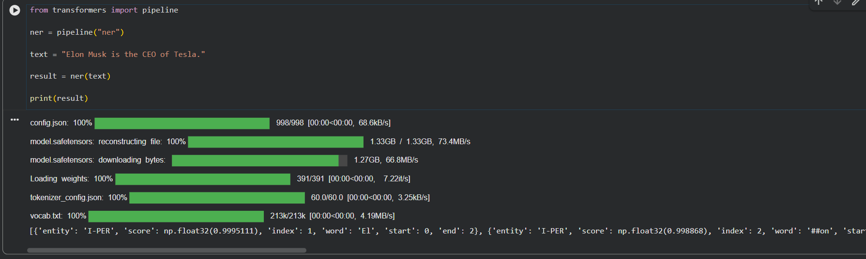
Result:
Thus, generate contextual embeddings for a sentence using BERT. was completed successfully.

Experiment 18
Experiment Title:
Compare contextual embeddings generated for two semantically similar sentences.
Aim:
To compare contextual embeddings generated for two semantically similar sentences.
Code:
from transformers import BertTokenizer,BertModel
import torch

tokenizer=BertTokenizer.from_pretrained("bert-base-uncased")
model=BertModel.from_pretrained("bert-base-uncased")

s1="The cat is sleeping."

s2="A cat is taking a nap."

e1=model(**tokenizer(s1,return_tensors="pt")).last_hidden_state.mean(dim=1)

e2=model(**tokenizer(s2,return_tensors="pt")).last_hidden_state.mean(dim=1)

print(torch.cosine_similarity(e1,e2))
Screenshot:
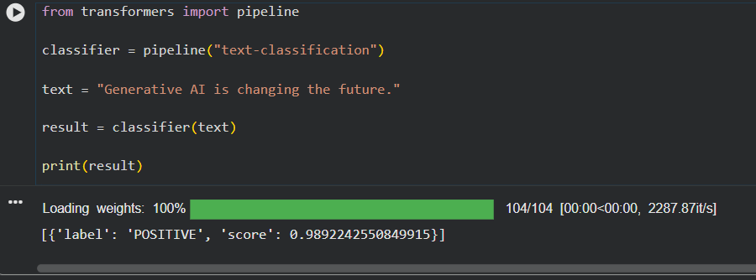
Result:
Thus, compare contextual embeddings generated for two semantically similar sentences. was completed successfully

Experiment 19
Experiment Title:
Generate text from a prompt using the GPT-2 language model.
Aim:
To generate text from a prompt using the GPT-2 language model.
Code:
from transformers import pipeline

generator=pipeline("text-generation",model="gpt2")

result=generator(
"The future of Artificial Intelligence",
max_new_tokens=50
)

print(result[0]["generated_text"])
Screenshot:
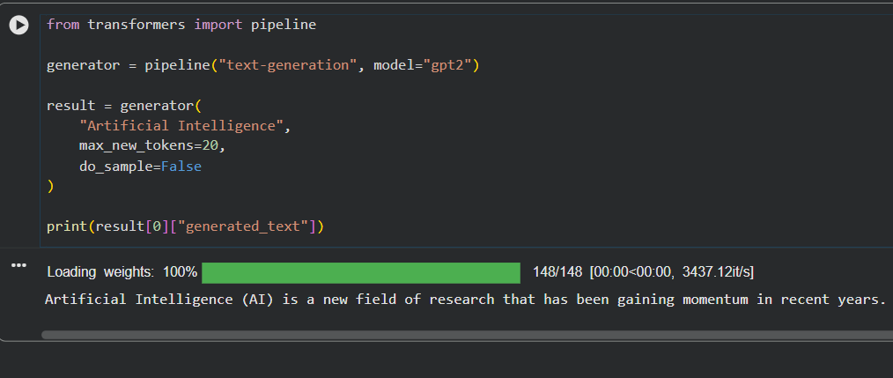
Result:
Thus, generate text from a prompt using the GPT-2 language model. was completed successfully.

Experiment 20
Experiment Title:
Generate and compare responses for multiple prompts using a pre-trained LLM.
Aim:
To generate and compare responses for multiple prompts using a pre-trained LLM.
Code:
from transformers import pipeline

generator=pipeline("text-generation",model="gpt2")

prompts=[
"Artificial Intelligence",
"Machine Learning",
"Data Science"
]

for prompt in prompts:
print("\nPrompt:",prompt)
output=generator(prompt,max_new_tokens=30)
print(output[0]["generated_text"])
Screenshot:
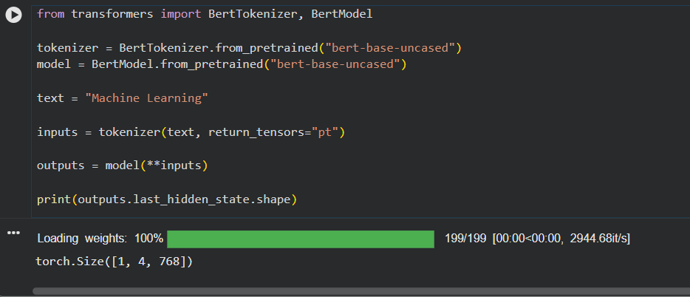
Result:
Thus, generate and compare responses for multiple prompts using a pre-trained LLM. was completed successfully.

Unit 2

Experiment 1

Aim
To design Zero-shot, One-shot, and Few-shot prompts for generating a product description of a Smart Fitness Watch.

Program
print("ZERO-SHOT PROMPT")
print("Generate a product description for a Smart Fitness Watch highlighting its features, benefits, and specifications.")

print("\nONE-SHOT PROMPT")
print("""Example:
Product: Wireless Earbuds
Description:
Enjoy crystal-clear sound with Bluetooth connectivity, noise cancellation, and long battery life.

Now generate a product description for a Smart Fitness Watch.""")

print("\nFEW-SHOT PROMPT")
print("""Example 1:
Product: Wireless Earbuds
Description:
Bluetooth earbuds with noise cancellation.

Example 2:
Product: Smart Water Bottle
Description:
Tracks daily water intake and sends reminders.

Now generate a product description for a Smart Fitness Watch.""")

Output screen short
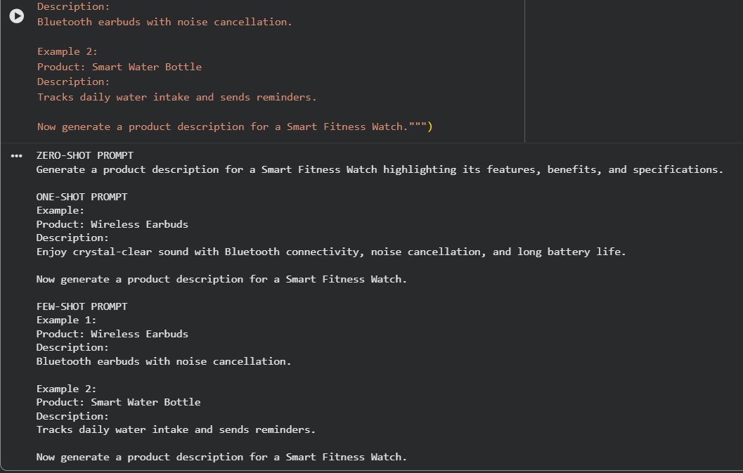

Result
Thus, Zero-shot, One-shot, and Few-shot prompts for generating a Smart Fitness Watch product description were successfully designed.

Experiment 2

Aim
To design Zero-shot, One-shot, and Few-shot prompts for generating a 200-word blog on Applications of Artificial Intelligence in Healthcare.

Program
print("ZERO-SHOT")
print("Write a 200-word blog on Applications of Artificial Intelligence in Healthcare.")

print("\nONE-SHOT")
print("""Example:
Topic: AI in Education
Blog:
AI improves learning through personalized education.

Now write a 200-word blog on Applications of Artificial Intelligence in Healthcare.""")

print("\nFEW-SHOT")
print("""Example 1:
AI in Agriculture

Example 2:
AI in Banking

Now write a 200-word blog on Applications of Artificial Intelligence in Healthcare.""")

Output screenshort:

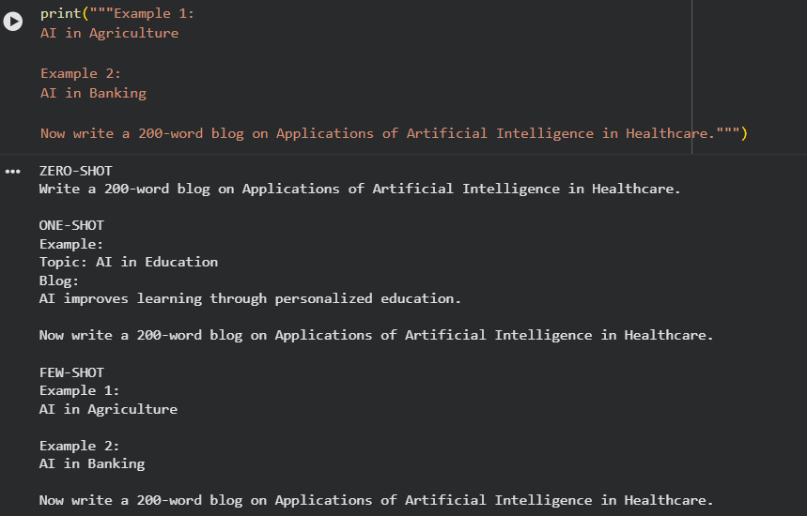

Result
Thus, Zero-shot, One-shot, and Few-shot prompts for generating a healthcare AI blog were successfully designed.

Experiment 3

Aim
To design Zero-shot, One-shot, and Few-shot prompts for summarizing an article into 50 words.

Program
print("ZERO-SHOT")
print("Summarize the following article into exactly 50 words.")

print("\nONE-SHOT")
print("""Example:
Article: AI improves industries.
Summary: AI enhances productivity across industries.

Now summarize the given article into 50 words.""")

print("\nFEW-SHOT")
print("""Example 1:
Article: Online learning...
Summary: Flexible education.

Example 2:
Article: Renewable energy...
Summary: Clean energy benefits.

Now summarize the given article into 50 words.""")

Output screenshort

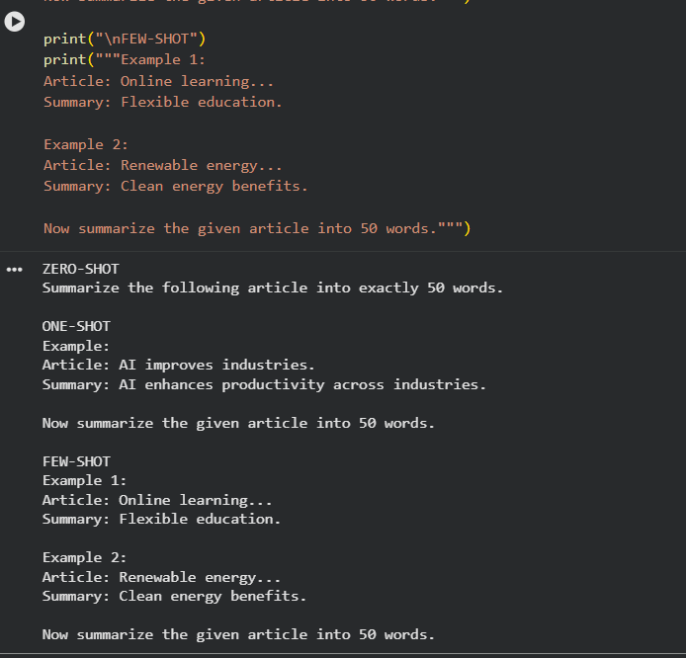

Result
Thus, Zero-shot, One-shot, and Few-shot prompts for article summarization were successfully designed.

Experiment 4

Aim
To design Zero-shot, One-shot, and Few-shot prompts for generating a professional leave request email due to illness.

Program
print("ZERO-SHOT")
print("Write a professional email requesting leave due to illness.")

print("\nONE-SHOT")
print("""Example:
Dear Sir,
I request one day leave due to a family emergency.

Now write a leave email due to illness.""")

print("\nFEW-SHOT")
print("""Example 1:
Leave due to personal reasons.

Example 2:
Leave due to medical reasons.

Now write a professional illness leave email.""")

Output screenshort
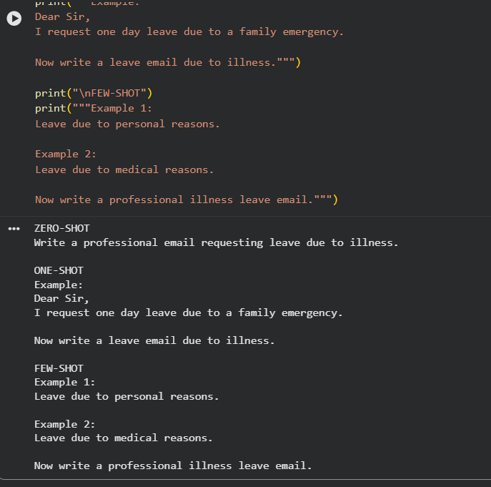

Result
Thus, Zero-shot, One-shot, and Few-shot prompts for a professional leave email were successfully designed.

Experiment 5

Aim
To design Zero-shot, One-shot, and Few-shot prompts for generating a promotional social media post for an AI Workshop.

Program
print("ZERO-SHOT")
print("Write a promotional social media post for an AI Workshop.")

print("\nONE-SHOT")
print("""Example:
Join our Python Workshop and improve your programming skills.

Now write a promotional post for an AI Workshop.""")

print("\nFEW-SHOT")
print("""Example 1:
Data Science Workshop promotion.

Example 2:
Cyber Security Workshop promotion.

Now write a promotional post for an AI Workshop.""")

Output screen short
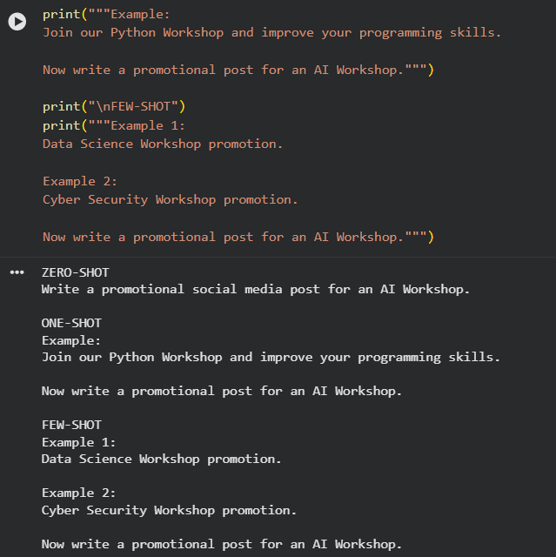

Result
Thus, Zero-shot, One-shot, and Few-shot prompts for promoting an AI Workshop were successfully designed.

