SIMATS ENGINEERING
Department of ComputerScience and Engineering ASSESSMENT TOOL2 - CONCEPT MAPPING
Course Code: | CSA1205 | Course Title: | Computer Architecture for Multicore Systems
CO Assessed: | CO1 | Assessment: | ASSESSMENT TOOL 2- CONCEPT MAPPING
Weightage: | 35% | Total Marks: | 25
CO1 Statement: | Analyze the functional units of a computer system including CPU, memory, bus structures, and I/O components by examining instruction execution cycles, addressing modes, and performance metrics such as CPI, clock cycles, and benchmarking (BL4)
Student Name: | Shailaja S | Reg.No.: | 192511026
Department: | BE CSE | Date: | 19/07/2026

Instruction to Students
1. Answer two questions as per the Instruction.
2. Each question carries a 12.5 mark.
3. Only the appropriate Tools can be used
4. Time allotted for the exam is 60 min

ANNEXURE A
1. Construct a detailed concept map showing the relationship between CPU (ALU, Control Unit, Registers), memory (cache, RAM), and I/O devices. Extend the map to include single-bus, multi-bus, and hierarchical bus structures, and clearly illustrate how data and control signals flow among these components during execution. Indicate possible points of delay or bottlenecks and how different bus structures help in improving performance.
- The CPU places a memory address on the address lines and asserts a "read" control signal.
- Memory decodes the address, fetches data, and drives it onto the data lines a few cycles later.
- CPU latches the data into a register (like MDR).
- The bus is now free for the next request which might be the CPU again, or a DMA-capable I/O device that requested control.

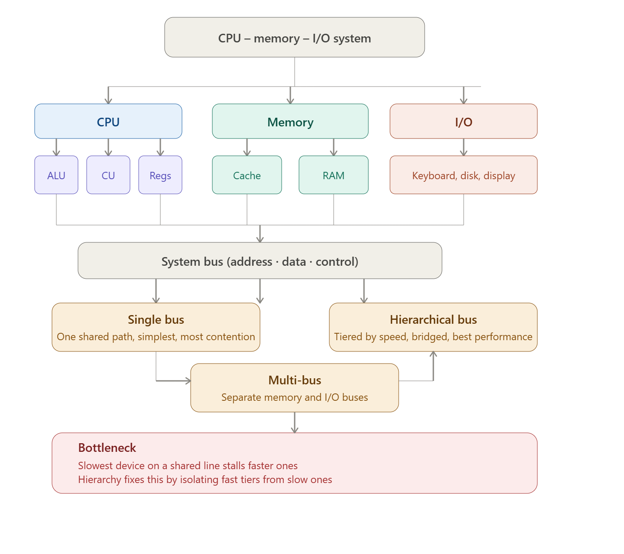

2. Develop a comprehensive concept map linking the instruction execution cycle (fetch, decode, execute) with CPU performance parameters such as CPI, clock cycles, and execution time. Show how each stage contributes to overall execution time, and include connections to factors like memory access, instruction complexity, and pipeline stalls. Also, represent how benchmarking is used to evaluate performance.

- Fetch — The CPU places the address held in the program counter (PC) onto the address bus and asserts a "read" signal; memory returns the instruction a few cycles later (cache hit) or many more cycles later (cache miss, RAM access).
- Decode — The control unit reads the fetched instruction from the instruction register (IR) and determines the opcode, addressing mode, and operands; more complex instructions (multiple addressing modes, multi-operand formats) take more cycles here.
- Operand fetch — If operands live in memory rather than registers, the CPU issues another memory access to retrieve them, adding further cycles.
- Execute — The ALU performs the actual operation (arithmetic, logic, address calculation); a pipelined CPU tries to overlap this with the fetch/decode of the next instruction, but a data hazard, control hazard, or branch misprediction forces a stall, effectively wasting cycles.
- Write-back — The result is written to a register or, for a store instruction, back out to memory over the bus.
- PC update — The program counter is incremented (or overwritten by a branch/jump target), and the cycle repeats for the next instruction.

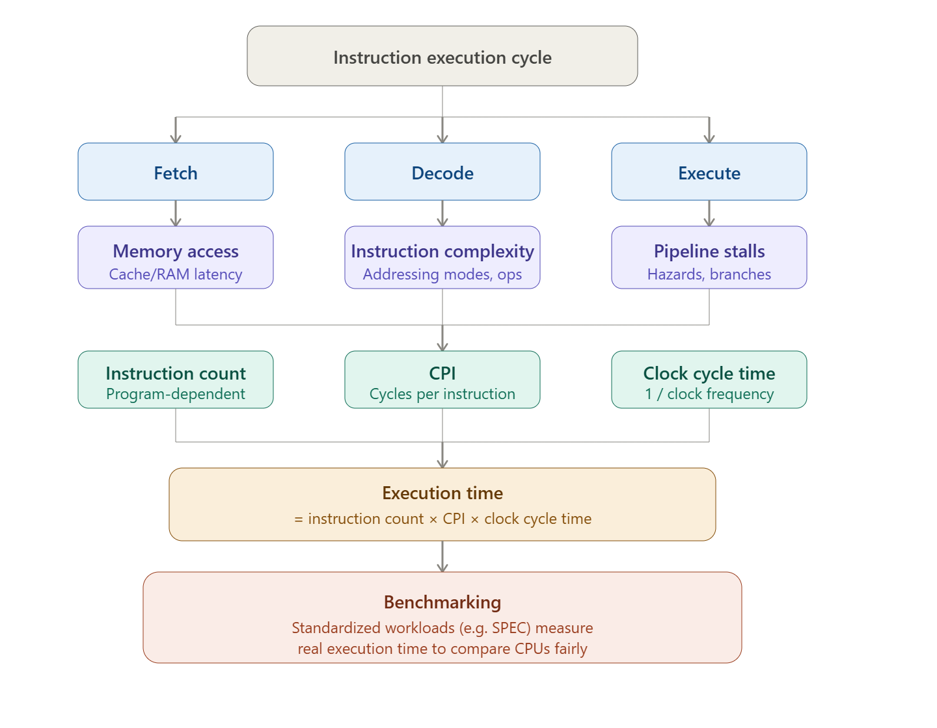

3. Create a concept map comparing 8085 and 8086 architectures, including their instruction sets, register organization, addressing modes, and memory segmentation (in 8086). Clearly show how these architectural features influence program execution, multitasking capability, and efficiency in real-time applications.
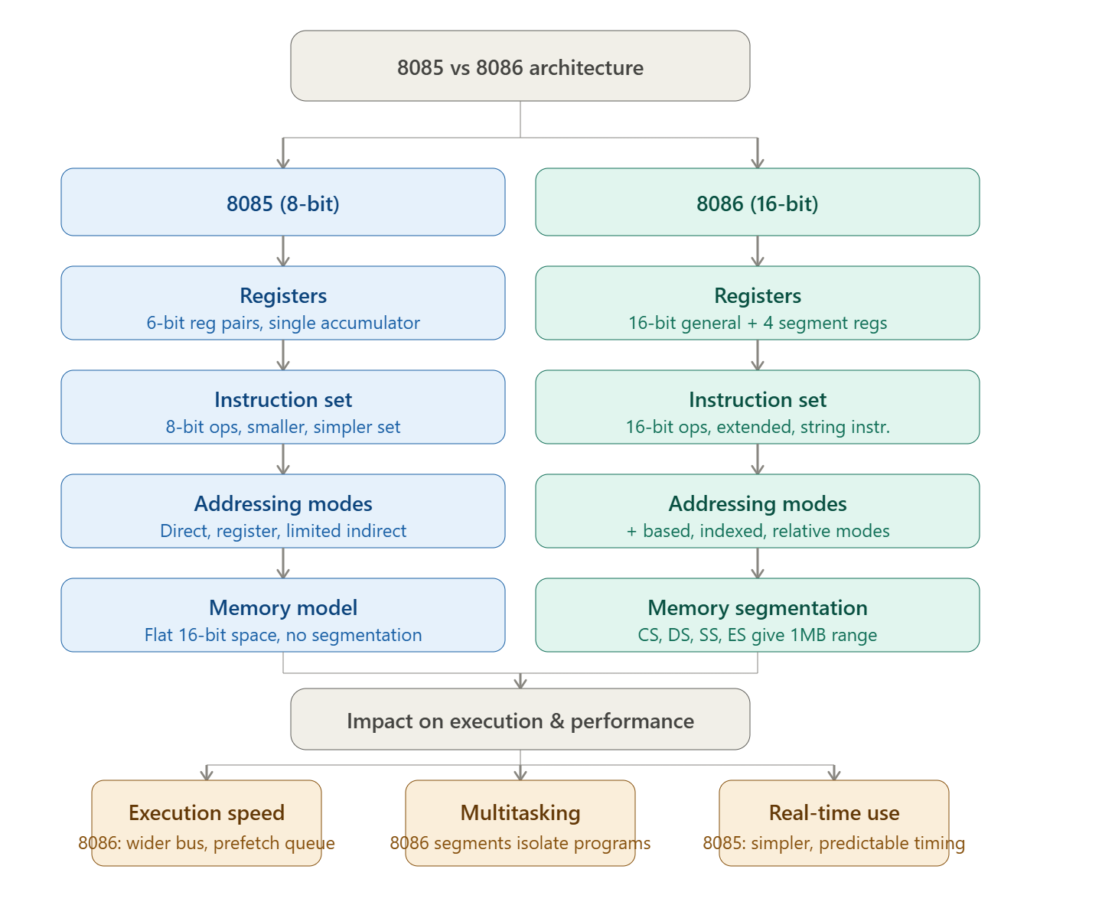

4. Draw a detailed concept map that connects various addressing modes (immediate, direct, register, indirect, indexed) with instruction types (data transfer, arithmetic, control instructions). Illustrate how each addressing mode affects memory access time, instruction size, and execution speed, and show real-world scenarios where specific addressing modes are preferred.

- Register addressing — by far the most common. Arithmetic operations are fastest when both operands are already in registers, since there's no memory access at all and the ALU can act on them in a single cycle. Compilers aggressively try to keep loop counters, accumulators, and frequently-used variables in registers specifically so arithmetic can use this mode.
- Example: ADD A, B.
- Immediate addressing — very common for arithmetic with a known constant, like incrementing by 1, adding a fixed offset, or comparing against a literal value. The constant is baked into the instruction itself, so there's zero memory access for that operand. Example: ADD A, #10.

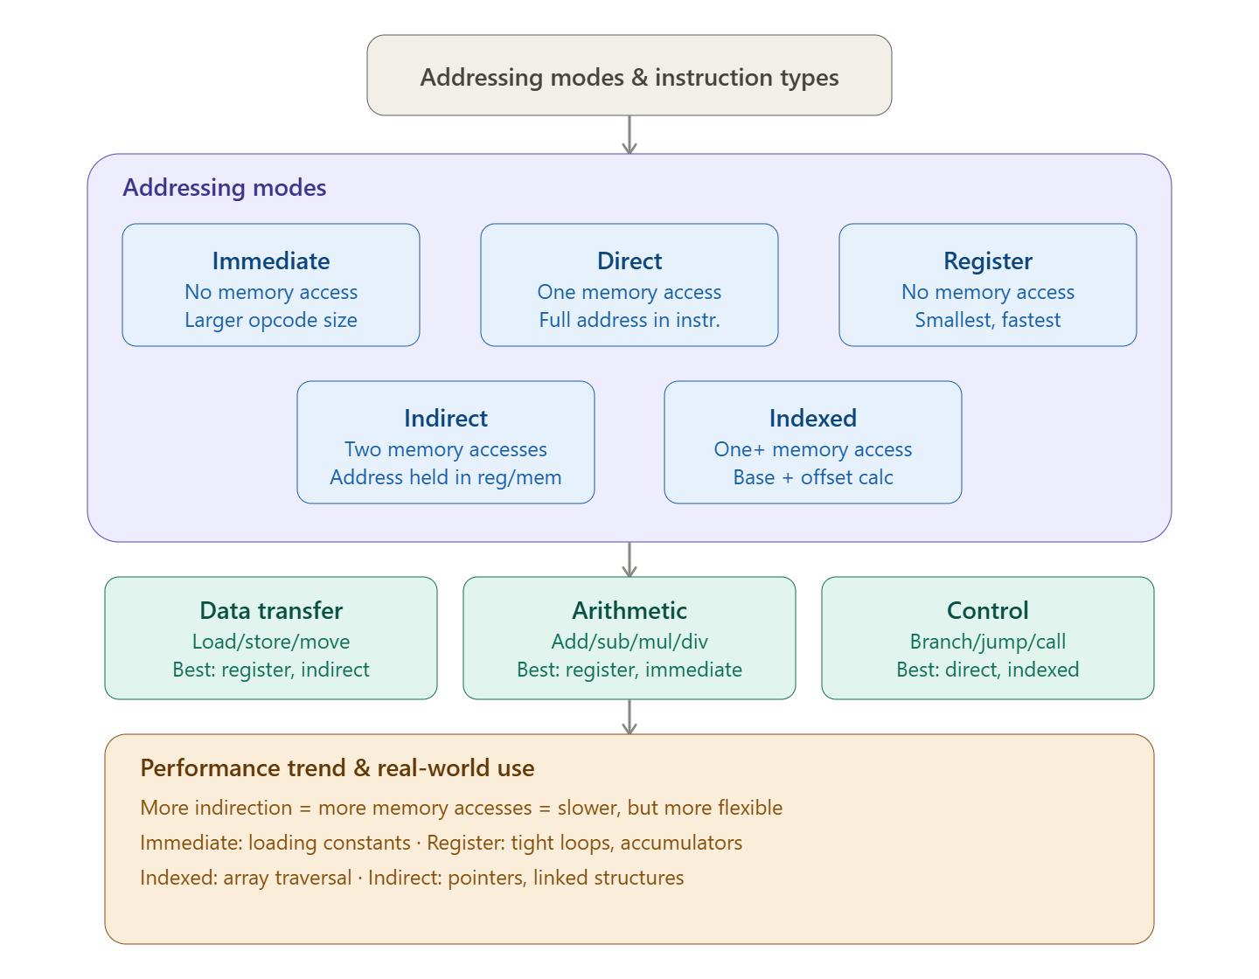

5. Prepare an elaborate concept map integrating number systems (binary and hexadecimal) with instruction representation, memory storage, and debugging processes. Show how data is converted between formats, how instructions are stored and interpreted by the CPU, and why hexadecimal representation is commonly used in low-level programming and system design.
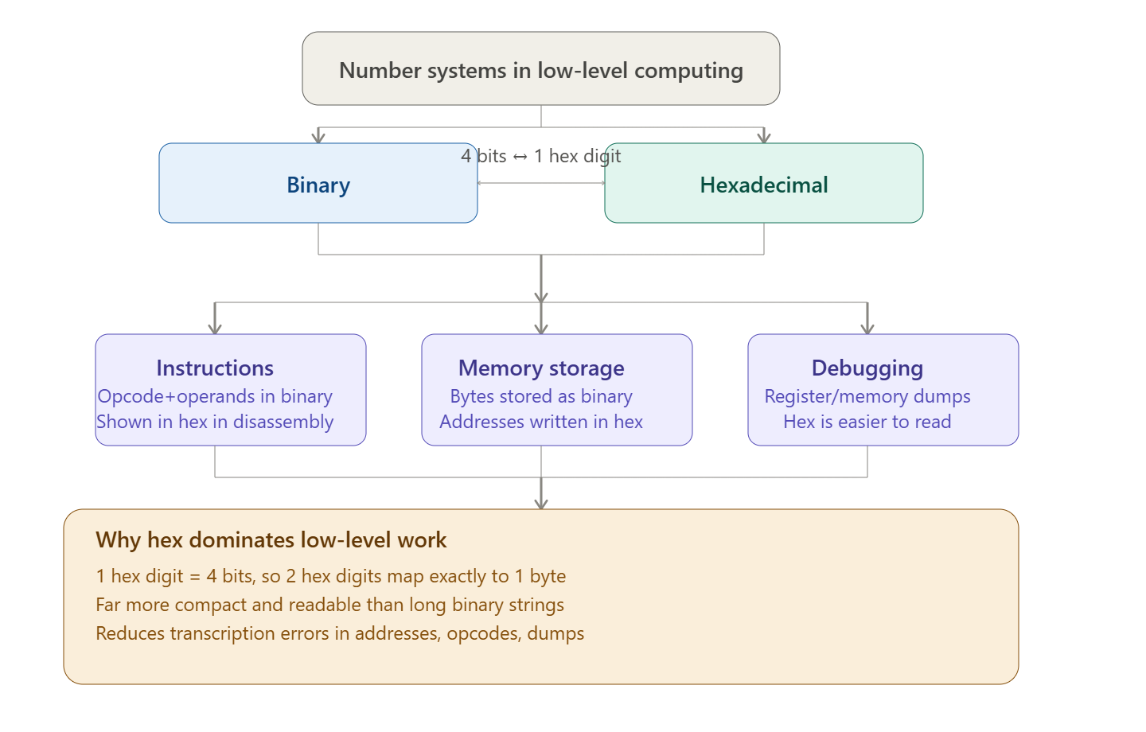

Code of Conduct:
I SHAILAJA S(192511026) (Name / Reg No) certify that this submission is my original work and that I have adhered to the guidelines specified for this assessment. I understand that any violation of academic integrity rules will result in disciplinary action.
Signature of the student:
MARKS ALLOCATION
Criteria | Concept  Identification  (25%) | Linkages  (25%) | Organization  (20%) | Integration of  Literature (20%) | Clarity  (10%)
Q1
Q2

RUBRICS FOR CALCULATION:
Criteria | Weightage | Level 4 –  Exemplary | Level 3 –  Proficient | Level 2 –  Developing | Level 1 –  Beginning
Concept  Identification | 25% | Identifies all key  concepts from  literature accurately and comprehensively | Identifies most key concepts with  minor omissions | Identifies limited concepts; some are irrelevant or  missing | Fails to identify  essential concepts
Linkages | 25% | Establishes clear,  meaningful, and  accurate relationships between concepts | Shows correct  relationships with minor gaps | Relationships are weak, unclear, or partially incorrect | No meaningful  relationships  established
Organization | 20% | Concepts are well  structured  hierarchically with logical flow and  grouping | Mostly organized with minor  structural issues | Some organization but lacks clear  hierarchy | No logical  organization or  structure
Integration of  Literature | 20% | Integrates multiple studies effectively to show connections and comparisons | Shows some  integration of  literature | Limited  integration; mostly isolated concepts | No integration of  literature evidence
Clarity | 10% | Concept map is clear, neat, visually  structured, and easy to interpret | Generally clear  with minor  readability issues | Clarity is reduced; difficult to interpret in parts | Poorly presented and hard to understand

