SIMATS ENGINEERING
ASSESSMENT TOOL 1

COURSE NAME: Artificial Intelligence COURSE CODE: CSA17

COURSE OUTCOME COVERED

CO3: Analyze knowledge representation and reasoning using propositional logic, FOL, inference, resolution, chaining methods, knowledge representation to perform logical reasoning for drawing valid conclusions and decision making. (BL4)

Assessment Tool Weightage: 50%

Time Duration: 1 Hour

QUESTIONS: 4 Total Marks:40

Annexure A

CASE STUDY

Code of Conduct:

I SHAILAJA S (192511026) (Name / Reg No) certify that this submission is my original work and that I have adhered to the guidelines specified for this assessment.
I understand that any violation of academic integrity rules will result in disciplinary action.

Signature of the student:

Annexure A

CASE STUDY

Case Study 1 — Smart Medical Diagnosis System
A hospital is designing a rule-based Logical Agent for preliminary patient diagnosis. The system’s knowledge base contains:
I. If a patient has Fever AND Cough → Possible Flu
Ii. If a patient has Fever AND Rash → Possible Measles
Iii. If a patient has Cough AND Breathlessness → Possible Pneumonia
Iv. Facts about Patient A: Fever = True, Cough = True, Breathlessness = True
(a) Represent the above rules and facts precisely using Propositional Logic symbols. Define each symbol used.
(b) Apply Forward Chaining on the knowledge base to derive all possible diagnoses for Patient A. Show each inference step with the rule fired and fact derived.
(c) The goal is to confirm ‘Patient A has Pneumonia.’ Apply Backward Chaining and draw the goal reduction tree to verify this goal.

(a) Propositional Logic Representation
Let the following propositional symbols be defined:

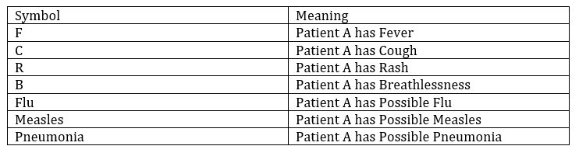

Rules:
- Rule I: F ∧ C → Flu
- Rule II: F ∧ R → Measles
- Rule III: C ∧ B → Pneumonia
Facts about Patient A:
- F = True
- C = True
- B = True
- Therefore, the knowledge base can be represented as: KB = {F, C, B, (F ∧ C → Flu), (F ∧ R → Measles), (C ∧ B → Pneumonia)}.

(b) Forward Chaining
Forward chaining starts with the known facts and applies rules whose conditions are satisfied.

Initial Facts
F = True, C = True, B = True

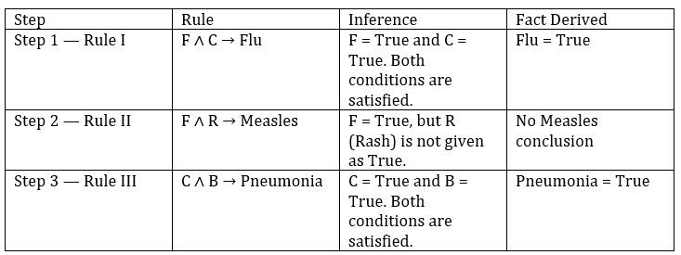

Forward Chaining Result
The possible diagnoses derived for Patient A are Possible Flu and Possible Pneumonia. Possible Measles cannot be derived because Rash is not known to be true.

(c) Backward Chaining
Goal: Confirm whether Patient A has Possible Pneumonia.
Backward chaining starts with the goal and searches for a rule that can derive that goal. Rule III can derive Pneumonia: C ∧ B → Pneumonia.

Goal reduction tree

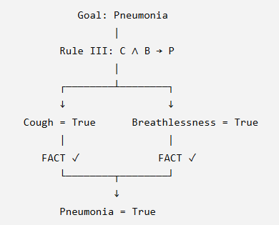

Case Study 2 — Autonomous Traffic Management Agent
A smart city traffic controller uses a FOL-based knowledge base to manage emergency vehicle routing:
- ∀x: Vehicle(x) ∧ Emergency Type(x) → ClearPath(x) [Rule 1]
- ∀x: ClearPath(x) → Green Signal(x) ∧ ¬Red Signal(x) [Rule 2]
- ∀x ∀y: Vehicle(x) ∧ Behind (x, y) ∧ Green Signal(y) → Proceed(x) [Rule 3]
- Facts: Vehicle (Ambulance), Emergency Type (Ambulance), Vehicle (Car A), Behind (Car A, Ambulance)
(a) Apply Unification to match Rule 1 with the given facts. Show the complete substitution set θ (MGU) at each step.
(b) Using the Resolution method, prove that ‘Proceed (Car A)’ is true. Convert relevant clauses to CNF and show each resolution step.
(c) Analyze whether the current FOL knowledge base is sufficient to handle two simultaneous emergency vehicles. Identify what additional rules or facts are needed and justify logically.

(a) Apply Unification to Rule 1

Rule 1: ∀x [Vehicle(x) ∧ Emergency Type(x) → ClearPath(x)]
The antecedent of Rule 1 is Vehicle(x) ∧ Emergency Type(x). We match it with the facts about Ambulance.
Step 1: Match Vehicle(x) with Vehicle (Ambulance).
Substitution: θ₁ = {x → Ambulance}
After substitution: Vehicle (Ambulance)
Step 2: Match Emergency Type(x) with Emergency Type (Ambulance).
Using θ₁, x = Ambulance, so the second predicate also matches.
Substitution remains: θ₂ = {x → Ambulance}
Step 3: Both premises are true:
Vehicle (Ambulance) ∧ Emergency Type (Ambulance)
Therefore Rule 1 derives: ClearPath (Ambulance)
Most General Unifier (MGU): θ = {x → Ambulance}
- Thus, the complete substitution set contains only one substitution because the same constant Ambulance satisfies both predicates.

(b) Resolution Proof of Proceed (Car A)
Resolution proves a conclusion by converting the relevant statements to CNF and resolving complementary literals.

CNF Conversion
Rule 1: Vehicle(x) ∧ Emergency Type(x) → ClearPath(x)
CNF: ¬Vehicle(x) ∨ ¬Emergency Type(x) ∨ ClearPath(x)
Rule 2: ClearPath(x) → Green Signal(x) ∧ ¬Red Signal(x)
CNF 2a: ¬ClearPath(x) ∨ Green Signal(x)
CNF 2b: ¬ClearPath(x) ∨ ¬Red Signal(x)
Rule 3: Vehicle(x) ∧ Behind (x, y) ∧ Green Signal(y) → Proceed(x)
CNF: ¬Vehicle(x) ∨ ¬Behind (x, y) ∨ ¬Green Signal(y) ∨ Proceed(x)

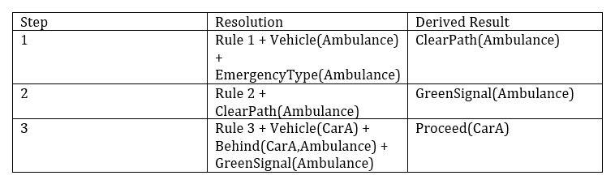

(c) Two Simultaneous Emergency Vehicles
The current FOL knowledge base is only partially sufficient. Because Rules 1–3 are universally quantified, they can be applied separately to two emergency vehicles. However, the knowledge base does not contain rules for priority, route conflicts, intersection allocation, or deciding which vehicle should proceed first.

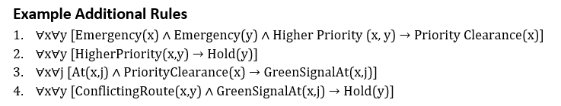

Case Study 3 — Agricultural Expert Reasoning System
An agricultural advisory logical agent operates with the following propositional knowledge base (KB):
- P1: soil Dry → Irrigation Needed
- P2: Irrigation Needed ∧ Crop Wheat → Apply Drip Method
- P3: ¬Apply Drip Method ∧ Crop Wheat → Crop at Risk
- Facts: Soil Dry = True, Crop Wheat = True
(a) Convert all sentences P1, P2, P3 and the facts into Conjunctive Normal Form (CNF). Show each conversion step (eliminate implication → move ¬ inward → distribute).
(b) Using Resolution Refutation, prove the theorem ‘Apply Drip Method’. Negate the goal, combine with the KB in CNF, and derive the empty clause □. Draw the resolution proof tree.
(c) If the fact ‘soil Dry’ is removed from the KB, analyze step-by-step how logical conclusions change. Does ‘Crop at Risk’ still follow? Apply appropriate reasoning patterns to justify.

(a) Conversion of P1, P2, P3 and Facts into CNF

Let:
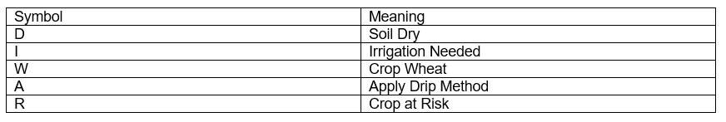
P1: Soil Dry → Irrigation Needed
Step 1 — Eliminate implication: D → I ≡ ¬D ∨ I
CNF: ¬D ∨ I
P2: Irrigation Needed ∧ Crop Wheat → Apply Drip Method
Step 1 — Eliminate implication: (I ∧ W) → A ≡ ¬ (I ∧ W) ∨ A
Step 2 — Move ¬ inward using De Morgan’s law: (¬I ∨ ¬W) ∨ A
CNF: ¬I ∨ ¬W ∨ A
P3: ¬Apply Drip Method ∧ Crop Wheat → Crop at Risk
Step 1 — Eliminate implication: (¬A ∧ W) → R ≡ ¬ (¬A ∧ W) ∨ R
Step 2 — Move ¬ inward: A ∨ ¬W ∨ R
CNF: A ∨ ¬W ∨ R
Facts:
Soil Dry = True → D
Crop Wheat = True → W
Unit clauses D and W are already in CNF.

CNF Summary Table

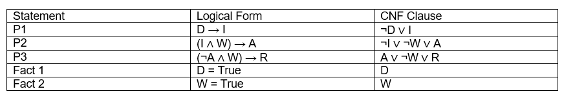

(b) Resolution Refutation: Prove “Apply Drip Method”
Goal: A. For resolution refutation, negate the goal and add ¬A to the CNF knowledge base.
Initial clauses:
- C1: ¬D ∨ I
- C2: ¬I ∨ ¬W ∨ A
- C3: A ∨ ¬W ∨ R
- C4: D
- C5: W
- C6: ¬A (negated goal)
Resolution steps:

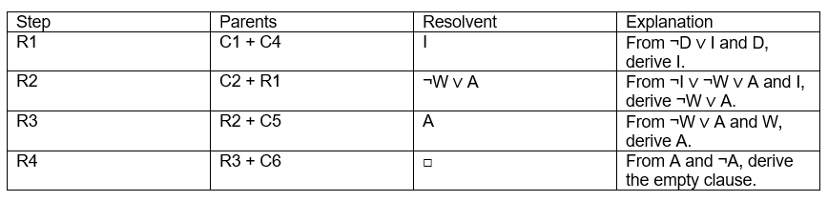

Resolution Proof Tree

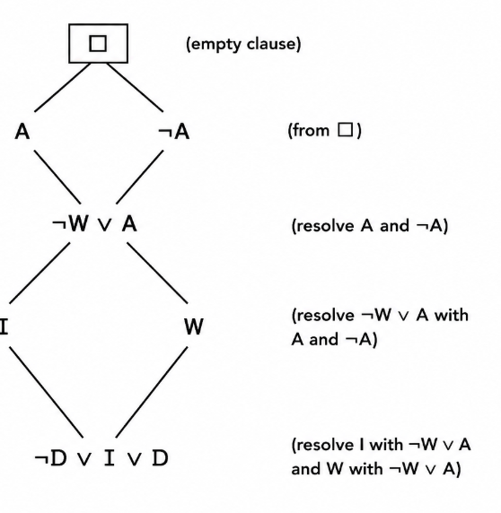

Case Study 4 — Wumpus World Knowledge Agent
An AI agent navigating the Wumpus World perceives: Stench at [1,2], Breeze at [1,1], Glitter at [2,2]. The agent uses a propositional KB with these rules:
- Stench [1,2] → Wumpus is adjacent to cell [1,2]
- Breeze [1,1] → Pit is adjacent to cell [1,1]
- Glitter [x, y] → Gold is at [x, y]
- ¬Wumpus [x, y] ∧ ¬Pit [x, y] → Safe [x, y]
(a) Construct the agent’s belief state from its percepts. Apply Modus Ponens systematically to derive new knowledge facts. List all derived conclusions.
(b) Using Forward Chaining from the agent’s percepts, identify the possible locations of the Wumpus and Pit. Show each reasoning step precisely.
(c) Evaluate whether the path [1,1] → [1,2] → [2,2] is safe for the agent to collect the gold. Use the knowledge derived in (a) and (b) to justify your conclusion with logical inference.

(a) Construct the Belief State and Apply Modus Ponens
Initial Percepts:
- Stench [1,2] = True
- Breeze [1,1] = True
- Glitter [2,2] = True
Rule 1:
Stench [1,2] → Wumpus adjacent to [1,2].
Derived fact:
Wumpus is in one of the cells adjacent to [1,2].
Rule 2:
Breeze [1,1] → Pit adjacent to [1,1].
Derived fact:
Pit is in one of the cells adjacent to [1,1].
Rule 3:
Glitter [2,2] → Gold [2,2].
Derived fact:
Gold is at [2,2].
Rule 4:
¬Wumpus ∧ ¬Pit → Safe.
Derived fact:
A cell is safe only when both Wumpus and Pit are known to be absent.
Conclusion:
The agent knows the locations of possible hazards and that gold is at [2,2].
(b) Forward Chaining – Possible Wumpus and Pit Locations
Step 1:
Stench [1,2] is perceived.
Step 2:
Therefore, Wumpus is adjacent to [1,2].
Possible Wumpus cells:
[1,1], [1,3], [2,2].
Step 3:
Breeze [1,1] is perceived.
Step 4:
Therefore, Pit is adjacent to [1,1].
Possible Pit cells:
[1,2], [2,1].
Step 5:
Glitter [2,2] confirms Gold at [2,2].
- Conclusion:
Possible Wumpus locations = [1,1], [1,3], [2,2].
Possible Pit locations = [1,2], [2,1].

(c) Safety of the Path
Path:
[1,1] → [1,2] → [2,2]
Step 1:
[1,2] has Stench, so a Wumpus may be adjacent to it.
Step 2:
[1,1] has Breeze, so a Pit may be adjacent to it.
Step 3:
[1,2] is a possible Pit location.
Step 4:
[2,2] is a possible Wumpus location.
Step 5:
The KB does not prove ¬Wumpus and ¬Pit for all cells in the path.
Conclusion:
The path cannot be guaranteed safe using the available knowledge. The agent should not assume that [1,2] and [2,2] are safe. Gold is at [2,2], but reaching it involves risk.

RUBRICS FOR CALCULATION

Criteria | Weightage | Level 4 – Exemplary | Level 3 – Proficient | Level 2 – Developing | Level 1 – Beginning
Understanding of Case | 25 | Thorough understanding; clearly identifies all key issues | Good understanding with most issues identified | Basic understanding; some issues missed | Poor understanding; problem not identified correctly
Application of Concepts | 25 | Effectively applies relevant concepts to analyze the case deeply | Applies appropriate concepts with minor gaps | Limited application of concepts | Fails to apply relevant concepts
Analysis | 20 | In-depth analysis with strong reasoning and insights | Good analysis with logical reasoning | Basic analysis with limited depth | Weak or no analysis; lacks reasoning
Solution Design | 20 | Innovative, feasible solutions with strong justification | Logical solutions with adequate justification | Basic solutions with weak justification | Incorrect or no solution provided
Clarity | 10 | Clear, well-structured, and easy to understand | Organized and understandable presentation | Limited clarity and structure | Poor clarity; difficult to understand

