SIMATS ENGINEERING
ASSESSMENT TOOL 4

COURSE NAME: Artificial Intelligence COURSE CODE: CSA17

COURSE OUTCOME COVERED

CO3: Analyze knowledge representation and reasoning using propositional logic, FOL, inference, resolution, chaining methods, knowledge representation to perform logical reasoning for drawing valid conclusions and decision making. (BL4)

Assessment Tool Weightage: 20%

Time Duration: 1 Hour
QUESTIONS: 5 Total Marks:30

Annexure A

Resolution Algorithm Implementation

Code of Conduct:

I SHAILAJA S (192511026) (Name / Reg No) certify that this submission is my original work and that I have adhered to the guidelines specified for this assessment.
I understand that any violation of academic integrity rules will result in disciplinary action.

Signature of the student:

Annexure A

Resolution Algorithm Implementation

Question 1 – Rain and Wet Ground

Knowledge Base
- If it rains, then the ground becomes wet.
- It is raining.
Goal
Prove that the ground is wet using the Resolution Algorithm.

Tasks
- Represent the statements in propositional logic.
- Convert all statements into CNF.
Negate the goal.
- Apply the Resolution Algorithm step by step.
- Show the Empty Clause (□) if the goal is proved.

1. Propositional Logic Representation
Let:
- R = "It rains"
- W = "The ground is wet"
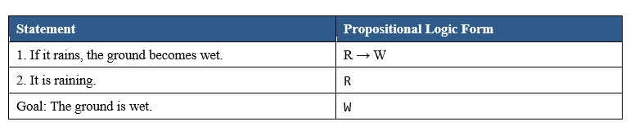

2.Conversion to Conjunctive Normal Form (CNF)
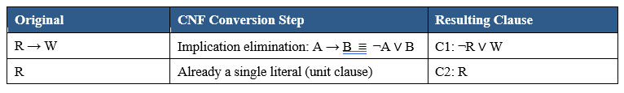

3. Negate the Goal
Goal: W Negated goal: ¬W → C3: ¬W
This negated goal is added to the clause set. If we can derive a contradiction (the empty clause □) from KB ∧ ¬Goal, the original goal is proved.

4.Clause Set for Resolution
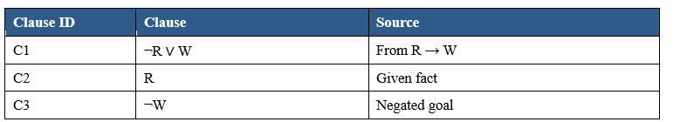

5. Apply the Resolution Algorithm Step by Step
Step 1: Resolve C1 and C2 on the complementary literals R and ¬R.
- C1: ¬R ∨ W
- C2: R
- Resolvent → C4: W

Step 2: Resolve C4 and C3 on the complementary literals W and ¬W.
- C4: W
- C3: ¬W
- Resolvent → □ (the empty clause)

6.Resolution Proof Tree

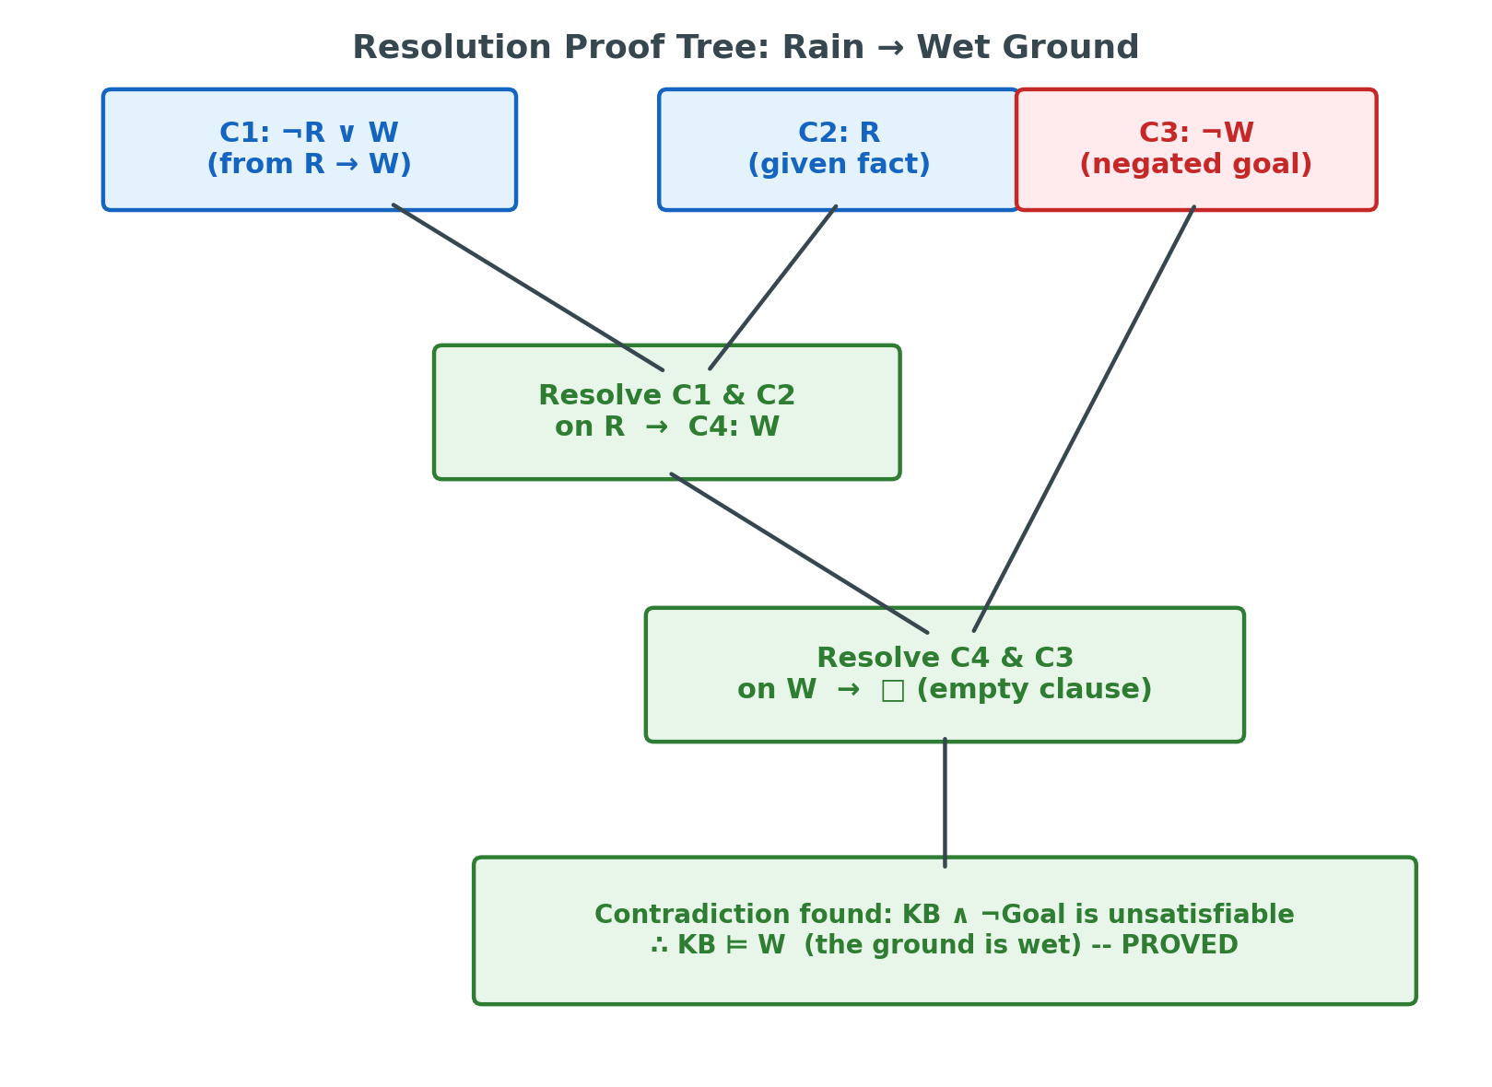

Question 2 – Student Assignment Submission

Knowledge Base
- If a student submits the assignment, then the student receives internal marks
- Rahul submitted the assignment.

Goal
Prove that Rahul receives internal marks using the Resolution Algorithm.

Tasks

Write the propositional logic expressions.

Convert the premises into CNF.
Negate the goal.
- Apply the Resolution Algorithm.
- Conclude whether the goal is proved.

Convert Premises into CNF

Step 1: Convert Premise 1 (P → Q) to CNF
Using the implication elimination rule: A → B ≡ ¬A ∨ B
Therefore, P → Q ≡ ¬P ∨ Q
Step 2: Premise 2 is already in CNF form
P (a single literal, already in clause form)
Step 3: Negate the Goal
Goal: Q
Negated Goal: ¬Q
Final Clause Set (CNF):
Clause 1: ¬P ∨ Q (from Premise 1)
Clause 2: P (from Premise 2)
Clause 3: ¬Q (Negated Goal)

Applying the Resolution Algorithm

Step 1: Resolve Clause 2 and Clause 1
Clause 2: P
Clause 1: ¬P ∨ Q
P and ¬P are complementary literals, so they cancel out.
Resolvent: Q
Step 2: Resolve the new clause Q with Clause 3
Clause (Resolvent): Q
Clause 3: ¬Q
Q and ¬Q are complementary literals, so they cancel out.
Resolvent: NIL (Empty Clause)
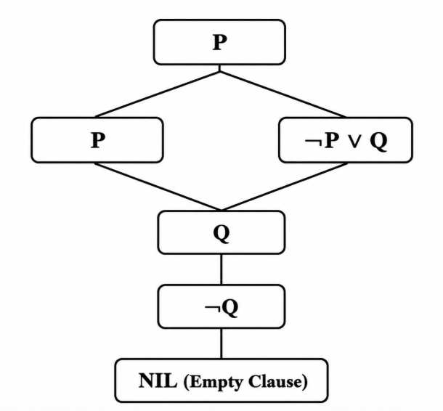

Question 3 – Library Membership

Knowledge Base

If a person is a library member, then the person can borrow books.

Priya is a library member.

Goal
- Prove that Priya can borrow books using the Resolution Algorithm.

Tasks

Represent the knowledge base using propositional logic.

Convert each statement into CNF.
Negate the goal.
- Perform resolution until no new clauses can be generated.
- State the final conclusion.
Convert Each Statement into CNF and Negate the Goal
Statement 1:
P → Q
Using the implication rule:
P → Q ≡ ¬P ∨ Q
So, Clause 1 is:
¬P ∨ Q
Statement 2:
P
So, Clause 2 is:
P
Negation of the Goal:
Goal = Q
Negated Goal = ¬Q
So, Clause 3 is:
¬Q
CNF Clauses
- ¬P ∨ Q
- P
- ¬Q
Perform Resolution
We resolve the clauses step by step.
Step 1: Resolve P and ¬P ∨ Q
Clauses:
- P
- ¬P ∨ Q
Resolving on P and ¬P:
P + (¬P ∨ Q) → Q
Therefore, the new clause is:
Q
Step 2: Resolve Q and ¬Q
Clauses:
- Q
- ¬Q
Resolving on Q and ¬Q:
Q + ¬Q → NIL
Therefore:
NIL = Empty Clause
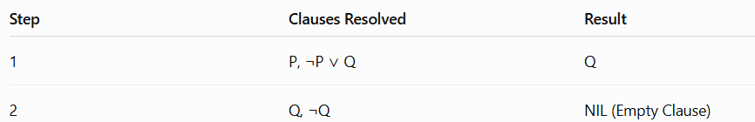

Question 4 – Placement Eligibility

Knowledge Base

If a student clears the aptitude test, then the student is eligible for placement.

Arun cleared the aptitude test.

Goal

Prove that Arun is eligible for placement using the Resolution Algorithm.

Tasks

Convert the statements into propositional logic.

Write the CNF clauses.

Negate the goal.

Apply the Resolution Algorithm step by step.

Draw the resolution tree and conclude.

- Convert the Statements into Propositional Logic
Let:
- P = Arun cleared the aptitude test.
- Q = Arun is eligible for placement.
The given statements are:
- If a student clears the aptitude test, then the student is eligible for placement.
P → Q
- Arun cleared the aptitude test.
P
Goal:
Q = Arun is eligible for placement.

2. Write the CNF Clauses
Convert the implication:
P → Q
Using the implication rule:
P → Q ≡ ¬P ∨ Q
Therefore:
- Clause 1: ¬P ∨ Q
- Clause 2: P

- Negate the Goal
The goal is:
Q
Negate the goal:
¬Q
Therefore, the clauses used for resolution are:
- ¬P ∨ Q
- P
- ¬Q — Negated Goal
4. Apply the Resolution Algorithm Step by Step
Step 1: Resolve Clause 1 and Clause 2.
- ¬P ∨ Q
- P
Resolving on P and ¬P:
(¬P ∨ Q) + P → Q
New clause:
Q
Step 2: Resolve the new clause Q with the negated goal ¬Q.
- Q
- ¬Q
Therefore:
Q + ¬Q → NIL
NIL represents the Empty Clause.
No further resolution is possible.

5.Resolution Tree

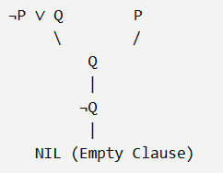

Question 5 – Access Control System

Knowledge Base

If a user enters the correct password, then the user is authenticated.

If a user is authenticated, then the user is granted access.

The user entered the correct password.

Goal
Prove that the user is granted access using the Resolution Algorithm.

Tasks

Represent the knowledge base in propositional logic.

Convert all implications into CNF.

Negate the goal.

Apply the Resolution Algorithm to derive the Empty Clause (□).

Explain each resolution step and write the final conclusion.

1. Represent the Knowledge Base in Propositional Logic
Let:
- P = User entered the correct password.
- Q = User is authenticated.
- R = User is granted access.
Given statements:
- If a user enters the correct password, then the user is authenticated.
P → Q
- If a user is authenticated, then the user is granted access.
Q → R
- The user entered the correct password.
P
Goal:
R = User is granted access.

- Convert All Implications into CNF

Statement 1:
P → Q
Using implication:
P → Q ≡ ¬P ∨ Q
So, Clause 1:
¬P ∨ Q
Statement 2:
Q → R
Using implication:
Q → R ≡ ¬Q ∨ R
So, Clause 2:
¬Q ∨ R
Statement 3:
P
So, Clause 3:
P
Therefore, the CNF clauses are:
- ¬P ∨ Q
- ¬Q ∨ R
- P
3. Negate the Goal
The goal is:
R
Negation of the goal:
¬R
Therefore, add:
Clause 4: ¬R
The complete set of clauses is:
- ¬P ∨ Q
- ¬Q ∨ R
- P
- ¬R
4. Apply the Resolution Algorithm to Derive the Empty Clause (□)
Resolution Step 1
Resolve:
- P
- ¬P ∨ Q
Resolving on P and ¬P:
P + (¬P ∨ Q) → Q
New clause:
Q
Resolution Step 2
Resolve:
- Q
- ¬Q ∨ R
Resolving on Q and ¬Q:
Q + (¬Q ∨ R) → R
New clause:
R
Resolution Step 3
Resolve:
- R
- ¬R
Resolving on R and ¬R:
R + ¬R → □
Here, □ represents the Empty Clause (NIL).

- Final Conclusion

Since the resolution process derives the Empty Clause (□), the negated goal ¬R is contradictory with the knowledge base.
Therefore, the original goal is proved:
∴ The user is granted access.

RUBRICS FOR CALCULATION

Numerical Problems
Criteria | Weightage | Level 4 (Exemplary) | Level 3 (Proficient) | Level 2 (Developing) | Level 1 (Beginning)
Problem Understanding | 20% | Clearly interprets problem, identifies all parameters and requirements accurately | Understands problem with minor gaps | Partial understanding; misses key elements | Misinterprets or unable to understand problem
Method Selection | 20% | Selects most appropriate method/formula with strong justification | Selects correct method with minor errors | Inappropriate or partially correct method | Unable to select method
Solution Process | 25% | Logical, systematic steps with correct approach throughout | Mostly correct steps with minor mistakes | Disorganized steps; multiple errors | No clear process
Accuracy of Calculation | 20% | All calculations accurate; correct final answer | Minor calculation errors | Frequent errors; incorrect final answer | No valid calculations
Interpretation of Results | 15% | Clearly interprets results with units and engineering relevance | Basic interpretation with minor omissions | Limited or unclear interpretation | No interpretation

