CO2-AT2-Architecture Design Assignment

Problem Statement: Smart Renewable Battery Recycling Platform
NAME: JK RISHIK SLOT: D
REGNO :192511052 COURSE CODE: CSA1007

Introduction
The Smart Renewable Battery Recycling Platform is developed to improve the battery recycling process by using a well-organized software system. The platform helps recycling industries manage battery inventory, monitor recycling operations, predict hazardous conditions, track battery transportation, generate sustainability reports, and notify recycling operators. A suitable software architecture helps the system perform efficiently, ensures better maintenance, and supports future improvements.

1. Analyze System Requirements
1.1 System Objectives
The main objectives of the Smart Renewable Battery Recycling Platform are:
- To monitor battery inventory.
- To optimize recycling operations.
- To predict hazardous battery conditions.
- To track battery transportation.
- To generate sustainability reports.
- To notify recycling operators.
Functional Requirements
The system should provide the following functions:
- User Login and Authentication.
- Battery Inventory Management.
- Recycling Task Management.
- Hazard Detection and Alert System.
- Logistics Tracking.
- Sustainability Report Generation.
- Notification Management.
Non-Functional Requirements
The system should satisfy the following quality requirements:
- High Performance
- Security
- Reliability
- Scalability
- Maintainability
- Availability
- User-Friendly Interface

Quality Attributes
The software architecture should support scalability, maintainability, reliability, availability, security, and performance so that the system can operate efficiently and support future enhancements.

2. Selection of Software Architecture
- The Layered Architecture is selected for the Smart Renewable Battery Recycling Platform.
- Layered Architecture divides the application into different layers, where each layer performs a specific responsibility. This makes the system easier to understand, develop, test, and maintain.
- The selected architecture is suitable because the system contains different modules such as battery inventory, recycling management, hazard detection, logistics tracking, and report generation. Each module can work independently while communicating with the other layers whenever required.
- The architecture also supports future improvements without affecting the complete system.

3.Software Architecture Diagram:
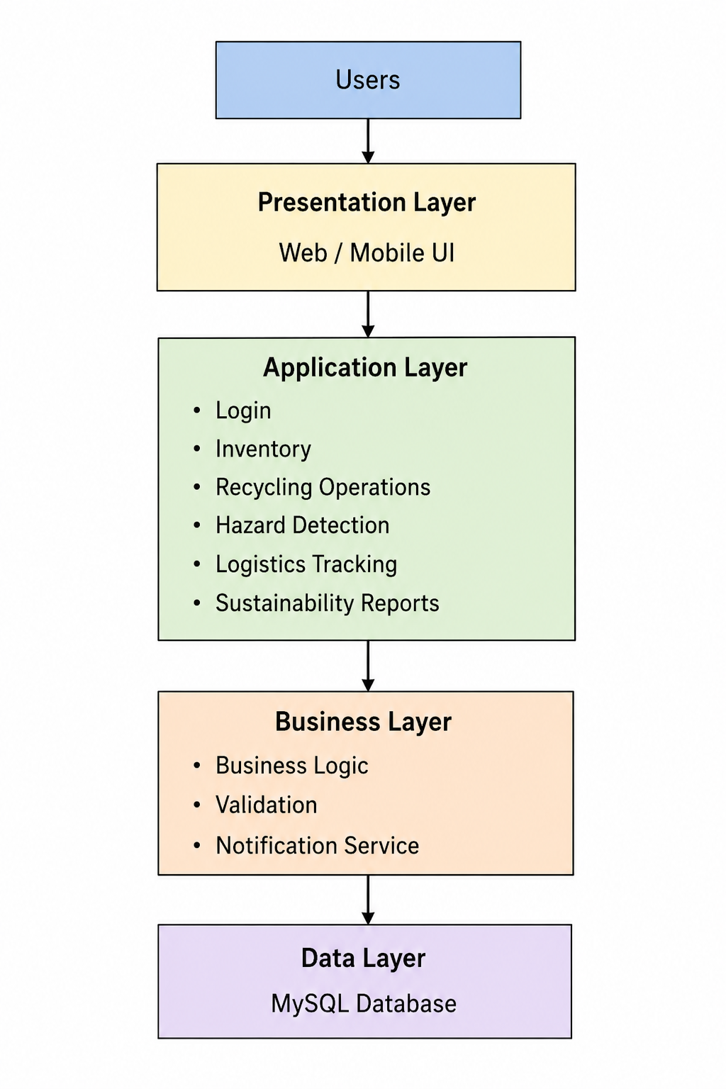

4. Components and Their Interactions:

Presentation Layer:

The Presentation Layer provides the user interface for administrators, managers, recycling operators, safety officers, and logistics managers. Users interact with the system through this layer to perform different operations.

Application Layer:

The Application Layer processes user requests. It manages user authentication, battery inventory, recycling operations, hazard monitoring, logistics tracking, notifications, and report generation.

Business Layer:

The Business Layer contains the business logic of the system. It validates user requests, processes application rules, generates notifications, and controls communication between the application and database.

Data Layer:

The Data Layer stores all system information, including user details, battery records, recycling activities, transportation information, and sustainability reports.

System Workflow:

The user first logs into the system through the Presentation Layer. The request is processed by the Application Layer, where the required module performs the requested operation

5. Quality Attributes

Scalability

The layered architecture allows the system to support additional users and new modules without affecting existing functionalities.

Security

User authentication and role-based access control protect sensitive information from unauthorized access.

Performance

The architecture provides efficient communication between different layers, resulting in faster processing of user requests.

Reliability

The separation of components improves system stability and reduces the possibility of failures.

Maintainability

Each layer can be modified independently, making software maintenance easier and reducing development time.

Availability

The system is designed to provide continuous service with proper database management and regular maintenance.

6. Justification of Architectural Decisions:

The Layered Architecture was selected because it provides a simple and organized structure for developing the Smart Renewable Battery Recycling Platform. Each layer performs a specific responsibility, making the application easier to understand and maintain.

One advantage of this architecture is that changes made in one layer usually do not affect the other layers. This simplifies software testing and future development.

Although communication between multiple layers may slightly increase processing time, the advantages of modularity, maintainability, and scalability outweigh this limitation.

The selected architecture also supports future enhancements such as mobile application support, cloud integration, AI-based hazard prediction, and advanced analytics without requiring major modifications to the existing system.

Conclusion

The Layered Architecture is an appropriate choice for the Smart Renewable Battery Recycling Platform because it provides a structured and modular design. The architecture supports important quality attributes such as scalability, maintainability, reliability, security, performance, and availability. It also provides flexibility for future enhancements and ensures efficient communication between different components of the system. Therefore, this architecture is well suited for developing a reliable and sustainable battery recycling management platform.

Code of Conduct:
I Rishik Jk (Name / Reg No) certify that this submission is my original work and that I have adhered to the guidelines specified for this assessment. I understand that any violation of academic integrity rules will result in disciplinary action.
Signature of the student: JK RISHIK

