SESSION 2 – C PROGRAMS
Programs, sample outputs, and complexity analysis
Nithya sree .S (192511058)

1. Find Unique Elements in an Array
Aim: To create a new array containing only the unique elements from the input array, preserving their original order.
C Code
#include <stdio.h>

int main() {
int n, a[100], unique[100];
int i, j, count = 0, found;

printf("Enter number of elements: ");
scanf("%d", &n);

printf("Enter elements: ");
for (i = 0; i < n; i++) {
scanf("%d", &a[i]);
}

for (i = 0; i < n; i++) {
found = 0;
for (j = 0; j < count; j++) {
if (a[i] == unique[j]) {
found = 1;
break;
}
}
if (!found) {
unique[count] = a[i];
count++;
}
}

printf("Unique elements: ");
for (i = 0; i < count; i++) {
printf("%d ", unique[i]);
}

return 0;
}

Sample Input
Enter number of elements: 7
Enter elements: 4 2 4 7 2 9 7

Sample Output Screenshot
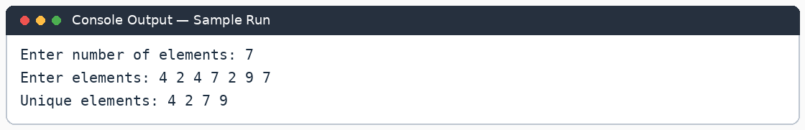
Complexity Analysis: Time: O(n²), because each element may be compared with the unique elements already stored. Auxiliary space: O(n) for the new unique array (the input array is separate).

2. Bubble Sort
Aim: To sort an array of integers in ascending order using the bubble sort technique.
C Code
#include <stdio.h>

int main() {
int n, a[100], i, j, temp;

printf("Enter number of elements: ");
scanf("%d", &n);

printf("Enter elements: ");
for (i = 0; i < n; i++) {
scanf("%d", &a[i]);
}

for (i = 0; i < n - 1; i++) {
for (j = 0; j < n - i - 1; j++) {
if (a[j] > a[j + 1]) {
temp = a[j];
a[j] = a[j + 1];
a[j + 1] = temp;
}
}
}

printf("Sorted array: ");
for (i = 0; i < n; i++) {
printf("%d ", a[i]);
}

return 0;
}

Sample Input
Enter number of elements: 5
Enter elements: 5 1 4 2 8
Sample Output Screenshot
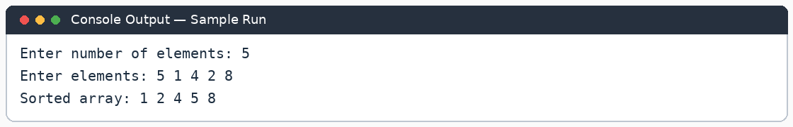
Complexity Analysis: Time: O(n²) in the average and worst cases. Auxiliary space: O(1), because sorting is done in the same array.

3. Binary Search in a Sorted Array
Aim: To check whether a target value exists in a sorted array using binary search.
C Code
#include <stdio.h>

int main() {
int n, a[100], i, x;
int low, high, mid, found = 0;

printf("Enter number of elements: ");
scanf("%d", &n);

printf("Enter elements in sorted order: ");
for (i = 0; i < n; i++) {
scanf("%d", &a[i]);
}

printf("Enter value to search: ");
scanf("%d", &x);

low = 0;
high = n - 1;

while (low <= high) {
mid = low + (high - low) / 2;

if (a[mid] == x) {
found = 1;
break;
} else if (a[mid] < x) {
low = mid + 1;
} else {
high = mid - 1;
}
}

if (found) {
printf("%d exists in the array.", x);
} else {
printf("%d does not exist in the array.", x);
}

return 0;
}

Sample Input
Enter number of elements: 6
Enter elements in sorted order: 2 5 8 12 16 23
Enter value to search: 12
Sample Output Screenshot
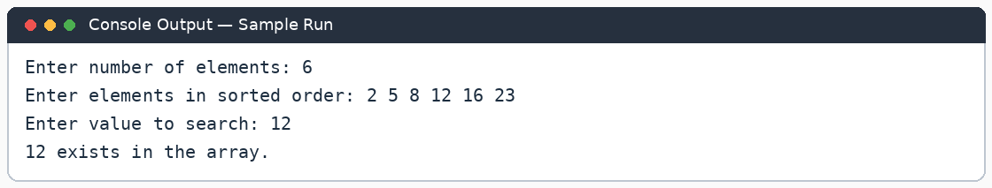
Complexity Analysis: Time: O(log n), because the search range is halved in each iteration. Auxiliary space: O(1) for this iterative implementation.

4. Sort in O(n log n) Using Heap Sort
Aim: To sort an array in ascending order without built-in sorting functions, using heap sort for O(n log n) time and constant auxiliary space.
C Code
#include <stdio.h>

void heapify(int a[], int n, int i) {
int largest = i;
int left = 2 * i + 1;
int right = 2 * i + 2;
int temp;

if (left < n && a[left] > a[largest]) {
largest = left;
}
if (right < n && a[right] > a[largest]) {
largest = right;
}

if (largest != i) {
temp = a[i];
a[i] = a[largest];
a[largest] = temp;
heapify(a, n, largest);
}
}

void heapSort(int a[], int n) {
int i, temp;

for (i = n / 2 - 1; i >= 0; i--) {
heapify(a, n, i);
}

for (i = n - 1; i > 0; i--) {
temp = a[0];
a[0] = a[i];
a[i] = temp;
heapify(a, i, 0);
}
}

int main() {
int n, a[100], i;

printf("Enter number of elements: ");
scanf("%d", &n);

printf("Enter elements: ");
for (i = 0; i < n; i++) {
scanf("%d", &a[i]);
}

heapSort(a, n);

printf("Sorted array: ");
for (i = 0; i < n; i++) {
printf("%d ", a[i]);
}

return 0;
}

Sample Input
Enter number of elements: 6
Enter elements: 12 11 13 5 6 7
Sample Output Screenshot
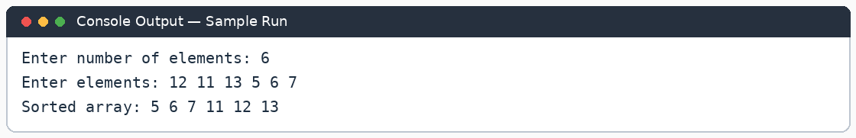
Complexity Analysis: Time: O(n log n) in the best, average, and worst cases. Auxiliary space: O(log n) due to recursive heapify calls; the array is sorted in place. Heap sort is a strong choice when avoiding an additional O(n) array.
.

