PROGRAMMING IN JAVA
ASSIGNMENT – 2
Course Code: UBA0920
Submitted by:
Name: K Suthesika
Register Number: 192511070
GitHub Repository: https://github.com/192511070simats-code/CSA09-192511070-Assignment2
Academic Year: 2026 – 2027

TASK 01 – BUILDING TEXT UNDER LOAD
String, StringBuilder and StringBuffer
AIM
To compare the performance and memory behaviour of String, StringBuilder and StringBuffer in Java while generating railway e-ticket text under different workloads. The aim is to identify the most suitable approach based on execution time, object creation, memory usage and thread safety.
THEORY
In Java, String, StringBuilder and StringBuffer are used to store and manipulate text. However, they differ in terms of mutability, object creation, performance and thread safety.
1. String
String is immutable, which means its value cannot be changed after creation. When we concatenate strings using the + operator, a new String object is created for the resulting text. Repeated concatenation inside loops can increase object creation and reduce performance.
2. StringBuilder
StringBuilder is mutable, which means its content can be modified without creating a new String object for every append operation. It uses the append() method to add text. It is generally faster than String concatenation and StringBuffer in single-threaded operations because its methods are not synchronized.
3. StringBuffer
StringBuffer is also mutable and provides the append() method to modify text. Its methods are synchronized, making individual method operations thread-safe. However, synchronization can introduce some performance overhead compared with StringBuilder.
Performance Comparison
String concatenation may require repeated copying of existing text, while StringBuilder and StringBuffer use expandable internal buffers. Therefore, StringBuilder is generally suitable for building individual ticket text, whereas StringBuffer can be useful when multiple threads share a text buffer and need synchronized access.
EXPERIMENTAL DESIGN
The performance of String, StringBuilder and StringBuffer is compared using three different workloads. All three approaches use the same input data to ensure a fair comparison.
Workload Details
Workload | Number of Tickets | Fields per Ticket
Small | 1 | 6
Large | 10,000 | 50
Custom | 5,000 | 100

Methods Used
- String concatenation using the + operator.
- StringBuilder using the append() method.
- StringBuffer using the append() method.
Measurements
- Execution time using System.nanoTime().
- Average execution time across repeated runs.
- Estimated intermediate String object creation.
- Approximate memory usage before and after execution.
The program performs one warm-up run for each method and then measures the average execution time over 10 repetitions.
PREDICTIONS
Before executing the program, the following results were predicted:
- StringBuilder: It was predicted to be the fastest because it is mutable and appends text without creating a new String object for every field. It also does not have synchronization overhead.
- String: It was predicted to be the slowest because String is immutable. Repeated concatenation using the + operator creates new String objects and copies existing content.
- Execution Time: As the number of tickets and fields increases, the execution time of all three methods was expected to increase. String was expected to become significantly slower, while StringBuilder was expected to perform best. StringBuffer was expected to be slightly slower than StringBuilder because of synchronization.
- Individual Ticket Text: StringBuilder was predicted to be the most suitable choice because it provides efficient text construction.
- Shared Booking Log: StringBuffer was predicted to be suitable for synchronized operations when multiple threads access a shared text buffer. However, synchronization of individual methods does not automatically make a complete multi-step logging operation atomic.
INITIAL EXPERIMENTAL RESULT – SMALL WORKLOAD
Workload: 1 ticket containing 6 fields.
Method | Total Length | Execution Time (ns)
String | 54 | 421,400
StringBuilder | 54 | 61,800
StringBuffer | 54 | 337,600

Observation:
In the initial small-workload test, StringBuilder recorded the lowest execution time of 61,800 ns. String recorded 421,400 ns, while StringBuffer recorded 337,600 ns. All three methods generated the same total text length of 54 characters.
These are initial single-run measurements. Repeated experiments and average execution times are required for a more reliable comparison.
REPEATED EXPERIMENTAL RESULTS – SMALL WORKLOAD
Workload: 1 ticket containing 6 fields.
Number of repetitions: 10 (after one warm-up run for each method).
Method | Total Length | Average Execution Time (ns)
String | 54 | 14,300
StringBuilder | 54 | 3,720
StringBuffer | 54 | 4,010

Approximate Memory Results
Method | Memory Before (KB) | Memory After (KB) | Difference (KB)
String | 1,113 | 1,113 | 0
StringBuilder | 663 | 745 | 81
StringBuffer | 663 | 684 | 20

Observation:
StringBuilder achieved the lowest average execution time of 3,720 ns. StringBuffer took 4,010 ns, while String took 14,300 ns. All three methods generated the same output length of 54 characters. Therefore, StringBuilder performed best for this small workload.
The memory readings represent approximate retained-heap differences and do not represent total memory allocated during execution.
REPEATED EXPERIMENTAL RESULTS – LARGE WORKLOAD
Workload: 10,000 tickets containing 50 fields each.
Number of repetitions: 10 (after one warm-up run for each method).
Method | Total Length | Average Execution Time (ns)
String | 6,344,500 | 64,038,460
StringBuilder | 6,344,500 | 25,975,720
StringBuffer | 6,344,500 | 24,076,560

Memory Results:
Method | Memory Before (KB) | Memory After (KB) | Difference (KB)
String | 31,272 | 77,980 | 46,708
StringBuilder | 30,249 | 60,969 | 30,720
StringBuffer | 30,249 | 60,969 | 30,720

Observation:
StringBuffer achieved the lowest average execution time of 24,076,560 ns, followed closely by StringBuilder at 25,975,720 ns. String was the slowest at 64,038,460 ns. All three methods generated the same output length.
The approximate retained-memory difference was highest for String in this run. These memory readings can vary because of garbage collection and JVM memory management.
REPEATED EXPERIMENTAL RESULTS – CUSTOM WORKLOAD
Workload: 5,000 tickets containing 100 fields each.
Number of repetitions: 10 (after one warm-up run for each method).
Method | Total Length | Average Execution Time (ns)
String | 6,339,000 | 82,304,090
StringBuilder | 6,339,000 | 20,603,180
StringBuffer | 6,339,000 | 19,838,970

Method | Memory Before (KB) | Memory After (KB) | Difference (KB)
String | 31,095 | 58,059 | 26,964
StringBuilder | 30,072 | 59,768 | 29,696
StringBuffer | 30,073 | 59,769 | 29,696

Observation:
StringBuffer achieved the lowest average execution time of 19,838,970 ns, followed closely by StringBuilder at 20,603,180 ns. String was the slowest at 82,304,090 ns. All three methods generated the same output length of 6,339,000 characters.
Although String showed a lower retained-memory difference in this run, this does not mean it allocated less memory overall. Garbage collection and JVM memory management can affect these approximate readings.
OBJECT CREATION ESTIMATES
Repeated String concatenation creates a new result String during each concatenation. StringBuilder and StringBuffer use one mutable buffer per ticket and create a final String when toString() is called.
Workload | Estimated String Result Objects | StringBuilder Objects | StringBuffer Objects
Small (1 × 6) | About 6 | 1 builder + 1 final String | 1 buffer + 1 final String
Large (10,000 × 50) | About 500,000 | 10,000 builders + 10,000 final Strings | 10,000 buffers + 10,000 final Strings
Custom (5,000 × 100) | About 500,000 | 5,000 builders + 5,000 final Strings | 5,000 buffers + 5,000 final Strings

Analysis:
String creates approximately one intermediate result String for each concatenation. Therefore, increasing the number of tickets and fields increases the number of temporary String results.
StringBuilder and StringBuffer reduce repeated intermediate String creation by appending fields to mutable buffers. A final String is created for each ticket using toString().
These are source-level estimates. They exclude arrays, internal backing arrays and other implementation-specific objects created by the Java runtime.
COMPARISON OF PREDICTED AND OBSERVED BEHAVIOUR
Workload | Prediction | Actual Observation | Result
Small (1 × 6) | StringBuilder would be fastest. | StringBuilder was fastest. | Prediction matched
Large (10,000 × 50) | String would be slowest; StringBuilder would be fastest. | String was slowest, but StringBuffer was fastest. | Partially matched
Custom (5,000 × 100) | String would be slowest; StringBuilder would be fastest. | String was slowest, but StringBuffer was slightly faster. | Partially matched

Analysis:
The experiments show that repeated String concatenation becomes less efficient as the workload increases. This supports the prediction that String immutability causes additional object creation and character copying.
StringBuilder performed best in the small workload and in the later custom-workload execution-time measurement. However, StringBuffer was fastest in the earlier large and custom workload runs. Therefore, the experiments do not establish that StringBuilder will always be the fastest in every execution.
The results can vary because of JVM warm-up, garbage collection, system activity and measurement order. Overall, the experiments support using mutable string-building classes instead of repeated String concatenation for larger workloads.
ALTERNATIVE CONCEPTS
Java provides other ways to combine multiple strings without repeatedly using the + operator inside a loop.
1. String.join()
String.join() combines multiple strings using a specified delimiter.
Example:
String ticket = String.join(" | ",
"PNR: 123456",
"Passenger: Ravi",
"Coach: A1",
"Berth: 25",
"Fare: 500");
It produces one ticket text with the fields separated by |. This is useful when the fields are already available as strings.
2. StringJoiner
StringJoiner joins strings with a delimiter and can also add a prefix and suffix.
Example:
StringJoiner ticket = new StringJoiner(" | ", "[", "]");

ticket.add("PNR: 123456");
ticket.add("Passenger: Ravi");
ticket.add("Coach: A1");
ticket.add("Berth: 25");
ticket.add("Fare: 500");

String finalTicket = ticket.toString();
It is useful when fields are added one by one and a consistent separator is required.
3. String.format()
String.format() creates formatted text using placeholders.
Example:
String ticket = String.format(
"PNR: %s | Passenger: %s | Coach: %s | Berth: %s | Fare: %s",
"123456", "Ravi", "A1", "25", "500");
It is useful when the ticket has a fixed structure and requires readable formatting.
Comparison:
- String.join() is suitable for combining an existing collection or sequence of strings.
- StringJoiner is suitable for dynamically adding fields with delimiters, prefixes and suffixes.
- String.format() is suitable for structured text with fixed placeholders.
- StringBuilder is suitable for repeatedly appending fields, especially inside loops.
These alternatives improve readability for certain situations. Their performance depends on the workload and implementation, so they should not automatically be assumed to be faster than StringBuilder.
TIME AND SPACE COMPLEXITY ANALYSIS
Let n represent the number of fields in one railway ticket.
- String using repeated + operator
String is immutable. Every concatenation creates a new String result and copies the previous content along with the new field.
- Time Complexity: O(n²) character copying in the general case, assuming fields have approximately equal lengths.
- Space Complexity: O(n²) cumulative temporary character storage across intermediate results in a straightforward concatenation model.
2. StringBuilder
StringBuilder is mutable. It appends new fields to an expandable character buffer instead of creating a new String result for every append.
- Time Complexity: O(n) amortized for appending all fields, plus the final O(n) conversion using toString().
- Space Complexity: O(n) for the character buffer and final String, excluding temporary capacity changes.
3. StringBuffer
StringBuffer is also mutable and uses synchronized methods to support thread-safe individual operations.
- Time Complexity: O(n) amortized for appending all fields, plus O(n) for final String conversion. Synchronization introduces additional overhead.
- Space Complexity: O(n) for the buffer and final String.
Complexity Comparison:
Approach | Time Complexity | Space Complexity
String with repeated + | O(n²) | O(n²) cumulative temporary storage
StringBuilder | O(n) amortized | O(n)
StringBuffer | O(n) amortized | O(n)

The peak live memory used by the program can vary depending on garbage collection and the Java runtime. Cumulative temporary allocation and peak live memory are not the same measurement.
FINAL DESIGN RECOMMENDATION
1. Individual e-ticket generation – StringBuilder
I recommend StringBuilder for generating individual railway e-tickets. Each ticket can be built independently using append() operations. StringBuilder is mutable and does not require synchronization, making it efficient for single-threaded ticket construction.
2. Shared booking log – StringBuffer
I recommend StringBuffer when multiple threads need to append entries to a shared mutable text buffer. Its synchronized methods help protect individual buffer operations from concurrent modification.
However, synchronization of individual methods does not guarantee that a complete multi-step log entry is appended atomically. To prevent entries from different threads from becoming mixed, the complete append operation should be protected using suitable synchronization or a dedicated logging mechanism.
Overall Conclusion:
StringBuilder is the preferred choice for individual ticket generation because it provides efficient text construction. StringBuffer can be used for a shared mutable booking log when synchronized operations are required. The final choice should depend on the application's concurrency and logging requirements.
CODE
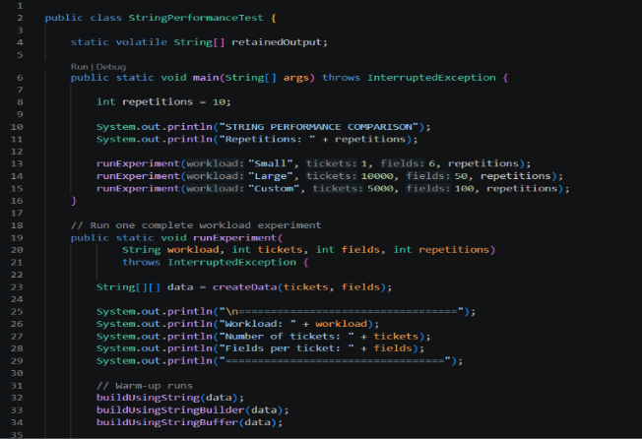
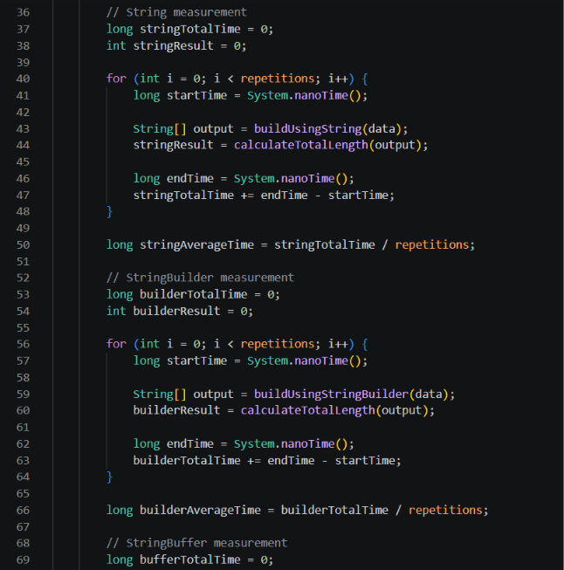
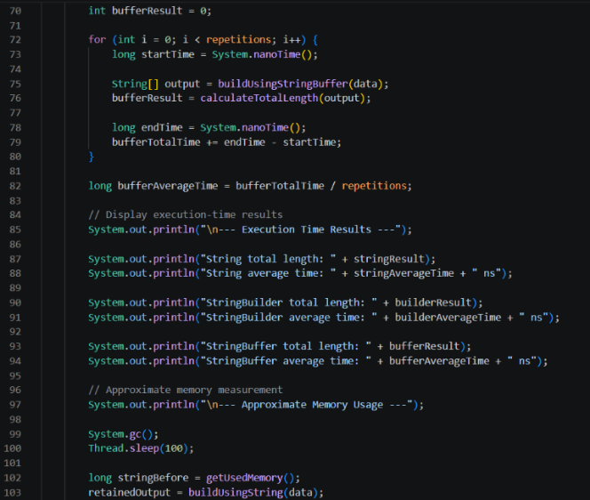
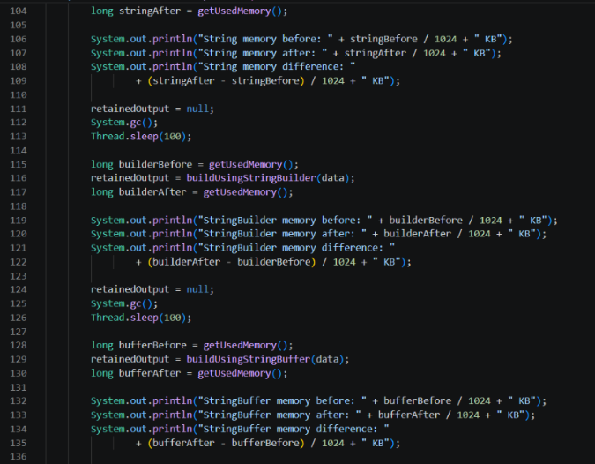
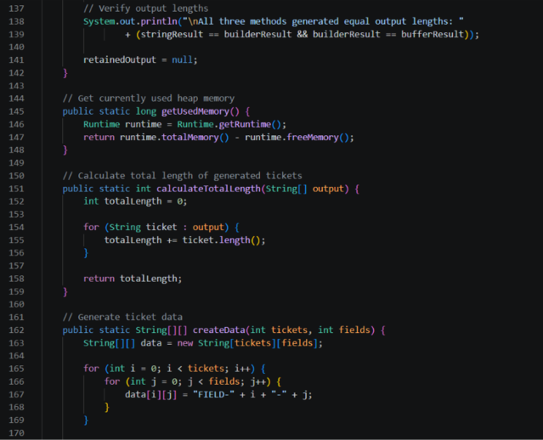
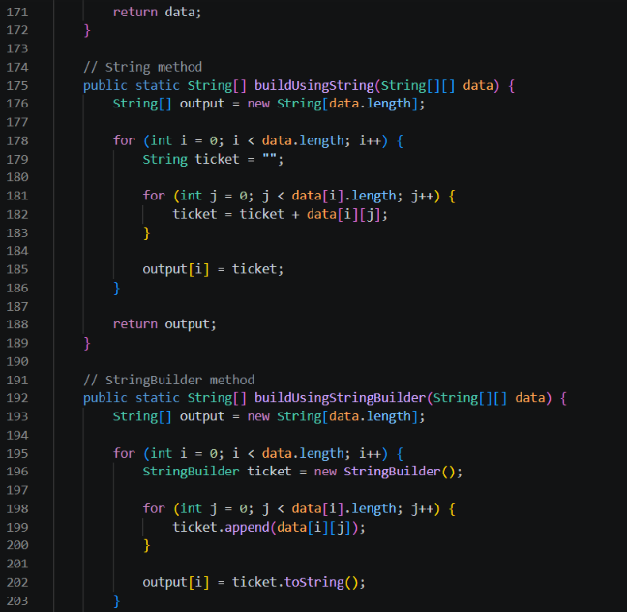
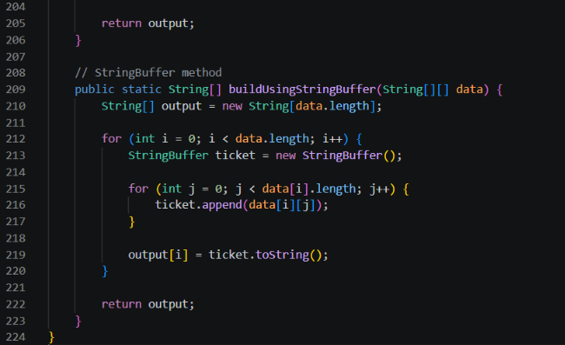

OUTPUT


