SIMATS ENGINEERING
ASSESSMENT TOOL 1
COURSE NAME: CSA16 COURSE CODE: Data Warehousing and Data Mining
NAME: ARUN PANDIAN K
REG NO: 192511086

Course Outcome Covered
CO3: Evaluate the effectiveness of classification techniques on real-time data for accurate prediction, enabling informed decision-making. (BL3, BL4, BL5)

1. Age vs Photograph Preference — Chi-Square Test of Independence (10 Marks)
Observed data:
Age of Child | A | B | C | Row Total
5–6 years | 18 | 22 | 20 | 60
7–8 years | 2 | 28 | 40 | 70
9–10 years | 20 | 10 | 40 | 70
Column Total | 40 | 60 | 100 | 200

Step 1: Expected Frequencies
E(row, col) = (Row Total × Column Total) / Grand Total
Age of Child | A | B | C
5–6 years | 12 | 18 | 30
7–8 years | 14 | 21 | 35
9–10 years | 14 | 21 | 35

Step 2: Chi-Square Statistic
χ² = Σ (O − E)² / E, computed cell by cell:
Cell | O | E | (O−E)²/E
5–6, A | 18 | 12 | 3
5–6, B | 22 | 18 | 0.889
5–6, C | 20 | 30 | 3.333
7–8, A | 2 | 14 | 10.286
7–8, B | 28 | 21 | 2.333
7–8, C | 40 | 35 | 0.714
9–10, A | 20 | 14 | 2.571
9–10, B | 10 | 21 | 5.762
9–10, C | 40 | 35 | 0.714

χ² (calculated) ≈ 29.60
Degrees of freedom = (rows − 1)(columns − 1) = (3 − 1)(3 − 1) = 4
Critical value of χ² at α = 0.05, df = 4 is 9.488.
Since 29.60 > 9.488, we reject the null hypothesis of independence.
Conclusion: There IS a statistically significant relationship between the age of the child and photograph preference.

What is wrong with this study?
- Very small, non-random sample (only 3 children per age group in effect, drawn from an unspecified population) — results cannot be generalised.
- Only three photographs were used, all of adults; the study does not control for the order in which photographs were shown, which can bias a child's choice.
- No information is given on how 'preference' was measured (forced choice vs. rating), and each child may have been allowed only one choice, ignoring the strength of preference.
- Confounding variables such as gender of child, photograph content (facial expression, attractiveness, familiarity) are not controlled.
- Chi-square shows association, not causation — the test cannot say that age causes the difference in preference, only that the two variables are not independent in this sample.

R Code — Covariance and Correlation
# Preference data
A <- c(18, 2, 20)
B <- c(22, 28, 10)
C <- c(20, 40, 40)
prefs <- data.frame(A, B, C)

# Sample covariance between B and C
cov(B, C)

# Sample covariance matrix for the preferences
cov(prefs)

# Sample correlation between B and C
cor(B, C)

# Sample correlation matrix for the preferences
cor(prefs)

2. Boxplot for Tennis Team Scoring — Outlier Detection (10 Marks)
Player ID | Player Name | Points Scored
P1 | Player A | 12
P2 | Player B | 15
P3 | Player C | 14
P4 | Player D | 10
P5 | Player E | 18
P6 | Player F | 20
P7 | Player G | 22
P8 | Player H | 13
P9 | Player I | 11
P10 | Player J | 35
P11 | Player K | 16
P12 | Player L | 17
P13 | Player M | 19
P14 | Player N | 21
P15 | Player O | 23

Step 1: Sort the Data (n = 15)
10, 11, 12, 13, 14, 15, 16, 17, 18, 19, 20, 21, 22, 23, 35

Step 2: Five-Number Summary
- Minimum = 10
- Q1 (lower quartile, 4th value) = 13
- Median (8th value) = 17
- Q3 (upper quartile, 4th value from top) = 21
- Maximum = 35
IQR = Q3 − Q1 = 21 − 13 = 8

Step 3: Outlier Fences (1.5 × IQR rule)
- Lower fence = Q1 − 1.5 × IQR = 13 − 12 = 1
- Upper fence = Q3 + 1.5 × IQR = 21 + 12 = 33
Any value below 1 or above 33 is flagged as an outlier.
Result: Player J's score of 35 exceeds the upper fence (33), so Player J is a scoring outlier.
The coach can build this boxplot in Weka (Visualize panel), Excel, or R (boxplot(points)) — the box spans Q1–Q3 with a line at the median, whiskers extend to the fences, and Player J's value plots as an isolated point above the upper whisker.
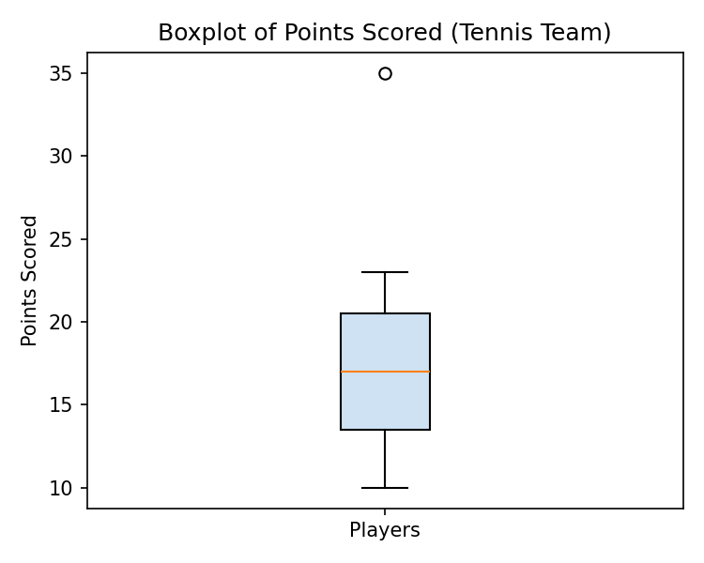

3. Decision Tree Classifier for Loan Approval (10 Marks)
Dataset (15 records): Age, Income, Employment_Status, Credit_Score → Loan_Approved
Age | Income | Employment_Status | Credit_Score | Loan_Approved
young | high | employed | good | yes
young | high | self-employed | average | yes
middle | high | employed | good | yes
old | medium | employed | good | yes
old | low | unemployed | poor | no
old | low | self-employed | average | no
middle | low | unemployed | poor | no
young | medium | employed | average | yes
young | low | unemployed | poor | no
old | medium | self-employed | good | yes
middle | medium | employed | average | yes
middle | high | self-employed | good | yes
old | medium | unemployed | poor | no
young | medium | self-employed | average | yes
middle | low | employed | poor | no

Step 1: Choose the Root Attribute
Testing each attribute for how well it separates Yes/No shows Credit_Score gives the cleanest split:
- Credit_Score = good → 5 records, all Loan_Approved = yes
- Credit_Score = poor → 5 records, all Loan_Approved = no
- Credit_Score = average → 5 records, 4 yes / 1 no (needs a further split)
Because 'good' and 'poor' are already pure (single-class) subsets, Credit_Score is chosen as the root — it has the lowest weighted entropy / highest information gain of the four attributes.

Step 2: Split the 'Average' Branch
Within Credit_Score = average, splitting on Income cleanly separates the remaining cases:
- Income = low → old, low, self-employed, average, no (1 record → no)
- Income = medium → 3 records (young/middle, employed or self-employed) → all yes
- Income = high → 1 record (young, high, self-employed) → yes

Resulting Decision Tree
Credit_Score
├── good → Loan_Approved = YES
├── poor → Loan_Approved = NO
└── average
├── Income = low → Loan_Approved = NO
├── Income = medium → Loan_Approved = YES
└── Income = high → Loan_Approved = YES
This tree classifies all 15 training records correctly. Employment_Status and Age were not needed once Credit_Score and Income were used, since they added no further information gain in this dataset — in Weka this can be reproduced via Classify → trees → J48 on the ARFF file shown in the screenshot.

4. Comparing Two Year-9 Classes (5 Marks)
Note: the exam scores were read as Class A = {76, 35, 47, 64, 95, 66, 89, 36, 84} and Class B = {51, 56, 84, 60, 59, 70, 63, 66, 50}, each with n = 9 students.

(i) Mean, Median, and Range
Statistic | Class A | Class B
Sorted data | 35,36,47,64,66,76,84,89,95 | 50,51,56,59,60,63,66,70,84
Mean | 65.78 | 62.11
Median | 66 | 60
Range | 60 (95 − 35) | 34 (84 − 50)

Class A scored higher on all three measures: mean, median, and range.

(ii) Boxplot and Inferences
Statistic | Class A | Class B
Q1 | 41.5 | 53.5
Q3 | 86.5 | 68.0
IQR | 45.0 | 14.5
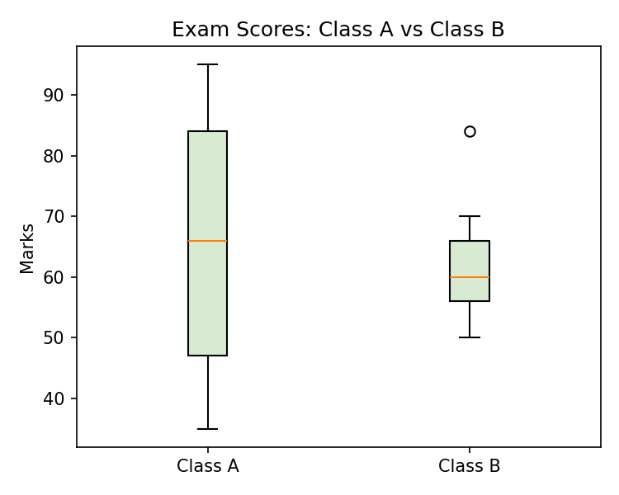
Inferences:
- Class A has a noticeably higher median score and a much larger spread (IQR = 45 vs 14.5), meaning student performance in Class A was far more variable — some students scored very low (35–36) while others scored very high (89–95).
- Class B's scores are more tightly clustered around its median, suggesting more consistent performance across the class.
- Neither class shows outliers by the 1.5×IQR rule, so the wider spread in Class A reflects genuine variability in ability rather than a few extreme scores.
- If consistency is the goal, Class B's teaching outcome looks more uniform; if raw top-end performance matters, Class A produced the highest scorers.

5. Age and Body Fat Percentage in 18 Adults (10 Marks)
age
%fat | 9.5 | 26.5 | 7.8 | 17.8 | 31.4 | 25.9 | 27.4 | 27.2 | 31.2

age
%fat | 34.6 | 42.5 | 28.8 | 33.4 | 30.2 | 34.1 | 32.9 | 41.2 | 35.7

(a) Mean, Median, and Standard Deviation
Sorted age (n = 18): 23,23,27,27,39,41,47,49,50,52,54,54,56,57,58,58,60,61
Sorted %fat (n = 18): 7.8,9.5,17.8,25.9,26.5,27.2,27.4,28.8,30.2,31.2,31.4,32.9,33.4,34.1,34.6,35.7,41.2,42.5
Statistic | Age | %fat
Mean | 46.44 | 28.78
Median | 51.0 ( (50+52)/2 ) | 30.7 ( (30.2+31.2)/2 )
Sample Std. Dev. | 13.22 | 9.25

(Std. dev. computed using the sample formula: s = √[Σ(x − x̄)² / (n − 1)] )

(b) Boxplots
Statistic | Age | %fat
Q1 (lower quartile) | 39 | 26.5
Q3 (upper quartile) | 57 | 34.1
IQR | 18 | 7.6
Lower fence | 12 | 15.1
Upper fence | 84 | 45.5
Outliers | None | 7.8 and 9.5 (below lower fence)
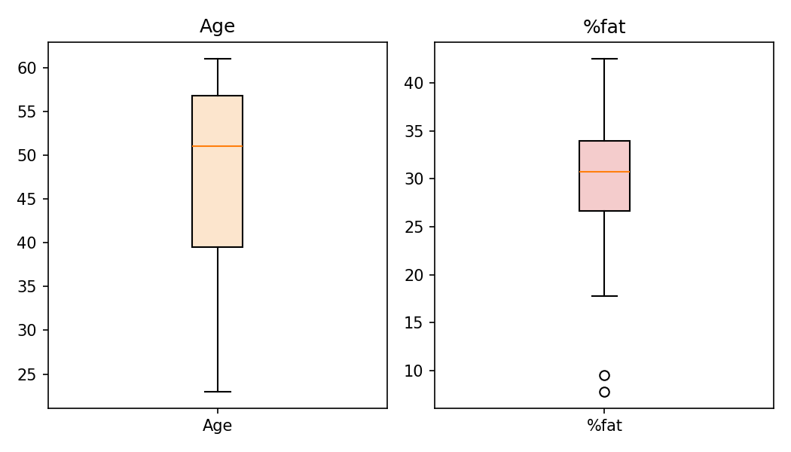
Inference: the age distribution is fairly symmetric with no outliers, while the %fat distribution has two low values (7.8 and 9.5) that fall below the lower fence and would plot as outliers on the boxplot — these belong to the two youngest adults (age 23), consistent with lower body-fat percentage at a younger age.

R Code
age <- c(23,23,27,27,39,41,47,49,50,52,54,54,56,57,58,58,60,61)
fat <- c(9.5,26.5,7.8,17.8,31.4,25.9,27.4,27.2,31.2,34.6,42.5,28.8,
33.4,30.2,34.1,32.9,41.2,35.7)

mean(age); median(age); sd(age)
mean(fat); median(fat); sd(fat)

boxplot(age, main = 'Age')
boxplot(fat, main = '%fat')

