U5-AT3 REVERSE ENGINEERING

SYSTEM DECOMPOSITION & ANALYSIS
System decomposition and analysis involves studying an existing AI-based system and breaking it into smaller functional components to understand how the complete system operates. A typical AI system can be decomposed into components such as the user interface, data collection module, data preprocessing module, AI/ML model, decision-making module, database, and output module. Data usually flows from the user or external sources into the data collection layer, where it is cleaned and transformed before being passed to the machine learning model. The trained model analyzes the processed data and generates predictions or recommendations, which are then handled by the decision-making component and presented to the user. During reverse engineering, the algorithms, dependencies, inputs, outputs, communication mechanisms, and relationships between these components are identified without relying only on the original source code. This helps understand the architecture and behavior of the existing AI system and provides a foundation for maintenance, testing, and future improvements.
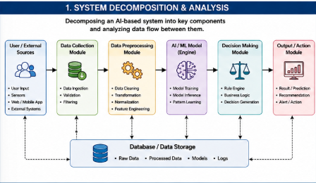

ARCHITECTURE RECONSTRUCTION
Architecture reconstruction is the process of identifying and rebuilding the internal architecture of a black-box software system by observing its inputs, outputs, behavior, and interactions. In an AI-based application, the major modules may include the user interface, API or communication layer, authentication module, data processing module, AI engine, database, and result-generation module. When a user provides input, the interface sends the request to the application or API layer, which validates and forwards the data to the appropriate processing component. The processed information is then supplied to the AI engine, which applies its underlying model or algorithms and returns a prediction or decision. The result is sent back through the application layer and displayed to the user. Reverse engineers can represent these relationships using architecture diagrams, component diagrams, sequence diagrams, and data-flow diagrams. By analyzing the communication between modules, dependencies, and observed behavior, the hidden structure of the black-box system can be reconstructed without directly accessing its original design documentation.
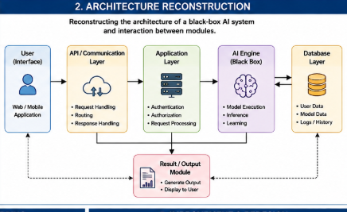

ALGORITHM IDENTIFICATION
Algorithm identification focuses on discovering the machine learning algorithms and decision-making techniques used by an existing AI application. The process begins by examining the type of input data, preprocessing operations, model outputs, and system behavior. For example, if an application produces classification results, possible algorithms may include Decision Trees, Random Forest, Support Vector Machines, Logistic Regression, or Neural Networks. The data processing pipeline may include data cleaning, handling missing values, normalization, feature extraction, feature selection, and data transformation before the information reaches the AI model. By observing how changes in input affect the output, reverse engineers can infer the model's decision-making logic and identify whether the system uses supervised, unsupervised, or reinforcement learning. Model characteristics, prediction patterns, performance metrics, and processing requirements can further help determine the likely algorithm. The purpose is to understand how raw data is transformed into a final intelligent decision and identify opportunities for replacing or improving the existing algorithm.
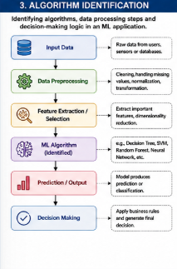

DATA FLOW & PROCESS MAPPING
Data flow and process mapping involves tracing how information moves through an existing distributed AI application and identifying the processing performed at each stage. In a distributed AI system, data may originate from users, IoT devices, sensors, web applications, or external databases and then be transmitted to data collection or message-processing services. The incoming data can be stored in distributed storage systems and processed using technologies such as Apache Spark, Hadoop, or cloud-based processing services. After preprocessing, the data is distributed to different AI or machine learning components for training, prediction, or analysis. The resulting information may then be stored in a database and delivered to the application through APIs or communication services. Reverse engineering maps this complete pipeline, including data sources, storage systems, processing nodes, AI models, communication channels, and output services. Understanding this flow helps identify bottlenecks, unnecessary data transfers, communication delays, and failures in the distributed processing pipeline.
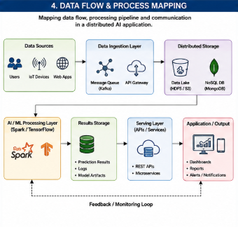

IMPROVEMENT & REDESIGN
Data flow and process mapping involves tracing how information moves through an existing distributed AI application and identifying the processing performed at each stage. In a distributed AI system, data may originate from users, IoT devices, sensors, web applications, or external databases and then be transmitted to data collection or message-processing services. The incoming data can be stored in distributed storage systems and processed using technologies such as Apache Spark, Hadoop, or cloud-based processing services. After preprocessing, the data is distributed to different AI or machine learning components for training, prediction, or analysis. The resulting information may then be stored in a database and delivered to the application through APIs or communication services. Reverse engineering maps this complete pipeline, including data sources, storage systems, processing nodes, AI models, communication channels, and output services. Understanding this flow helps identify bottlenecks, unnecessary data transfers, communication delays, and failures in the distributed processing pipeline.
