SIMATS

JAVA PROGRAMMING LAB ASSIGNMENT

DESIGN, IMPLEMENT AND VALIDATE AN
OBJECT-ORIENTED MODEL FOR A CAMPUS
SMART-PARKING SYSTEM

Submitted By
DEVALAKSHMI S
Register Number: 192511134

Faculty Name: ______________Mathivanan________________
Department: Computer Science and Engineering (B.E.)
GITHUB LINK: https://github.com/192511134simats/CSA09-192511134-Assignment1/tree/main

Academic Year: 2026–2027

TABLE OF CONTENTS

SECTION | TITLE
1 | Introduction
2 | Task 1 – Problem Analysis and Object Identification
3 | Task 2 – Choose the Data Representation
4 | Task 3 – Design the Control Logic
5 | Task 4 – Design Classes, Objects and Constructors
6 | Task 5 – Static Members and Object Life Cycle
7 | Task 6 – Design the Inheritance Hierarchy
8 | Task 7 – Override and Specialise Behaviour
9 | Task 8 – Apply Polymorphism
10 | Task 9 – Introduce Abstraction
11 | Task 10 – Encapsulation through Packages and Access Modifiers
12 | Task 11 – Implement, Test and Defend the Design
13 | Task 12 – Re-evaluate and Adapt the Design
14 | Conclusion
15 | References
Appendix A | Completed Java Programs
Appendix B | Execution and GitHub Submission Checklist

INTRODUCTION
A campus smart-parking system manages the parking spaces available to students, staff and visitors. A multi-level facility contains several floors, and each floor may contain a different number of slots. Vehicles entering the campus must be assigned a suitable free slot and issued a unique parking ticket. When a vehicle leaves, the slot is released and the parking fee is calculated.
The system must support two-wheelers, cars and electric vehicles (EVs). EVs may use charging facilities, and charging fees are calculated separately from parking fees. Students and staff holding valid monthly passes park without a parking charge, while visitors pay the applicable fee. The design must be easy to extend when the university adds vehicle categories and pricing rules.

Objectives
- Identify the objects, classes, attributes, methods and business rules in the parking problem.
- Choose suitable Java data types and data structures for floors, slots, vehicles and tickets.
- Implement slot allocation, slot release and fee calculation using clear control logic.
- Apply constructors, static members, inheritance, overriding, polymorphism, abstraction and encapsulation.
- Test normal, boundary and invalid cases and analyse time and space complexity.
- Adapt the design for e-bikes, delivery vans, a one-day visitor pass and different slot counts per floor.

Scope and assumptions
- The initial facility has one or more floors; each floor can have a different number of slots.
- Each slot holds at most one vehicle. A null slot represents an empty slot.
- Registration numbers are unique and are normalised to uppercase before comparison.
- Every started parking hour is charged as a full hour, as stated in the supplied FeeDemo starter code.
- Parking fee rates used in this report are illustrative implementation assumptions; the faculty may specify different rates.
- Monthly-pass holders are not charged a parking fee. EV charging is an additional charge when charging energy is supplied.
- All money values are represented using double for the teaching exercise; a production billing system should use BigDecimal.

TASK 1 – PROBLEM ANALYSIS AND OBJECT IDENTIFICATION (4 MARKS)

1.1 Inputs and outputs
Inputs | Outputs
Vehicle registration number, vehicle category, user/pass type, entry time, exit time, floor/slot availability, EV charging units | Allocated floor and slot, unique ticket number, entry/exit records, parking duration, parking fee, charging fee, slot-release result, daily collection

1.2 Candidate classes and justification
Candidate class | Main responsibility | Why it is required
ParkingFacility | Own floors/slots; allocate and release slots; find vehicles | Central authority for facility capacity and slot state
ParkingSlot | Represent one physical slot and its occupied/free state | Prevents two vehicles occupying one slot
Vehicle | Store registration number and common vehicle behaviour | Provides a common parent type for vehicle categories
TwoWheeler | Provide two-wheeler parking rate | Vehicle-specific rate
Car | Provide car parking rate | Vehicle-specific rate
ElectricCar | Represent a car with charging capability | Combines car behaviour and EV charging
ParkingTicket | Store ticket number, vehicle, slot, entry/exit time and fee | Provides an auditable parking transaction
User/Pass | Represent student, staff or visitor eligibility | Applies free-parking or visitor rules
PricingRule | Calculate a fee according to category and time | Keeps pricing policy separate and extensible

1.3 Nouns and verbs
Important nouns become candidate classes or fields: vehicle, registration number, floor, slot, ticket, entry time, exit time, duration, fee, user, monthly pass and charging unit. Important verbs become methods: enter, allocate, search, issue, record, calculate, charge, release, validate and exit.

1.4 Business rules
- A slot cannot hold two vehicles at the same time.
- A vehicle must have a valid, non-empty registration number.
- A registration number cannot have two active parking tickets.
- A ticket number must be unique and must not be reused.
- A vehicle can enter only when a suitable free slot exists.
- An exit operation must validate the ticket and occupied slot before releasing it.
- Monthly-pass students and staff pay no parking fee while the pass is valid.
- Visitors pay the applicable fee; EV charging is charged separately.
- Negative parking duration, invalid slot indexes and invalid charging units must be rejected.

1.5 Alternative concept: parallel arrays
If vehicles were stored as parallel arrays such as regNo[], type[], entryTime[] and fee[], every vehicle's data would have to be kept at the same index. Finding a vehicle by registration number requires a linear scan, O(n). The design is fragile because inserting or deleting one record in only one array can misalign the data. An object-based design groups related fields in a Vehicle or ParkingTicket object and improves readability and maintainability.
Design | Search by registration number | Space per vehicle | Maintainability
Parallel arrays | O(n) unless an additional index is maintained | Sum of each parallel field's storage | Low; indexes must remain synchronised
Objects in a collection | O(n) in an ArrayList; average O(1) with a HashMap index | Object header plus fields/references | Higher; related data stays together

1.6 Evidence expected
The evidence for this task is the candidate-class analysis, responsibilities, business rules, assumptions and the comparison above. These decisions are used by the implementation in the later tasks.

TASK 2 – CHOOSE THE DATA REPRESENTATION (3 MARKS)

2.1 Data types
Field | Suggested Java type | Reason
Floor number | int | Whole-number index
Slot number | int | Whole-number index within a floor
Registration number | String | Alphanumeric vehicle identifier
Vehicle category | enum VehicleType | Restricts values to known categories
Entry/exit time | LocalDateTime | Date and time with clear date-time operations
Duration | long minutes | Whole-number duration; avoids fractional-minute errors
Parking fee | double (exercise) | Simple numeric billing example; BigDecimal preferred in production
Charging energy | double kWh | May contain fractional kWh
Ticket number | long | Unique increasing ticket identifier
Pass validity | boolean or date range | Indicates eligibility and expiry

2.2 Array representation
The original starter code uses a jagged two-dimensional array: String[][] slots. Each row represents a floor, and each row length is the number of slots on that floor. For example, new ParkingFacility(new int[]{2, 1}) creates two floors: floor 0 has two slots and floor 1 has one slot.
String[][] slots = new String[slotsPerFloor.length][];
for (int floor = 0; floor < slotsPerFloor.length; floor++) {
slots[floor] = new String[slotsPerFloor[floor]];
}

A jagged array is appropriate because the number of slots can differ between floors. A rectangular array would waste space or impose an artificial maximum slot count.

2.3 Casting and precision
Integer division can produce an incorrect fee. For example, 90 / 60 using integer operands produces 1, not 1.5. Since every started hour is charged in full, the correct billable-hour calculation is (minutes + 59) / 60 using integer arithmetic, or Math.ceil(minutes / 60.0). The first approach avoids floating-point rounding for whole-minute durations.
int billableHours = (minutes + 59) / 60; // 1–60 -> 1, 61–120 -> 2
double fee = billableHours * ratePerHour;

2.4 Input methods
For a console program, Scanner can read registration numbers, categories, durations and charging units. Command-line arguments are suitable for fixed demonstration inputs. A GUI or mobile application would validate input before passing it to the service layer.

2.5 Alternative concept and complexity
A single one-dimensional array can flatten floor and slot into one index using index = floor * slotsPerFloor + slot only when every floor has the same number of slots. With unequal floor capacities, this formula is not valid without prefix offsets. An ArrayList of floor objects or a jagged array directly represents unequal capacities.
Representation | Locate slot | Space
Jagged array | O(1) when floor and slot are known; O(F×S) worst case to scan all slots | O(total slots)
Flat array with equal floor size | O(1) using arithmetic index | O(F×S)
ArrayList<ParkingSlot> | O(1) by index; O(n) search without an index | O(n) plus object overhead

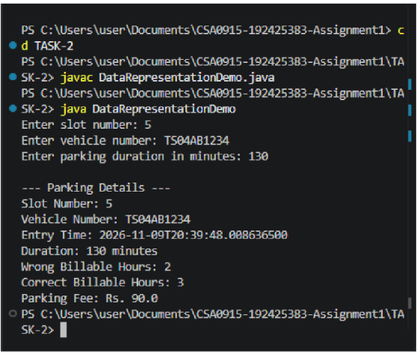
Chosen representation: a jagged array for the basic ParkingFacility exercise, then a ParkingSlot object model for the extensible final design.

TASK 3 – DESIGN THE CONTROL LOGIC (4 MARKS)

3.1 Allocation algorithm
The allocation operation scans floors in ascending order and slots within each floor. The first null slot is assigned the vehicle registration number and its floor/slot coordinates are returned. If the scan finishes without finding a free slot, null is returned.

Pseudocode: allocate
ALLOCATE(vehicleNo)
IF vehicleNo is null or blank THEN
RETURN INVALID
END IF
FOR each floor f
FOR each slot s in floor f
IF slots[f][s] is null THEN
slots[f][s] = vehicleNo
RETURN (f, s)
END IF
END FOR
END FOR
RETURN NO_SPACE

3.2 Release algorithm
RELEASE(floor, slot)
IF floor is outside valid floor range THEN RETURN false
IF slot is outside valid slot range for floor THEN RETURN false
IF slots[floor][slot] is null THEN RETURN false
slots[floor][slot] = null
RETURN true

3.3 Fee computation
The starter code requires every started hour to be charged in full. For a non-negative duration, billableHours = (minutes + 59) / 60. The fee is billableHours multiplied by the vehicle's hourly rate. A zero-minute stay costs zero. Monthly-pass users have zero parking fee. The EV charging fee is added separately.
CALCULATE_FEE(minutes, hourlyRate, passValid)
IF minutes < 0 OR hourlyRate < 0 THEN RETURN INVALID
IF passValid THEN RETURN 0
billableHours = (minutes + 59) / 60
RETURN billableHours * hourlyRate

3.4 Completed ParkingFacility program
The following program completes the two TODO sections from the supplied starter class. Save it as ParkingFacility.java.
import java.util.Arrays;

public class ParkingFacility {
// slots[floor][slot] stores a vehicle number; null means free.
private final String[][] slots;

public ParkingFacility(int[] slotsPerFloor) {
if (slotsPerFloor == null || slotsPerFloor.length == 0) {
throw new IllegalArgumentException("At least one floor is required");
}
slots = new String[slotsPerFloor.length][];
for (int f = 0; f < slotsPerFloor.length; f++) {
if (slotsPerFloor[f] < 0) {
throw new IllegalArgumentException("Slot count cannot be negative");
}
slots[f] = new String[slotsPerFloor[f]];
}
}

/** Returns {floor, slot} of the first free slot, or null if full. */
public int[] allocate(String vehicleNo) {
if (vehicleNo == null || vehicleNo.trim().isEmpty()) {
throw new IllegalArgumentException("Vehicle number is required");
}
for (int f = 0; f < slots.length; f++) {
for (int s = 0; s < slots[f].length; s++) {
if (slots[f][s] == null) {
slots[f][s] = vehicleNo.trim().toUpperCase();
return new int[] { f, s };
}
}
}
return null;
}

/** Frees a valid occupied slot; otherwise returns false. */
public boolean release(int floor, int slot) {
if (floor < 0 || floor >= slots.length) return false;
if (slot < 0 || slot >= slots[floor].length) return false;
if (slots[floor][slot] == null) return false;
slots[floor][slot] = null;
return true;
}

public static void main(String[] args) {
ParkingFacility p = new ParkingFacility(new int[] {2, 1});
System.out.println(Arrays.toString(p.allocate("TN01AB1111")));
System.out.println(Arrays.toString(p.allocate("TN02CD2222")));
System.out.println(Arrays.toString(p.allocate("TN03EF3333")));
System.out.println(Arrays.toString(p.allocate("TN04GH4444")));
System.out.println(p.release(0, 1) + " " + p.release(0, 1)
+ " " + p.release(5, 0));
System.out.println(Arrays.toString(p.allocate("TN04GH4444")));
}
}

3.5 Expected output
[0, 0]
[0, 1]
[1, 0]
null
true false false
[0, 1]

Figure 3.1: Execution Output of ParkingFacility.java
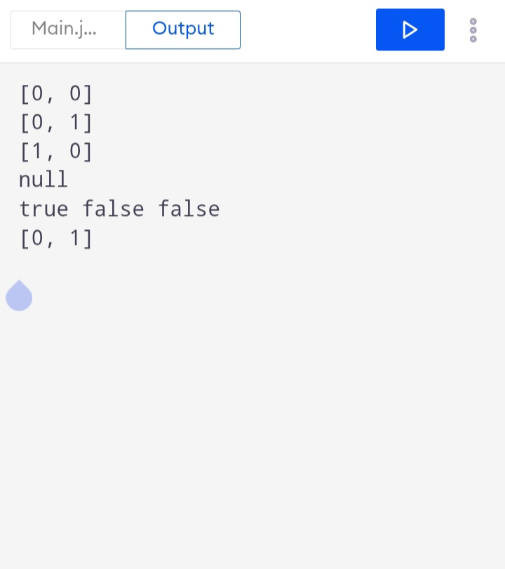
Complexity: allocation is O(F×S) in the worst case, where F is the number of floors and S is the maximum slots per floor (more precisely, it scans the total number of slots N). Release is O(1) after validating the indexes. Storage is O(N).

TASK 4 – DESIGN CLASSES, OBJECTS AND CONSTRUCTORS (4 MARKS)

4.1 Class design
A class defines state and behaviour; an object is a runtime instance of a class. ParkingFacility, Vehicle, ParkingTicket and ParkingSlot are the main domain classes. Constructors establish valid initial state so that an object is not created with missing or invalid data.

4.2 Constructor choices
- Default constructor: useful only when a safe, meaningful default state exists.
- Parameterized constructor: receives required values such as registration number and ticket number.
- Overloaded constructors: provide alternative valid ways to create an object.
- Constructor chaining: this(...) calls another constructor in the same class to avoid duplicated validation.
- super(...): invokes the superclass constructor before subclass-specific initialisation.
- Copy constructor: not required for ordinary ticket creation; it may be useful for an explicit defensive copy, but duplicating a ticket must not duplicate a unique ticket number.

4.3 Example constructor implementation
class ParkingTicket {
private final long ticketNo;
private final Vehicle vehicle;
private final int floor;
private final int slot;
private final java.time.LocalDateTime entryTime;

public ParkingTicket(long ticketNo, Vehicle vehicle,
int floor, int slot) {
if (ticketNo <= 0 || vehicle == null || floor < 0 || slot < 0) {
throw new IllegalArgumentException("Invalid ticket details");
}
this.ticketNo = ticketNo;
this.vehicle = vehicle;
this.floor = floor;
this.slot = slot;
this.entryTime = java.time.LocalDateTime.now();
}

public long getTicketNo() { return ticketNo; }
public Vehicle getVehicle() { return vehicle; }
public int getFloor() { return floor; }
public int getSlot() { return slot; }
public java.time.LocalDateTime getEntryTime() { return entryTime; }
}

4.4 Memory model
A local reference variable is commonly stored in a method's stack frame, while an object created with new is stored on the heap. The reference points to the object. When no reachable reference points to an object, it becomes eligible for garbage collection. Java does not require the programmer to manually free ordinary objects.

4.5 Alternative: setters or factory method
A default constructor followed by setters can temporarily create an incomplete object. A parameterized constructor validates required fields before the object is exposed. A static factory method can make creation more descriptive, for example ParkingTicket.issue(...). Object creation takes O(1) time for a fixed number of fields and O(1) additional object space, excluding referenced objects.

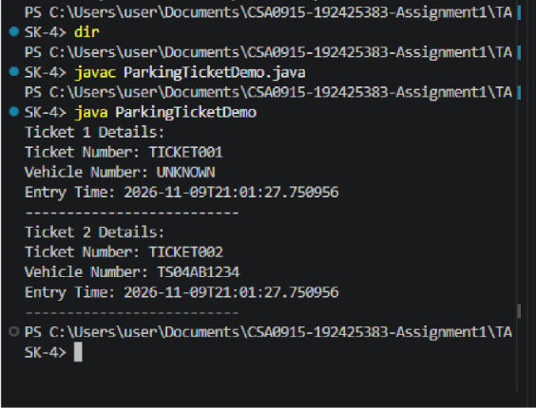

TASK 5 – APPLY STATIC MEMBERS AND OBJECT LIFE CYCLE (3 MARKS)

5.1 Static versus instance members
A ticket counter and total occupancy belong to the parking system as a whole, not to one individual ticket. A static counter is therefore appropriate when one facility instance is used. An instance field is appropriate for a property that differs between facility objects, such as the capacity or current slots of each facility.
class TicketNumberGenerator {
private static long nextTicketNumber = 1;

public static synchronized long next() {
return nextTicketNumber++;
}
}

5.2 Static methods and static blocks
A static method can generate a ticket number without requiring an object. A static initialisation block is appropriate only for one-time class-level setup. It should not be used for ordinary per-facility initialisation.

5.3 Two facilities
If the university operates north and south facilities, a single static counter shared by ParkingFacility gives unique ticket numbers across both facilities. If each facility has an instance counter, both could issue ticket number 1, causing a collision when tickets are combined. A central ticket service or database sequence is preferable in a multi-process production system.

5.4 Object life cycle
A ticket is created when a vehicle enters, remains reachable while the vehicle is parked and the transaction is active, and is archived or becomes eligible for garbage collection after exit when no references remain. A real system should retain completed ticket records in persistent storage for audit purposes.

5.5 Space analysis
A static counter uses O(1) storage regardless of the number of facility objects or tickets. An instance counter uses O(k) counter storage for k facility objects. Ticket objects require O(n) storage for n retained tickets.
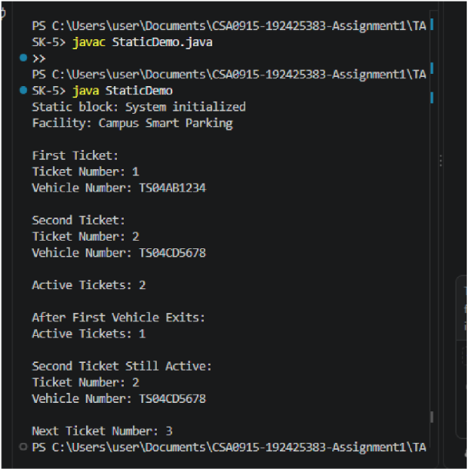

TASK 6 – DESIGN THE INHERITANCE HIERARCHY (4 MARKS)

6.1 Vehicle hierarchy
Use single inheritance for the vehicle family. Vehicle is the abstract superclass. TwoWheeler and Car extend Vehicle. ElectricCar extends Car and implements the Chargeable interface. This reflects the fact that an electric car is a car and also has an additional charging capability.

6.2 UML-style class diagram
Type | Relationship / members
Vehicle (abstract) | regNo; getRegNo(); abstract ratePerHour(); calculateFee(minutes)
TwoWheeler | extends Vehicle; ratePerHour() = Rs 10
Car | extends Vehicle; ratePerHour() = Rs 30
ElectricCar | extends Car; implements Chargeable; chargingFee(kWh)
Chargeable (interface) | chargingFee(double kWh)

Text diagram: Vehicle (abstract) → TwoWheeler; Vehicle (abstract) → Car → ElectricCar. Chargeable is an interface implemented by ElectricCar.

6.3 Use of super and constructor order
class Vehicle {
private final String regNo;
protected Vehicle(String regNo) {
if (regNo == null || regNo.trim().isEmpty())
throw new IllegalArgumentException("Registration required");
this.regNo = regNo.trim().toUpperCase();
}
public String getRegNo() { return regNo; }
protected abstract double ratePerHour();
}

class Car extends Vehicle {
Car(String regNo) { super(regNo); }
@Override protected double ratePerHour() { return 30.0; }
}

class ElectricCar extends Car implements Chargeable {
ElectricCar(String regNo) { super(regNo); }
@Override public double chargingFee(double kWh) {
if (kWh < 0) throw new IllegalArgumentException("Invalid kWh");
return kWh * 12.0;
}
}

When new ElectricCar(...) is created, the ElectricCar constructor invokes Car's constructor using super(...); Car invokes Vehicle's constructor. The Vehicle constructor executes first, then Car, then ElectricCar.

6.4 Inheritance versus composition
Composition would use a Vehicle object containing a VehicleType or a PricingRule reference. This is more flexible when capabilities vary independently, but it requires delegation. Inheritance is simple for the supplied demonstration and allows dynamic dispatch through Vehicle references. For future categories with unrelated capabilities, composition and interfaces may reduce class explosion.
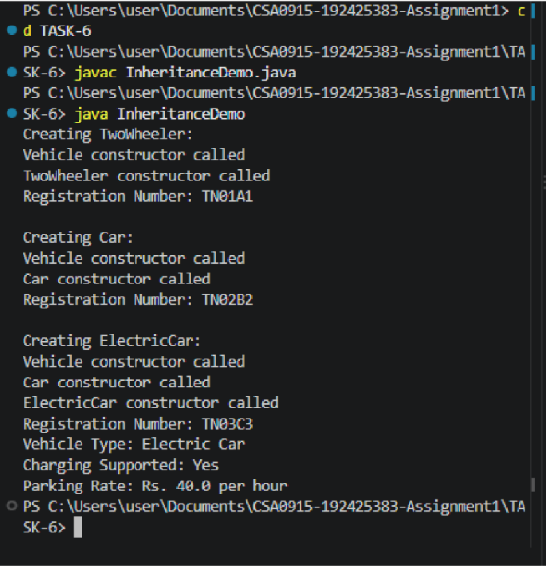

TASK 7 – OVERRIDE AND SPECIALISE BEHAVIOUR (4 MARKS)

7.1 Method overriding
The ratePerHour() method is abstract in Vehicle and overridden by each concrete vehicle class. The @Override annotation lets the compiler detect signature mistakes. The overriding method must not reduce visibility and must use a compatible return type.

7.2 equals(), hashCode() and toString()
Vehicle equality is based on the normalised registration number. If two Vehicle objects have the same registration number, equals() returns true. hashCode() must use the same field so equal objects have equal hash codes. toString() provides a readable description.
@Override
public boolean equals(Object obj) {
if (this == obj) return true;
if (!(obj instanceof Vehicle)) return false;
Vehicle other = (Vehicle) obj;
return regNo.equals(other.regNo);
}

@Override
public int hashCode() {
return regNo.hashCode();
}

@Override
public String toString() {
return getClass().getSimpleName() + "[" + regNo + "]";
}

7.3 Use of final
- final variable: cannot be reassigned after initialisation; useful for registration number.
- final method: cannot be overridden by subclasses; useful when behaviour must remain fixed.
- final class: cannot be extended; use only when extension is intentionally prohibited.

7.4 Alternative: switch on a type field
A single calculateFee() method with a switch over a vehicle type can work for a small fixed set of categories. Every new category requires modifying the switch, increasing maintenance risk. Overriding moves category-specific behaviour into the corresponding subclass. Both approaches take O(1) time for fee-rate selection; the major difference is extensibility and code organisation, not asymptotic runtime.
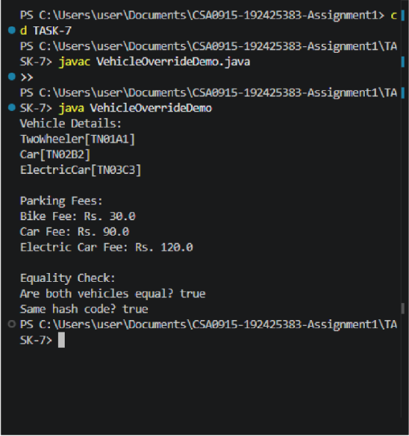

TASK 8 – APPLY POLYMORPHISM (4 MARKS)

8.1 Compile-time polymorphism
Method overloading provides compile-time polymorphism. The compiler chooses the method based on the argument list, such as calculateFee(int minutes) or calculateFee(LocalDateTime entry, LocalDateTime exit).

8.2 Runtime polymorphism
A Vehicle[] can store references to TwoWheeler, Car and ElectricCar objects. A call to calculateFee() through a Vehicle reference invokes the overridden behaviour of the actual object at runtime. This is dynamic method dispatch.

8.3 Completed FeeDemo program
Save the following as FeeDemo.java. It completes the supplied TODOs: billable hours use ceiling division, Car uses Rs 30 per hour, and ElectricCar charges Rs 12 per kWh.
interface Chargeable {
double chargingFee(int kWh);
}

abstract class Vehicle {
private final String regNo;

protected Vehicle(String regNo) {
if (regNo == null || regNo.trim().isEmpty())
throw new IllegalArgumentException("Registration required");
this.regNo = regNo.trim().toUpperCase();
}

public String getRegNo() { return regNo; }
protected abstract double ratePerHour();

/** Every started hour is charged in full. */
public double calculateFee(int minutes) {
if (minutes < 0) throw new IllegalArgumentException("Negative duration");
int billableHours = (minutes + 59) / 60;
return billableHours * ratePerHour();
}

@Override
public boolean equals(Object o) {
return o instanceof Vehicle &&
regNo.equals(((Vehicle)o).regNo);
}

@Override public int hashCode() { return regNo.hashCode(); }
}

class TwoWheeler extends Vehicle {
TwoWheeler(String regNo) { super(regNo); }
@Override protected double ratePerHour() { return 10.0; }
}

class Car extends Vehicle {
Car(String regNo) { super(regNo); }
@Override protected double ratePerHour() { return 30.0; }
}

class ElectricCar extends Car implements Chargeable {
ElectricCar(String regNo) { super(regNo); }
@Override public double chargingFee(int kWh) {
if (kWh < 0) throw new IllegalArgumentException("Negative kWh");
return kWh * 12.0;
}
}

public class FeeDemo {
public static void main(String[] args) {
Vehicle[] parked = {
new TwoWheeler("TN01A1"),
new Car("TN02B2"),
new ElectricCar("TN03C3")
};

for (Vehicle v : parked) {
double fee = v.calculateFee(130);
if (v instanceof Chargeable) {
fee += ((Chargeable) v).chargingFee(10);
}
System.out.println(v.getClass().getSimpleName() + " " +
v.getRegNo() + " -> Rs " + fee);
}

System.out.println(new Car("TN02B2").equals(
new ElectricCar("TN02B2")));
}
}

8.4 Expected output
TwoWheeler TN01A1 -> Rs 30.0
Car TN02B2 -> Rs 90.0
ElectricCar TN03C3 -> Rs 210.0
true.

Figure 8.1: Execution Output of FeeDemo.java
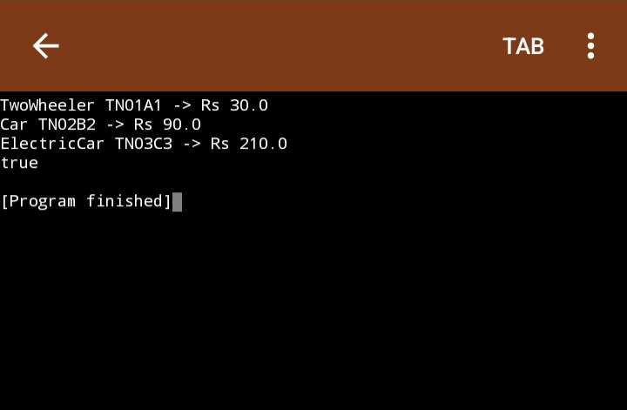
The last line is true because equality is defined by registration number in the Vehicle superclass. The two objects have the same registration number, even though their concrete classes differ. This is correct if registration number uniquely identifies a vehicle. If the business requires vehicle category to be part of identity, equals() must compare both registration number and category.

8.5 Dispatch complexity
A virtual method call is treated as O(1) for this analysis. A chain of k instanceof checks may take O(k) in the worst case and must be updated when new categories are added. Dynamic dispatch keeps the caller independent of the concrete subclass.

TASK 9 – INTRODUCE ABSTRACTION (4 MARKS)

9.1 Abstract class
Vehicle should be abstract because a generic vehicle has common registration data but does not have one universal hourly rate. The abstract ratePerHour() method forces each concrete vehicle type to provide its own rate.

9.2 Interface
Chargeable represents an optional capability. ElectricCar implements it, while ordinary cars and two-wheelers do not need to provide a charging method. A Payable interface could similarly represent fee-paying users if the model becomes more detailed.

9.3 Why both are useful
- An abstract class shares state, constructors and common implemented methods.
- An interface defines a capability that unrelated classes can implement.
- Java classes can extend only one class but can implement multiple interfaces.
- Interfaces avoid forcing all vehicle categories to inherit a feature they do not support.

9.4 Alternative design
If Vehicle became an interface with default methods, it could not hold ordinary per-object instance fields or use constructors to guarantee registration-number initialisation. A separate class would be needed to store shared state. Chargeable as an abstract class would prevent a class already extending Car from extending another class for charging. The current abstract-class-plus-interface design is therefore appropriate.
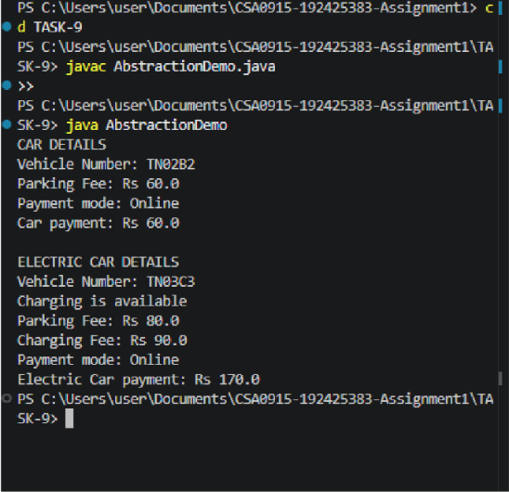

TASK 10 – ENFORCE ENCAPSULATION THROUGH PACKAGES AND ACCESS MODIFIERS (3 MARKS)

10.1 Package structure
src/
parking/
model/
Vehicle.java
TwoWheeler.java
Car.java
ElectricCar.java
ParkingTicket.java
ParkingSlot.java
service/
ParkingFacility.java
PricingService.java
TicketService.java
app/
Main.java

10.2 Access modifier decisions
Modifier | Use in this design | Reason
private | Fields such as regNo, ticketNo, slots | Protects object state
protected | Superclass constructor or extension hook where needed | Allows subclasses controlled access
public | Constructors and service methods used by app layer | Defines supported external API
package-private | Internal helper methods within a package | Avoids exposing implementation details

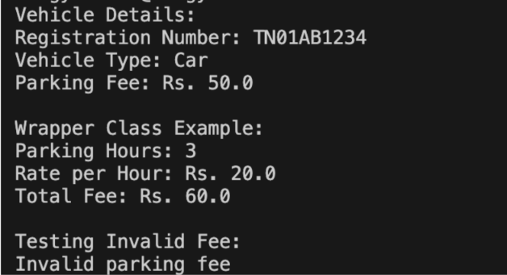

10.3 Validation in getters and setters
Immutable identity fields such as registration number and ticket number should normally be final and have getters only. Mutable fields such as a pass expiry date should use a setter that validates null values and valid date ranges. A slot setter should reject invalid states and should not be publicly exposed; allocation and release should be controlled by ParkingFacility.

10.4 Wrapper classes and autoboxing
Java automatically converts between primitive values and wrapper objects in many contexts. For example, int can be boxed into Integer. Comparing Integer objects using == may compare references rather than numeric values. Use equals() or unbox to int. Null wrapper values can cause NullPointerException during unboxing.

10.5 Public fields alternative
If fields were public, every caller could change a slot or registration number without validation. The same validation would need to be repeated in multiple calling locations, increasing maintenance cost and making invalid states possible. Encapsulation centralises validation and protects invariants.

TASK 11 – IMPLEMENT, TEST AND DEFEND THE DESIGN (5 MARKS)

11.1 Test strategy
The implementation should be tested with normal operations, boundary cases and invalid inputs. The following test table provides the cases to execute and record. Replace the actual-result column with the output from your own Java run before submission.
Test | Input / scenario | Expected result | Actual result
T1 | Allocate first vehicle | [0, 0] | Record after execution
T2 | Allocate second vehicle in 2-slot floor | [0, 1] | Record after execution
T3 | Allocate third vehicle | [1, 0] | Record after execution
T4 | Allocate when all slots full | null / no space | Record after execution
T5 | Release occupied valid slot | true | Record after execution
T6 | Release same slot again | false | Record after execution
T7 | Release invalid floor or slot | false | Record after execution
T8 | Fee for 0 minutes | Rs 0 | Record after execution
T9 | Fee for exactly 60 minutes | 1 hourly unit | Record after execution
T10 | Fee for 61 minutes | 2 hourly units | Record after execution
T11 | Negative duration | Rejected with validation error | Record after execution
T12 | Duplicate active registration | Rejected by ticket/service layer | Record after execution

11.2 Manual collection example
Illustrative daily collection using the rates in FeeDemo: one two-wheeler parks for 130 minutes (3 × Rs 10 = Rs 30); one car parks for 130 minutes (3 × Rs 30 = Rs 90); one electric car parks for 130 minutes (3 × Rs 30 = Rs 90) and uses 10 kWh of charging (10 × Rs 12 = Rs 120). Total = Rs 30 + Rs 90 + Rs 210 = Rs 330. This amount should match the program's calculated collection for the same inputs.

11.3 Active-ticket storage alternatives
Structure | Find ticket by registration | Space for n vehicles | Comment
ArrayList<ParkingTicket> | O(n) linear search | O(n) | Simple; preserves order
HashMap<String, ParkingTicket> | Average O(1), worst O(n) | O(n) | Best when registration lookup is frequent

11.4 Limitations and defence
- The starter array model is suitable for demonstrating allocation but does not by itself store full ticket history.
- An integrated application should use a map keyed by registration number to reject duplicates and find active tickets quickly.
- Persistent storage is required so ticket records survive program termination.
- Concurrency control is required if several entry gates allocate slots simultaneously.
- Money should use BigDecimal in a production billing system to avoid binary floating-point representation issues.
Evidence required: compile and run each program, capture screenshots showing source execution and output, and include the screenshots in the final PDF. Do not label an expected output as an actual screenshot.
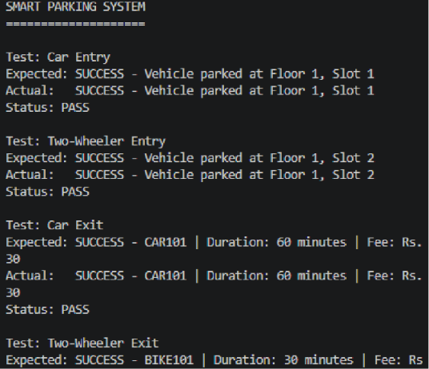
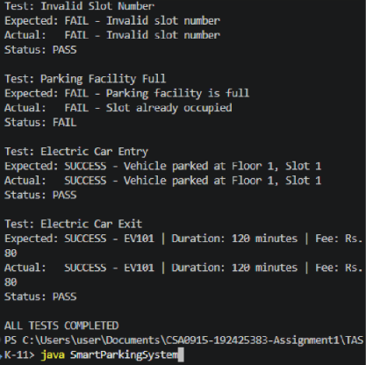

TASK 12 – RE-EVALUATE AND ADAPT THE DESIGN (8 MARKS)

12.1 Changed requirements
The university adds two vehicle categories: e-bikes (flat parking fee) and delivery vans (double the car rate between 9 AM and 5 PM). Visitors may purchase a one-day pass. The facility expands from 3 to 5 floors, and floors may have different slot capacities.

12.2 Impact analysis
Change | Impact | Design response
E-bike category | New fee rule and vehicle type | Add E-Bike subclass or a category pricing strategy
Delivery van | Time-dependent rate | Add DeliveryVan with time-aware pricing rule
One-day visitor pass | New pass validity and fee eligibility | Add Pass abstraction with validity dates
Five floors | More capacity and variable floor sizes | Use jagged array or List<List<ParkingSlot>>
Different slots per floor | Rectangular array assumption becomes unsafe | Retain jagged array or collection per floor

12.3 Evaluation of original design
The original design should be MODIFIED rather than completely redesigned. The abstract Vehicle class, Chargeable interface, ParkingTicket concept and separation between facility and vehicle remain useful. The fixed two-dimensional rectangular-array assumption must be replaced by a jagged structure or floor objects. Pricing should be moved into a PricingRule abstraction so that new pricing policies do not require edits to every vehicle class.

12.4 Revised class structure
Class / interface | Responsibility
Vehicle (abstract) | Common registration identity and base vehicle behaviour
TwoWheeler, Car, ElectricCar | Existing vehicle categories
EBike | Flat parking fee
DeliveryVan | Time-sensitive parking fee
Chargeable | Optional EV charging capability
ParkingPass (abstract) | Validity period and pass eligibility
OneDayVisitorPass | Visitor pass valid for one calendar day
PricingRule (interface) | Computes fee from vehicle, entry and exit times
ParkingFacility | Manages floors, slots and allocation
ParkingTicket | Records vehicle, assigned slot, times and pass reference

12.5 PricingRule example
import java.time.LocalDateTime;

interface PricingRule {
double parkingFee(Vehicle vehicle,
LocalDateTime entry,
LocalDateTime exit);
}

class FlatRateRule implements PricingRule {
private final double amount;
FlatRateRule(double amount) {
if (amount < 0) throw new IllegalArgumentException();
this.amount = amount;
}
public double parkingFee(Vehicle v, LocalDateTime in,
LocalDateTime out) {
return amount;
}
}

class DeliveryVanRule implements PricingRule {
private final double normalRate;
DeliveryVanRule(double normalRate) {
if (normalRate < 0) throw new IllegalArgumentException();
this.normalRate = normalRate;
}
public double parkingFee(Vehicle v, LocalDateTime in,
LocalDateTime out) {
if (out.isBefore(in)) throw new IllegalArgumentException();
// Illustrative rule: charge double rate for time overlapping 09:00–17:00.
// A production implementation should split the stay at each time boundary.
long minutes = java.time.Duration.between(in, out).toMinutes();
int hours = (int)((minutes + 59) / 60);
boolean overlapsBusinessHours =
in.toLocalTime().isBefore(java.time.LocalTime.of(17, 0)) &&
out.toLocalTime().isAfter(java.time.LocalTime.of(9, 0));
return hours * normalRate * (overlapsBusinessHours ? 2.0 : 1.0);
}
}

Important implementation note: the example DeliveryVanRule is a simplified illustration. For exact billing across stays that cross 9 AM or 5 PM, calculate the overlap duration within the 9 AM–5 PM interval and charge normal and double rates for the respective portions.

12.6 One-day pass rule
class OneDayVisitorPass {
private final java.time.LocalDate validDate;

OneDayVisitorPass(java.time.LocalDate validDate) {
if (validDate == null) throw new IllegalArgumentException();
this.validDate = validDate;
}

boolean isValidAt(java.time.LocalDateTime time) {
return validDate.equals(time.toLocalDate());
}
}

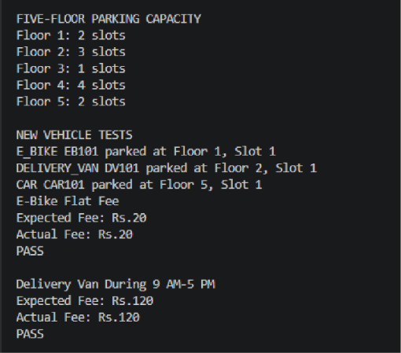

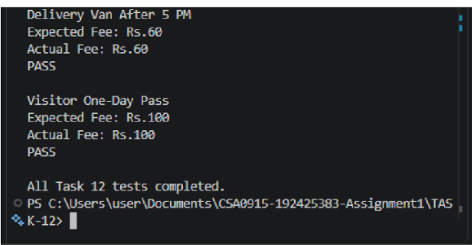12.7 Evidence-based defence
The modified design changes only the parts affected by new requirements: new vehicle subclasses, pass validation, pricing-rule implementations and floor representation. Existing Vehicle, Car, ElectricCar and ticket identity behaviour can remain stable. A new vehicle category can be introduced by adding a class and a pricing rule rather than editing a long conditional chain. The design therefore follows the Open/Closed Principle: open for extension and closed for unnecessary modification.

12.8 Trade-offs
- More classes and interfaces increase the initial code size but reduce the number of existing classes that must change.
- Pricing strategies add one level of indirection but make time-based and flat-fee rules easier to test independently.
- Jagged arrays are efficient for fixed capacities; a list of floor objects is more flexible when capacity changes at runtime.
- A one-day pass needs explicit date-boundary validation, including the campus time zone in a deployed system.

CONCLUSION
The campus smart-parking problem can be modelled effectively using object-oriented Java. The basic ParkingFacility program demonstrates safe allocation and release using a jagged array. The vehicle hierarchy demonstrates inheritance, overriding and runtime polymorphism, while Chargeable demonstrates an interface for optional capability. Encapsulation protects important fields and validation rules.
The original design is suitable for the initial requirements but should be modified to support e-bikes, delivery vans, one-day passes and unequal floor capacities. A PricingRule abstraction and flexible floor representation allow future requirements to be added with fewer changes to tested classes. The final implementation must be validated with actual execution results and screenshots.

REFERENCES
- SIMATS Engineering, Java Programming Lab Assignment: Design, Implement and Validate an Object-Oriented Model for a Campus Smart-Parking System (assignment instructions supplied in the lab portal).
- Oracle. Java Platform, Standard Edition Documentation. https://docs.oracle.com/en/java/
- Oracle. The Java Tutorials – Object-Oriented Programming Concepts. https://docs.oracle.com/javase/tutorial/java/concepts/
- Oracle. Java Collections Framework documentation. https://docs.oracle.com/en/java/javase/

APPENDIX A – COMPLETED JAVA PROGRAMS
Program 1: ParkingFacility.java – completed allocation and release TODOs. The full source is provided in Task 3.
Program 2: FeeDemo.java – completed billable-hour calculation, Car rate and ElectricCar charging fee TODOs. The full source is provided in Task 8.
For the integrated submission, organise additional model and service classes under the package structure in Task 10. Keep each public Java class in a file with the same name.

Compilation and execution
javac ParkingFacility.java
java ParkingFacility

javac FeeDemo.java
java FeeDemo

APPENDIX B – GITHUB AND FINAL SUBMISSION CHECKLIST
- Create a repository named CSA09-192511134-Assignment1 (confirm exact naming convention with faculty).
- Create separate folders Task01 through Task12, or organise source files under src/parking/model, src/parking/service and src/parking/app.
- Upload Java source files, input files if used, and genuine output screenshots.
- Add README.md containing student name, register number, Java version, repository overview, compile/run commands and a short result note for each task.
- Commit work progressively; the assignment asks for at least one commit for each task.
- Include UML diagrams, pseudocode, test tables and complexity analysis in the report.
- Put the GitHub repository URL on the report cover page after the repository is created.
- Export the final report as PDF and verify that tables, code and diagrams are readable.

README.md template
# Campus Smart-Parking System – Java Assignment

Student: DEVALAKSHMI S
Register Number: 192511134
Course: Java Programming Lab

## Java version
Record the Java version used for compilation.

## Project structure
- Task01/
- Task02/
- ...
- Task12/
- README.md

## Compile and run
Use the javac and java commands documented for each program.

## Results
Add a short note and output screenshot for every completed task.

## Design
The project demonstrates classes, objects, constructors, static members,
inheritance, overriding, polymorphism, abstraction, interfaces and encapsulation.

GitHub repository link:https://github.com/192511134simats/CSA09-192511134-Assignment1/blob/main/README.md

