CSA0381 – DATA STRUCTURES FOR DEPTH FIRST SEARCH
PRACTICAL EXAMINATION PROGRAMS
TEJASREE G
192511204

- MATRIX MULTIPLICATION

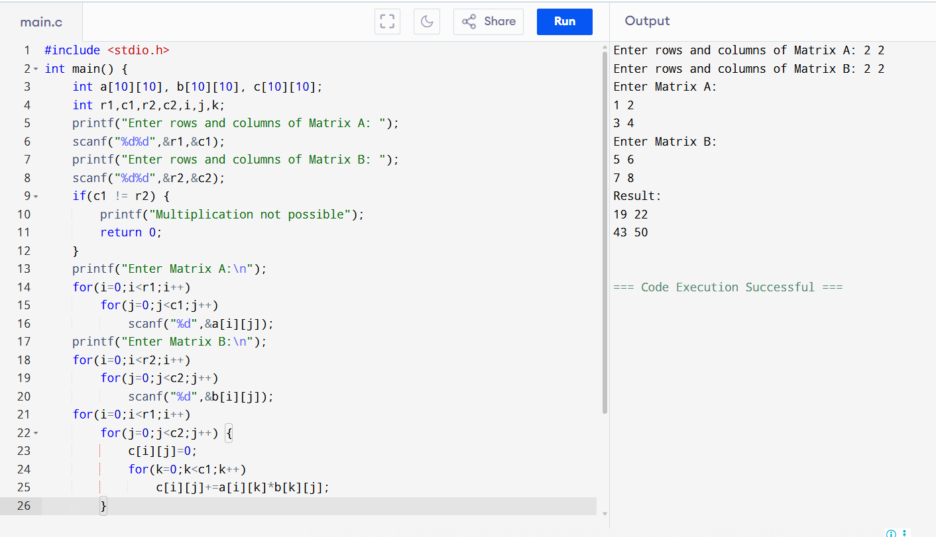

- ODD OR EVEN NUMBER
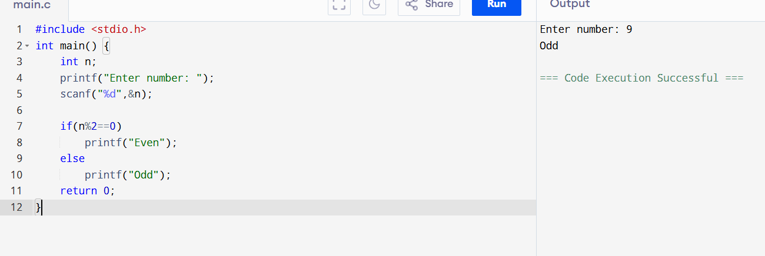

- FACTORIAL WITHOUT RECURSION
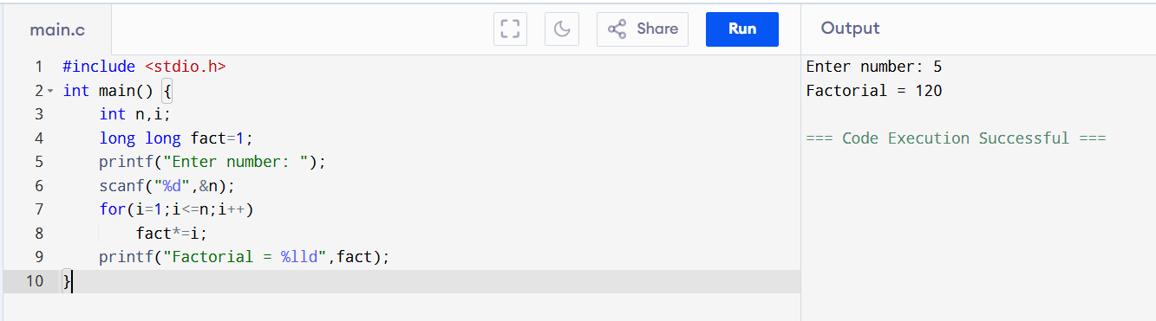

- FIBONACCI WITHOUT RECURSION
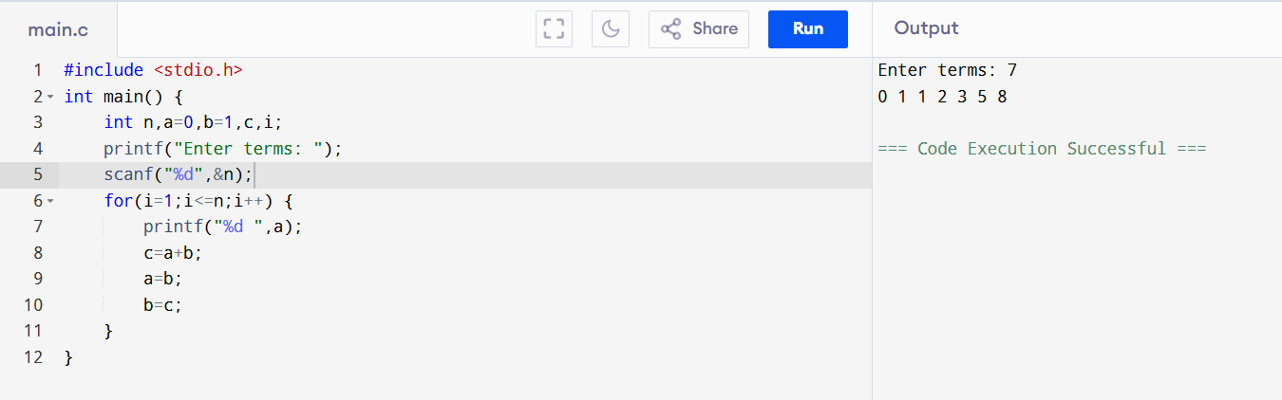

- FACTORIAL USING RECURSION

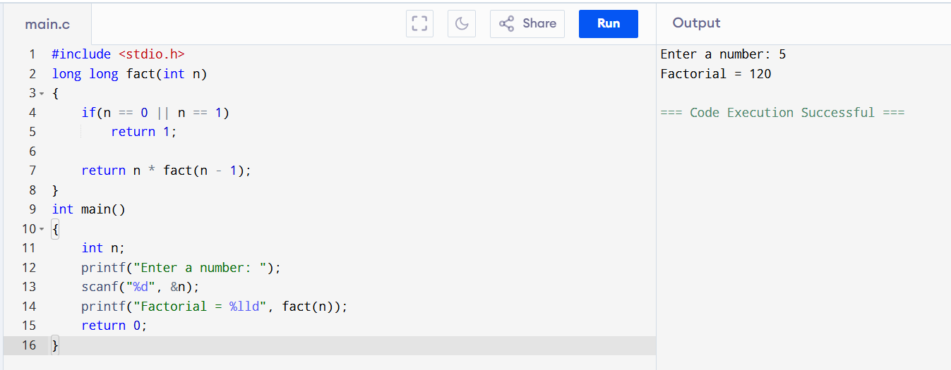

- FIBONACCI USING RECURSION
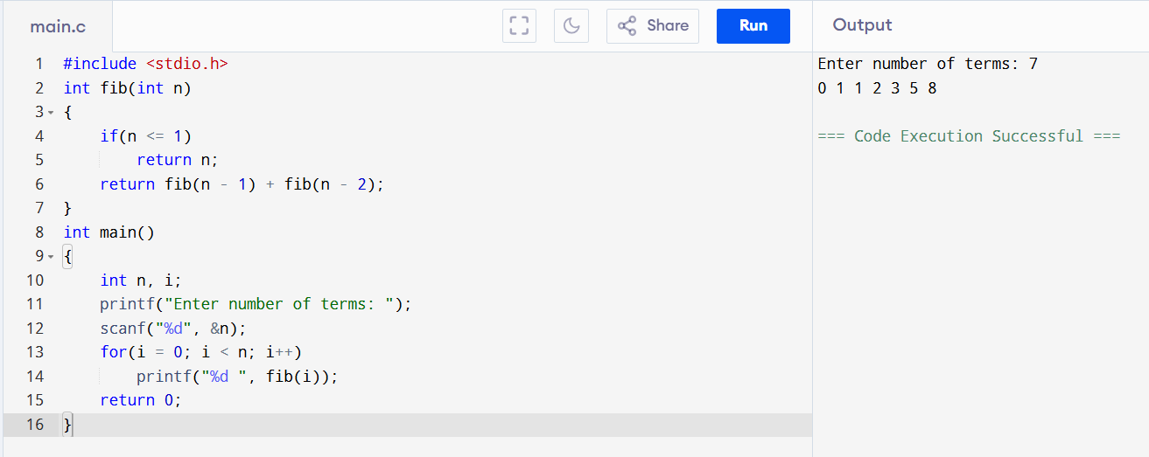

- ARRAY OPERATIONS (INSERT, DELETE, DISPLAY)
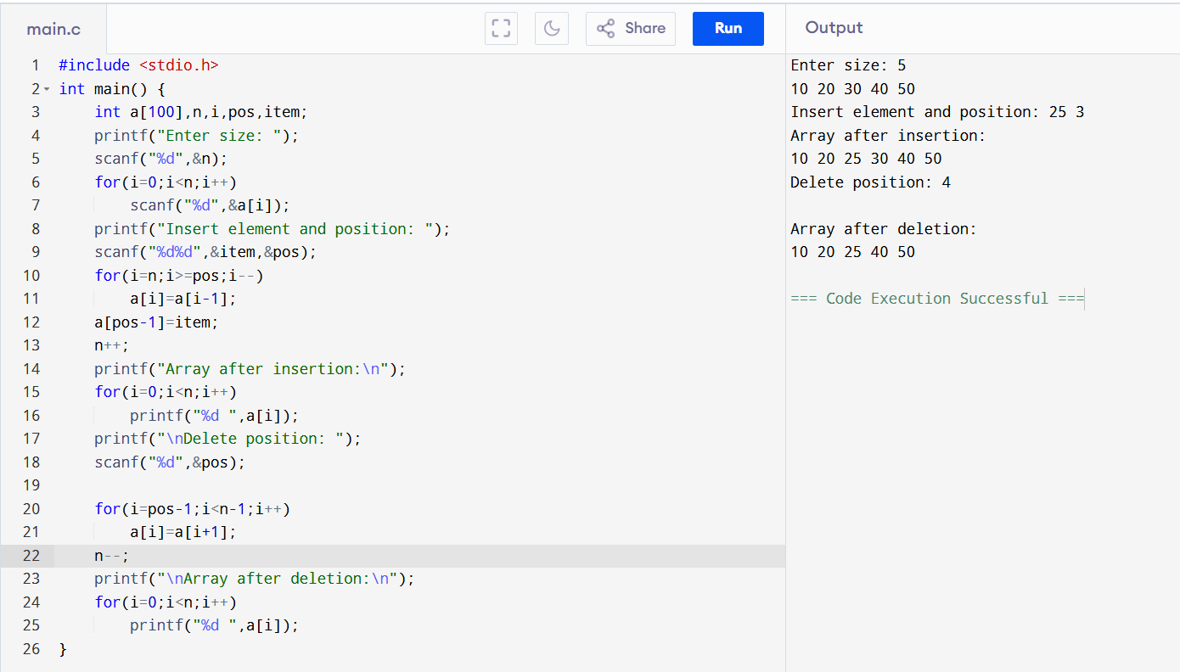

- LINEAR SEARCH
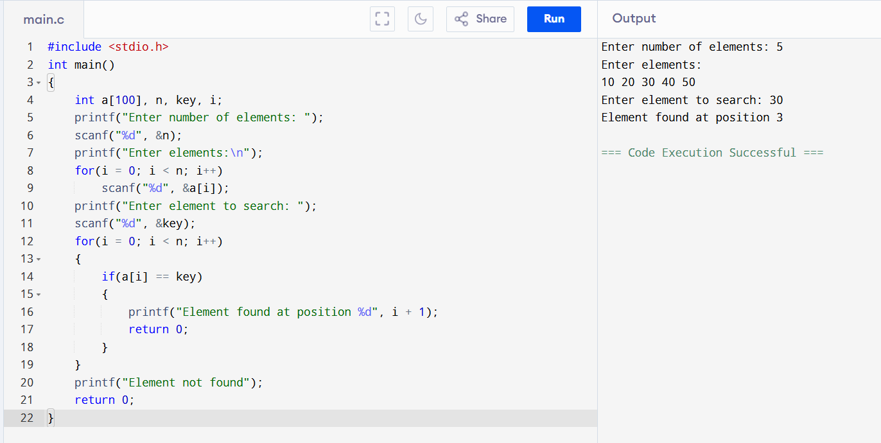
- BINARY SEARCH
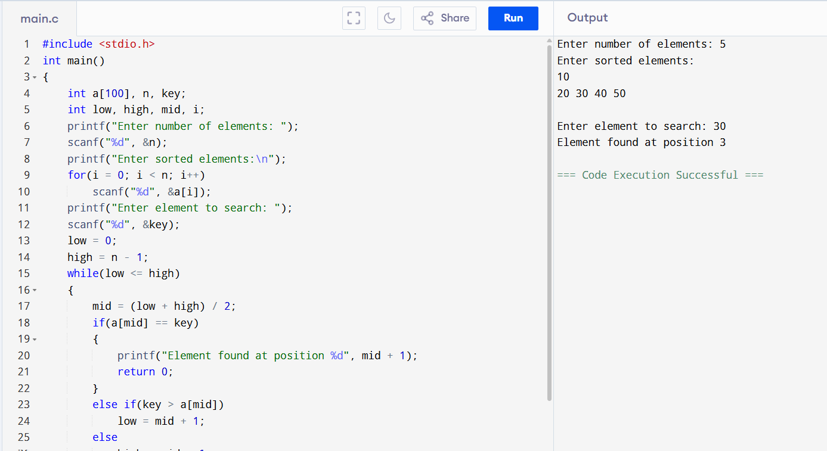

- LINKED LIST OPERATIONS
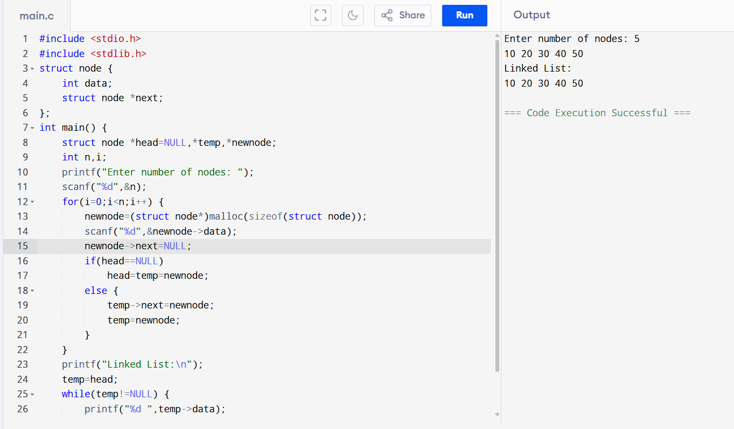

- STACK OPERATIONS (PUSH, POP, DISPLAY)

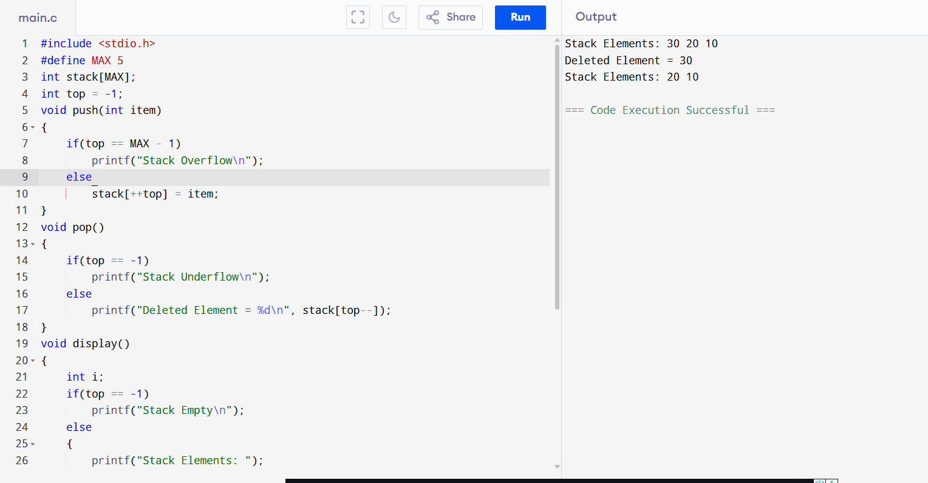

- QUEUE OPERATIONS
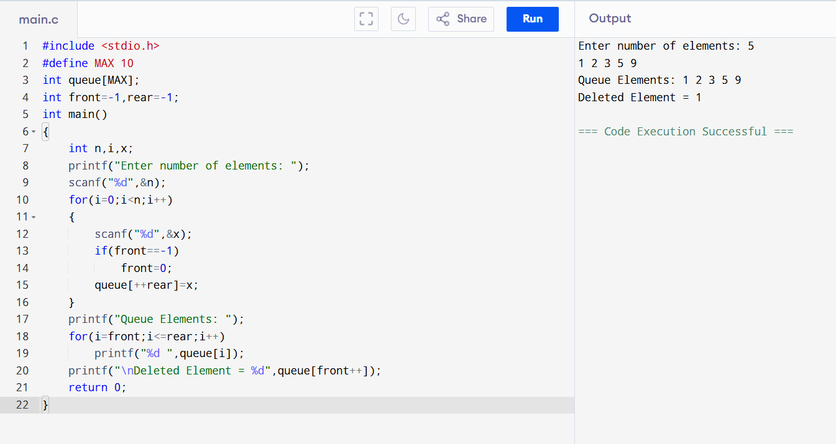

- INSERTION SORT
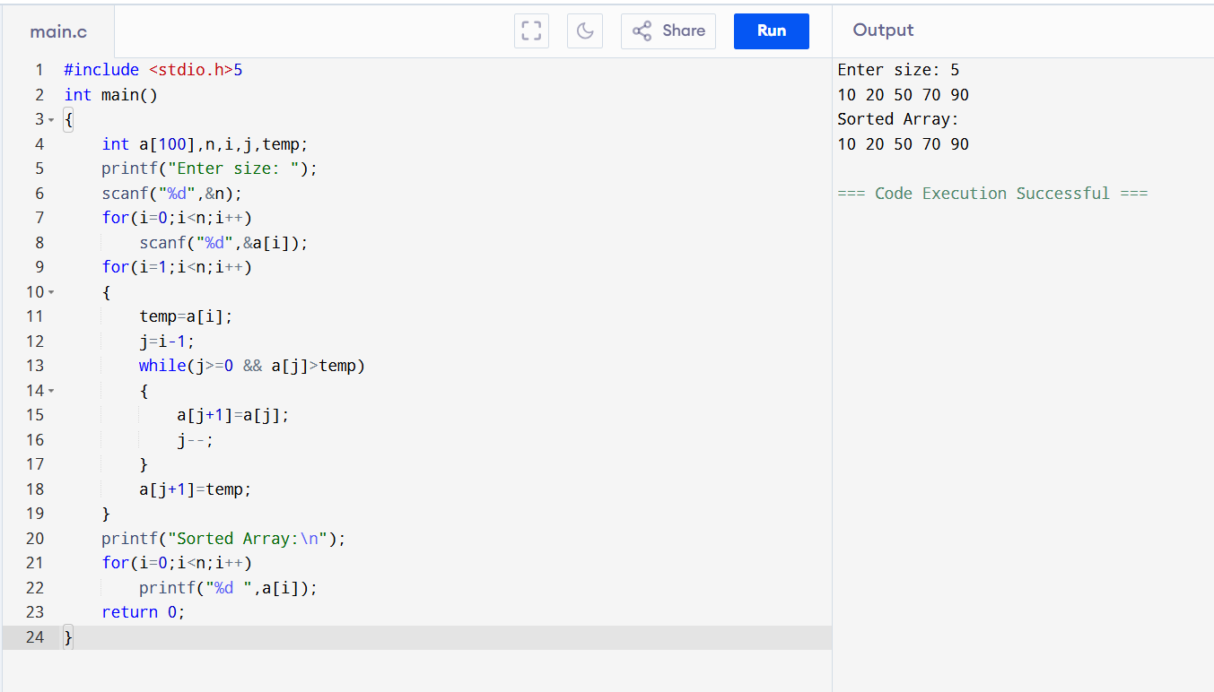

- SELECTION SORT
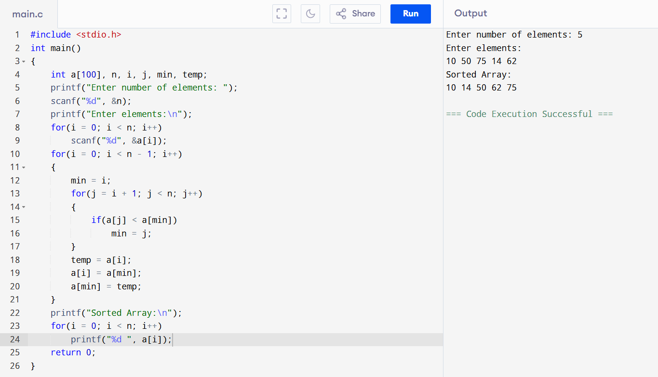

- BUBBLE SORT
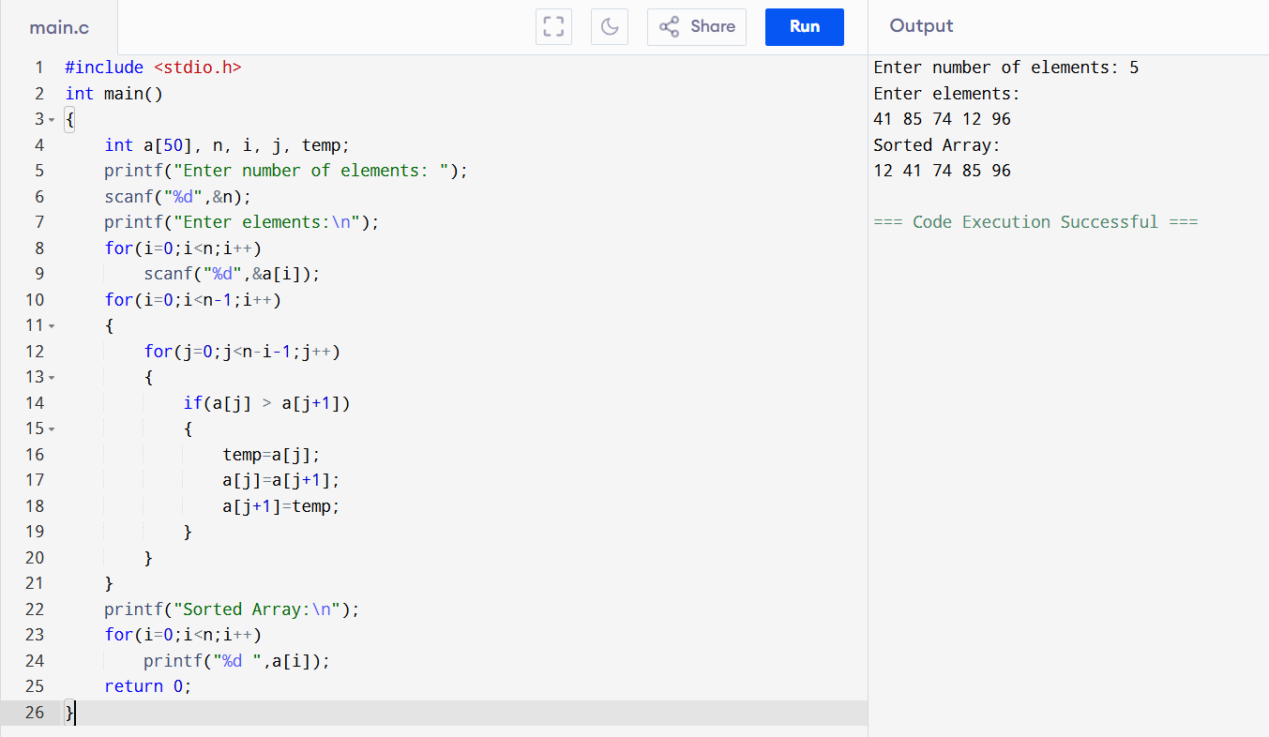

- MERGE SORT
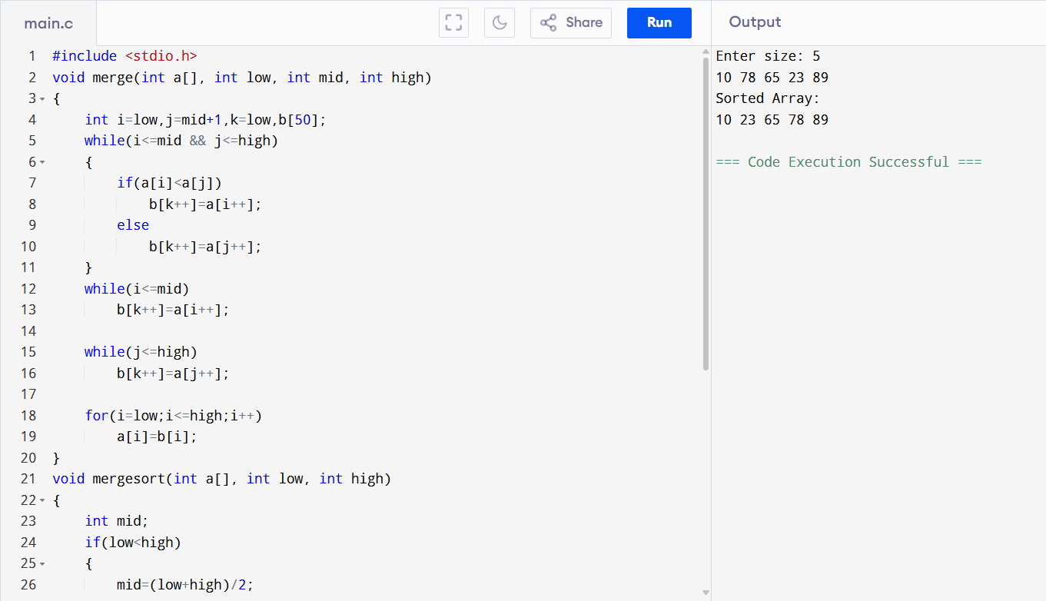

- QUICK SORT
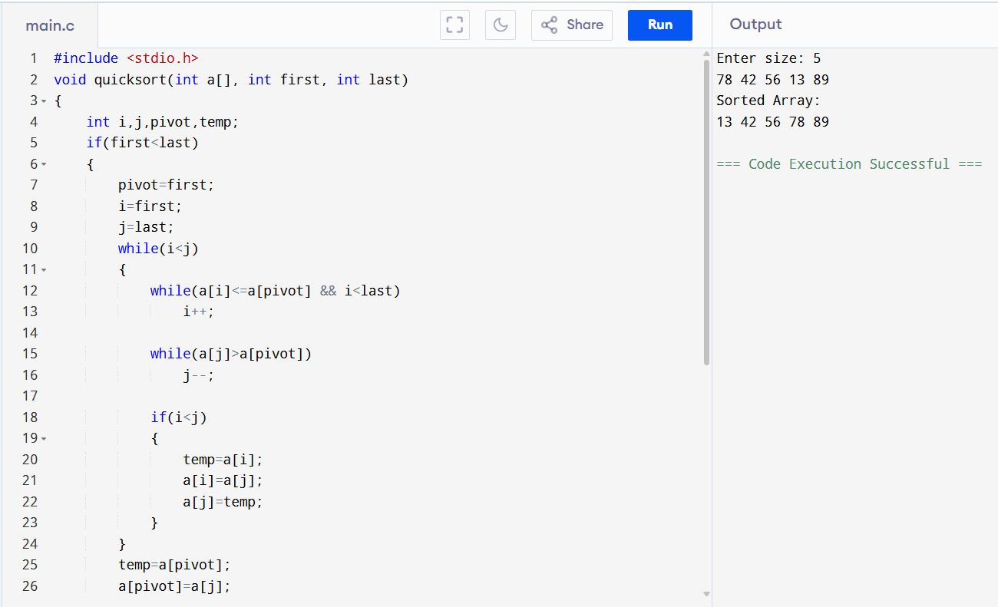

- BST CREATION
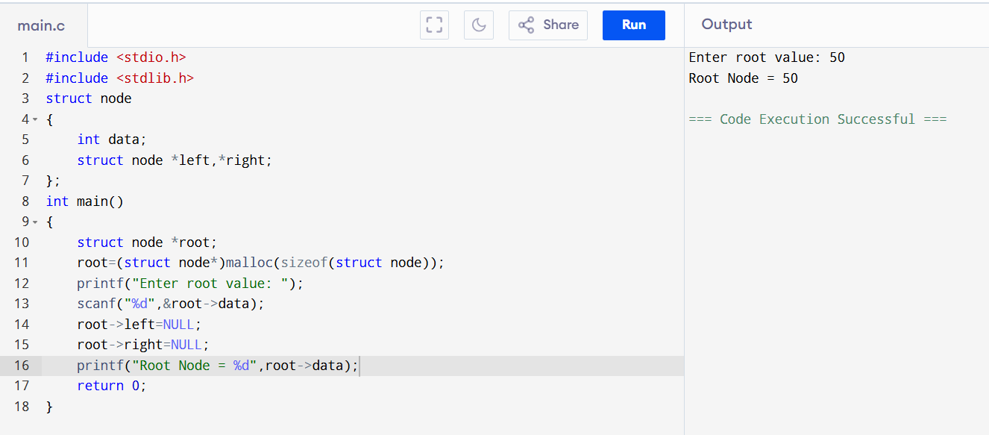

- INORDER TRAVERSAL
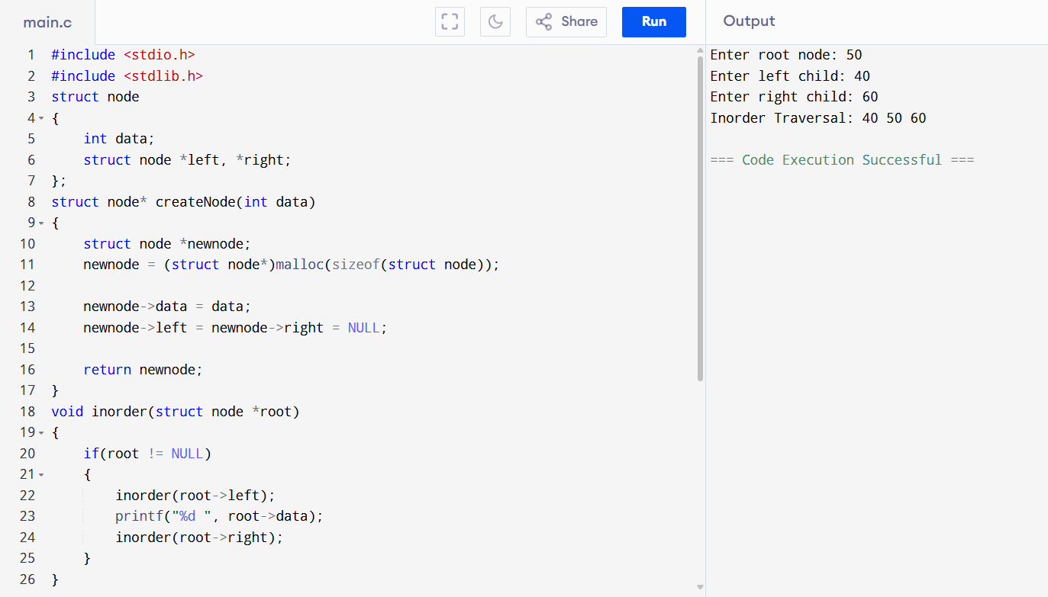

20. PREORDER TRAVERSAL OF BST

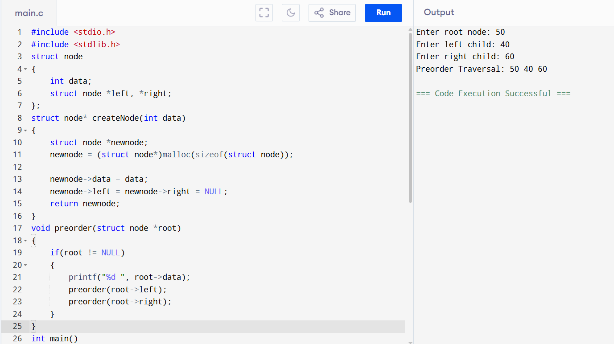

21. POSTORDER TRAVERSAL OF BST

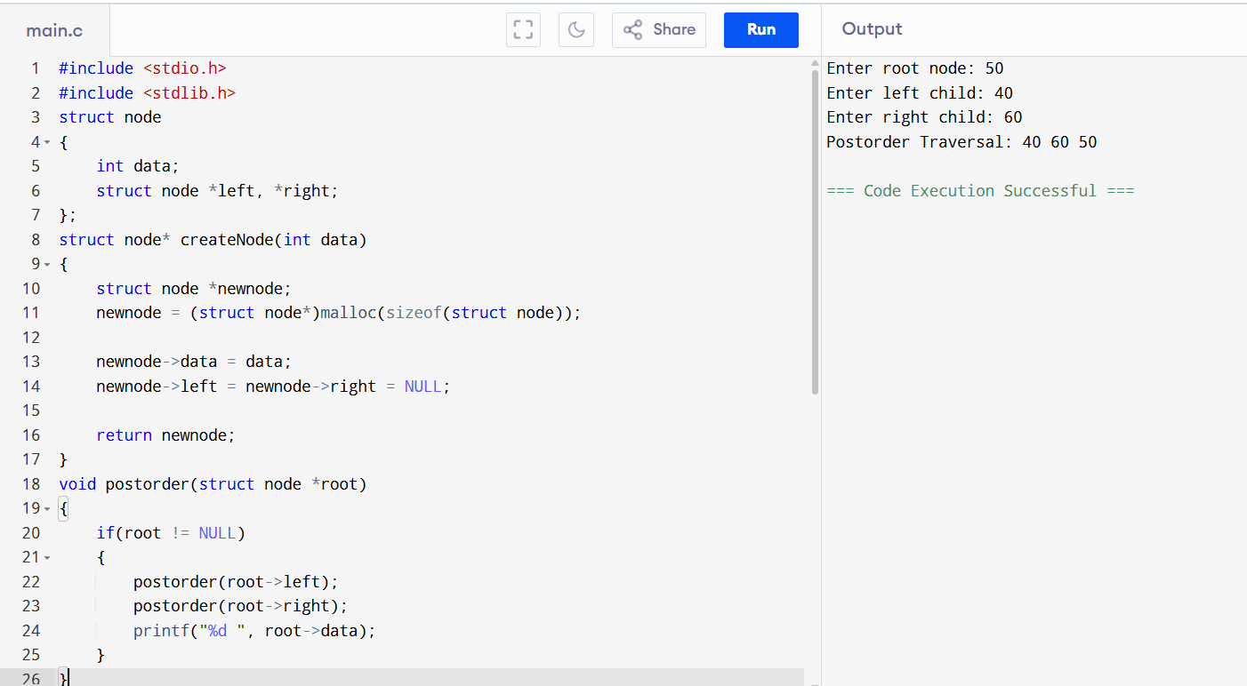

22. HEAP SORT

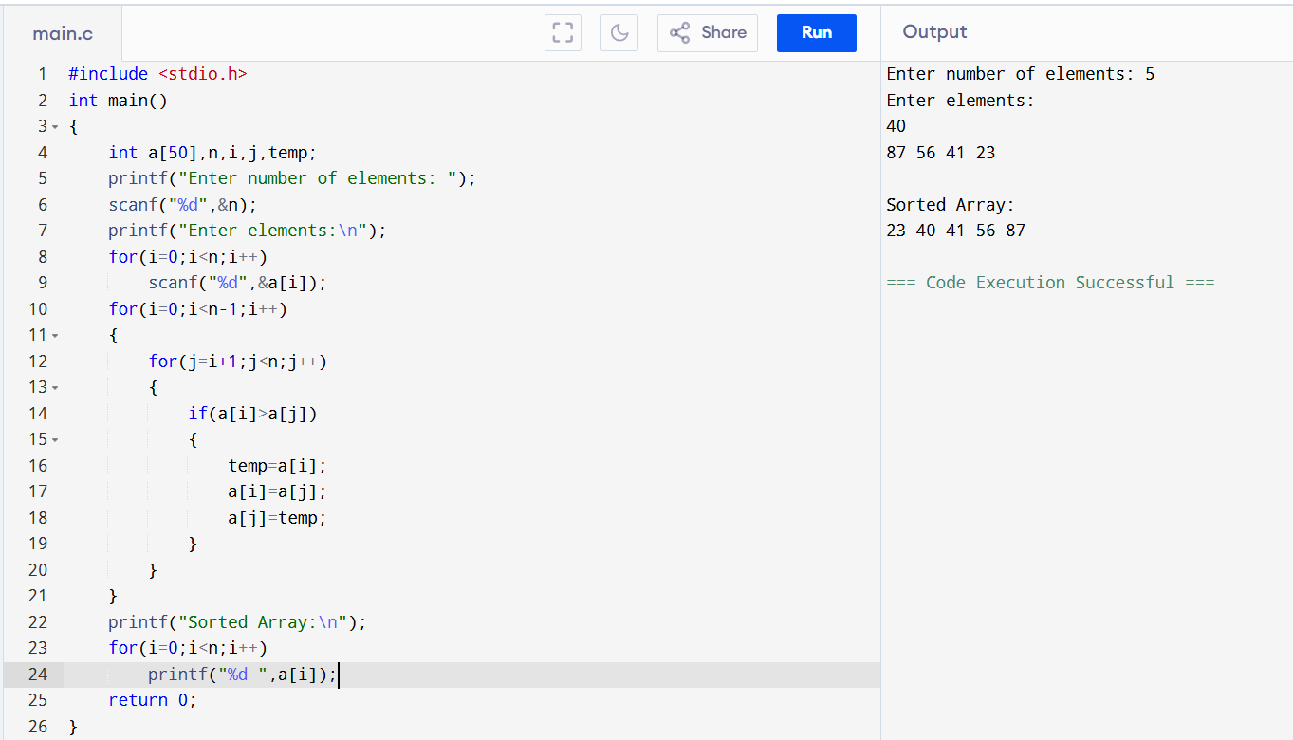

23. BREADTH FIRST SEARCH (BFS)

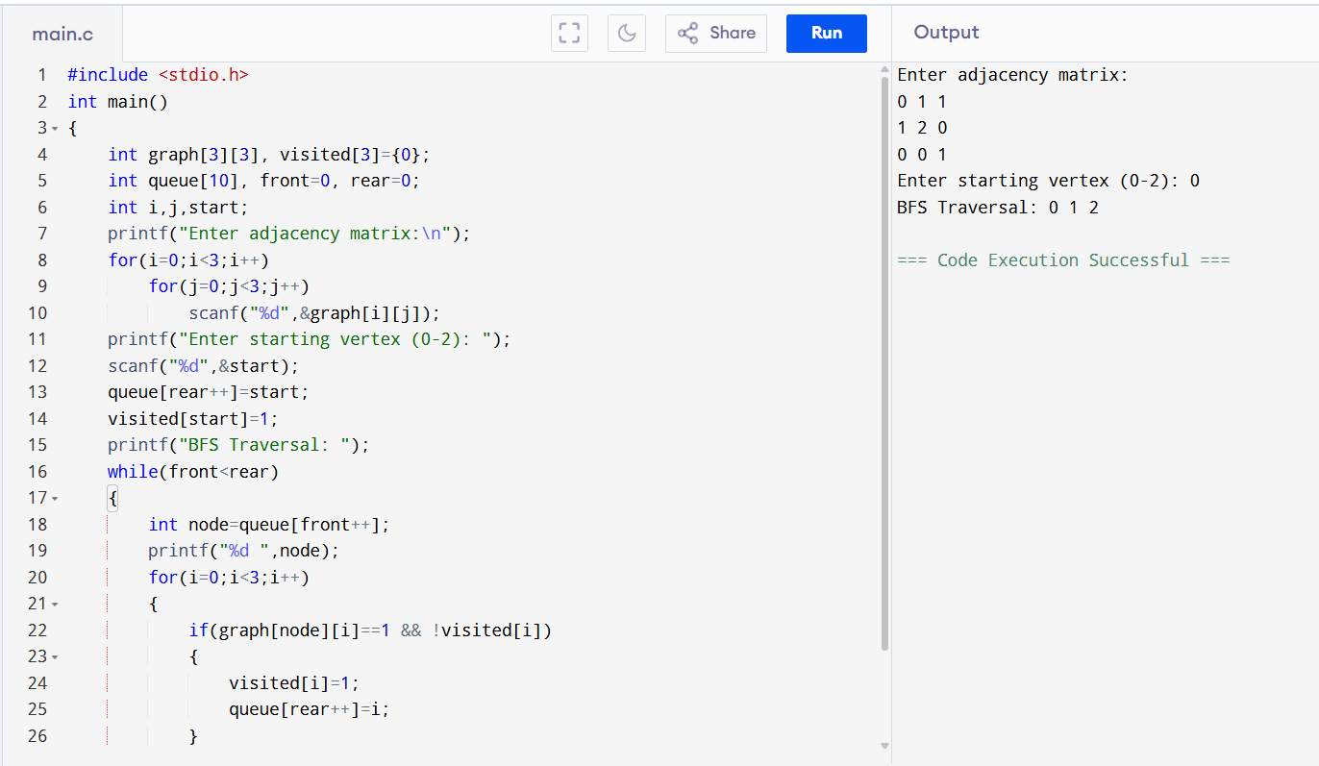

24. DEPTH FIRST SEARCH (DFS)

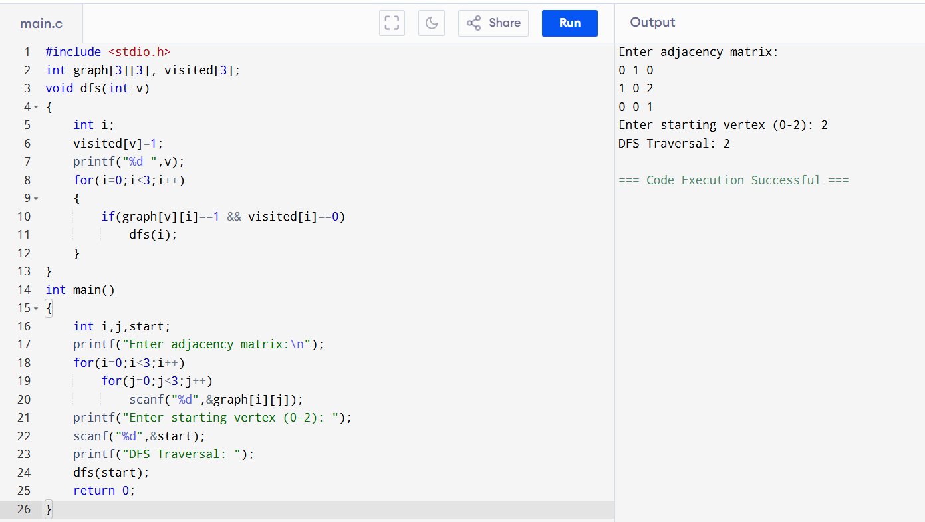

25. DIJKSTRA'S ALGORITHM

