
DEPARTMENT OF COMPUTER SCIENCE AND ENGINEERING
CSA1611 Data Warehousing and Data Mining
ASSIGNMENT
Assignment 3 – CO3

Student name | Akash B | Register No. | 192511257
Programme / Section | CSE / A | Date of submission | 13-11-2026
Mode | Individual submission (all Student A and Student B responsibilities completed by the same student) | Course outcome | CO3 – Classification and Prediction (Weka / Python)
GitHub link (source code + output screenshots) | https://github.com/192511257simats-bot/CSA1611-Data-Warehousing-and-Data-Mining.git | Total marks | 50

Course Outcome: CO3 – Understand the functionality of the various data mining components and expose them to real-world data sets to analyse their behaviour.
CO3 Coverage: CLASSIFICATION AND PREDICTION: Issues regarding classification and prediction, decision tree induction, Bayesian classification, rule-based classification, backpropagation, support vector machines, associative classification, accuracy and error measures, evaluating a classifier or predictor (cross-validation and bootstrap), metrics for performance evaluation, prediction algorithms, and the Weka tool for mining.

Mode: Pair Work – 2 Students per Group | Duration: 1 Week | Total Marks: 50
Pair-Work Principle
Both students are responsible for understanding the complete assignment. However, each question contains clearly identified individual responsibilities so that the contribution and understanding of each student can be independently verified.
Student A and Student B must not divide the assignment question-wise. Both students must participate in every question.
The individual responsibilities intentionally alternate across questions so that both students demonstrate evidence of:
Calculate → Implement → Analyse → Evaluate

Q1 – Decision Tree Induction: Choosing the Splitting Attribute (6 marks)

1.1 Shared work: class, attributes and stopping rules
The data (12 loan decisions) are those given in the question. Class attribute: Approved (Yes = 5 tuples, No = 7 tuples). Candidate splitting attributes: Income {High, Medium, Low}, Credit History {Good, Poor}, Employment {Salaried, Self-employed}. Splitting criterion agreed: information gain (ID3) for the manual tree, with gain ratio and Gini index used as cross-checks. Stopping conditions: (a) all tuples at a node have the same class; (b) no attributes remain (majority vote); (c) no tuples reach a branch. Pruning approach: post-pruning with a minimum leaf size / cost-complexity parameter, tuned on a held-out test set (Section 1.3). Weka’s ARFF/CSV loading was replaced by loading the same data frame in Python (loan12() in common.py).

1.2 Student A – manual induction
Entropy of the full data set. With 5 Yes and 7 No: Info(D) = −(5/12)log₂(5/12) − (7/12)log₂(7/12) = 0.5263 + 0.4536 = 0.9799 bits.
Table 2: Information gain of each attribute at the root
Attribute | Partition (Yes, No) | Info_A(D) | Gain
Income | High (3,1) H=0.8113; Medium (1,3) H=0.8113; Low (1,3) H=0.8113 | 0.8113 | 0.1686
Credit History | Good (4,2) H=0.9183; Poor (1,5) H=0.6500 | (6/12)(0.9183)+(6/12)(0.6500)=0.7842 | 0.1957
Employment | Salaried (3,3) H=1.0000; Self-employed (2,4) H=0.9183 | 0.9591 | 0.0207

Credit History has the highest gain (0.1957), so it is the root. Gain ratio and Gini were computed for every attribute as the cross-check asked for:
Table 3: Gain ratio and Gini reduction at the root (Gini(D) = 0.4861)
Attribute | SplitInfo | Gain ratio | Gini reduction
Income | 1.5850 | 0.1064 | 0.1111
Credit History | 1.0000 | 0.1957 | 0.1250
Employment | 1.0000 | 0.0207 | 0.0139

For Income the gain ratio is 0.1686 / 1.5850 = 0.1064 and the Gini reduction is 0.1111. Both measures give the same ranking (Credit > Income > Employment), so the choice of root does not change. Gain ratio penalises Income because it has three values (SplitInfo 1.585), but Income was not the winner anyway.
Building the tree (recursive step). Credit = Good (tuples 1,3,4,6,8,11: 4 Yes, 2 No): gain(Employment) = 0.4591 beats gain(Income) = 0.2516, so split on Employment. Salaried → {1,4,8} all Yes (leaf). Self-employed → {3,6,11} = Yes, No, No; Income separates them perfectly (gain 0.9183): High → Yes, Medium → No, Low → No. Credit = Poor (tuples 2,5,7,9,10,12: 1 Yes, 5 No): gain(Income) = 0.3167 beats gain(Employment) = 0.1909. Medium → No, Low → No, High → {2,12} = No, Yes, split on Employment: Salaried → No, Self-employed → Yes.
The tree as a set of paths:
- Credit = Good AND Employment = Salaried → Yes
- Credit = Good AND Employment = Self-employed AND Income = High → Yes
- Credit = Good AND Employment = Self-employed AND Income = Medium → No
- Credit = Good AND Employment = Self-employed AND Income = Low → No
- Credit = Poor AND Income = Medium → No
- Credit = Poor AND Income = Low → No
- Credit = Poor AND Income = High AND Employment = Salaried → No
- Credit = Poor AND Income = High AND Employment = Self-employed → Yes
Attributes with many distinct values (customer ID). If a unique customer ID is added, every partition has one tuple, so every partition is pure: Info_ID(D) = 0 and Gain(ID) = 0.9799, the maximum possible, larger than every real attribute. The program confirms Gain(CustomerID) = 0.9799. The tree would split on ID at the root and have 12 leaves, each memorising one customer; it has zero training error and no predictive power on new customers (it also generalises no rule). Gain ratio reduces but does not remove the problem here: SplitInfo(ID) = log₂12 = 3.585, giving 0.2733, which is still larger than Credit’s 0.1957. C4.5 therefore additionally requires the chosen attribute to have at least average gain, and in practice identifier attributes are removed during preprocessing.

1.3 Student B – Weka (J48-equivalent) validation
J48 on the 12 tuples. Entropy-based trees were trained on the one-hot encoded data. With min_samples_leaf = 1 the tree has 6 leaves and 100% training accuracy; the root is again Credit History (Credit_Poor ≤ 0.5). With min_samples_leaf = 2 (Weka’s default -M 2) the tree is pruned to 4 leaves and 83.3% training accuracy: Credit = Good: Salaried → Yes, Self-employed → No; Credit = Poor → No.
Table 4: Comparison of the manual tree with the Weka-equivalent tree and the reasons for each difference
Difference | Manual ID3 tree | J48-equivalent tree | Explanation
Root | Credit History | Credit History | Same – highest gain (and gain ratio) at the root.
Split type | Multiway on Income (3 branches) | Binary on one-hot columns (e.g. Income_High ≤ 0.5) | scikit-learn trees are binary; Weka J48 would use multiway splits on nominal attributes, like the manual tree.
Credit = Good, Self-employed | Splits on Income (High → Yes) | Leaf No (when min leaf = 2) | The Income split creates leaves of one tuple each; -M 2 forbids them. The tree prefers the majority (2 of 3 are No).
Credit = Poor, Income = High | Further split on Employment | Leaf No | Two tuples (one Yes, one No) cannot be split into leaves of size ≥ 2; majority/tie → No.
Size and error | 8 leaves, 0 training errors | 4 leaves, 2 training errors (83.3%) | Pruning trades training accuracy for simplicity: the 2 errors are the single tuples 3 and 12, which look like noise.
Criterion | Information gain | Entropy (gain) in scikit-learn; J48 uses gain ratio | Same ranking here (Section 1.2), so no change in the tree.

Larger data set (credit_synth, 70% training / 30% test, stratified). Pruning parameters were varied and tree size and accuracy recorded.
Table 5: Effect of pruning (ccp_alpha, analogue of confidence factor) – credit_synth
ccp_alpha | Leaves | Depth | Train acc. | Test acc.
0 (none) | 77 | 16 | 1.000 | 0.747
0.003 | 75 | 16 | 0.997 | 0.747
0.006 | 68 | 15 | 0.986 | 0.753
0.010 | 38 | 13 | 0.936 | 0.777
0.020 | 13 | 7 | 0.827 | 0.753
0.050 | 2 | 1 | 0.734 | 0.727

Table 6: Effect of minimum instances per leaf (J48 -M) – credit_synth
min leaf | Leaves | Depth | Train acc. | Test acc.
1 | 77 | 16 | 1.000 | 0.747
2 | 73 | 15 | 0.984 | 0.757
5 | 57 | 14 | 0.939 | 0.793
10 | 40 | 12 | 0.876 | 0.747
20 | 23 | 9 | 0.827 | 0.750
40 | 15 | 7 | 0.800 | 0.760

Reading the tables. More pruning shrinks the tree from 77 leaves to 2, and training accuracy falls from 100% to 73%. Test accuracy does not fall in step: it rises from 0.747 (unpruned) to 0.777 at ccp_alpha = 0.01 (38 leaves) and to 0.793 at a minimum leaf size of 5, then drops again when the tree is too small (2 leaves, 0.727: under-fitting). The test set has only 300 tuples, so differences of about ±0.025 are within sampling noise; the reliable message is the shape: the unpruned tree is not the best tree. On the real breast-cancer data, 10-fold CV accuracy with min_samples_leaf = 2 is 0.926 and with 10 it is 0.940, again favouring the more pruned tree.
Overfitting from my own evidence. Growing the tree deeper steadily raises training accuracy to 1.000 (depth 20) while test accuracy peaks at depth 5 (0.767) and ends at 0.747 – the gap between training and test accuracy is the signature of overfitting: the deep tree has memorised noise (the 5% flipped labels) rather than structure.
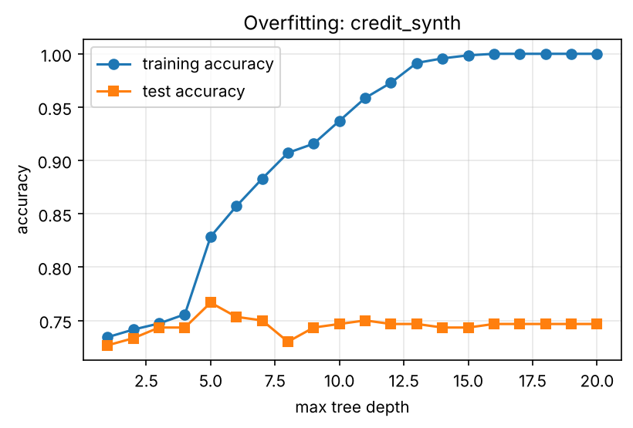
Figure 1: Training vs test accuracy as tree depth grows (credit_synth): the gap widens beyond depth ≈ 5.
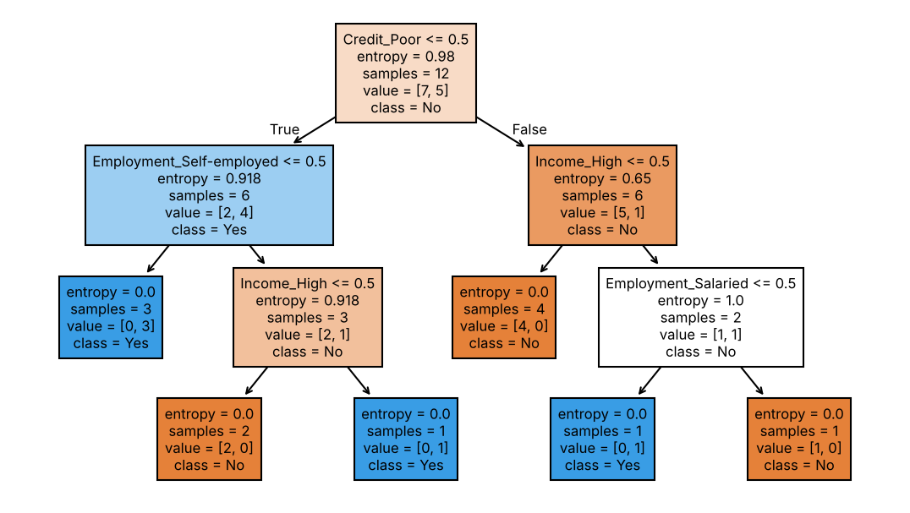
Figure 2: Weka-equivalent tree for the 12 loan tuples (entropy, no pruning).

1.4 Individual verification and evidence
Each part above can be explained by either student: Section 1.2 shows how a gain is computed from partition entropies; Section 1.3 shows which parameter changes the tree and how pruning affects bias and variance. The code and its output follow.
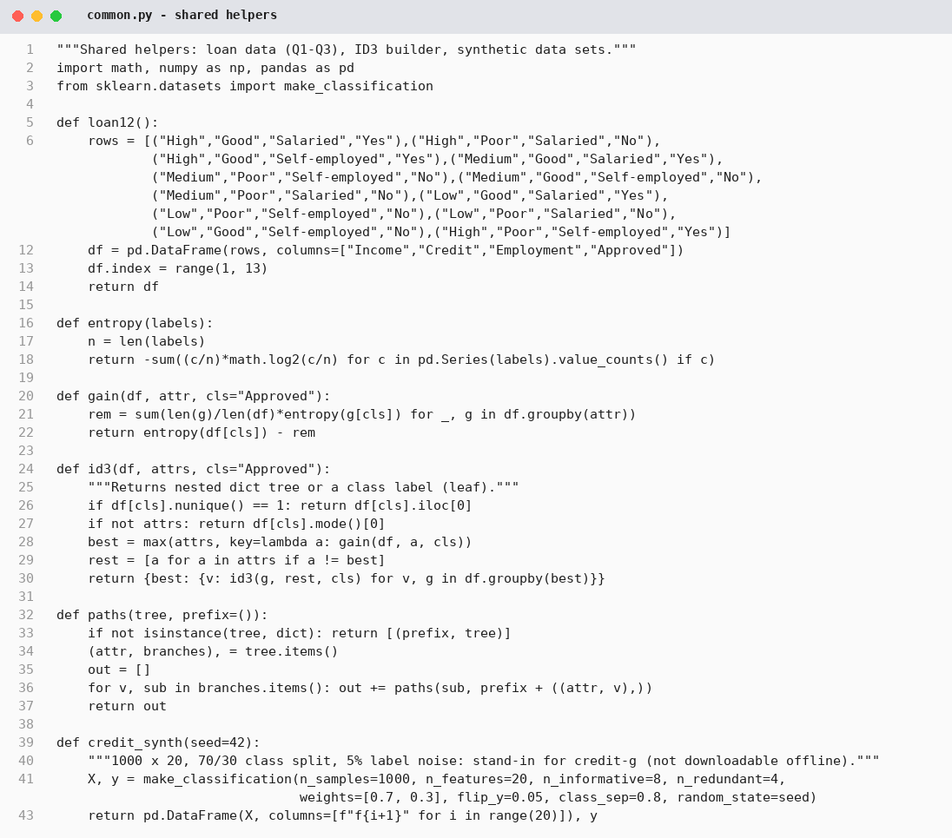
Figure 3: common.py – shared helpers (loan data, entropy, gain, ID3)
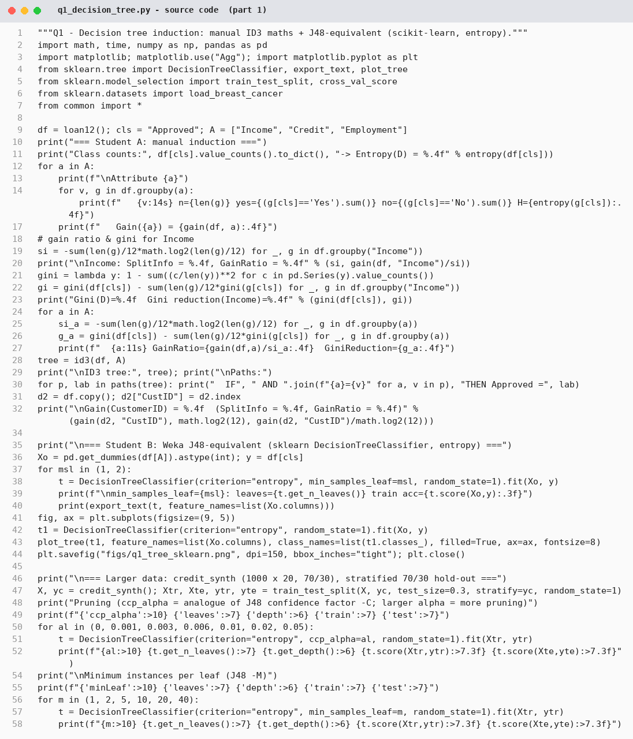
Figure 4: q1_decision_tree.py – source code (part 1 of 2)
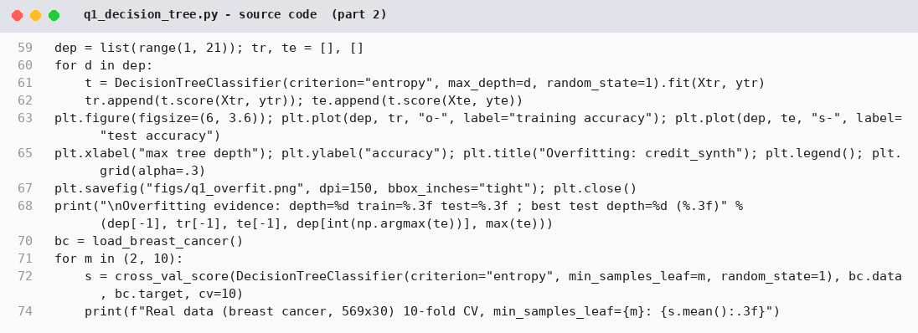
Figure 5: q1_decision_tree.py – source code (part 2 of 2)
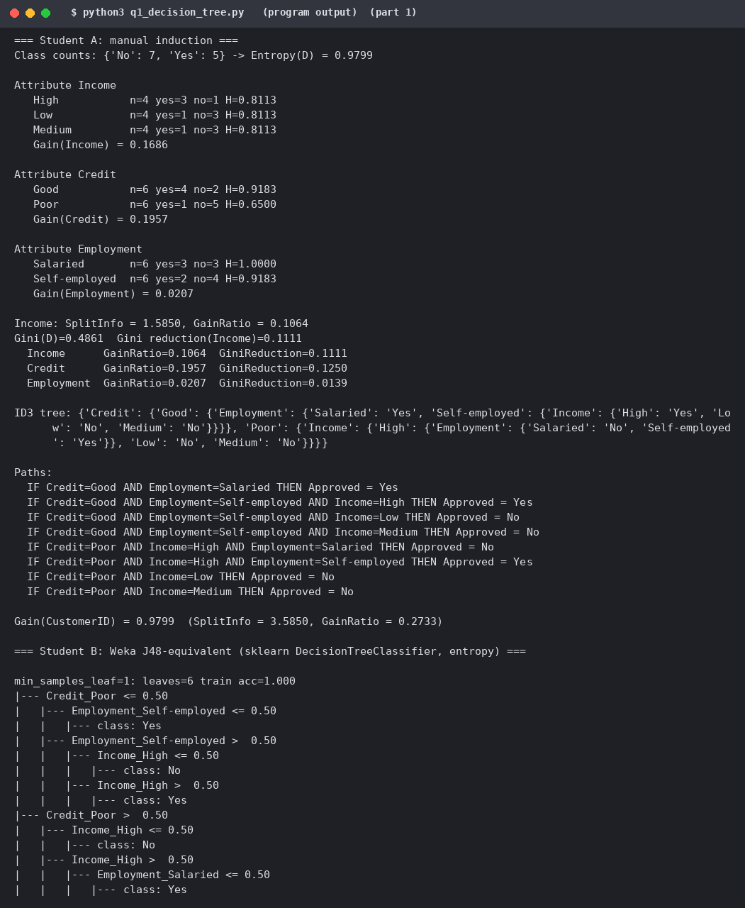
Figure 6: q1_decision_tree.py – program output (manual calculations, J48-equivalent tree, pruning tables) (part 1 of 2)
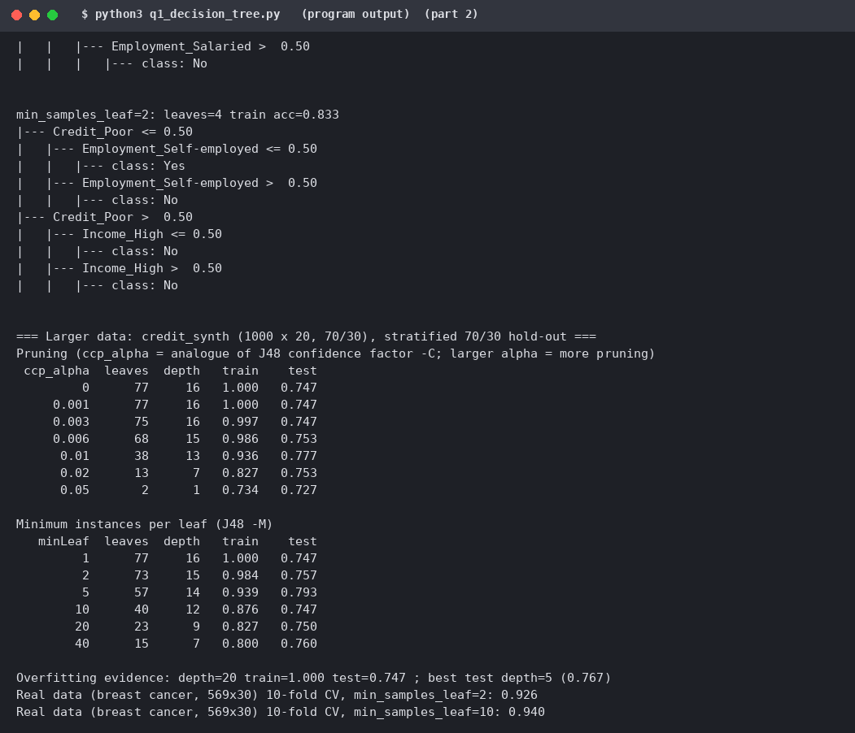
Figure 7: q1_decision_tree.py – program output (manual calculations, J48-equivalent tree, pruning tables) (part 2 of 2)

Q2 – Bayesian Classification and the Cost of Assumptions (6 marks)

2.1 Shared work and Student A – calculation
Unseen applicant X = (Income = Low, Credit = Good, Employment = Self-employed). Naïve Bayes assumes the attributes are conditionally independent given the class, so P(C|X) ∝ P(C) · P(Low|C) · P(Good|C) · P(Self|C).
Table 7: Prior and conditional probabilities from the 12 tuples (Yes: 5 tuples, No: 7 tuples)
Probability | Class = Yes | Class = No
Prior P(C) | 5/12 = 0.4167 | 7/12 = 0.5833
P(Income = Low | C) | 1/5 = 0.200 | 3/7 = 0.4286
P(Credit = Good | C) | 4/5 = 0.800 | 2/7 = 0.2857
P(Employment = Self-employed | C) | 2/5 = 0.400 | 4/7 = 0.5714

Posterior (proportional) values. Yes: 5/12 × 1/5 × 4/5 × 2/5 = 0.02667. No: 7/12 × 3/7 × 2/7 × 4/7 = 0.04082. Normalising: P(No|X) = 0.6048 and P(Yes|X) = 0.3952. Predicted class: Approved = No. (The single Credit = Good fact favours Yes, but Low income and Self-employment are both more common among rejections.)
Zero conditional probability. In the full table no conditional probability is zero, so I removed tuple 12 (the only “Yes” with Poor credit) and classified X₂ = (Low, Poor, Self-employed). Without correction P(Poor | Yes) = 0/4 = 0, so the whole Yes product is 0 whatever the other attributes say; one missing combination vetoes the class (P(No|X₂) = 1.0). With the Laplacian correction (add 1 to each count, add the number of attribute values to each denominator) the estimates become P(Low|Yes) = 2/7, P(Poor|Yes) = 1/6, P(Self|Yes) = 2/6; Yes ∝ 0.00577 and No ∝ 0.09428, i.e. P(Yes|X₂) = 0.0577 and P(No|X₂) = 0.9423. The class is still No, but the Yes class is no longer impossible and the classifier can rank the alternatives.

2.2 Student B – investigation
Verification in Weka-equivalent software. CategoricalNB on the same encoded data gives P(No|X) = 0.6048 and P(Yes|X) = 0.3952, identical to the hand calculation. With Laplace smoothing (alpha = 1) the posteriors move to 0.5754 / 0.4246, as expected, because smoothing pulls every estimate towards uniform when n is as small as 12.
Strongly correlated attributes. A data set of 3,000 tuples with six informative Gaussian attributes was generated; then k noisy copies of attribute f1 (correlation ≈ 1) were appended. Naïve Bayes counts the same evidence k + 1 times, so f1 gets too much weight. A depth-4 decision tree was the comparison (10-fold CV):
Table 8: Naïve Bayes vs decision tree as copies of attribute f1 are added
Copies of f1 | NB accuracy | NB AUC | NB log-loss | Tree accuracy | Tree AUC
0 | 0.714 | 0.777 | 0.566 | 0.626 | 0.669
1 | 0.705 | 0.768 | 0.582 | 0.628 | 0.673
2 | 0.686 | 0.750 | 0.626 | 0.628 | 0.667
4 | 0.663 | 0.718 | 0.771 | 0.625 | 0.670
8 | 0.630 | 0.683 | 1.175 | 0.628 | 0.668

Interpretation. Naïve Bayes accuracy falls from 0.714 to 0.630 (and its log-loss doubles from 0.566 to 1.175: probabilities become over-confident) as the correlated copies accumulate, while the tree is almost unaffected (0.625–0.628) because it simply uses f1 once. On independent attributes NB is clearly better here (0.714 vs 0.626), because the evidence is spread across six attributes and a shallow tree cannot combine them. After eight copies the advantage has vanished.
Why NB can still rank well when independence is violated. The classification only needs the order of the class posteriors, not their exact values. Double counting correlated evidence inflates both classes’ scores in the same direction, so the argmax (and the ranking, measured by AUC: still 0.683 > 0.5 after eight copies) often survives even though the probabilities themselves are wrong. It fails when the duplicated evidence points to the wrong class strongly enough to outvote the rest, as the falling accuracy shows.

2.3 Joint conclusion
Prefer Naïve Bayes when the data are small, high-dimensional or sparse (text), attributes are roughly independent given the class, training must be fast and incremental, or when a ranking or a quick probabilistic baseline is needed. Prefer a decision tree when attributes interact or are strongly correlated, when rules must be shown to a human, when numeric thresholds and interactions matter, or when well-calibrated probabilities are required. Naïve Bayes should be avoided (or smoothed/feature-selected) when duplicated or redundant attributes are present, or when some attribute values never occur with some class (zero-frequency problem).

2.4 Evidence
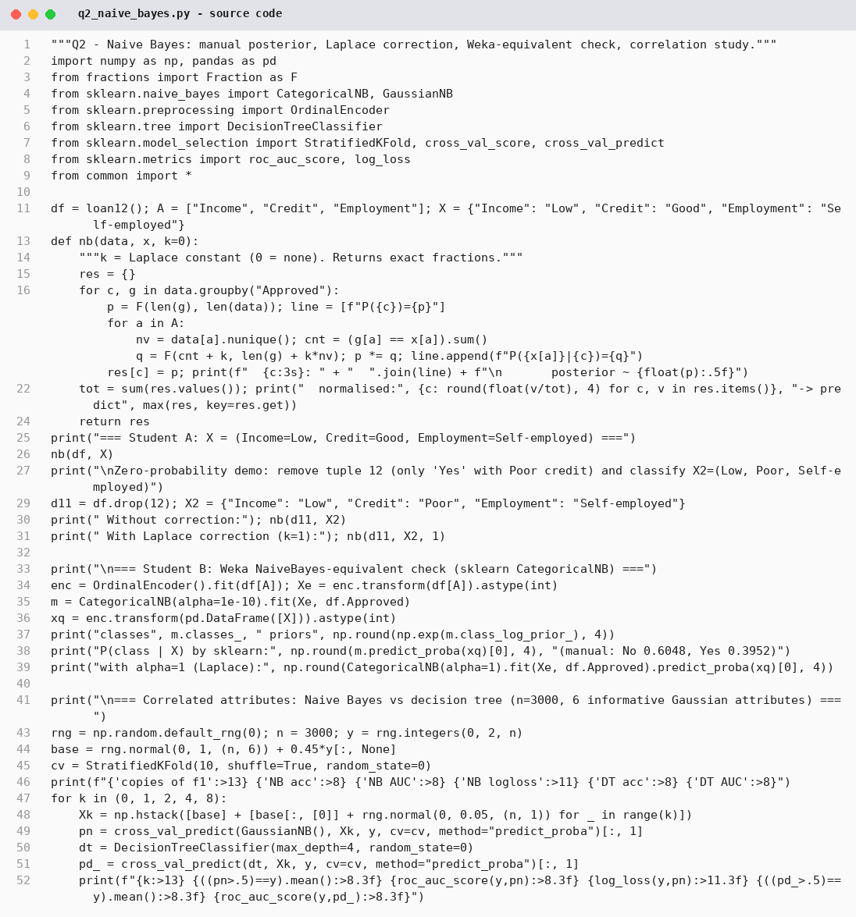
Figure 8: q2_naive_bayes.py – source code
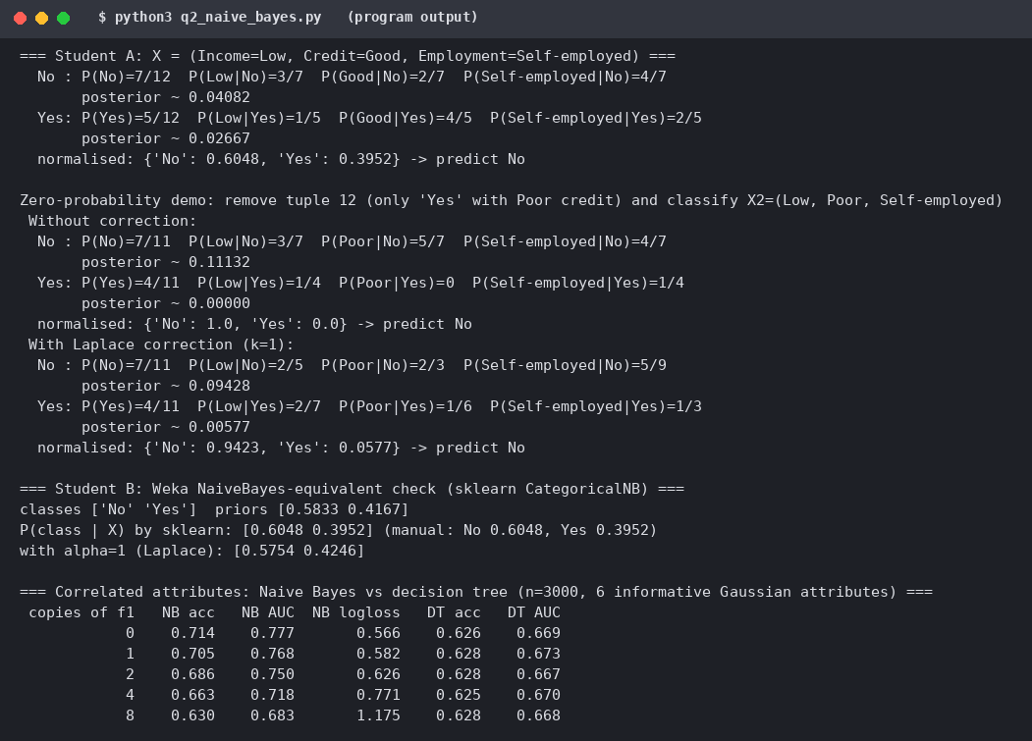
Figure 9: q2_naive_bayes.py – program output (exact fractions, Laplace, verification, correlation study)

Q3 – Rule-Based and Associative Classification (7 marks)

3.1 Shared work – tree to IF–THEN rules
Each root-to-leaf path of the Q1 tree becomes one rule; the leaf class is the consequent. The rules are mutually exclusive (one tuple matches exactly one rule) and exhaustive. A tree shows the order in which questions are asked and is compact for sequential decisions, but a rule deep in the tree is hard to read and sub-trees may be replicated. A rule set is a flat set of independent statements: each rule can be read, checked and edited by itself, rules can be added or removed without restructuring, and rules need not be exclusive or exhaustive, which brings the conflict problem.

3.2 Student A – rule quality
Table 9: Rules from the Q1 tree: coverage and accuracy on the 12 tuples
Rule | IF … THEN … | Coverage | Accuracy
R1 | Credit=Good AND Employment=Salaried → Yes | 3/12 = 25.0% | 3/3 = 100%
R2 | Credit=Good AND Employment=Self-employed AND Income=High → Yes | 1/12 = 8.3% | 1/1 = 100%
R3 | Credit=Good AND Employment=Self-employed AND Income=Low → No | 1/12 = 8.3% | 1/1 = 100%
R4 | Credit=Good AND Employment=Self-employed AND Income=Medium → No | 1/12 = 8.3% | 1/1 = 100%
R5 | Credit=Poor AND Income=High AND Employment=Salaried → No | 1/12 = 8.3% | 1/1 = 100%
R6 | Credit=Poor AND Income=High AND Employment=Self-employed → Yes | 1/12 = 8.3% | 1/1 = 100%
R7 | Credit=Poor AND Income=Low → No | 2/12 = 16.7% | 2/2 = 100%
R8 | Credit=Poor AND Income=Medium → No | 2/12 = 16.7% | 2/2 = 100%

Coverage = (tuples matching the antecedent) / 12; accuracy = (matching tuples with the rule’s class) / (matching tuples). The eight rules together cover all 12 tuples exactly once and are 100% accurate on this training data; five of them cover only one tuple, which is again a sign of memorisation.
Conflict resolution. When several rules fire for one tuple and predict different classes a strategy is needed. Size ordering gives priority to the rule with the most attribute tests (the “toughest” requirement). Rule ordering ranks rules by a quality measure (class-based or by confidence/accuracy) and the first matching rule wins; a default rule handles tuples matched by no rule. Example from the data: take tuple 6 = (Medium, Good, Self-employed). With all single and two-condition rules of confidence ≥ 60%, five rules fire: Income=Medium ∧ Self-employed → No (conf 1.00), Credit=Good ∧ Self-employed → No (0.67), Income=Medium → No (0.75), Employment=Self-employed → No (0.67) and Credit=Good → Yes (0.67). The “Yes” rule conflicts with the other four. Size ordering picks a two-condition rule; between the two such rules rule ordering picks the one with higher confidence (1.00) → No, which is the correct class of tuple 6. Tuple 11 behaves the same way.
Sequential covering (learning rules one at a time). For class Yes: (1) start with an empty rule and greedily add the condition with the highest FOIL gain until the rule covers only Yes tuples; (2) remove the tuples the rule covers; (3) repeat on the rest until no positives remain. On the 12 tuples: Rule 1 = Credit=Good ∧ Employment=Salaried → Yes covers tuples {1, 4, 8}, which are removed, leaving {2, 3, 5, 6, 7, 9, 10, 11, 12}; Rule 2 = Income=High ∧ Employment=Self-employed → Yes covers {3, 12}, which are removed, leaving {2, 5, 6, 7, 9, 10, 11}, all No, which are handled by the default rule “No”. Two rules plus a default classify all 12 tuples correctly, against eight rules for the tree – the rule learner found a more compact description because rules need not partition the space in a fixed attribute order.

3.3 Student B – associative classification
JRip/PART comparison on credit_synth. A pruned J48-like tree (min leaf 5) has 57 leaves, i.e. 57 rules, with test accuracy 0.793. My sequential-covering learner (a JRip-like algorithm, features discretised into low/mid/high thirds, rules limited to three conditions) learned 9 rules for the minority class plus a default rule, with test accuracy 0.753 and recall of the minority class 0.489. The rule set is much smaller and each rule can be read in isolation (for example IF f20 is high ∧ f6 is high ∧ f18 is high THEN class 1), but the compactness costs about four points of accuracy because every rule is restricted to three conditions and no RIPPER-style optimisation is performed. The tree rules are mutually exclusive with long conditions; the learned rules overlap and are ordered.
How class-association rules (CARs) differ. Rule learners such as the tree or sequential covering search for a small set of rules greedily. Associative classification first mines all rules of the form (itemset) → class that satisfy a minimum support and a minimum confidence (as in CBA/CMAR), then selects and ranks them. Support = fraction of all tuples that contain the antecedent and the class (how general or reliable the rule is); confidence = fraction of the tuples matching the antecedent that have the class (how accurate it is). Because every frequent combination is examined, CARs can find rules that greedy search misses, but there may be very many, and low-support classes are hard to find.
Table 10: Class-association rules for Approved = Yes (min support 25% = 3 tuples, min confidence 70%)
CAR | Support | Confidence
Income = High → Yes | 3/12 = 25.0% | 3/4 = 75.0%
Credit = Good ∧ Employment = Salaried → Yes | 3/12 = 25.0% | 3/3 = 100%

Only these two rules pass both thresholds. “Credit = Good → Yes” (support 33%, confidence 4/6 = 66.7%) just fails the 70% confidence threshold, so it is not a CAR, and no rule for Yes with three attributes reaches 25% support.

3.4 Joint design question: explaining a rejection to a customer
I recommend IF–THEN rules obtained from a pruned decision tree, with the confidence/support of the matching rule quoted as the supporting evidence. A rejection is then explained by one short statement the customer can read and contest (“Credit history is Poor and income is Low → rejected; 2 of 2 similar past applicants were rejected”). A tree is also explainable but the officer must trace a path and the sub-tree structure may hide that the same reason appears in several branches; a rule is self-contained. Associative rules give the best statistical backing (support/confidence) but many of them fire for the same customer, with possibly conflicting classes (see tuple 6), which makes “the” reason for a rejection ambiguous unless a conflict-resolution order is also explained. The rules with a documented ordering and a default are therefore the most defensible representation.

3.5 Evidence
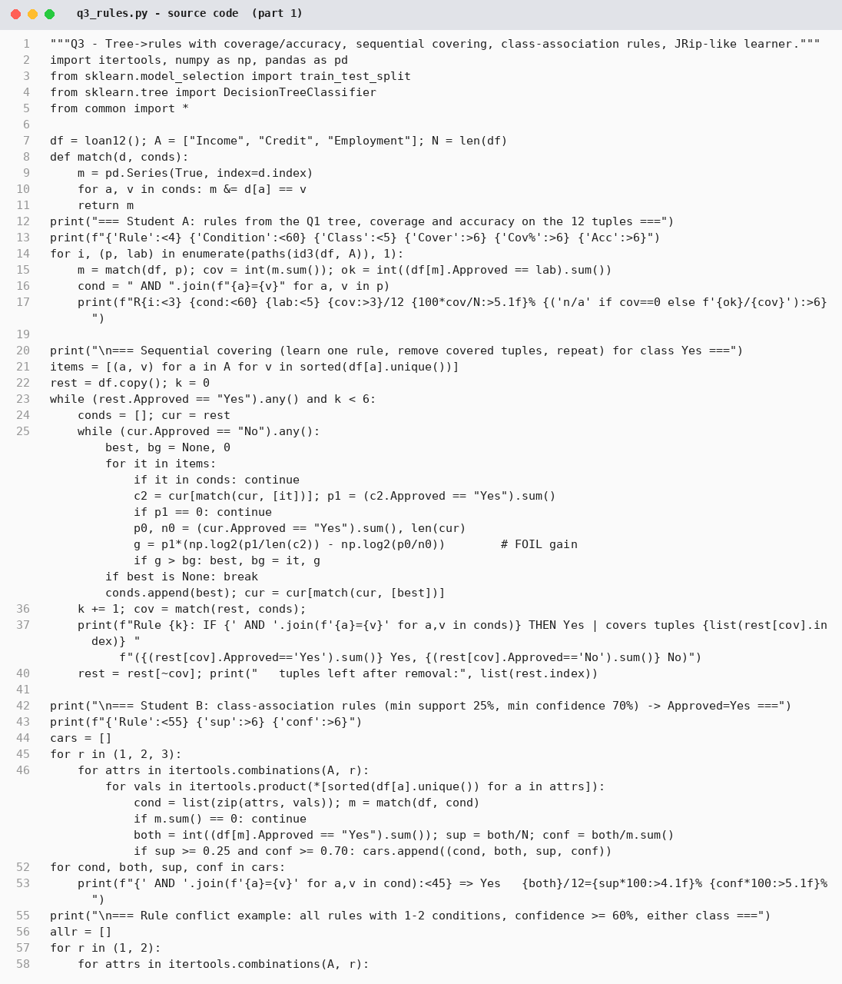
Figure 10: q3_rules.py – source code (part 1 of 2)
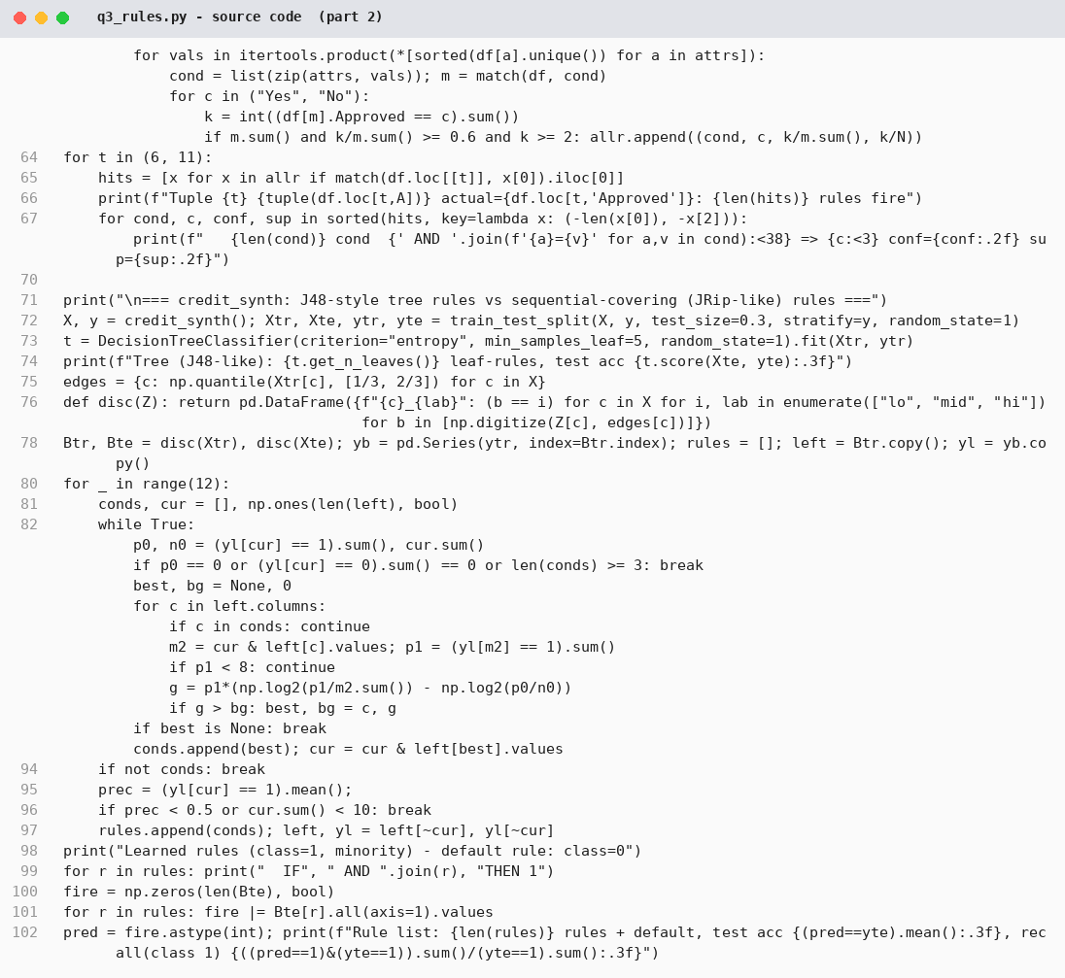
Figure 11: q3_rules.py – source code (part 2 of 2)
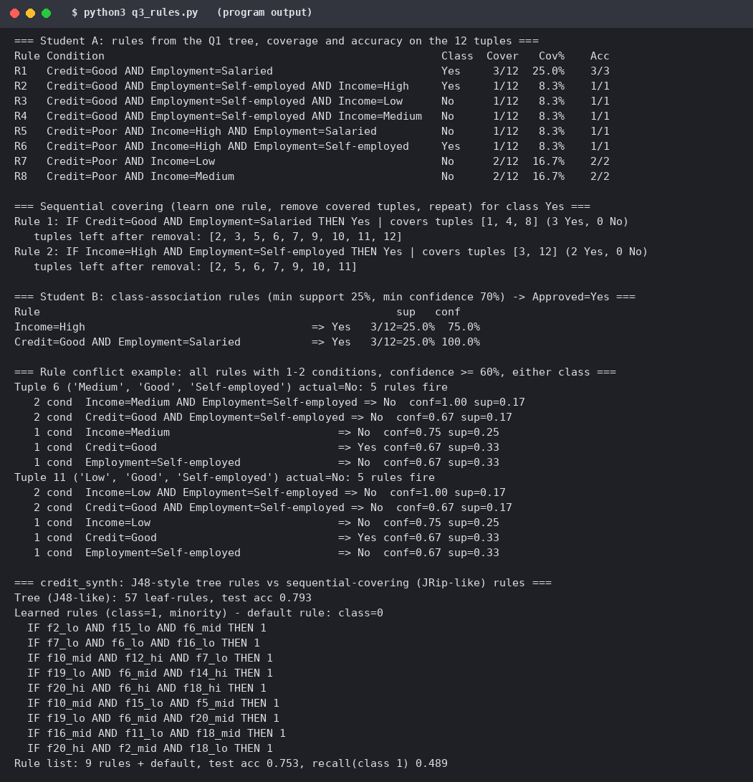
Figure 12: q3_rules.py – program output (rules, coverage/accuracy, sequential covering, CARs, conflicts)

Q4 – Backpropagation: What Does the Network Learn? (7 marks)

4.1 Shared work – the network
2 inputs, 2 hidden units, 1 output unit, sigmoid σ(z) = 1/(1+e^−z) everywhere. Inputs x1 = 1, x2 = 0; target t = 1; learning rate η = 0.9. Weights: w(x1→h1) = 0.2, w(x2→h1) = 0.4, w(x1→h2) = −0.3, w(x2→h2) = 0.1, w(h1→o) = −0.3, w(h2→o) = −0.2; biases θ(h1) = −0.4, θ(h2) = 0.2, θ(o) = 0.1.

4.2 Student A – one training step
Forward pass.
Table 11: Forward pass
Unit | Net input | Output
h1 | 0.2(1) + 0.4(0) − 0.4 = −0.2000 | σ(−0.2) = 0.4502
h2 | −0.3(1) + 0.1(0) + 0.2 = −0.1000 | σ(−0.1) = 0.4750
o | −0.3(0.4502) + −0.2(0.4750) + 0.1 = −0.1301 | σ(−0.1301) = 0.4675

Error E = ½(t − o)² = ½(1 − 0.4675)² = 0.14176.
Error terms. Output: δo = o(1 − o)(t − o) = 0.4675 × 0.5325 × 0.5325 = 0.13256. Hidden units (error propagated back through the weights to the output): δh1 = h1(1 − h1) · δo · w(h1→o) = 0.4502 × 0.5498 × 0.13256 × (−0.3) = −0.00984; δh2 = 0.4750 × 0.5250 × 0.13256 × (−0.2) = −0.00661.
Updates (Δw = η · δ · input, Δθ = η · δ):
Table 12: Weights and biases before and after one iteration
Parameter | Before | Update | After
w(h1→o) | −0.3000 | 0.9 × 0.13256 × 0.4502 = +0.0537 | −0.2463
w(h2→o) | −0.2000 | 0.9 × 0.13256 × 0.4750 = +0.0567 | −0.1433
θ(o) | 0.1000 | 0.9 × 0.13256 = +0.1193 | 0.2193
w(x1→h1) | 0.2000 | 0.9 × (−0.00984) × 1 = −0.0089 | 0.1911
w(x2→h1) | 0.4000 | 0.9 × (−0.00984) × 0 = 0 | 0.4000
θ(h1) | −0.4000 | 0.9 × (−0.00984) = −0.0089 | −0.4089
w(x1→h2) | −0.3000 | 0.9 × (−0.00661) × 1 = −0.0059 | −0.3060
w(x2→h2) | 0.1000 | 0 | 0.1000
θ(h2) | 0.2000 | 0.9 × (−0.00661) = −0.0059 | 0.1940

Recomputed output. h1 = 0.4458, h2 = 0.4721, o = 0.5105, E = 0.11982. The error decreased from 0.14176 to 0.11982 (−15.5%) and the output moved towards the target 1. Note that w(x2→·) did not change because x2 = 0: a weight is only updated in proportion to its input.
Why small random initial weights? (i) Symmetry breaking: if all weights are identical, both hidden units compute the same function and receive the identical error signal, so they stay identical forever and the network behaves as if it had one hidden unit. I verified this: starting from all weights 0.5 and biases 0, after 50 updates h1 = h2 = 0.692980 and w(h1→o) = w(h2→o) = 1.090914 – exactly equal. (ii) Avoiding saturation: large weights give large net inputs, the sigmoid saturates, σ′(z) = σ(1 − σ) ≈ 0 and learning stalls (vanishing gradient). (iii) Small values keep the units in the near-linear region where gradients are large; random values give each unit a different starting direction so the units specialise.

4.3 Student B – behaviour of the learner
Real data set: breast cancer (569 × 30), standardised, stratified 70/30 split, MLPClassifier with SGD and momentum 0.9 (the Weka MultilayerPerceptron uses momentum 0.2 and a default of 500 epochs; the learning rate, hidden units and epochs were varied as asked).
Table 13: Learning rate, hidden units and epochs vs training and test accuracy (breast cancer)
Learning rate | Hidden units | 10 epochs (train / test) | 100 epochs (train / test) | 500 epochs (train / test)
0.001 | 10 | 0.533 / 0.567 | 0.922 / 0.895 | 0.980 / 0.947
0.01 | 2 | 0.812 / 0.819 | 0.972 / 0.942 | 0.992 / 0.959
0.01 | 10 | 0.907 / 0.889 | 0.990 / 0.953 | 0.990 / 0.953
0.01 | 50 | 0.942 / 0.936 | 0.990 / 0.965 | 0.995 / 0.959
0.1 | 10 | 0.987 / 0.942 | 0.995 / 0.959 | 0.997 / 0.953
1.0 | 10 | 0.987 / 0.953 | 1.000 / 0.953 | 1.000 / 0.953

Interpretation. (a) Learning rate: with η = 0.001 ten epochs are far too few (0.533 train accuracy, close to the majority rate); the same network needs about 500 epochs to reach 0.947 on the test set, whereas η = 0.1–1.0 is accurate after ten epochs: a small rate means slow training. (b) Hidden units: 2 hidden units already reach 0.959 test accuracy after 500 epochs, 50 units 0.965 after 100 epochs; more units learn faster but add no accuracy on this nearly linearly separable data set. (c) Epochs: beyond about 100 epochs training accuracy approaches 1.0 but test accuracy stays flat or slips (0.965 → 0.959 for 50 units), the beginning of overfitting. At η = 1.0 the optimiser stops early (tolerance rule), so the 100- and 500-epoch rows are identical.
Overfitting and unstable training are shown clearly on the noisy credit_synth set (5% label noise), by recording train/test accuracy after every epoch (figure below). A large network (200 hidden units, η = 0.05) reaches its best test accuracy 0.863 at epoch 30 and then memorises the noise: at epoch 300 training accuracy is 1.000 but test accuracy is only 0.830. A small network with a suitable rate (10 hidden, η = 0.01) is still improving at epoch 300 (train 0.927, test 0.857): the slow case. With an excessive rate (η = 3.0) the weights overshoot: training accuracy stays near 0.82 and the test accuracy fluctuates (best 0.780, final 0.750) – unstable, non-monotone learning.
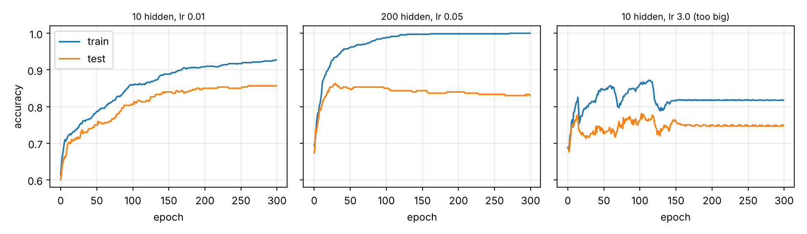
Figure 13: Training and test accuracy per epoch: slow (left), overfitting (centre), unstable (right).
Comparison with the Q1 decision tree. On credit_synth the MLP (50 hidden units, 500 iterations) needed 0.384 s to train against 0.0094 s for the tree – about 41× longer – and it has several sensitive parameters (rate, units, epochs, initial weights). The tree’s decision can be read as rules; the network’s knowledge is spread over many weights and cannot be turned into a statement a loan officer can give a customer. Strengths of neural classifiers: they learn non-linear, interacting patterns, tolerate noisy inputs and need no assumptions about the distribution, and give fast classification after training. Limitations: long training, parameter tuning, risk of local minima and overfitting, need for scaled inputs, and poor interpretability.

4.4 Individual verification – how the output error reaches a hidden weight
The error at the output, (t − o), is multiplied by the slope of the output unit, o(1 − o), giving δo. This δo is sent back along the connection w(h1→o) (δo × w), multiplied by the slope of the hidden unit, h1(1 − h1), giving δh1 = h1(1 − h1) δo w(h1→o). The weight w(x1→h1) is finally changed by η δh1 x1. It follows that a hidden weight changes only if (i) the output is wrong, (ii) the hidden unit is not saturated, (iii) the downstream weight is non-zero and (iv) the input on that connection is non-zero – the reason w(x2→h1) did not move.
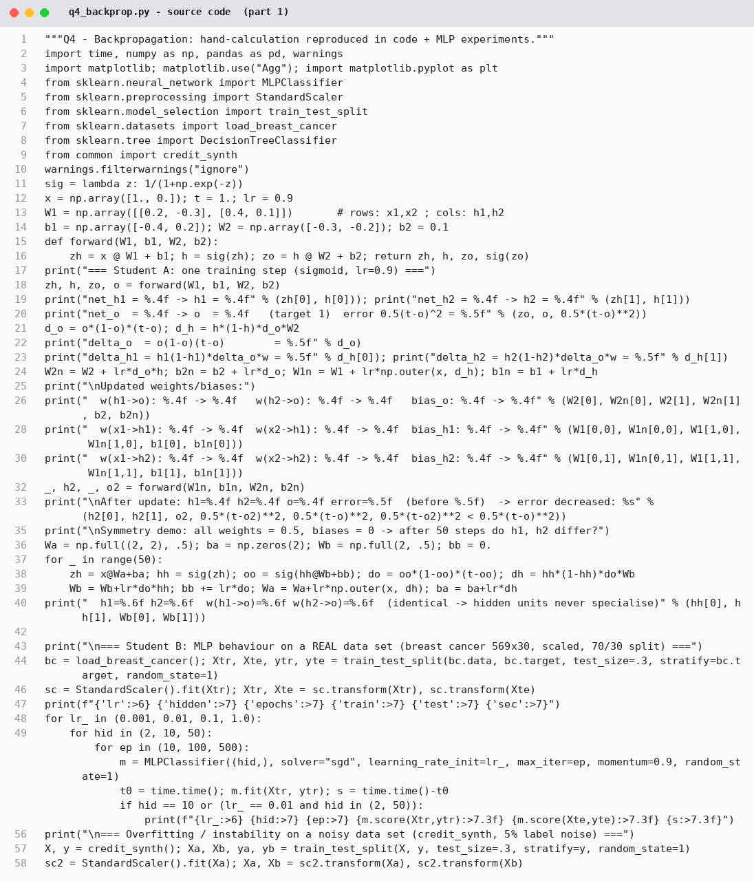
Figure 14: q4_backprop.py – source code (part 1 of 2)
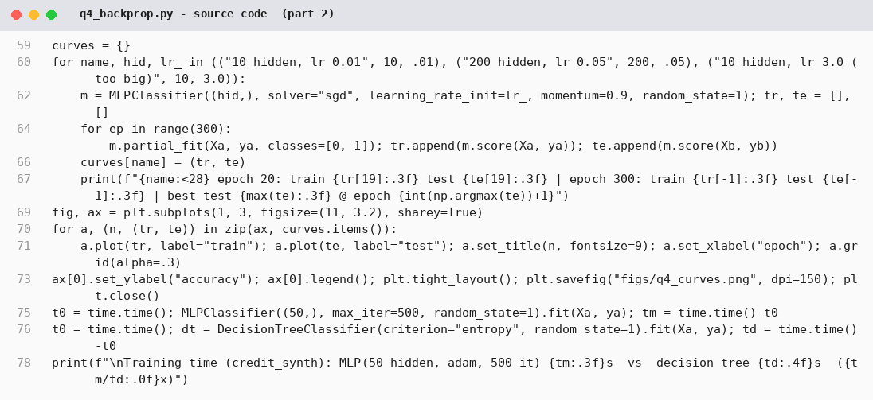
Figure 15: q4_backprop.py – source code (part 2 of 2)
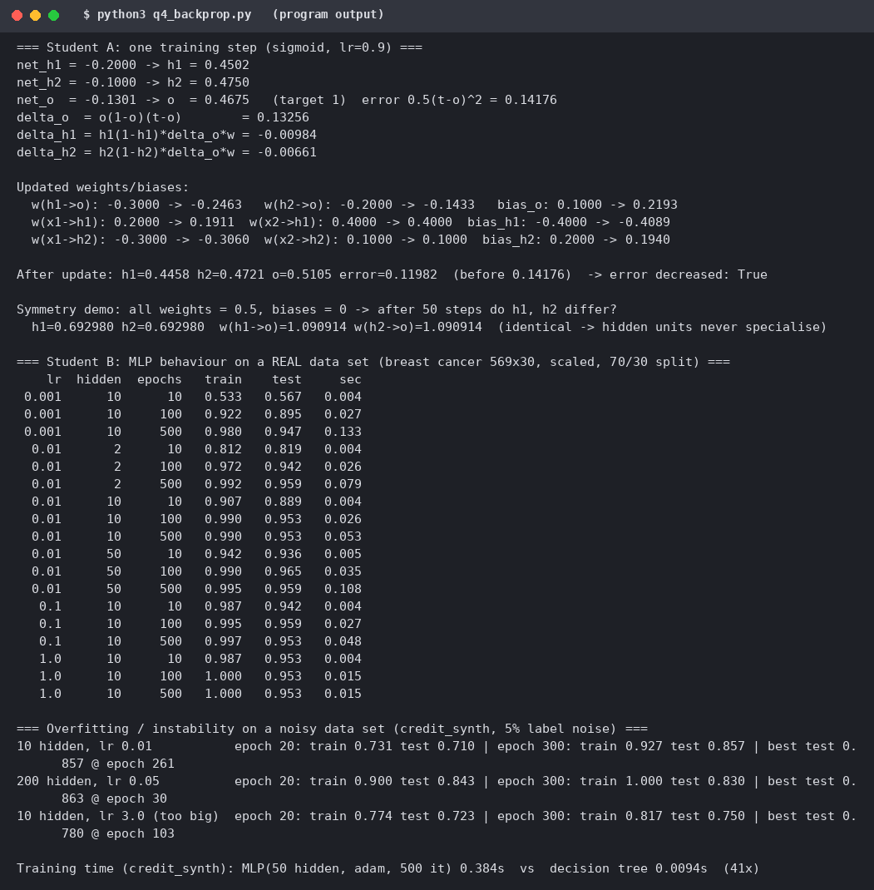
Figure 16: q4_backprop.py – program output

Q5 – Support Vector Machines: Margin, Kernels and Scaling (7 marks)

5.1 Shared work
Class +1: (3,3), (4,3), (4,4). Class −1: (1,1), (1,2), (2,1). The plot (below, with the hyperplane) shows the classes are linearly separable by many lines; the maximum-margin separator is the one for which the distance to the closest point of either class is largest. Only the points closest to it (the support vectors) determine it.

5.2 Student A – geometry
Support vectors by inspection: the closest +1 point to the −1 class is (3,3); the closest −1 points to it are (1,2) and (2,1), both at distance √5, and (3,3) projects onto the midpoint (1.5, 1.5) of the segment joining them. Support vectors: (3,3), (1,2), (2,1). The other points (4,3), (4,4), (1,1) are farther away.
Separating hyperplane: the line through the middle of the margin is x1 + x2 = 4.5, i.e. w = (2/3, 2/3), b = −3: w·x + b = (2/3)(x1 + x2) − 3. Check: f(3,3) = 4 − 3 = +1, f(1,2) = f(2,1) = 2 − 3 = −1 and f(1,1) = −5/3, f(4,4) = +7/3. The program (hard-margin linear SVM, C = 10⁶) returns the same support vectors and w = (0.666, 0.667), b = −3.000.
Margin width = 2/‖w‖ = 2 / (2√2/3) = 3/√2 = 2.121 (the program gives 2.1215); the distance from the hyperplane to each support vector is 1.061.
Removing points. Removing a non-support vector – (4,4) or (1,1) – changes nothing: w, b, the margin (2.122) and the support vectors are identical, because the solution depends only on the support vectors. Removing the support vector (3,3) changes the solution: the margin widens to 2.828 and the hyperplane becomes x1 + x2 = 5 with (4,3) and the points (2,1)/(1,2) as support vectors (the library reports (2,1) and (4,3); (1,2) lies on the same margin line).
Soft margin C and kernels. C controls the trade-off between a wide margin and training errors: a large C punishes every margin violation (narrow margin, low bias, possible overfitting, fewer support vectors), a small C tolerates violations (wider margin, smoother boundary, more support vectors) and is needed when classes overlap or contain noise. For data that are not linearly separable, a kernel K(x, z) = φ(x)·φ(z) implicitly maps the points into a higher-dimensional space where a linear separator exists, without computing φ; common kernels are polynomial (x·z + 1)^d and the RBF exp(−γ‖x − z‖²).
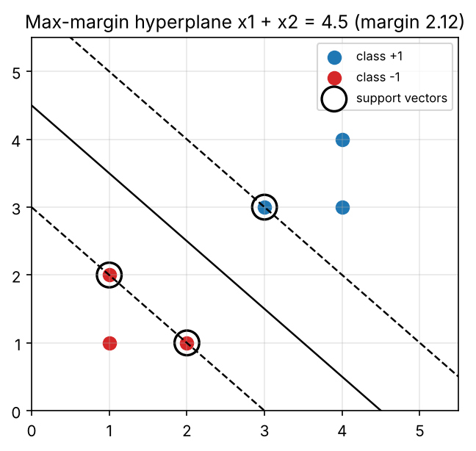
Figure 17: The six points, the maximum-margin hyperplane x1 + x2 = 4.5 (solid), the margin lines (dashed) and the support vectors (circled).

5.3 Student B – experiments
Non-linear data: two concentric circles (400 points, noise 0.12), 70/30 split.
Table 14: Kernels on the concentric-circles data (C = 1)
Kernel | Train acc. | Test acc. | # support vectors
Linear | 0.575 | 0.550 | 276
Polynomial (degree 3) | 0.664 | 0.633 | 260
RBF (γ = 1) | 1.000 | 1.000 | 58

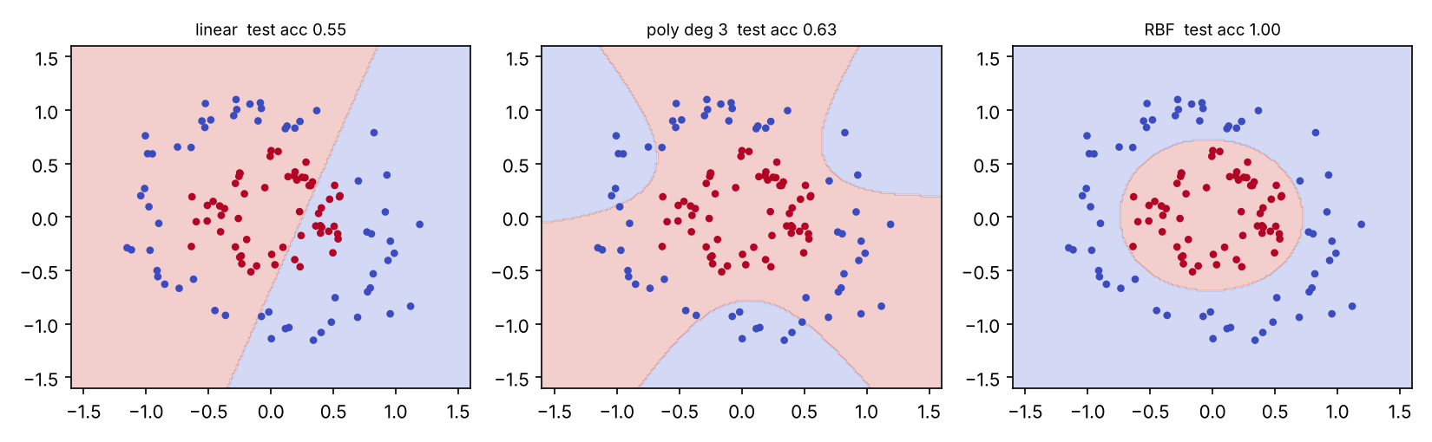
Figure 18: Decision regions of the linear, polynomial and RBF kernels (test points shown).
Table 15: Effect of C (RBF, γ = 1) and of γ (RBF, C = 1)
Parameter | Value | Train acc. | Test acc. | # SV
C | 0.01 | 1.000 | 1.000 | 280
C | 1 | 1.000 | 1.000 | 58
C | 100 | 1.000 | 1.000 | 10
C | 1000 | 1.000 | 0.992 | 10
γ | 0.01 | 0.664 | 0.633 | 280
γ | 0.1 | 0.975 | 0.958 | 262
γ | 10 | 0.996 | 1.000 | 62
γ | 1000 | 1.000 | 0.817 | 278

Interpretation. The circles are not separable by a line, so the linear kernel is close to chance (0.55) and the cubic polynomial is poor (0.63), while the RBF kernel separates them perfectly with only 58 support vectors. Increasing C from 0.01 to 100 shrinks the number of support vectors from 280 to 10 (a narrower margin and fewer margin violations); at C = 1000 test accuracy starts to drop (0.992), the first sign of overfitting. γ acts as the “width” of each point’s influence: γ = 0.01 is too smooth (under-fit, 0.633); γ = 1000 makes the boundary hug individual points (train 1.000, test 0.817, 278 support vectors) – a classic overfit. A large number of support vectors is therefore a warning sign of either an under-fit smooth model or an over-fit spiky one.
Table 16: Effect of not scaling the attributes (RBF kernel, C = 1)
Data set | Unscaled | Scaled (z-score)
Breast cancer (feature ranges 0.01 … 4000), 5-fold CV accuracy | 0.912 | 0.974
Circles with x2 multiplied by 1000 (test accuracy) | 0.817 (150 SV) | 1.000 (54 SV)

Interpretation. The kernel is based on Euclidean distance; an attribute with large numeric range dominates the distance and therefore the margin, so the other attributes are practically ignored. Scaling raised accuracy from 0.912 to 0.974 on the real data and from 0.817 to 1.000 on the circles with the distorted axis. Attributes must be scaled (and categorical ones encoded) before an SVM or any distance-based method.

5.4 Joint conclusion
An SVM is a good choice for moderate-sized, high-dimensional, numeric data with a clear margin (text, gene expression, image features) and for non-linear problems when an RBF/polynomial kernel is tuned. The experiments showed its practical limitations: it is sensitive to scaling, to C and γ (accuracy ranged from 0.63 to 1.00 on the same data by changing γ alone), training time grows roughly quadratically with the number of tuples, the model gives no probabilities or readable rules directly, and a large number of support vectors makes prediction slow.
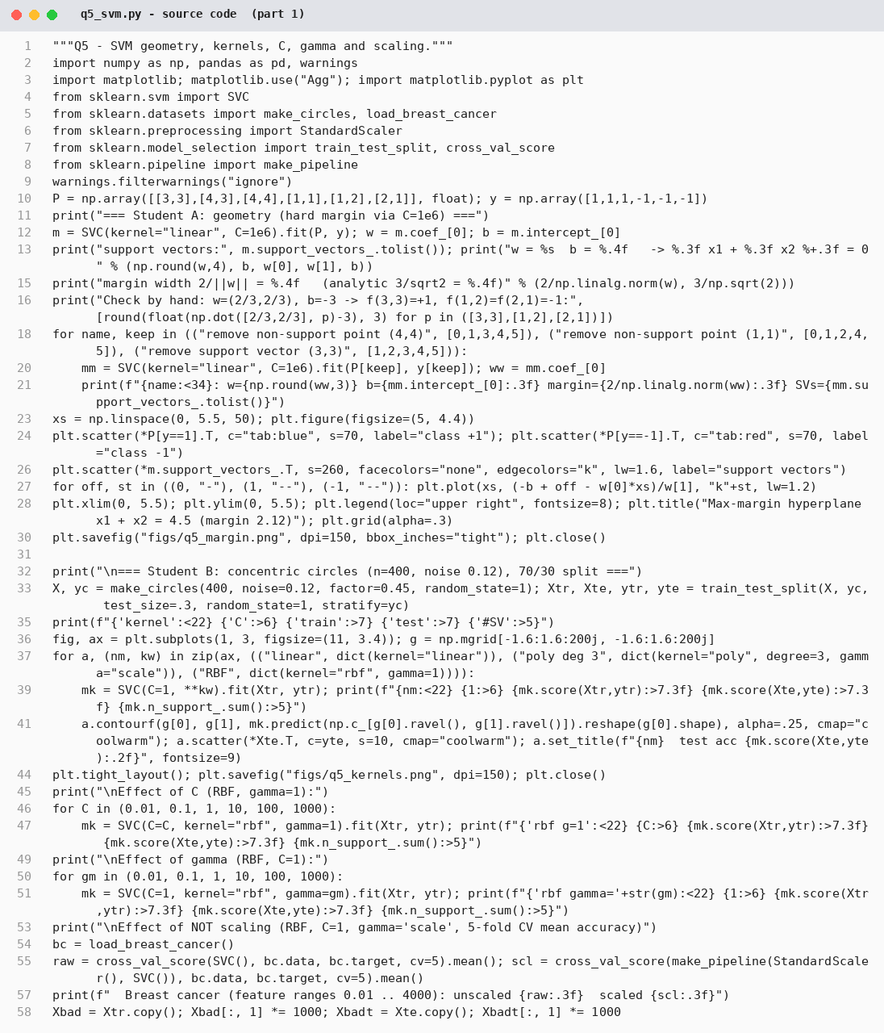
Figure 19: q5_svm.py – source code (part 1 of 2)
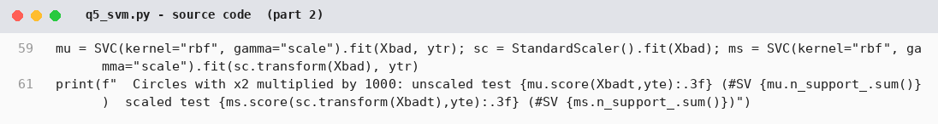
Figure 20: q5_svm.py – source code (part 2 of 2)
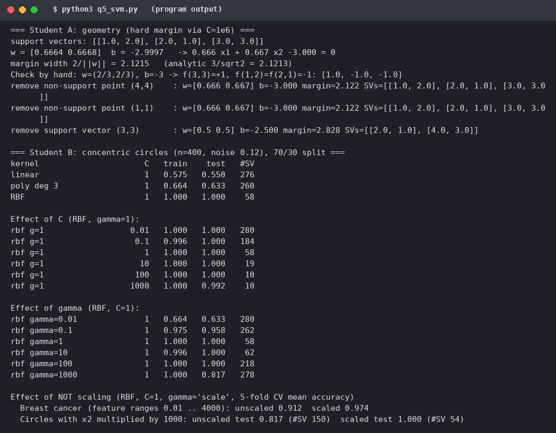
Figure 21: q5_svm.py – program output

Q6 – Evaluating Classifiers and Predictors (7 marks)

6.1 Shared work – which measure for fraud detection?
Confusion matrix of 1,000 transactions: TP = 40, FN = 20, FP = 30, TN = 910 (60 frauds, 940 legitimate). Fraud is rare and a missed fraud is more costly than a false alarm, so accuracy is not the meaningful measure; recall (sensitivity) of the fraud class, precision, F-measure and the ROC/PR behaviour are.

6.2 Student A – metrics and prediction error
Table 17: Metrics from the confusion matrix
Measure | Formula | Value
Accuracy | (TP+TN)/N = 950/1000 | 0.9500
Error rate | 1 − accuracy = 50/1000 | 0.0500
Sensitivity (recall) | TP/(TP+FN) = 40/60 | 0.6667
Specificity | TN/(TN+FP) = 910/940 | 0.9681
Precision | TP/(TP+FP) = 40/70 | 0.5714
F-measure (F1) | 2PR/(P+R) = 2(0.5714)(0.6667)/(1.2381) | 0.6154

Class imbalance. A classifier that predicts “not fraud” for every transaction is right on all 940 legitimate transactions: accuracy 940/1000 = 94.0%, only one point below the real classifier’s 95.0%, yet its recall is 0 – it never finds a fraud. Accuracy is dominated by the majority class, so on imbalanced data it can look excellent for a useless model; the real classifier’s extra 1 point of accuracy hides a gain from 0% to 66.7% recall.
Prediction error. Actual {12, 15, 20, 25}, predicted {10, 18, 19, 30}: errors (pred − actual) = −2, +3, −1, +5. MAE = (2+3+1+5)/4 = 2.75; MSE = (4+9+1+25)/4 = 9.75; RMSE = √9.75 = 3.1225. RMSE ≥ MAE always; the gap grows with the variability of the errors. RMSE is preferred when large errors are disproportionately harmful (squaring penalises them) and when a loss function based on variance is wanted; MAE is preferable when all errors matter in proportion and outliers should not dominate. Demonstration: if the last prediction were 50 instead of 30, MAE becomes 7.75 but RMSE 12.64.
ROC curve. The classifier gives a score (probability) to every test tuple. The tuples are sorted by decreasing score; the threshold is lowered step by step, and at each threshold the true-positive rate TP/P (y-axis) is plotted against the false-positive rate FP/N = 1 − specificity (x-axis). The curve runs from (0,0) (nothing flagged) to (1,1) (everything flagged). The diagonal is a random classifier; the closer the curve is to the top-left corner the better; the area under the curve (AUC) equals the probability that a randomly chosen positive is scored above a randomly chosen negative (0.5 = chance, 1 = perfect). The fraud classifier above is one point of the ROC space: (FPR, TPR) = (0.032, 0.667).

6.3 Student B – estimation methods on an imbalanced data set
Data: credit_synth (1000 tuples, 30% positive; the majority-class rate is 0.688). Classifiers: J48-like tree (entropy, min leaf 2), Naïve Bayes, SMO-like linear SVM (standardised).
Table 18: Accuracy estimates by method
Method | J48-like | Naïve Bayes | SMO (linear)
Holdout (2/3 train, 1/3 test, one split) | 0.737 | 0.710 | 0.713
10-fold cross-validation | 0.723 | 0.733 | 0.697
Bootstrap .632 (B = 100) | 0.788 | 0.732 | 0.707
Resubstitution (training data) | 0.976 | 0.750 | 0.707

Table 19: Repeated holdout – eight random 2/3 – 1/3 splits
Classifier | Accuracies of the eight splits | Mean | SD | Range
J48-like | 0.740 0.707 0.760 0.722 0.722 0.701 0.692 0.754 | 0.725 | 0.025 | 0.692–0.760
Naïve Bayes | 0.719 0.710 0.749 0.731 0.695 0.701 0.743 0.766 | 0.726 | 0.025 | 0.695–0.766
SMO | 0.689 0.710 0.692 0.710 0.686 0.704 0.710 0.689 | 0.698 | 0.011 | 0.686–0.710

Interpretation. A single holdout split can be off by ±3 points: the J48-like tree ranges from 0.692 to 0.760 over eight splits (sd 0.025), and which classifier “wins” on one split depends on the split (NB beats J48 on some splits and loses on others). The resubstitution accuracy (0.976 for the tree) is useless as an estimate of future performance. The .632 bootstrap estimate for the tree (0.788) is optimistic because it gives 36.8% weight to the 0.976 training accuracy of an over-fitting learner; for classifiers that fit the training data perfectly the .632 estimator is known to be biased upward. I trust stratified 10-fold cross-validation (repeated): every tuple is tested once, the estimate has lower variance than a single holdout, it keeps the class proportions in each fold and uses 90% of the data for training; with repetitions the variation can be measured.
Paired comparison (10 × 10-fold CV with the same folds for all classifiers, corrected resampled t-test as in the Weka Experimenter):
Table 20: Paired comparison, 100 test folds, α = 0.05
Classifier | Mean accuracy | Comparison | Mean difference | t | p | Meaningful?
J48-like | 0.7480 | NB vs J48 | −0.0138 | −0.70 | 0.487 | No
Naïve Bayes | 0.7342 | SMO vs J48 | −0.0487 | −3.07 | 0.003 | Yes (SMO worse)
SMO (linear) | 0.6993 | SMO vs NB | −0.0349 | −2.13 | 0.036 | Yes (SMO worse)

J48-like and Naïve Bayes are not significantly different (p = 0.49), so the 1.4-point gap is noise. The linear SMO is significantly worse than both. A look at its predictions explains why: with a 0.5 threshold its accuracy (0.708) is barely above the majority-class rate (0.688) and its recall of the positive class is only 0.141 – it mostly predicts the majority class. The ROC/AUC values (NB 0.737, J48-like 0.693, SMO 0.645) confirm the same order, and show how accuracy alone (0.727, 0.733, 0.708) hides a large difference in recall (0.590, 0.487, 0.141).
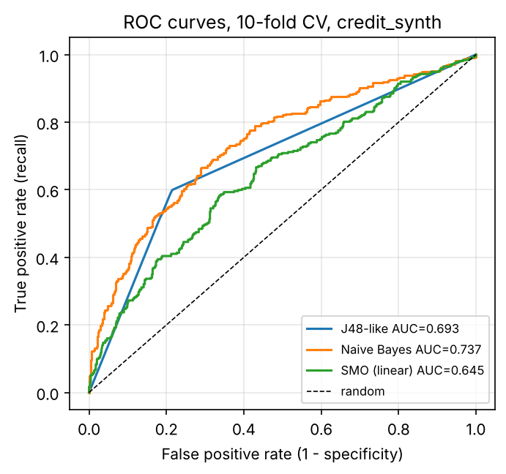
Figure 22: ROC curves of the three classifiers (10-fold CV predictions, credit_synth).

6.4 Individual verification
Accuracy alone is misleading because it weights every tuple equally, so the majority class decides it: 94% for “never fraud” versus 95% for a classifier that finds two-thirds of the frauds, and 0.708 for an SVM that finds 14% of the positives against the majority baseline of 0.688. The estimation method I would trust is repeated stratified 10-fold cross-validation, reported with its standard deviation and judged together with recall/precision and AUC.
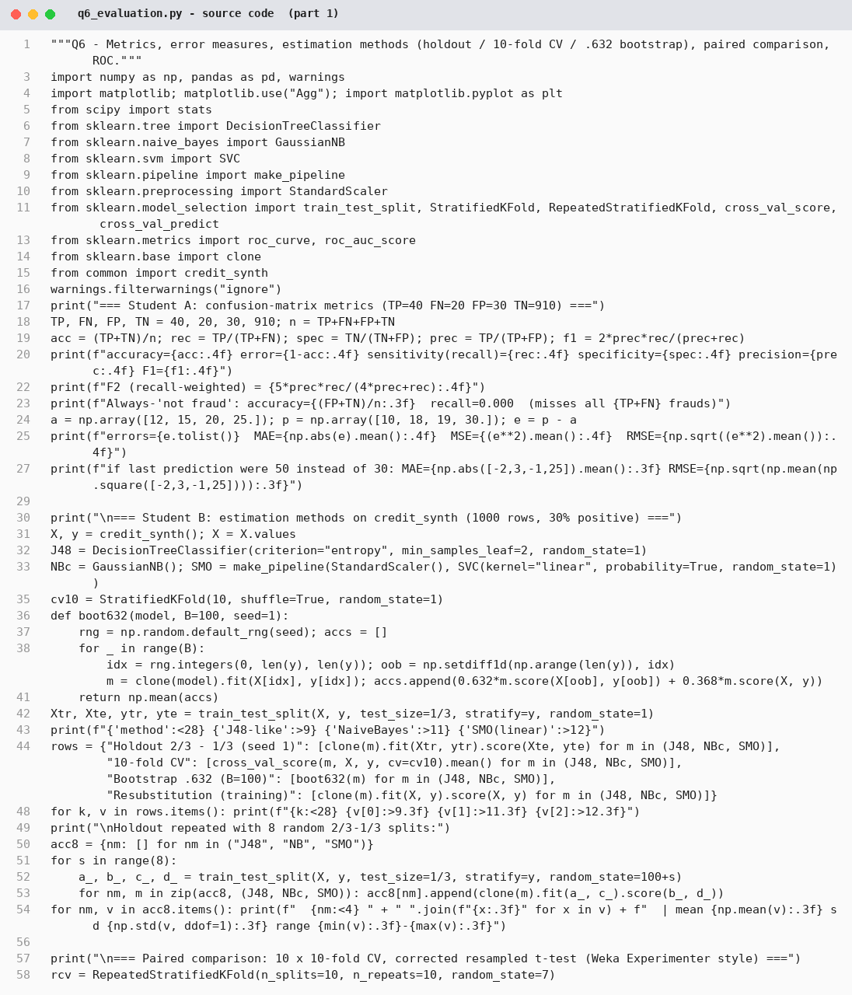
Figure 23: q6_evaluation.py – source code (part 1 of 2)
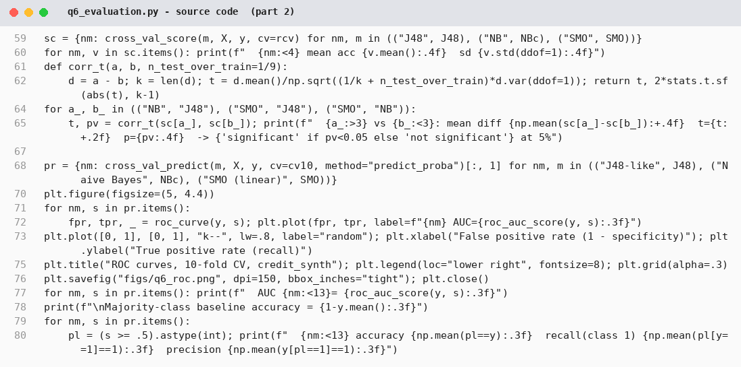
Figure 24: q6_evaluation.py – source code (part 2 of 2)
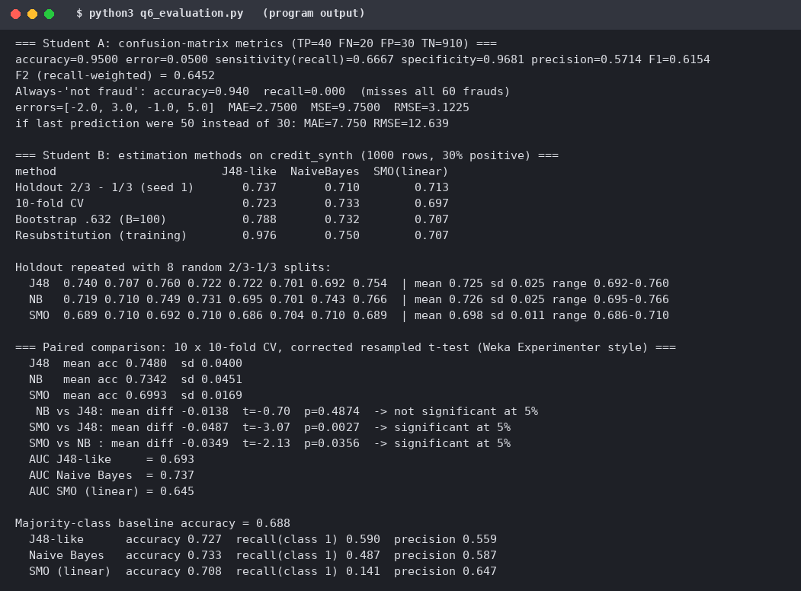
Figure 25: q6_evaluation.py – program output

Q7 – Day-4 Design Challenge: Design a Classification Solution from First Principles (10 marks)
Problem. Identify patients likely to be readmitted within 30 days. Only 6% are readmitted; a false negative costs ten times a false positive; doctors must understand each alert; data: age, diagnosis group, length of stay, prior admissions, lab results, discharge medications, some values missing. Because this is an individual submission, the two independent proposals of Stage 1 are my two separately developed first designs (written one after the other, before comparing them), and I answer the A and B validation roles in Stage 4.

Stage 1 – independent design proposals (retained as first written)
Table 21: The two initial proposals
Aspect | Proposal 1 (Student A view) | Proposal 2 (Student B view)
Technique | Decision tree (J48) because doctors can read it. | Logistic regression because it outputs a risk probability and a coefficient per factor.
Preprocessing, imbalance, missing values | SMOTE oversampling of readmitted patients to 50:50; replace missing values by the mean. | Class weights 10:1 in the learning algorithm; median imputation plus a “was missing” indicator; one-hot diagnosis group; standardise numbers.
Evaluation measure and method | Accuracy with 10-fold cross-validation. | Recall, precision, AUC and total cost with stratified 10-fold CV.
Explaining to doctors | Show the path of the tree. | Show the risk probability and the three factors that contribute most for this patient.

Stage 2 – comparison of the designs
Table 22: Design-comparison record
Topic | Agree / differ | Strength and weakness | Decision
Technique | Differ | Tree: easy to read but unstable and prone to overfitting, probabilities coarse (few distinct leaf values). Logistic regression: smooth risk score, linear only. | Keep logistic regression; keep a shallow tree only as a check.
Imbalance | Differ | SMOTE makes synthetic patients and distorts probabilities; class weights/cost-sensitive learning uses the 10:1 cost directly. | Use cost-sensitive learning; compare with oversampling.
Missing values | Differ | Mean imputation hides that a lab test was not done (which can be informative). | Median imputation + missing indicator (from Proposal 2).
Evaluation | Differ | Accuracy rewards “flag nobody” (93.6%). Proposal 2 had no explicit cost. | Total cost (10·FN + FP), recall, precision, AUC.
Explanation | Agree on need | Tree path is intuitive; coefficients and per-patient contributions are equally readable and give a risk level. | Per-patient top-3 factors + odds ratios.
Missing from both | – | Decision threshold from the cost ratio; calibration; failure conditions; leakage (e.g. no post-discharge data). | Added in the final design.

Stage 3 – joint final design
- Technique: logistic regression with class weights {readmitted: 10, not: 1}, i.e. cost-sensitive learning that implements the 10:1 cost ratio. A depth-3 weighted tree is kept as a baseline/second opinion.
- Preprocessing: median imputation with a missing-value indicator for every incomplete attribute (labs, medications), one-hot encoding of diagnosis group, standardisation of numeric attributes; no post-discharge variables to avoid leakage.
- Imbalance: class weights (alternatively oversampling inside each training fold – never before splitting).
- Evaluation: stratified 10-fold cross-validation; recall and precision of the readmitted class, ROC-AUC, and total cost = 10 × FN + 1 × FP.
- Cost-sensitive decision rule: flag the patient if the expected cost of not flagging exceeds that of flagging: p · 10 > (1 − p) · 1, i.e. p ≥ 1/11 ≈ 0.091 on calibrated probabilities. A model trained with 10:1 weights has this shift built in, so its natural threshold is 0.5.
- Explanation to doctors: each alert shows the risk level, the three attributes that push the risk up most for this patient (coefficient × value) and the odds ratio of each factor.

Stage 4 – Student A: analytical validation
Expected cost of two thresholds (illustrative confusion matrices for 1,000 patients: 60 readmitted, 940 not):
Table 23: Expected cost of two decision thresholds (cost = 10 × FN + 1 × FP)
Threshold | TP | FN | FP | TN | Accuracy | Recall | Precision | Cost
0.50 | 18 | 42 | 8 | 932 | 0.950 | 0.30 | 0.69 | 10×42 + 8 = 428
0.09 | 45 | 15 | 230 | 710 | 0.755 | 0.75 | 0.16 | 10×15 + 230 = 380
Flag nobody | 0 | 60 | 0 | 940 | 0.940 | 0 | – | 10×60 = 600
Flag everybody | 60 | 0 | 940 | 0 | 0.060 | 1.00 | 0.06 | 940

The threshold of 0.50 has the highest accuracy (95.0%) but is the more costly (428) because it misses 42 of the 60 patients; the cost-based threshold has much lower accuracy (75.5%) and a precision of 16% but cuts the cost to 380 and finds 75% of the patients at risk. Accuracy is inappropriate as a selection measure because it counts a missed patient and a needless alert equally, is dominated by the 94% who are not readmitted (flag-nobody scores 94.0%, higher than the cost-optimal model) and ignores the 10:1 cost ratio.
Strengths and limitations of the chosen technique. Strengths: gives a probability that can be thresholded with the cost rule; stable with small positive classes (60 patients per 1,000); coefficients are interpretable (odds ratios); handles missingness with indicators; fast and easy to audit. Limitations: linear and additive – interactions (e.g. diagnosis × prior admissions) and non-monotone effects are missed; sensitive to outliers and to collinear labs; the probabilities need checking for calibration; with 10:1 weights they are shifted and are no longer true probabilities.

Stage 4 – Student B: experimental validation
A public readmission data set could not be downloaded, so the final design and baselines were implemented on a synthetic readmission-like data set with the stated structure: 8,000 patients, readmission rate 6.4%, age, diagnosis group (5 levels), length of stay, prior admissions, two labs and number of discharge medications; about 12% of the values of the two labs and the medication count are missing. All results are 10-fold stratified cross-validation predictions.
Table 24: Experimental validation (10-fold CV, cost = 10 × FN + FP, 8,000 patients, 514 readmitted)
Model | Threshold | Recall | Precision | AUC | Total cost
Baseline: decision tree, depth 6, no cost handling | 0.50 | 0.027 | 0.200 | 0.653 | 5,056
Baseline tree | 0.09 | 0.335 | 0.133 | 0.653 | 4,539
Logistic regression, no imbalance handling | 0.50 | 0.006 | 0.375 | 0.735 | 5,115
Logistic regression, no imbalance handling | 0.09 | 0.510 | 0.160 | 0.735 | 3,891
FINAL: logistic regression, class weight 10:1 | 0.50 | 0.512 | 0.159 | 0.733 | 3,901
Cost-sensitive tree, depth 3, weight 10:1 | 0.50 | 0.350 | 0.129 | 0.631 | 4,555
Flag nobody (accuracy 0.936) | – | 0 | – | 0.500 | 5,140

Table 25: Effect of the imbalance-handling method (logistic regression)
Method | Threshold | Recall | Precision | Total cost
None | 0.50 | 0.006 | 0.375 | 5,115
None, cost threshold 1/11 | 0.091 | 0.510 | 0.160 | 3,891
Class weight 10:1 (cost-sensitive learning) | 0.50 | 0.512 | 0.159 | 3,901
Random oversampling × 10 (inside each training fold) | 0.50 | 0.506 | 0.157 | 3,931

Findings. (1) Without cost handling the models are no better than flagging nobody (cost 5,056–5,115 vs 5,140); the 0.5 threshold gives recall of 0.6% for logistic regression. (2) The final design reduces the total cost from 5,140 to 3,901 (−24%) and finds 51% of the patients who are readmitted, at the price of a precision of 16%, so about 5 of 6 alerts are false alarms – acceptable at a 10:1 cost ratio. (3) Class weights, oversampling and threshold shifting all produce about the same cost (3,891–3,931); they are equivalent ways of encoding the cost ratio, and the cost-minimising threshold found empirically (0.10) is close to the theoretical 1/11 = 0.091. (4) The depth-6 baseline tree has a weaker AUC (0.653 vs 0.733) and the shallow weighted tree is weaker still (0.631): the linear model ranks the patients better on this data, and the tree’s coarse probabilities cannot be tuned finely with a threshold.
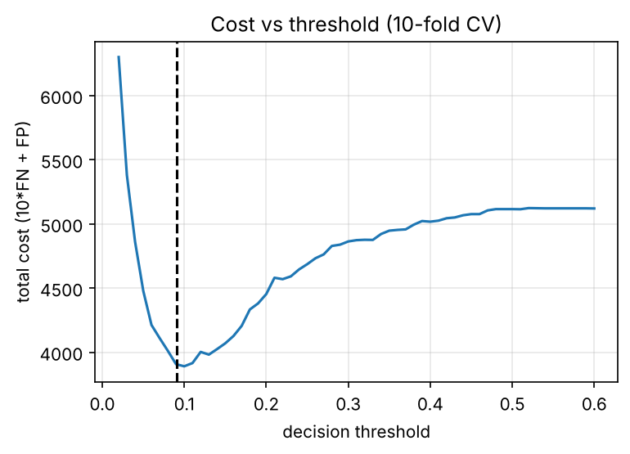
Figure 26: Total cost against decision threshold for logistic regression; the dashed line is the theoretical threshold 1/11.
Doctor-facing explanation. The standardised coefficients of the final model give these odds ratios (per one standard deviation of a numeric attribute, or for the diagnosis-group indicator): prior admissions ×1.65, age ×1.50, creatinine ×1.40, length of stay ×1.38, sodium ×0.70 (lower sodium raises the risk); diagnosis group cardiac ×1.40, diabetes ×0.63, orthopaedic ×0.70, other ×0.64. An alert would be displayed in the form (illustrative): “High risk – above the alert level of 9%. Main factors: many prior admissions, high creatinine, advanced age.”

Stage 5 – cross-defence
Student A – what experimental evidence supports the design? In 10-fold CV the final design cuts the total cost from 5,140 (flag nobody) to 3,901, finds 51.2% of the readmissions, has the best AUC among the interpretable options (0.733 vs 0.653 for the baseline tree) and is matched by two other imbalance methods (3,891 / 3,931), showing that the result is due to the cost-sensitive principle, not a lucky setting. The cost-optimal threshold from the data (0.10) agrees with the theory (0.091).
Student B – how were the cost ratio and threshold derived from the confusion matrix? The cost matrix gives C(FN) = 10 and C(FP) = 1 (TP and TN cost 0). For a patient with readmission probability p, the expected cost of not flagging is p × 10 and the expected cost of flagging is (1 − p) × 1. Flag when 10p ≥ 1 − p, i.e. p ≥ 1/11 = 0.091. Table cost values come from the confusion matrix: cost = 10·FN + 1·FP, e.g. at threshold 0.50 the matrix has FN = 42, FP = 8 → 428; at 0.09, FN = 15, FP = 230 → 380. Training with weights 10:1 moves the model’s natural cut-off to 0.5 on the weighted scale, which is why the final model uses 0.5.

Stage 6 – joint evaluation
Why the problem is hard for accuracy-driven classifiers. With 6% positives the default classifier maximises accuracy by predicting “not readmitted” (94% accurate, zero recall); the loss is asymmetric (10:1) while accuracy is symmetric; the positives are few (60 per 1,000) so trees overfit them; and missing values are informative. What I sacrificed for interpretable alerts: a possibly higher discrimination from a non-linear ensemble (not tested here), exact probabilities (weighting shifts them), and precision – 84% of the alerts are false. Conditions under which the design fails: (a) the readmission rate drops, e.g. from 6% to 0.5%: with the same sensitivity and false-positive rate, precision would fall from about 16% to about 1.4% (roughly 70 false alerts per true one), so the threshold would have to be re-derived and the probabilities re-calibrated; (b) the cost ratio changes, which moves the threshold 1/(1+ratio); (c) the hospital population or coding changes (concept drift); (d) data are missing not at random in a way the indicator cannot capture; (e) the effects are strongly non-linear or interact; (f) leakage of post-discharge information; (g) alert fatigue if staff ignore alerts when 5 of 6 are false.
What a data miner should examine before choosing a classifier. Data: size, number and type of attributes (numeric, categorical), class distribution and imbalance, missing values and their mechanism, noise, correlated or redundant attributes, identifiers and possible leakage, scale of the attributes, drift over time. Business requirement: costs of the different errors, whether a score/ranking or a yes/no decision is required, the need for explanation and auditability (law, trust), speed of training and of prediction, how often the model is updated, and the performance measure that reflects the objective (cost, recall at a given precision, AUC), together with an estimation method that can be trusted for that data size.
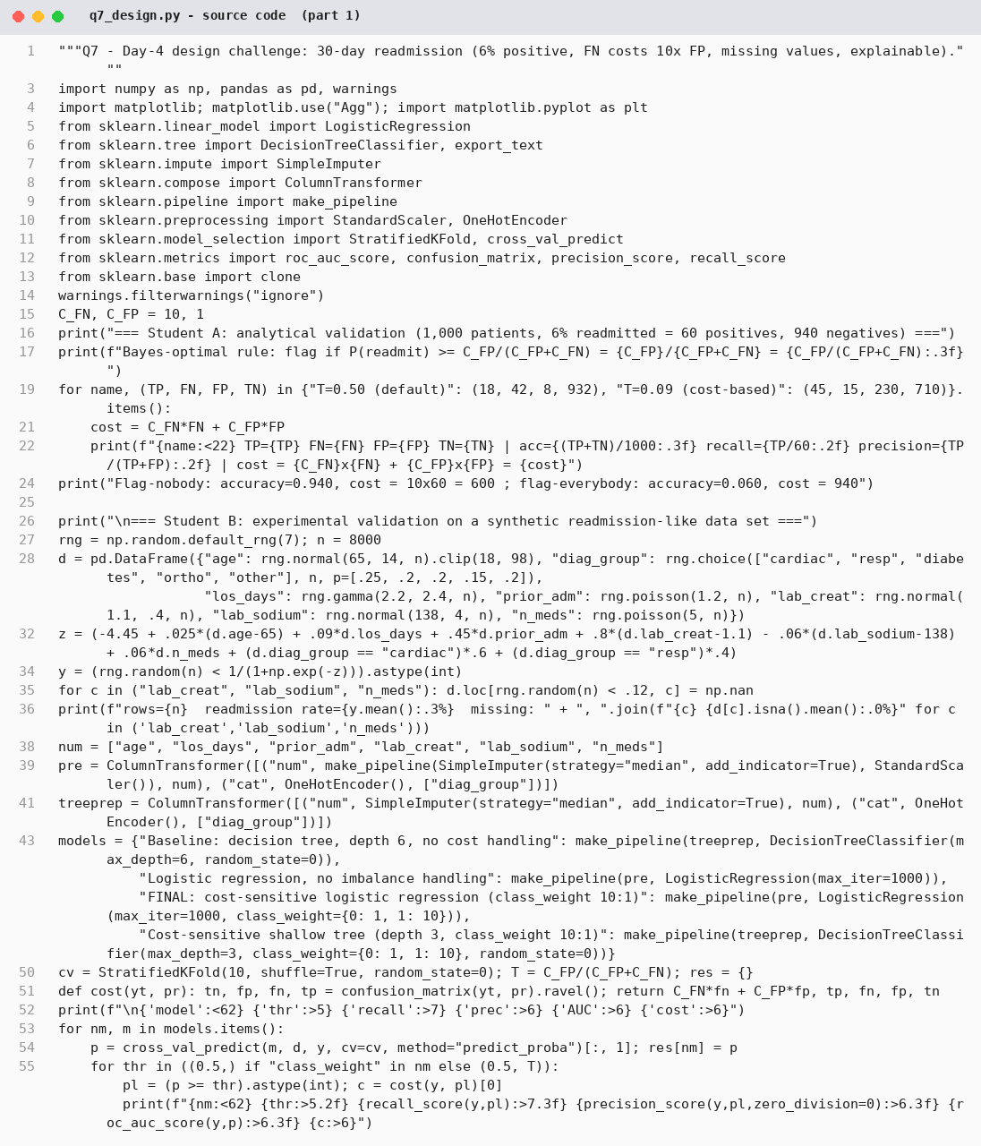
Figure 27: q7_design.py – source code (part 1 of 2)
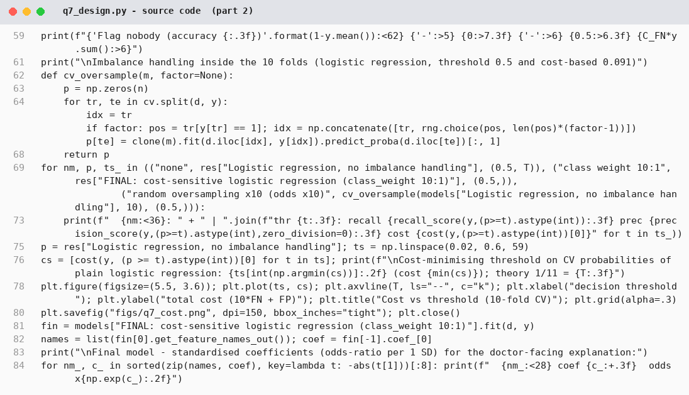
Figure 28: q7_design.py – source code (part 2 of 2)
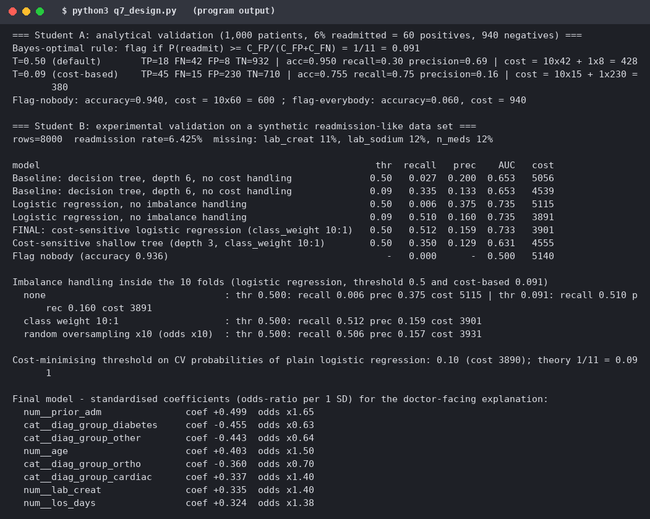
Figure 29: q7_design.py – program output

MARK DISTRIBUTION
Question | Assessed Area | Marks
Q1 | Decision Tree Induction | 6
Q2 | Bayesian Classification | 6
Q3 | Rule-Based and Associative Classification | 7
Q4 | Backpropagation | 7
Q5 | Support Vector Machines | 7
Q6 | Evaluating Classifiers and Predictors | 7
Q7 | Day-4 Design Challenge – Classification Solution | 10
TOTAL |  | 50

CONTRIBUTION RECORD
This is an individual submission; the student completed both the Student A and the Student B responsibilities of every question and all joint parts. Primary contribution does not imply exclusive responsibility.
Question | Student A – Primary Contribution | Student B – Primary Contribution | Joint Work
Q1 | Manual entropy/gain, gain ratio/Gini, tree, customer-ID case | J48-equivalent runs, tree comparison, pruning study, overfitting | Class, criterion, stopping rules, data loading
Q2 | Priors, conditionals, posterior, zero probability and Laplace | Verification in software, correlated-attribute experiment, ranking explanation | NB vs tree recommendation
Q3 | Rule coverage/accuracy, conflict resolution, sequential covering | JRip-like vs tree rules, CAR mining, support/confidence | Tree-to-rule conversion, recommendation for loan officer
Q4 | One back-propagation step, symmetry/initialisation | MLP experiments, overfitting/instability, comparison with tree | Network set-up, error-propagation explanation
Q5 | Support vectors, hyperplane, margin, removal effects, C and kernels | Kernel/C/γ experiments, scaling study | Plot, conclusion on SVM use
Q6 | Metrics, class imbalance, MAE/MSE/RMSE, ROC explanation | Holdout/CV/bootstrap, repeated holdout, paired test, ROC | Choice of measure
Q7 | Cost calculation, accuracy argument, technique limits; Proposal 1 | Implementation, baselines, imbalance study; Proposal 2 | Comparison, final design, cross-defence, joint evaluation

Individual verification – transfer questions (prepared answers)
- “If the readmission rate falls from 6% to 0.5%, what happens to precision and would you change the threshold?” With the same recall and false-positive rate, the number of true alerts falls twelvefold while false alerts stay about the same, so precision drops to roughly 1–2%. The cost rule p ≥ 1/11 is unchanged, but the model must be re-calibrated for the new base rate (predicted probabilities fall), so the effective score threshold changes; I would re-fit or re-calibrate on recent data and re-check the cost.
- “If Income were replaced by a customer ID with a unique value per tuple, what would the decision tree do?” It would choose the ID at the root because its gain (0.9799 = Info(D)) is the maximum, produce 12 pure one-tuple leaves with no generalisation, and fail on new customers (Section 1.2). Gain ratio only partly helps (0.2733 > 0.1957); the ID must be removed.
- “If the SVM attributes are not scaled and one is measured in thousands, what happens to the margin?” The large attribute dominates ‖x − z‖ and so the margin and kernel: the hyperplane becomes almost parallel to that axis and the other attributes are effectively ignored. In the experiment accuracy fell from 1.000 to 0.817 (circles) and from 0.974 to 0.912 (breast cancer); scaling restores it.

