

DEPARTMENT OF COMPUTER SCIENCE AND ENGINEERING
CSA1611 Data Warehousing and Data Mining
Assignment 1 – CO1

Student name | Akash B
Register number | 192511257
Section / Programme | A / CSE
Submission | 12-11-2026
GitHub repository (source code + output screenshots) | https://github.com/192511257simats-bot/CSA1611-Data-Warehousing-and-Data-Mining.git
Technology used | Python 3 + SQLite (warehouse, ETL, OLAP application), pandas, matplotlib; KNIME Analytics Platform (Task 9)

CO1 Coverage: Operational vs decision-support systems, data warehouse architecture, ETL, dimensional data modelling (star and snowflake schemas), data cubes, OLAP operations, query processing, open-source BI tools and KNIME for reporting.

Course Outcome: CO1 – Model the data for a data warehouse and apply the various operations that can be performed on the data sets.
Assignment Title: Design, Build and Validate a Data Warehouse and OLAP Reporting Solution for a Retail Chain (Total Marks - 50)
Duration: 1 week

TASK 1 - Analyse the Decision-Support Requirement (4 marks)

1.1 Why FreshCart's OLTP system cannot support management analysis
FreshCart's normalised OLTP database (Orders, OrderLines, Customers, Products, Stores, Employees, Promotions, Suppliers, Returns) is designed for fast, short transactions at 120 billing counters. Management reports run on the same database, so three problems appear. (a) Contention: a quarter-wise analytical query reads every OrderLine row and competes with billing writes at peak hours. (b) Cost of joins: to report by region and category, the OLTP schema needs an 8-table join chain (OrderLines-Orders-Products-Brands-Categories-Stores-Cities-States-Regions); in my 1,000,000-line experiment this single query needed about 53 million SQLite VM steps and 2.0 s on an otherwise idle machine - on a live system under billing load it will be slower. (c) No single definition of 'net sales': each department applies its own rules, so the same question gives different answers. The warehouse fixes one definition: net_amount = quantity x unit_price - discount_amount, with returns held in a separate fact table so that 'net of returns' is a visible, agreed calculation.

1.2 Business questions, measures and dimensions
# | Business question | Type | Measures | Dimensions (level)
Q1 | Which product categories show declining net sales quarter over quarter in each region? | Strategic | net sales, % change vs previous quarter | Product (category), Time (quarter), Store (region)
Q2 | Which promotions raised the average basket value, and in which stores? | Tactical | net sales / order count (average basket), basket size | Promotion, Store, Time (month)
Q3 | How does weekend sales performance differ from weekday performance for each department? | Tactical | net sales, units, sales per day-type | Time (day-type), Product (department)
Q4 | Which customer segments return the most items, and of which products? | Strategic | return quantity, refund amount, return rate = returns / units sold | Customer (segment), Product (category/product), Time
Q5 | What is each store's year-to-date sales compared with the same period last year? | Strategic | net sales YTD, YoY growth % | Store, Time (year, YTD range)
Q6 | Which 20% of products generate 80% of net sales in each department? | Strategic | net sales, cumulative share | Product (product), Product (department)
Q7 | Which stores gave discounts above 15% of gross sales this month? | Tactical | discount amount, gross amount, discount ratio | Store, Time (month), Promotion
Q8 | How is revenue split across loyalty tiers in each city, and is the Platinum share growing? | Strategic | net sales, distinct customers, tier share % | Customer (loyalty tier), Store (city), Time (quarter)
Table 1.1 - Eight business questions with measures and dimensions (Q1-Q5 are the five questions given in the scenario).

1.3 Operational system versus decision-support system - related to FreshCart
Aspect | FreshCart OLTP today | FreshCart data warehouse (needed)
Purpose | Record each sale, return, loyalty swipe and promotion as it happens; must never slow the billing counter | Answer Q1-Q8: trends, comparisons, 'why did sales fall' for category managers and executives
Data currency | Current state; customer address and tier are overwritten | Historical (at least 2 years: YTD vs last year in Q5); snapshots kept so history is preserved (see SCD in Task 5)
Structure | 3NF, 9+ tables, optimised for insert/update of one order | Star schema: one sales fact surrounded by Date, Product, Store, Customer, Promotion; denormalised hierarchies
Query pattern | Short, indexed look-ups: 'add line to order 1001' | Large scans and group-bys: 'sum net sales by category, region, quarter over 2 years'
Users | Cashiers, store staff (hundreds, concurrent) | Analysts, category managers, executives (tens, read-only)
Volume | Current transactions; old data archived | 1,000 -> 1,000,000+ line items and growing; plus pre-aggregates
Table 1.2 - Differences related to FreshCart's situation.

1.4 Which questions cannot be answered efficiently from the OLTP database?
- Q1, Q5, Q6, Q8 - they scan the whole OrderLines history, need the 8-table join chain and a calendar roll-up (quarter, YTD) that the OLTP does not store. Measured on 1,000,000 lines: OLTP 2,007 ms vs a pre-aggregated table 7.9 ms for Q1 (Task 8).
- Q2 - average basket needs a per-order sum first and then an average per promotion and store; two levels of aggregation over Orders + OrderLines + Promotions during trading hours.
- Q4 - 'returns' must be compared with units sold for the same segment and product, i.e. two fact tables; the OLTP has no shared, conformed customer-segment or product hierarchy.
- Q3, Q7 are answerable from OLTP for small data, but not under peak-hour load and not with one agreed definition of net sales.
Conclusion: a separate decision-support system is required because (i) analytical scans must be isolated from billing, (ii) history must be kept when OLTP values are overwritten, (iii) hierarchies and one definition of net sales must be built into the model, and (iv) pre-computed aggregates are needed once the data reaches 1,000,000+ lines.

TASK 2 - Propose the Warehouse Architecture (3 marks)
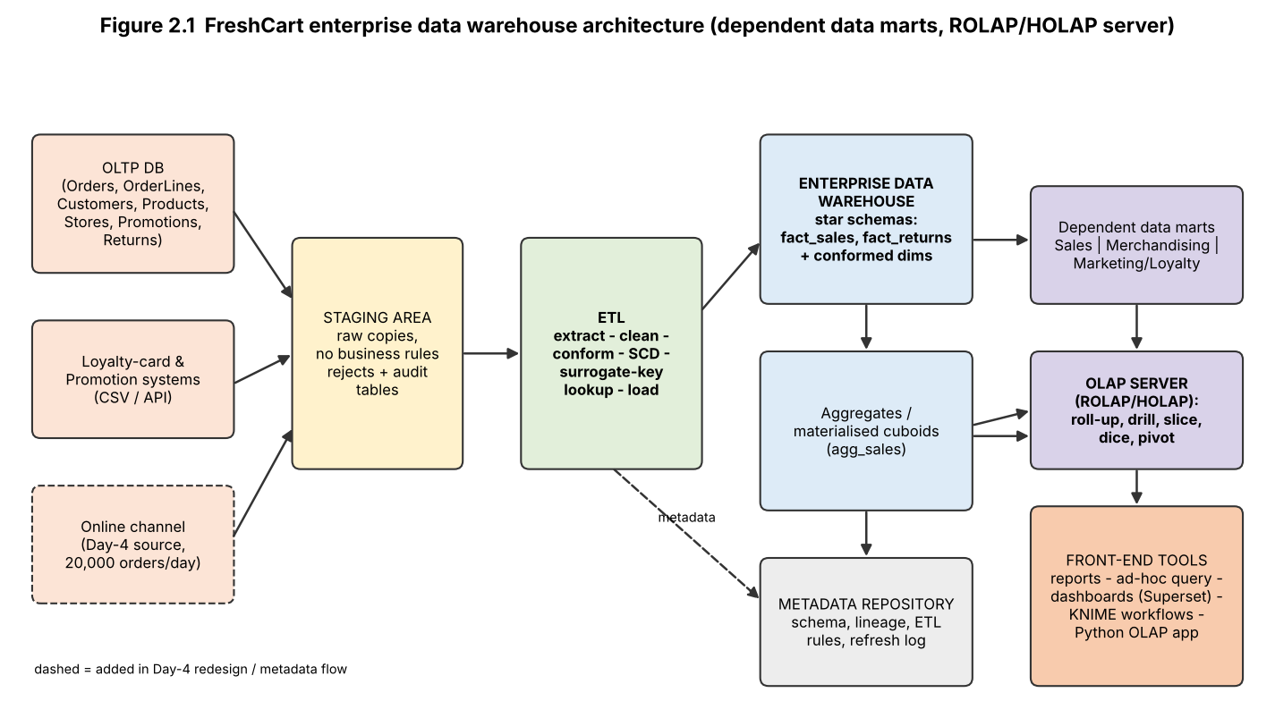
Figure 2.1 - FreshCart warehouse architecture (dashed items are added in the Day-4 redesign).

2.1 Components and their role
Component | FreshCart specification
Data sources | OLTP database (Orders, OrderLines, Customers, Products, Stores, Promotions, Returns); loyalty-card and promotion feeds (CSV/API). Online channel is added in Task 11.
Staging area | Raw, un-transformed copy of each extract with a load-batch id; reject and audit tables live here. Isolates the OLTP: extract once, transform away from the billing server.
ETL | Extract (full first time, incremental afterwards) - clean - conform - SCD logic - surrogate-key lookup - load dimensions first, then facts (Task 5).
Warehouse storage | Enterprise data warehouse holding star schemas fact_sales and fact_returns with conformed Date, Product, Store, Customer, Promotion dimensions, plus aggregate tables.
Data marts | Dependent marts (logical subsets, built from the warehouse): Sales/Store Operations, Merchandising (product/category), Marketing/Loyalty (customer, promotion).
OLAP server | ROLAP/HOLAP: detailed data stays relational, frequently used cuboids are materialised (Task 6) and answered from summary tables.
Metadata repository | Schema definitions, business definition of net sales, ETL rules, lineage, refresh log and data-quality results.
Front-end tools | Reports and dashboards (open-source BI such as Superset), KNIME workflows, ad-hoc SQL, and the Python OLAP application (Task 7).
Table 2.1 - Architecture components for FreshCart.

2.2 Choice of architecture type and why
Option | Verdict for FreshCart | Reason
Enterprise warehouse + dependent data marts (chosen) | Selected | Departments currently disagree on 'net sales'. One central warehouse with conformed dimensions gives one definition; marts are subsets built from it so they cannot drift.
Independent data marts | Rejected | Each department would build its own mart with its own rules - the exact problem FreshCart has. Cross-department questions (Q1, Q4) would need reconciliation of different Product and Customer dimensions.
Virtual warehouse (views over OLTP) | Rejected | Queries would still run on the billing database; Task 8 shows 2 s for one query at 1,000,000 lines, with no history of overwritten attributes.
Hybrid (warehouse first, marts as needed) | Adopted as the roll-out plan | Build the enterprise warehouse for the sales and returns processes first; derive marts only when a department needs different access.
Table 2.2 - Architecture type comparison.

TASK 3 - Design the Star Schema (6 marks)

3.1 Business process and declared grain
Business process: retail sales (point-of-sale checkout, in-store). Declared grain: *one row per product line on one customer order* - i.e. one row for each (order_id, line_no) in OrderLines. Every measure and dimension below is single-valued at this grain; the grain is declared before the measures are listed.
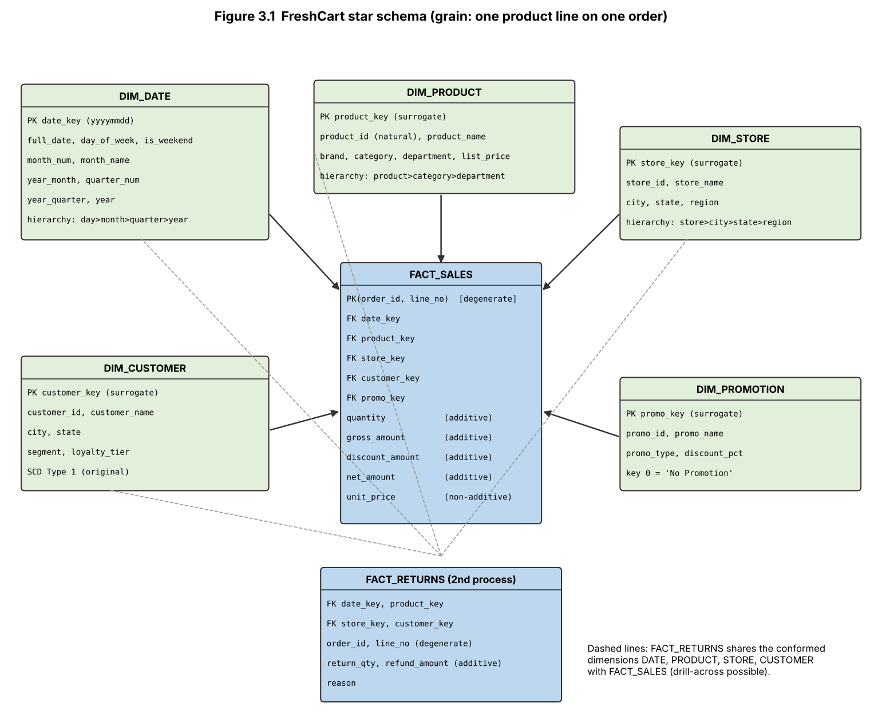
Figure 3.1 - Star schema for FreshCart sales; FACT_RETURNS shares the conformed dimensions.

3.2 Fact table and measures
Measure | Definition | Additivity | Consistent with grain because
quantity | units on the line | Additive | line-level fact, can be summed across every dimension
gross_amount | quantity x unit_price | Additive | line-level; sums across product, store, time, customer
discount_amount | promotion/loyalty discount on the line | Additive | allocated to the line when loading (order-level discounts are spread over lines in ETL)
net_amount | gross_amount - discount_amount (the agreed 'net sales') | Additive | derived at line level; sums to the company-wide figure
unit_price | price per unit at sale | Non-additive | cannot be summed; report as sum(gross)/sum(quantity)
discount ratio, average basket (derived) | discount/gross; net sales / count of orders | Non-additive | ratios - always computed from additive parts, never summed
(semi-additive example) loyalty-points balance | balance at a point in time - not in this transaction fact | Semi-additive | would belong to a periodic-snapshot fact; additive across customers but not across time
Table 3.1 - Measures and their additivity. order_id and line_no are degenerate dimensions (no dimension table).

3.3 Dimensions, attributes and concept hierarchies
Dimension | Attributes | Concept hierarchy | Keys
DIM_DATE | full_date, day_of_week, is_weekend, month_num, month_name, year_month, quarter_num, year_quarter, year | day -> month -> quarter -> year (also day -> week) | PK date_key = yyyymmdd (smart key by convention)
DIM_PRODUCT | product_id (natural), product_name, brand, category, department, list_price | product -> category -> department (brand is an alternative branch) | PK product_key (surrogate), natural key product_id
DIM_STORE | store_id (natural), store_name, city, state, region | store -> city -> state -> region | PK store_key (surrogate)
DIM_CUSTOMER | customer_id (natural), name, city, state, segment, loyalty_tier | segment (flat); city -> state | PK customer_key (surrogate)
DIM_PROMOTION | promo_id, promo_name, promo_type, discount_pct | promo_name -> promo_type; key 0 = 'No Promotion' | PK promo_key (surrogate)
Table 3.2 - Dimension tables. Foreign keys in FACT_SALES: date_key, product_key, store_key, customer_key, promo_key; composite PK (order_id, line_no).

3.4 Conformed dimensions - second fact table (FACT_RETURNS)
FACT_RETURNS has grain *one row per returned product line* and the measures return_qty and refund_amount (both additive). It uses the same DIM_DATE, DIM_PRODUCT, DIM_STORE and DIM_CUSTOMER tables as FACT_SALES. Because the dimensions are identical, the two facts can be compared (drill-across) on shared attributes: return rate by customer segment and category = sum(return_qty) / sum(quantity). This answers Q4 without any reconciliation of definitions.

3.5 DDL statements
CREATE TABLE dim_date (date_key INT PRIMARY KEY, full_date DATE NOT NULL UNIQUE, day_of_week VARCHAR(10), is_weekend TINYINT,
month_num TINYINT, month_name VARCHAR(10), year_month CHAR(7), quarter_num TINYINT, year_quarter CHAR(7), year SMALLINT);
CREATE TABLE dim_product (product_key INT AUTO_INCREMENT PRIMARY KEY, product_id INT NOT NULL UNIQUE, product_name VARCHAR(60),
brand VARCHAR(30), category VARCHAR(30), department VARCHAR(30), list_price DECIMAL(10,2));
CREATE TABLE dim_store (store_key INT AUTO_INCREMENT PRIMARY KEY, store_id INT NOT NULL UNIQUE, store_name VARCHAR(30),
city VARCHAR(30), state VARCHAR(30), region VARCHAR(20));
CREATE TABLE dim_customer (customer_key INT AUTO_INCREMENT PRIMARY KEY, customer_id INT NOT NULL UNIQUE, customer_name VARCHAR(50),
city VARCHAR(30), state VARCHAR(30), segment VARCHAR(15), loyalty_tier VARCHAR(10));
CREATE TABLE dim_promotion (promo_key INT AUTO_INCREMENT PRIMARY KEY, promo_id INT NOT NULL UNIQUE, promo_name VARCHAR(30),
promo_type VARCHAR(20), discount_pct DECIMAL(5,2));
CREATE TABLE fact_sales (
date_key INT NOT NULL, product_key INT NOT NULL, store_key INT NOT NULL, customer_key INT NOT NULL, promo_key INT NOT NULL,
order_id BIGINT NOT NULL, line_no SMALLINT NOT NULL, -- degenerate dimensions
quantity INT NOT NULL CHECK (quantity > 0), gross_amount DECIMAL(12,2), discount_amount DECIMAL(12,2), net_amount DECIMAL(12,2),
PRIMARY KEY (order_id, line_no),
FOREIGN KEY (date_key) REFERENCES dim_date(date_key), FOREIGN KEY (product_key) REFERENCES dim_product(product_key),
FOREIGN KEY (store_key) REFERENCES dim_store(store_key), FOREIGN KEY (customer_key) REFERENCES dim_customer(customer_key),
FOREIGN KEY (promo_key) REFERENCES dim_promotion(promo_key));
CREATE TABLE fact_returns (
date_key INT NOT NULL, product_key INT NOT NULL, store_key INT NOT NULL, customer_key INT NOT NULL,
order_id BIGINT NOT NULL, line_no SMALLINT NOT NULL, return_qty INT, refund_amount DECIMAL(12,2), reason VARCHAR(20),
FOREIGN KEY (date_key) REFERENCES dim_date(date_key), FOREIGN KEY (product_key) REFERENCES dim_product(product_key),
FOREIGN KEY (store_key) REFERENCES dim_store(store_key), FOREIGN KEY (customer_key) REFERENCES dim_customer(customer_key));
The executable version used in the experiments is in build_db.py (Appendix A). The benchmark copy of fact_sales has no PRIMARY KEY/secondary index on purpose, so that design (ii) in Task 8 measures an un-indexed star schema.

TASK 4 - Compare with a Snowflake Schema (4 marks)
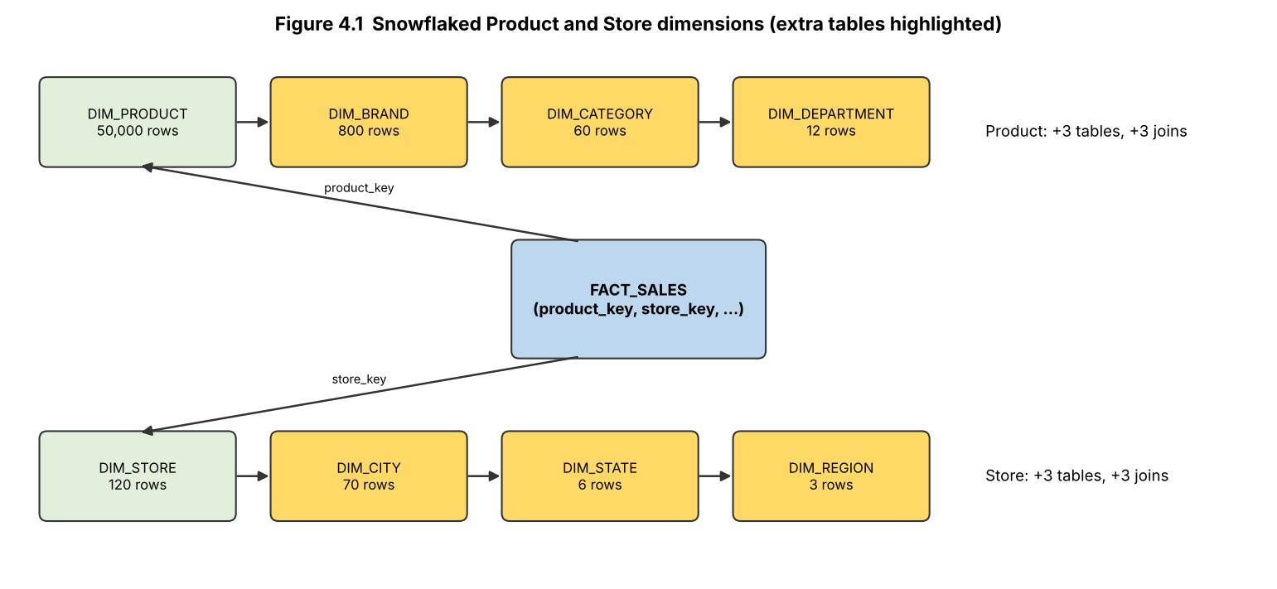
Figure 4.1 - Snowflaked Product (product -> brand -> category -> department) and Store (store -> city -> state -> region) dimensions.

4.1 Additional tables, keys and joins
Snowflake table | Rows | Columns (PK / FK) | Extra join
DIM_BRAND | 800 | brand_key PK, brand_name, category_key FK | product -> brand
DIM_CATEGORY | 60 | category_key PK, category_name, department_key FK | brand -> category
DIM_DEPARTMENT | 12 | department_key PK, department_name | category -> department
DIM_CITY | 70 | city_key PK, city_name, state_key FK | store -> city
DIM_STATE | 6 | state_key PK, state_name, region_key FK | city -> state
DIM_REGION | 3 | region_key PK, region_name | state -> region
Table 4.1 - Six extra tables, six extra keys and six extra joins. DIM_PRODUCT keeps brand_key and DIM_STORE keeps city_key as foreign keys.

4.2 Storage calculation (byte widths are stated assumptions)
Assumed widths: surrogate/foreign key 4 B, SKU 12 B, product name 40 B, size 10 B, brand/category/department name 25 B, store code 10 B, store name 30 B, city/state name 25 B, region 20 B.
Dimension | Star (one table) | Snowflake (normalised chain) | Saving
Product | 50,000 x (4+12+40+10+25+25+25 = 141 B) = 7,050,000 B (7.05 MB) | 50,000 x 70 B = 3,500,000 + 800 x 33 = 26,400 + 60 x 33 = 1,980 + 12 x 29 = 348 -> 3,528,728 B (3.53 MB) | 3,521,272 B = 49.9%
Store | 120 x (4+10+30+25+25+20 = 114 B) = 13,680 B | 120 x 68 + 70 x 33 + 6 x 33 + 3 x 24 = 8,340 B | 5,340 B = 39.0%
Total | 7.064 MB | 3.537 MB | 3.53 MB
Table 4.2 - Dimension storage (output of task4_calc.py, Figure 4.2).
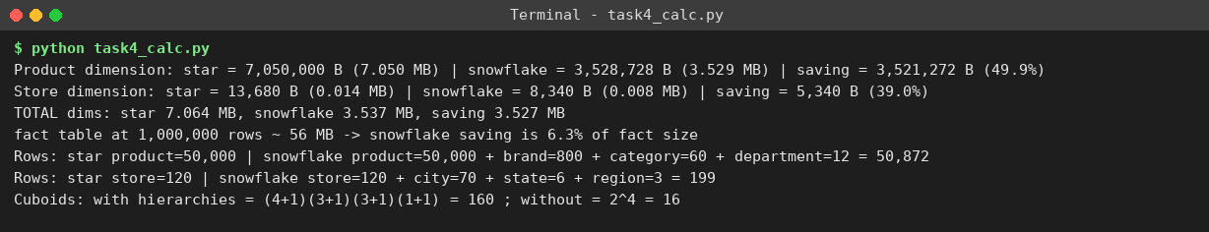
Figure 4.2 - Output of task4_calc.py (storage and cuboid numbers).
At 1,000,000 fact rows the fact table is about 56 MB (5 foreign keys, order_id, line_no, quantity and 3 amounts = 56 B/row), so the 3.5 MB saved is only 6.3% of the fact table; at one year of online data (+21.9 million rows, Task 11) it falls below 0.5%. Snowflaking saves space where it matters least.

4.3 Join counts for three representative queries
Query | Star joins | Snowflake joins | OLTP-style joins
Q-A (=Q1): net sales by region, category, quarter | 3 (date, product, store) | 8 (date + product-brand-category + store-city-state-region) | 8
Q-B (=Q2): weekend vs weekday sales by department | 2 (date, product) | 5 (date + product-brand-category-department) | 5
Q-C (=Q3): YTD net sales by state, 2026 vs 2025 | 2 (date, store) | 4 (date + store-city-state) | 4
Table 4.3 - Join counts. The normalised OLTP schema has the same dimension chains as the snowflake, so its measured times are a realistic proxy for a snowflake's cost.

4.4 Effects and decision
- Query performance (measured at 1,000,000 rows, Task 8): OLTP/snowflake-like chain vs star - Q1 2,007 ms vs 1,452 ms (-28%), Q2 1,379 vs 1,048 ms (-24%), Q3 956 vs 533 ms (-44%); VM work roughly halves because 8 joins become 3.
- ETL maintenance: a snowflake must load and key-check 8 tables in dependency order (region, state, city, store ...); a rename of a category touches one row, whereas in the star it must update thousands of product rows (a point in favour of snowflake for frequently changing hierarchies).
- Ease of understanding: a business user must follow 8 joins for Q-A in the snowflake but only 3 in the star; the star's category/department/region columns are directly usable in BI tools.
Decision: star schema for FreshCart. The saving is small (6.3% of the fact table), and joins double query work. I would change to a snowflake if (i) a dimension grew into the tens of millions of members so that repeating long text attributes costs real space, (ii) hierarchy attributes (e.g. category names) were updated frequently, or (iii) outrigger tables such as brand were shared by several dimensions.

TASK 5 - Design the ETL Process (5 marks)
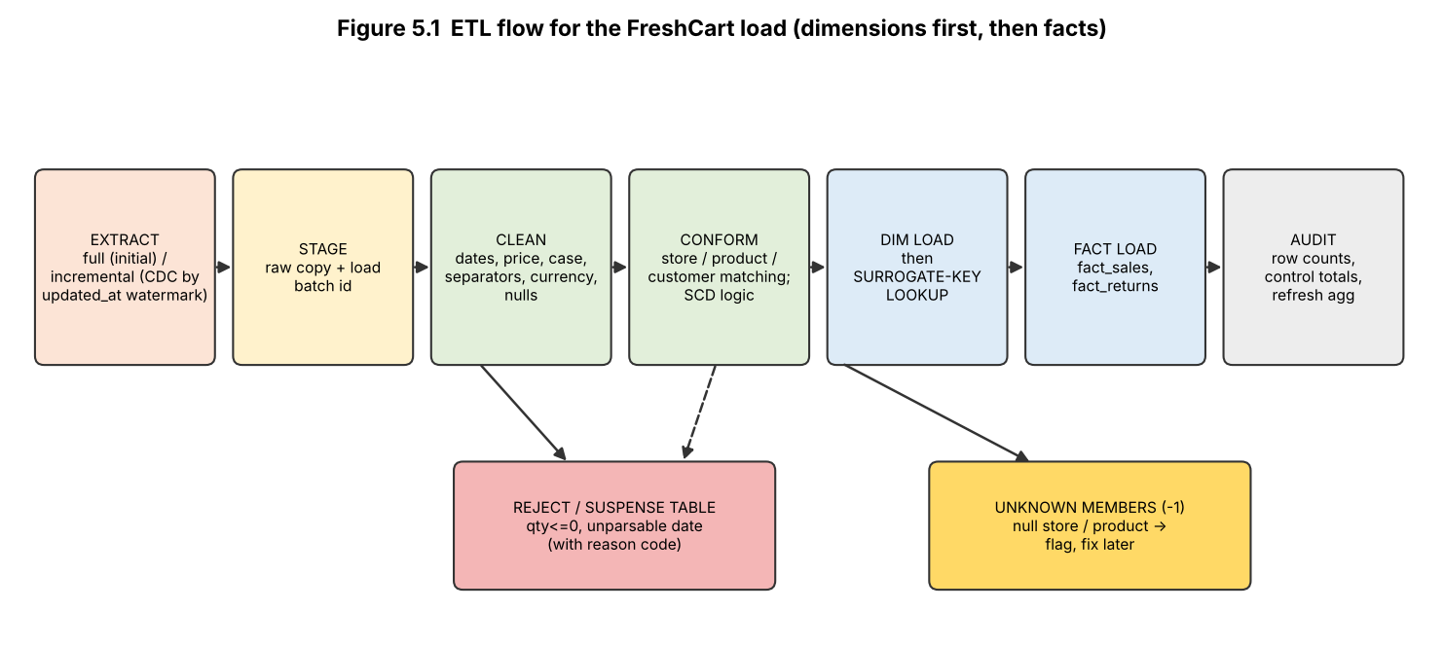
Figure 5.1 - ETL flow: extract -> stage -> clean -> conform -> dimension load and surrogate-key lookup -> fact load -> audit.

5.1 Data-quality problems and transformation rules
# | Defect (order) | Rule applied
1 | Three date formats: 03/11/2026, 2026-11-03, 04-Nov-26 (1001-1006) | Parse with an ordered list of formats (dd/mm/yyyy, yyyy-mm-dd, dd-Mon-yy) -> ISO date -> date_key; unparsable -> reject
2 | Store name case and abbreviation: 'chennai-04', 'Hyd-02' (1002, 1006) | Trim, title-case, expand abbreviation through the store master (Hyd -> Hyderabad) -> 'Hyderabad-02'
3 | Product name variants: 'Basmati rice 5 kg' vs 'Basmati Rice 5kg' (1002) | Lower-case, remove space before the unit, look up the product master -> product 9001
4 | Customer name variants: 'R. Kumar' vs 'Rajesh Kumar' (1002); 'Meena S' incomplete (1004) | Match on surname + initial against the customer master; flag 'fuzzy-match' for steward review (production: match on loyalty id / phone)
5 | Negative quantity -3 (1003) | Rule qty > 0 for fact_sales. Row is rejected with reason code and routed to the Returns pipeline for validation against the original sale
6 | Null store (1004) | Sale is real, so load it against the Unknown store member (key -1) with a DQ flag; fix when the store is supplied
7 | Currency '9.40 (USD)' (1005) | Strip the currency tag, convert with the rate table (assumed 83.00) -> 780.20 INR; consistent with 780.00 list price, within 5% tolerance
8 | Null product (1006) | Load against the Unknown product member (key -1), DQ flag; cannot be inferred
9 | Thousands separator '1,250' (1006) | Remove separators before numeric cast -> 1250.00
10 | Possible duplicate 1001 vs 1002 (same customer, store, product, day) | Different order ids -> kept as two orders; flagged by the duplicate check on the conformed business key
Table 5.1 - Every data-quality problem in the extract and the rule that resolves it.

5.2 Before and after the transformation
Before (raw extract):
Order | Customer | Store | Product | Qty | Unit price | Date
1001 | Rajesh Kumar | Chennai-04 | Basmati Rice 5kg | 2 | 620.00 | 03/11/2026
1002 | R. Kumar | chennai-04 | Basmati rice 5 kg | 1 | 620.00 | 2026-11-03
1003 | Anita Joseph | Pune-11 | Olive Oil 1L | -3 | 780.00 | 04-Nov-26
1004 | Meena S | (null) | Tea 250g | 4 | 95.50 | 04/11/2026
1005 | Anita Joseph | Pune-11 | Olive Oil 1L | 3 | 9.40 (USD) | 04/11/2026
1006 | Vikram Rao | Hyd-02 | (null) | 1 | 1,250 | 05/11/2026

After (conformed rows loaded into fact_sales; 1003 rejected):
Order | Cust key | Store | Prod key | Product | Qty | Unit price | Net | Date | DQ flag
1001 | 501 | Chennai-04 | 9001 | Basmati Rice 5kg | 2 | 620.00 | 1,240.00 | 2026-11-03 | -
1002 | 501 | Chennai-04 | 9001 | Basmati Rice 5kg | 1 | 620.00 | 620.00 | 2026-11-03 | fuzzy-match
1004 | 503 | Unknown (-1) | 9003 | Tea 250g | 4 | 95.50 | 382.00 | 2026-11-04 | null store
1005 | 502 | Pune-11 | 9002 | Olive Oil 1L | 3 | 780.20 | 2,340.60 | 2026-11-04 | USD converted
1006 | 504 | Hyderabad-02 | -1 | Unknown | 1 | 1,250.00 | 1,250.00 | 2026-11-05 | null product; separator

Rejected order | Reason
1003 | qty <= 0 (possible return) -> route to Returns pipeline
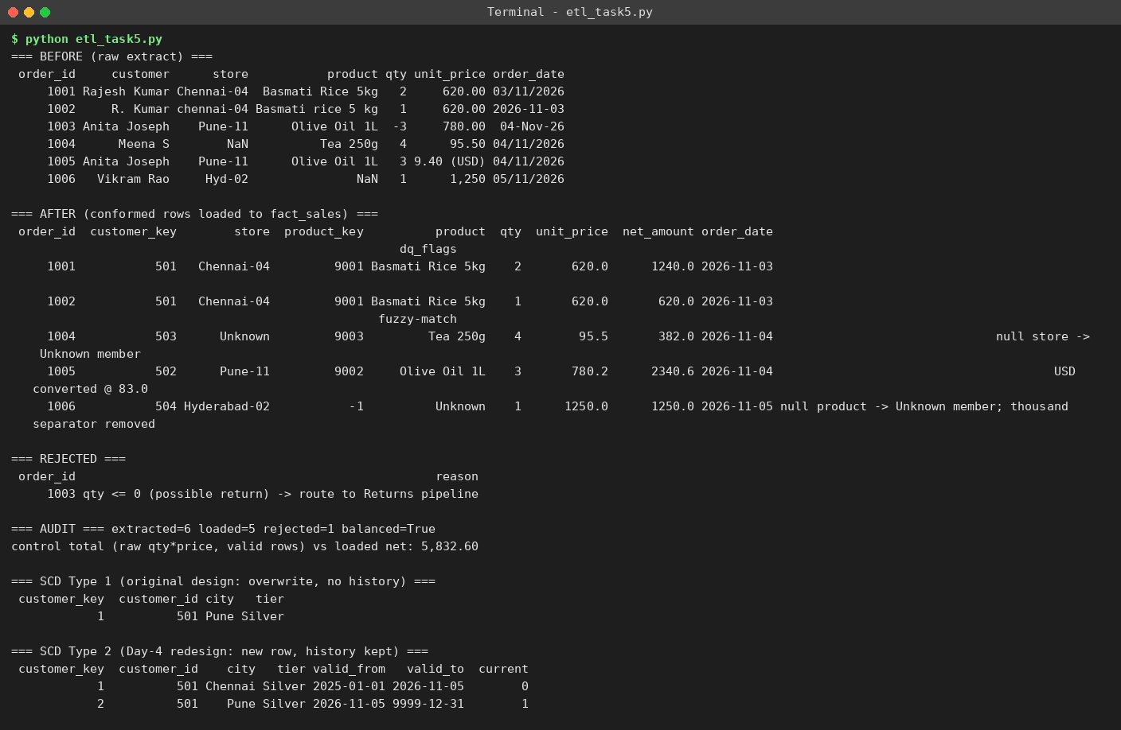
Figure 5.2 - Output of etl_task5.py: before, after, rejected, audit and SCD demonstration.

5.3 Surrogate-key lookup and unknown / late-arriving members
For each fact row the ETL looks up the natural key (store code, product code, customer id) in the dimension and returns its surrogate key. Not found: an *inferred member* is inserted into the dimension with the natural key, all other attributes 'Unknown' and an `inferred` flag; the fact loads against it. When the real dimension row arrives later (late-arriving dimension), the inferred row is updated in place (Type 1), so facts already loaded need no change. Null natural key: the fact is loaded against the reserved member -1 'Unknown' and counted in the unknown-member report (order 1004 store, order 1006 product). Late-arriving facts are loaded with the dimension row valid on the transaction date.

5.4 Slowly changing dimension for a customer address change
Decision for the original design: Type 1 (overwrite) for address, with the customer key unchanged. Reasons: none of the eight business questions in Task 1 analyses sales by a customer's historical address; most address changes are corrections; and Type 1 keeps the dimension at 20,000 rows. Example: customer 501 moves Chennai -> Pune; the row becomes (501, Pune, Silver) and history is lost (Figure 5.2). Known risk: past sales are reported under the new address. I test the size of this risk in Task 11-A (4.08% of sales misattributed to state, 5.96% to tier) and adopt Type 2 (new row with valid_from/valid_to) in the Day-4 redesign. Type 3 (previous-value column) was rejected because it stores only one prior address.

5.5 Initial load, incremental load, order of loading, rejects and audit
Topic | Design
Initial load | One-time full extract of all history; dimensions bulk-loaded, fact loaded in large batches with indexes dropped and rebuilt afterwards; produces the first summary tables.
Incremental load | Daily (later hourly) load of rows with updated_at > last watermark (change data capture); dimensions upserted (Type 1 / Type 2); facts appended; idempotent through the (order_id, line_no) key so a re-run does not duplicate.
Order of loading | 1) Date, 2) Product, Store, Promotion, Customer dimensions (parents first), 3) Fact_sales, 4) Fact_returns (needs the sale), 5) refresh aggregates. Facts need the surrogate keys, so dimensions must be loaded first.
Rejected records | Written to a reject table with order id, rule code and raw values; reviewed daily; corrected rows are re-submitted. Here: 1003.
Audit | Rows extracted = loaded + rejected: 6 = 5 + 1 (balanced); control total of loaded net amount 5,832.60 compared with the staging total; unknown-member rate (2 of 5 rows = 40% in this tiny sample) is reported and monitored.
Table 5.2 - Load strategy.

TASK 6 - Model the Data Cube and Apply OLAP Operations (5 marks)

6.1 Number of cuboids
Without hierarchies: each of the 4 dimensions is either present or aggregated away -> 2^4 = 16 cuboids. With hierarchies: a dimension with L levels can appear at any of its L levels or at the virtual top level ALL, so the count is the product of (L+1): Time (4 levels: day, month, quarter, year) 5 x Product (3 levels) 4 x Store (3 levels) 4 x Customer segment (1 level) 2 = 160 cuboids.
Base cuboid = (day, product, store, segment): the lowest level of every dimension, about one cell per distinct combination actually sold (at most the 1,000,000 fact rows). Apex cuboid = (ALL, ALL, ALL, ALL): a single cell holding the grand total of net sales.

6.2 OLAP operations tied to FreshCart questions
Operation | Business question and cuboid | Equivalent SQL on the star schema
Roll-up | Q1: which categories decline quarter over quarter in each region? Roll time from month to quarter and store from state to region -> cuboid (quarter, category, region, ALL) | SELECT s.region, p.category, d.year_quarter, SUM(f.net_amount) FROM fact_sales f JOIN dim_date d ON ... JOIN dim_product p ON ... JOIN dim_store s ON ... GROUP BY s.region, p.category, d.year_quarter;
Drill-down | Dairy fell in the South - which states and months? Drill time quarter -> month and store region -> state -> cuboid (month, department, state, ALL) | SELECT s.state, d.year_month, SUM(f.net_amount) FROM fact_sales f JOIN ... WHERE p.department='Dairy' AND s.region='South' GROUP BY s.state, d.year_month;
Slice | Sales of Tamil Nadu stores only, by department and quarter: fix store.state = 'Tamil Nadu' (one dimension, one value) | SELECT p.department, d.year_quarter, SUM(f.net_amount) FROM fact_sales f JOIN ... WHERE s.state='Tamil Nadu' GROUP BY p.department, d.year_quarter;
Dice | Dairy and Bakery in the South and West regions during 2026 (selection on three dimensions) | ... WHERE p.department IN ('Dairy','Bakery') AND s.region IN ('South','West') AND d.year=2026 GROUP BY p.department, s.region;
Pivot | Q3/Q1 style report: rotate the cube so departments are rows and regions are columns for 2026 | SELECT p.department, SUM(CASE WHEN s.region='South' THEN f.net_amount END) AS south, SUM(CASE WHEN s.region='West' THEN f.net_amount END) AS west, SUM(CASE WHEN s.region='North' THEN f.net_amount END) AS north FROM fact_sales f JOIN ... GROUP BY p.department;
Table 6.1 - Five OLAP operations. Each is executed interactively in Task 7 (Figures 7.1-7.5) with reconciliation.

6.3 Which cuboids to materialise
Materialising all 160 cuboids is wasteful (the lower cuboids are almost as large as the base). I used the greedy benefit algorithm of Harinarayan-Rajaraman-Ullman: start with the base cuboid, repeatedly add the cuboid that most reduces the total cost of answering all 160 cuboids, where a query is answered by its cheapest materialised ancestor. Sizes are estimated as min(product of level cardinalities, 1,000,000).
Pick | Cuboid (time, product, store, customer) | Est. rows | Benefit (rows saved)
1 | (month, department, store, segment) | 126,720 | 55,889,920
2 | (month, category, state, segment) | 31,680 | 18,534,400
3 | (quarter, category, store, segment) | 230,400 | 9,235,200
4 | (day, department, state, segment) | 192,672 | 6,458,624
5 | (day, ALL, store, segment) | 321,120 | 2,715,520
Table 6.2 - Greedy selection: 5 of 160 cuboids (3.1% of the lattice) cut total query cost from 160,000,000 to 67,166,336 rows (-58.0%).
Reasoning and link to implementation: the first two picks are month-level cuboids at coarse product and store levels, which answer the roll-up questions Q1, Q3 and Q5 and everything coarser. In the implemented warehouse I materialised one practical aggregate, agg_sales (month, weekend flag, department, category, region, state) - similar to pick 2 plus the weekend flag needed by Q3 - which has only 15,840 rows at 1,000,000 fact rows (Task 8). Segment-level cuboids would be added next for Q4/Q8.
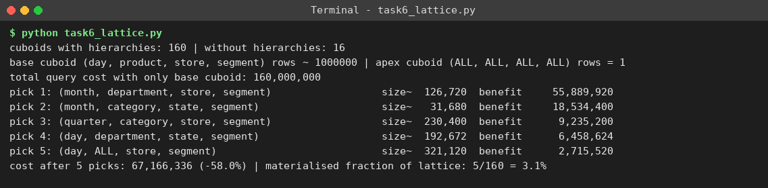
Figure 6.1 - Output of task6_lattice.py (cuboid counts and greedy selection).

TASK 7 - Develop an OLAP Application (5 marks)

7.1 Design
The application olap_app.py (Python, SQLite, pandas) is a menu-driven program: the user types the operation, the dimension, the level and the filter values; nothing is hard-coded. State is a cuboid definition {time, product, store, customer -> level}. Roll-up / drill-down move a dimension one level up/down its hierarchy (ALL at the top); slice adds one filter value; dice adds a list of values; pivot turns two chosen dimensions into a cross-tab. Every result is immediately reconciled: the same selection is recomputed from the normalised OLTP tables (a different schema, different joins, date logic from raw dates) and compared row by row; the program prints PASS or FAIL.

7.2 Data generation method and data sizes
build_db.py generates the OLTP data with a fixed random seed and then runs the ETL into the star schema. Dimension sizes follow Task 4 (50,000 products, 800 brands, 60 categories, 12 departments, 120 stores, 70 cities, 6 states, 3 regions; 20,000 customers in 4 segments and 4 loyalty tiers; 25 promotions plus 'No Promotion'). Orders have 1-5 lines (average 3); product popularity is Zipf-like; weekend days carry 1.4x weight; 25% of orders have a 5-20% promotion; 3% of lines are returned; dates run from 2025-01-01 to 2026-10-31.
Fact rows | Orders | Returns | ETL load time | SUM(net) star | SUM(qty*price-disc) source | Reconcile
1,000 | 325 | 30 | 0.08 s | 380,633.59 | 380,633.59 | MATCH
10,000 | 3,299 | 300 | 0.08 s | 3,872,646.05 | 3,872,646.05 | MATCH
100,000 | 33,252 | 3,000 | 0.21 s | 38,750,442.1 | 38,750,442.1 | MATCH
1,000,000 | 333,287 | 30,000 | 1.75 s | 388,119,172.74 | 388,119,172.74 | MATCH
Table 7.1 - Four data sizes and grand-total reconciliation between the warehouse and the source data (independent calculation).

7.3 Demonstration of the five operations (100,000 rows) - screenshots
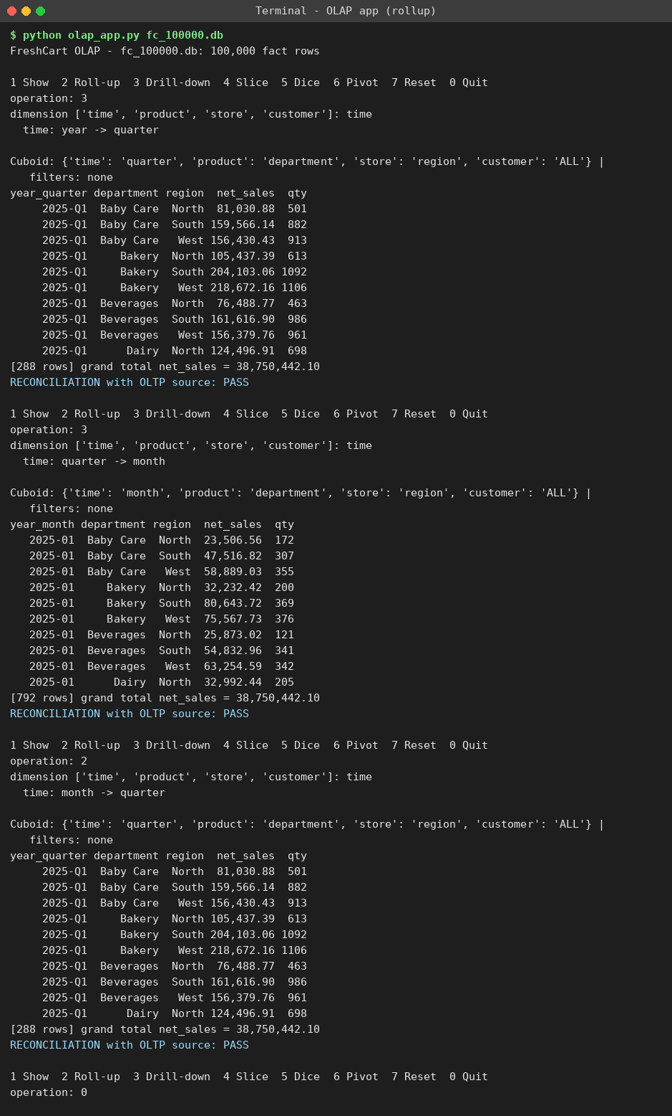
Figure 7.1 - Roll-up (the user drills time year -> quarter -> month, then rolls up month -> quarter). Reconciliation: PASS.
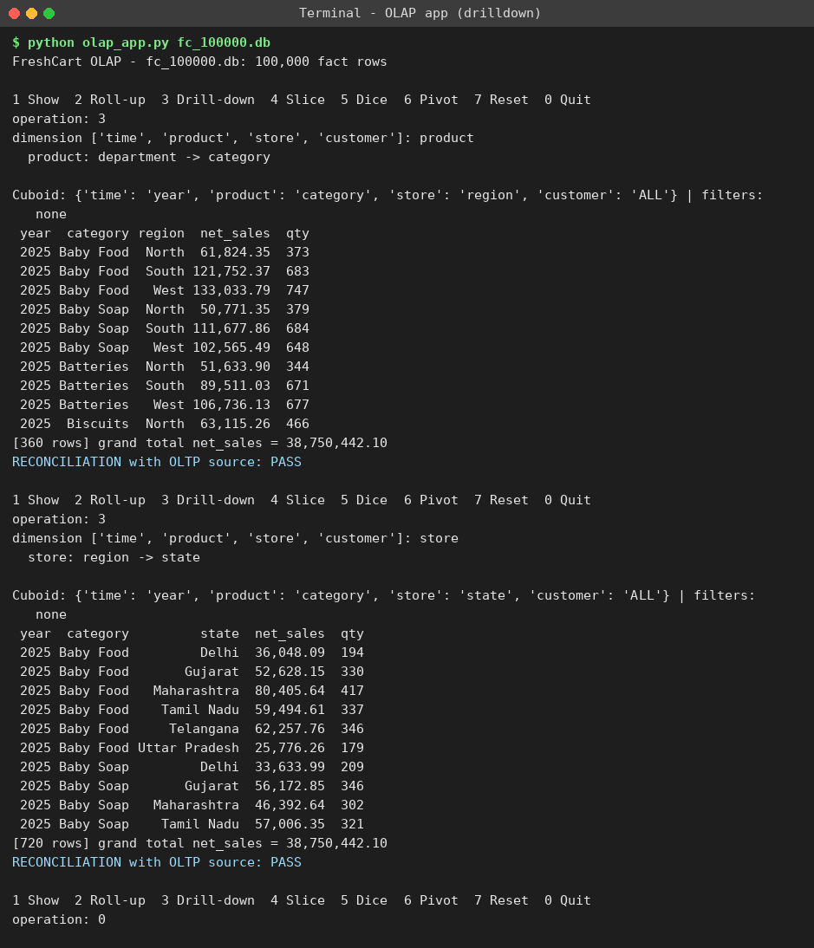
Figure 7.2 - Drill-down on product (department -> category) and store (region -> state). Reconciliation: PASS.
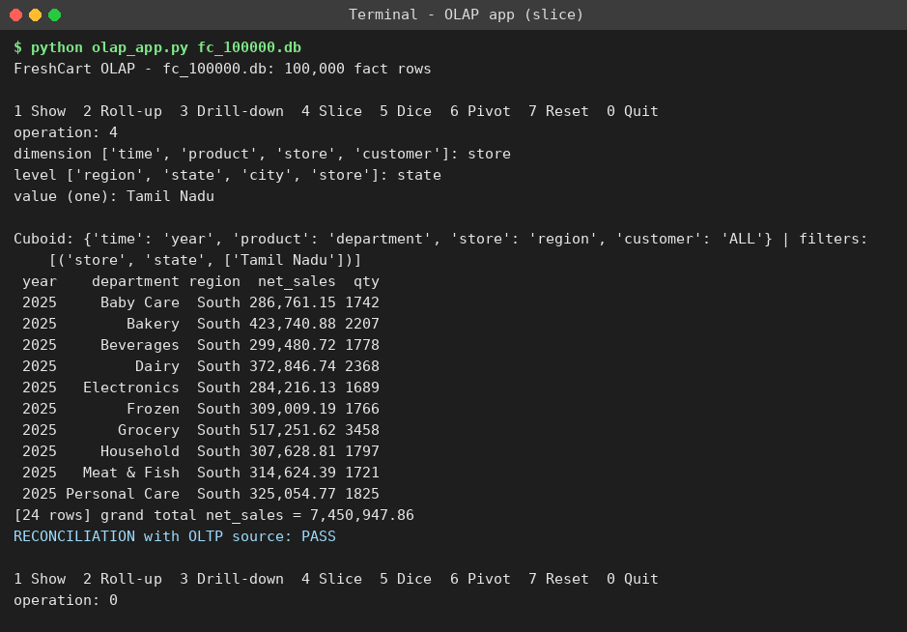
Figure 7.3 - Slice: store.state = 'Tamil Nadu' - grand total 7,450,947.86, reconciled with OLTP.
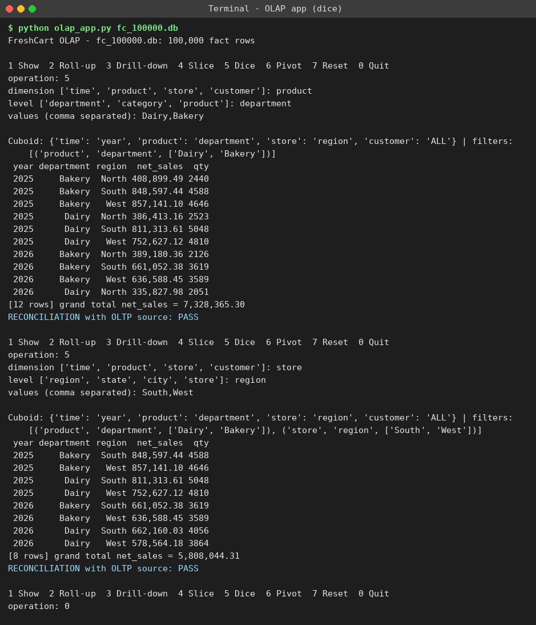
Figure 7.4 - Dice: department in (Dairy, Bakery) and region in (South, West).
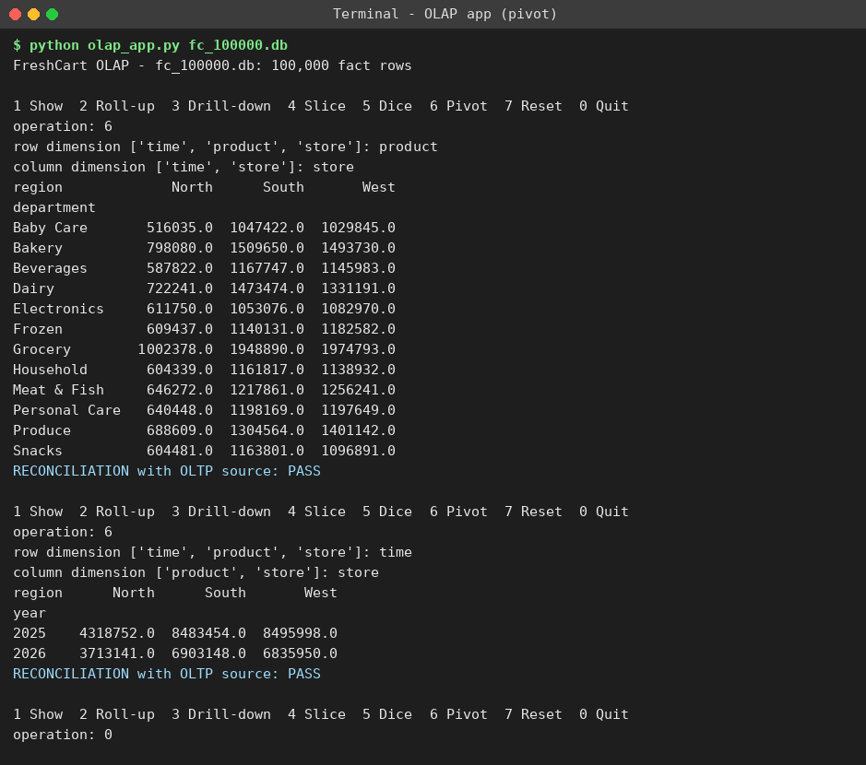
Figure 7.5 - Pivot: department x region and year x region cross-tabs, each reconciled.

7.4 Boundary / failure tests and the 1,000,000-row run
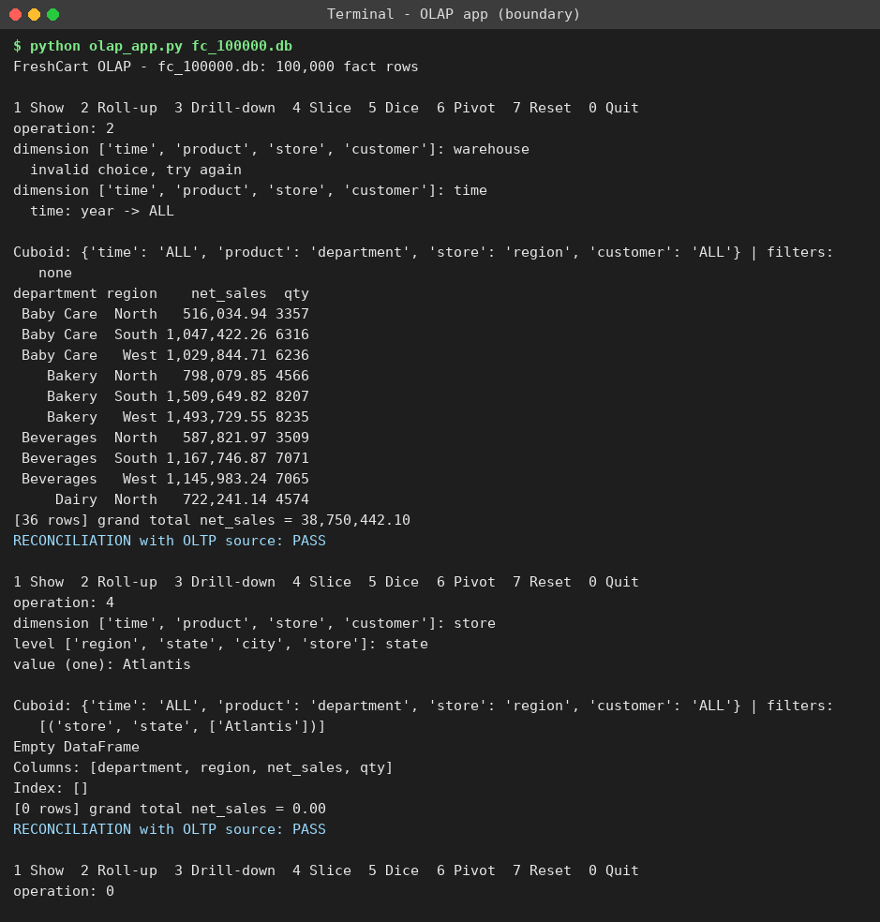
Figure 7.6 - Invalid dimension 'warehouse' is rejected and re-prompted; slice on a non-existent state returns 0 rows and still reconciles (0 = 0).
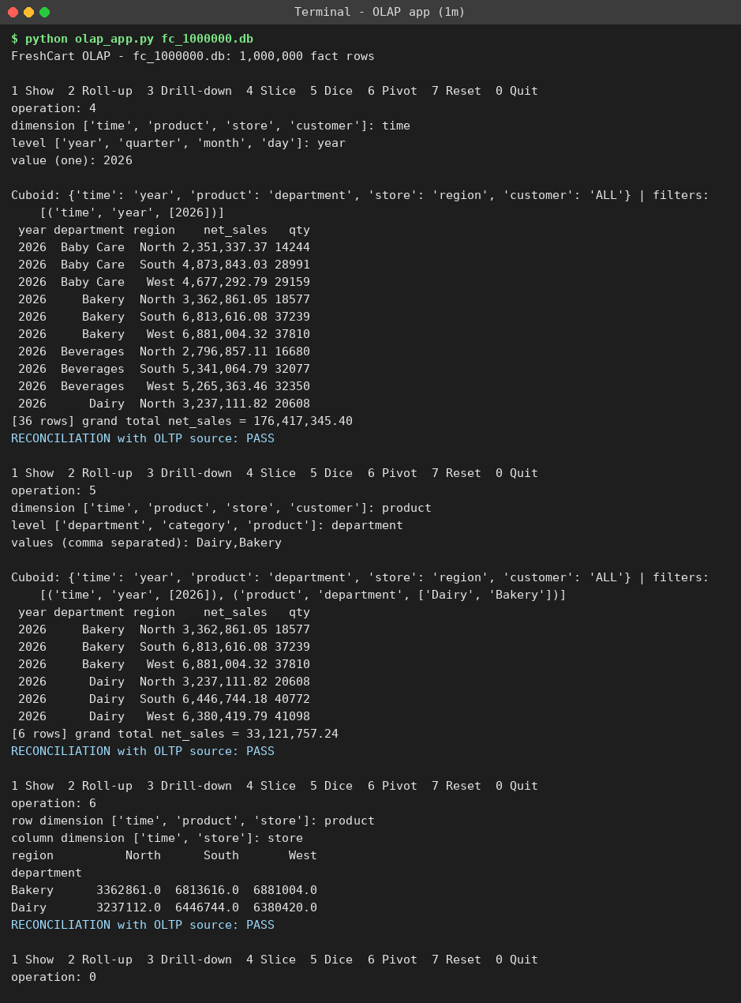
Figure 7.7 - The same application at 1,000,000 fact rows: slice year 2026, dice Dairy/Bakery, pivot - all PASS (2026 Dairy+Bakery total 33,121,757.24).
Result: all reconciliation checks passed on every operation (0 FAIL in all session logs). Grand totals match to the paisa at all four sizes (Table 7.1: 388,119,172.74 at 1,000,000 rows). This shows that the dimensional model and the surrogate-key ETL preserve the source facts and support all five OLAP operations. Source code: Appendix A (olap_app.py, build_db.py).

TASK 8 - Evaluate Query Processing Performance (4 marks)

8.1 Experiment design
Three analytical queries (Q1 net sales by region, category, quarter; Q2 weekend vs weekday sales by department; Q3 YTD Jan-Oct net sales by state, 2026 vs 2025) were run on (i) the normalised OLTP-style schema, (ii) the star schema without secondary indexes, and (iii) the star schema with indexes (five single-column foreign-key indexes plus one covering index) and a summary table agg_sales (month x weekend flag x department x category x region x state). Each query was run three times; the median time is reported together with the rows scanned by full table scans (from the query plan), SQLite VM steps (a measure of work that does not depend on the clock) and the number of joins. All four designs returned identical totals for every query and size (Table 8.4). Engine: SQLite 3.45 on a single-core 3 GB machine; the absolute times are small, but the ratios and growth trends are what matter.
Q1 net sales by region, category, quarter - joins: OLTP 8, star 3, star+idx 3, summary 0
Fact rows | (i) OLTP | (ii) Star | (iii-a) Star+idx | (iii-b) Summary
1,000 | 2.3 ms  1,000 rows  70k steps | 1.2 ms  1,000 rows  37k steps | 1.1 ms  1,000 rows  37k steps | 0.7 ms  920 rows  27k steps
10,000 | 18.0 ms  10,000 rows  565k steps | 11.3 ms  10,000 rows  282k steps | 10.2 ms  10,000 rows  283k steps | 4.2 ms  6,944 rows  147k steps
100,000 | 180.0 ms  100,000 rows  5,336k steps | 138.8 ms  100,000 rows  2,623k steps | 109.2 ms  100,000 rows  2,623k steps | 7.6 ms  15,568 rows  303k steps
1,000,000 | 2007.1 ms  1,000,000 rows  53,036k steps | 1452.2 ms  1,000,000 rows  26,023k steps | 1261.3 ms  1,000,000 rows  26,023k steps | 7.9 ms  15,840 rows  308k steps
Table 8.1 - Q1 net sales by region, category, quarter: median time, rows scanned (full scans) and VM steps (thousands).
Q2 weekend vs weekday net sales by department - joins: OLTP 5, star 2, star+idx 2, summary 0
Fact rows | (i) OLTP | (ii) Star | (iii-a) Star+idx | (iii-b) Summary
1,000 | 1.1 ms  1,000 rows  43k steps | 0.7 ms  1,000 rows  26k steps | 0.6 ms  1,000 rows  25k steps | 0.3 ms  920 rows  18k steps
10,000 | 12.2 ms  10,000 rows  422k steps | 8.4 ms  10,000 rows  254k steps | 7.4 ms  10,000 rows  254k steps | 1.9 ms  6,944 rows  135k steps
100,000 | 137.5 ms  100,000 rows  4,218k steps | 111.0 ms  100,000 rows  2,536k steps | 90.3 ms  100,000 rows  2,536k steps | 7.7 ms  15,568 rows  304k steps
1,000,000 | 1379.3 ms  1,000,000 rows  42,181k steps | 1048.4 ms  1,000,000 rows  25,360k steps | 959.5 ms  1,000,000 rows  25,360k steps | 4.5 ms  15,840 rows  309k steps
Table 8.2 - Q2 weekend vs weekday net sales by department: median time, rows scanned (full scans) and VM steps (thousands).
Q3 YTD (Jan-Oct) net sales by state, 2026 vs 2025 - joins: OLTP 4, star 2, star+idx 2, summary 0
Fact rows | (i) OLTP | (ii) Star | (iii-a) Star+idx | (iii-b) Summary
1,000 | 0.7 ms  1,000 rows  37k steps | 0.4 ms  1,000 rows  22k steps | 0.3 ms  1,000 rows  23k steps | 0.2 ms  920 rows  16k steps
10,000 | 7.4 ms  10,000 rows  370k steps | 3.7 ms  10,000 rows  223k steps | 2.9 ms  10,000 rows  223k steps | 1.8 ms  6,944 rows  115k steps
100,000 | 87.2 ms  100,000 rows  3,695k steps | 47.3 ms  100,000 rows  2,224k steps | 39.0 ms  100,000 rows  2,224k steps | 3.7 ms  15,568 rows  259k steps
1,000,000 | 956.4 ms  1,000,000 rows  36,974k steps | 533.3 ms  1,000,000 rows  22,258k steps | 377.4 ms  1,000,000 rows  22,258k steps | 3.8 ms  15,840 rows  264k steps
Table 8.3 - Q3 YTD (Jan-Oct) net sales by state, 2026 vs 2025: median time, rows scanned (full scans) and VM steps (thousands).

8.2 Storage and load time of the additional structures
Fact rows | Index build | Index storage | Summary build | Summary rows | Summary storage | Totals identical in all 4 designs
1,000 | 0.01 s | 0.12 MB | 0.01 s | 920 | 0.09 MB | Yes
10,000 | 0.02 s | 0.79 MB | 0.03 s | 6,944 | 0.61 MB | Yes
100,000 | 0.18 s | 7.95 MB | 0.24 s | 15,568 | 1.36 MB | Yes
1,000,000 | 1.84 s | 81.06 MB | 2.44 s | 15,840 | 1.4 MB | Yes
Table 8.4 - Cost of the extra structures (indexes and summary table) and correctness check.
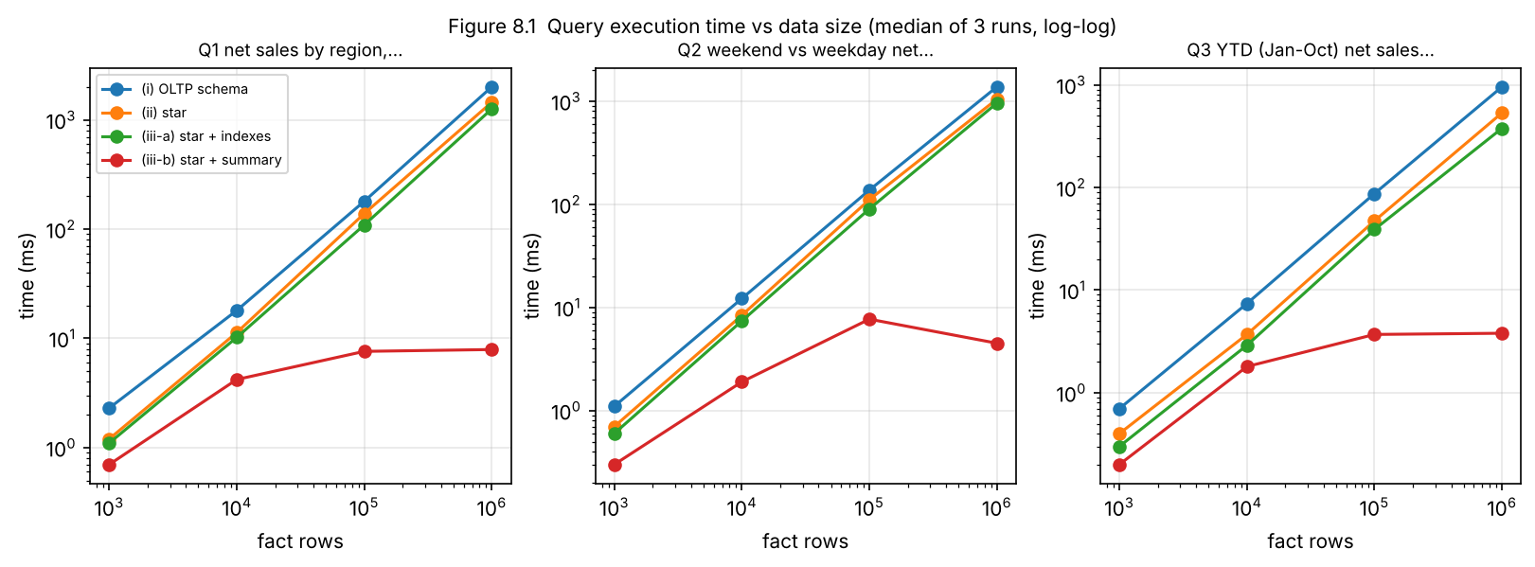
Figure 8.1 - Execution time vs data size (log-log).
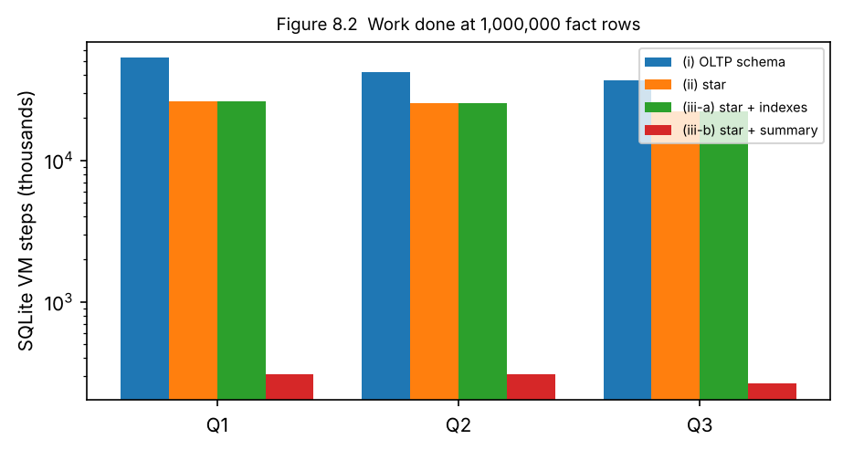
Figure 8.2 - Work done (VM steps) at 1,000,000 fact rows - summary table does about 1/100 of the work.
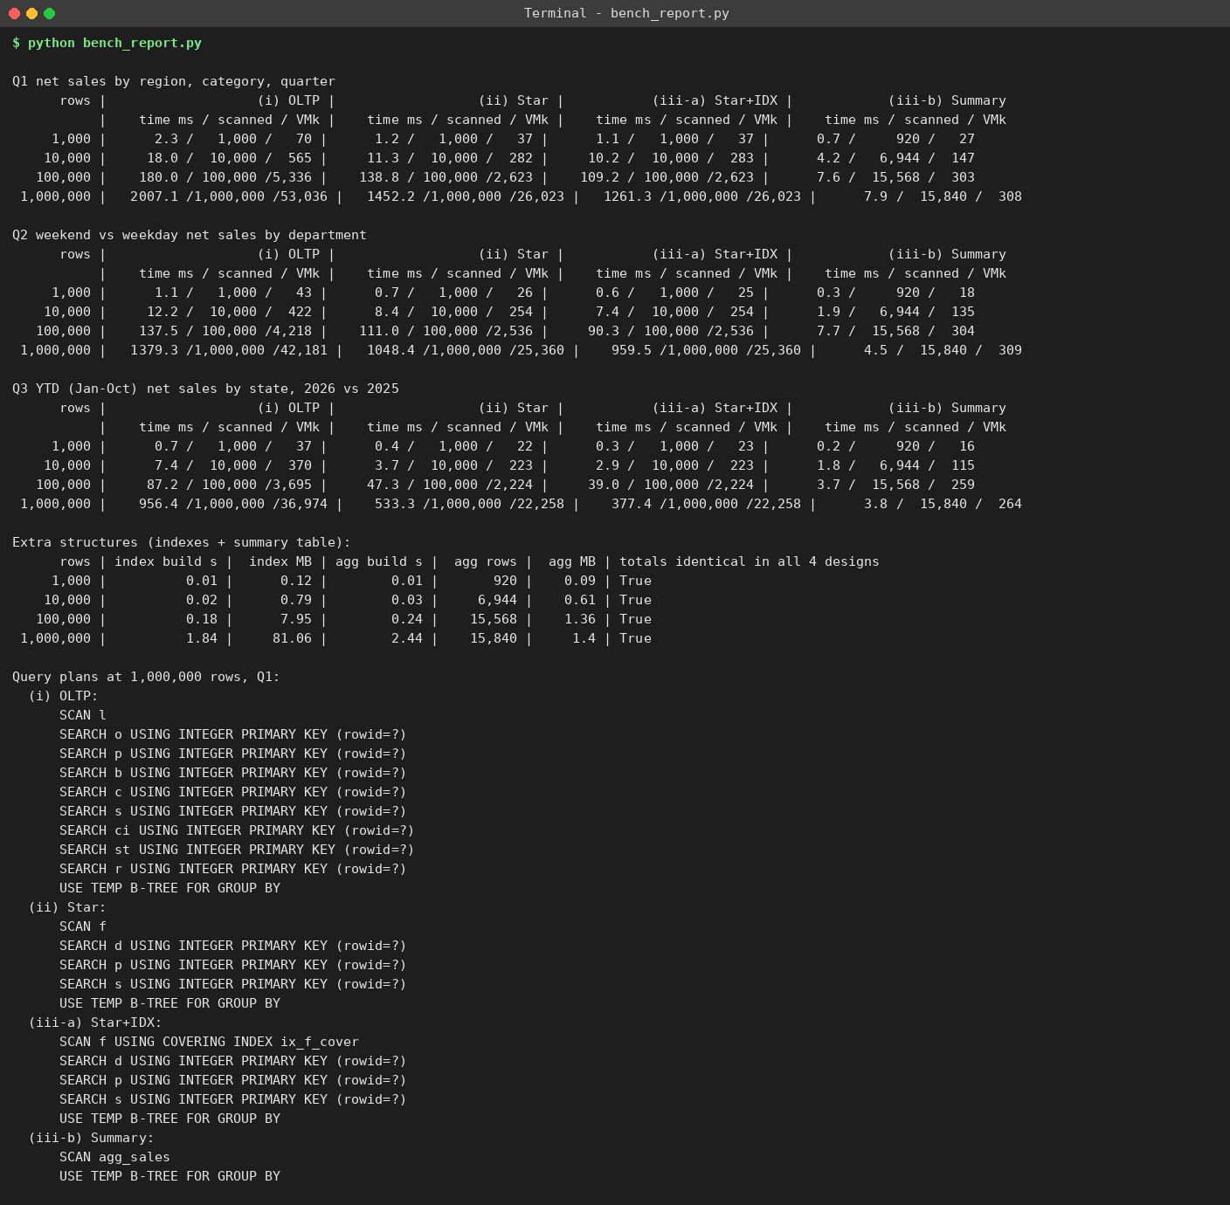
Figure 8.3 - Output of bench_report.py (all tables, query plans at 1,000,000 rows).

8.3 Query plans (1,000,000 rows, Q1)
Design | Plan (from EXPLAIN QUERY PLAN)
(i) OLTP | SCAN order_lines; SEARCH orders, products, brands, categories, stores, cities, states, regions by PRIMARY KEY (8 look-ups per line); temp B-tree for GROUP BY
(ii) Star | SCAN fact_sales; SEARCH dim_date, dim_product, dim_store by PRIMARY KEY (3 look-ups per line); temp B-tree for GROUP BY
(iii-a) Star + indexes | SCAN fact_sales USING COVERING INDEX ix_f_cover; SEARCH 3 dimensions by PRIMARY KEY; GROUP BY - still reads every fact row
(iii-b) Summary | SCAN agg_sales (15,840 rows); GROUP BY - no joins, no fact table
Table 8.5 - Query plans.

8.4 Interpretation - why the differences occur
- Star vs OLTP: both scan the 1,000,000-row fact/line table, but the star needs 3 look-ups per row instead of 8. VM steps for Q1 fall from 53.0 million to 26.0 million (2.04x), time from 2,007 to 1,452 ms (-28%). The gain grows with the number of joins removed (Q3: 4 -> 2 joins, -44%).
- Indexes barely help: rows scanned stay at 1,000,000 because all three queries aggregate the whole fact table - a B-tree index only helps selective predicates. The covering index only shortens each row read (Q1 -13%, Q3 -29% in time). Cost: 81 MB of extra storage (about 41% of the 196 MB database), 1.84 s to build, and slower inserts - important for the hourly load in Task 11.
- Summary table is the real win: the query reads 15,840 rows instead of 1,000,000 (63x fewer) and does no joins: Q1 7.9 ms vs 2,007 ms (~250x), Q2 4.5 vs 1,379 ms, Q3 3.8 vs 956 ms. Its size depends on the dimension cardinalities, not on the number of sales, so time stays flat (3.8-8 ms) from 100,000 rows upwards while the other designs grow 10x for each 10x of data.
- Trade-offs of summary structures: (1) extra storage (1.4 MB at 1,000,000 rows - tiny) and 2.44 s rebuild time; (2) staleness - it must be refreshed after every load (made incremental in Task 11); (3) it only answers questions at its grain (no product-level, store-level or segment-level detail); (4) at 1,000 rows it gives almost nothing (920 rows vs 1,000), so it is justified only once data is large.
- Honest limits: SQLite on one core measures relative effects; a production warehouse (columnar, parallel) would be faster in absolute terms, but the same ordering - OLTP > star > indexed star >> summary - and the linear growth of scans would remain.

TASK 9 - Build a KNIME Reporting Workflow (3 marks)
The KNIME workflow reads the warehouse exports (fact_sales.csv and the four dimension CSV files generated by knime_equivalent.py from the 100,000-row warehouse), cleans, joins, aggregates and writes a management report. To allow checking of the KNIME result, the same node chain was reproduced in pandas and its output is shown below; the KNIME report must give the same numbers.
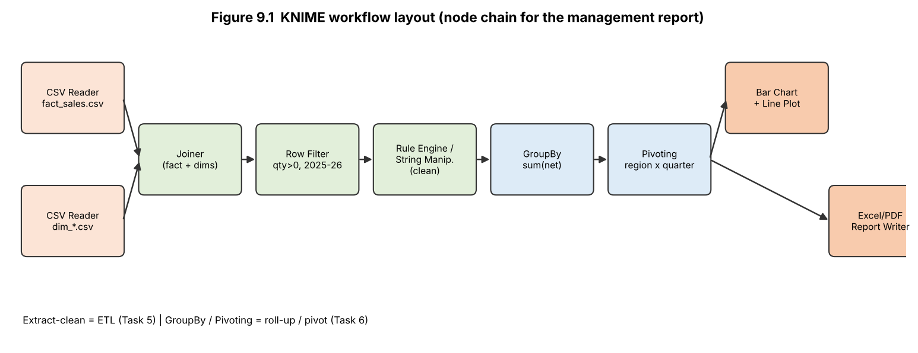
Figure 9.1 - KNIME workflow layout (node chain).
KNIME node | Purpose | Corresponding concept (Tasks 5/6)
CSV Reader (fact_sales.csv, dim_*.csv) | Reads the warehouse tables | Extract / warehouse storage
Joiner (x3: fact+date, +product, +store) | Joins the fact to the dimensions on surrogate keys | Star-join; surrogate-key lookup
Row Filter (quantity > 0, year in 2025-2026) | Removes invalid or out-of-range rows | Cleaning rule 'qty > 0' (Table 5.1)
Rule Engine / String Manipulation | Standardises text, derives quarter labels and flags | Transformation rules
GroupBy (region, year_quarter; sum net_amount) | Aggregates net sales | Roll-up to (quarter, region) cuboid
Pivoting (rows = region, columns = quarter) | Cross-tab for the report | Pivot operation
Bar Chart / Line Plot, Excel or PDF Report Writer | Management report and chart | Front-end reporting tool
Table 9.1 - KNIME nodes and their mapping to ETL/OLAP concepts.
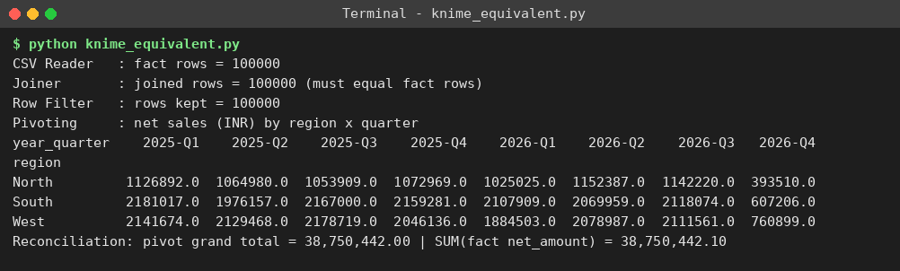
Figure 9.2 - pandas reproduction of the KNIME node chain: row counts at each node and the region x quarter pivot (grand total 38,750,442 reconciles with SUM(net_amount) = 38,750,442.10).
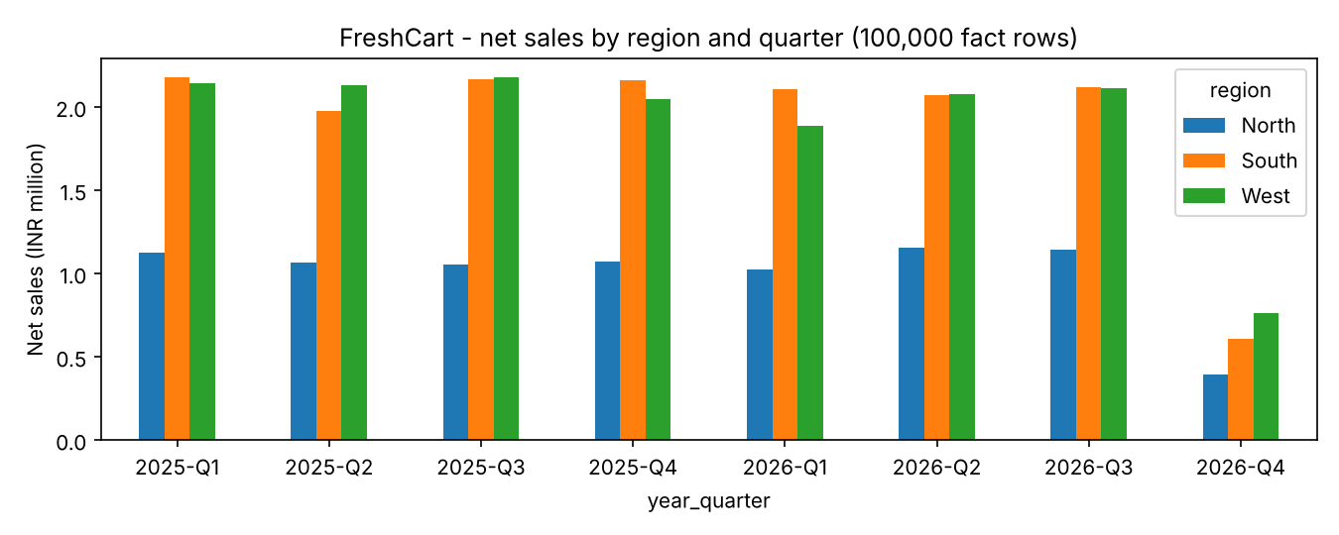
Figure 9.3a - Report chart (net sales by region and quarter). 2026-Q4 is partial (data ends 31 Oct 2026).
[Insert here your own screenshot of the KNIME workflow canvas and the exported report - Figure 9.3b.] Build the nodes in the order of Table 9.1 and compare its pivot with Figure 9.2.
Limitation at 1,000,000+ rows: KNIME processes tables in the memory/disk of one desktop; Joiner, GroupBy and Pivoting nodes become slow and memory-hungry, the workflow re-reads the complete CSV on every run, and there is no pre-computed cuboid, so every refresh repeats the full aggregation (the same scan cost measured in Task 8: about 1-2 seconds per million rows even in a fast engine, much more in a desktop tool). The fix is to push the aggregation to the database (DB Query/GroupBy nodes on agg_sales) rather than pulling detailed rows.

TASK 10 - Recommend and Defend the Final Design (3 marks)
Recommendation: an enterprise data warehouse with dependent data marts, built as a star schema (fact_sales, fact_returns, conformed Date/Product/Store/Customer/Promotion dimensions), loaded by a staged ETL with surrogate keys and unknown-member handling, with SCD Type 2 for customer address and loyalty tier, a small set of materialised aggregates refreshed incrementally, and an OLAP layer/BI front end on top.
Decision | Better than | Evidence from my own experiments
Star schema | Snowflake; OLTP queries | Task 4: snowflake saves 3.53 MB = 6.3% of the 56 MB fact table but needs 8 joins instead of 3 (Q-A). Task 8: star is 24-44% faster than the 8/5/4-join normalised schema at 1,000,000 rows and does half the VM work.
Enterprise DW + dependent marts | Independent marts; virtual DW | Task 1/2: single definition of net sales; virtual DW would run on the billing DB (2 s per query at 1M lines).
Summary table (5 of 160 cuboids) | Indexes alone | Task 8: summary is ~250x faster at 1M rows for 1.4 MB; indexes cost 81 MB and give only 10-30%.
SCD Type 2 + hourly micro-batch | Type 1 + nightly rebuild | Task 11: Type 1 misattributes 4.08% of sales by state and 5.96% by tier; incremental refresh 0.17 s vs 6.98 s full rebuild at 2.8M rows.
Table 10.1 - Recommendation and supporting evidence.
- Trade-offs and load cost: the warehouse duplicates data (about 113 MB for 1,000,000 lines plus 81 MB indexes); initial star load took 1.75 s at 1,000,000 rows (SQLite) and the summary 2.44 s; Type 2 adds rows and complexity to lookups; the summary must be refreshed and only answers its own grain.
- Limitations: synthetic data (no real data skew or dirty data beyond Task 5's sample); one single-core SQLite engine; no concurrency test; KNIME limit at large volume (Task 9).
- At 1,000,000+ rows and beyond: star scans grow linearly (about 1.0-1.5 s per million rows here -> roughly 30 s per query for the 22 million rows the online channel adds per year), so un-aggregated dashboards stop being interactive. The design remains practical because the summary table stays about 16-20 thousand rows regardless of volume (3.8-8 ms), and beyond tens of millions of rows the same star schema should be moved to partitioned (by month) columnar storage with materialised views - no model change is needed.

TASK 11 - Day-4 Design Challenge: Re-evaluate and Adapt the Design (8 marks)
Changed requirement: online channel (about 20,000 orders per day = roughly 60,000 lines per day, about 2,500 lines per average hour and 7,500 in a 3x peak hour), a different product-code format ('ONL-00123'), a new 'delivery partner' attribute, customers who change address and loyalty tier often, reporting by the address and tier valid at the time of the order, and hourly dashboards. Decision: modify the design - keep the star schema and architecture, redesign the customer dimension and the load process, add channel and delivery-partner dimensions.

A. Impact Analysis (2 marks)
Area | Structure | Load process | Performance
Affected | DIM_CUSTOMER (Type 1 -> Type 2: add valid_from, valid_to, is_current); FACT_SALES (+channel_key, +partner_key); new DIM_CHANNEL, DIM_DELIVERY_PARTNER, PRODUCT_XREF; new 'Online hub' store row; aggregate gets a channel column | Nightly batch -> hourly micro-batch; new source adapter; product-code crosswalk; SCD-2 logic in customer load; customer lookup must use the version valid on the order timestamp | Fact grows ~21.9 million rows/year (20x the 1M test); aggregate full rebuild becomes unaffordable; index maintenance on every insert
Not affected | Grain (one product line on one order), DIM_DATE, DIM_PRODUCT, DIM_STORE, DIM_PROMOTION, FACT_RETURNS design, hierarchies and the 160-cuboid lattice | Staging -> ETL -> warehouse pipeline order, dimensions-before-facts rule, reject/audit design | Star-join query shape and the OLAP application (new channel is just another dimension/filter)
Table 11.1 - Impact of the online channel on structure, load process and performance.

B. Evaluation of the Original Design (2 marks)
Test method (day4.py, 1,000,000-row warehouse, section A and C-D of its output, Figure 11.2): simulate customers who move or change tier (8% / 12% - assumption), reconstruct the true as-of-order answer, compare it with the Type 1 answer; simulate hourly batches and compare the original refresh method (full aggregate rebuild) with the volume.
Test | Result | Verdict
Star grain, hierarchies, cubes, OLAP queries | Unchanged: an online line is still 'one product on one order'; channel is only an extra dimension | Adequate
Sales by address and tier at the time of the order (Type 1) | 1,569 customers moved (7.8%), 2,375 changed tier (11.9%). 4.08% of net sales is attributed to the wrong state and 5.96% to the wrong loyalty tier. Per-state totals look almost correct (errors about +-1%) because moves partly cancel - the error hides in the totals but is wrong for every moved customer | Fails (correctness)
Product code 'ONL-xxxxx' vs numeric product_id | By construction no online code matches DIM_PRODUCT.product_id, so 100% of online lines would load against Unknown (-1) without a crosswalk | Fails
Delivery partner attribute | No column or dimension exists to hold it | Fails (structure)
Hourly refresh with the original method (full aggregate rebuild) | 2.47 s at 1.01 million rows; 6.98 s at 2.81 million rows (one month of online data); projected ~61 s at 22 million rows by year-end; grows linearly and repeats work already done 23 times a day | Works now, does not scale
Table 11.2 - Where the original design is adequate and where it fails.

C. Adaptation / Redesign (2 marks)
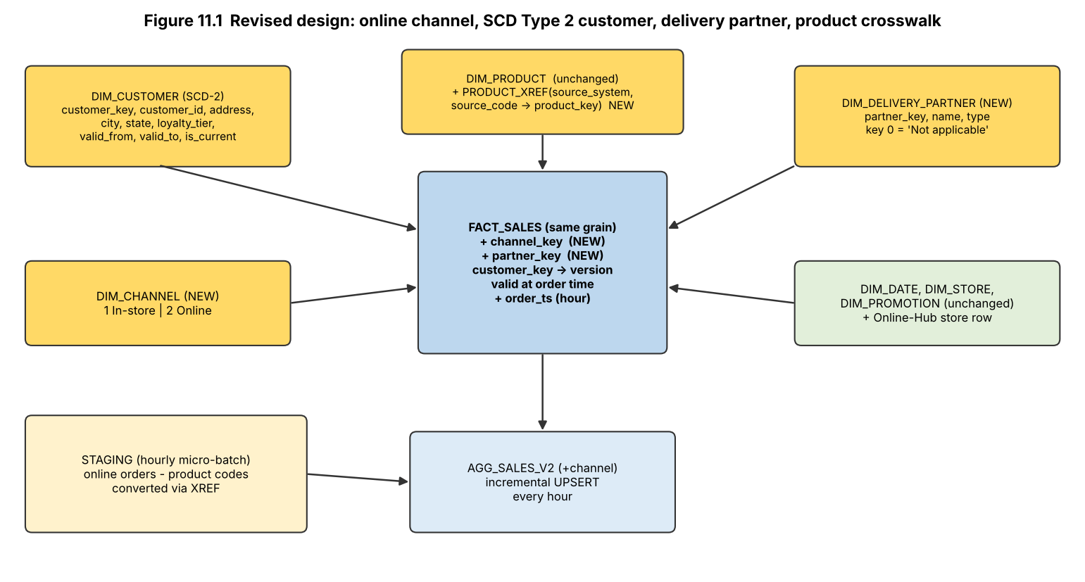
Figure 11.1 - Revised design (new/changed structures in yellow).
- SCD Type 2 customer: customer_key identifies a version; when address or tier changes the current row is closed (valid_to = change time, is_current = 0) and a new row is inserted. The fact load looks up the customer version with valid_from <= order time < valid_to, so reports use the address and tier that applied at the order.
- New dimensions: DIM_CHANNEL (1 In-store, 2 Online) and DIM_DELIVERY_PARTNER (0 = 'Not applicable' for in-store, so existing rows stay valid); both keys are added to FACT_SALES with defaults so the 1,000,000 existing rows needed no rewrite (the DDL and back-fill took 0.17 s).
- PRODUCT_XREF (source_system, source_code -> product_key): conforms the online code format to the single product dimension; an unmatched code creates an inferred member.
- Hourly micro-batch ETL: stage the hour's online orders -> apply SCD-2 changes -> look up surrogate keys (product via XREF, customer version as of order time) -> append to fact_sales -> UPSERT the delta into agg_sales_v2 (INSERT ... ON CONFLICT DO UPDATE adds the batch's sums to the existing group) instead of rebuilding it.
-- SCD-2 change (simplified)
UPDATE dim_customer SET valid_to = :ts, is_current = 0 WHERE customer_id = :id AND is_current = 1;
INSERT INTO dim_customer(customer_id, ..., city, loyalty_tier, valid_from, valid_to, is_current) VALUES (:id, ..., :new_city, :new_tier, :ts, '9999-12-31', 1);
-- fact load with as-of-order customer version and product crosswalk
INSERT INTO fact_sales(..., customer_key, product_key, channel_key, partner_key, ...)
SELECT ..., cs.customer_key, x.product_key, 2, g.partner FROM stg g
JOIN product_xref x ON x.source_system='ONLINE' AND x.source_code=g.pcode
JOIN dim_customer cs ON cs.customer_id=g.customer_id AND g.ts >= cs.valid_from AND g.ts < cs.valid_to;
-- incremental aggregate merge
INSERT INTO agg_sales_v2(...) SELECT ... FROM <new batch rows> GROUP BY ... ON CONFLICT(...) DO UPDATE SET net_sales = net_sales + excluded.net_sales, ...;

D. Evidence-Based Defence (2 marks)
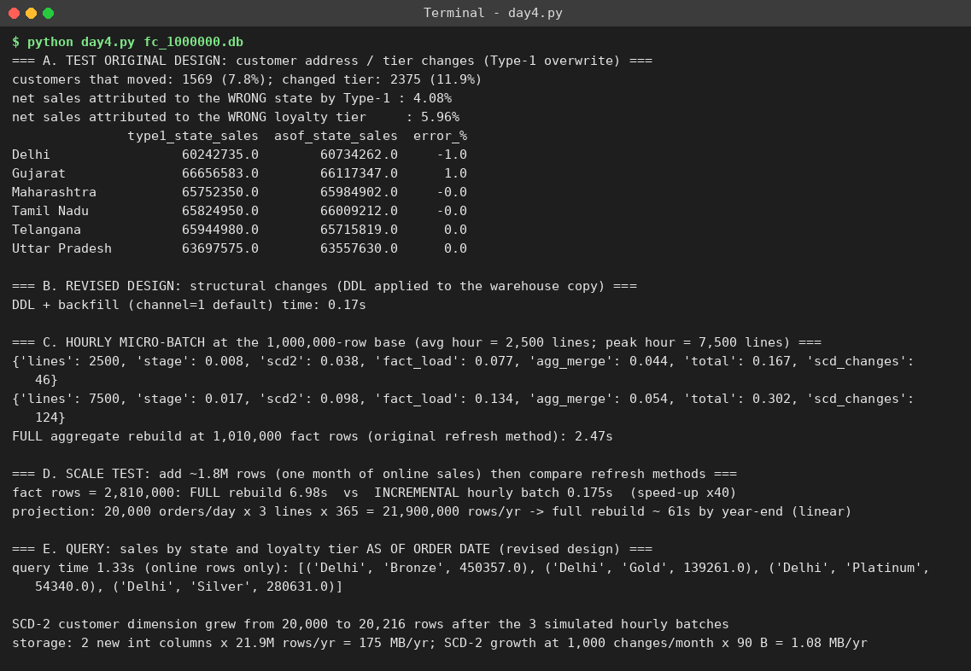
Figure 11.2 - Output of day4.py: Type 1 error test, revised-design DDL, hourly micro-batch timings, scale test.
Measurement (1,000,000-row base) | Result
Hourly micro-batch, average hour (2,500 lines) | 0.167 s total: stage 0.008 + SCD-2 0.038 (46 changes) + fact load 0.077 + aggregate merge 0.044
Hourly micro-batch, peak hour (7,500 lines) | 0.302 s total (124 SCD-2 changes) - about 0.01% of the 3,600 s hourly window
Full aggregate rebuild (original method) | 2.47 s at 1.01 M rows; 6.98 s at 2.81 M rows; ~61 s projected at 22 M rows
Incremental batch at 2.81 M rows | 0.175 s - essentially unchanged: 40x faster than full rebuild and independent of history size
Query 'sales by state and tier as of order time' (2.81 M rows, no extra index) | 1.33 s - acceptable for ad-hoc use; dashboards read agg_sales_v2 (ms)
Storage | SCD-2 customer dimension 20,000 -> 20,216 rows after 3 hourly batches; at ~1,000 changes/month about 1.1 MB/year. Two new int columns on 21.9 M rows/year = 175 MB/year
Correctness | Type 2 as-of-order join removes the 4.08% (state) and 5.96% (tier) misattribution of Type 1
Table 11.3 - Evidence supporting the decision to modify (not replace) the design.
Why modify rather than retain or fully redesign: the star grain, dimensions, hierarchies, cube lattice, OLAP queries and the architecture all remained valid (Part A), so a full redesign would throw away working structures; but retaining the design fails on correctness (Type 1) and on refresh economics (full rebuild). The changes are additive and cheap (0.17 s DDL on 1M rows).
What I would monitor after deployment:
- Micro-batch duration against the 3,600 s window (alert at 50%) and rows loaded per batch vs rows extracted (audit balance).
- Unknown-member rate (lines with product/store/customer = -1) and unmapped ONL- codes in the crosswalk; delivery-partner null rate.
- SCD-2 dimension growth and the share of customers with more than 5 versions (churn of address/tier).
- Aggregate-versus-fact reconciliation (SUM(net) in agg_sales_v2 = SUM(net) in fact_sales, daily); late-arriving data volume.
- Query latency of dashboards (95th percentile), fact table and index growth (about 175 MB/year plus indexes), and when to partition the fact by month or move to columnar storage.

MARK DISTRIBUTION
Task | Marks
Task 1 – Decision-Support Requirement | 4
Task 2 – Warehouse Architecture | 3
Task 3 – Star Schema Design | 6
Task 4 – Snowflake Comparison | 4
Task 5 – ETL Design | 5
Task 6 – Data Cube and OLAP Operations | 5
Task 7 – OLAP Application | 5
Task 8 – Query Processing Performance | 4
Task 9 – KNIME Reporting Workflow | 3
Task 10 – Final Design Recommendation | 3
Subtotal | 42
Task 11 – Day-4 Design Challenge | 8
TOTAL | 50

