
DEPARTMENT OF COMPUTER SCIENCE AND ENGINEERING
CSA1611 Data Warehousing and Data Mining
Assignment 2 – CO2
Student Name | Akash B | Register No. | 192511257
Course | CSA1611 Data Warehousing and Data Mining | Assessment | Assignment 2 – CO2

CO2 Coverage: Data mining from a database perspective, data mining functionalities, steps in the data mining process (KDD), architecture and classification of data mining systems, basic data mining tasks and issues, data dispersion, data cleaning, integration, transformation, reduction and discretization.

Course Outcome: CO2 – Analyse data dispersion techniques and list the various algorithms available for mining the data.

Nature: Individual | Duration: 1 Week | Total Marks: 50

Q1 – Matching Business Problems to Mining Functionalities (5 Marks)

1.1 Mapping of the six TeleNova problems
# | Functionality | Learning type / knowledge produced | Attributes required & data source | Candidate algorithms & reason
P1 Plans & add-ons bought together | Association analysis | Unsupervised; rules such as {Plan-X} ⇒ {Roaming pack} (support, confidence, lift) | Customer-id, plan-id, add-on-id, purchase date. Source: billing/sales fact table in the data warehouse (transaction database) | Apriori (level-wise, prunes by the anti-monotone property); FP-growth (no candidate generation, faster on 8 M subscribers)
P2 Will a customer leave next month? | Classification (predicting the class label churn = Yes/No for a given customer) | Supervised; a classification model / decision rules | Tenure, plan, ARPU, complaints, recharge pattern, usage trend, churn label of past months. Source: warehouse (CRM + billing + usage integrated) | Decision tree (ID3/C4.5 – interpretable rules for retention team); Naïve Bayes (fast, handles many categorical attributes); k-NN as a baseline
P3 Natural usage segments, no labels | Clustering | Unsupervised; groups (segments) with centroids | Voice minutes, data MB, SMS count, night-time share, roaming share. Source: usage summary tables in the warehouse | k-means (scalable to 8 M rows, easy to explain); hierarchical / BIRCH or DBSCAN (to check number and shape of clusters)
P4 SIMs with very different calling behaviour | Outlier (anomaly) analysis | Unsupervised; list of outlying SIMs | Calls/day, average call duration, distinct numbers called, international ratio. Source: call-detail records (operational database) summarised in warehouse | Statistical z-score / IQR test (distribution-based); density/distance-based method such as LOF or DBSCAN noise points
P5 Characteristics of high-value vs low-value customers | Concept / class description (characterisation + discrimination) | Descriptive (data is already grouped by value class); generalised summaries, comparison tables | ARPU, tenure, plan type, age band, region, value class. Source: data warehouse / OLAP cube | Attribute-oriented induction and OLAP roll-up/drill-down (characterisation); class comparison tables / decision-tree for discrimination
P6 How monthly data usage changed over 24 months | Evolution analysis (time-series / trend analysis) | Descriptive over time; trends, seasonal patterns, change points | Customer-id, month, data-usage MB. Source: warehouse fact table with a time dimension | Time-series trend analysis (moving average, regression trend); sequential-pattern / similarity search on usage series

Table 1.1 – Six business problems mapped to mining functionality

1.2 Design decision – the “all-purpose mining algorithm” proposal
Recommendation: reject the proposal. The evidence from Table 1.1 is:
- The six problems need six different kinds of knowledge. Rules (P1), a label predictor (P2), groups (P3), exceptions (P4), summaries (P5) and trends (P6) are different outputs; an algorithm designed to produce one cannot produce another.
- Different learning settings. P2 is supervised and needs labelled history; P1, P3, P4 are unsupervised and have no labels; P5 and P6 are descriptive. One algorithm cannot be both trained with labels and run without them.
- Different input shapes. P1 works on transactions (itemsets), P3/P4 on numeric vectors, P6 on ordered time series, P5 on aggregated cube cells. Forcing them into one representation loses information.
- Different quality measures. Support/confidence/lift (P1), accuracy/recall (P2), silhouette (P3), precision of flagged SIMs (P4) – there is no single success criterion.
- No single algorithm is best for every problem (the “no free lunch” idea), and a black box would not give the interpretable rules the marketing team needs for P1, P2 and P5.
Better decision: buy or build one mining platform (a toolbox) that contains Apriori/FP-growth, decision trees, k-means, outlier detectors and OLAP/time-series tools on a shared warehouse, and choose the algorithm per problem as in Table 1.1.

Q2 – The KDD Process, System Architecture and Mining Issues (5 Marks)

2.1 KDD steps mapped to MediCore activities
KDD step | Activities MediCore must perform
1. Selection | Define the goal (predict 30-day readmission). Select relevant tables/attributes from admission (age, diagnosis, length of stay, discharge type), laboratory (creatinine, HbA1c, haemoglobin), pharmacy (number and type of drugs, changes at discharge) and billing (procedures, insurance class). Choose the patient cohort and the time window.
2. Preprocessing (cleaning + integration) | Match the same patient across the four systems (common patient-id / probabilistic matching); remove duplicates; handle missing lab values and impossible values; standardise units and codes (ICD, drug names); de-identify names and contact details.
3. Transformation | Derive the label readmitted_30d from admission dates; construct attributes (number of previous admissions, comorbidity count, lab trend); normalise numeric attributes; generalise ICD codes to disease groups; discretise age into bands; reduce attributes.
4. Data mining | Apply classification (decision tree, Naïve Bayes) to predict readmission, association mining for drug/diagnosis combinations, clustering of patient types, and outlier analysis for abnormal stays.
5. Interpretation / evaluation | Evaluate on unseen patients (recall on readmitted patients, precision, lift); remove redundant or trivial patterns; clinicians review the patterns; visualise rules; deploy as a risk score and feed the new knowledge back into the knowledge base.

Table 2.1 – KDD process for MediCore

2.2 Architecture of the data mining system
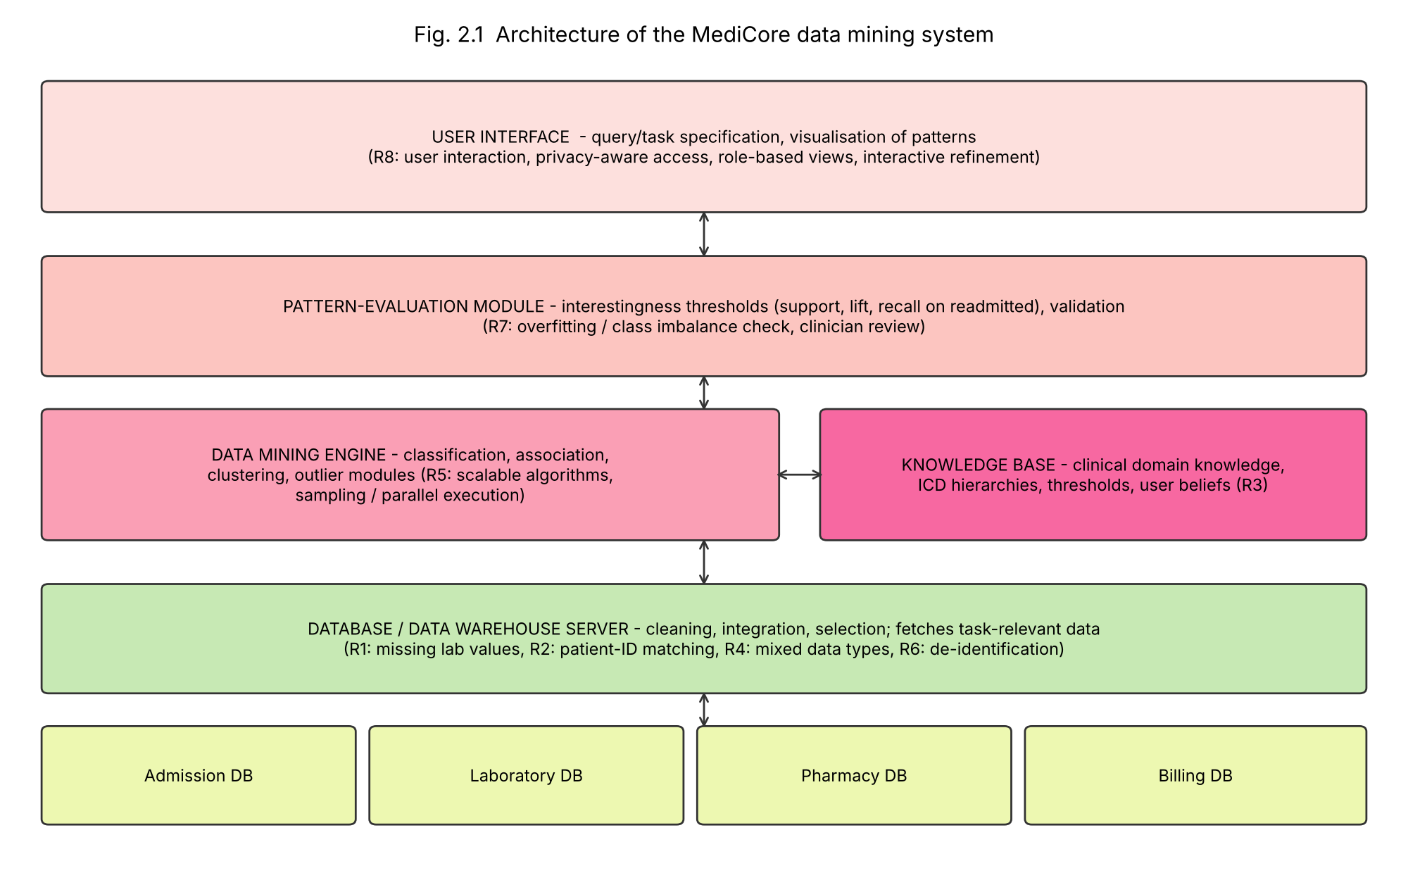
Fig. 2.1 – Architecture of the MediCore mining system, with the requirements R1–R8 marked where they are handled
Req. | Requirement of MediCore | Handled in
R1 | Missing / noisy laboratory values | Database / warehouse server (cleaning)
R2 | Matching patients across 4 source systems | Database / warehouse server (integration)
R3 | Clinical domain knowledge (ICD hierarchy, normal lab ranges, clinician beliefs) | Knowledge base
R4 | Mixed data: numeric, codes, dates, free-text notes | Database / warehouse server (transformation)
R5 | Millions of lab and billing records – scalability | Mining engine (sampling, parallel, scalable algorithms)
R6 | Patient privacy (de-identification, access control) | Database / warehouse server and user interface
R7 | Validation of patterns, class imbalance (few readmissions) | Pattern-evaluation module
R8 | Interactive use by clinicians, easy-to-read output | User interface

Table 2.2 – Requirements handled by architecture component

2.3 Classification of the system on four views
View | Classification for MediCore
Kinds of data mined | Relational and warehouse data (admission, lab, pharmacy, billing), temporal data (admission dates, lab trends); optionally text (discharge notes)
Kinds of knowledge mined | Classification and prediction (main goal: readmission risk); also association (drug combinations), characterisation of readmitted patients, outlier analysis
Techniques utilised | Machine-learning/statistical techniques (decision trees, Naïve Bayes), data-warehouse/OLAP-based summarisation, data-cleaning and visualisation techniques; query-driven, interactive
Applications adapted | Healthcare – hospital quality improvement, discharge planning, resource allocation

Table 2.3 – Classification of the MediCore system

2.4 Data mining issues specific to MediCore
Category | Issue in this scenario | Mitigation
Mining methodology | Readmissions are rare (class imbalance) and labels are noisy | Stratified sampling, class weights, evaluate with recall/precision rather than accuracy
User interaction | Clinicians will not trust a black box; need to refine the task | Interpretable models (trees/rules), interactive drill-down, incorporate domain knowledge
Efficiency and scalability | Millions of lab and billing rows across four systems | Warehouse pre-aggregation, attribute reduction, sampling, incremental/parallel algorithms
Diversity of data types | Numbers, ICD codes, dates, free-text notes, different units | Transformation to a common schema, code generalisation, text features extracted separately
Privacy and social impact | Sensitive health data; risk of discrimination | De-identification, role-based access, audit logs, privacy-preserving mining, check bias across groups, comply with law
Data quality / integration | Same patient with different ids; missing lab tests | Entity-matching rules, missing-value handling with indicators, data-quality dashboard

Table 2.4 – Issue–mitigation table

2.5 Reply to the director: “We already have SQL and statistics”
Tool | Example at MediCore | What it gives
SQL query | SELECT patient_id FROM admissions WHERE readmitted_30d = 1; | Retrieves facts that are already stored. The analyst must know exactly what to ask.
Basic statistical summary | Readmission rate, mean length of stay, median age of readmitted patients | Describes what happened in the whole data set; one or two attributes at a time.
Data mining | Build a decision tree on age, diagnosis, number of drugs, creatinine trend, previous admissions, discharge type to find which combinations predict readmission, then score new patients | Discovers unknown, multi-attribute patterns, validates them on unseen patients and produces a model that can predict for tomorrow’s patient.

A query cannot find “diabetic patients above 65 discharged on 5 or more drugs with rising creatinine are 3 times more likely to return”, because nobody knew to ask for that combination. A statistical summary can show the average, but it does not search the huge space of attribute combinations nor build a predictive model. SQL and statistics are therefore useful inside KDD (selection, preprocessing, summaries) but do not replace mining. (The rule above is illustrative of the kind of pattern mining finds, not a real finding.)

Q3 – Describing and Comparing Data Dispersion (7 Marks)
Data (n = 24, already sorted): 28, 31, 33, 35, 35, 36, 38, 40, 41, 42, 42, 43, 45, 46, 48, 50, 52, 53, 55, 58, 61, 64, 72, 95

3.1 Central tendency (manual)
- Σx = 1143, so mean = 1143 / 24 = 47.625
- n is even, so the median is the average of the 12th and 13th values: (43 + 45)/2 = 44
- Mode: 35 and 42 each appear twice – the data is bimodal (35 and 42)
- Midrange = (min + max)/2 = (28 + 95)/2 = 61.5
Interpretation: mean (47.6) > median (44) > mode (35, 42), which indicates a right-skewed (positively skewed) distribution, a long tail caused by the slow deliveries 72 and 95 (computed skewness = 1.42). The midrange is very sensitive to the extreme value 95.

3.2 Dispersion (manual)
Quartile convention used: the median of each half (Tukey / “exclusive” method). The lower half is the first 12 values, the upper half the last 12.
- Range = 95 − 28 = 67
- Q1 = median of lower half = (36 + 38)/2 = 37; Q3 = median of upper half = (53 + 55)/2 = 54; IQR = 54 − 37 = 17
- Σx² = 59,555; SS = Σx² − (Σx)²/n = 59,555 − 1143²/24 = 59,555 − 54,435.375 = 5,119.625
- Sample variance s² = SS/(n−1) = 5,119.625/23 = 222.59; standard deviation s = √222.59 = 14.92 (population version: 213.32 and 14.61)

3.3 Five-number summary, boxplot and outliers
Min | Q1 | Median | Q3 | Max
28 | 37 | 44 | 54 | 95

1.5 × IQR rule: 1.5 × 17 = 25.5. Lower fence = 37 − 25.5 = 11.5; upper fence = 54 + 25.5 = 79.5. The value 95 > 79.5 is an outlier; 72 is inside the fence (not an outlier); no value is below 11.5.
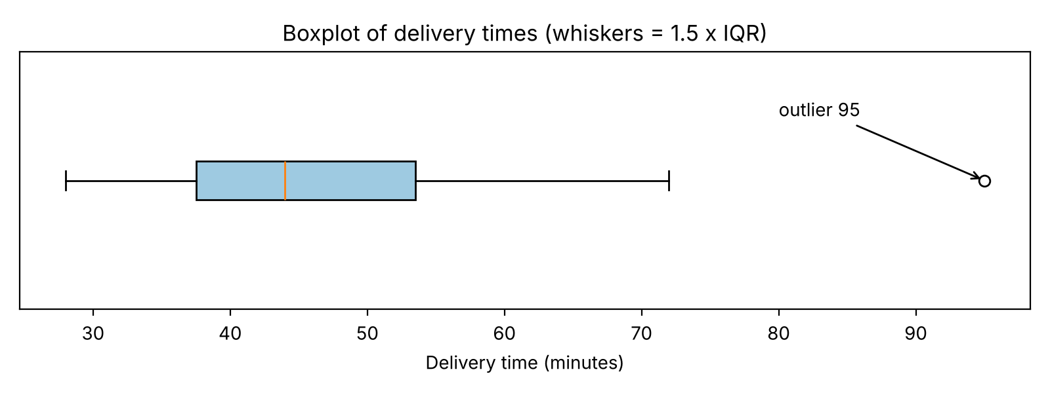
Fig. 3.1 – Boxplot of the 24 delivery times; the point at 95 minutes is the only outlier

3.4 After removing the largest value (95), n = 23
Σx = 1048, mean = 45.57; median = 12th value = 43; Q1 = 36 (median of first 11 values), Q3 = 53 (median of last 11 values), IQR = 17; range = 72 − 28 = 44; midrange = 50; variance = 126.26; SD = 11.24; no outlier remains (fences 10.5 and 78.5).
Measure | With 95 | Without 95 | Change
Mean | 47.63 | 45.57 | −4.3 %
Median | 44 | 43 | −2.3 %
Midrange | 61.5 | 50 | −18.7 %
Range | 67 | 44 | −34.3 %
Q1 / Q3 | 37 / 54 | 36 / 53 | −2.7 % / −1.9 %
IQR | 17 | 17 | 0 %
Variance | 222.59 | 126.26 | −43.3 %
Std. deviation | 14.92 | 11.24 | −24.7 %

Table 3.1 – Effect of removing the outlier
The measures that changed most are the variance (−43 %), range (−34 %), standard deviation (−25 %) and midrange (−19 %). The reason: they depend directly on the extreme values (range, midrange) or on squared deviations from the mean (variance, SD), so one value 47 minutes above the mean contributes a huge share of Σ(x − mean)². The median, quartiles and IQR are position-based and barely moved – they are robust measures.

3.5 Classification of the measures
Measure | Class | Why / use with warehouse partitions
Mean | Algebraic | = sum/count; each partition returns (sum, count) – 2 distributive values; combine them.
Variance, standard deviation | Algebraic | Computed from (count, Σx, Σx²), each of which is distributive and can be added across partitions.
Range | Algebraic (max − min) | Each partition returns its min and max (distributive); global range = global max − global min.
Median | Holistic | No fixed-size summary per partition is enough; needs all the data (or an approximation such as histograms / quantile sketches). Medians of partition medians are not the global median.

Table 3.2 – Distributive / algebraic / holistic measures. (Sum, count, min and max are the distributive building blocks.) Implication: with data spread across many warehouse partitions, mean, variance, SD and range can be computed in parallel and combined cheaply, whereas the exact median and quartiles are expensive and are usually approximated.

3.6 Verification with a tool
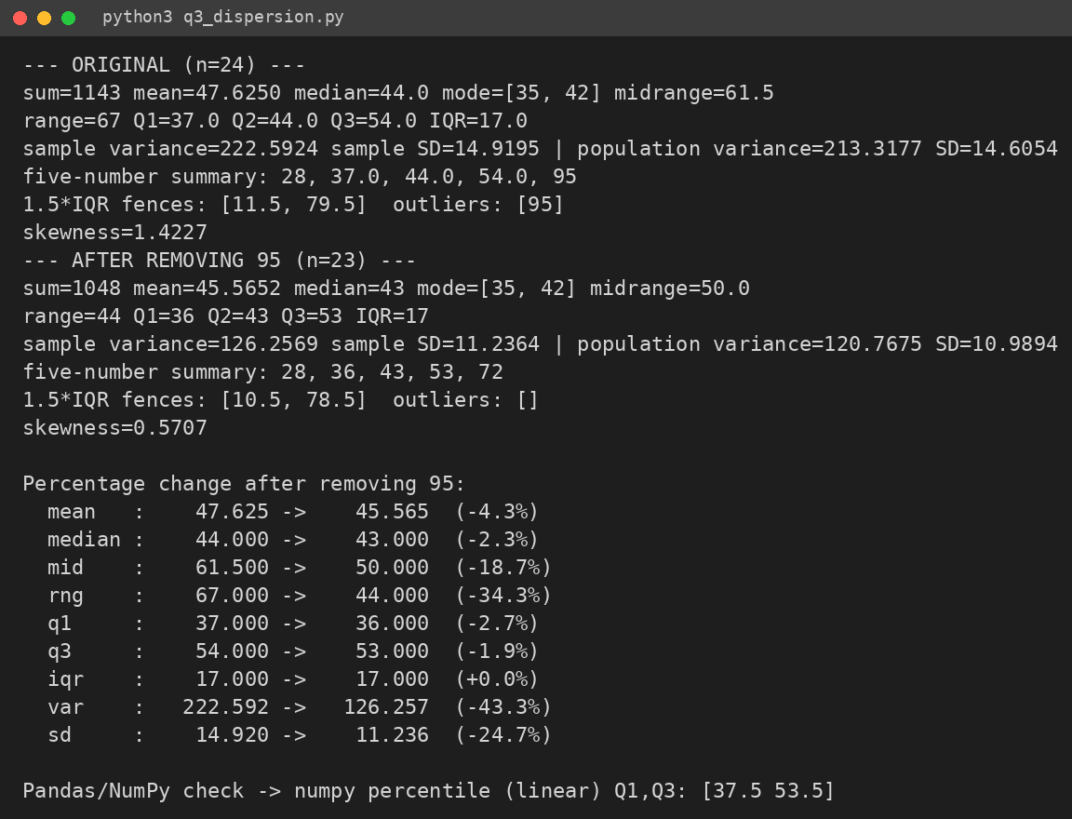
Screenshot 3.1 – Output of q3_dispersion.py (Python)
All manual values (mean 47.625, median 44, Q1 37, Q3 54, IQR 17, s² 222.59, s 14.92, outlier 95) match the program. The only difference: NumPy’s default percentile uses linear interpolation and gives Q1 = 37.5 and Q3 = 53.5, because it uses a different quartile convention than the median-of-halves rule used by hand. Likewise, NumPy’s var/std default is the population version (ddof = 0), so ddof = 1 was set to match the sample formula. Neither difference changes the outlier conclusion.

3.7 Inquiry – which “typical” delivery time to promise?
Recommend the median (44 minutes) as the typical value because the distribution is right-skewed and has an outlier, so the mean (47.6) is pulled upward by 72 and 95. Because a customer cares about being late, also report the spread/upper tail: the IQR (37–54 min, i.e. the middle 50 % of orders) and a high percentile such as the 75th (54 min) or 90th (about 63 min), plus the count of outliers. For example: “Typical delivery 44 minutes; 3 out of 4 orders arrive within 54 minutes.” Reporting only the median would hide the slow tail; reporting only the mean would overstate the typical time.

Q4 – Cleaning Noisy and Incomplete Data (6 Marks)

4.1 Defects in the extract
Meter | Value | Defect | Category
M102 | kWh = (missing) | Value absent | Missing value
M105 | Household type = (missing) | Value absent | Missing value
M104 | kWh = −14 | Energy consumption cannot be negative | Invalid value
M105 | Voltage = 2300 | 10× nominal 230 V – physically impossible for household supply, probably a decimal/typing error | Invalid value (gross noise)
M103 | Region = ‘north’ | Same region spelt in different case from ‘North’ | Inconsistency
M106 | Region = ‘S.’ | Abbreviation of ‘South’ used by another source | Inconsistency

Table 4.1 – Defect list. Other values (229–232 V, 5, 11, 19 and 38 kWh) are plausible; 5 kWh is low but legitimate.

4.2 Handling strategies
Defect | Strategy | Justification
M102 missing kWh | Class-wise mean (mean kWh of Apartments), or regression on voltage/previous hours | Consumption depends on household type, so the Apartment mean is better than the global mean; ignoring the tuple wastes the other 4 fields.
M105 missing household type | Fill manually from the meter registry (master data); otherwise most probable value by inference | Household type is a fixed attribute of the meter and can be looked up; a model could predict it from consumption, but the registry is exact.
M104 kWh = −14 | Treat as missing and impute with the class-wise mean (House), after checking the meter log; do not just flip the sign | The cause is unknown (reverse flow, sign error); guessing 14 could introduce a wrong value.
M105 voltage 2300 | Fill manually / correct by rule to 230 after verifying against device specification; if not verifiable, set to missing and use the attribute mean (≈230) | Voltage is almost constant, so the attribute mean is close to the truth; the tuple is otherwise valid so is not ignored.
Region spellings | Standardise with a mapping table (north → North, S. → South) | An inconsistency, not a missing value – fixed by a consistency rule, no statistics needed.

Table 4.2 – Strategy table

4.3 Equal-frequency binning (depth 4) on the 12 sorted values
Bin | Values | Smoothing by bin means | Smoothing by bin boundaries
Bin 1 | 5, 9, 11, 14 | mean = 39/4 = 9.75 → 9.75, 9.75, 9.75, 9.75 | 5, 5, 14, 14 (9 is closer to 5 [4 vs 5]; 11 is closer to 14 [3 vs 6])
Bin 2 | 18, 19, 23, 26 | mean = 86/4 = 21.5 → 21.5 ×4 | 18, 18, 26, 26 (19→18; 23→26)
Bin 3 | 27, 30, 33, 38 | mean = 128/4 = 32 → 32 ×4 | 27, 27, 38, 38 (30→27; 33→38)

Table 4.3 – Binning. Bin means are rounded only for display.

4.4 Regression, clustering and the difference between 2300 V and 5 kWh
- Regression: fit kWh (or voltage) against explanatory variables such as hour of day and household type; a reading far from the fitted line (residual larger than about 3 standard errors) is likely noise and can be replaced by the fitted value.
- Clustering: group readings by similarity; values that fall in no cluster (far from all centroids) are outliers/noise and can be reviewed, or replaced by the cluster centre.
- 2300 V vs 5 kWh: 5 kWh is a statistically unusual-looking but valid reading – it is possible for a small apartment, so smoothing it would destroy real information. 2300 V violates a domain constraint (nominal supply is about 230 V) and is an error, not natural variation; it must be corrected or removed using domain rules, not smoothed by binning with neighbouring values.

4.5 Inquiry – replacing all missing values with the global mean
Mean imputation keeps the mean unchanged but shrinks dispersion: every filled value sits exactly at the centre, so the variance falls roughly in proportion to the share of missing values (variance × about (1 − p)). A simulation with 30 % missing values (Screenshot 4.1) reduced SD from 8.04 to 6.77 (variance factor 0.71 ≈ 1 − 0.30). Effects on mining: an artificial spike at the mean; correlations are weakened; clusters become artificially compact; real outliers look less extreme; classifiers become over-confident; confidence intervals are too narrow. It should be avoided when many values are missing (above roughly 5–10 %), when the data are not missing completely at random (missingness itself carries information), when the attribute is skewed (the mean is not typical – use the median), when the attribute is a key predictor, or when later tasks are clustering or outlier detection. Better: class-wise mean, regression/most-probable value, multiple imputation, and a missing-indicator attribute. In the Q7 data set the 8.7 % missing incomes already reduced the SD from 41,067 to 39,244 when filled with the mean.
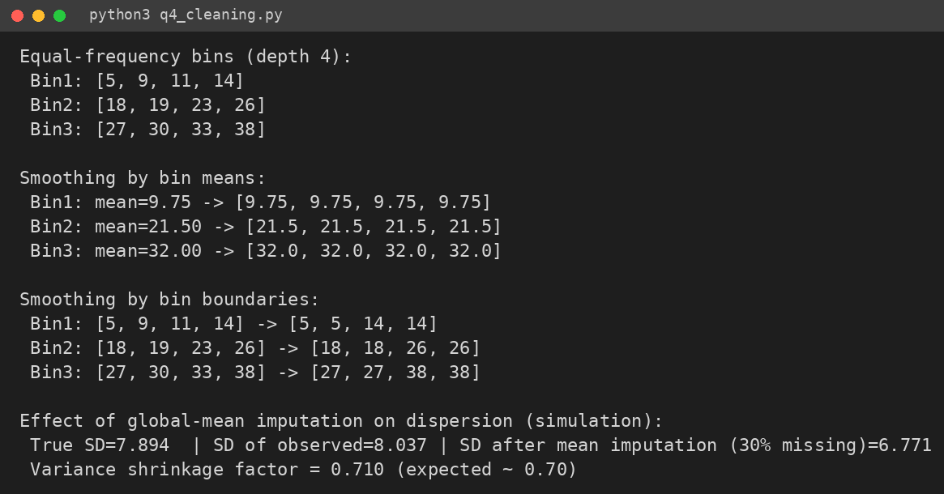
Screenshot 4.1 – Output of q4_cleaning.py (binning and mean-imputation experiment)

Q5 – Integration and Transformation of Data (7 Marks)

Part A – Integration
Conflict type | Admissions DB | LMS | Resolution in integrated schema
Entity identification | student_id | sid | Both identify the same student; map sid → student_id using a cross-reference table (check ID format, e.g. leading zeros/prefix); use dob + name only as fallback matching key
Naming | name; dob | full_name | Rename to full_name; keep dob; standardise ‘surname, first’ vs ‘first surname’ spelling
Naming (same meaning) | scholarship | scholarship_flag | Both describe scholarship status; keep one attribute scholarship_flag
Unit / format | dob (e.g. DD-MM-YYYY) | attendance_pct (0–100 or fraction), marks (out of 100 or weighted) | dob → ISO YYYY-MM-DD; attendance_pct stored as 0–100; marks converted to a common scale out of 100
Value | hostel_status (Hostel / Day / H / D); scholarship (Yes/No or amount) | scholarship_flag (1/0 or Y/N) | Common domain: hostel_status ∈ {Hostel, Day scholar}; scholarship_flag ∈ {Y, N}; resolve any disagreement by trusting the Admissions (authoritative) source

Table 5.1 – Conflict-resolution table (the question does not list the stored values, so the typical value formats are stated as assumptions). Integrated schema: Student(student_id, full_name, dob, hostel_status, scholarship_flag, attendance_pct, marks).
Why redundancy appears: the same attribute under two names (scholarship / scholarship_flag), derived attributes (age from dob), or attributes that carry the same information (e.g. attendance and marks). Redundancy wastes storage, slows mining and can mislead models (multicollinearity). Correlation analysis (Pearson r for numeric, χ² for nominal attributes) measures the strength of the relationship: |r| close to 1 or a large χ² means one attribute can largely be derived from the other, so one of them can be dropped.

Part B – Redundancy analysis

B1. Pearson correlation between attendance (x) and marks (y)
x | y | x − x̄ | y − ȳ | (x − x̄)(y − ȳ) | (x − x̄)² | (y − ȳ)²
60 | 52 | −16.667 | −16.333 | 272.22 | 277.78 | 266.78
70 | 58 | −6.667 | −10.333 | 68.89 | 44.44 | 106.78
75 | 66 | −1.667 | −2.333 | 3.89 | 2.78 | 5.44
80 | 70 | 3.333 | 1.667 | 5.56 | 11.11 | 2.78
85 | 79 | 8.333 | 10.667 | 88.89 | 69.44 | 113.78
90 | 85 | 13.333 | 16.667 | 222.22 | 177.78 | 277.78
Σ=460 | Σ=410 |  |  | 661.67 | 583.33 | 773.33

x̄ = 460/6 = 76.667, ȳ = 410/6 = 68.333. r = 661.67 / √(583.33 × 773.33) = 661.67 / 671.67 = 0.985. Interpretation: a very strong positive linear relationship – students with higher attendance score higher marks. Because |r| is so high, the attributes are largely redundant for a predictive model (one could be dropped or combined), but correlation does not prove that attendance causes higher marks.

B2. χ² test: hostel status vs scholarship
Observed (Expected) | Scholarship | No scholarship | Total
Hostel | 120 (85.71) | 180 (214.29) | 300
Day scholar | 80 (114.29) | 320 (285.71) | 400
Total | 200 | 500 | 700

Expected = row total × column total / grand total: E(Hostel, Sch) = 300×200/700 = 85.71; E(Hostel, No) = 300×500/700 = 214.29; E(Day, Sch) = 400×200/700 = 114.29; E(Day, No) = 400×500/700 = 285.71.
χ² = (120−85.71)²/85.71 + (180−214.29)²/214.29 + (80−114.29)²/114.29 + (320−285.71)²/285.71 = 13.714 + 5.486 + 10.286 + 4.114 = 33.60. df = (2−1)(2−1) = 1; critical value = 3.84. Since 33.60 > 3.84, we reject independence at the 0.05 level: hostel status and scholarship are associated (40 % of hostel students hold a scholarship versus 20 % of day scholars). Association is not causation, and the attributes are not duplicates, so both can be kept.

Part C – Transformation

C1. Normalisation of income (20,000; 35,000; 50,000; 80,000; 150,000)
Income | Min-max (0–1) | z-score (population SD) | Decimal scaling (j = 6)
20,000 | 0.0000 | −1.0217 | 0.020
35,000 | 0.1154 | −0.6957 | 0.035
50,000 | 0.2308 | −0.3696 | 0.050
80,000 | 0.4615 | 0.2826 | 0.080
150,000 | 1.0000 | 1.8043 | 0.150

Min-max: (v − 20,000)/(150,000 − 20,000), e.g. 35,000 → 15,000/130,000 = 0.1154. z-score: mean = 335,000/5 = 67,000; population SD = √(10.58×10⁹/5) = 46,000; e.g. (35,000 − 67,000)/46,000 = −0.6957 (using the sample SD 51,430 the z-scores would be −0.914 … 1.614). Decimal scaling: j = smallest integer with max|v′| < 1: 150,000/10⁶ = 0.15 (10⁵ would give 1.5, too large), so j = 6.

C2. Euclidean distance before and after normalisation
Before: A = (19, 35,000), B = (21, 80,000): d = √(2² + 45,000²) = √(4 + 2,025,000,000) ≈ 45,000.00002.
After min-max: age (19−17)/8 = 0.25 and (21−17)/8 = 0.50; income 0.1154 and 0.4615. d = √((0.25)² + (0.3462)²) = √(0.0625 + 0.1198) = 0.427.
What this reveals: before normalisation the distance is completely dominated by income (the age difference contributes 4 out of 2,025,000,004 – essentially 0 %), so a distance-based method (k-NN, k-means, hierarchical clustering) would effectively ignore age. After normalisation age contributes about 34 % and income 66 % of the squared distance, so both attributes count. Normalisation is therefore needed before distance-based mining.

C3. Examples of aggregation, generalisation and attribute construction
- Aggregation: daily attendance records → monthly / semester attendance_pct per student, or student marks → average marks per department.
- Generalisation: dob → age group (17–19, 20–22); marks → grade (A/B/C); individual hostel blocks → Hostel.
- Attribute construction: age computed from dob; performance_index = 0.5 × attendance_pct + 0.5 × marks; scholarship_per_mark ratio.
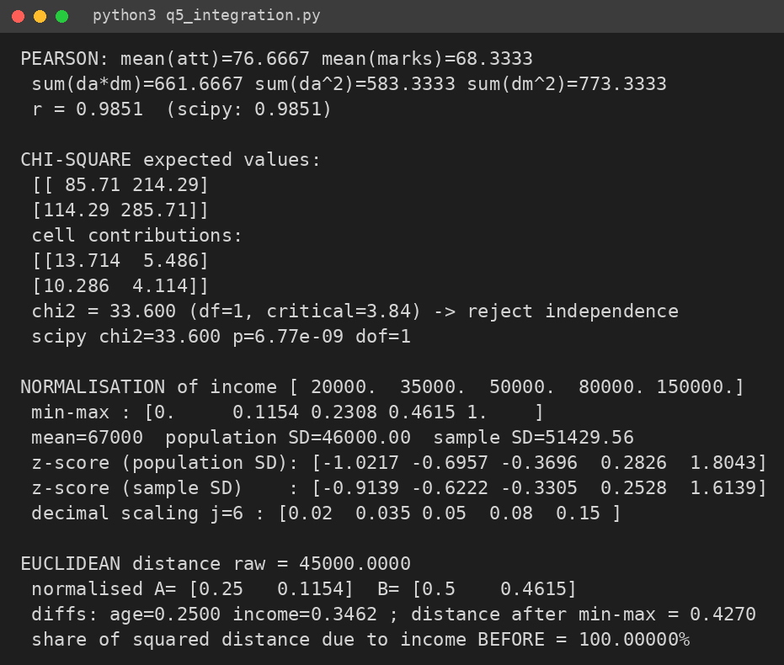
Screenshot 5.1 – Output of q5_integration.py (verifies r, χ², normalisation and distances)

Q6 – Data Reduction and Discretization (7 Marks)

Part A – Choosing reduction strategies for 200 sensors × 5 million rows/month
Category | Technique | When suitable for this data
Data-cube aggregation | Roll up readings from seconds to hourly/daily min, max, mean per machine | When failures are detected at hourly level – cuts rows by 100× or more but loses second-level spikes
Attribute subset selection | Forward selection (add best attribute step by step); backward elimination (drop worst step by step); decision-tree induction (keep attributes used in the tree) | Many of the 200 sensors are irrelevant or duplicates (e.g. neighbouring temperature sensors); decision-tree induction is cheapest at this size and keeps interpretable sensors
Dimensionality reduction | PCA – projects correlated numeric sensors onto fewer uncorrelated components | Continuous, strongly correlated sensors (vibration, temperature, pressure); less suitable if engineers need to know which sensor failed
Numerosity reduction | Sampling; histograms (store bin counts); clustering (replace rows by cluster centres) | Sampling to prototype fast; histograms for distribution summary; clustering to compress normal operation
Compression | Lossless (gzip/run-length) for archives; lossy wavelet/PCA for signals | Lossless for raw archive; wavelet for high-frequency sensor signals when small distortion is tolerable

Table 6.1 – Reduction techniques

Sampling comparison (only 0.5 % rows are failures)
Method | How it works | Failure-detection suitability
SRS without replacement (SRSWOR) | Each row can be chosen once | Unbiased overall, but a 1 % sample of 5 M rows would hold only about 250 of the 25,000 failures – too few and varying
SRS with replacement (SRSWR) | A row can be picked repeatedly | Similar to SRSWOR; duplicates add nothing, rare class still rare
Cluster sampling | Randomly select whole groups (e.g. machines or days), keep all rows in them | Cheap, but if failures occur in only a few machines/days the sample may contain none
Stratified sampling | Divide into strata (failure / normal, or machine type) and sample each | Best: keep all (or most) failure rows and a smaller sample of normal rows; guarantees the rare class is represented (weights are kept or restored for evaluation)

Table 6.2 – Sampling methods. Number of principal components: standardise the sensors first, then keep the smallest number of components whose cumulative explained variance is at least 95 % (checked with the scree-plot elbow and the Kaiser rule eigenvalue > 1). Because failures may live in low-variance directions, the final number is validated by checking that failure recall does not fall when mining on the reduced data.

Part B – Discretization by calculation
Temperature (n = 20): 3, 7, 7, 9, 12, 14, 14, 15, 18, 21, 21, 22, 25, 25, 27, 31, 36, 36, 40, 44

Equal-width (4 intervals)
Width = (44 − 3)/4 = 10.25. Boundaries: 3, 13.25, 23.5, 33.75, 44.
Interval | Values | Count
[3, 13.25) | 3, 7, 7, 9, 12 | 5
[13.25, 23.5) | 14, 14, 15, 18, 21, 21, 22 | 7
[23.5, 33.75) | 25, 25, 27, 31 | 4
[33.75, 44] | 36, 36, 40, 44 | 4

Equal-frequency (4 bins, 20/4 = 5 values each)
Bin | Values | Interval | Count
1 | 3, 7, 7, 9, 12 | 3 – 12 | 5
2 | 14, 14, 15, 18, 21 | 14 – 21 | 5
3 | 21, 22, 25, 25, 27 | 21 – 27 | 5
4 | 31, 36, 36, 40, 44 | 31 – 44 | 5

Note that the value 21 occurs twice and lands in bins 2 and 3 – a standard drawback; in practice identical values are kept in the same bin.

Entropy-based split on labelled data
Data: 10(N) 12(N) 15(N) 18(N) 22(Y) 25(Y) 28(N) 31(Y) 35(Y) 40(Y): 5 N and 5 Y, so Info(S) = −½log₂½ − ½log₂½ = 1.000. For a split point t: Info_t(S) = (|S₁|/10)·H(S₁) + (|S₂|/10)·H(S₂); Gain = 1 − Info_t(S).
Split t | Left (N,Y) | Right (N,Y) | H(left) | H(right) | Info_t | Gain
11.0 | (1,0) | (4,5) | 0.000 | 0.991 | 0.892 | 0.108
13.5 | (2,0) | (3,5) | 0.000 | 0.954 | 0.764 | 0.237
16.5 | (3,0) | (2,5) | 0.000 | 0.863 | 0.604 | 0.396
20.0 (best) | (4,0) | (1,5) | 0.000 | 0.650 | 0.390 | 0.610
23.5 | (4,1) | (1,4) | 0.722 | 0.722 | 0.722 | 0.278
26.5 | (4,2) | (1,3) | 0.918 | 0.811 | 0.876 | 0.125
29.5 | (5,2) | (0,3) | 0.863 | 0.000 | 0.604 | 0.396
33.0 | (5,3) | (0,2) | 0.954 | 0.000 | 0.764 | 0.237
37.5 | (5,4) | (0,1) | 0.991 | 0.000 | 0.892 | 0.108

Table 6.3 – Information gain of the nine candidate split points. Example (t = 20): left = {10,12,15,18} all N → entropy 0; right = {22,25,28,31,35,40}, 1 N and 5 Y: H = −(1/6)log₂(1/6) − (5/6)log₂(5/6) = 0.650; Info = (4/10)·0 + (6/10)·0.650 = 0.390; Gain = 0.610. Best split point = 20 (gain 0.610). The process can be applied recursively to the right part to refine intervals.

Comparison
Equal-width and equal-frequency binning are unsupervised: they ignore the class label. Equal-width gives unbalanced intervals (5, 7, 4, 4) and is sensitive to outliers; equal-frequency gives balanced bins but can cut through groups of the same class and splits ties. Entropy-based discretization is supervised: it chooses the boundary (20) that best separates the classes – the left interval is 100 % N and the right is 83 % Y. For a classification task the supervised, entropy-based discretization is preferable because the intervals keep the class information; unsupervised binning is suitable for descriptive/clustering tasks where no label exists.
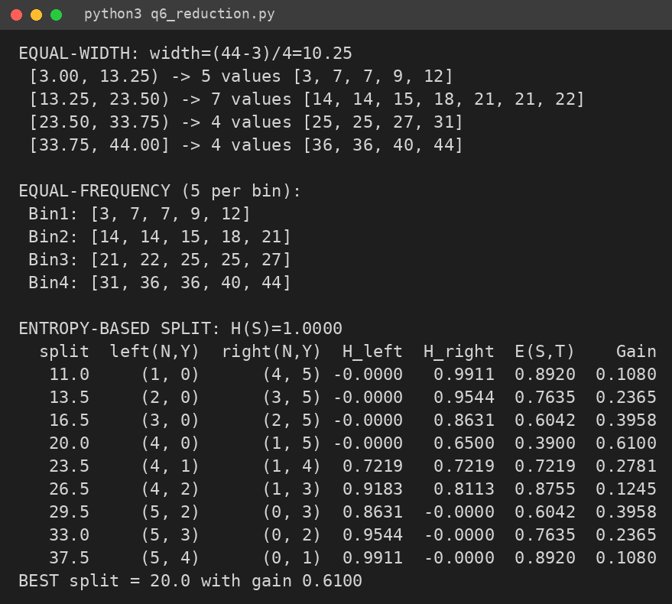
Screenshot 6.1 – Output of q6_reduction.py (interval counts and information gain)

Q7 – Day-4 Design Challenge: Diagnose, Redesign and Validate (13 Marks)

A. Diagnose the computational bottleneck / defects (2 marks)
# | Defect in pipeline | Principle violated | How it misleads the model / evaluation
1 | Missing income → global mean | Imputation must preserve distribution and use information; the mean is not typical for skewed data | Shrinks variance, creates artificial spike; hides that missing income is itself a risk signal (defaulters miss income more often)
2 | Occupation (18 % missing) dropped | Do not discard a useful attribute because of missing values – avoid information loss | Removes an attribute that explains default risk; model loses predictive power
3 | Right-skewed income cut into 5 equal-width bins | Discretization should respect the distribution | Most customers fall in the first one or two bins and the rich tail occupies the rest, so resolution where the data are dense is lost
4 | Min-max scaling on the complete dataset before splitting | Avoid data leakage – statistics must come from training data only | Test-set minimum/maximum influence training, so evaluation is optimistically biased
5 | Random 10 % sample for training with 3 % defaults | Sampling must keep the minority class (use stratification); do not throw away data unnecessarily | Only about 40–45 defaulters remain, the model learns “nobody defaults”
6 | Evaluated with accuracy only | Use metrics suitable for imbalanced classes | Predicting “no default” for everyone already gives 97 % accuracy – accuracy of 97 % proves nothing

Table 7.1 – Defects of the original pipeline

B. Design objective (2 marks)
Objective (measurable) | Target
Main metric: recall on defaulters (class 1) on an untouched test set | ≥ 70 %
Acceptable trade-off: precision on defaulters | ≥ 20 % (at most about 4 false alarms per true default)
Overall accuracy | stay ≥ 90 % (a drop from 97 % is accepted)
Ranking quality | ROC-AUC and PR-AUC must exceed the original pipeline

Constraints: (1) no leakage – every statistic (median, bin edges, scaler, categories, threshold) is learnt on training data only; (2) the test set is used once, for final evaluation; (3) the model must stay interpretable (logistic regression), and train in seconds on a laptop; (4) customer identifiers are not used (privacy); (5) results reproducible with a fixed random seed; (6) a missed defaulter is assumed more costly than a false alarm.

C. Revised preprocessing strategy (4 marks)
Step | Technique chosen | Alternative rejected & why | Train data only?
1 Split | Stratified 70/30 split before any preprocessing | Plain random split – may give too few defaulters in one part | —(performed first)
2 Cleaning | Validate ranges, remove duplicates, add income_missing flag | Silent filling – loses the signal that income was missing | Rules: yes
3 Missing income | Median imputation + missing indicator | Global mean – distorted by skew; ignoring tuples – loses 9 % data | Yes (median from train)
4 Occupation | Keep it; missing → category ‘Unknown’; one-hot encode | Dropping attribute – loses information; mode imputation – invents values | Yes (categories from train)
5 Integration | Join sources on customer-id, remove duplicate records; correlation check on numeric attributes | Keeping redundant attributes – multicollinearity | Yes
6 Transformation | log(1 + income), then z-score for numeric attributes | Min-max on full data – leakage and outlier sensitivity | Yes (mean/SD from train)
7 Discretization | Income into 5 equal-frequency (quantile) bins, one-hot encoded | Equal-width – skew puts most customers in one bin | Yes (bin edges from train)
8 Reduction / sampling | Keep all training rows; handle imbalance with class weights. Only 7 attributes, so no attribute reduction is needed | 10 % random sample – discards defaulters. Random undersampling or SMOTE are options but applied on training only | Yes
9 Model + threshold | Logistic regression (balanced); decision threshold set by 5-fold CV on the training set so that recall ≥ 70 % | Default 0.5 threshold – predicts almost no defaults | Yes
10 Evaluation | Untouched test set; precision, recall, F1, ROC-AUC, PR-AUC, confusion matrix | Accuracy only – misleading | Test only for scoring

Table 7.2 – Ordered redesigned pipeline

D. Predictions before implementing (1 mark)
These expectations follow from the principles above (they are stated as reasoning, not as measured values):
- Dispersion of income: filling with the global mean lowers the SD slightly and leaves a heavy right skew; after log-transform with median imputation and quantile bins the skew should be close to 0 and the spread is compressed (coefficient of variation falls sharply).
- Class distribution in training: the original pipeline keeps about 3 % defaulters but only a few dozen rows; the redesign trains on all training rows (about 400 defaulters). With balanced class weights the minority class is treated as roughly 50 % of the effective weight.
- Accuracy vs recall: accuracy will fall (from about 97 % to somewhere in the 90 % range) because we accept false alarms, but recall on defaulters should rise from almost 0 % to at least the 70 % target. Precision will be low (a minority-class problem) but above 20 %.

E. Implementation and validation (2 marks)
Data set: the UCI German Credit file could not be downloaded in the offline working environment, so a synthetic credit data set was generated by q7_pipeline.py (20,000 loans, about 3 % defaults, right-skewed income with 8.7 % missing, occupation with 17.8 % missing, informative missingness). The pipelines themselves are data-set independent and can be rerun on German Credit by replacing the loading step. Tool: Python/scikit-learn, logistic regression in both pipelines, so the comparison isolates the effect of preprocessing. Both pipelines are scored on the same 6,000 test rows (171 defaulters). Settings: random_state = 42, test size 30 %, 5 quantile bins, class_weight = balanced, threshold chosen by 5-fold CV on training only.
Pipeline | Accuracy | Precision | Recall | F1 | ROC-AUC | PR-AUC | TP | FN | FP | TN
Baseline: predict all 'No default' | 0.972 | 0.000 | 0.000 | 0.000 | 0.500 | 0.029 | 0 | 171 | 0 | 5829
Original (flawed) | 0.972 | 0.000 | 0.000 | 0.000 | 0.814 | 0.143 | 0 | 171 | 0 | 5829
Redesigned (thr=0.74) | 0.935 | 0.271 | 0.754 | 0.399 | 0.954 | 0.428 | 129 | 42 | 347 | 5482

Table 7.3 – Test-set results (same test data for all rows)
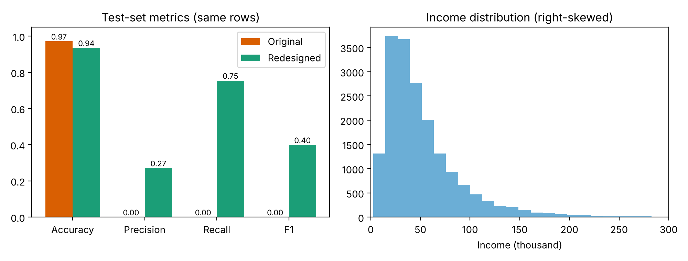
Fig. 7.1 – Left: metric comparison original vs redesigned. Right: skewed income distribution that motivates the log/quantile treatment
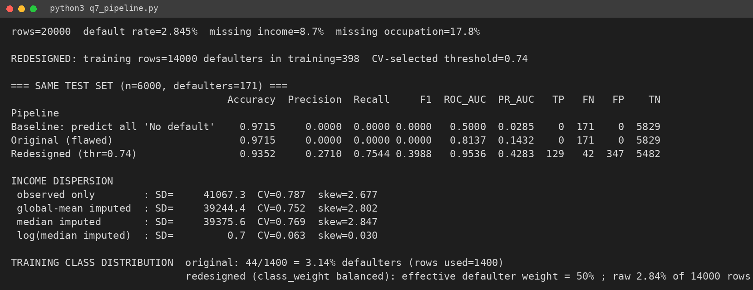
Screenshot 7.1 – Output of q7_pipeline.py
Dispersion of income (from the screenshot): observed SD = 41,067 (skew 2.68); after global-mean imputation SD = 39,244 (skew 2.80); after log-transform of the median-imputed income SD = 0.7 and skew = 0.03.

F. Defence of the final design (2 marks)
Prediction vs result: income skew fell to ≈ 0 as predicted. Recall rose from 0.00 to 0.75 (target ≥ 0.70, predicted: met), precision is 0.27 (target ≥ 0.20: met), accuracy fell from 0.972 to 0.935 (still above 0.90 as predicted), and ROC-AUC rose from 0.81 to 0.95. The original model’s 97 % accuracy equals the always-‘no default’ baseline – it catches no defaulters (TP = 0 of 171). The redesigned pipeline catches 129 of 171 defaulters.
Why the final pipeline is defensible: every defect in Table 7.1 is removed – no leakage (split first, all statistics from training), no information loss (occupation kept as ‘Unknown’, missing-income flag kept), distribution-aware transformation (log + quantile bins), a stratified split, imbalance handled without discarding data, and an evaluation based on recall/precision. Logistic regression keeps the model explainable.
Remaining risk: the model raises many false alarms (347 good loans flagged against 129 true defaults, precision 0.27), so rejecting these applicants could turn away profitable customers; the threshold also depends on the assumed cost ratio and may drift if the borrower population or economy changes. In addition, results come from synthetic data and should be confirmed on real bank data before use, with monitoring after deployment.
MARK DISTRIBUTION
Question | Assessed Area | Marks
Q1 | Mining Functionalities and Algorithm Mapping | 5
Q2 | KDD Process, Architecture and Issues | 5
Q3 | Data Dispersion | 7
Q4 | Data Cleaning | 6
Q5 | Data Integration and Transformation | 7
Q6 | Data Reduction and Discretization | 7
Q7 | Day-4 Design Challenge – Diagnose, Redesign and Validate | 13
TOTAL |  | 50

Submission Requirements
Submit:
- Your assignment report containing the required evidence for Q1–Q7
- Spreadsheets/code/workflows used for calculations and validation
- Screenshots of tool outputs (Weka/KNIME/Python) with the settings used
- Datasets (or links) used in Q7
Manual calculations are primary evidence. Tool output may be used to verify your work but must not replace the working shown.
Assessment Verification
Students may be asked to explain any part of their:
- Manual calculations and their method
- Choice of preprocessing techniques
- Predictions and results
- Design Challenge
during a brief verification discussion/viva. The student should therefore be able to explain and defend the evidence submitted as their own work.
Overall Assessment Expectation
This assignment does not primarily assess your ability to reproduce textbook definitions or tool outputs.
It assesses your ability to:
Understand → Describe → Clean → Transform → Reduce → Predict → Validate → Defend
Your conclusions and design decisions must be supported by your own reasoning and evidence.

